|  |  |
| --- | --- |
| mavtern  INTERNSHIPS AND OPPURTUNITIES | Abstract  To develop a website for the students in a community to know about all the available internship opportunities in their areas of interest.  Team Members(05)  Anumandla, Saikrishna  Mandadi Pravallika  Naredi, Yash Sunil  Gandra, Harshitha  Gokavarapu, Satyanarayana |
|  |  |

**UNIVERSITY OF TEXAS ARLINGTON**

**Internships For Students**

The main purpose of our project by the end of semester is to deliver a website which provides opportunities for UTA (community) students to apply for available Internships and company recruiters to update the Internship postings. Students will be able to look for companies that are providing internships and at the same time companies can search for the students who are seeking opportunities.

Our website will have three users with three specific user roles. 1) Website administrator who is responsible for monitoring the website in order to control spam, inappropriate posts, and the creation/deletion of users. 2) Company recruiter who will be able to post jobs with specific requirements and details and review student resumes and applications. 3) Lastly our website will have students from different communities who can create a profile which describes their area of interest and skills. Also students will have the feasibility to upload their resume as well as search for internship/job openings. Student will have the company recruiter details (Email, Phone number etc.) which helps the student to communicate with company recruiter for further details on job/internship postings.

As an additional feature we will include a recommendation engine, which provides job suggestions based on the areas of interests and skills of the student provided. Also student will be provided with an option to search for jobs based on criteria such as location and salary.

For security and verification purposes, students can only create accounts with a valid UTA student ID and email address and recruiters can only create accounts with a valid company details such as email address and phone number.

However, our website will be specific to UTA student communities which will help recruiters narrow their searches and increase the likelihood that UTA students can find the perfect match.

Our website will be designed with a modern perspective in mind; it will be adaptive-responsive, so that it can be viewed from any device. It will run on different browsers. It will be written in web-based languages: HTML5, CSS, PHP, JavaScript and we will use an SQL database.

For this project, things to develop: -

* To develop an online database for purpose of student internship opportunities by using PHP, MySQL.
* Users of this internship project are categorized into 3 types with specific user roles.
* Website administrator: Responsible for monitoring the website in order to control spam, inappropriate posts, and the creation/deletion of users.
* Company recruiter: He will be able to post internship opportunities/jobs with specific requirements and correct company details. Also reviews student resumes and applications.
* Students (different communities): Students can create their profile describing their area of interest and skills. Also they will have feasibility to upload their resume and search for job/internship postings based on their skills, location and salary. Also students can fill their data even by linking their profiles with LinkedIn.
* Students will be notified whenever their most searched or desired positions are updated.
* Good User Interface to the website that we created either by using JSP or any Framework.
* As research and development, students can even give feedback about the website or any improvements that can be made to the website through a form.
* Finally, by the end of this semester we will deliver proper and more systematic internship placement system

|  |  |
| --- | --- |
| Team Meeting 01(Team 05) | 7 Feb 201812:00 PMNedderman Hall |

|  |  |  |  |
| --- | --- | --- | --- |
| Meeting called by: | Gokavarapu, Satyanarayana | Type of meeting: | Team discussion |
| Facilitator: | Anumandla, Saikrishna | Note taker: | Mandadi Pravallika |
| Timekeeper: | Gandra, Harshitha |  |  |

|  |  |
| --- | --- |
| Attendees: | Gokavarapu, Satyanarayana  Anumandla, Saikrishna  Gandra, Harshitha  Mandadi Pravallika  Naredi, Yash Sunil |

# Minutes

|  |  |  |  |  |
| --- | --- | --- | --- | --- |
| Agenda item: | Project and cover page discussion. | Presenter: | Naredi, Yash Sunil |  |

#### Discussion:

To describe about our project with more details as per the requirements and syllabus.

#### Conclusions:

Project outline was achieved and basic roles are assigned.

| Action items | Person responsible | Deadline |
| --- | --- | --- |
| * To describe in detail about our project and the need to implement, reason, delivery, users and content of our project. | Naredi, Yash Sunil  Anumandla, Saikrishna  Gokavarapu, Satyanarayana  Mandadi Pravallika  Gandra, Harshitha | 11 Feb 2018 |

# Other Information

#### Observers:

Naredi, Yash Sunil

Anumandla, Saikrishna

Gokavarapu, Satyanarayana

Mandadi Pravallika

Gandra, Harshitha

#### Resources:

LinkedIn, Glassdoor, Syllabus, Announcements.

#### Special notes:

Various internship websites were referred during team discussion to obtain more insights.

|  |  |
| --- | --- |
| Team Meeting 02(Team 05) | 21 Feb 201812:00 PMNedderman Hall |

|  |  |  |  |
| --- | --- | --- | --- |
| Meeting called by: | Anumandla, Saikrishna | Type of meeting: | Team discussion |
| Facilitator: | Mandadi Pravallika | Note taker: | Gokavarapu, Satyanarayana |
| Timekeeper: | Gandra, Harshitha |  |  |

|  |  |
| --- | --- |
| Attendees: | Gokavarapu, Satyanarayana  Anumandla, Saikrishna  Gandra, Harshitha  Mandadi Pravallika  Naredi, Yash Sunil |

# Minutes

|  |  |  |  |  |
| --- | --- | --- | --- | --- |
| Agenda item: | Designing a project layout and page layout. | Presenter: | Mandadi Pravallika |  |

#### Discussion:

To design a project layout and website page layout.

#### Conclusions:

Project layout and page layout is designed.

| Action items | Person responsible | Deadline |
| --- | --- | --- |
| * Discussed about the next steps in the project and designed   a project layout and a page layout using different tools. Also assigned roles to each team member. | Naredi, Yash Sunil  Anumandla, Saikrishna  Gokavarapu, Satyanarayana  Mandadi Pravallika  Gandra, Harshitha | 28 Feb 2018 |

# Other Information

#### Observers:

Naredi, Yash Sunil

Anumandla, Saikrishna

Gokavarapu, Satyanarayana

Mandadi Pravallika

Gandra, Harshitha

#### Resources:

LinkedIn, Dice, Syllabus, Announcements.

#### Special notes:

Various website page layouts were referred during team discussion to obtain more insights.

|  |  |
| --- | --- |
| Team Meeting 03(Team 05) | 28 Feb 201812:00 PMNedderman Hall |

|  |  |  |  |
| --- | --- | --- | --- |
| Meeting called by: | Naredi, Yash Sunil | Type of meeting: | Team discussion |
| Facilitator: | Mandadi Pravallika | Note taker: | Gokavarapu, Satyanarayana |
| Timekeeper: | Gandra, Harshitha |  |  |

|  |  |
| --- | --- |
| Attendees: | Gokavarapu, Satyanarayana  Anumandla, Saikrishna  Gandra, Harshitha  Mandadi Pravallika  Naredi, Yash Sunil |

# Minutes

|  |  |  |  |  |
| --- | --- | --- | --- | --- |
| Agenda item: | Discussion on backend database. | Presenter: | Anumandla, Saikrishna |  |

#### Discussion:

Discussed about the database to use and also discussed how to populate and retrieve data from database.

#### Conclusions:

We have decided to use SQL database with MySQL and PHP.

| Action items | Person responsible | Deadline |
| --- | --- | --- |
| * Concluded on which database to use and roles were assigned   to each member to research more on database queries. Also populated a test database with test data. | Naredi, Yash Sunil  Anumandla, Saikrishna  Gokavarapu, Satyanarayana  Mandadi Pravallika  Gandra, Harshitha | 04 Mar 2018 |

# Other Information

#### Observers:

Naredi, Yash Sunil

Anumandla, Saikrishna

Gokavarapu, Satyanarayana

Mandadi Pravallika

Gandra, Harshitha

#### Resources:

LinkedIn, Dice, Syllabus, Announcements.

#### Special notes:

Various website page layouts were referred during team discussion to obtain more insights.

|  |  |
| --- | --- |
| Team Meeting 04(Team 05) | 28 March 201812:00 PMNedderman Hall |

|  |  |  |  |
| --- | --- | --- | --- |
| Meeting called by: | Gandra, Harshitha | Type of meeting: | Team discussion |
| Facilitator: | Anumandla, Saikrishna | Note taker: | Naredi, Yash Sunil |
| Timekeeper: | Mandadi Pravallika |  |  |

|  |  |
| --- | --- |
| Attendees: | Gokavarapu, Satyanarayana  Anumandla, Saikrishna  Gandra, Harshitha  Mandadi Pravallika  Naredi, Yash Sunil |

# Minutes

|  |  |  |  |  |
| --- | --- | --- | --- | --- |
| Agenda item: | Discussion on website UI and additional features | Presenter: | Gandra, Harshitha |  |

#### Discussion:

Discussed about the Internship website UI and adding more features to the website.

#### Conclusions:

We have created multiple HTML pages for Home, login etc and CSS pages, also connected backend database.

| Action items | Person responsible | Deadline |
| --- | --- | --- |
| * Concluded on the website graphical user interface. Added   multiple HTML pages for Home, login etc and added CSS  pages for styling. Tested few use case scenarios with  populating database. | Naredi, Yash Sunil  Anumandla, Saikrishna  Gokavarapu, Satyanarayana  Mandadi Pravallika  Gandra, Harshitha | 04 April 2018 |

# Other Information

#### Observers:

Naredi, Yash Sunil

Anumandla, Saikrishna

Gokavarapu, Satyanarayana

Mandadi Pravallika

Gandra, Harshitha

#### Resources:

LinkedIn, Dice, Syllabus, Announcements.

#### Special notes:

Various website pages were referred during team discussion to obtain more insights

DATABASE:

--

-- Database: `jobportal`

--

-- --------------------------------------------------------

--

-- Table structure for table `admin`

--

CREATE TABLE `admin` (

  `id_admin` int(11) NOT NULL,

  `username` varchar(255) NOT NULL,

  `password` varchar(255) NOT NULL

) ENGINE=InnoDB DEFAULT CHARSET=latin1;

----------------------------------------------------------

--

-- Table structure for table `apply_job_post`

--

CREATE TABLE `apply_job_post` (

  `id_apply` int(11) NOT NULL,

  `id_jobpost` int(11) NOT NULL,

  `id_company` int(11) NOT NULL,

  `id_user` int(11) NOT NULL,

  `status` int(11) NOT NULL DEFAULT '0'

) ENGINE=InnoDB DEFAULT CHARSET=latin1;

-- --------------------------------------------------------

--

-- Table structure for table `cities`

--

CREATE TABLE `cities` (

  `id` int(11) NOT NULL,

  `name` varchar(30) NOT NULL,

  `state_id` int(11) NOT NULL

) ENGINE=InnoDB DEFAULT CHARSET=latin1;

--

-- Dumping data for table `cities`

--

CREATE TABLE `company` (

  `id_company` int(11) NOT NULL,

  `name` varchar(255) NOT NULL,

  `companyname` varchar(255) NOT NULL,

  `country` varchar(255) NOT NULL,

  `state` varchar(255) NOT NULL,

  `city` varchar(255) NOT NULL,

  `contactno` varchar(255) NOT NULL,

  `website` varchar(255) NOT NULL,

  `email` varchar(255) NOT NULL,

  `password` varchar(255) NOT NULL,

  `aboutme` varchar(255) DEFAULT NULL,

  `logo` varchar(255) NOT NULL,

  `createdAt` timestamp NOT NULL DEFAULT CURRENT_TIMESTAMP,

  `active` int(11) NOT NULL DEFAULT '2'

) ENGINE=InnoDB DEFAULT CHARSET=latin1;

--

-- Table structure for table `countries`

--

CREATE TABLE `countries` (

  `id` int(11) NOT NULL,

  `sortname` varchar(3) NOT NULL,

  `name` varchar(150) NOT NULL,

  `phonecode` int(11) NOT NULL

) ENGINE=InnoDB DEFAULT CHARSET=utf8;

--

--

-- Table structure for table `job_post`

--

CREATE TABLE `job_post` (

  `id_jobpost` int(11) NOT NULL,

  `id_company` int(11) NOT NULL,

  `jobtitle` varchar(255) NOT NULL,

  `description` text NOT NULL,

  `minimumsalary` varchar(255) NOT NULL,

  `maximumsalary` varchar(255) NOT NULL,

  `experience` varchar(255) NOT NULL,

  `qualification` varchar(255) NOT NULL,

  `createdat` timestamp NOT NULL DEFAULT CURRENT_TIMESTAMP

) ENGINE=InnoDB DEFAULT CHARSET=latin1;

--

-- Table structure for table `mailbox`

--

CREATE TABLE `mailbox` (

  `id_mailbox` int(11) NOT NULL,

  `id_fromuser` int(11) NOT NULL,

  `fromuser` varchar(255) NOT NULL,

  `id_touser` int(11) NOT NULL,

  `subject` varchar(255) NOT NULL,

  `message` text NOT NULL,

  `createdAt` timestamp NOT NULL DEFAULT CURRENT_TIMESTAMP

) ENGINE=InnoDB DEFAULT CHARSET=latin1;

--

-- Table structure for table `reply_mailbox`

--

CREATE TABLE `reply_mailbox` (

  `id_reply` int(11) NOT NULL,

  `id_mailbox` int(11) NOT NULL,

  `id_user` int(11) NOT NULL,

  `usertype` varchar(255) NOT NULL,

  `message` text NOT NULL,

  `createdAt` timestamp NOT NULL DEFAULT CURRENT_TIMESTAMP

) ENGINE=InnoDB DEFAULT CHARSET=latin1;

--

-- Table structure for table `states`

--

CREATE TABLE `states` (

  `id` int(11) NOT NULL,

  `name` varchar(30) NOT NULL,

  `country_id` int(11) NOT NULL DEFAULT '1'

) ENGINE=InnoDB DEFAULT CHARSET=latin1;

--

-- Table structure for table `users`

--

CREATE TABLE `users` (

  `id_user` int(11) NOT NULL,

  `firstname` varchar(255) NOT NULL,

  `lastname` varchar(255) NOT NULL,

  `email` varchar(255) NOT NULL,

  `password` varchar(255) NOT NULL,

  `address` text,

  `city` varchar(255) DEFAULT NULL,

  `state` varchar(255) DEFAULT NULL,

  `contactno` varchar(255) DEFAULT NULL,

  `qualification` varchar(255) DEFAULT NULL,

  `stream` varchar(255) DEFAULT NULL,

  `passingyear` varchar(255) DEFAULT NULL,

  `dob` varchar(255) DEFAULT NULL,

  `age` varchar(255) DEFAULT NULL,

  `designation` varchar(255) DEFAULT NULL,

  `resume` varchar(255) DEFAULT NULL,

  `hash` varchar(255) DEFAULT NULL,

  `active` int(11) NOT NULL DEFAULT '0',

  `aboutme` text,

  `skills` text

) ENGINE=InnoDB DEFAULT CHARSET=latin1;

--

--

-- Indexes for table `admin`

--

ALTER TABLE `admin`

  ADD PRIMARY KEY (`id_admin`);

--

-- Indexes for table `apply_job_post`

--

ALTER TABLE `apply_job_post`

  ADD PRIMARY KEY (`id_apply`);

--

-- Indexes for table `cities`

--

ALTER TABLE `cities`

  ADD PRIMARY KEY (`id`);

--

-- Indexes for table `company`

--

ALTER TABLE `company`

  ADD PRIMARY KEY (`id_company`),

  ADD UNIQUE KEY `email` (`email`);

--

-- Indexes for table `countries`

--

ALTER TABLE `countries`

  ADD PRIMARY KEY (`id`);

--

-- Indexes for table `job_post`

--

ALTER TABLE `job_post`

  ADD PRIMARY KEY (`id_jobpost`);

--

-- Indexes for table `mailbox`

--

ALTER TABLE `mailbox`

  ADD PRIMARY KEY (`id_mailbox`);

--

-- Indexes for table `reply_mailbox`

--

ALTER TABLE `reply_mailbox`

  ADD PRIMARY KEY (`id_reply`);

--

-- Indexes for table `states`

--

ALTER TABLE `states`

  ADD PRIMARY KEY (`id`);

--

-- Indexes for table `users`

--

ALTER TABLE `users`

  ADD PRIMARY KEY (`id_user`),

  ADD UNIQUE KEY `email` (`email`);

--

-- AUTO_INCREMENT for dumped tables

--

--

-- AUTO_INCREMENT for table `admin`

--

ALTER TABLE `admin`

  MODIFY `id_admin` int(11) NOT NULL AUTO_INCREMENT, AUTO_INCREMENT=2;

--

-- AUTO_INCREMENT for table `apply_job_post`

--

ALTER TABLE `apply_job_post`

  MODIFY `id_apply` int(11) NOT NULL AUTO_INCREMENT;

--

-- AUTO_INCREMENT for table `cities`

--

ALTER TABLE `cities`

  MODIFY `id` int(11) NOT NULL AUTO_INCREMENT, AUTO_INCREMENT=48315;

--

-- AUTO_INCREMENT for table `company`

--

ALTER TABLE `company`

  MODIFY `id_company` int(11) NOT NULL AUTO_INCREMENT, AUTO_INCREMENT=101;

--

-- AUTO_INCREMENT for table `countries`

--

ALTER TABLE `countries`

  MODIFY `id` int(11) NOT NULL AUTO_INCREMENT, AUTO_INCREMENT=247;

--

-- AUTO_INCREMENT for table `job_post`

--

ALTER TABLE `job_post`

  MODIFY `id_jobpost` int(11) NOT NULL AUTO_INCREMENT, AUTO_INCREMENT=101;

--

-- AUTO_INCREMENT for table `mailbox`

--

ALTER TABLE `mailbox`

  MODIFY `id_mailbox` int(11) NOT NULL AUTO_INCREMENT;

--

-- AUTO_INCREMENT for table `reply_mailbox`

--

ALTER TABLE `reply_mailbox`

  MODIFY `id_reply` int(11) NOT NULL AUTO_INCREMENT;

--

-- AUTO_INCREMENT for table `states`

--

ALTER TABLE `states`

  MODIFY `id` int(11) NOT NULL AUTO_INCREMENT, AUTO_INCREMENT=4121;

--

-- AUTO_INCREMENT for table `users`

--

ALTER TABLE `users`

  MODIFY `id_user` int(11) NOT NULL AUTO_INCREMENT, AUTO_INCREMENT=101;

WEBSITE-FLOW :

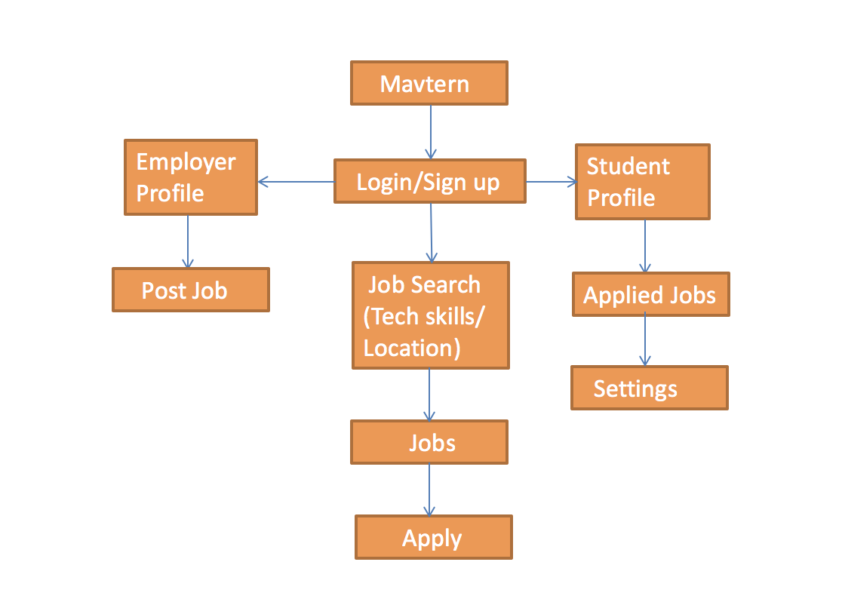

WEBPAGE LAYOUT (Prototype):

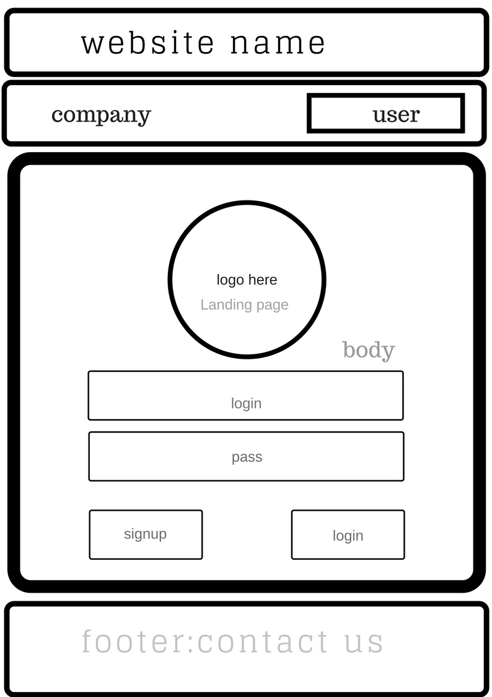

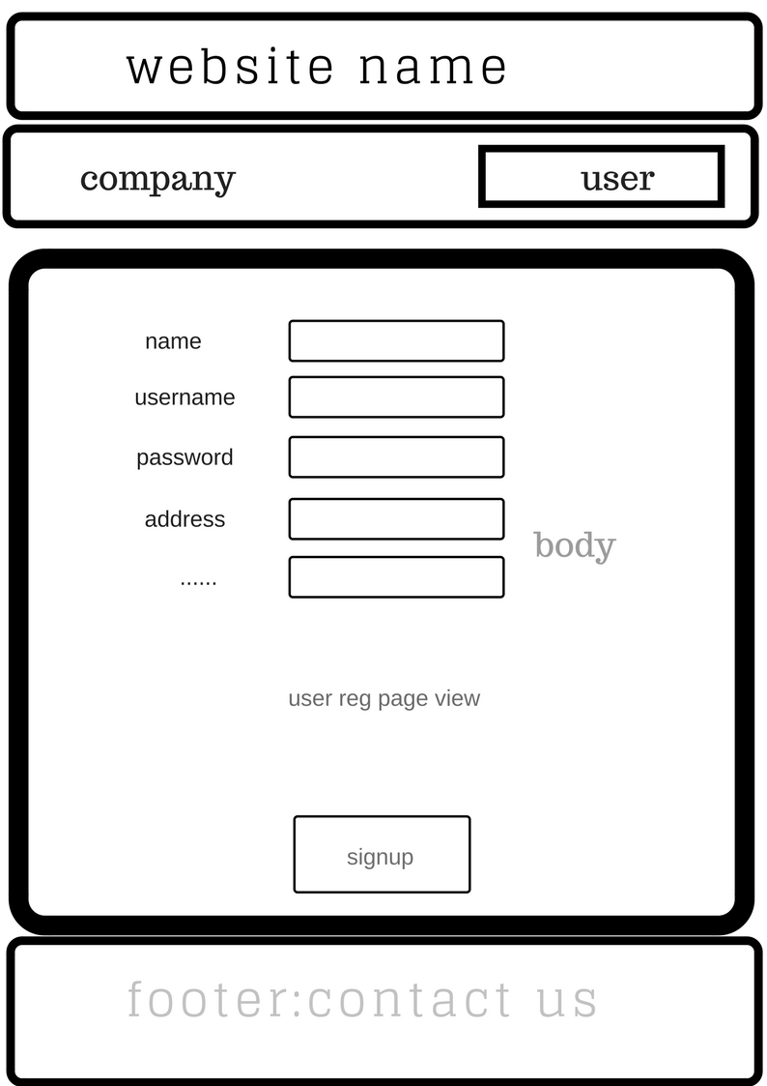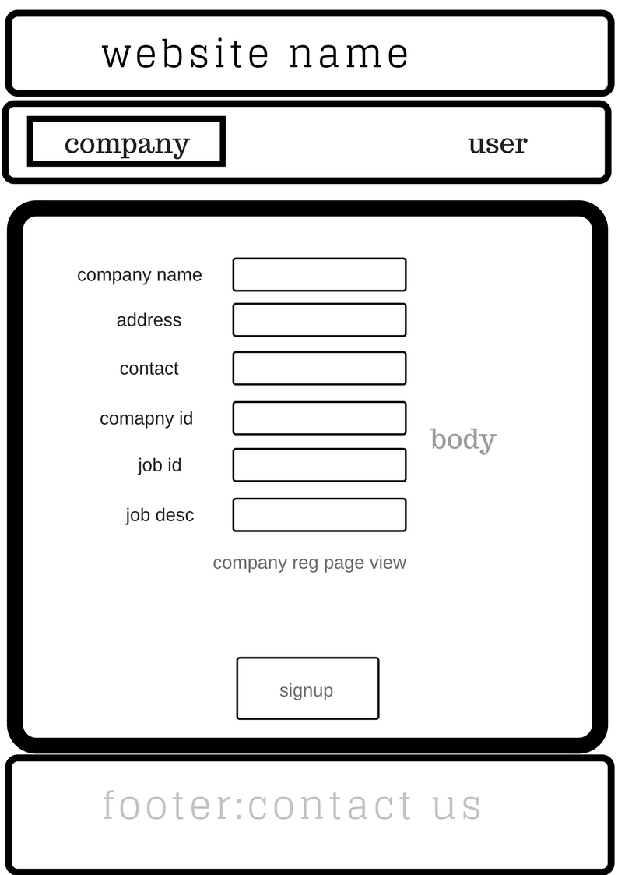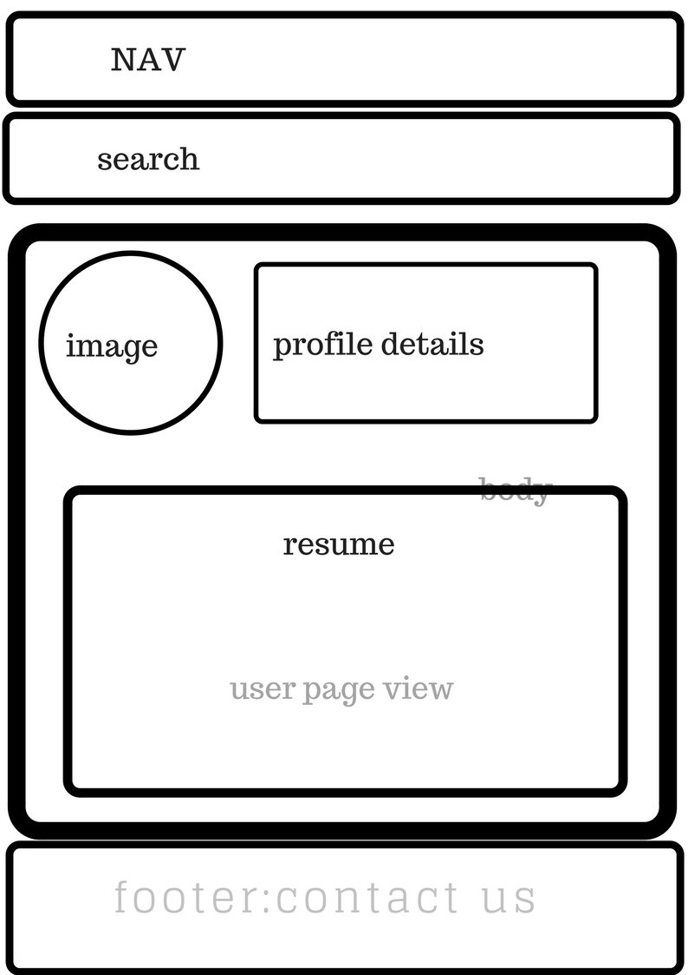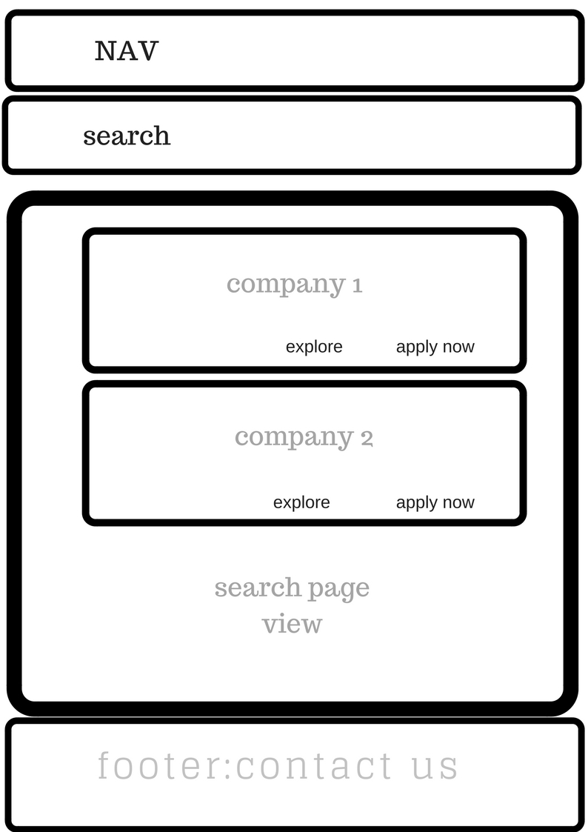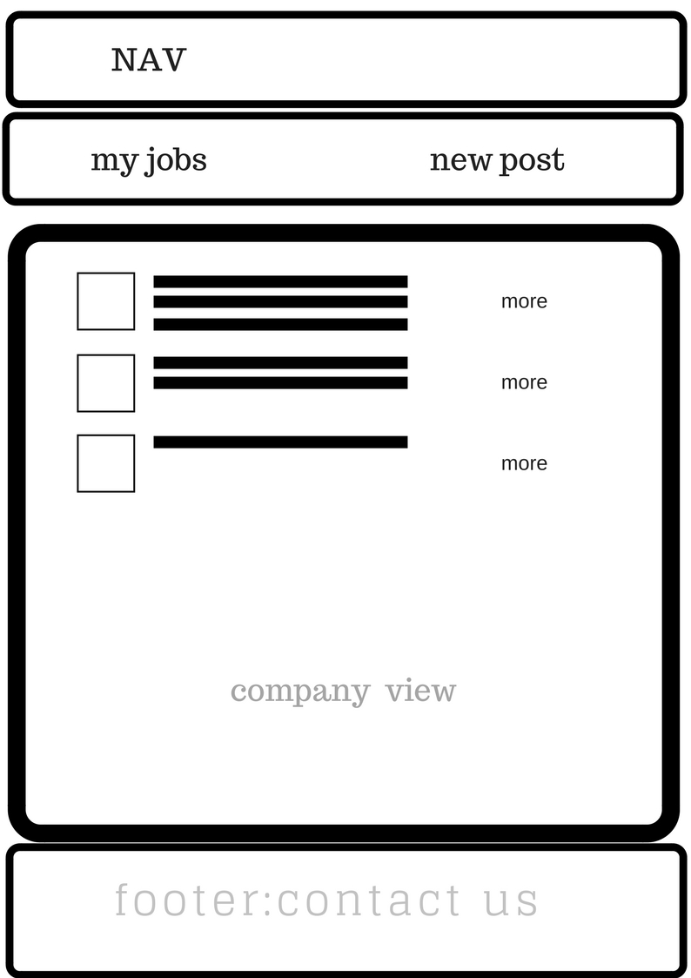

**References:**

1. <https://stackoverflow.com/>
2. <https://www.w3schools.com/php/default.asp>
3. <https://www.apachefriends.org/index.html>
4. <https://www.tutorialspoint.com/php/php_and_mysql.htm>