BEE CODES- HVAC CHILLERS

Objective & Scope
The purpose of this BEE Code is to establish rules and guidelines for conducting tests on Chillers at site conditions. This code is simplified to enable calculations and estimations at site conditions with normally available in-line and portable instruments.
This code deals with the Refrigeration Systems of the following types:
• Chilling Packages using Vapour Compression Cycle
• Chilling Packages using Vapour Absorption Cycle

This code does not cover small machines like window air-conditioners and split air-conditioners. It also does not cover ice builders.

Guiding Principles

The Net Refrigerating Effect is the useful cooling in the evaporator. Depending on the type of machine, either mechanical power or thermal power input is consumed by the refrigeration machine.

The Specific Power/Fuel/Steam Consumption, COP and EER can be estimated if the Net Refrigeration Effect and the Power/Fuel/Steam Consumption are known.

In some refrigeration machines, direct estimation of refrigeration effect in the evaporator is not possible. In such cases, the refrigeration effect can be estimated indirectly from the condenser cooling load.

Planning of the Test

- A chiller may operate under variable load condition in field conditions. For Vapor Compression Chilling Package, ensure that refrigerant is correctly charged and the operation is under steady temperature conditions (in the evaporator and condenser) through out the test period.
- For a Vapour Absorption Chilling Package, ensure the operation is under steady temperature conditions (in the evaporator, condenser and generator) throughout the duration of the test.
- COP at any actual operating load can be estimated by the methods described in this code. However, make sure that steady load conditions are maintained throughout the test period. Cyclic load variations during the test should be avoided.
- If thermo-wells are provided in the system, make sure that they are properly cleaned and suitable fluid is filled in at least 2 hours before test.

Vapour Compression Chilling Package- Measurements

a) Measurement of fluid (water, brine, air etc.) flow rate in evaporator.
b) Measurement of cooling air or cooling water flow rate, as applicable, in the condenser.
c) When the fluid being cooled is liquid, measurement of liquid temperature at the inlet and outlet of the evaporator.
d) When the fluid being cooled is air, measurement of dry bulb temperature and wet bulb temperatures of air at the inlet and outlet of the evaporator (normally called air handling unit).
e) For water-cooled condensers, water temperature at the inlet and outlet of the condenser.
f) For air-cooled condensers, dry bulb and wet bulb temperatures of the air at inlet and outlet of the condenser.
g) Estimation of shaft power of compressor from electrical power input to the motor or engine fuel consumption rate or turbine steam flow rate.

Vapour Absorption Chilling Package -Measurements

a) Measurement of fluid (water, brine, air etc.) flow rate in the evaporator.
b) Measurement of cooling water flow rate, as applicable, in the condenser.
c) Measurement of cooled fluid temperature at the inlet and outlet of the evaporator.
d) For water-cooled condensers, measurement of water temperature at the inlet and outlet of the condenser.
e) Measurement of steam mass flow rate for steam heated package.
f) Measurement of fuel flow rate for direct-fired package.

Recommended Accuracies for Measuring Instruments
The recommended accuracies for each of the above instruments and measurements is given below. For calibrating various instruments, visit www.nabl-india.org for a detailed list of accredited laboratories. Calibration interval suggested for instruments is 6 months.

Instrument and range | Accuracy
Fluid Flow, kg/hr or m³/hr | 2%
Steam flow | 3%
Temperature | 1%.(Precision of 0.1 C)
Humidity | 0.5%
Airflow | 1.0%

Methodology- 1: Direct Estimation of Net Refrigeration Effect in Evaporator

COP = Q_{l} x d x C_{p} x (T_{e-i}- T_{e-o})
3600 x W_{c}
For Vapour Compression Chilling Packages with electric motor driven compressors,
W_{c} = W_{m-i} x η_{m} x η_{t}

For Steam Fired Vapour Absorption Chilling Packages,
W_{c} = M_{st} x (h_{st} - h_{cond})
3600

For Direct Fired Packages using Vapour Absorption Cycle,
W_{c} = M_{f} x GCV
3600

Q_{l} = Fluid flow in evaporator, m³/h
d_{l} = Density of cooled liquid, kg/m³
C_{p} = Specific heat of fluid, kJ/kg-K
T_{e-i} = Fluid temperature at evaporator inlet, K
T_{e-o} = Fluid temperature at evaporator outlet, K
W_{m-i} = Motor input Power, kW
W_{e} = Engine Shaft Power, kW
W_{tur} = Steam Turbine Shaft Power, kW
W_{c} = Compressor Shaft Power or Thermal Power Input, kW
η_{m} = Motor efficiency, pu
η_{t} = Drive transmission efficiency, pu
M_{st} = Steam consumption rate, kg/h
h_{st} = Enthalpy of steam at operating pressure, kJ/kg
h_{cond} = Enthalpy of condensate, kJ/kg
M_{f} = Fuel consumption rate, kg/h
GCV = Gross Calorific Value of fuel, kJ/kg

Methodology- 2: Indirect Estimation of Net Refrigeration Effect in Evaporator by Measurements on Condenser side
- This method can be used when measurement or estimation of cooled fluid flow rate in the evaporator is not possible or inconvenient, but measurement of cooling water or cooling air flow rate in the condenser is possible.
- Estimation of Heat Rejection Rate in the Condenser.
- Measurement/Estimation of Electrical Power input, Shaft Power or Thermal Power input to the Refrigeration machine.
- Estimation of Refrigeration Effect in the Evaporator by the difference of Heat Rejection in the Condenser and the Refrigeration Effect.
- Estimation of Specific Power/Fuel/Steam Consumption, COP and EER.

For the above Vapour Absorption Chilling package, condenser side measurements were also done simultaneously. COP is estimated by using format given in table 3. Measurements and estimation of parameters is also given in Table 3 below.

COP = Q_{co} x d_{w} x C_{p-w} x (T_{co-o}- T_{ab-i}) - 1
3600 x W_{c}

For Vapour Compression Chilling Packages with electric motor driven compressors,
W_{c} = W_{m-i} x η_{m} x η_{t}

For Steam Fired Vapour Absorption Chilling Packages,
W_{c} = M_{st} x (h_{st} - h_{cond})
3600
For Fuel Fired For Direct Fired Packages using Vapour Absorption Cycle,

COP = Q_{co} x d_{w} x C_{p-w} x (T_{co-o}- T_{ab-i}) - η_{comb}
3600 x W_{c}
W_{c} = M_{f} x GCV
3600

Q_{co} = Fluid flow in condenser, m³/h
d_{w} = Density of water, kg/m³
C_{p-w} = Specific heat of water, kJ/kg-K
T_{ab-i} = Fluid temperature at absorber inlet, K for Vapour Absorption Chiller and fluid temperature at condenser inlet for Vapour Compression Chiller
T_{co-o} = Fluid temperature at condenser outlet, K
W_{c} = Compressor Shaft Power, kW
W_{e} = Engine Shaft Power, kW
W_{tur} = Steam Turbine Shaft Power, kW
W_{c} Compressor Shaft Power or Thermal Power Input, kW
η_{m} = Motor efficiency, pu
η_{t} = Drive transmission efficiency, pu
η_{comb} = Combustion Efficiency
M_{st} = Steam consumption rate, kg/h
h_{st} = Enthalpy of steam at operating pressure, kJ/kg
h_{cond} = Enthalpy of condensate, kJ/kg
M_{f} = Fuel consumption rate, kg/h
GCV = Gross Calorific value of fuel, kJ/kg

Methodology-3 - Psychrometric method: Evaporator side

COP = Q_{air} x d_{air} x (h_{air-i} - h_{air-o})
3600 x W_{c}
For electric motor driven compressors, W_{c} = W_{m-i} x η_{m} x η_{t}

Q_{air} = Air flow in evaporator, m³/h
d_{air} = Density of air, kg/m³
h_{air-i} = Enthalpy of air at evaporator inlet, kJ/kg
h_{air-o} = Enthalpy of air at evaporator outlet, kJ/kg
W_{m-i} = Motor input Power, kW
W_{e} = Engine Shaft Power, kW
W_{tur} = Steam Turbine Shaft Power, kW
W_{c} = Compressor Shaft Power
η_{m} = Motor efficiency, pu
η_{t} = Drive transmission efficiency, pu

Remarks:

The above methodologies given are only a summary of the original document. The final codes will be available by November 2005 with BEE.

BEST PRACTICES: HVAC-CHILLERS

The Need For Radical Thinking

With industrial development, the demand for process related refrigeration and air conditioning is bound to increase. However, modern lifestyles with the increasing demand of comfort air conditioning in commercial buildings and homes, using conventional air conditioning methods and equipments, is a source of concern for an energy scarce country like India.
Significant developments have taken place in the technology related to the hardware and controls related to refrigeration and air conditioning systems to help improve energy efficiency. However, the right attitude and design philosophy can play a larger role than technology in conserving energy. This implies that use of nature-assisted cooling techniques and minimal use of energy guzzling refrigeration equipments is the key energy conservation.
There is an urgent need to promote and commercialize all proven techniques that use natural processes to eliminate or minimize the use of conventional refrigeration and air conditioning. Basic design of industrial processes and also architectural spaces should strive to minimize the demand for conventional refrigeration and air conditioning. A strategy focusing on both refrigeration load reduction and energy efficiency improvement for conventional refrigeration is necessary to limit the unmitigated growth of conventional refrigeration.

Refrigeration System Efficiency
The cooling effect of refrigeration systems is generally quantified in tons of refrigeration. British measuring units are still popularly used by refrigeration and air conditioning engineers, hence it is necessary to know the energy equivalents.
1 Ton of Refrigeration (TR) = 3023 kcal/h
= 3.51 kW_{thermal}
= 12000 Btu/hr
The commonly used figures of merit for comparison of refrigeration systems are Coefficient of Performance (COP), Energy Efficiency Ratio (EER) and Specific Power Consumption (kW/TR). These are defined as follows:
If both refrigeration effect and the work done by the compressor (or the input power) are taken in the same units (TR or kcal/hr or kW or Btu/hr), the ratio is
COP = Refrigeration Effect
Work done
If the refrigeration effect is quantified in Btu/hr and the work done is in Watts, the ratio is
EER = Refrigeration Effect (Btu/hr)
Work done (Watts)
Higher COP or EER indicates better efficiency.
The other commonly used and easily understood figure of merit is
Specific Power Consumption = Power Consumption (kW)
Refrigeration effect (TR)
Lower Specific Power Consumption implies better efficiency.

Factors that affect the COP
The following figure -1 shows a typical vapour compression system. Fig 2 shows a typical P-H ( Pressure enthalpy diagram of R22.
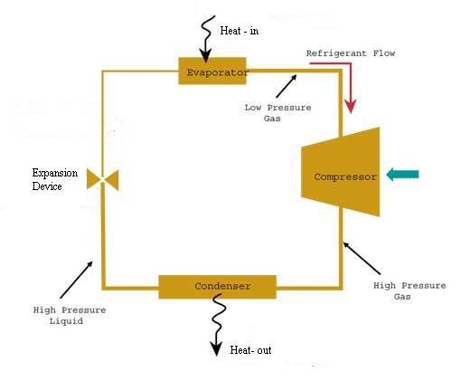
Fig.1. Vapour compression system
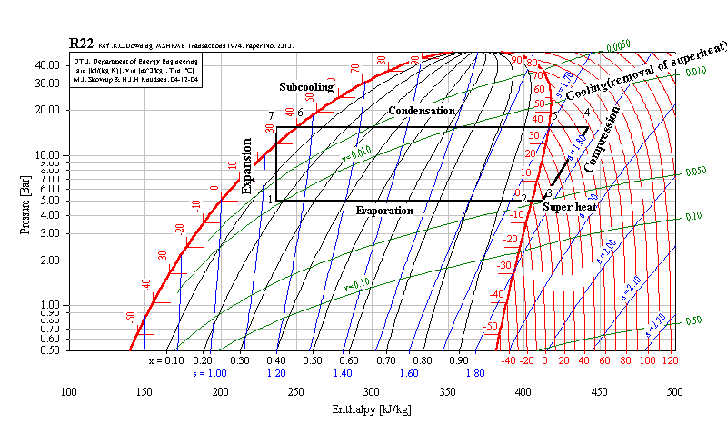
COP is affected by the evaporator temperature and the condenser temperature. Higher the evaporator temperature and lower the condenser temperature, better is the COP. 1ºC higher temperature of refrigerant in the evaporator or 1ºC lower in the condenser improves the COP by 2% to 4%.
The evaporator temperature can be increased by:
- Changing process temperature settings.
- Installing an evaporator of higher rating i.e. more heat transfer area.
- Keeping the heat transfer surface clean i.e. avoiding fouling, defrosting as per requirement etc.

The condenser temperature can be decrease by:
- Installing a condenser of higher rating i.e. more heat transfer area.
- The condenser temperature is allowed to float down with ambient temperature
- Water cooled or evaporatively cooled condensers are used instead of air cooled condensers

COP is also affected by:
- The efficiency of the type of compressor used.
- The amount of refrigerant charged in the system. Systems with refrigerant leaks consume more power.
- The physical properties of refrigerant used.

Points to be remembered
- The refrigerant type can affect the efficiency of the system by about 10%.
- Relative performance and efficiency of a refrigerant is affected by the type of compressor and the operating conditions.
- Too much or too little charge of refrigerant can reduce efficiency.
- Insufficient refrigerant reduces the wetted area the evaporator, increases the superheat, reduces the suction pressure, increases the temperature lift and reduces the efficiency.
- Refrigerant, contaminated with air or other gases, will affect the efficiency of the system.

Specific Energy Consumption of Vapor Compression Systems
The efficiency of refrigeration systems depends on the operating temperature and hence all figures of merit related to efficiency have to specified at a certain operating temperature.

Well designed, well maintained, water cooled or evaporatively cooled vapour compression systems, using reciprocating, screw or scroll compressors, for chilled water at about 8°C have COP of 4 to 5.8, EER in the range of 14 to 20 Btu/hr/W or Specific Power Consumption in the range of 0.61 to 0.87 kW/TR.

Open-type compressors are more efficient than semi-hermetic compressors; in semi-hermetic compressors, the motor is also cooled by the refrigerant.

Centrifugal compressors, which are generally used for cooling loads about 150 TR, can have COP of about 6, EER greater than 20 and Specific Power Consumption of 0.59 kW/TR.

The COP of systems with air cooled condensers is generally about 20% to 40% higher. In areas with dry weather, the COP improves significantly, if evaporatively cooled saturated air is provided instead of ambient dry air.

The COP of well designed small machines like window air conditioners and split air conditioning units are generally in the vicinity of 2.5. The COP is poor due the required compactness of the machine which limits heat transfer area and the limitation of air cooled condenser.

It may be noted that COP is calculated taking into account only the compressor power consumption. The power consumption of other parasitic loads like pumps, fans etc. are not considered.

Specific Energy Consumption of Vapor Absorption Systems
The electrical power consumption of the vapor absorption machine is only about 2% of a comparable vapor compression machine, excluding the power consumption of cooling water system. . It may also be noted that for the same heat load, the heat rejected in an absorption machine is about 60% more than in a vapor compression machine, hence the cooling water pumping power consumption is likely to be significantly higher. Electricity savings are large; however, the economics would depend on the cost of heat energy used in the absorption system.
- To improve the part load efficiency of absorption chillers, variable speed drive can be used for controlling the speed of the dilute LiBr solution pump; this prevents the unnecessary sensible heating of surplus solution in the generator during low refrigeration loads.
- Lithium bromide will be supplied with inhibitors to limit corrosion, but regular checks (say once in a year) of chemical composition of the solution is advisable. Slow corrosion by inhibited lithium bromide will produce non-condensable gases, which will cause a very gradual loss of vacuum. If vacuum degrades more quickly than the manufacturers expect, this can provide early warning that corrosion is occurring.
- The chilled water and condenser water circuits should also be protected against corrosion and scaling by using conventional treatment.

Lithium Bromide – Water Absorption Chillers

Single Effect Absorption chillers at about 8°C have COP of about 0.5 to 0.6, EER is about 2.1 and Specific Steam Consumption is about 8.75 kg/hr/TR, at a steam pressure of 3 bar or lower.
Double Effect Absorption chillers at about 8°C have COP in the range of 1 to 1.2, EER in the range of 3.5 to 4 Btu/hr/W and Specific Steam Consumption in the range of 4.5 to 5.25 kg/hr/TR, at a steam pressure of 8 to 8.5 bar. In the case directly fired double effect absorption chillers, the Specific Fuel Consumption is likely to be about 0.35 m³/hr/TR of natural gas or about 0.30 kg/h/TR of fuel oil.
Triple Effect Absorption chillers are being marketed by international refrigeration majors and the reported COP is 1.6 i.e. EER of over 5. The steam consumption is likely to be about 2.3 kg/hr/TR.
Water – Ammonia Absorption Chillers
Single Effect Absorption chillers at about -10°C have COP of about 0.55, EER is about 1.9 and Specific Steam Consumption is about 10.2 kg/hr/TR, at a steam pressure of 3 bar. At -40°C, the COP drops to about 0.45.
The COP of absorption chillers improves when the evaporator is operated at higher temperature.
The COP of the chiller being poor implies that the load dumped on the condenser is very large. It should also be noted that the cooling water passes through both the absorber and condenser. Hence any deficiency in the cooling water system can affect the cooling capacity and the COP of the machine.

Energy Saving Ideas

Minimising Refrigeration & Air-conditioning

Use Cooling Tower Water at Higher Flows for Process Cooling
For process applications, the possibility of replacing chilled water with cooling water with higher flows and increased heat transfer area needs to be explored. This approach can also help in replacing sub-zero brine with chilled water in some applications. Technology imported from colder countries generally specifies chilled water for cooling applications as temperatures between 10°C to 20°C are usually available from cooling towers for most part of the year in these countries. At the time of technology transfer or equipment purchase, redesign of the heat exchangers for summer cooling water temperatures, prevalent in India, or highest possible chilled water temperatures should be seriously explored.

Use Evaporative Cooling for Comfort Cooling in Dry Areas
In dry areas, reasonable comfort temperatures can be achieved in summer by use of evaporative cooling i.e. by humidification of air by small desert coolers or central humidification plants. The energy consumption is likely to be about only about 10% to 20% of an air conditioning system.

Building Structure Cooling
A significant portion of the air conditioning load is due the heat transmitted through the walls and heat stored in the walls. This results in the room inner wall surface being at temperatures higher than that of the human body. This results in discomfort as the human body is unable to radiate heat to the walls; hence heat transfer (body cooling) is possible only by convection (air movement) and perspiration. Cooling of the building structure (walls and roof) itself can lead to dramatic reduction in the wall temperature and human comfort.
Building structure cooling helps neutralize this solar heat load by cooling the structure itself. The Central Building Research Institute, Roorkee, has proposed evaporative roof cooling (using wetted mats on roof tops) to neutralize the heat load. Wetted mats can be spread on the roof, the water will evaporate, effectively neutralising the solar heat load. The mats can be kept wet by small pump which is controlled by a moisture sensor or timer. It may be noted that the mat should be only wet and not flooded with water. This system can very effectively eliminate or significantly reduce energy consumption air-conditioning plants.
A Mumbai based company, specializing in innovations in refrigeration and air conditioning, has extended this concept further and attempted cooling the roof and the floor by burying a grid of water filled pipes (fig. 3.1), under vacuum, in the roof and floor. Water evaporates at 25ºC and the grid is connected to a small cooling tower, which acts as the heat sink and condenses the water vapour.

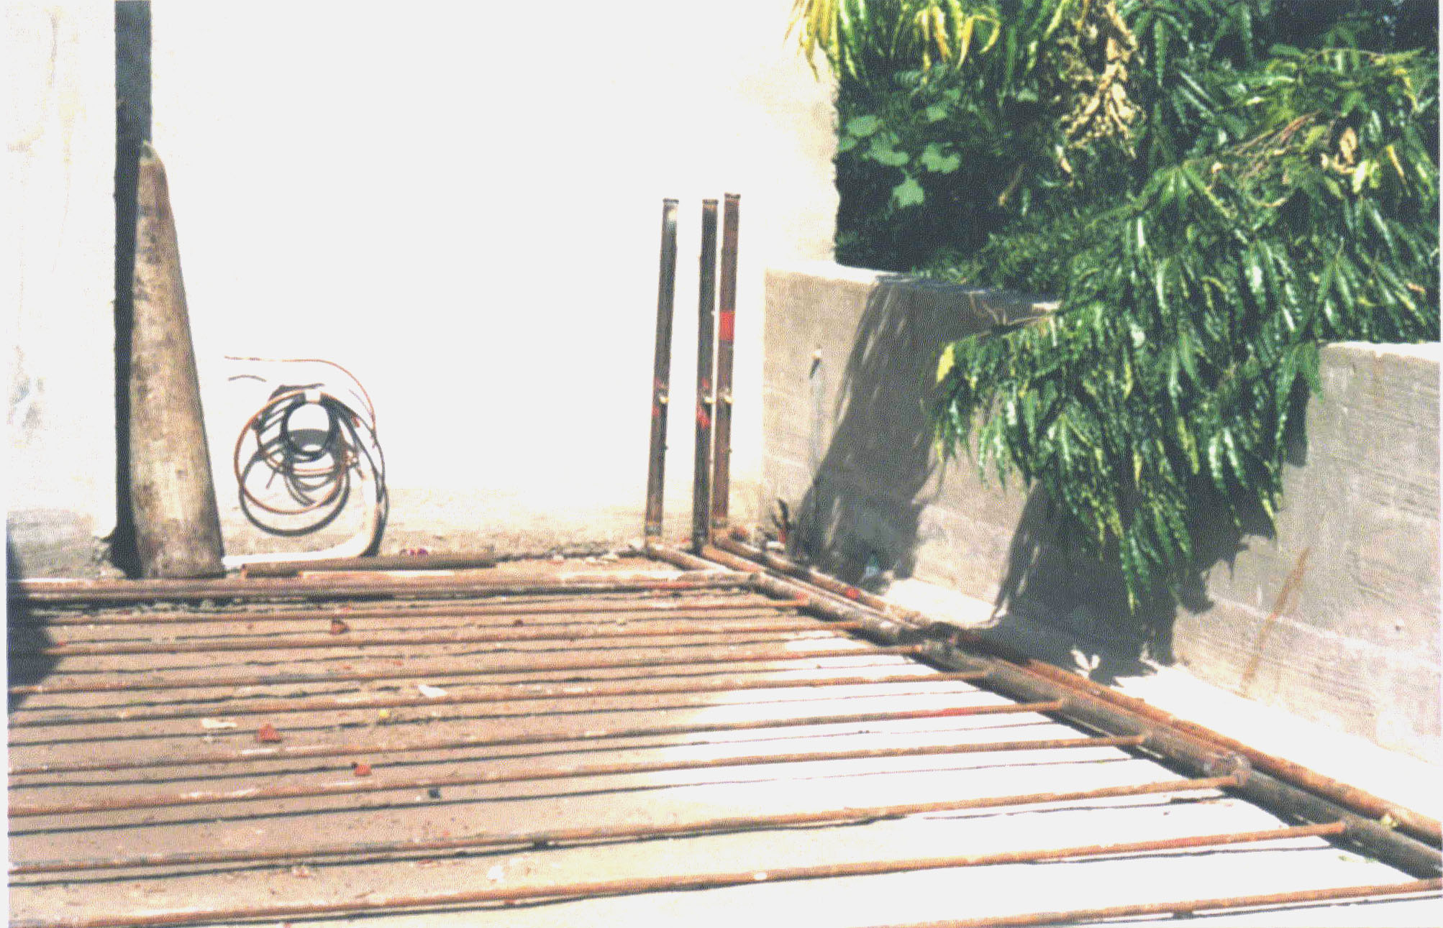

Fig. 4: Building Structure Cooling: Grid of Pipes on the Roof and Floor
(picture before application of cement plaster)

This concept was first attempted in a pent house at Ahmedabad. The house is cooled by a mixture of refrigerants which circulate in pipes buried in the walls and roof by thermo-siphon action. The solar heat and heat from the rooms is dissipated in a small cooling tower and pump located on the terrace, so the wall temperatures remain low. In May, with Ahmedabad ambient temperature at 41.6°C, the terrace floor temperature was 61.9°C, but the structure cooling system ensured that the room temperature was only 27°C. In fact, observations reveal that the room temperature remained almost constant through out the day and night.
The comparison of a house at Jaipur, with structure cooling system, with a neighbouring conventional house without structure cooling is shown in table 1. It may be noted that the roof underside temperature with structure cooling is 29.3ºC compared to 45.2ºC without structure cooling. With structure cooling the cooled part of the building becomes a heat sink for the entire structure. A cooler structure helps more efficient heat tranfer from the human body to the struture and increase the comfort level. This can help eliminate or reduce the need for air conditioning.

Table 1
Reduction in Roof Underside Temperature due to Structure Cooling
 | Roof Temperature (ºC)
 | Top side | Under side | Difference
House with Roof Cooling | 54.6 | 29.3 | 25.3
Neighboring house without roof cooling | 52.8 | 45.2 | 7.6
Note: Reduction in roof heating load is 75% with air conditioning at 24ºC

Building structure cooling potential has to aggressively exploited with innovative methods to eliminate or minimize the need for air conditioning.

Operating at Higher Evaporator Temperature

Table.2 shows the variation of refrigeration capacity, power consumption and specific power consumption for a particular vapour compression system with evaporator refrigerant gas temperature. It may be observed that higher the temperature, higher the system capacity, higher the power input and lower the specific power consumption (kW/TR). This clearly indicates that the cooling effect increases in greater proportion than the power consumption, thus the system will cool faster and shut off.
Table.2
Effect of Evaporator and Condenser Temperatures
on Refrigeration Machine Performance
Evaporator Temperature °C |  | Condenser Temperatures °C
Evaporator Temperature °C |  | +35 | +40 | +45 | +50
+5 | Capacity (TR) | 151 | 143 | 135 | 127
+5 | Power cons. (kW) | 94 | 102.7 | 110.6 | 117.8
+5 | Sp. Power (kW/TR) | 0.62 | 0.72 | 0.82 | 0.93
0 | Capacity (TR) | 129 | 118 | 111 | 104
0 | Power cons. (kW) | 90 | 96.8 | 103 | 108.9
0 | Sp. Power (kW/TR) | 0.70 | 0.82 | 0.93 | 1.05
-5 | Capacity (TR) | 103 | 96 | 90 | 84
-5 | Power cons. (kW) | 84.2 | 89.6 | 94.7 | 99.4
-5 | Sp. Power (kW/TR) | 0.82 | 0.93 | 1.05 | 1.19

Increasing the Chilled Water Temperature Set Point
The rationale behind temperature settings for process applications needs to be reviewed, keeping the present high energy costs in view. The aim is to avoid unnecessary super-cooling, without affecting production, quality and safety. Increasing energy costs have forced many industries to experiment and stabilize operation at higher temperatures.
Improve air Distribution in Cold Storages
In cold storage units, single large coil may lead to non-uniform temperatures in the cold store, which in turn leads to lower temperature settings. Replacement of single large coil-fan-diffuser units (for better air distribution) by smaller wall or ceiling mounted small fan-coil units can help lower temperature settings (at the compressor end) and large energy savings.
Improve Air Distribution and Circulation in Air Conditioned Rooms
In some air-conditioning systems, lower temperatures are set to over come problems of poor air distribution; making changes in ducting may be a more economical solution than permanently paying higher energy bills. In air-conditioned spaces, use of circulation fans can provide apparent comfort and help raise the room temperature settings to about 26°C instead of 24°C. Quiet fans can be concealed behind suspended grid to ensure that the décor is not affected. The reduction in energy consumption in the refrigeration machine will be significantly more than that consumed by the circulation fans.

Reduction in Heat Loads

Keep Unnecessary Heat Loads Out
Unnecessary heat loads may be kept outside air-conditioned spaces. Often, laboratory ovens/furnaces are kept in air-conditioned spaces. Such practices may be avoided. Provide dedicated external air supply and exhaust to kitchens, cleaning rooms, combustion equipment etc. to prevent negative pressure and entry of conditioned air from near by rooms. In cold stores, Idle operation of fork lift trucks should be avoided.
Use False Ceilings
Air-conditioning of unnecessary space wastes energy. In rooms with very high ceiling, provision of false ceiling with return air ducts can reduce the air-conditioning load. Relocate air diffusers to optimum heights in areas with high ceilings.
Use Small Control Panel Coolers
CNC machine shops, Telecom switching rooms etc. are air-conditioned. As cooling is required only for the control panels, use of small power panel coolers and hydraulic oil coolers (0.1 to 0.33 TR are available) can make the whole centralised air-conditioning redundant and save energy.
Use Pre-Fabricated, Modular Cold Storage Units
Cold stores should be designed with collapsible insulated partitions so that the space can be expanded or contracted as per the stored product volumes. The idea is to match product volumes and avoid unnecessary cooling of space and reduce losses. Modular cold store designs are commercially available.
Cycle Evaporator Fans in Cold Stores
In cold stores that remain shut for long periods, the heat load of the fans can be the major load. After attainment of temperature, refrigerant flow in evaporator fan-coils units and fan operation can be cycled on and off, using a programmable controller. This will reduce the heat load of fans and save energy (see case study).

Minimising Heat Ingress

Check and Maintain Thermal Insulation

Repair damaged insulation after regular checks. Insulate any hot or cold surfaces. Replace wet insulation. Insulate HVAC ducts running outside and through unoccupied spaces. Provide under-deck insulation on the ceiling of the top most floor of air-conditioned buildings.
Insulate Pipe Fittings
Generally, chilled water/brine tanks, pipe lines and end-use equipment in the industry are well insulated. However, valves, flanges etc. are often left uninsulated. With rising energy costs, it pays to insulate pipe flanges, valves, chilled water & brine pumps etc. also (fig. 5). Pre-formed insulation or ‘home-made’ box type insulation can be used
Reduce Excessive Use of Glass on Buildings
Modern commercial buildings use glass facades and/or large window area (almost 30% of the wall area) resulting in large solar heat gain and heat transmission. This architecture is suitable for cold countries, while in India it increases the air conditioning load for about eight to ten months in a year. In existing building, the possibility of replacing the glass panes with laminated insulation boards should be seriously considered. The colour of the laminations can be chosen to suit the internal and external décor. Glass facades, if desired, can be provided in the form of a glass curtain external to a convention wall with necessary window area.

Fig 5: Insulated pipe and fittings
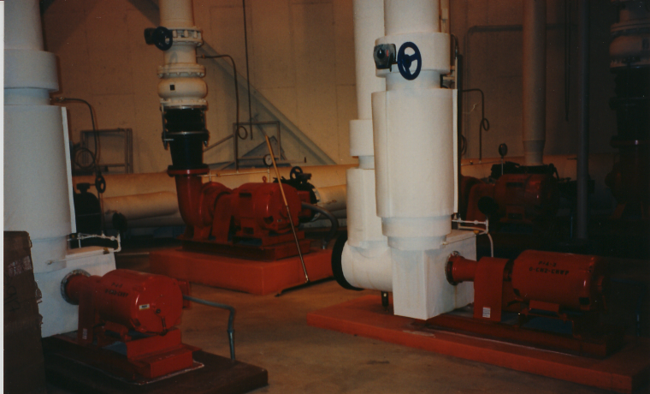
Use Glass with Low Solar Heat Gain Coefficient (SHGC) and Thermal Conductivity
Table 3 shows the SHGC, Thermal Conductivity and Daylight Transmittance for different types glass panes. Use of glass with low SHGC and thermal conductivity is recommended. Daylight transmittance is important, if electric lighting (another heat load) has to be minimized.
Table 3
Properties of Different Types of Window Glass
Product | Solar Heat Gain  Coefficient (SHGC) | Thermal  Conductivity | Daylight  Transmittance
Clear Glass | 0.72 | 3.16 | 79
Body Tinted Glass | 0.45 | 3.24 | 65
Hard Coated Solar Control Glass | 0.26 | 3.27 | 24
Soft Coated Solar Control Glass | 0.18 | 3.08 | 15
Low Emissivity Glass | 0.56 | 2.33 | 61
Solar Control + Low Emissivity Glass | 0.23 | 1.77 | 41

It is reported that the Biological Sciences Building at Indian Institute of Technology, Kanpur, Roof and Wall Insulation has reduced the cooling load by 23%. The windows to wall ratio is only 7% and double glass insulated glass windows has reduced the cooling load by another 9%.

Use Low Conductivity Window Frames
Consider the use of plastic window frames in place of steel and aluminium frames. This can reduce the heat ingress by conduction.
Provide Insulation on Sun-Facing Roofs and Walls
Building insulation has not received much attention in India. Air-conditioned hotels and corporate office buildings should be provided with insulated walls (hollow bricks with insulation, double walls with insulation filling etc.) to reduce the heat ingress. Providing roof under-deck insulation is a common practice.
Use Doors, Air-Curtains, PVC Strip Curtains for Air Conditioned Spaces
Add vestibules or revolving door or self-closing doors to primary exterior doors. Air-curtains and/or PVC strip curtains are recommended for air-conditioned spaces with heavy traffic of people or pallet trucks. Use intermediate doors in stairways and vertical passages to minimise building stack effect.
A seven storied modern, air conditioned office building in Mumbai with about 70000 ft² has a heat load of 185 TR in summer. About window to wall ratio is about 30%. A simulation revealed that blocking 50% of the windows with laminated rigid insulation boards can reduce the air conditionng load by 13%. Providing gymsum board panels along walls with a one inch air gap can reduce the air conditioning load by an additional 4%.

The air conditioning system comprised 56 nos. air cooled package air conditioners with an average COP of 2.7. Replacement of air cooled condensers by water cooler condensers could reduce the specific energy consumption by about 40%.

Reducing Ventilation Heat Load

Ventilation is required to provide healthy conditions to the occupants of air conditioned rooms. About 15 cfm per person ventilation air has to provided. In India, the issue of Indoor Air Quality is usually ignored. Even if ventilation ports are provided, these are kept closed and ventilation is usually only due to door openings.
Indoor Air Quality is a serious issue in the developed countries and, in future, buildings in India may also have to adhere to norms. However, with ventilation, the heat load increases due to heat load added by the fresh air. Air to air heat exchangers can help reduce this heat load by pre-cooling the incoming air with out-going exhaust air.
Air-to-Air Heat Exchangers for Pre-cooling Ventilation Air
Heat Wheels
Heat wheels (fig. 6) are rotary heat exchangers packed with aluminium honey comb fill. One half of the wheel is in contact with the warm air and the other half with the cold air. The sensible heat of the incoming warm air is transferred to one half of the fill; as it rotates slowly and moves into the cold half, the fill transfers the heat to the cold stream. Desiccant coated heat wheels are also available; here, in addition to sensible heat transfer, latent heat transfer also takes place as the desiccant absorbs moisture also.

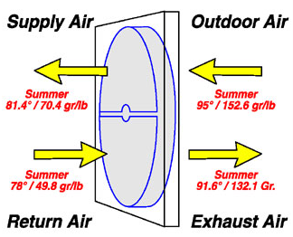

Fig. 6: Heat Wheel

Use Evaporators and Condensers with Higher Heat Transfer Efficacy
Use Heat Exchangers with Larger Surface Area
In the Indian industry, the specific power consumption for chilled water at 6° to 8°C, in reasonably well maintained vapour compression systems, is likely to be around 0.8 kW/TR (only for compressor; pumps & fans are not included). The best systems available in India today can give specific power consumption lower than 0.6 kW/TR (compressor power). In the USA, the normal specific power consumption figures of chillers is expected to be about 0.56 kW/TR. The high efficiency chiller of Trane, USA, has a specific power consumption of 0.48 kW/TR.
This low specific power consumption has been achieved mainly by use of larger and more effective heat transfer area in the chiller and condenser. Larger area implies more effective heat transfer. This, in turn, implies that the refrigerant temperatures, for the same heat load, will be higher in the evaporator and lower in the condenser. Table 2 shows very clearly that higher evaporator temperatures and lower condenser temperatures lead to significant drop in the specific power consumption in the compressor. Hence replacement of chillers/ condensers or increase of area by adding additional chillers/condensers in parallel can lead to significant energy savings.
1°C higher temperature in the evaporator or 1°C lower temperature in the condenser can reduce the specific power consumption by 2 to 3%.

Use Plate Heat Exchangers for Process and Refrigeration Machine Condenser Cooling
The use of Plate Heat Exchangers for condenser cooling can lead to lower temperature approach, hence reducing the compressor energy consumption. Plate heat exchangers have a temperature approach of 1°C to 5°C instead of around 5°C to 10°C for shell and tube heat exchangers.
Avoid the Use of Air Cooled Condensers
To take advantage of the wet bulb temperature, avoid the use of air-cooled condensers for large cooling loads. Air cooled condensers may be permitted only for small cooling loads or in conditions of extreme scarcity of water or lack of space for cooling tower. Use the lowest temperature condenser water available that the chiller can handle.
Evaporative Pre-coolers for Air-cooled Condensers
The performance of air-cooled condensers is limited by the dry bulb temperature. The performance of these condensers can be improved, in dry weather conditions, by providing humidified air near wet bulb temperature. This pre-cooler consists of a fill material with trickling water through which the air is drawn. Depending on the design, the fan power may increase or a booster fan may be required to over come the additional resistance to air flow. The potential for energy saving in dry summer months may be about 30% to 40%.

Energy Saving Opportunities in Normal Operation

Use Building Thermal Inertia in Air Conditioning for Early Switch Off
Once the entire building in cool, it takes a few hours to again come back to normal temperature. This building thermal lag can be used to minimise HVAC equipment operating time by shutting the air-conditioning system half hour or one hour before closing time.

Put HVAC Window Air Conditoners and Split Units on Timer or Occupancy Sensing Control
Window air conditioners and Split air conditioners installed for office cabins may operate unnecessarily for long time without cabins being occupied. The use of timers or infra-red occupancy sensors can help swtich of these machines automatically.

Interlock Fan Coil Units in Hotels with Door Lock or Master Switch
In hotels, unnecessary operation of Fan Coil Units can be prevented by providing an interlock with the door locking system or by switching control at the reception desk. The fan of the fan-coil unit should get switched off or go to low speed mode and the chilled water flow should be cut off by a solenoid valve. This can reduce the air-conditioning load in business hotels, during day time, when rooms are mostly not occupied.

Improve Utilisation Of Outside Air.
In systems with facility for using fresh air, maximise the use of fresh air when ambient conditions are favourable.
Maintain Correct Anti-freeze Concentration
In systems operating below 5°C, maintain brine or glycol concentration at appropriate levels, this has a significant impact on heat transfer and/or pumping energy.

Install a Chiller Control System to Co-Ordinate Multiple Chillers.
Study part-load characteristics and cycling costs to determine the most efficient mode for operating multiple chillers. Run the chillers with lowest operating costs to serve the base load. Link Chiller control system to the Building Automation System to maximize savings.

Permit Lower Condenser Pressures during Favourable Ambient Conditions
Favourable ambient conditions reduce cooling air or cooling water temperatures, which will reduce condensing temperatures and pressures, thus reducing the compressor power. The control systems may set to allow the machines to operate at lower condenser pressure.

Optimise Water/Brine/Air Flow Rates
Optimise condenser water flow rate and refrigerated water/brine flow rate to maintain the design temperature difference across the chillers and condensers. air flow rate. For normal process cooling and air conditioning applications, the chilled water flow rate is generally maintained around 2.4 gpm/TR of refrigeration load and the cooling water flow rate is maintained around 3 gpm/TR of refrigeration load. For comfort air-conditioning the air flow rate is generally around 400 cfm/TR. In situations where the flows are higher, speed reduction should considered. With electronic variable speed drives, the flow can be changed to match the operating load by maintaining a constant temperature drop or pick-up across the evaporator and condenser at all times.

Maintenance to Ensure Energy Efficient Operation

Temperature Settings
Regularly check control settings as these can drift over a period of time. Instrumentation should have the facility of programming and locking the settings with password protection.
Clean Fouled Heat Exchangers
Inefficient operation of refrigeration machines is usually due to fouling of condensers. This happens generally due to the absence of water treatment or poor water treatment practices. Scaling of condenser tubes reduces the heat transfer efficacy, increase the refrigerant temperature and pressure in the condenser, reduces the cooling capacity, increases the power consumption in the compressor. If this problem is ignored, it can also lead to tripping to the compressor on high discharge pressure. Chemical cleaning of heat exchangers is necessary to maintain the heat transfer efficacy. On-line monitoring and dosing systems are available for water treatment, this can ensure scale free operation on a continuous basis.
In the case of evaporative condensers, cleaning air side of condenser tubes helps in maintaining good heat transfer efficacy.
Air handling unit coil tube and fins should also be regularly cleaned externally.
Specify Appropriate Fouling Factors for Condensers
Fouling factors are considered in heat exchanger design to oversize the heat exchangers to offset the effect of fouling. However, equipment suppliers generally consider a fouling factor of 0.0005; a good water treatment programme is required to contain fouling within this limit. Ordinary scale of CaCO₃ of only 0.6 mm is equivalent to a fouling factor of 0.002. Studies have shown that 0.6 mm scale can result in an energy loss of about 20%. Absence of water treatment programmes or poorly managed water treatment programs can very easily lead to scales of this magnitude. Hence proper sizing of heat exchangers, based on realistic fouling factors, and a scientific water treatment programme (based on regular water quality measurements) are essential to maintain efficiency of refrigeration systems.

Desuperheater for Recovering Condenser Waste Heat

The discharge gas temperatures are likely to be in the vicinity of 100ºC to 120ºC. Use of desuperheaters can help recovery this heat in the form of hot water. Heat can also be recovered from the oil from screw compressors where the oil temperature is likely to be around 80ºC. Desuperheaters have helped some hotels to minimize the operation of hot water generators.

A novel heat pump has been developed at the Heat Pump Laboratory, IIT, Bombay, which is capable of providing room air conditioning, heating tap water to 45°C and cooling potable water to 15°C. This heat pump has been designed to cater to the domestic and the light commercial market with nominal air conditioning capacity of 1, 1.5 and 2 TR in window and split models. In a typical home end use, this heat pump can provide night time bed room air conditioning, chilled potable drinking water and, with a small storage tank, hot water for the morning.

Sizing & Selecting the Right Refrigeration Machine
Assess energy availability at the location i.e. electricity, cheap heat source or waste heat. Energy economics for Vapour Compression System or Vapour Absorption System or an Hybrid System will be decided by the refrigeration load profile and the cost of energy.
For very low temperatures, evaporator temperatures below -20ºC, the two stage vapour compression systems with inter-cooling will have to be considered to limit the discharge pressures. For evaporator temperatures below -50ºC, cascade systems may have to be considered. If cheap heat source or waste heat is available, the possibility of using Water – Ammonia Absorption chillers also exists.
Avoid over sizing to the extent possible – try to match the actual load, provide efficient method of modulation. Use of larger chillers will increase the parasitic loads like pumps, fans etc. Sizes and number of chillers should be selected to match the load profile as closely as possible; the same applies to parasitic loads like pumps, fans etc. This may even imply selecting unequally sized machines.
Water-cooled machines are generally preferable for refrigeration systems. In case water scarcity, absence of water treatment facility, non-availability of space for cooling towers etc. forces the decision.

In the case of air-conditioning systems, the system type can have a significant impact on the energy consumption. Air can be cooled directly by refrigerant in the AHU cooling coil (DX-type chiller) or by chilled water in the AHU cooling coil. Table 5.4 shows a comparison of likely energy consumption for a typical 100 TR air-conditioning system with different types of systems. The DX chiller with the water cooled condenser is the most efficient.
The selection of equipment for vapour compression systems should be done that most of the working equipments will work near their full load and near their best operating efficiency points at assessed plant refrigeration load at various points of time. It should also be ensured that associated equipments like pumps, fans etc. are also sized to ensure minimize energy consumption and reduce the “parasitic load” on the system. Select cooling coils for high temperature drops at design conditions to reduce pumping energy.
Table 4 compares 3 types of chilling plants for a particular installation. It appears that for air conditioning, DX chiller with water cooled condenser is the right combination. However, this is valid only for the particular site. Analysis should be done on a case to case basis.

Table 4
Comparison of Likely Energy Consumption for
a Typical 100 TR Air-Conditioning System
Type | DX chiller (air cooled condenser) | DX chiller (water cooled condenser) | Chilled water system
Capacity, TR | 100 | 100 | 100
Saturated Suction temp, °C | 6.1 | 6.1 | 4.4
Saturated Discharge temp, °C | 52.7 | 37.8 | 37.8
Compressor power, kW (a) | 104.5 | 62.0 | 62.0
Chilled water pump, kW (b) | 0.0 | 0.0 | 12.8
Condenser cooling fan/pump (c) | 7.8 | 13.5 | 13.5
Total power, kW (a) + (b) +(c) | 112.3 | 75.5 | 88.3
Total Specific power, kW/TR | 1.12 | 0.76 | 0.88
When comparing efficiencies of different chillers, efficiencies should be compared at both full load and part loads. The purchase decision should be based on the most likely load that is likely to prevail for the longest time period.
In applications where over sizing is inevitable, consider the use of variable speed drives on compressors and pumps.
In the case of Absorption Chillers, since capacity control up to 25% can be done without drop in efficiency, single chiller configurations can be permitted. However, variable speed drives may be installed to optimize the flow of pumps depending on the load.
Don’t oversize refrigeration plants unnecessarily, it may cost more to buy and run!

