# MULTIVIBRATOR

**Types of multivibrator:-**

1. **Astable Multivibrator**

Regenerative switching circuits such as **Astable Multivibrators** are the most commonly used type of relaxation oscillator because not only are they simple, reliable and ease of construction they also produce a constant square wave output waveform.

Unlike the [Monostable Multivibrator](http://www.electronics-tutorials.ws/waveforms/monostable.html) or the [Bistable Multivibrator](http://www.electronics-tutorials.ws/waveforms/bistable.html) we looked at in the previous tutorials that require an “external” trigger pulse for their operation, the **Astable Multivibrator** has automatic built in triggering which switches it continuously between its two unstable states both set and reset.

The **Astable Multivibrator** is another type of cross-coupled transistor switching circuit that has **NO** stable output states as it changes from one state to the other all the time. The astable circuit consists of two switching transistors, a cross-coupled feedback network, and two time delay capacitors which allows oscillation between the two states with no external trigger signal to produce the change in state.

In [Electronic Circuits](http://amazon.in/s/?field-keywords=Basic+Electronics+for+Scientists+and+Engineers)

, astable multivibrators are also known as **Free-running Multivibrator** as they do not require any additional inputs or external assistance to oscillate. Astable’s produce a continuous square wave from its output or outputs, (two outputs no inputs) which can then be used to flash lights or produce a sound in a loudspeaker.

The basic transistor circuit for an **Astable Multivibrator** produces a square wave output from a pair of grounded emitter cross-coupled transistors. Both transistors either NPN or PNP, in the multivibrator are biased for linear operation and are operated as [Common Emitter Amplifiers](http://www.electronics-tutorials.ws/transistor/tran_1.html) with 100% positive feedback.

This configuration satisfies the condition for oscillation when: ( βA = 1∠ 0o ). This results in one stage conducting “fully-ON” (Saturation) while the other is switched “fully-OFF” (cut-off) giving a very high level of mutual amplification between the two transistors. Conduction is transferred from one stage to the other by the discharging action of a capacitor through a resistor as shown below.

### Basic Astable Multivibrator Circuit

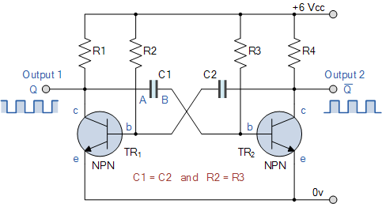

Assume that transistor, TR1 has just switched “OFF” and its collector voltage is rising towards Vcc, meanwhile transistor TR2 has just turned “ON”. Plate “A” of capacitor C1 is also rising towards the +6 volts supply rail of Vcc as it is connected to the collector of TR1. The other side of capacitor, C1, plate “B”, is connected to the base terminal of transistor TR2 and is at 0.6v because transistor TR2 is conducting therefore, capacitor C1 has a potential difference of 5.4 volts across it, 6.0 – 0.6v, (its high value of charge).

The instant that transistor, TR1 switches “ON”, plate “A” of the capacitor immediately falls to 0.6 volts. This fall of voltage on plate “A” causes an equal and instantaneous fall in voltage on plate “B” therefore plate “B” of the capacitor C1 is pulled down to -5.4v (a reverse charge) and this negative voltage turns transistor TR2 hard “OFF”. One unstable state.

Capacitor C1 now begins to charge in the opposite direction via resistor R3 which is also connected to the +6 volts supply rail, Vcc, thus the case of transistor TR2 is moving upwards in a positive direction towards Vcc with a time constant equal to the C1 x R3 combination.

However, it never reaches the value of Vcc because as soon as it gets to 0.6 volts positive, transistor TR2 turns fully “ON” into saturation starting the whole process over again but now with capacitor C2 taking the base of transistor TR1 to -5.4v while charging up via resistor R2 and entering the second unstable state. This process will repeat itself over and over again as long as the supply voltage is present.

The amplitude of the output waveform is approximately the same as the supply voltage, Vcc with the time period of each switching state determined by the time constant of the RC networks connected across the base terminals of the transistors. As the transistors are switching both “ON” and “OFF”, the output at either collector will be a square wave with slightly rounded corners because of the current which charges the capacitors. This could be corrected by using more components as we will discuss later.

If the two time constants produced by C2 x R2 and C1 x R3 in the base circuits are the same, the mark-to-space ratio ( t1/t2 ) will be equal to one-to-one making the output waveform symmetrical in shape. By varying the capacitors, C1, C2 or the resistors, R2, R3 the mark-to-space ratio and therefore the frequency can be altered.

We saw in the [RC Discharging](http://www.electronics-tutorials.ws/rc/rc_2.html) tutorial that the time taken for the voltage across a capacitor to fall to half the supply voltage, 0.5Vcc is equal to 0.69 time constants of the capacitor and resistor combination. Then taking one side of the astable multivibrator, the length of time that transistor TR2 is “OFF” will be equal to 0.69T or 0.69 times the time constant of C1 x R3. Likewise, the length of time that transistor TR1 is “OFF” will be equal to 0.69T or 0.69 times the time constant of C2 x R2 and this is defined as.

### Astable Multivibrators Periodic Time

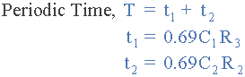

Where, R is in Ω’s and C in Farads.

By altering the time constant of just one RC network the mark-to-space ratio and frequency of the output waveform can be changed but normally by changing both RC time constants together at the same time, the output frequency will be altered keeping the mark-to-space ratios the same at one-to-one.

If the value of the capacitor C1 equals the value of the capacitor, C2, C1 = C2 and also the value of the base resistor R2 equals the value of the base resistor, R3, R2 = R3 then the total length of time of the **Multivibrators** cycle is given below for a symmetrical output waveform.

### Frequency of Oscillation

astable multivibrator equation

Where, R is in Ω’s, C is in Farads, T is in seconds and ƒ is in Hertz.

and this is known as the “Pulse Repetition Frequency”. So **Astable Multivibrators** can produce TWO very short square wave output waveforms from each transistor or a much longer rectangular shaped output either symmetrical or non-symmetrical depending upon the time constant of the RC network as shown below.

### Astable Multivibrator Waveforms

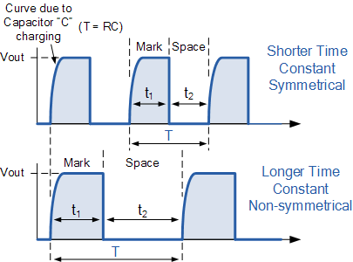

## Astable Multivibrator Example No1

An **Astable Multivibrators** circuit is required to produce a series of pulses at a frequency of 500Hz with a mark-to-space ratio of 1:5. If  R2 = R3 = 100kΩ’s, calculate the values of the capacitors, C1 and C2 required.

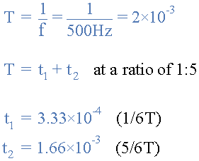

and by rearranging the formula above for the periodic time, the values of the capacitors required to give a mark-to-space ratio of 1:5 are given as:

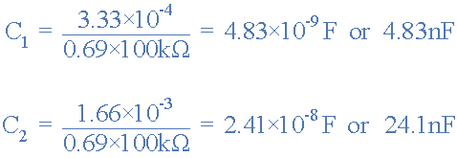

The values of 4.83nF and 24.1nF respectively, are calculated values, so we would need to choose the nearest preferred values for C1 and C2 allowing for the capacitors tolerance. In fact due to the wide range of tolerances associated with the humble capacitor the actual output frequency may differ by as much as ±20%, (400 to 600Hz in our simple example) from the actual frequency needed.

If we require the output astable waveform to be non-symmetrical for use in timing or gating type circuits, etc, we could manually calculate the values of R and C for the individual components required as we did in the example above. However, when the two R’s and C´s are both equal, we can make our life a little bit easier for ourselves by using tables to show the astable multivibrators calculated frequencies for different combinations or values of both R and C. For example,

### Astable Multivibrator Frequency Table

|  |  |  |  |  |  |  |  |  |  |
| --- | --- | --- | --- | --- | --- | --- | --- | --- | --- |
| Res. | Capacitor Values | | | | | | | | |
| 1nF | 2.2nF | 4.7nF | 10nF | 22nF | 47nF | 100nF | 220nF | 470nF |
| 1.0kΩ | 714.3kHz | 324.6kHz | 151.9kHz | 71.4kHz | 32.5kHz | 15.2kHz | 7.1kHz | 3.2kHz | 1.5kHz |
| 2.2kΩ | 324.7kHz | 147.6kHz | 69.1kHz | 32.5kHz | 14.7kHz | 6.9kHz | 3.2kHz | 1.5kHz | 691Hz |
| 4.7kΩ | 151.9kHz | 69.1kHz | 32.3kHz | 15.2kHz | 6.9kHz | 3.2kHz | 1.5kHz | 691Hz | 323Hz |
| 10kΩ | 71.4kHz | 32.5kHz | 15.2kHz | 7.1kHz | 3.2kHz | 1.5kHz | 714Hz | 325Hz | 152Hz |
| 22kΩ | 32.5kHz | 14.7kHz | 6.9kHz | 3.2kHz | 1.5kHz | 691Hz | 325Hz | 147Hz | 69.1Hz |
| 47kΩ | 15.2kHz | 6.9kHz | 3.2kHz | 1.5kHz | 691Hz | 323Hz | 152Hz | 69.1Hz | 32.5Hz |
| 100kΩ | 7.1kHz | 3.2kHz | 1.5kHz | 714Hz | 325Hz | 152Hz | 71.4Hz | 32.5Hz | 15.2Hz |
| 220kΩ | 3.2kHz | 1.5kHz | 691Hz | 325Hz | 147Hz | 69.1Hz | 32.5Hz | 15.2Hz | 6.9Hz |
| 470kΩ | 1.5kHz | 691Hz | 323Hz | 152Hz | 69.1Hz | 32.5Hz | 15.2Hz | 6.6Hz | 3.2Hz |
| 1MΩ | 714Hz | 325Hz | 152Hz | 71.4Hz | 32.5Hz | 15.2Hz | 6.9Hz | 3.2Hz | 1.5Hz |

Pre-calculated frequency tables can be very useful in determining the required values of both R and C for a particular symmetrical output frequency without the need to keep recalculating them every time a different frequency is required.

By changing the two fixed resistors, R2 and R3 for a dual-ganged potentiometer and keeping the values of the capacitors the same, the frequency from the **Astable Multivibrators** output can be more easily “tuned” to give a particular frequency value or to compensate for the tolerances of the components used.

For example, selecting a capacitor value of 10nF from the table above. By using a 100kΩ’s potentiometer for our resistance, we would get an output frequency that can be fully adjusted from slightly above 71.4kHz down to 714Hz, some 3 decades of frequency range. Likewise a capacitor value of 47nF would give a frequency range from 152Hz to well over 15kHz.

## Astable Multivibrator Example No2

An **Astable Multivibrator** circuit is constructed using two timing capacitors of equal value of 3.3uF and two base resistors of value 10kΩ. Calculate the minimum and maximum frequencies of oscillation if a 100kΩ dual-gang potentiometer is connected in series with the two resistors.

with the potentiometer at 0%, the value of the base resistance is equal to 10kΩ.

astable multivibrator upper frequency

with the potentiometer at 100%, the value of the base resistance is equal to 10kΩ + 100kΩ = 110kΩ.

astable multivibrator lower frequency

Then the output frequency of oscillation for the astable multivibrator can be varied from between 2.0 and 22 Hertz.

When selecting both the resistance and capacitance values for reliable operation, the base resistors should have a value that allows the transistor to turn fully “ON” when the other transistor turns “OFF”. For example, consider the circuit above. When transistor TR2 is fully “ON”, (saturation) nearly the same voltage is dropped across resistor R3 and resistor R4.

If the transistor being used has a current gain, β of 100 and the collector load resistor, R4 is equal to say 1kΩ the maximum base resistor value would therefore be 100kΩ. Any higher and the transistor may not turn fully “ON” resulting in the multivibrator giving erratic results or not oscillate at all. Likewise, if the value of the base resistor is too low the transistor may not switch “OFF” and the multivibrator would again not oscillate.

An output signal can be obtained from the collector terminal of either transistor in the Astable Multivibrators circuit with each output waveform being a mirror image of itself. We saw above that the leading edge of the output waveform is slightly rounded and not square due to the charging characteristics of the capacitor in the cross-coupled circuit.

But we can introduce another transistor into the circuit that will produce an almost perfectly square output pulse and which can also be used to switch higher current loads or low impedance loads such as LED’s or loudspeakers, etc without affecting the operation of the actual astable multivibrator. However, the down side to this is that the output waveform is not perfectly symmetrical as the additional transistor produces a very small delay. Consider the two circuits below.

### Astable Multivibrators Driving Circuit

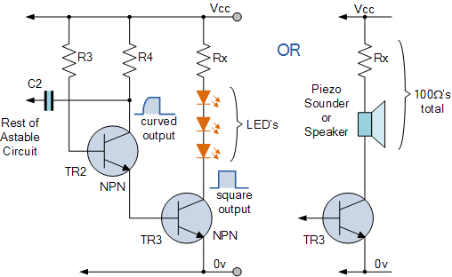

An output with a square leading edge is now produced from the third transistor, TR3 connected to the emitter of transistor, TR2. This third transistor switches “ON” and “OFF” in unison with transistor TR2. We can use this additional transistor to switch [Light Emitting Diodes](http://www.electronics-tutorials.ws/diode/diode_8.html), [Relays](http://www.electronics-tutorials.ws/io/io_5.html) or to produce a sound from a [Sound Transducer](http://www.electronics-tutorials.ws/io/io_8.html) such as a speaker or piezo sounder as shown above.

The load resistor, Rx needs to be suitably chosen to take into account the forward volt drops and to limit the maximum current to about 20mA for the LED circuit or to give a total load impedance of about 100Ω’s for the speaker circuit. The speaker can have any impedance less than 100Ω’s. By connecting an additional transistor, TR4 to the emitter circuit of the other transistor, TR1 in a similar fashion we can produce an astable multivibrator circuit that will flash two sets of lights or LED’s from one to the other at a rate determined by the time constant of the RC timing network.

In the next tutorial about Waveforms and Signals, we will look at the different types of **Astable Multivibrators** that are used to produce a continuous output waveform. These circuits known as relaxation oscillators produce either a square or rectangular wave at their outputs for use in sequential circuits as either a clock pulse or timing signal. These types of circuits are called Waveform Generators.

# (2) MONOSTABLE MULTIVIBRATOR:-

Monostable multivibrator block diagram.

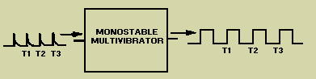

The schematic for a monostable multivibrator is shown in figure 3-11. Like the astable multivibrator, one transistor conducts and the other cuts off when the circuit is energized.

Figure 3-11. - Monostable multivibrator schematic.

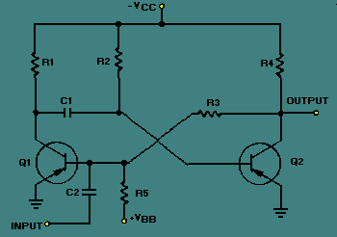

Recall that when the astable multivibrator was first energized, it was impossible to predict which transistor would initially go to cutoff because of circuit symmetry. The one-shot circuit is not symmetrical like the astable multivibrator. Positive voltage VBB is applied through R5 to the base of Q1. This positive voltage causes Q1 to cut off. Transistor Q2 saturates because of the negative voltage applied from -VCC to its base through R2. Therefore, Q1 is cut off and Q2 is saturated before a trigger pulse is applied, as shown in figure 3-12. The circuit is shown in its stable state.

Figure 3-12. - Monostable multivibrator (stable state).

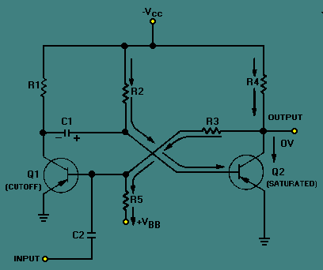

Let's take a more detailed look at the circuit conditions in this stable state (refer to figure 3-12). As stated above, Q1 is cut off, so no current flows through R1, and the collector of Q1 is at -VCC. Q2 is saturated and has practically no voltage drop across it, so its collector is essentially at 0 volts. R5 and R3 form a voltage divider from VBB to the ground potential at the collector of Q2. The tie point between these two resistors will be positive. Thus, the base of Q1 is held positive, ensuring that Q1 remains cutoff. Q2 will remain saturated because the base of Q2 is very slightly negative as a result of the voltage drop across R2. If the collector of Q1 is near -VCC and the base of Q2 is near ground, C1 must be charged to nearly VCC volts with the polarity shown.

Now that all the components and voltages have been described for the stable state, let us see how the circuit operates (see figure 3-13). Assume that a negative pulse is applied at the input terminal. C2 couples this voltage change to the base of Q1 and starts Q1 conducting. Q1 quickly saturates, and its collector voltage immediately rises to ground potential. This sharp voltage increase is coupled through C1 to the base of Q2, causing Q2 to cut off; the collector voltage of Q2 immediately drops to VCC. The voltage divider formed by R5 and R3 then holds the base of Q1 negative, and Q1 is locked in saturation.

Figure 3-13. - Monostable multivibrator (triggered).

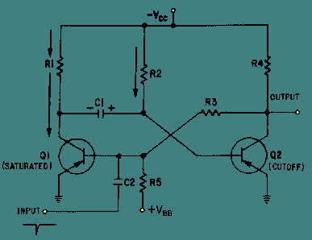

The one-shot multivibrator has now been turned on by applying a pulse at the input. It will turn itself off after a period of time. To see how it does this, look at figure 3-13 again. Q1 is held in saturation by the negative voltage applied through R3 to its base, so the circuit cannot be turned off here. Notice that the base of Q2 is connected to C1. The positive charge on C1 keeps Q2 cutoff. Remember that a positive voltage change (essentially a pulse) was coupled from the collector of Q1 when it began conducting to the base of Q2, placing Q2 in cutoff. When the collector of Q1 switches from -VCC volts to 0 volts, the charge on C1 acts like a battery with its negative terminal on the collector of Q1, and its positive terminal connected to the base of Q2. This voltage is what cuts off Q2. C1 will now begin to discharge through Q1 to ground, back through -VCC, through R2 to the other side of C1. The time required for C1 to discharge depends on the RC time constant of C1 and R2. Figure 3-14 is a timing diagram that shows the negative input pulse and the resultant waveforms that you would expect to see for this circuit description.

Figure 3-14. - Waveforms of a monostable multivibrator (triggered).

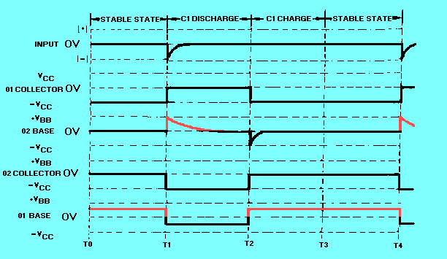

The only part of the operation not described so far is the short C1 charge time that occurs right after Q1 and Q2 return to their stable states. This is simply the time required for C1 to gain electrons on its left side. This charge time is determined by the R1C1 time constant.

Another version of the monostable multivibrator is shown in figure 3-15. View (A) is the circuit and view (B) shows the associated waveforms. In its stable condition (T0), Q1 is cut off and Q2 is conducting. The input trigger (positive pulse at T1) is applied to the collector of Q1 and coupled by C1 to the base of Q2 causing Q2 to be cut off. The collector voltage of Q2 then goes -VCC. The more negative voltage at the collector of Q2 forward biases Q1 through R4. With the forward bias, Q1 conducts, and the collector voltage of Q1 goes to about 0 volts. C1 now discharges and keeps Q2 cut off. Q2 remains cut off until C1 discharges enough to allow Q2 to conduct again (T2). When Q2 conducts again, its collector voltage goes toward 0 volts and Q1 is cut off. The circuit returns to its quiescent state and has completed a cycle. The circuit remains in this stable state until the next trigger arrives (T3).

Figure 3-15A. - Monostable miltivibrator and waveshapes. Schematic

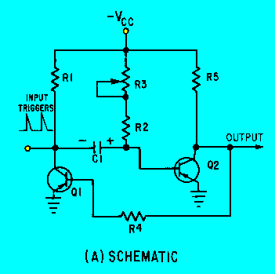

Figure 3-15B. - Monostable miltivibrator and waveshapes. Waveshapes

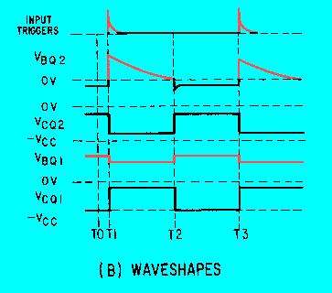

Note that R3 is variable to allow adjustment of the gate width. Increasing R3 increases the discharge time for C1 which increases the cutoff time for Q2. Increasing the value of R3 widens the gate. To decrease the gate width, decrease the value of R3. Figure 3-16 shows the relationships between the trigger and the output signal. View (A) of the figure shows the input trigger; views (B) and (C) show the different gate widths made available by R3. Although the durations of the gates are different, the duration of the complete cycle remains the same as the pulse repetition time of the triggers. View (D) of the figure illustrates that the trailing edge of the positive alternation is variable.

Figure 3-16. - Monostable multivibrator waveforms with a variable gate.

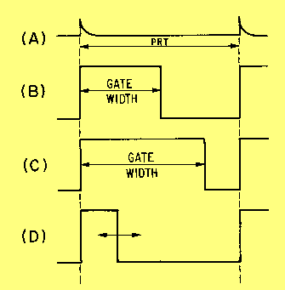

The reason the monostable multivibrator is also called a one-shot multivibrator can easily be seen. For every trigger pulse applied to the multivibrator.

# (3)BISTABLE MULTIVIBRATOR:-

The bistable multivibrator has two absolutely stable states. It will remain in whichever state it happens to be until a trigger pulse causes it to switch to the other state. For instance, suppose at any particular instant, transistor Q1 is conducting and transistor Q2is at cut-off. If left to itself, the bistable multivibrator will stay in this position for ever. However, if an external pulse is applied to the circuit in such a way that Q1 is cut-off and Q2 is turned on, the circuit will stay in the new position. Another trigger pulse is then required to switch the circuit back to its original state.

In other words a multivibrator which has both the state stable is called a bistable multivibrator. It is also called flip-flop, trigger circuit or binary. The output pulse is obtained when, and why a driving (triggering) pulse is applied to the input. A full cycle of output is produced for every two triggering pulses of correct polarity and amplitude.

Figure (a) shows the circuit of a bistable multivibrator using two NPN transistors. Here the output of a transistor Q2​is coupled put of a transistor Q1 through a resistor R2. Similarly, the output of a transistor Q1 is coupled to the base of transistor Q2 through a resistor R1. The capacitors C2 and C1 are known as speed up capacitors. Their function is to increase the speed of the circuit in making abrupt transition from one stable state to another stable state. The base resistors (R3 and R4) of both the transistors are connected to a common source (-VBB). The output of a bistable multivibrator is available at the collector terminal of the both the transistor Q1 and Q2. However, the two outputs are the complements of each other.

Let us suppose, if Q1 is conducting, then the fact that point A  is at nearly ON makes the base of Q2 negative (by the potential divider R2 - R4) and holds Q2 off.

Similarly with Q​2​ OFF, the potential divider from VCC to -VBB (RL2​, R​1​, R3) is designed to keep base of Q1 at about 0.7V ensuring that Q1 conducts. It is seen that Q1 holds Q2 OFF and Q​2​ hold Q1 ON.

Suppose, now a positive pulse is applied momentarily to R. It will cause Q2 to conduct. As collector of Q​2​ falls to zero, it cuts Q1 OFF and consequently, the BMV switches over to its other state.

Similarly, a positive trigger pulse applied to S will switch the BMV back to its original state.

Uses:

1. In timing circuits as frequency divider
2. In counting circuits
3. In computer memory circuits

## Bistable Multivibrator Triggering

To change the stable state of the binary it is necessary to apply an appropriate pulse in the circuit, which will try to bring both the transistors to active region and the resulting regenerative feedback will result on the change of state.

Triggering may be of two following types:

1. Asymmetrical triggering
2. Symmetrical triggering

### (I) Asymmetrical triggering

In asymmetrical triggering, there are two trigger inputs for the transistors Q1 and Q2. Each trigger input is derived from a separate triggering source. To induce transition among the stable states, let us say that initially the trigger is applied to the bistable. For the next transition, now the identical trigger must appear at the transistor Q2. Thus it can be said that the asymmetrical triggering the trigger pulses derived from two separate source and connected to the two transistors Q1 and Q2 individually, sequentially change the state of the bistable.

Figure (b) shows the circuit diagram of an asymmetrically triggered bistable multivibrator.

Initially Q1 is OFF and transistor Q2 is ON. The first pulse derived from the trigger source A, applied to the terminal turn it OFF by bringing it from saturation region to active transistor Q1 is ON and transistor Q2 is OFF. Any further pulse next time then the trigger pulse is applied at the terminal B, the change of stable state will result with transistor Q​2​ On and transistor Q1 OFF.

Asymmetrical triggering finds its application in the generation of a gate waveform, the duration of which is controlled by any two independent events occurring at different time instants. Thus measurement of time interval is facilitated.

### (II) Symmetrical Triggering

There are various symmetrical triggering methods called symmetrical collector triggering, symmetrical base triggering and symmetrical hybrid triggering. Here we would liked to explain only symmetrical base triggering (positive pulse) only as given under symmetrical Base Triggering.

Figure (c) shows the circuit diagram of a binary with symmetrical base triggering applying a positive trigger pulses.

Diodes D1 and D2 are steering diodes. Here the positive pulses, try to turn ON and OFF transistor. Thus when transistor Q1 is OFF and transistor Q2 is ON, the respective base voltages and V​B1N, OFF and V​B2N, ON. It will be seen that V​B1N, OFF > V​B1N, ON. Thus diode D​2​ is more reverse-biased compared to diode D1.

When the positive differentiated pulse of amplitude greater than (V​B1N, OFF + Vɣ) appears, the diode D​1​ gets forward biased, and transistor Q1 enters the active region and with subsequent regenerative feedback Q1 gets ON, and transistor Q2 becomes OFF. On the arrival of the next trigger pulse now the diode D2 will be forward biased and ultimately with regenerative feedback it will be in the ON state.

**STORAGE CRO**

**Two storage techniques are used in oscilloscope CRTs as,**  
- mesh storage  
-phosphor storage.   
  
The Storage targets can be distinguished from standard phosphor targets by their ability to retain a waveform pattern for a long time, independent of phosphor persistence.  
A mesh-storage CRT uses a dielectric material deposited on a storage mesa as the storage target. This mesh is placed between the deflection plates and the standard phosphor target in the CRT.  
The writing beam, which is the focused electron beam of the standard CRT, charges the dielectric material positively e where hit. The storage target is then bombarded with low velocity electrons from a flood gun and the positively charged areas of the storage target allow these electrons to pass through to the standard phosphor target and thereby reproduced the stored image on the screen.   
Thus the mesh storage has both a storage target and a phosphor display target. The phosphor storage CRT uses a thin layer of phosphor to serve both as the storage and the display element.  
Mesh Storage It is used to display Very Low Frequencies (VLF) signals an: finds many applications in mechanical and biomedical fields. The convention-scope has a display with a phosphor persistence ranging from a few microseconds to a few seconds. 

[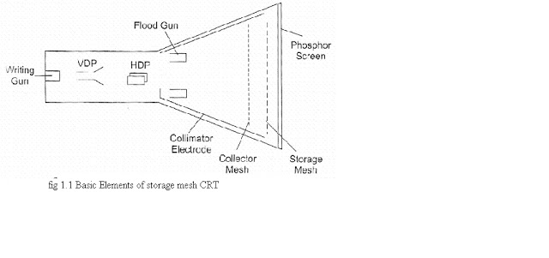](http://2.bp.blogspot.com/-J47msd_Paqg/T3C2JTjD-kI/AAAAAAAAAV0/Elj4LA_ONw8/s1600/f1.bmp)

A mesh storage CRT,  contains a dielectric material deposed on a storage mesh, a collector mesh, flood guns and a collimator, in addition BO all the elements of a standard CRT. The storage target, a thin deposition of a dielectric material such as Magnesium Fluoride on the storage mesh, makes use of a property known as secondary emission. The writing gun etches a positively charged pattern on the storage mesh or target by knocking off secondary emission electrons.   
  
Because of the excellent insulating property of the Magnesium fluoride coating, this positively charged pattern remains exactly in the position where it is deposited. In order to make a pattern visible, a special electron gun, called the flood gun, is switched on (even after many hours).   
  
  
The electron paths ire adjusted by the collimator electrode, which constitutes a low voltage electrostatic lens system (to focus the electronbeam), Most of the electrons are stopped and collected by the collector mesh. Only electrons near the stored positive charge are pulled to the storage target with sufficient force to hit the phosphor screen.   
  
The CRT will now display the signal and it will remain visible as long as the flood guns operate. To erase the pattern on the storage mesh, a negative voltage is applied to neutralize the stored positive charge.  
  
**Since the storage mesh makes use of secondary emission, between the first and second** crossover more electrons are emitted than are absorbed by the material, and hence a net positive charge results. Below the first crossover a net negative charge results, since the impinging electrons do not have sufficient energy to force an equal number to be emitted.   
  
In order to store a trace, assume that the storage surface is uniformly charge; and write gun (beam emission gun) will hit the storage target. Those areas of the storage surface hit by the deflecting beam lose electrons, which are collects by the collector mesh. Hence, the write beam deflection pattern is traced on the storage surface as a positive charge pattern.  
  
 Since the insulation of the dielectric material is high enough to prevent any loss of charge for a considerable length of time, the pattern is stored. To view, the stored trace, a flood gun is used when the write gun is turned off. The flood gun, biased very near the storage mesh potential, emits flood of electrons which move towards the collector mesh, since it is biased slightly more positive than the deflection region.   
  
The collimator ,a conductive coating on the CRT envelope with an applied potential, helps to align the flood electrons so that they approach the storage target perpendicularly When the electrons penetrate beyond the collector mesh, they encounter either a positively charged region on the storage surface or a negatively charged region where no trace has been stored.   
  
The positively charged areas allow the electrons to pass through to the post accelerator region and the display target phosphor. The negatively charged region repels the flood electrons back to the collector mesh. Thus the charge pattern on the storage surface appears reproduced on the CRT display phosphor just as though it were being traced with a deflected beam.

 Dual Trace CRO:

**The block diagram of dual trace oscilloscope which consist of following steps,**

1. Electronics gun (single)  
  
2.Separate vertical input channels ( Two)   
  
3. Attenuators   
  
4. pr-amplifiers  
  
5. Electronic switch.

[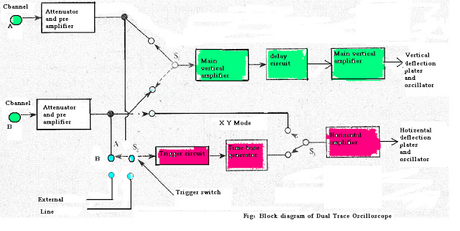](http://3.bp.blogspot.com/-eUeDhErrveQ/UE9vOIcWaSI/AAAAAAAAAmc/hWnTqACiP5c/s1600/diagram+Dual+trace+osilloscope.bmp)

The two separate input signals can be applied to **single electron gun** with the help of **electronic switching** it Produces a dual trace display .Each separate vertical input channel are uses separate **attenuators and pr-amplifier** stages, so the amplitude of each signal can be independently controlled. Output of the pr-amplifiers is given to the electronic switch, which passes one signal at a time into the **main vertical amplifier** of the oscilloscope.   
The **time base-generator** is similar to that of single input oscilloscope.  
  
  
By using switch S2 the circuit can be **triggered** on either A or B  
channel, waveforms, or an external signal, or on line frequency. The **horizontal amplifier** can be  
fed from sweep generator or from channel B by switching S1. When switch S, is in channel B, its  
oscilloscope operates in the X-Y mode in which channel A acts as the vertical input signal and  
channel B as the horizontal input signal.

# Power Supplies

|  |
| --- |
|  |

### Types of Power Supply

There are many types of power supply. Most are designed to convert high voltage AC mains electricity to a suitable low voltage supply for electronics circuits and other devices. A power supply can by broken down into a series of blocks, each of which performs a particular function.

For example a 5V regulated supply:

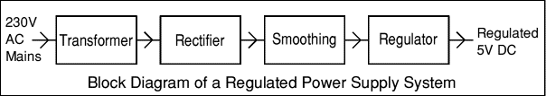

Each of the blocks is described in more detail below:

* [Transformer](http://electronicsclub.info/powersupplies.htm#transformer) - steps down high voltage AC mains to low voltage AC.
* [Rectifier](http://electronicsclub.info/powersupplies.htm#rectifier) - converts AC to DC, but the DC output is varying.
* [Smoothing](http://electronicsclub.info/powersupplies.htm#smoothing) - smooths the DC from varying greatly to a small ripple.
* [Regulator](http://electronicsclub.info/powersupplies.htm#regulator) - eliminates ripple by setting DC output to a fixed voltage.

Power supplies made from these blocks are described below with a circuit diagram and a graph of their output:

* [Transformer only](http://electronicsclub.info/powersupplies.htm#tonly)
* [Transformer + Rectifier](http://electronicsclub.info/powersupplies.htm#tr)
* [Transformer + Rectifier + Smoothing](http://electronicsclub.info/powersupplies.htm#trs)
* [Transformer + Rectifier + Smoothing + Regulator](http://electronicsclub.info/powersupplies.htm#trsr)

### Dual Supplies

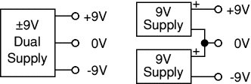Some electronic circuits require a power supply with positive and negative outputs as well as zero volts (0V). This is called a 'dual supply' because it is like two ordinary supplies connected together as shown in the diagram.

Dual supplies have three outputs, for example a ±9V supply has +9V, 0V and -9V outputs.

### Transformer only

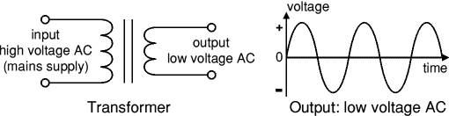

The **low voltage AC** output is suitable for lamps, heaters and special AC motors. It is **not** suitable for electronic circuits unless they include a rectifier and a smoothing capacitor.

### Transformer + Rectifier

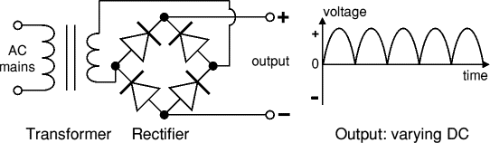

The **varying DC** output is suitable for lamps, heaters and standard motors. It is **not** suitable for electronic circuits unless they include a smoothing capacitor.

### Transformer + Rectifier + Smoothing

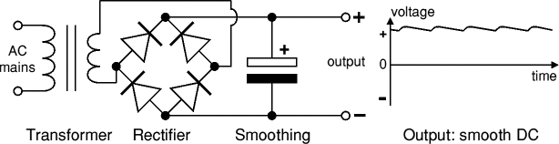

The **smooth DC** output has a small ripple. It is suitable for most electronic circuits.

### Transformer + Rectifier + Smoothing + Regulator

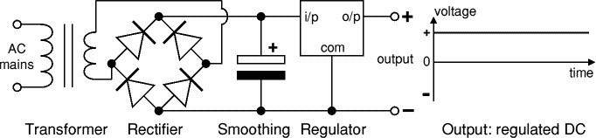

The **regulated DC** output is very smooth with no ripple. It is suitable for all electronic circuits.

### Transformer

|  |
| --- |
| transformer symbol |
| Transformer circuit symbol |
| Transformer, photograph © Rapid Electronics |
|  |
| |  | | --- | |  | |

Transformers convert AC electricity from one voltage to another with little loss of power. Transformers work only with AC and this is one of the reasons why mains electricity is AC.

Step-up transformers increase voltage, step-down transformers reduce voltage. Most power supplies use a step-down transformer to reduce the dangerously high mains voltage (230V in UK) to a safer low voltage.

The input coil is called the **primary** and the output coil is called the **secondary**. There is no electrical connection between the two coils, instead they are linked by an alternating magnetic field created in the soft-iron core of the transformer. The two lines in the middle of the circuit symbol represent the core.

Transformers waste very little power so the power out is (almost) equal to the power in. Note that as voltage is stepped down current is stepped up.

The ratio of the number of turns on each coil, called the **turns ratio**, determines the ratio of the voltages. A step-down transformer has a large number of turns on its primary (input) coil which is connected to the high voltage mains supply, and a small number of turns on its secondary (output) coil to give a low output voltage.

|  |  |  |  |  |  |
| --- | --- | --- | --- | --- | --- |
| turns ratio = | Vp | = | Np | and | power out = power in |
| Vs | Ns | Vs × Is = Vp × Ip |

|  |  |  |
| --- | --- | --- |
| Vp = primary (input) voltage Np = number of turns on primary coil Ip  = primary (input) current |  | Vs = secondary (output) voltage Ns = number of turns on secondary coil Is  = secondary (output) current |

RectifierThere are several ways of connecting diodes to make a rectifier to convert AC to DC. The [bridge rectifier](http://electronicsclub.info/powersupplies.htm#bridgerectifier) is the most important and it produces **full-wave** varying DC. A full-wave rectifier can also be made from just two diodes if a centre-tap transformer is used, but this method is rarely used now that diodes are cheaper. A [single diode](http://electronicsclub.info/powersupplies.htm#singlediode) can be used as a rectifier but it only uses the positive (+) parts of the AC wave to produce **half-wave** varying DC.

#### Bridge rectifier

A bridge rectifier can be made using four individual diodes, but it is also available in special packages containing the four diodes required. It is called a full-wave rectifier because it uses all the AC wave (both positive and negative sections). 1.4V is used up in the bridge rectifier because each diode uses 0.7V when conducting and there are always two diodes conducting, as shown in the diagram below. Bridge rectifiers are rated by the maximum current they can pass and the maximum reverse voltage they can withstand (this must be at least three times the supply [RMS](http://electronicsclub.info/acdc.htm#rms) voltage so the rectifier can withstand the peak voltages). Please see the [Diodes](http://electronicsclub.info/diodes.htm#bridge) page for more details, including pictures of bridge rectifiers.

|  |  |
| --- | --- |
| Operation of a Bridge Rectifier | Full-wave Varying DC |
| **Bridge rectifier** Alternate pairs of diodes conduct, changing over the connections so the alternating directions of AC are converted to the one direction of DC. | **Output: full-wave varying DC** (using all the AC wave) |

#### Single diode rectifier

A single diode can be used as a rectifier but this produces **half-wave** varying DC which has gaps when the AC is negative. It is hard to smooth this sufficiently well to supply electronic circuits unless they require a very small current so the smoothing capacitor does not significantly discharge during the gaps. Please see the [Diodes](http://electronicsclub.info/diodes.htm#rectifier) page for some examples of rectifier diodes.

|  |  |
| --- | --- |
| Single diode rectifier | Half-wave Varying DC |
| **Single diode rectifier** | **Output: half-wave varying DC** (using only half the AC wave) |

### Smoothing

Smoothing is performed by a large value [electrolytic capacitor](http://electronicsclub.info/capacitors.htm#polarised) connected across the DC supply to act as a reservoir, supplying current to the output when the varying DC voltage from the rectifier is falling. The diagram shows the unsmoothed varying DC (dotted line) and the smoothed DC (solid line). The capacitor charges quickly near the peak of the varying DC, and then discharges as it supplies current to the output.   
  
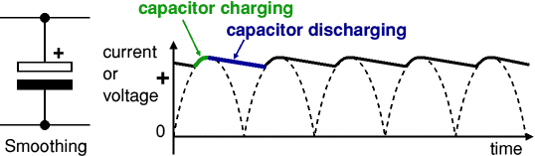

Note that smoothing significantly increases the average DC voltage to almost the peak value (1.4 × [RMS](http://electronicsclub.info/acdc.htm#rms) value). For example 6V RMS AC is rectified to full wave DC of about 4.6V RMS (1.4V is lost in the bridge rectifier), with smoothing this increases to almost the peak value giving 1.4 × 4.6 = 6.4V smooth DC.

|  |  |
| --- | --- |
|  |  |
|  |

### Regulator

|  |  |
| --- | --- |
| Voltage regulator | Voltage regulator, photograph © Rapid Electronics |
|  | Voltage regulator Photograph |

Voltage regulator ICs are available with fixed (typically 5, 12 and 15V) or variable output voltages. They are also rated by the maximum current they can pass. Negative voltage regulators are available, mainly for use in dual supplies. Most regulators include some automatic protection from excessive current ('overload protection') and overheating ('thermal protection').

Many of the fixed voltage regulator ICs has 3 leads and look like power transistors, such as the 7805 +5V 1A regulator shown on the right. They include a hole for attaching a [heatsink](http://electronicsclub.info/transistors.htm#heatsink) if necessary.

.

|  |
| --- |
| Zener diode |
| zener diode a = anode, k = cathode |
| Zener diode circuit |

#### Zener diode regulator

For low current power supplies a simple voltage regulator can be made with a resistor and a zener diode connected **in reverse** as shown in the diagram. Zener diodes are rated by their **breakdown voltage Vz** and **maximum power Pz** (typically 400mW or 1.3W).

The resistor limits the current (like an LED resistor). The current through the resistor is constant, so when there is no output current all the current flows through the zener diode and its power rating Pz must be large enough to withstand this.

Please see the [Diodes](http://electronicsclub.info/diodes.htm#zener) page for more information about zener diodes.

**Choosing a zener diode and resistor:**

1. The **zener voltage Vz** is the output voltage required
2. The **input voltage Vs** must be a few volts greater than Vz   
   (this is to allow for small fluctuations in Vs due to ripple)
3. The **maximum current Imax** is the output current required plus 10%
4. The **zener power Pz** is determined by the maximum current:  Pz > Vz × Imax
5. The **resistor resistance**:  R = (Vs - Vz) / Imax
6. The **resistor power rating**:  P > (Vs - Vz) × Imax

|  |  |  |  |
| --- | --- | --- | --- |
| Delay Circuits |  |  |  |

* [Time Delay Flash Trigger Circuit Circuit](http://www.next.gr/meter-counter/delay-circuits/time-delay-flash-trigger-circuit-l14889.html)

[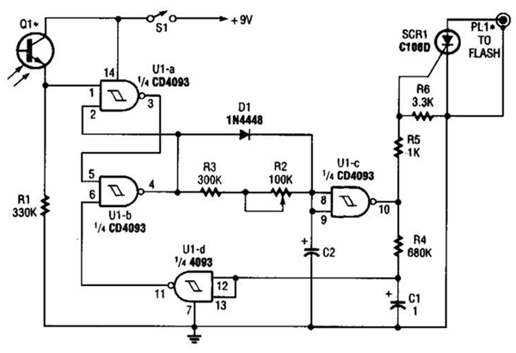](http://www.next.gr/meter-counter/delay-circuits/Time-Delay-Flash-Trigger-Circuit-Circuit-l14889.html)

* [Hour time-delay sampling circuit](http://www.next.gr/meter-counter/delay-circuits/hour-time-delay-sampling-circuit-l12433.html)

[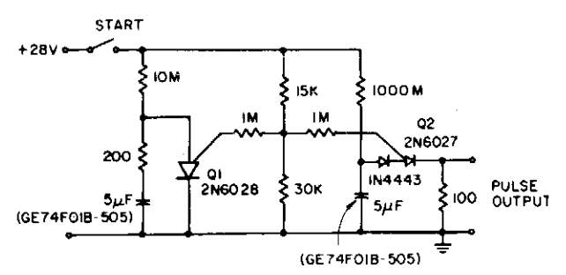](http://www.next.gr/meter-counter/delay-circuits/Hour-time-delay-sampling-circuit-l12433.html)

* [Adjustable-delay](http://www.next.gr/meter-counter/delay-circuits/adjustable-delay-l13255.html)

[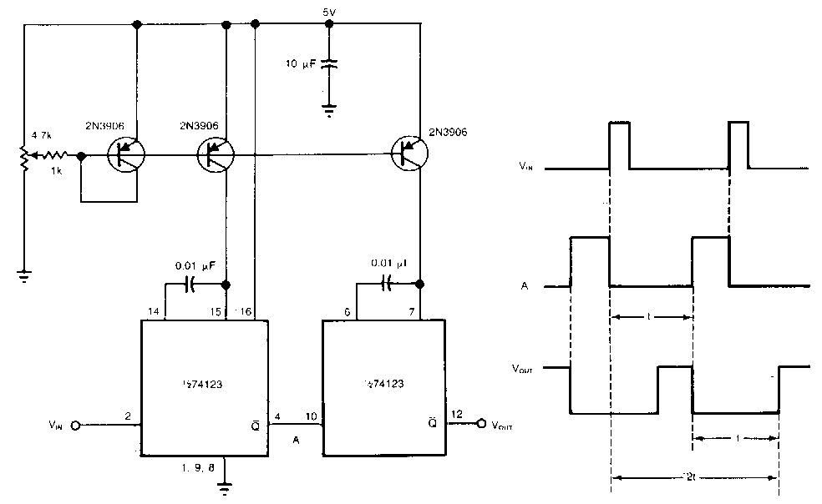](http://www.next.gr/meter-counter/delay-circuits/Adjustable-delay-l13255.html)

* [Delayed Pulse Generator Circuit](http://www.next.gr/meter-counter/delay-circuits/delayed-pulse-generator-circuit-l14958.html)

[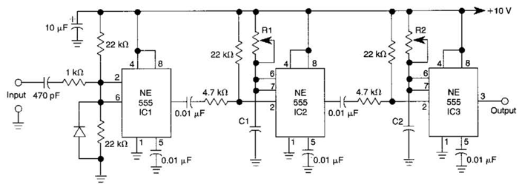](http://www.next.gr/meter-counter/delay-circuits/Delayed-Pulse-Generator-Circuit-l14958.html)

* [Time-Delay Auto-Kill Switch Circuit](http://www.next.gr/meter-counter/delay-circuits/time-delay-auto-kill-switch-circuit-l14577.html)

[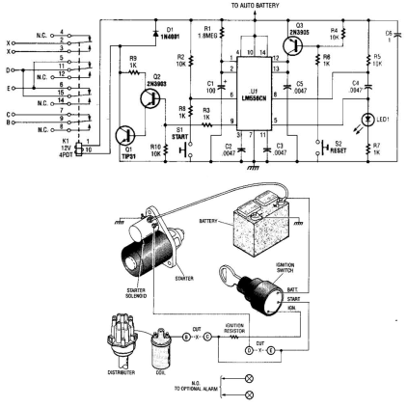](http://www.next.gr/meter-counter/delay-circuits/Time-Delay-Auto-Kill-Switch-Circuit-l14577.html)

* [Delayed Alarm Circuit](http://www.next.gr/meter-counter/delay-circuits/delayed-alarm-circuit-l14522.html)

[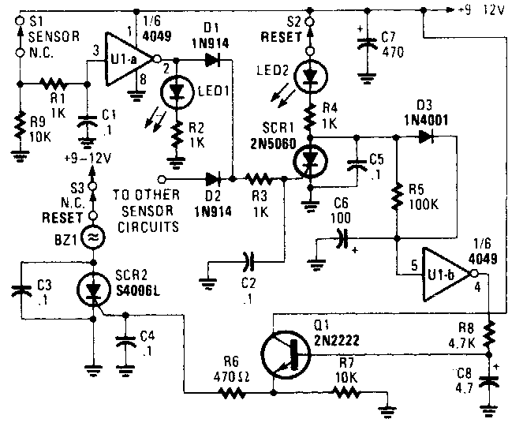](http://www.next.gr/meter-counter/delay-circuits/Delayed-Alarm-Circuit-l14522.html)

* [Simple-time-delay](http://www.next.gr/meter-counter/delay-circuits/simple-time-delay-l13784.html)

[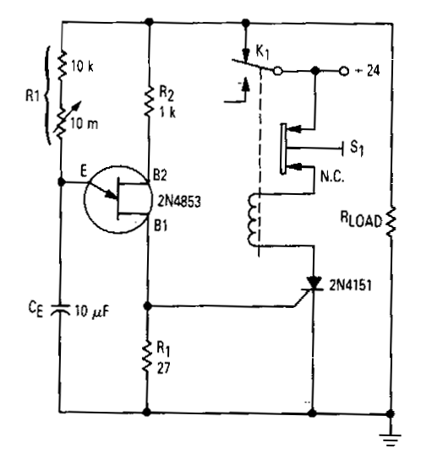](http://www.next.gr/meter-counter/delay-circuits/Simple-time-delay-l13784.html)

* [Leading-edge-delay](http://www.next.gr/meter-counter/delay-circuits/leading-edge-delay-l13253.html)

[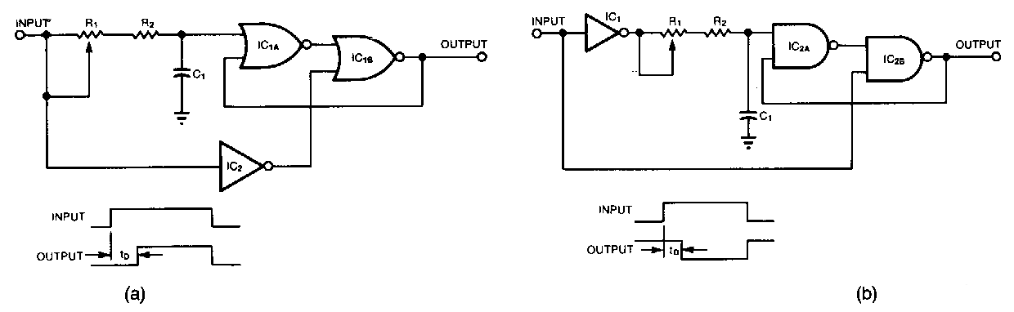](http://www.next.gr/meter-counter/delay-circuits/Leading-edge-delay-l13253.html)

* [Exit Delay For Burglar Alarms Circuit](http://www.next.gr/meter-counter/delay-circuits/exit-delay-for-burglar-alarms-circuit-l14529.html)

[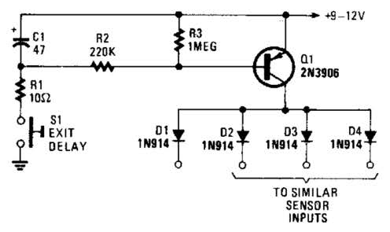](http://www.next.gr/meter-counter/delay-circuits/Exit-Delay-For-Burglar-Alarms-Circuit-l14529.html)

* [Pulse-delay-with-dual-edge-trigger](http://www.next.gr/meter-counter/delay-circuits/pulse-delay-with-dual-edge-trigger-l13254.html)

[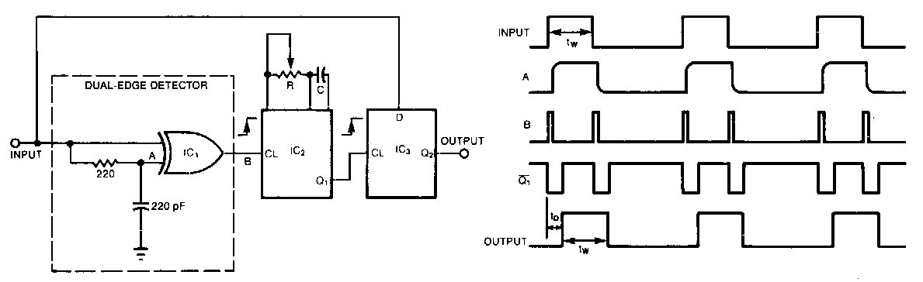](http://www.next.gr/meter-counter/delay-circuits/Pulse-delay-with-dual-edge-trigger-l13254.html)

* [Timing-threshold-and-load-driver](http://www.next.gr/meter-counter/delay-circuits/timing-threshold-and-load-driver-l13783.html)

[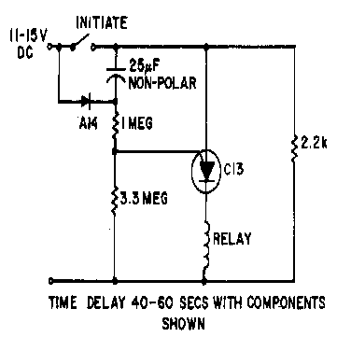](http://www.next.gr/meter-counter/delay-circuits/Timing-threshold-and-load-driver-l13783.html)

* [Electronic-time-delay](http://www.next.gr/meter-counter/delay-circuits/electronic-time-delay-l13782.html)

[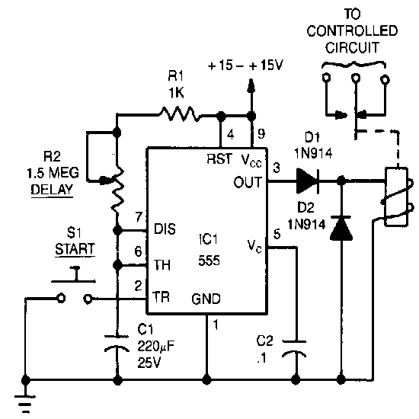](http://www.next.gr/meter-counter/delay-circuits/Electronic-time-delay-l13782.html)

* [Long delay timer using put](http://www.next.gr/meter-counter/delay-circuits/long-delay-timer-using-put-l12664.html)

[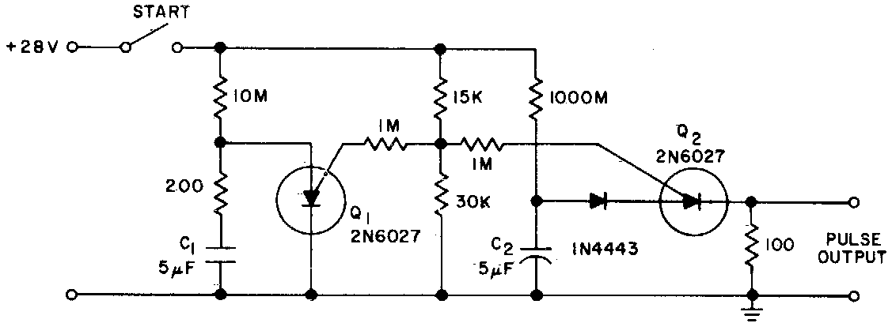](http://www.next.gr/meter-counter/delay-circuits/Long-delay-timer-using-put-l12664.html)

* [Ultra-precise long time delay relay](http://www.next.gr/meter-counter/delay-circuits/ultra-precise-long-time-delay-relay-l12665.html)

[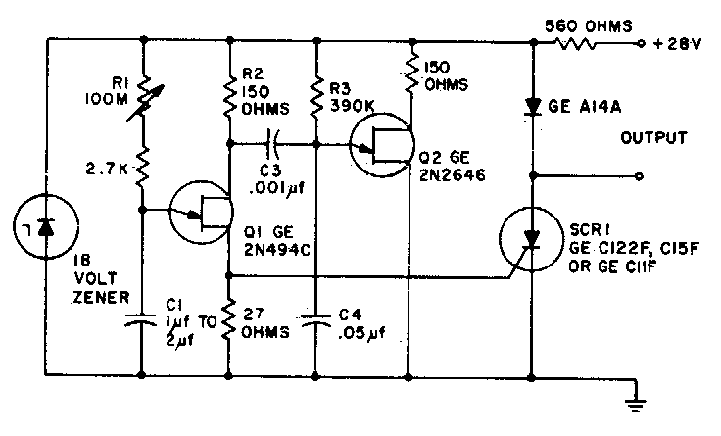](http://www.next.gr/meter-counter/delay-circuits/Ultra-precise-long-time-delay-relay-l12665.html)

* [Power-Off Time Delay Relay circuit](http://www.hobby-circuits.com/circuits/timer/642/power-off-time-delay-relay)

[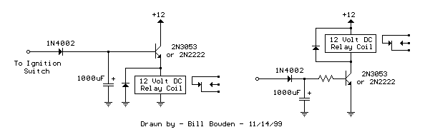](http://www.next.gr/circuits/Power-Off-Time-Delay-Relay-circuit-l45204.html)

* [Delay Wipers](http://www.rowand.net/shop/tech/delaywipers.htm)

[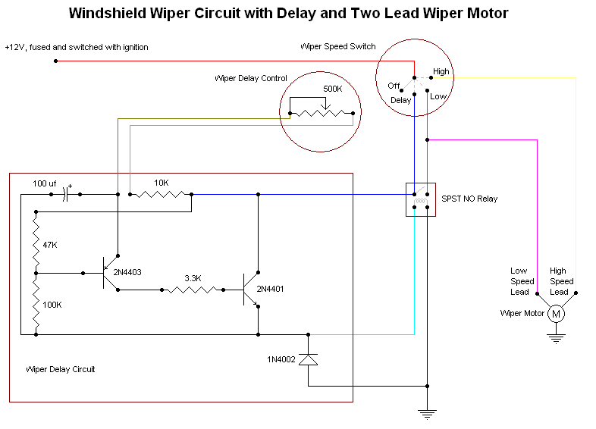](http://www.next.gr/circuits/Delay-Wipers-l49809.html)

* [Simple B+ delay circuit for tube power amp](http://www.diyaudio.com/forums/tubes-valves/195190-simple-b-delay-circuit-tube-power-amp-2.html)

[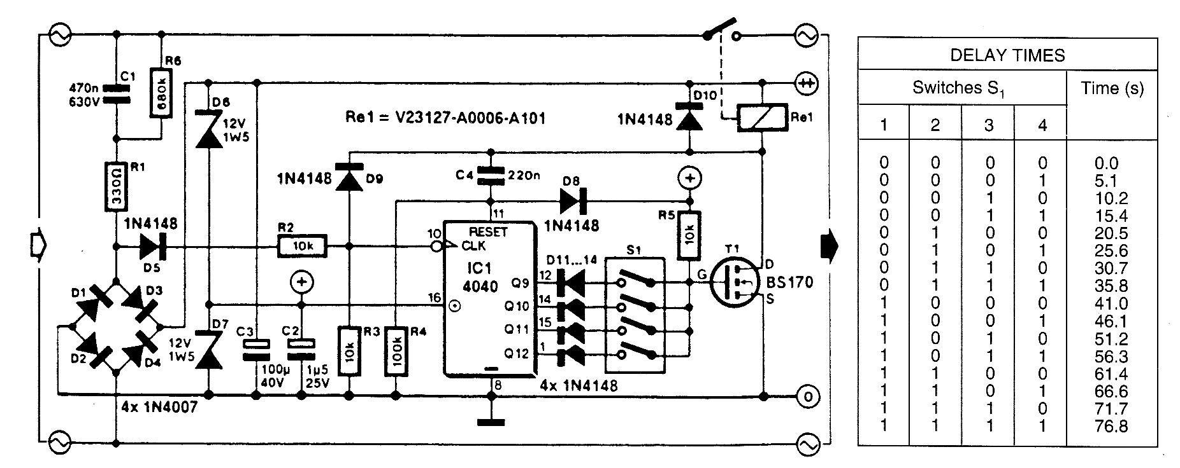](http://www.next.gr/circuits/Simple-B-delay-circuit-for-tube-power-amp-l38806.html)

* [delay circuit for surround sound](http://projectschematic.blogspot.com/2009/10/delay-circuit-for-surround-sound.html)

[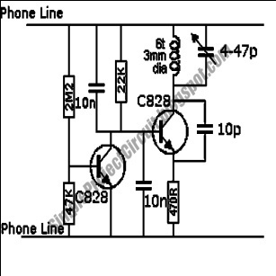](http://www.next.gr/circuits/delay-circuit-for-surround-sound-l31097.html)

* [High-Low voltage cut-off with delay and alarm with circuit diagram](http://www.circuitstoday.com/high-low-voltage-cut-off-with-delay-alarm)

[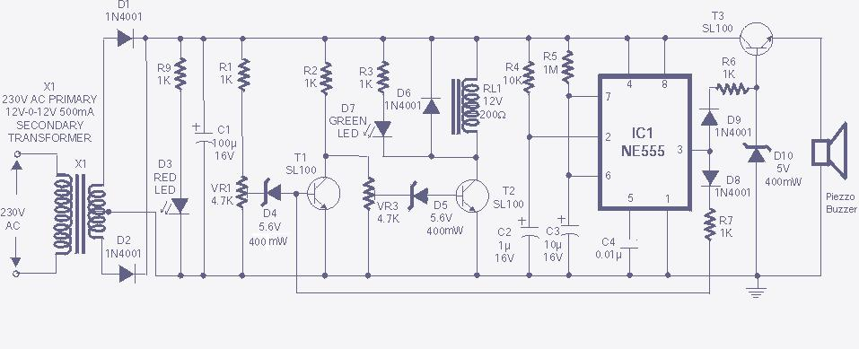](http://www.next.gr/circuits/High-Low-voltage-cut-off-with-delay-and-alarm-with-circuit-diagram-l37106.html)

* [Power-On Time Delay Relay circuit](http://www.hobby-circuits.com/circuits/timer/641/power-on-time-delay-relay)

[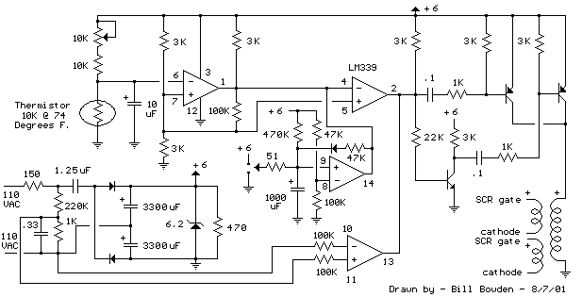](http://www.next.gr/circuits/Power-On-Time-Delay-Relay-circuit-l45203.html)

* [Delay-locked loop with binary-coupled capacitor](http://www.google.co.in/patents/us6483757)

[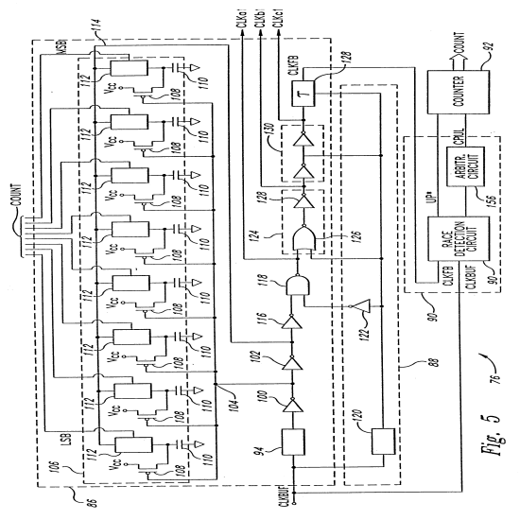](http://www.next.gr/circuits/Delay-locked-loop-with-binary-coupled-capacitor-l44347.html)

* [time delay](http://pilotpowersupply.com/articles/timedelay/)

[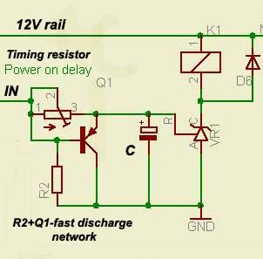](http://www.next.gr/circuits/time-delay-l30823.html)

* [Schematics Ultra-Long Time Delay By IC Timer 555 PCB](http://www.circuitlab.org/2011/06/schematics-ultra-long-time-delay-by-ic.html)

[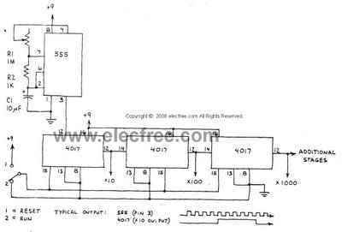](http://www.next.gr/circuits/Schematics-Ultra-Long-Time-Delay-By-IC-Timer-555-PCB-l36263.html)

* [high and low voltage cut out with delay and music circuit diagram](http://www.electronic-circuits-diagrams.com/psimages/powersuppliesckt5.shtml)

[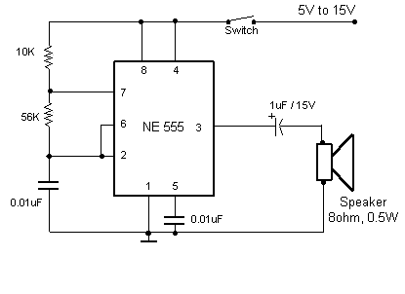](http://www.next.gr/circuits/high-and-low-voltage-cut-out-with-delay-and-music-circuit-diagram-l41220.html)

* [In-Car lights delay circuit](http://www.seekic.com/circuit_diagram/basic_circuit/in_car_lights_delay_circuit.html)

[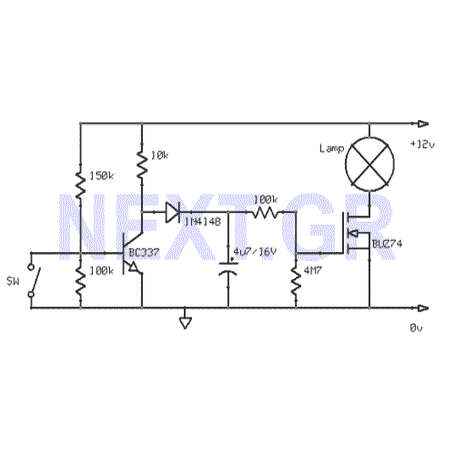](http://www.next.gr/circuits/In-Car-lights-delay-circuit-l51101.html)

* [Long Delay TimerCircuit](http://www.eeweb.com/blog/extreme_circuits/long-delay-timer-circuit-diagram)

[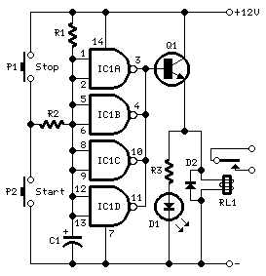](http://www.next.gr/circuits/Long-Delay-TimerCircuit-l40420.html)

* [Deep Blue Delay Schematic Diagram](http://www.tasel.net/blue-delay-guitar-effect-by-mad-professor/deep-blue-delay-schematic-diagram/)

[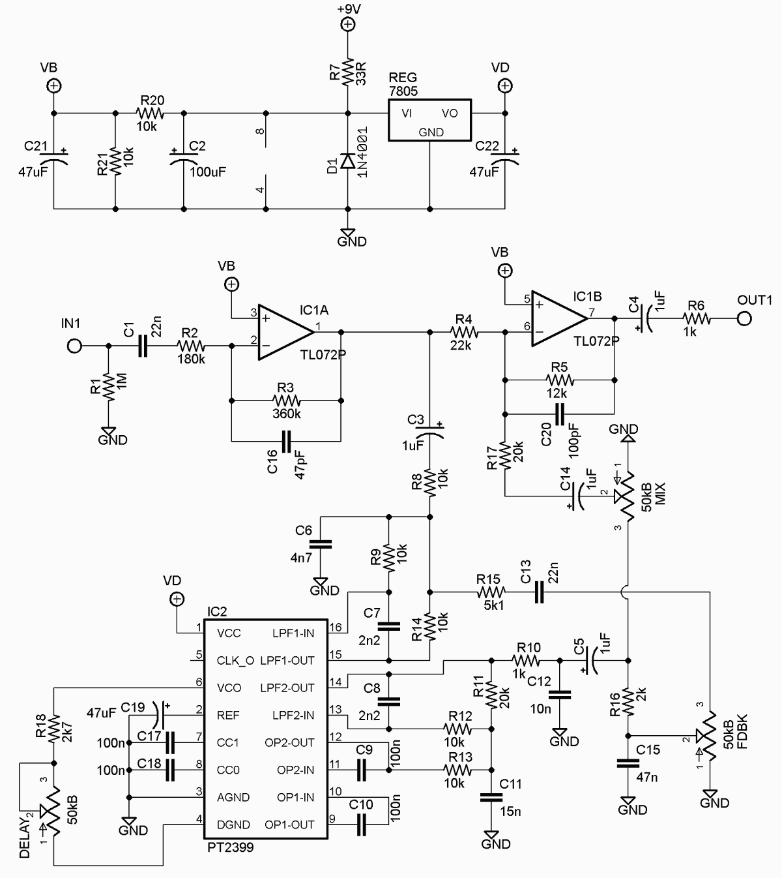](http://www.next.gr/circuits/Deep-Blue-Delay-Schematic-Diagram-l53353.html)

[Pioneer of Tube Audio Effects](http://www.effectrode.com/magnetic-delay/louis-barron-pioneer-of-tube-audio-effects/)

[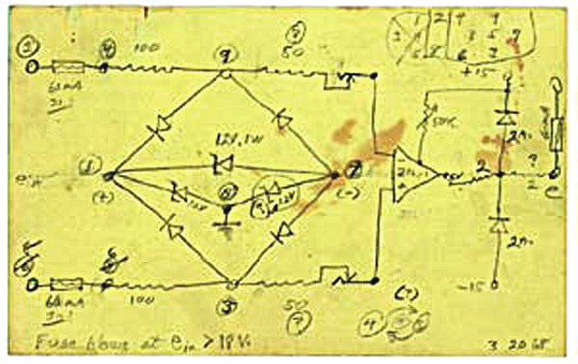](http://www.next.gr/circuits/Pioneer-of-Tube-Audio-Effects-l40713.html)

[Simple DC power delay circuit](http://www.circuitstoday.com/simple-dc-power-delay-circuit)

[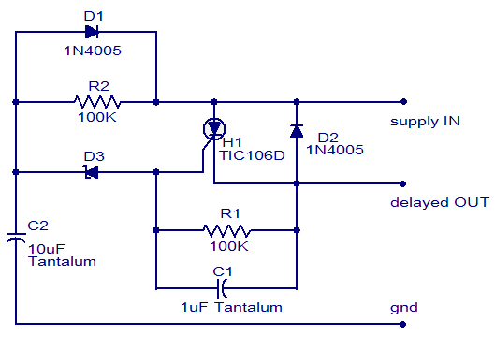](http://www.next.gr/circuits/Simple-DC-power-delay-circuit-l37245.html)

# Delay calculation

From Wikipedia, the free encyclopedia

Jump to: [navigation](http://en.wikipedia.org/wiki/Delay_calculation#mw-navigation), [search](http://en.wikipedia.org/wiki/Delay_calculation#p-search)

**Delay calculation** is the term used in [integrated circuit design](http://en.wikipedia.org/wiki/Integrated_circuit_design) for the calculation of the [gate delay](http://en.wikipedia.org/wiki/Gate_delay) of a single [logic gate](http://en.wikipedia.org/wiki/Logic_gate) and the wires attached to it. By contrast, [static timing analysis](http://en.wikipedia.org/wiki/Static_timing_analysis) computes the delays of entire paths, using delay calculation to determine the delay of each gate and wire.

There are many methods used for delay calculation for the gate itself. The choice depends primarily on the speed and accuracy required:

* Circuit simulators such as [SPICE](http://en.wikipedia.org/wiki/SPICE) may be used. This is the most accurate, but slowest, method.
* Two dimensional tables are commonly used in applications such as [logic synthesis](http://en.wikipedia.org/wiki/Logic_synthesis), [placement](http://en.wikipedia.org/wiki/Placement_%28EDA%29) and [routing](http://en.wikipedia.org/wiki/Routing_%28EDA%29). These tables take an output load and input slope, and generate a circuit delay and output slope.
* A very simple model called the *K-factor* model is sometimes used. This approximates the delay as a constant plus *k* times the load capacitance.
* A more complex model called Delay Calculation Language,[[1]](http://en.wikipedia.org/wiki/Delay_calculation" \l "cite_note-1) or DCL, calls a user-defined program whenever a delay value is required. This allows arbitrarily complex models to be represented, but raises significant software engineering issues.
* [Logical effort](http://en.wikipedia.org/wiki/Logical_effort) provides a simple delay calculation that accounts for gate sizing and is analytically tractable.

Similarly there are many ways to calculate the delay of a wire. The delay of a wire will normally be different for each destination. In order of increasing accuracy (and decreasing speed), the most common methods are:

* *Lumped C*. The entire wire capacitance is applied to the gate output, and the delay through the wire itself is ignored.
* [Elmore delay](http://en.wikipedia.org/wiki/Elmore_delay)[[2]](http://en.wikipedia.org/wiki/Delay_calculation#cite_note-2) is a simple approximation, often used where speed of calculation is important but the delay through the wire itself cannot be ignored. It uses the R and C values of the wire segments in a simple calculation. The delay of each wire segment is the R of that segment times the downstream C. Then all delays are summed from the root. (This assumes the network is tree structured, true of most nets in chips. In this case the Elmore delay can be calculated in time O(N) with two tree traversals. If the network is not tree structured the Elmore delay can still be computed, but involves matrix calculations.)
* *Moment matching* is a more sophisticated analytical method. It can be thought of as either matching multiple moments in the time domain, or finding a good rational approximation (a [Padé approximation](http://en.wikipedia.org/wiki/Pad%C3%A9_approximant)) in the frequency domain. (These are very closely related - see [Laplace transform](http://en.wikipedia.org/wiki/Laplace_transform).) It can also be thought of a generalization of Elmore delay, which matches the first moment in the time domain (or computes a one-pole approximation in the frequency domain - they are equivalent). The first use of this technique, AWE,[[3]](http://en.wikipedia.org/wiki/Delay_calculation" \l "cite_note-3) used explicit moment matching. Newer methods such as PRIMA[[4]](http://en.wikipedia.org/wiki/Delay_calculation" \l "cite_note-4) and PVL use implicit moment matching, based on [Krylov subspaces](http://en.wikipedia.org/wiki/Krylov_subspace). These methods are slower than Elmore but more accurate. Compared to circuit simulation they are faster but less accurate.
* Circuit simulators such as [SPICE](http://en.wikipedia.org/wiki/SPICE) may be used. This is usually the most accurate, but slowest, method.
* DCL, as defined above, can be used for interconnect as well as gate delay.

Often, it makes sense to combine the calculation of a gate and all the wire connected to its output. This combination is often called the *stage delay*.

The delay of a wire or gate may also depend on the behaviour of the nearby components. This is one of the main effects that is analyzed during [signal integrity](http://en.wikipedia.org/wiki/Signal_integrity) checks.

Delay Calculation in digital design

In the context of semi-custom digital design, pre-characterized digital information is often abstracted in the form of the above mentioned 2-D look up table (LUT). The idea behind semi-custom design method is to use blocks of pre-built and tested components to build something larger, say, a chip.

In this context, the blocks are [logic gates](http://en.wikipedia.org/wiki/Logic_gate) such as NAND, OR, AND, etc. Although in reality these gates will be composed of transistors, a semi-custom engineer will only be aware of the delay information from input pin to output pin, called a timing arc. The 2D table represents information about the variability of the gate's delay with respect to the two independent variables, usually the rate of change of the signal at the input and the load at the output pin. These two variable are called slew and load in design parlance.

A [static timing analysis](http://en.wikipedia.org/wiki/Static_timing_analysis) engine will first calculate the delay of the individual cells and string them together to do further analysis.

## Statistical delay calculation

As chip dimensions get smaller, the delays of both gates and wires may need to be treated as statistical estimates instead of deterministic quantities. For gates, this requires extensions to the library formats. For wires, this requires methods that can calculate the means and distributions of wire delays. In both cases it is critical to capture the dependence on the underlying variables such a threshold voltage and metal thickness, since these result in correlations among the delays of nearby components.