SENTINELX: CYBER ATTACK INTELLIGENCE AND
THREAT HUNTING PLATFORM
PROJECT REPORT
Submitted by
Shlok Gupta (24BCI0061)
Shreya Bhushan (24BCI0086)
Yashneil (24BDS0158)
Prepared For
DATABASE SYSTEMS (BCSE302P) - Lab PROJECT
FACULTY:
Dr. Anand Bihari
School of Computer Science and Engineering


Abstract
Most organisations already collect a lot of security data, such as firewall logs, intrusion alerts and lists of known bad IP addresses from threat feeds. The problem is that this data sits in different places, and news about a bad IP usually arrives days or weeks after that IP has already been probing the network. This project is our attempt at a small Security Operations Centre (SOC) built around one relational database, so that all of this is stored once, linked properly and searched with plain SQL.
SentinelX keeps network logs, detected attacks, the servers they hit, attacker groups, malware, known vulnerabilities (CVEs), indicators of compromise, incidents and analysts in 16 MySQL tables, all in Third Normal Form (3NF). Each table keeps only the attributes that a feature actually uses. Apart from the usual features like a dashboard, attack search and incident handling, we added two ideas of our own. The first is a retro-hunt. When a new bad IP is added, the database goes back through the old logs on its own to check whether that IP already reached us before anyone knew it was bad. The second is a "time machine" for threat data. Every indicator keeps two time periods, when it was actually hostile and when we found out, so any search can be repeated using only what we knew on an earlier day. We tested the system on 600,340 generated log rows and 115,376 attacks.

Table of Contents
1. Introduction 4
2. Objectives 4
3. Project Scope 4
4. Key Contacts and Stakeholders 5
5. Project Resource Requirements 5
6. System Architecture 5
7. ER Diagram 6
8. Database Design, Tables and Constraints 10
9. Module-wise Functional Description 18
10. Work Break Down 19
11. Limitations and Future Scope 19
12. Conclusion 20

1. Introduction
Anyone who has seen how a small security team works knows the routine. An alert fires, someone opens the firewall console, then the IDS, then a spreadsheet of known bad IPs, and tries to match timestamps by hand. Each tool keeps its own copy of the facts, so the same attacker or server shows up in several places with slightly different details. Threat feeds also tend to be late. By the time an IP address appears on a blocklist it has often been scanning people for weeks, and nobody goes back to check last month's logs.
We picked this topic for our DBMS lab project because it fits a relational database very naturally. There are clear entities (servers, attackers, malware, vulnerabilities, incidents), clear relationships between them (an attack hits one server, an incident can group many attacks) and good reasons to use constraints, triggers, transactions and indexes. Cloud services like Amazon GuardDuty already cover a lot of this, but checking old logs for a newly reported bad IP is still a manual job there. We wanted the database to do that part by itself, and that became the main idea of the project.

2. Objectives
Broadly, we set out to:
- Design a normalised relational schema in Third Normal Form (3NF) for a security operations centre that avoids update, insert and delete problems.
- Draw a clean ER diagram that keeps only the attributes we really use, and make sure it matches the tables we actually built.
- Keep every column only as large as it needs to be (for example 50 characters for an email) and back every rule with a constraint.
- Let the database do routine work by itself, like opening incidents for serious attacks and checking old logs when a new bad IP is added.
- Build a simple web dashboard on top of the database so the design can be shown working with real queries.

3. Project Scope
Within the time we had, the system covers:
- Basic data about servers and devices (assets), CVEs, attack types mapped to MITRE ATT&CK, attacker groups and malware.
- Storing raw network logs and detected attacks, with indexes on time and source IP so searches over the large tables stay fast.
- A dashboard with attacks and blocked attacks in the last 24 hours, open critical incidents, malicious IPs and servers under attack.
- Searching attacks by IP, country, attack type, malware, CVE, severity and date.
- Incident handling: automatic creation, assigning an analyst, response steps and closing.
- Retro-hunting and the time machine described above.
- User roles (admin, analyst, viewer) with different permissions.

4. Key Contacts and Stakeholders
Name | Registration Number | Role | Email / Phone
Shlok Gupta | 24BCI0061 | Team Member
Shreya Bhushan | 24BCI0086 | Team Member
Yashneil | 24BDS0158 | Team Member
Dr. Anand Bihari |  | Faculty Guide

5. Project Resource Requirements
Hardware Requirements
- A laptop or desktop with an Intel i5 (8th gen) or Ryzen 5 and at least 8 GB RAM. 16 GB was more comfortable with the database, backend and frontend running together.
- About 3 GB of free disk space for the database, tools and packages.
- An internet connection for installing packages.
Software Requirements
- MySQL 8.0 (8.0.16 or later, which enforces CHECK constraints), with the mysql client and MySQL Workbench to work with it.
- Python 3.11 with FastAPI for the backend, and pandas and scikit-learn for test data and the ML parts.
- Node.js 20 with React and Vite for the dashboard.
- draw.io for planning the ER diagram.
- Docker to run the whole setup with one command.
- Visual Studio Code, Git and a shared GitHub repository.

6. System Architecture
We kept a simple layered setup with the database in the middle. Every other part either writes to it or reads from it. Logs are loaded in batches and each batch goes in as one transaction, so a failed batch leaves nothing half written. The rules that must never be skipped, like opening incidents and running retro-hunts, are triggers inside MySQL instead of application code. The FastAPI backend connects with a limited database user and serves the React dashboard, and the ML jobs read from the database and write their results back into it.
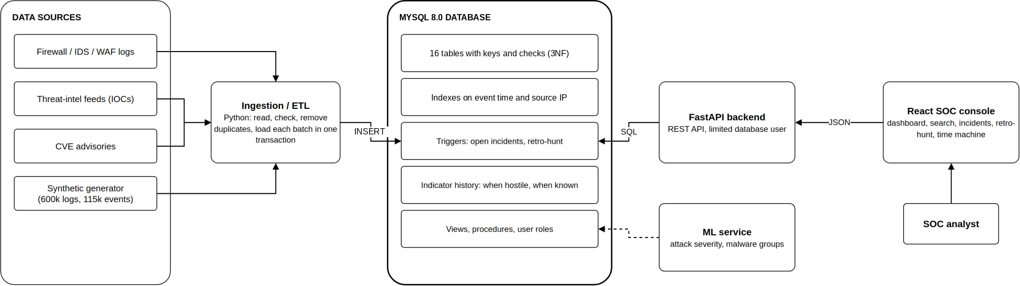
Fig. 1 System architecture

7. ER Diagram
Before looking at the diagram, here is what each entity means in this system:
Entity | What it represents
ASSET | A server or device we are protecting
VULNERABILITY | A published weakness (CVE) with its CVSS score
NETWORK_LOG | One raw line from the firewall or IDS
ATTACK_EVENT | One detected attack against an asset
ATTACK_TYPE | A kind of attack, mapped to a MITRE ATT&CK technique
MITIGATION (weak) | One response step for an attack type
THREAT_ACTOR | An attacker group
MALWARE | A piece of malicious software
IOC | An indicator of compromise, such as a bad IP, domain, file hash or URL
RETRO_HUNT_RUN | One automatic search of old logs for a newly added bad IP
INCIDENT | An investigation that groups related attacks
ANALYST | A person who uses the system

The ER diagram in Fig. 2 is drawn in Chen notation. Rectangles are entities, diamonds are relationships and ovals are attributes, with the primary key underlined. MITIGATION is a double rectangle because it is a weak entity: a step like "step 2" only makes sense inside its attack type, so its key is type_id plus step_no. Its partial key step_no has a dashed underline, and its relationship HAS_STEP is drawn as a double diamond. The ovals detected_at and patched_at hang off the EXPOSED_TO diamond because they describe the link between an asset and a CVE, not either one alone. A double line means every row on that side has to take part, for example every attack must target an asset. Each entity shows its key and at most three main attributes. Every column is listed in section 8. Foreign keys are not drawn as ovals because the relationship lines already show them.
Compared with our first version, the diagram now has no crossing lines and no long lines wrapping around the page, and 23 attributes that no feature used were removed (listed in section 8). It is easiest to read from the middle. ATTACK_EVENT is one detected attack. The triangle at the top is who attacks: MALWARE, THREAT_ACTOR and the IOCs that give them away. On the left is the attack catalogue: ATTACK_TYPE and its MITIGATION steps. At the bottom right is what we protect: the ASSET an attack hits, the VULNERABILITY it used and the raw NETWORK_LOG lines sent to that asset. On the right is how we respond: an IOC triggers a RETRO_HUNT_RUN, which searches old logs and may open an INCIDENT that an ANALYST handles. There are 12 entities and 17 relationships in total. Twelve relationships are one-to-many (one of them identifying), four are many-to-many and one (OPENS) is one-to-one.
Relationship | Between | Type | What it means | Linked by
TARGETS | ASSET, ATTACK_EVENT | 1 : N | An asset can be attacked many times, but each attack hits exactly one asset | attack_event.asset_id (NOT NULL)
CLASSIFIED_AS | ATTACK_TYPE, ATTACK_EVENT | 1 : N | Each attack has exactly one type | attack_event.type_id (NOT NULL)
ATTRIBUTED_TO | THREAT_ACTOR, ATTACK_EVENT | 1 : N | An attack may be linked to one attacker group | attack_event.actor_id
DELIVERS | MALWARE, ATTACK_EVENT | 1 : N | An attack may carry one piece of malware | attack_event.malware_id
EXPLOITS | VULNERABILITY, ATTACK_EVENT | 1 : N | An attack may use one CVE | attack_event.cve_id
EXPOSED_TO | ASSET, VULNERABILITY | M : N | An asset can have many CVEs and a CVE can affect many assets | link table asset_vulnerability
DESTINED_FOR | ASSET, NETWORK_LOG | 1 : N | Each log line is sent to one asset | network_log.dst_asset_id (NOT NULL)
HAS_STEP | ATTACK_TYPE, MITIGATION | 1 : N (identifying) | An attack type has numbered response steps | mitigation key (type_id, step_no)
DEVELOPS | THREAT_ACTOR, MALWARE | 1 : N | A group can build many pieces of malware | malware.actor_id
LINKED_TO | THREAT_ACTOR, IOC | 1 : N | An indicator may belong to one group | ioc.actor_id
INDICATES | MALWARE, IOC | 1 : N | An indicator may point to one piece of malware | ioc.malware_id
MATCHES | ATTACK_EVENT, IOC | M : N | An attack can match many indicators and the other way round | link table event_ioc
TRIGGERS | IOC, RETRO_HUNT_RUN | 1 : N | Every retro-hunt is started by one indicator | retro_hunt_run.ioc_version_id (NOT NULL)
HITS | RETRO_HUNT_RUN, NETWORK_LOG | M : N | A retro-hunt finds many old log lines | link table retro_hit
OPENS | RETRO_HUNT_RUN, INCIDENT | 1 : 1 | A retro-hunt opens at most one incident | retro_hunt_run.incident_id (UNIQUE)
GROUPS | INCIDENT, ATTACK_EVENT | M : N | An incident covers many attacks | link table incident_event
ASSIGNED_TO | ANALYST, INCIDENT | 1 : N | An analyst handles many incidents | incident.assigned_to

Each kind of relationship becomes tables in a fixed way. A one-to-many relationship becomes a foreign key on the N side; if participation is total (a double line), that column is NOT NULL. A many-to-many relationship becomes a link table whose primary key joins both keys. The one-to-one OPENS is a foreign key with a UNIQUE constraint. The identifying relationship HAS_STEP puts the owner's key inside the weak entity's primary key.

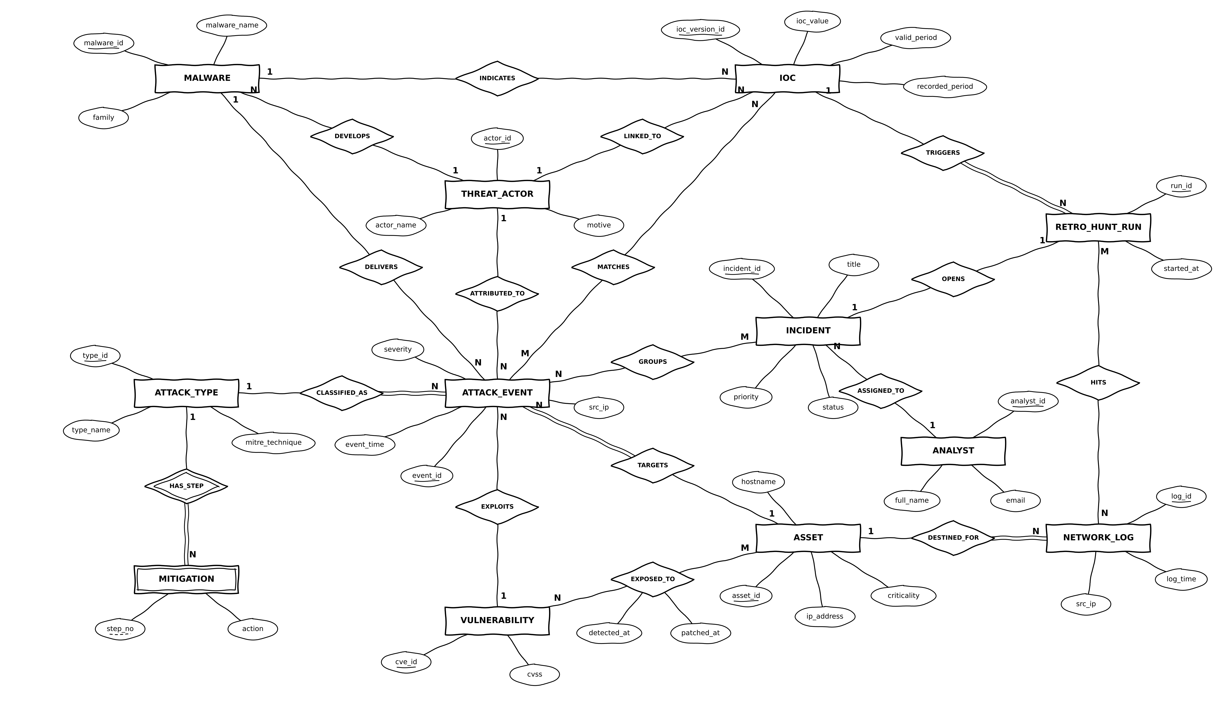
Fig. 2 ER diagram of SentinelX (Chen notation)

8. Database Design, Tables and Constraints
All 16 tables are in Third Normal Form (3NF). In every table, each non-key column depends on the key, the whole key and nothing but the key. In practice this means an attacker, a server or a CVE is stored exactly once. Changing an attacker's details touches one row, a server can be added before it is ever attacked, and deleting an attack never deletes what we know about the attacker. Every column that decides another column is itself a candidate key, so the tables also meet BCNF.

How we normalised
Step | What we did
Starting point | One flat row per attack with the time, source IP, host name, host OS, attack name, attacker name and country, malware name and family, CVE and score, and a list of IOCs like "198.51.100.23, evil-1.example".
1NF | Split the IOC list so each row holds one indicator. The key became (event, indicator).
2NF | Attack details depend only on the event and indicator details only on the indicator, so they went into ATTACK_EVENT, IOC and the link table EVENT_IOC.
3NF | Host details depend on the host, attacker details on the attacker, CVSS on the CVE and so on. Each of these moved to its own table: ASSET, THREAT_ACTOR, MALWARE, VULNERABILITY, ATTACK_TYPE and ANALYST.
3NF check | Checking every table again, we found two transitive dependencies in our own first draft. vulnerability.severity depended on cvss, not on cve_id, and malware.category depended on family, not on malware_id. Both columns were removed; a view works out severity from cvss.
Derived data | retro_hunt_run stored logs_matched and assets_touched, which are only counts of rows in retro_hit. We removed them and a view counts them instead, so they can never disagree with the hits.

Attributes we removed
After review we kept only the attributes that a module reads or writes. The 23 removed attributes are:
Entity | Removed | Why
ASSET | os, department, country_code | No page or query used them
VULNERABILITY | vendor, product, description, severity | Descriptive text is in the NVD; severity depends on cvss
NETWORK_LOG | bytes_sent, sensor | Not used by search, retro-hunt or the dashboard
ATTACK_TYPE | mitre_tactic | Reference data from the MITRE catalogue; never queried
THREAT_ACTOR | sophistication, first_seen | Not shown or filtered anywhere
MALWARE | category, severity, first_seen | category depends on family; severity belongs to the attack
IOC | confidence, source | Not used by retro-hunt or the time machine
RETRO_HUNT_RUN | finished_at, logs_matched, assets_touched | Counts are derived from retro_hit; finished_at never read
INCIDENT | origin | Retro-hunt incidents are already known through OPENS
ANALYST | is_active, created_at | Account housekeeping, not part of the data model

How we chose column sizes
Every text column is sized to the longest value it really needs instead of a default like 255. Fixed lists of values use ENUM, and small numbers use the smallest integer type that fits. These are the choices we thought about most.
Column | Type / Size | Why
analyst.email | VARCHAR(50) | Fits a normal address like name.surname@organisation.com, and a CHECK makes sure it looks like an email
full_name, actor_name, malware_name | VARCHAR(50) | Names stay well under 50 characters
asset.hostname | VARCHAR(63) | 63 is the longest single DNS label
ip_address, src_ip | VARCHAR(45) | MySQL has no IP type; 45 characters fits the longest IPv6 address in text form
vulnerability.cve_id | VARCHAR(16) | "CVE-", a 4 digit year, "-" and up to 7 digits
attack_type.mitre_technique | VARCHAR(9) | The longest form is T1234.001
ioc.ioc_value | VARCHAR(255) | Has to hold a full domain name, which can be 253 characters
origin_country, src_country | CHAR(2) | Two letter country code, checked to be two capital letters
malware.sha256 | CHAR(64) | A SHA-256 hash is always 64 hex characters
asset_type, motive, protocol, action, role, priority, status | ENUM | Only the listed values can be stored, and each takes 1 byte
criticality, severity, step_no | TINYINT | Small ranges like 1 to 10 fit in 1 byte
network_log.dst_port | SMALLINT UNSIGNED | Holds exactly 0 to 65535 in 2 bytes, so no extra check is needed
incident.title | VARCHAR(100) | Titles like "Brute Force on web-01 from 198.51.100.7" stay under 80

Tables
For each table below we give a short description, the CREATE TABLE statement for MySQL 8.0, and its normal form. The full script, with the tables in the order they must be created, is in sentinelx_mysql.sql.
Assets, vulnerabilities and logs

asset
Every server or device we protect. asset_id is the primary key, and hostname and ip_address are unique too. asset_type can only take one of the listed values, and criticality goes from 1 to 5.
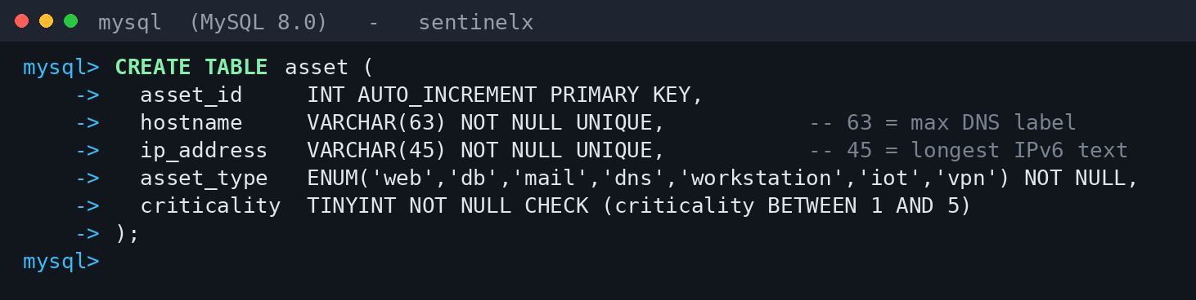
CREATE TABLE asset in MySQL
Normal form: Every column depends only on asset_id (hostname and ip_address are also candidate keys), and no non-key column depends on another. 3NF.

vulnerability
Published CVEs. cve_id is the primary key and must look like CVE-2024-3400. Severity is not stored: it follows from cvss, so the view v_vulnerability works it out when a page needs it.
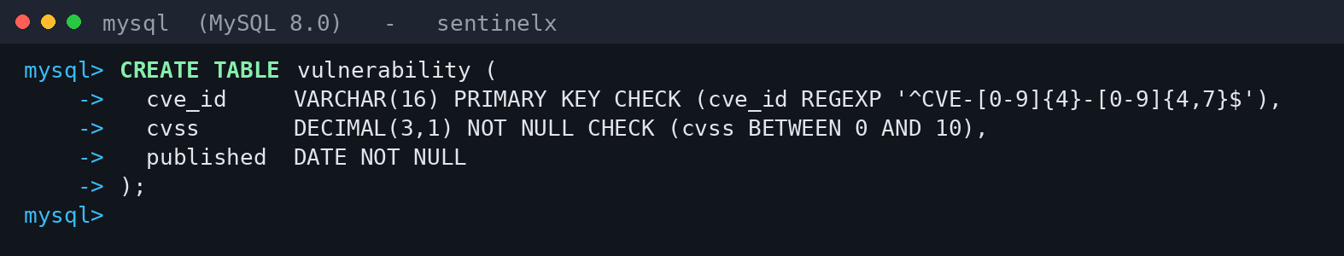
CREATE TABLE vulnerability in MySQL
Normal form: cvss and published depend only on cve_id. Storing severity would add the transitive dependency cve_id → cvss → severity, so it was removed. 3NF.

asset_vulnerability
The link table for the many-to-many relationship EXPOSED_TO between assets and CVEs. The primary key is (asset_id, cve_id). It also stores when the CVE was found on that asset and when it was patched, and patched_at cannot be earlier than detected_at.
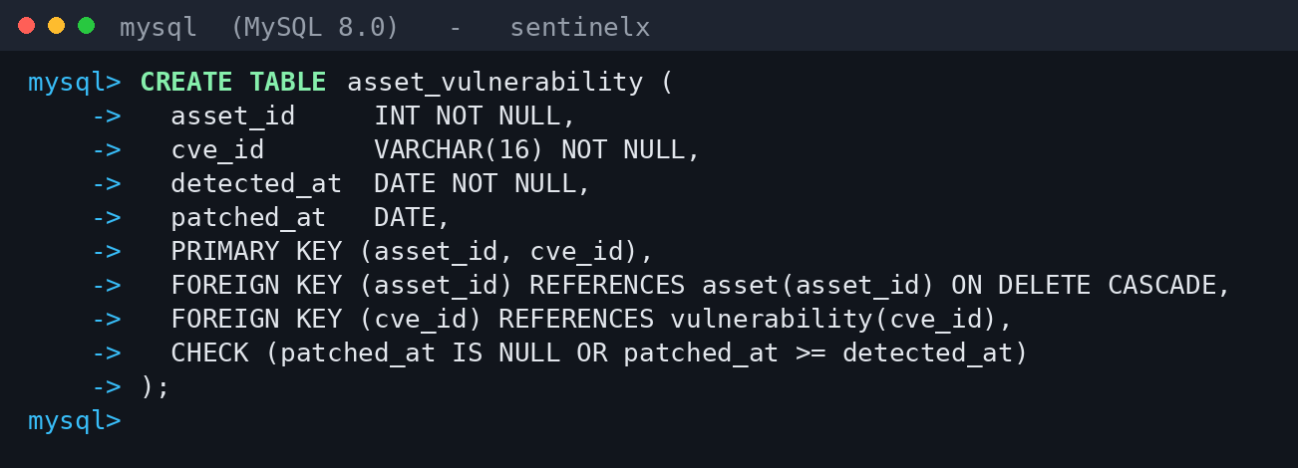
CREATE TABLE asset_vulnerability in MySQL
Normal form: detected_at and patched_at depend on the whole key, not on asset_id or cve_id alone. 3NF.

network_log
Raw log lines from the firewall and IDS. dst_asset_id must point to an existing asset. The index on (src_ip, log_time) lets a retro-hunt find the old lines for one IP in a time window without reading the whole table.
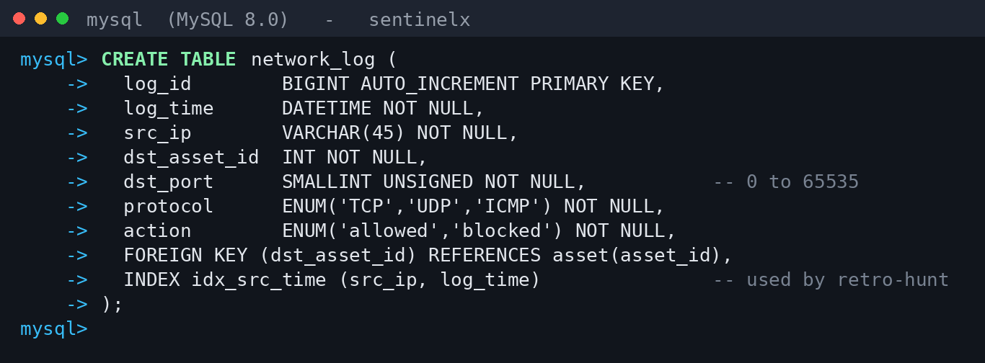
CREATE TABLE network_log in MySQL
Normal form: Everything depends on log_id. 3NF.
Attacks and attack types

attack_type
Kinds of attack, each with its MITRE ATT&CK technique ID such as T1110. type_name and mitre_technique are both unique, and base_severity is between 1 and 10.
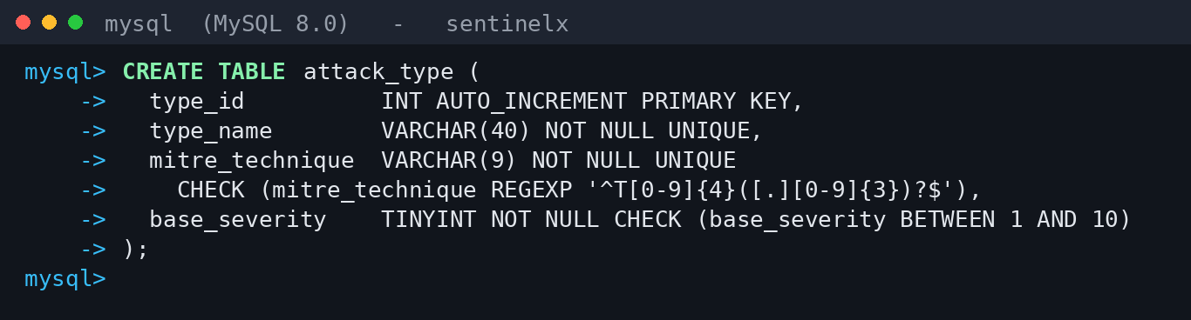
CREATE TABLE attack_type in MySQL
Normal form: Everything depends on type_id, and the other two unique columns are candidate keys as well. 3NF.

mitigation
Numbered response steps for each attack type. This is our weak entity, so the primary key is (type_id, step_no). If an attack type is deleted, its steps are deleted with it.
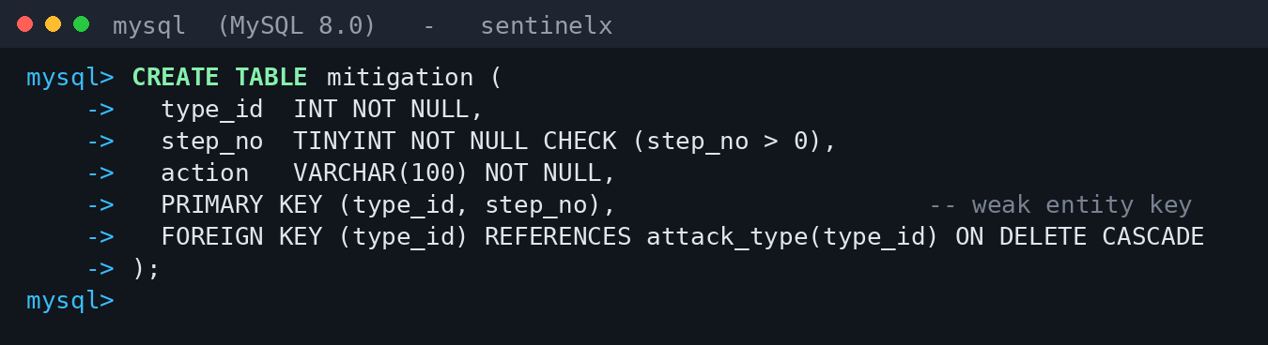
CREATE TABLE mitigation in MySQL
Normal form: action depends on the full key (type_id, step_no). 3NF.

attack_event
One row for each detected attack. Every attack must point to an asset and an attack type. The attacker, malware and CVE are optional because many attacks are never linked to them. The indexes on event_time and src_ip serve the dashboard and the attack search.
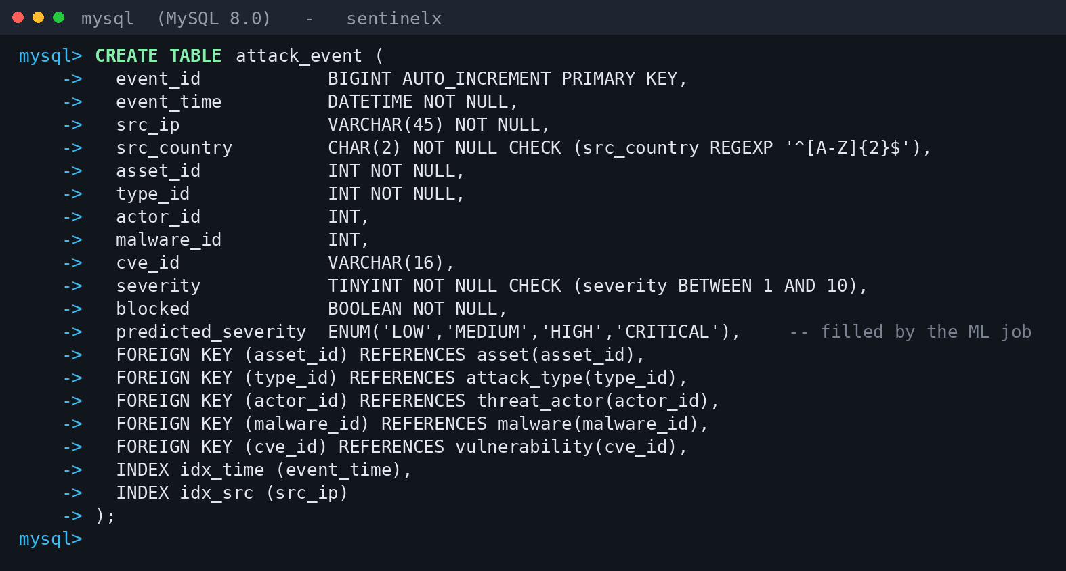
CREATE TABLE attack_event in MySQL
Normal form: Everything depends on event_id. src_country is stored here because the location of an IP can change over time, so it belongs to the attack and not to the IP. actor_id also stays, because the same malware can be used by more than one group, so malware_id does not decide actor_id. 3NF.
Attackers, malware, indicators and retro-hunts

threat_actor
Attacker groups with their country and motive. actor_name is unique. The names in our data are made up.
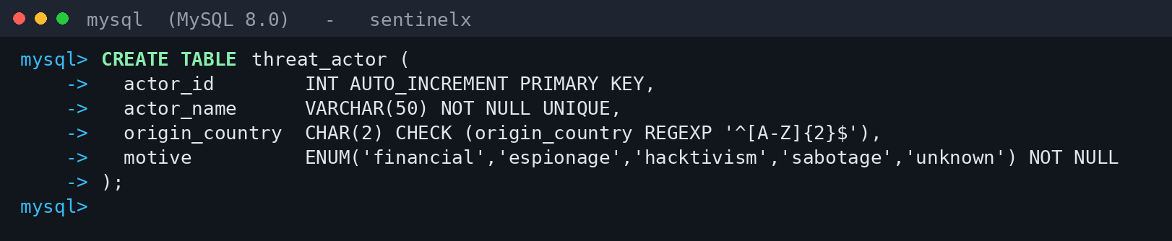
CREATE TABLE threat_actor in MySQL
Normal form: Everything depends on actor_id. 3NF.

malware
Malware samples. malware_name and sha256 are unique, and sha256 must be 64 hex characters. actor_id is optional and becomes NULL if the attacker group is deleted. cluster_id is filled in by the ML grouping job.
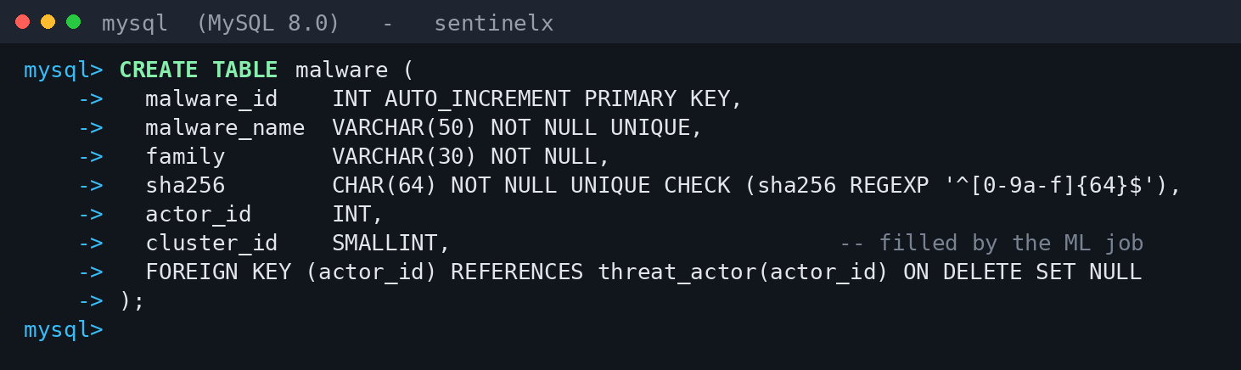
CREATE TABLE malware in MySQL
Normal form: Everything depends on malware_id. category was removed because family decides it, which was a transitive dependency. 3NF.

ioc
Indicators of compromise such as a bad IP or domain. Each row is one version. In the ER diagram valid_period (when the indicator was hostile) and recorded_period (when we knew about it) are single attributes; MySQL has no range type, so each is stored as a from/to pair, where a NULL end means the period is still open. A trigger rejects a new version that overlaps an existing one and blocks deletes, so the history cannot be lost.
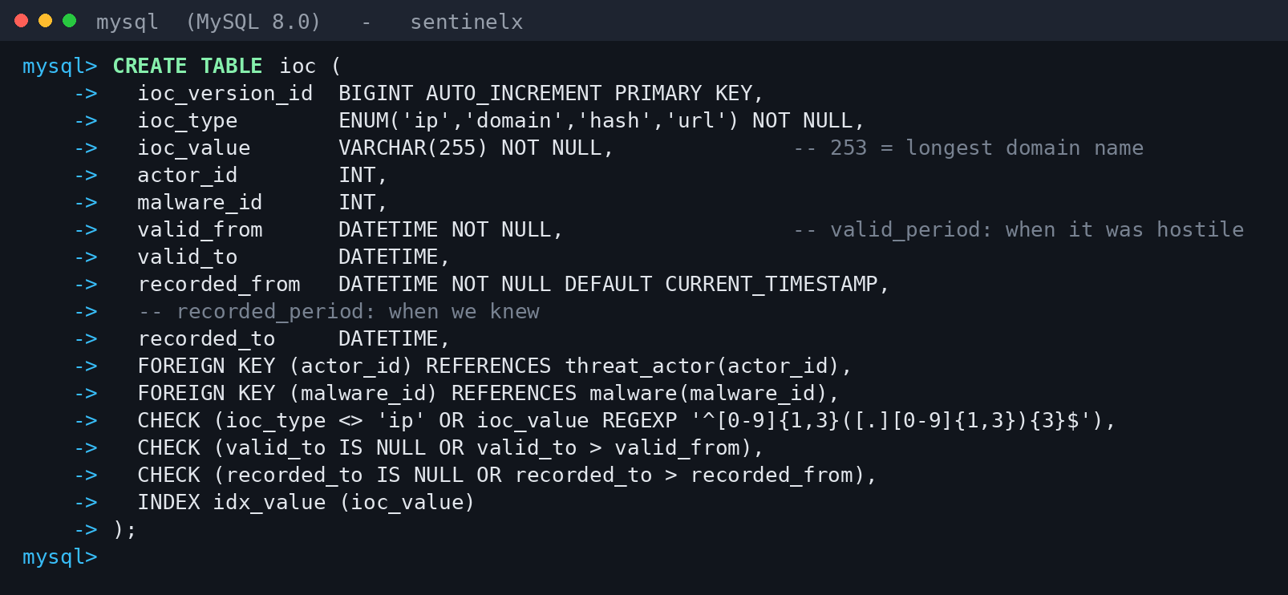
CREATE TABLE ioc in MySQL
Normal form: Everything depends on ioc_version_id. 3NF.

event_ioc
The link table for the many-to-many relationship MATCHES between attacks and indicators.
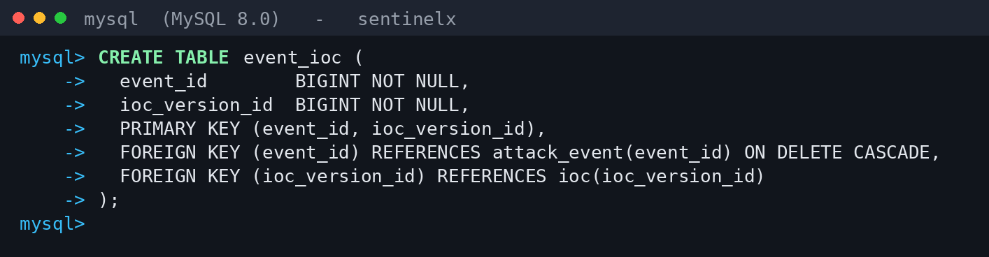
CREATE TABLE event_ioc in MySQL
Normal form: The whole row is the key. 3NF.

retro_hunt_run
One row each time the database searches old logs for a new bad IP. Every run must point to the indicator that started it. incident_id is unique, so a run can open at most one incident. The number of matched logs and touched assets comes from the view v_retro_hunt_summary.
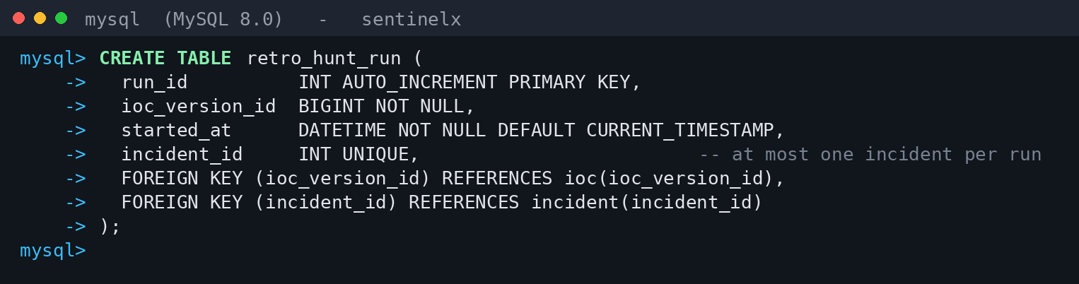
CREATE TABLE retro_hunt_run in MySQL
Normal form: Everything depends on run_id. The search window is not stored because the indicator already decides it, and the counts are not stored because retro_hit already holds them. 3NF.

retro_hit
The link table for the many-to-many relationship HITS: the old log lines a retro-hunt found.
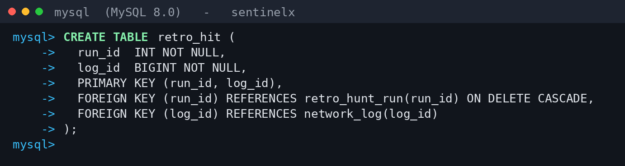
CREATE TABLE retro_hit in MySQL
Normal form: The whole row is the key. 3NF.
Incidents and analysts

analyst
People who use the system. email is unique, at most 50 characters and checked to look like an email address. role can only be admin, analyst or viewer.
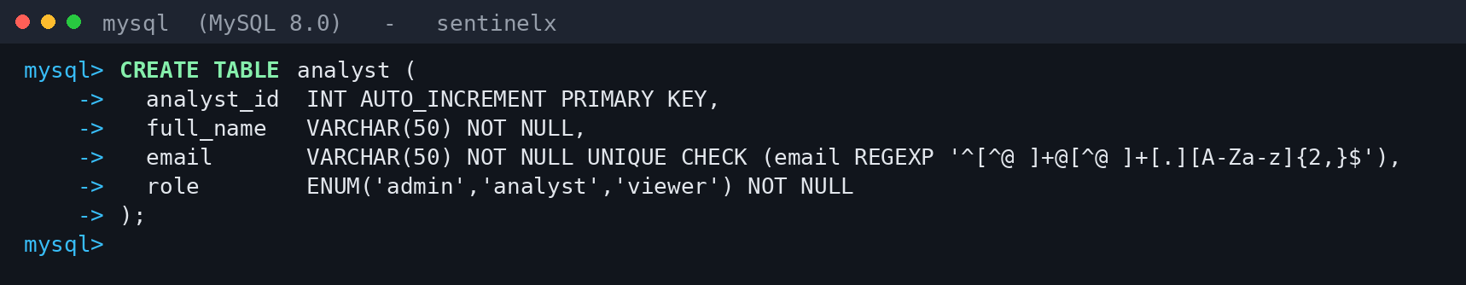
CREATE TABLE analyst in MySQL
Normal form: Everything depends on analyst_id, and email is also a candidate key. 3NF.

incident
An investigation. It can be opened by the trigger, by an analyst or by a retro-hunt. assigned_to is optional because a new incident has no owner yet. closed_at is filled in only when the status is CLOSED.
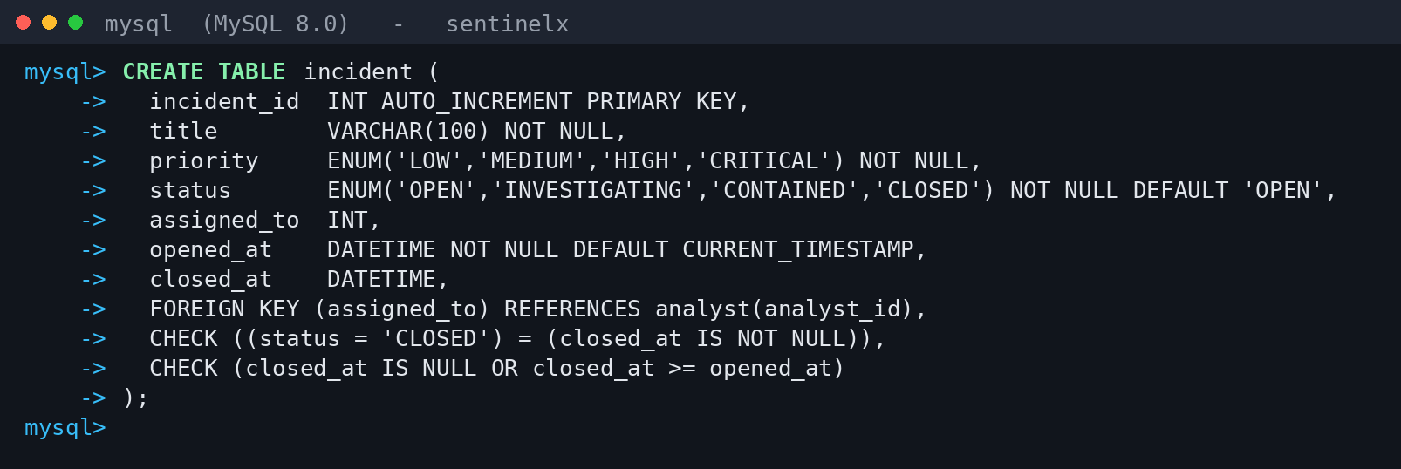
CREATE TABLE incident in MySQL
Normal form: Everything depends on incident_id. 3NF.

incident_event
The link table for the many-to-many relationship GROUPS between incidents and attacks.
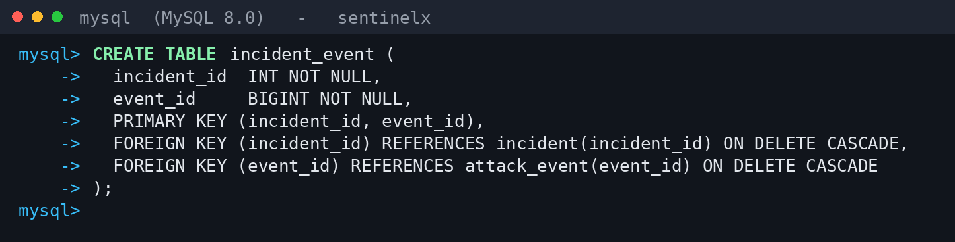
CREATE TABLE incident_event in MySQL
Normal form: The whole row is the key. 3NF.

9. Module-wise Functional Description
Dashboard and Attack Search
The home page shows attacks and blocked attacks in the last 24 hours, open critical incidents, malicious IPs and the most attacked servers. All of it is read from database views. The search page filters attacks by IP, country, attack type, malware, CVE, severity and date.
Incident Module
A trigger opens an incident for any attack of severity 8 or more. Attacks of the same type on the same server within one hour are added to the same incident so analysts are not flooded with duplicates. Assigning an incident goes through a stored procedure that locks the row first (SELECT ... FOR UPDATE), so two analysts cannot take the same incident at once.
Retro-Hunt Module
When a new bad IP is added, a trigger works out the period when the IP was already hostile but we did not know it yet, and searches the old logs for that period. The index on (src_ip, log_time) means MySQL reads only the matching rows instead of the whole log table. In our test data, an IP that had touched 9 servers 340 times a month earlier was raised as a critical incident as soon as it was added.
Time Machine Module
Every indicator keeps both "when it was hostile" and "when we knew", so a search can be repeated as of an earlier date. Over the same 180 days the search finds 4,934 attacks with what we knew in early April and 43,373 with what we know today. 3,286 attacks were only recognised later, usually about 11 days after they happened.
Threat Intelligence, ML and Roles
Separate pages list attacker groups, malware and CVEs. Two ML jobs write their answers into existing columns: the predicted severity of an attack and the group a malware sample belongs to. There are three MySQL roles. Admins can do everything, analysts work on incidents and indicators, and viewers can only read the dashboard views.

10. Work Break Down
Roughly how the work was split, although in practice there was a lot of overlap and all three of us reviewed each other's schema changes before merging.
Reg. No. | Name | Work Assigned
24BCI0061 | Shlok Gupta | Retro-hunt trigger and indicator history design, indexes, FastAPI backend, Docker setup
24BCI0086 | Shreya Bhushan | ER diagram, normalisation, table creation and constraints, views and stored procedures, user roles, this report
24BDS0158 | Yashneil | Test data generator, ML models, React dashboard, testing

11. Limitations and Future Scope
A few things we would do differently or add if this went beyond a lab project:
- The data is generated, not real. Attacker IPs come from address ranges reserved for documentation so no real address is marked as bad, and attacker and malware names are made up. The CVE IDs are real.
- Retro-hunts only work for IP addresses for now. Domains and file hashes would need DNS and file logs.
- MySQL has no range type or exclusion constraint, so the rule that two versions of an indicator never overlap is checked by a trigger instead of a declared constraint.
- The ML columns hold simple starting values until the models are fully trained.
- Logs are loaded in batches. Very high volumes would need a streaming pipeline such as Kafka, and old logs would need to move to archive tables.

12. Conclusion
Working on SentinelX made the usual database topics feel a lot less abstract. Normalisation stopped being an exercise once we found two transitive dependencies hiding in our own first draft, severity depending on cvss and category depending on family. Reviewing our ER diagram also taught us to keep only the attributes a feature really uses, which cut 23 columns and made the design much easier to read. The two parts we like most, retro-hunting and the time machine, turned out to be a trigger, two pairs of date columns and one index, which is a good reminder that careful table design does most of the work in a system like this.

REVIEW EVALUATION
COMPONENT | MARKS | SHLOK GUPTA | SHREYA BHUSHAN | YASHNEIL
ER-diagram | 3
Table Creation with description and screenshot | 5
Normal form | 2
TOTAL | 10 MARKS

