SENTINELX: CYBER ATTACK INTELLIGENCE AND
THREAT HUNTING PLATFORM
PROJECT REPORT (REVIEW 2)
Submitted by
Shlok Gupta (24BCI0061)
Shreya Bhushan (24BCI0086)
Yashneil (24BDS0158)
Prepared For
DATABASE SYSTEMS (BCSE302P) - Lab PROJECT
Submitted To
Dr. Anand Bihari
School of Computer Science and Engineering


Abstract
Most organisations already collect a lot of security data, such as firewall logs, intrusion alerts and lists of known bad IP addresses from threat feeds. The problem is that this data sits in different places, and news about a bad IP usually arrives days after that IP has already been probing the network. SentinelX is a small Security Operations Centre (SOC) built around one relational database, so that all of this is stored once, linked properly and searched with plain SQL.
The database has 16 MySQL tables in Third Normal Form (3NF). Review 1 covered the ER diagram, the tables and their constraints. This Review 2 report shows the design working: every statement in it was run on MySQL 8.0.46, and each screenshot is the real output of that run. We loaded a test dataset of 50,021 network log lines, 30 attacks, 12 indicators of compromise and 7 incidents, and ran 40 queries across the seven required categories, 11 multi-table business queries, 5 views, 2 functions, 4 stored procedures (2 of them with cursors), 4 triggers, transactions with savepoints, an index comparison with EXPLAIN, and a role-based security setup with three roles and three users. Two features are our own: a retro-hunt trigger that searches old logs as soon as a new bad IP is added, and a "time machine" that tells apart what we knew at the time of an attack from what we only learned later.

Table of Contents
1. Introduction 4
2. Objectives 4
3. Project Scope 4
4. Key Contacts and Stakeholders 4
5. Project Resource Requirements 5
6. System Architecture 5
7. Module-wise Functional Description 5
8. ER Diagram 7
9. Tables and Constraints 10
10. Data Population (INSERT, UPDATE, DELETE) 20
11. SQL Implementation 23
12. Advanced SQL Implementation 40
13. Transactions 68
14. Indexes and EXPLAIN 69
15. Design Changes since Review 1 73
16. Review 2 Requirements Checklist 73
17. Limitations and Future Scope 74
18. Conclusion 74
19. Work Break Down 74
20. Review Evaluation 75

1. Introduction
Anyone who has seen how a small security team works knows the routine. An alert fires, someone opens the firewall console, then the IDS, then a spreadsheet of known bad IPs, and tries to match timestamps by hand. Each tool keeps its own copy of the facts, so the same attacker or server shows up in several places with slightly different details. Threat feeds also tend to be late. By the time an IP address appears on a blocklist it has often been scanning people for weeks, and nobody goes back to check last month's logs.
We picked this topic for our DBMS lab project because it fits a relational database very naturally. There are clear entities (servers, attackers, malware, vulnerabilities, incidents), clear relationships between them (an attack hits one server, an incident can group many attacks) and good reasons to use constraints, triggers, transactions and indexes. Checking old logs for a newly reported bad IP is still a manual job in most tools, so we made the database do that part by itself, and that became the main idea of the project.

2. Objectives
- Design a normalised relational schema in Third Normal Form (3NF) for a security operations centre that avoids update, insert and delete problems.
- Draw a clean ER diagram that keeps only the attributes we really use, and make sure it matches the tables we actually built.
- Keep every column only as large as it needs to be and back every rule with a constraint.
- Let the database do routine work by itself, like opening incidents for serious attacks and checking old logs when a new bad IP is added.
- Prove the design with real execution: queries, views, routines, triggers, transactions and security, each with a screenshot of its output (Review 2).

3. Project Scope
- Basic data about servers and devices (assets), CVEs, attack types mapped to MITRE ATT&CK, attacker groups and malware.
- Storing raw network logs and detected attacks, with indexes on time and source IP so searches over the large tables stay fast.
- Dashboard and search views over attacks, assets and risk.
- Incident handling: automatic creation, assigning an analyst safely, escalation and closing.
- Retro-hunting and the time machine for indicators of compromise.
- User roles (admin, analyst, viewer) with least-privilege access through views and procedures.

4. Key Contacts and Stakeholders
Name | Registration Number | Role | Phone Number / Email
Shlok Gupta | 24BCI0061 | Team Member
Shreya Bhushan | 24BCI0086 | Team Member
Yashneil | 24BDS0158 | Team Member
Dr. Anand Bihari |  | Faculty Guide

5. Project Resource Requirements

5.1 Hardware Resource Requirements
- A laptop or desktop with an Intel i5 (8th gen) or Ryzen 5 and at least 8 GB RAM.
- About 3 GB of free disk space for MySQL, the tools and the database.

5.2 Software Resource Requirements
- Windows 11 (the machine all screenshots were taken on).
- MySQL Community Server 8.0.46 with the mysql command-line client. INTERSECT and EXCEPT need 8.0.31 or later; CHECK constraints are enforced from 8.0.16.
- MySQL Workbench for browsing the schema.
- Python 3.11 with FastAPI for the backend, and pandas and scikit-learn for the ML parts.
- Node.js 20 with React and Vite for the dashboard.
- draw.io for planning the ER diagram, and Git with a shared GitHub repository.

6. System Architecture
We kept a simple layered setup with the database in the middle. Every other part either writes to it or reads from it. Logs are loaded in batches and each batch goes in as one transaction, so a failed batch leaves nothing half written (section 13 shows this). The rules that must never be skipped, like opening incidents and running retro-hunts, are triggers inside MySQL instead of application code. The FastAPI backend connects with a limited database user, and the ML jobs write their results back into existing columns.
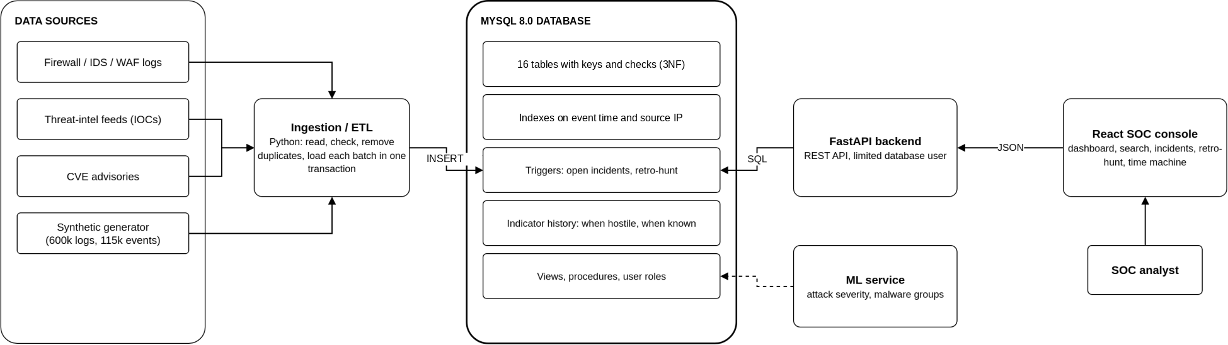
Fig. 1 System architecture

7. Module-wise Functional Description
Module | What it does | Database objects behind it
Dashboard and search | Attacks per asset, open vulnerabilities, risk, and attack search by IP, country, type, malware, CVE, severity and date | v_attack_details, v_asset_risk, fn_asset_risk, queries in section 11
Incident handling | Opens an incident for any attack of severity 8 or more, groups repeat attacks within an hour, assigns analysts safely, escalates priority | trg_attack_auto_incident, sp_assign_incident, sp_escalate_incidents
Retro-hunt | When a new bad IP is added, searches old logs from the time it was already hostile but not yet known, and opens an incident if it finds anything | trg_ioc_retro_hunt, retro_hunt_run, retro_hit, v_retro_hunt_summary
Time machine | Every indicator keeps when it was hostile and when we learned about it, so results can be split into "known then" and "learned later" | ioc.valid_from/valid_to, recorded_from/recorded_to, trg_ioc_no_overlap, trg_ioc_no_delete, CQ-05
Reports | Attack summary by type for any date range | sp_attack_report, sp_asset_risk_report
Roles and security | Admins can do everything, analysts work only on their own incidents, viewers only see reports | roles sx_admin, sx_analyst, sx_viewer; v_my_incidents

8. ER Diagram
The ER diagram on the next page is drawn in Chen notation and is unchanged from the revised Review 1. Rectangles are entities, diamonds are relationships and ovals are attributes, with the primary key underlined. MITIGATION is a weak entity (double rectangle) whose partial key step_no has a dashed underline, and its identifying relationship HAS_STEP is a double diamond. detected_at and patched_at belong to the EXPOSED_TO relationship itself. A double line means total participation, for example every attack must target an asset. There are 12 entities and 17 relationships: 12 one-to-many (one identifying), 4 many-to-many and 1 one-to-one.
Entity | What it represents
ASSET | A server or device we are protecting
VULNERABILITY | A published weakness (CVE) with its CVSS score
NETWORK_LOG | One raw line from the firewall or IDS
ATTACK_EVENT | One detected attack against an asset
ATTACK_TYPE | A kind of attack, mapped to a MITRE ATT&CK technique
MITIGATION (weak) | One response step for an attack type
THREAT_ACTOR | An attacker group
MALWARE | A piece of malicious software
IOC | An indicator of compromise: a bad IP, domain, file hash or URL
RETRO_HUNT_RUN | One automatic search of old logs for a newly added bad IP
INCIDENT | An investigation that groups related attacks
ANALYST | A person who uses the system

Relationship | Between | Type | Linked by
TARGETS | ASSET, ATTACK_EVENT | 1 : N | attack_event.asset_id (NOT NULL)
CLASSIFIED_AS | ATTACK_TYPE, ATTACK_EVENT | 1 : N | attack_event.type_id (NOT NULL)
ATTRIBUTED_TO | THREAT_ACTOR, ATTACK_EVENT | 1 : N | attack_event.actor_id
DELIVERS | MALWARE, ATTACK_EVENT | 1 : N | attack_event.malware_id
EXPLOITS | VULNERABILITY, ATTACK_EVENT | 1 : N | attack_event.cve_id
EXPOSED_TO | ASSET, VULNERABILITY | M : N | link table asset_vulnerability
DESTINED_FOR | ASSET, NETWORK_LOG | 1 : N | network_log.dst_asset_id (NOT NULL)
HAS_STEP | ATTACK_TYPE, MITIGATION | 1 : N (identifying) | mitigation key (type_id, step_no)
DEVELOPS | THREAT_ACTOR, MALWARE | 1 : N | malware.actor_id
LINKED_TO | THREAT_ACTOR, IOC | 1 : N | ioc.actor_id
INDICATES | MALWARE, IOC | 1 : N | ioc.malware_id
MATCHES | ATTACK_EVENT, IOC | M : N | link table event_ioc
TRIGGERS | IOC, RETRO_HUNT_RUN | 1 : N | retro_hunt_run.ioc_version_id (NOT NULL)
HITS | RETRO_HUNT_RUN, NETWORK_LOG | M : N | link table retro_hit
OPENS | RETRO_HUNT_RUN, INCIDENT | 1 : 1 | retro_hunt_run.incident_id (UNIQUE)
GROUPS | INCIDENT, ATTACK_EVENT | M : N | link table incident_event
ASSIGNED_TO | ANALYST, INCIDENT | 1 : N | incident.assigned_to

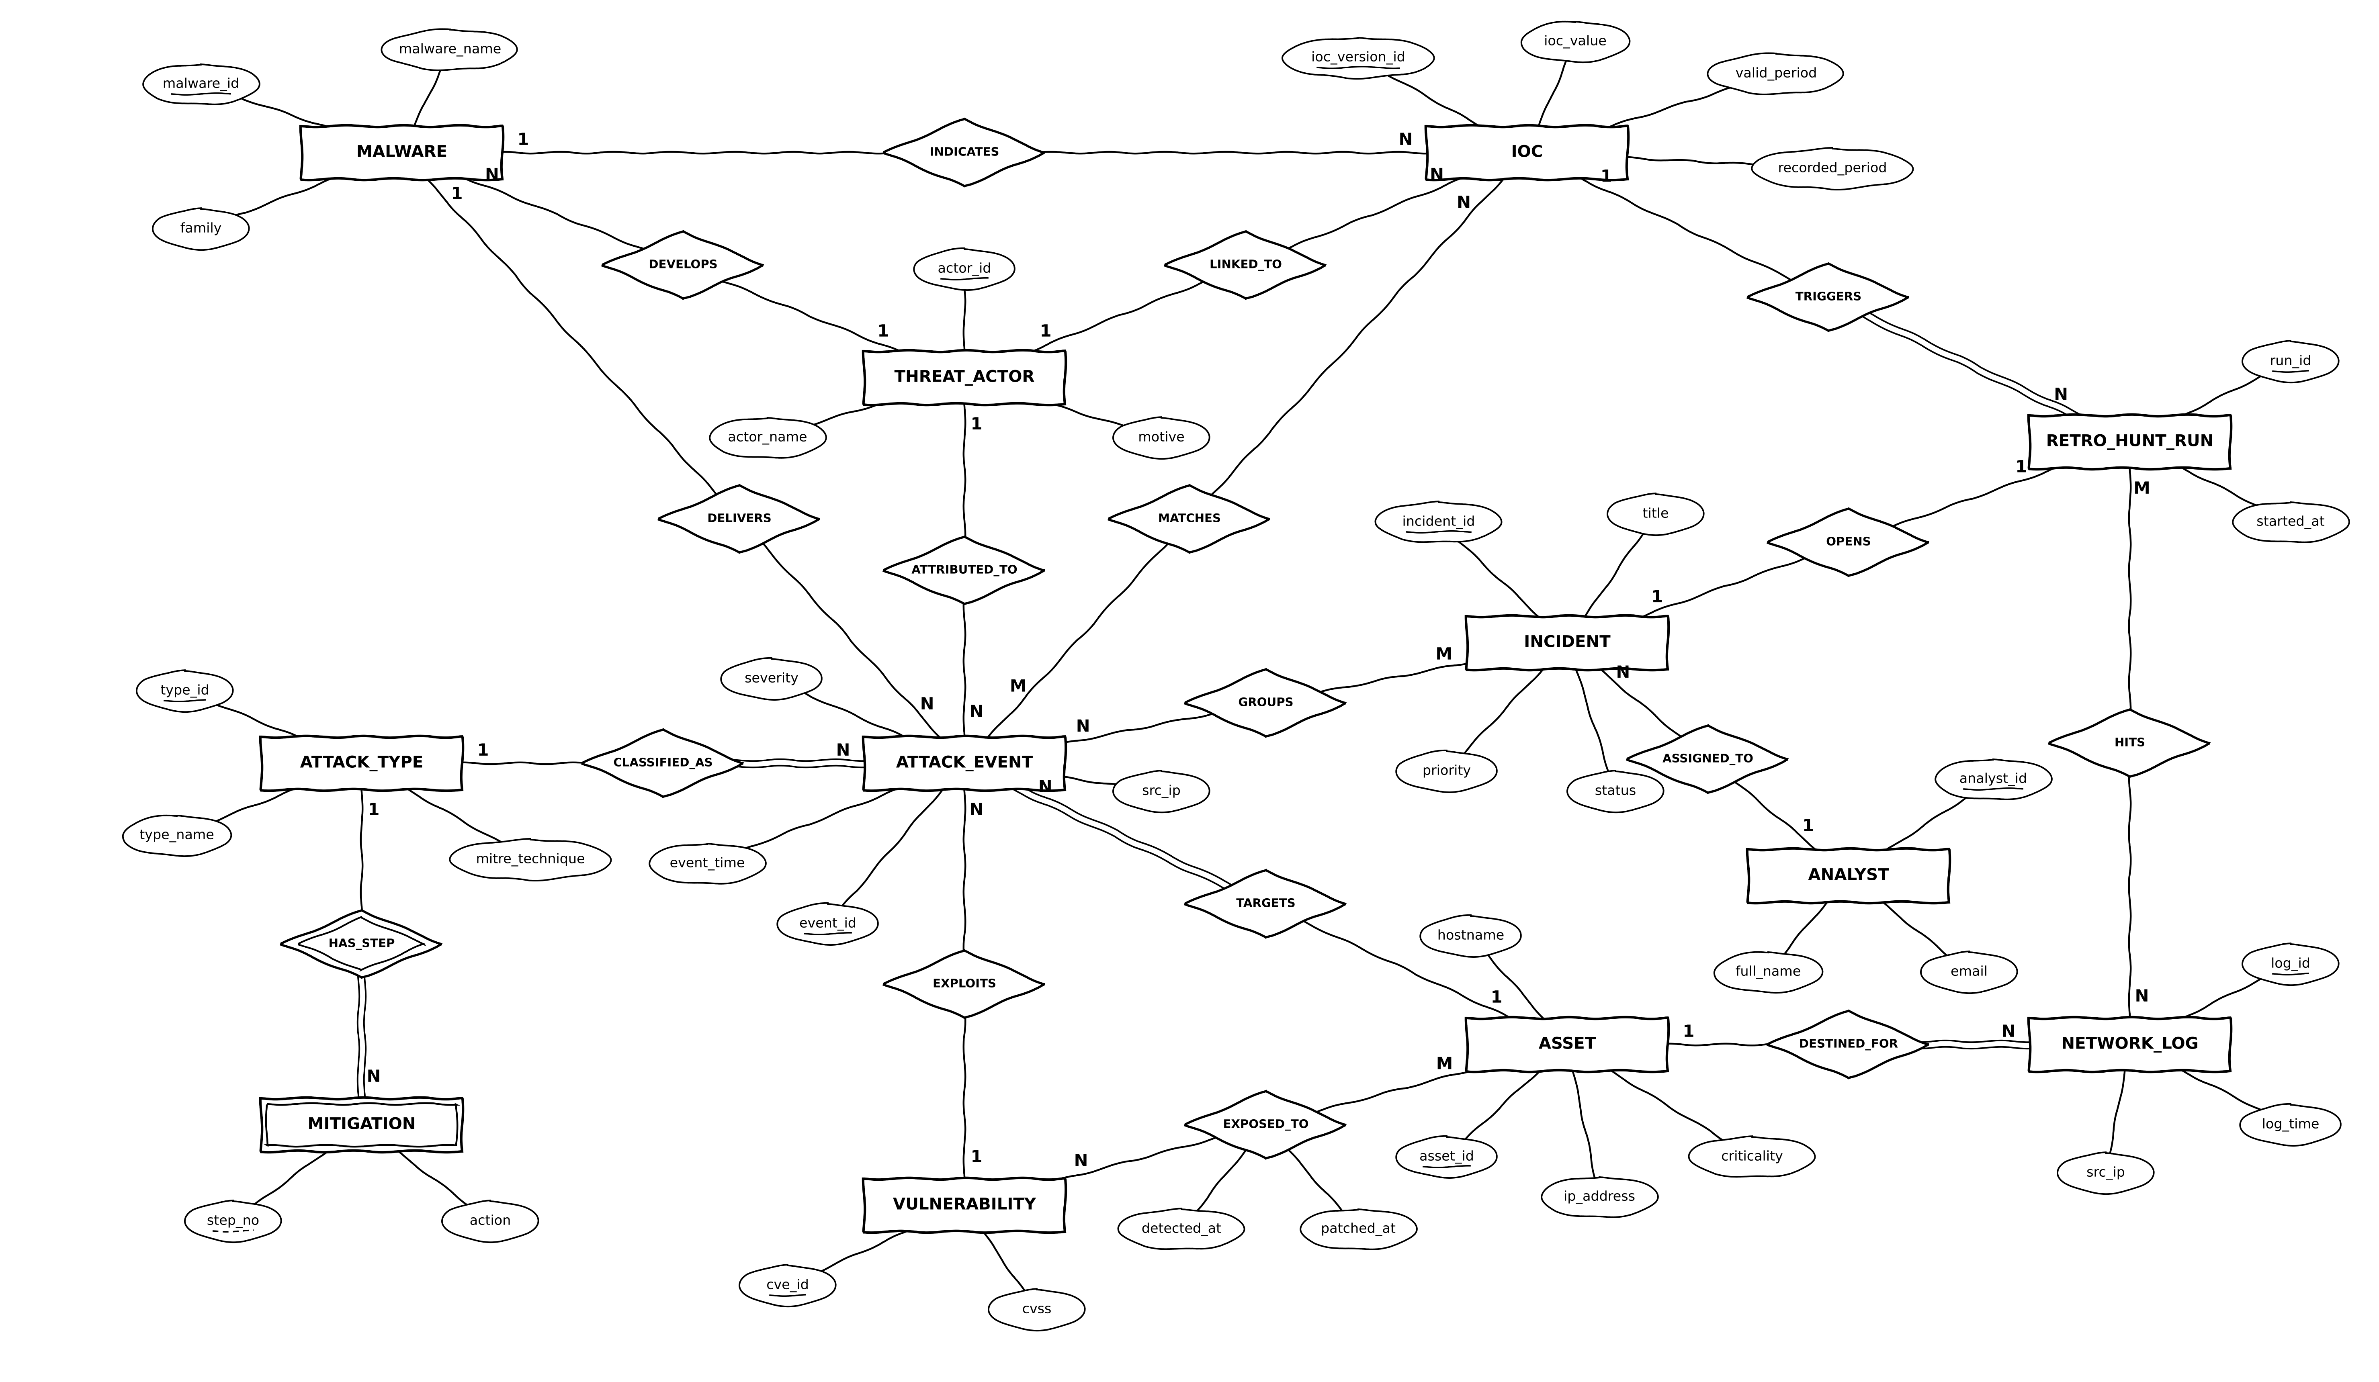
Fig. 2 ER diagram of SentinelX (Chen notation)

9. Tables and Constraints
All 16 tables are in Third Normal Form: in every table each non-key column depends on the key, the whole key and nothing but the key. Every column that decides another column is itself a candidate key, so the tables also meet BCNF. The normalisation steps and the 23 attributes removed after review are in section 15. For each table below we give a short description, its attributes with data types and constraints, the CREATE TABLE statement as MySQL ran it, and the normal form. MySQL echoes statements without comments, so the screenshots show the definitions without them.
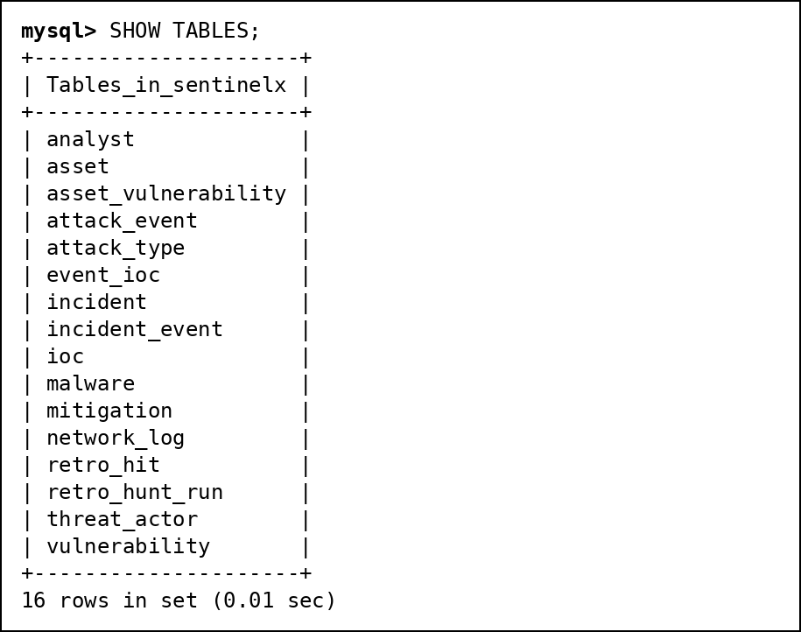
Fig. 3 SHOW TABLES after running the 16 CREATE TABLE statements

Table: asset
Every server or device we protect. hostname and ip_address are unique too.
Attribute | Data Type | Constraint
asset_id | INT | PRIMARY KEY, AUTO_INCREMENT
hostname | VARCHAR(63) | NOT NULL UNIQUE
ip_address | VARCHAR(45) | NOT NULL UNIQUE
asset_type | ENUM('web','db','mail','dns','workstation','iot','vpn') | NOT NULL
criticality | TINYINT | NOT NULL CHECK (criticality BETWEEN 1 AND 5)

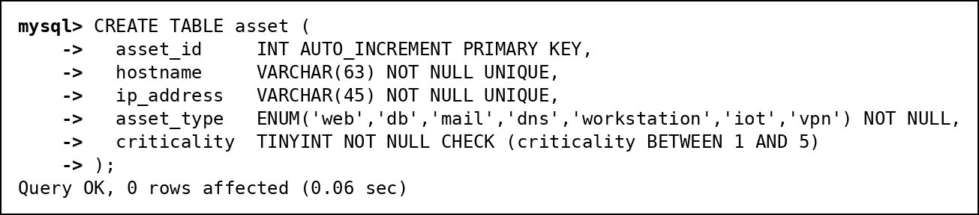
Fig. 4 CREATE TABLE asset executed in MySQL
Normal form: Every column depends only on asset_id (hostname and ip_address are also candidate keys). 3NF.

Table: vulnerability
Published CVEs. cve_id must look like CVE-2024-3400. Severity is not stored; the view v_vulnerability works it out from cvss.
Attribute | Data Type | Constraint
cve_id | VARCHAR(16) | PRIMARY KEY CHECK (cve_id REGEXP '^CVE-[0-9]{4}-[0-9]{4,7}$')
cvss | DECIMAL(3,1) | NOT NULL CHECK (cvss BETWEEN 0 AND 10)
published | DATE | NOT NULL

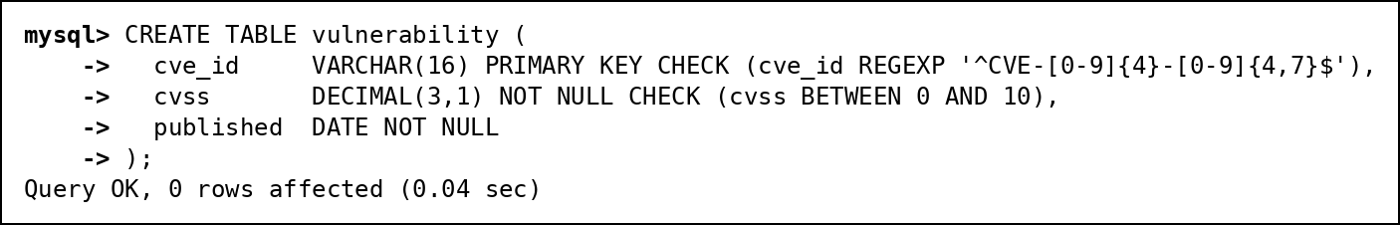
Fig. 5 CREATE TABLE vulnerability executed in MySQL
Normal form: cvss and published depend only on cve_id. Storing severity would add the transitive dependency cve_id -> cvss -> severity. 3NF.

Table: asset_vulnerability
Link table for EXPOSED_TO (M:N between assets and CVEs), with when the CVE was found and patched.
Attribute | Data Type | Constraint
asset_id | INT | NOT NULL; Part of composite PRIMARY KEY (asset_id, cve_id); FOREIGN KEY to asset(asset_id), on delete cascade
cve_id | VARCHAR(16) | NOT NULL; Part of composite PRIMARY KEY (asset_id, cve_id); FOREIGN KEY to vulnerability(cve_id)
detected_at | DATE | NOT NULL; CHECK (patched_at IS NULL OR patched_at >= detected_at)
patched_at | DATE | NULL allowed

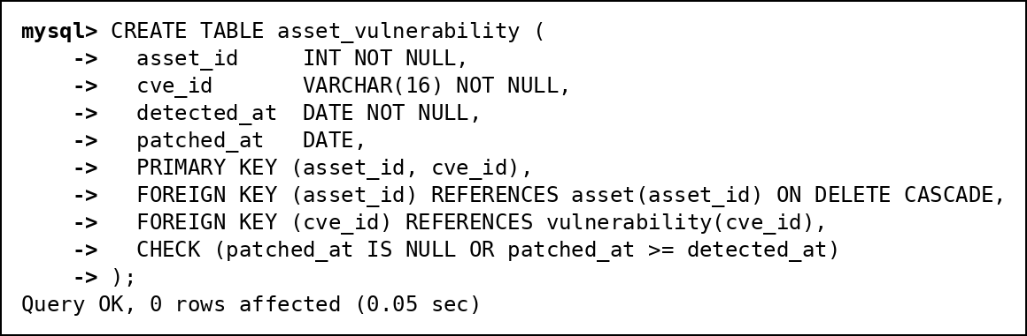
Fig. 6 CREATE TABLE asset_vulnerability executed in MySQL
Normal form: detected_at and patched_at depend on the whole key (asset_id, cve_id). 3NF.

Table: network_log
Raw log lines from the firewall and IDS. The index on (src_ip, log_time) serves the retro-hunt (section 14).
Attribute | Data Type | Constraint
log_id | BIGINT | PRIMARY KEY, AUTO_INCREMENT
log_time | DATETIME | NOT NULL
src_ip | VARCHAR(45) | NOT NULL; Indexed (idx_src_time: src_ip, log_time)
dst_asset_id | INT | NOT NULL; FOREIGN KEY to asset(asset_id)
dst_port | SMALLINT UNSIGNED | NOT NULL
protocol | ENUM('TCP','UDP','ICMP') | NOT NULL
action | ENUM('allowed','blocked') | NOT NULL

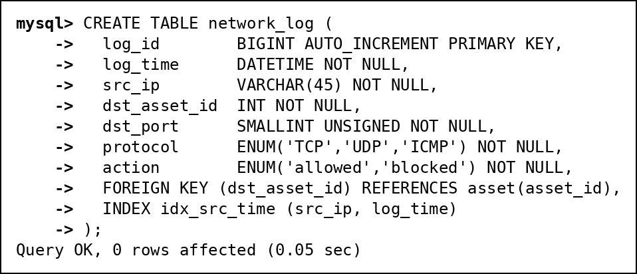
Fig. 7 CREATE TABLE network_log executed in MySQL
Normal form: Everything depends on log_id. 3NF.

Table: attack_type
Kinds of attack with their MITRE ATT&CK technique ID.
Attribute | Data Type | Constraint
type_id | INT | PRIMARY KEY, AUTO_INCREMENT
type_name | VARCHAR(40) | NOT NULL UNIQUE
mitre_technique | VARCHAR(9) | NOT NULL UNIQUE CHECK (mitre_technique REGEXP '^T[0-9]{4}([.][0-9]{3})?$')
base_severity | TINYINT | NOT NULL CHECK (base_severity BETWEEN 1 AND 10)

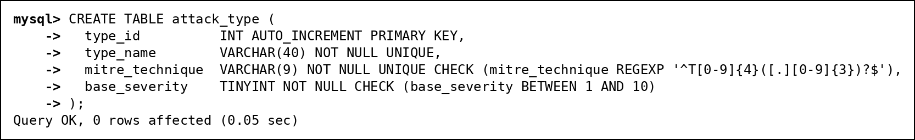
Fig. 8 CREATE TABLE attack_type executed in MySQL
Normal form: Everything depends on type_id; type_name and mitre_technique are candidate keys. 3NF.

Table: mitigation
Weak entity: numbered response steps for each attack type, deleted together with the type.
Attribute | Data Type | Constraint
type_id | INT | NOT NULL; Part of composite PRIMARY KEY (type_id, step_no); FOREIGN KEY to attack_type(type_id), on delete cascade
step_no | TINYINT | NOT NULL CHECK (step_no > 0); Part of composite PRIMARY KEY (type_id, step_no)
action | VARCHAR(100) | NOT NULL

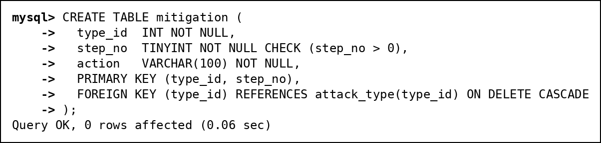
Fig. 9 CREATE TABLE mitigation executed in MySQL
Normal form: action depends on the full key (type_id, step_no). 3NF.

Table: threat_actor
Attacker groups with country and motive. The names are made up.
Attribute | Data Type | Constraint
actor_id | INT | PRIMARY KEY, AUTO_INCREMENT
actor_name | VARCHAR(50) | NOT NULL UNIQUE
origin_country | CHAR(2) | CHECK (origin_country REGEXP '^[A-Z]{2}$')
motive | ENUM('financial','espionage','hacktivism','sabotage','unknown') | NOT NULL

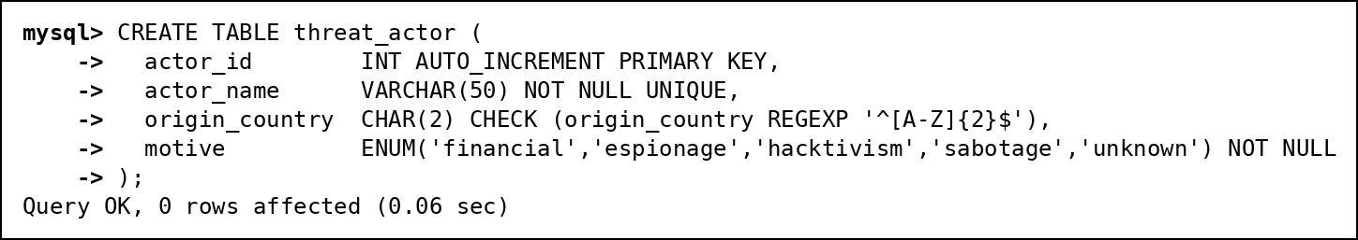
Fig. 10 CREATE TABLE threat_actor executed in MySQL
Normal form: Everything depends on actor_id. 3NF.

Table: malware
Malware samples. actor_id becomes NULL if the group is deleted; cluster_id is filled by the ML job.
Attribute | Data Type | Constraint
malware_id | INT | PRIMARY KEY, AUTO_INCREMENT
malware_name | VARCHAR(50) | NOT NULL UNIQUE
family | VARCHAR(30) | NOT NULL
sha256 | CHAR(64) | NOT NULL UNIQUE CHECK (sha256 REGEXP '^[0-9a-f]{64}$')
actor_id | INT | FOREIGN KEY to threat_actor(actor_id), on delete set null
cluster_id | SMALLINT | NULL allowed

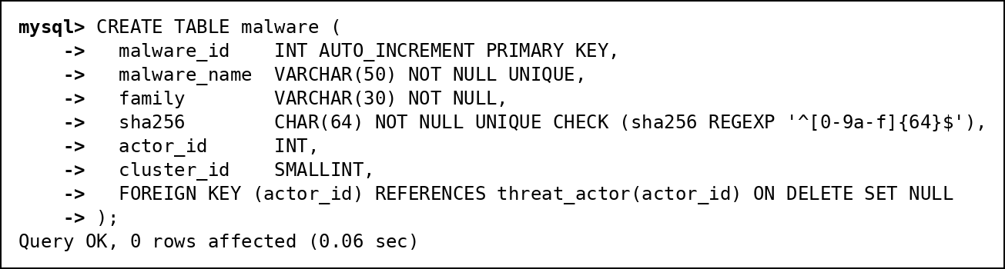
Fig. 11 CREATE TABLE malware executed in MySQL
Normal form: Everything depends on malware_id. category was removed because family decides it. 3NF.

Table: attack_event
One row per detected attack. Asset and type are required; attacker, malware and CVE are optional.
Attribute | Data Type | Constraint
event_id | BIGINT | PRIMARY KEY, AUTO_INCREMENT
event_time | DATETIME | NOT NULL; Indexed (idx_time: event_time)
src_ip | VARCHAR(45) | NOT NULL; Indexed (idx_src: src_ip)
src_country | CHAR(2) | NOT NULL CHECK (src_country REGEXP '^[A-Z]{2}$')
asset_id | INT | NOT NULL; FOREIGN KEY to asset(asset_id)
type_id | INT | NOT NULL; FOREIGN KEY to attack_type(type_id)
actor_id | INT | FOREIGN KEY to threat_actor(actor_id)
malware_id | INT | FOREIGN KEY to malware(malware_id)
cve_id | VARCHAR(16) | FOREIGN KEY to vulnerability(cve_id)
severity | TINYINT | NOT NULL CHECK (severity BETWEEN 1 AND 10)
blocked | BOOLEAN | NOT NULL
predicted_severity | ENUM('LOW','MEDIUM','HIGH','CRITICAL') | NULL allowed

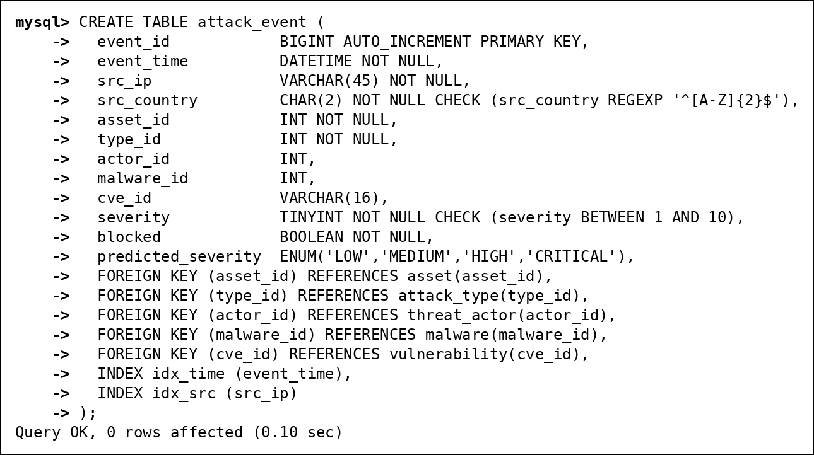
Fig. 12 CREATE TABLE attack_event executed in MySQL
Normal form: Everything depends on event_id. src_country stays because an IP's location changes over time; actor_id stays because malware is shared between groups. 3NF.

Table: analyst
People who use the system. email is unique and checked to look like an email address.
Attribute | Data Type | Constraint
analyst_id | INT | PRIMARY KEY, AUTO_INCREMENT
full_name | VARCHAR(50) | NOT NULL
email | VARCHAR(50) | NOT NULL UNIQUE CHECK (email REGEXP '^[^@ ]+@[^@ ]+[.][A-Za-z]{2,}$')
role | ENUM('admin','analyst','viewer') | NOT NULL

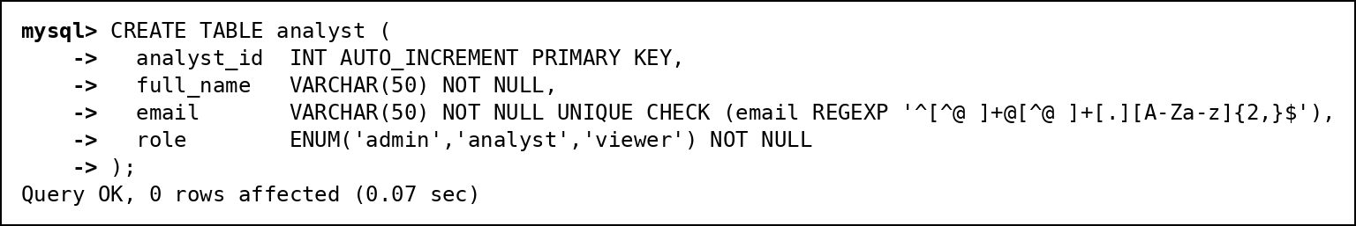
Fig. 13 CREATE TABLE analyst executed in MySQL
Normal form: Everything depends on analyst_id; email is also a candidate key. 3NF.

Table: incident
An investigation. closed_at is filled in only when the status is CLOSED.
Attribute | Data Type | Constraint
incident_id | INT | PRIMARY KEY, AUTO_INCREMENT
title | VARCHAR(100) | NOT NULL
priority | ENUM('LOW','MEDIUM','HIGH','CRITICAL') | NOT NULL
status | ENUM('OPEN','INVESTIGATING','CONTAINED','CLOSED') | NOT NULL DEFAULT 'OPEN'; CHECK ((status = 'CLOSED') = (closed_at IS NOT NULL))
assigned_to | INT | FOREIGN KEY to analyst(analyst_id)
opened_at | DATETIME | NOT NULL DEFAULT CURRENT_TIMESTAMP; CHECK (closed_at IS NULL OR closed_at >= opened_at)
closed_at | DATETIME | NULL allowed

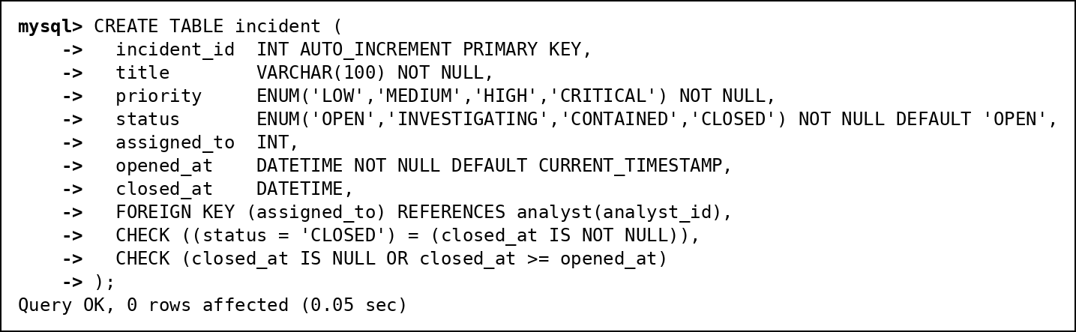
Fig. 14 CREATE TABLE incident executed in MySQL
Normal form: Everything depends on incident_id. 3NF.

Table: incident_event
Link table for GROUPS (M:N between incidents and attacks).
Attribute | Data Type | Constraint
incident_id | INT | NOT NULL; Part of composite PRIMARY KEY (incident_id, event_id); FOREIGN KEY to incident(incident_id), on delete cascade
event_id | BIGINT | NOT NULL; Part of composite PRIMARY KEY (incident_id, event_id); FOREIGN KEY to attack_event(event_id), on delete cascade

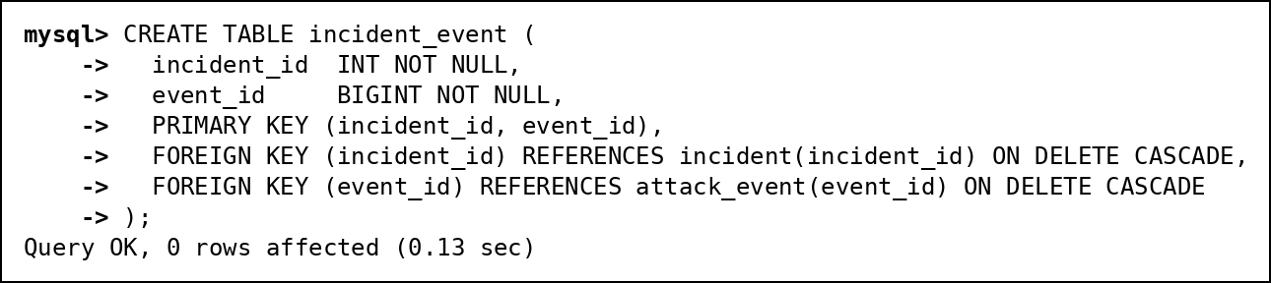
Fig. 15 CREATE TABLE incident_event executed in MySQL
Normal form: All-key table. 3NF.

Table: ioc
Indicators of compromise. valid_from/valid_to say when it was hostile and recorded_from/recorded_to say when we knew. Triggers keep the history append-only.
Attribute | Data Type | Constraint
ioc_version_id | BIGINT | PRIMARY KEY, AUTO_INCREMENT
ioc_type | ENUM('ip','domain','hash','url') | NOT NULL; CHECK (ioc_type <> 'ip' OR ioc_value REGEXP '^[0-9]{1,3}([.][0-9]{1,3}){3}$')
ioc_value | VARCHAR(255) | NOT NULL; Indexed (idx_value: ioc_value)
actor_id | INT | FOREIGN KEY to threat_actor(actor_id)
malware_id | INT | FOREIGN KEY to malware(malware_id)
valid_from | DATETIME | NOT NULL; CHECK (valid_to IS NULL OR valid_to > valid_from)
valid_to | DATETIME | NULL allowed
recorded_from | DATETIME | NOT NULL DEFAULT CURRENT_TIMESTAMP; CHECK (recorded_to IS NULL OR recorded_to > recorded_from)
recorded_to | DATETIME | NULL allowed

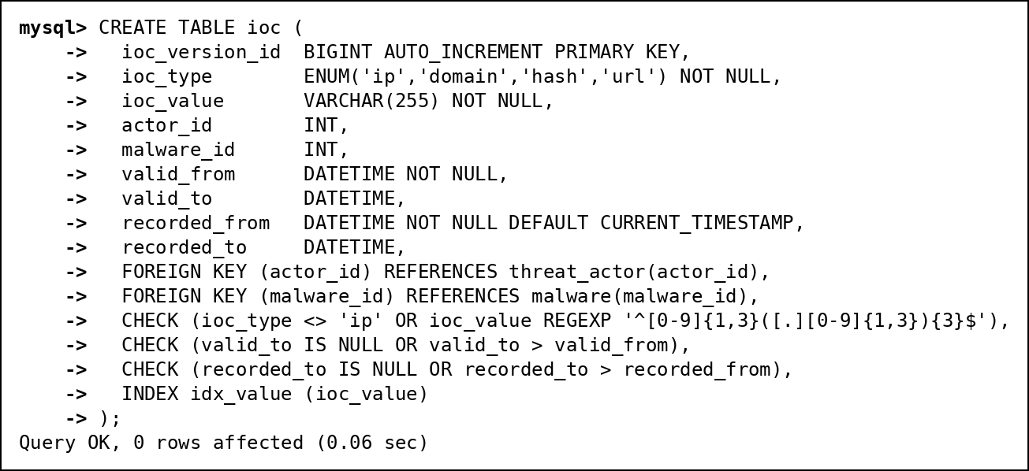
Fig. 16 CREATE TABLE ioc executed in MySQL
Normal form: Everything depends on ioc_version_id. 3NF.

Table: event_ioc
Link table for MATCHES (M:N between attacks and indicators).
Attribute | Data Type | Constraint
event_id | BIGINT | NOT NULL; Part of composite PRIMARY KEY (event_id, ioc_version_id); FOREIGN KEY to attack_event(event_id), on delete cascade
ioc_version_id | BIGINT | NOT NULL; Part of composite PRIMARY KEY (event_id, ioc_version_id); FOREIGN KEY to ioc(ioc_version_id)

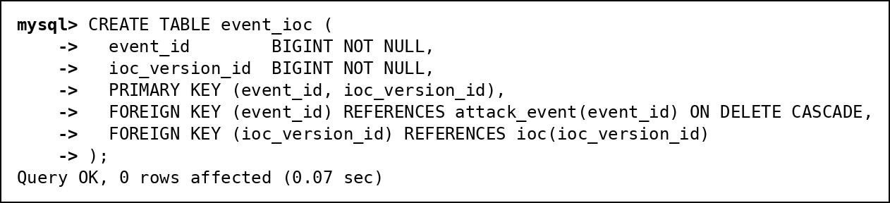
Fig. 17 CREATE TABLE event_ioc executed in MySQL
Normal form: All-key table. 3NF.

Table: retro_hunt_run
One row per automatic search of old logs. incident_id is UNIQUE (1:1 OPENS).
Attribute | Data Type | Constraint
run_id | INT | PRIMARY KEY, AUTO_INCREMENT
ioc_version_id | BIGINT | NOT NULL; FOREIGN KEY to ioc(ioc_version_id)
started_at | DATETIME | NOT NULL DEFAULT CURRENT_TIMESTAMP
incident_id | INT | UNIQUE; FOREIGN KEY to incident(incident_id)

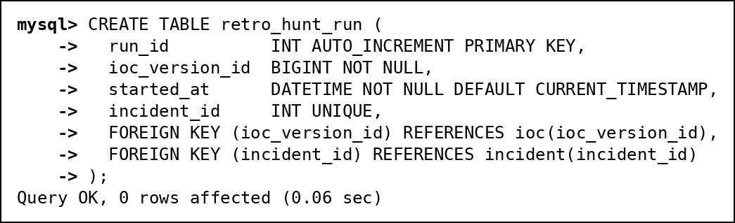
Fig. 18 CREATE TABLE retro_hunt_run executed in MySQL
Normal form: Everything depends on run_id; counts come from v_retro_hunt_summary instead of being stored. 3NF.

Table: retro_hit
Link table for HITS: the old log lines a retro-hunt found.
Attribute | Data Type | Constraint
run_id | INT | NOT NULL; Part of composite PRIMARY KEY (run_id, log_id); FOREIGN KEY to retro_hunt_run(run_id), on delete cascade
log_id | BIGINT | NOT NULL; Part of composite PRIMARY KEY (run_id, log_id); FOREIGN KEY to network_log(log_id)

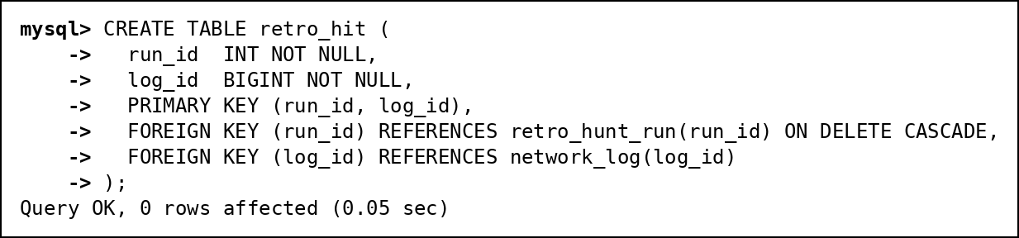
Fig. 19 CREATE TABLE retro_hit executed in MySQL
Normal form: All-key table. 3NF.

10. Data Population (INSERT, UPDATE, DELETE)
The data is a hand-made test set, small enough to check every result by hand, plus 50,000 generated background log lines so the index comparison in section 14 is meaningful. Attacker IPs come from the address ranges reserved for documentation (192.0.2.0/24, 198.51.100.0/24, 203.0.113.0/24), so no real address is marked as bad. The CVE IDs are real. The full script is 02_dml.sql; one INSERT per table type is shown here.

INSERT
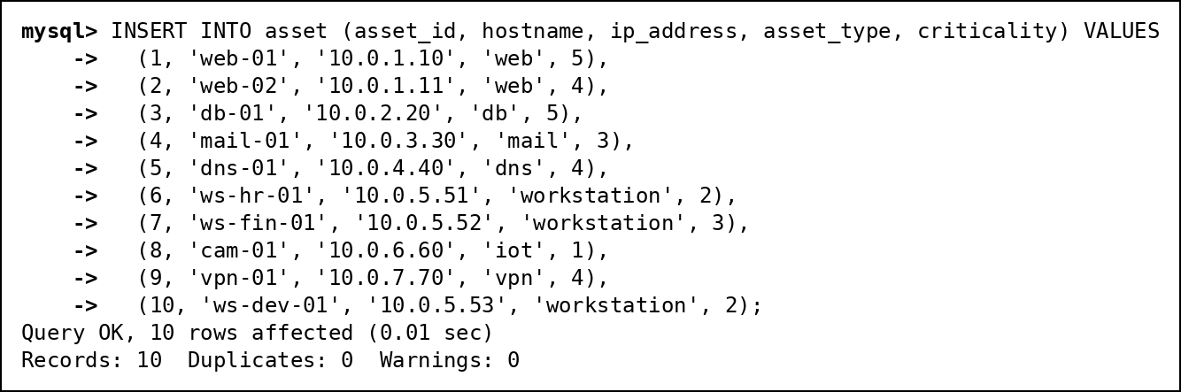
Fig. 20 INSERT of the 10 assets
The other 14 tables are filled the same way, with explicit keys so the links between tables are predictable. The background log lines are generated with a recursive CTE in one statement:
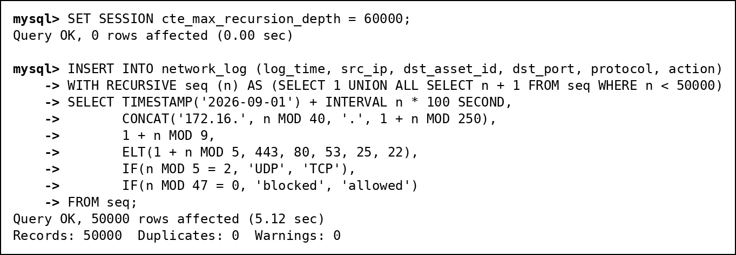
Fig. 21 Generating 50,000 background log lines with a recursive CTE

UPDATE
The ML job had not scored attacks 25 and 26. The UPDATE sets their predicted severity from the same bands the job uses.
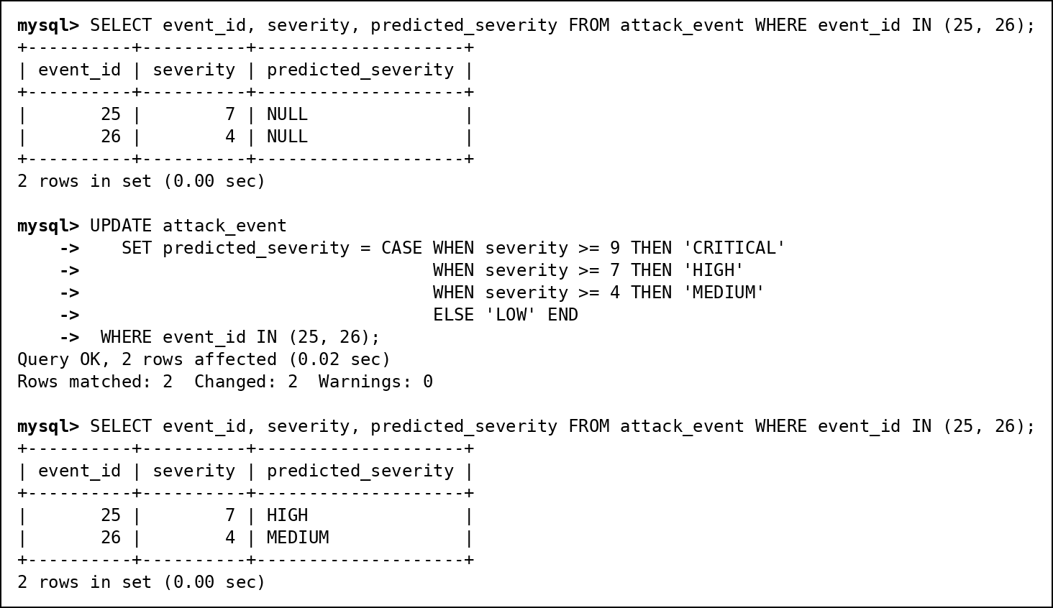
Fig. 22 UPDATE of predicted_severity, before and after

DELETE
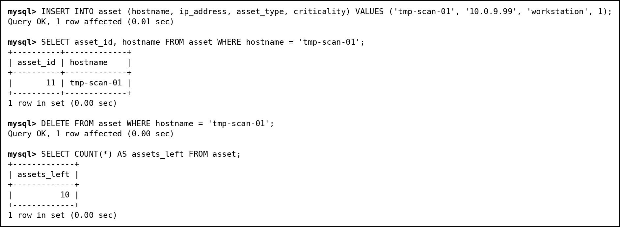
Fig. 23 INSERT and DELETE of a temporary asset

Constraints in action
Each statement below breaks one rule on purpose, and MySQL rejects it: a CHECK (criticality 9), a UNIQUE (duplicate hostname), a FOREIGN KEY on insert (type 99 does not exist), a FOREIGN KEY on delete (web-01 still has attacks), and the table-level CHECK that only closed incidents have a closed_at.
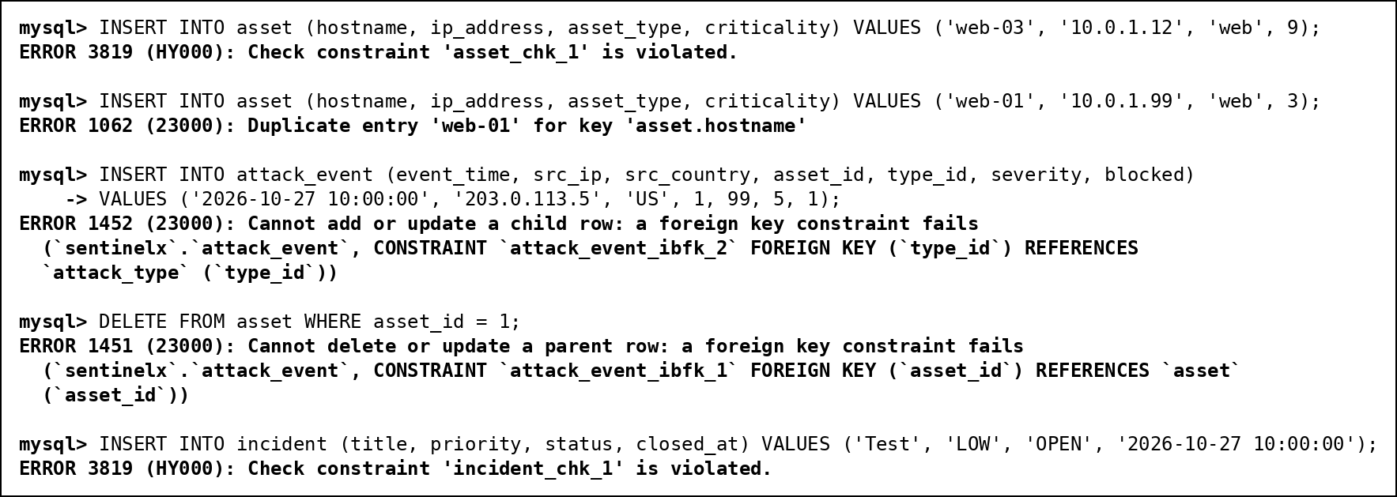
Fig. 24 Five rejected statements, one per constraint

Row counts
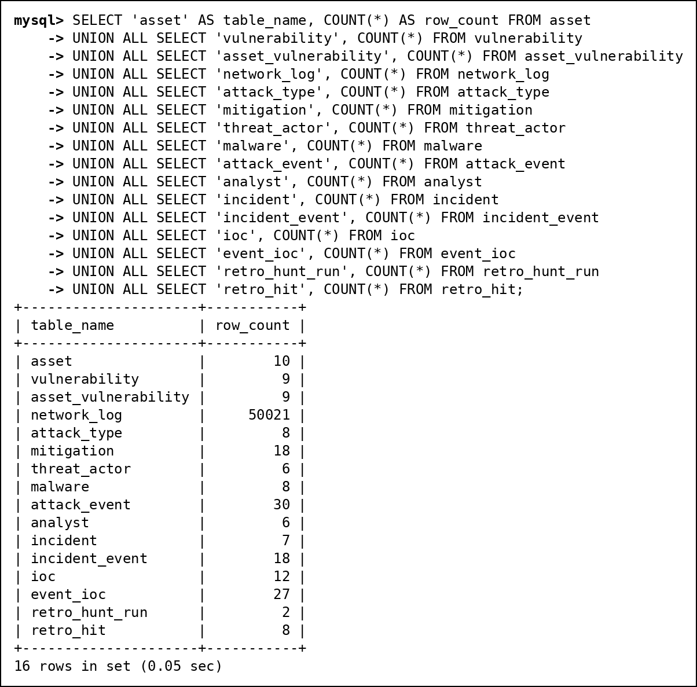
Fig. 25 Row count of every table after loading

11. SQL Implementation
Every query below was run on the loaded database, and each screenshot shows the statement together with its real output. The table shows how the 40 queries cover what the review requires.
Category | Required coverage | Min | Done | Query IDs
A. Basic queries | SELECT, WHERE, ORDER BY, DISTINCT, BETWEEN, IN, LIKE, IS NULL | 6 | 7 | A1, A2, A3, A4, A5, A6, A7
B. Aggregate queries | COUNT, SUM, AVG, MIN, MAX, GROUP BY, HAVING (WHERE vs HAVING in B5) | 5 | 6 | B1, B2, B3, B4, B5, B6
C. Joins | INNER, LEFT, RIGHT, FULL OUTER (emulated with UNION), SELF, CROSS | 6 | 6 | C1, C2, C3, C4, C5, C6
D. Subqueries | Scalar, single-row, multi-row (IN, ANY, ALL), correlated, EXISTS, NOT EXISTS, NOT IN with the NULL pitfall | 6 | 9 | D1, D2, D3, D4, D5, D6, D7, D8, D9
E. Set operations | UNION, UNION ALL, INTERSECT, EXCEPT | 4 | 4 | E1, E2, E3, E4
F. Advanced functions | CASE, COALESCE, NULLIF, date/time, string and numeric functions | 6 | 6 | F1, F2, F3, F4, F5, F6
G. Window functions | RANK, DENSE_RANK, ROW_NUMBER, running total, LAG, LEAD | 2 | 3 | G1, G2, G3

11.1 A. Basic queries
A1. Critical assets (criticality 4 or 5), most critical first
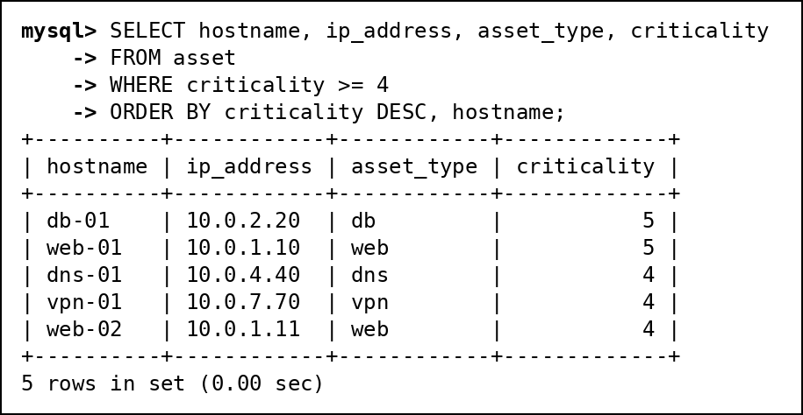
Fig. 26 A1: Critical assets (criticality 4 or 5), most critical first
A2. Countries that attacks came from (DISTINCT)
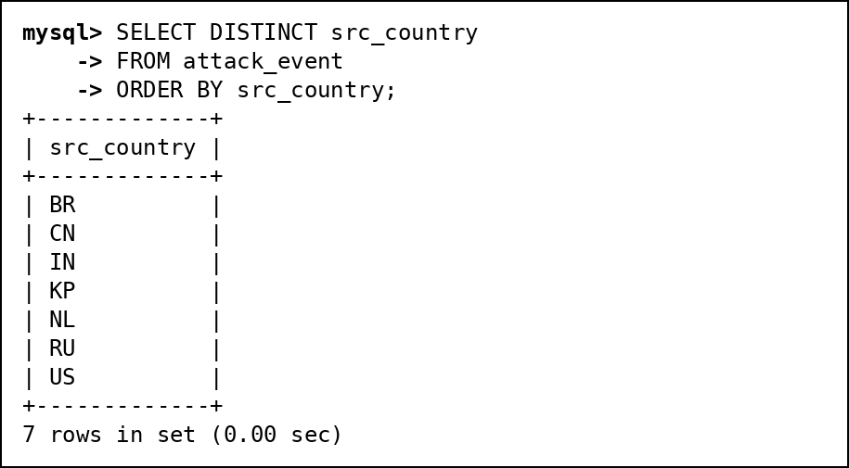
Fig. 27 A2: Countries that attacks came from (DISTINCT)
A3. Attacks between 10 and 14 October (BETWEEN)
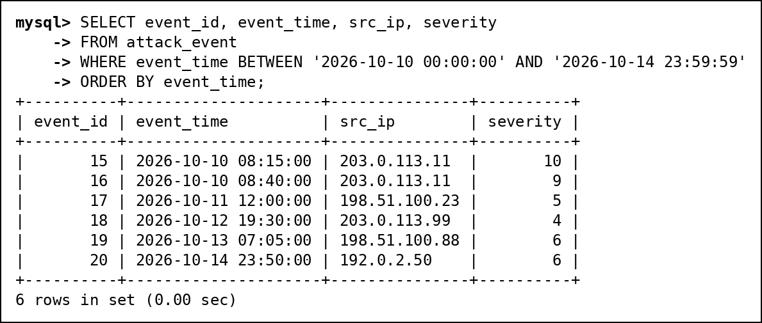
Fig. 28 A3: Attacks between 10 and 14 October (BETWEEN)
A4. Internet-facing servers: web, db and vpn assets (IN)
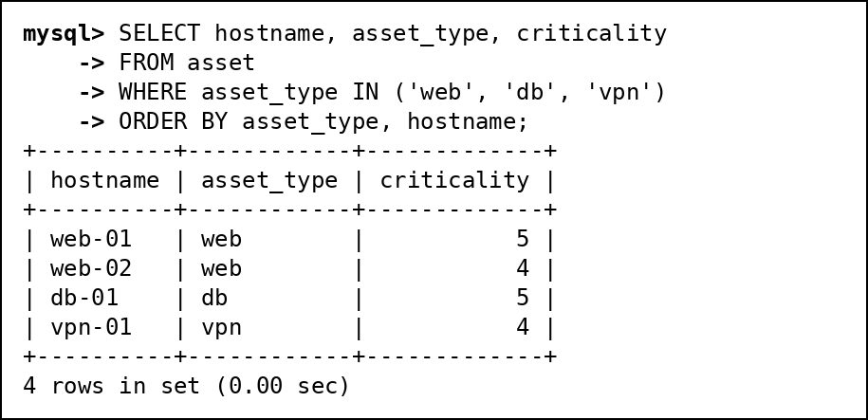
Fig. 29 A4: Internet-facing servers: web, db and vpn assets (IN)
A5. CVEs published in 2023 (LIKE)
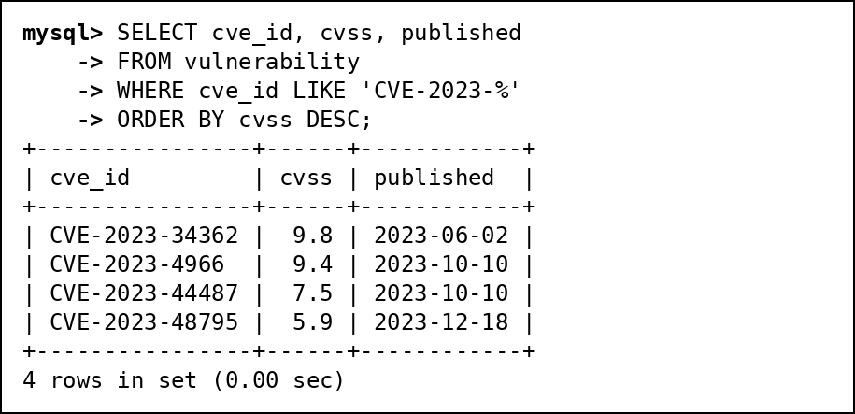
Fig. 30 A5: CVEs published in 2023 (LIKE)
A6. Incidents nobody owns yet (IS NULL)
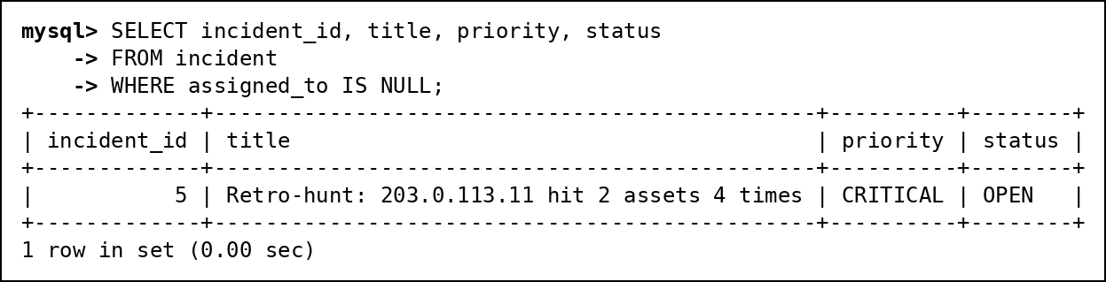
Fig. 31 A6: Incidents nobody owns yet (IS NULL)
A7. Attacks the ML job has not scored yet (IS NULL)
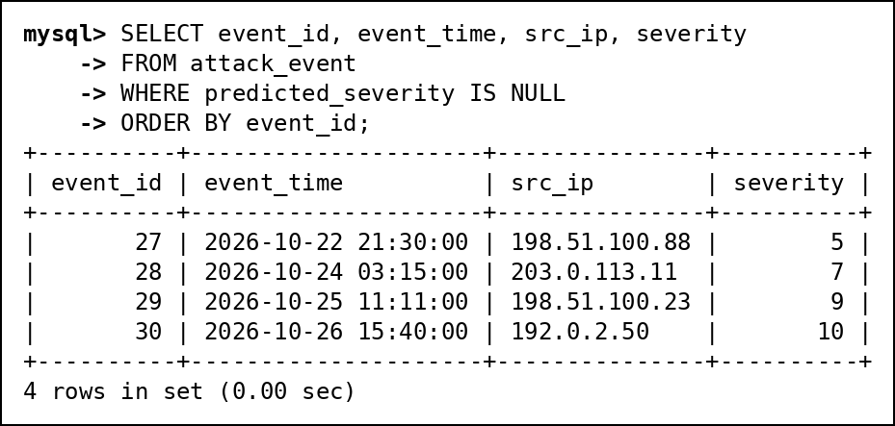
Fig. 32 A7: Attacks the ML job has not scored yet (IS NULL)

11.2 B. Aggregate queries
B1. Number of attacks per attack type (COUNT, GROUP BY)
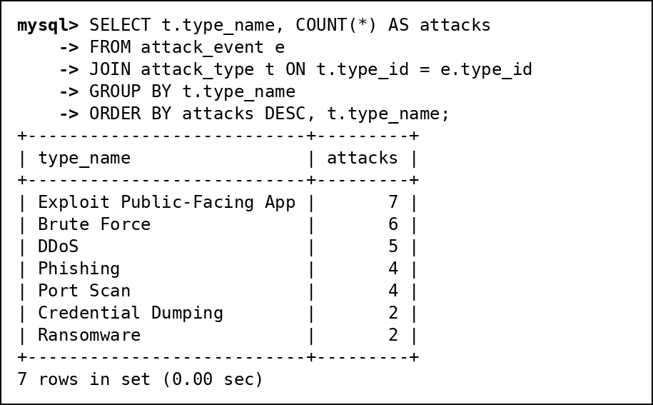
Fig. 33 B1: Number of attacks per attack type (COUNT, GROUP BY)
B2. Attacks, blocked attacks and average severity per asset (SUM, AVG)
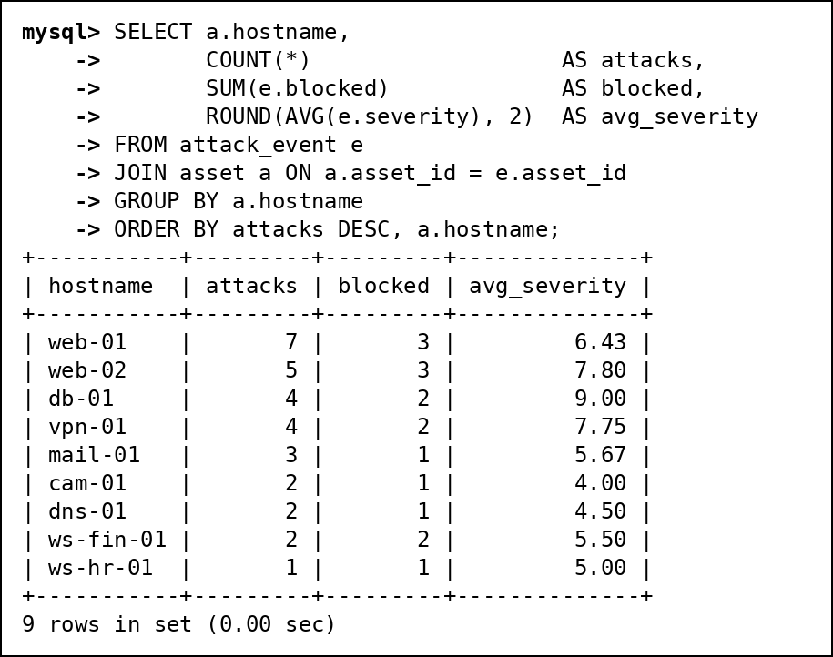
Fig. 34 B2: Attacks, blocked attacks and average severity per asset (SUM, AVG)
B3. First and last attack and worst severity per source country (MIN, MAX)
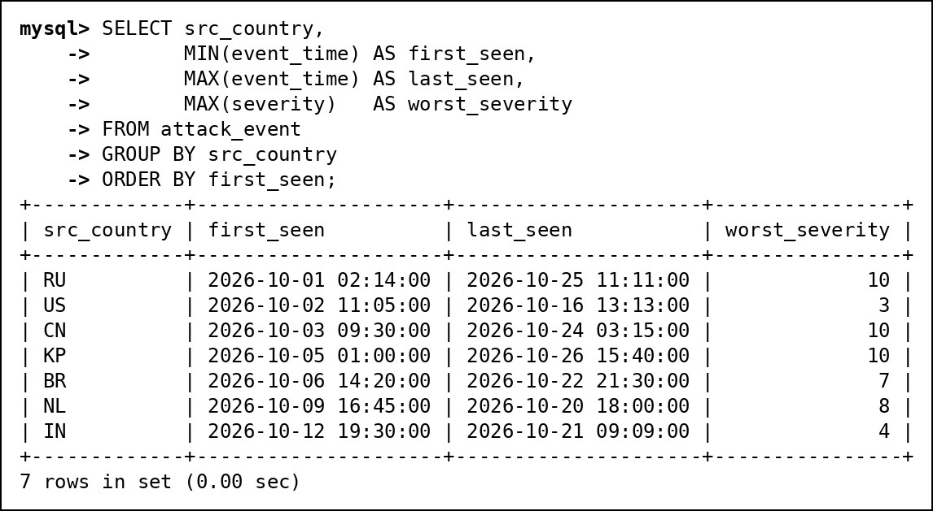
Fig. 35 B3: First and last attack and worst severity per source country (MIN, MAX)
B4. Source IPs with more than 3 attacks (HAVING)
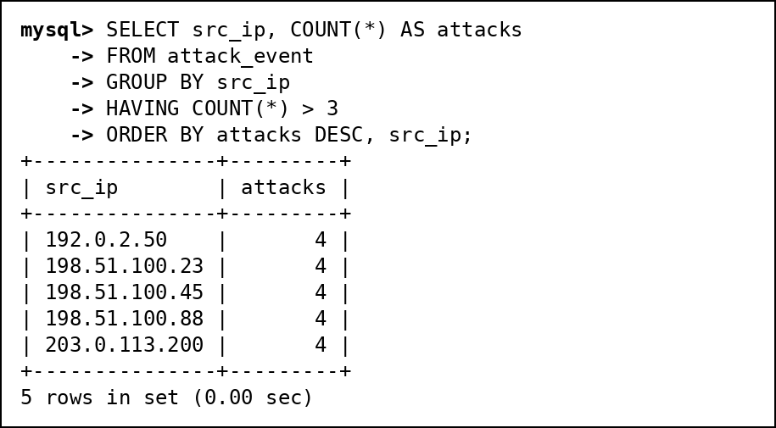
Fig. 36 B4: Source IPs with more than 3 attacks (HAVING)
B5. WHERE vs HAVING: assets with 2 or more serious attacks
WHERE removes attacks below severity 7 before any grouping happens; HAVING then removes whole groups (assets) that end up with fewer than 2 rows. Moving the severity filter into HAVING would not work, because severity is not a group-level value.
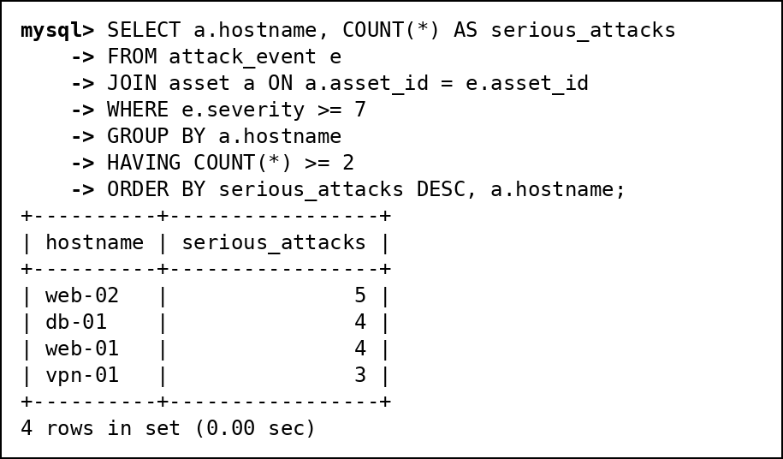
Fig. 37 B5: WHERE vs HAVING: assets with 2 or more serious attacks
B6. CVSS statistics by year of publication
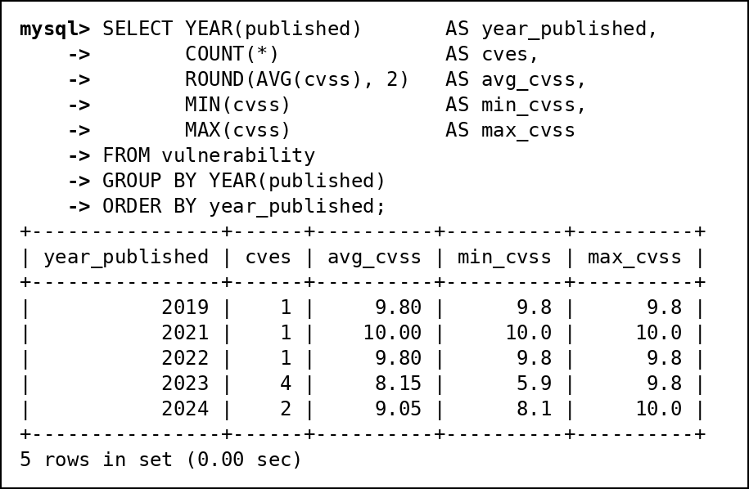
Fig. 38 B6: CVSS statistics by year of publication

11.3 C. Joins
C1. INNER JOIN: attacks of severity 9 or more with asset and attack type
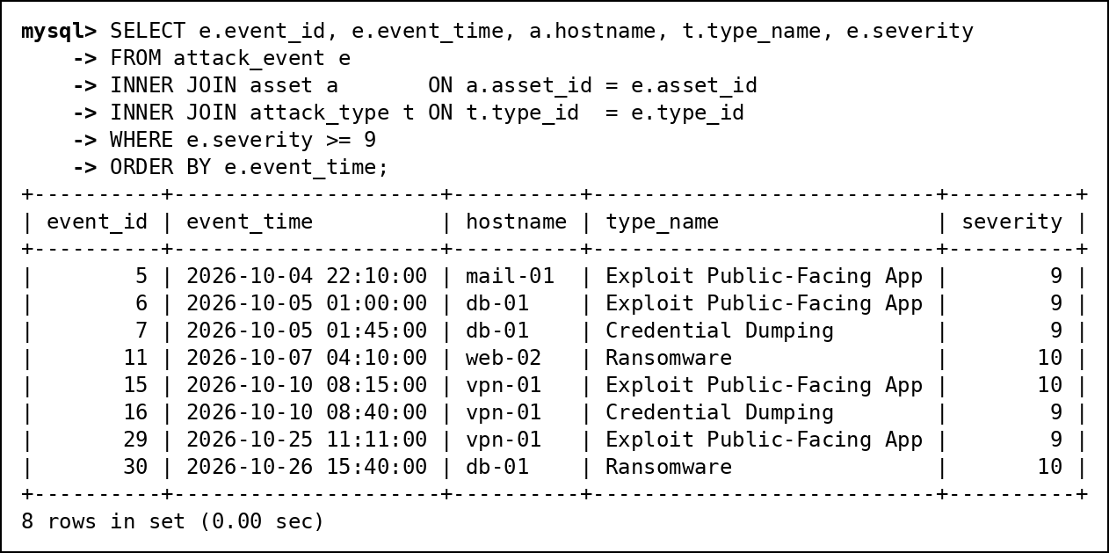
Fig. 39 C1: INNER JOIN: attacks of severity 9 or more with asset and attack type
C2. LEFT JOIN: every asset with its number of attacks, including assets never attacked
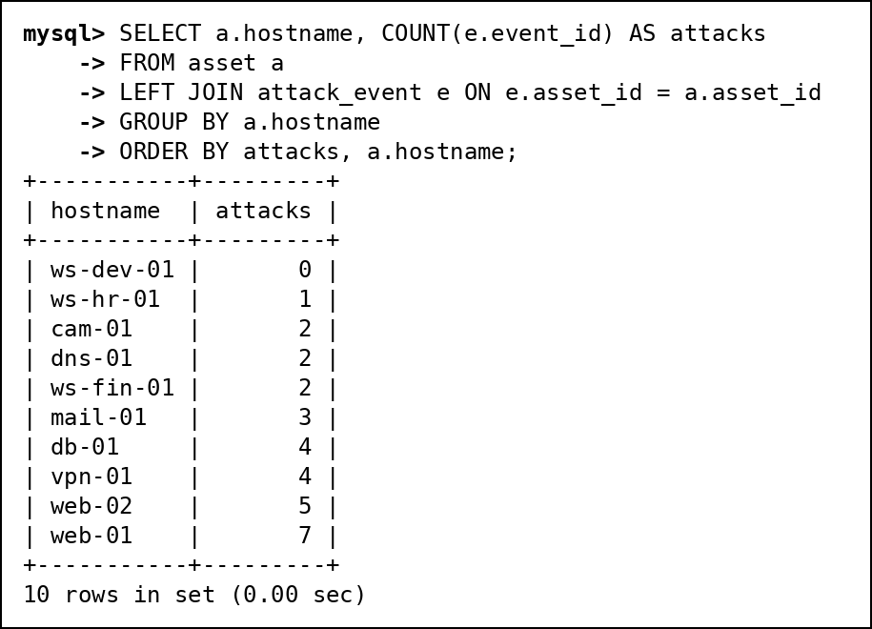
Fig. 40 C2: LEFT JOIN: every asset with its number of attacks, including assets never attacked
C3. RIGHT JOIN: every analyst with the incidents they own, including analysts with none
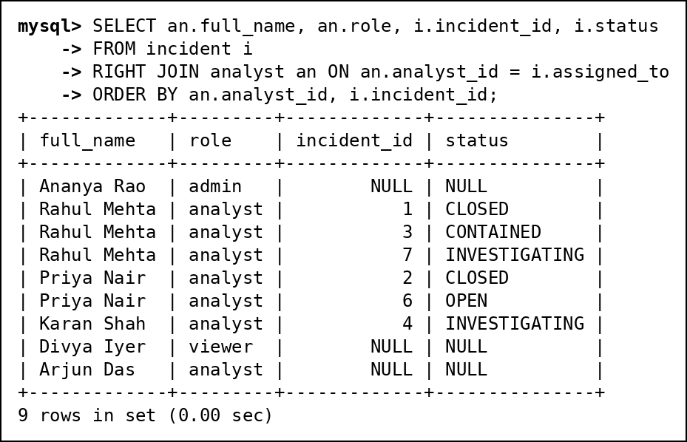
Fig. 41 C3: RIGHT JOIN: every analyst with the incidents they own, including analysts with none
C4. FULL OUTER JOIN emulation: threat actors and malware, keeping both unmatched sides
MySQL has no FULL OUTER JOIN, so it is emulated as LEFT JOIN UNION RIGHT JOIN. The result keeps Byte Bandits (no malware) and OrphanMiner (no known actor).
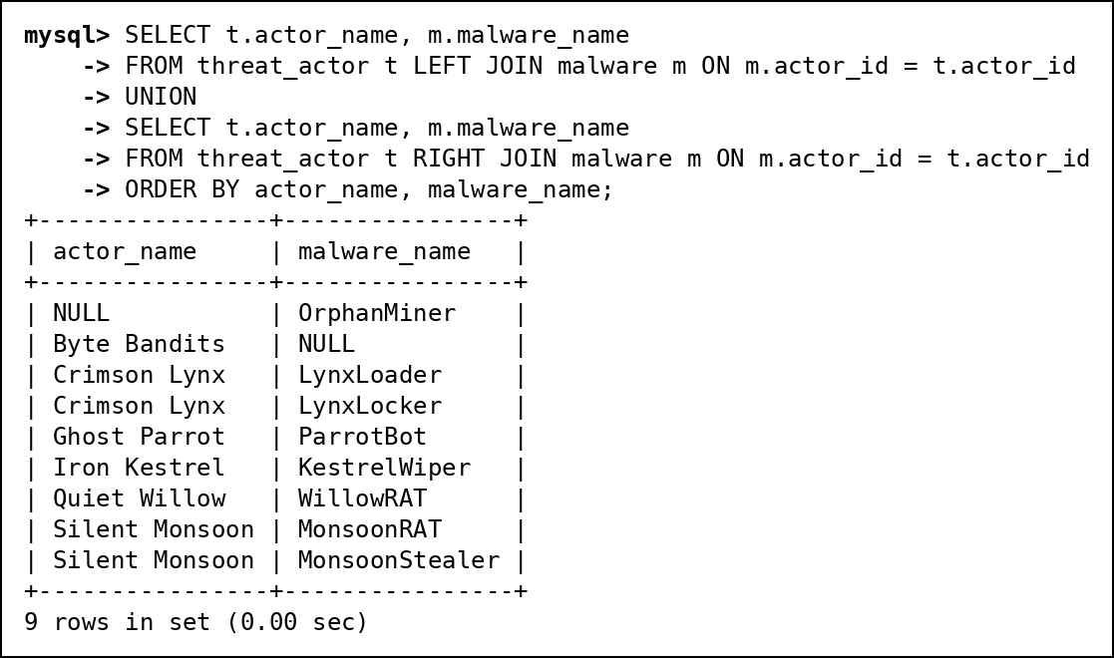
Fig. 42 C4: FULL OUTER JOIN emulation: threat actors and malware, keeping both unmatched sides
C5. SELF JOIN: pairs of malware that the ML job put in the same cluster
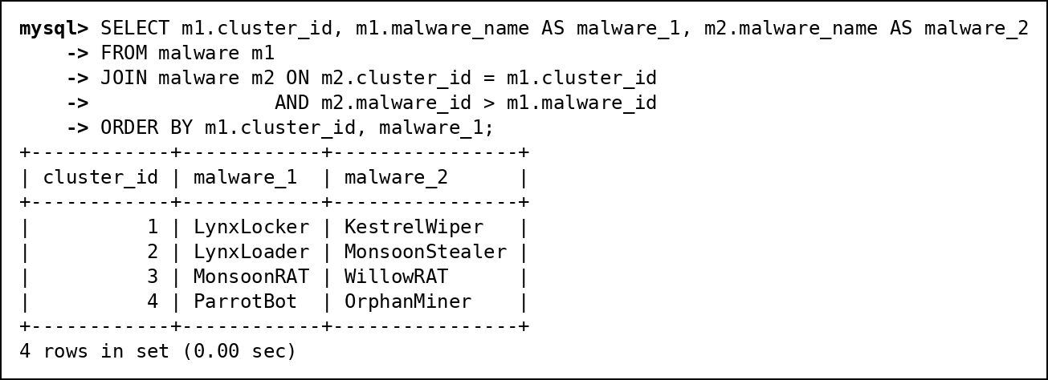
Fig. 43 C5: SELF JOIN: pairs of malware that the ML job put in the same cluster
C6. CROSS JOIN: hardening checklist of every criticality-5 asset against every severe attack type
A meaningful CROSS JOIN: every criticality-5 asset is paired with every attack type of base severity 8 or more, to produce a hardening checklist. Zero means the combination has not been seen yet.
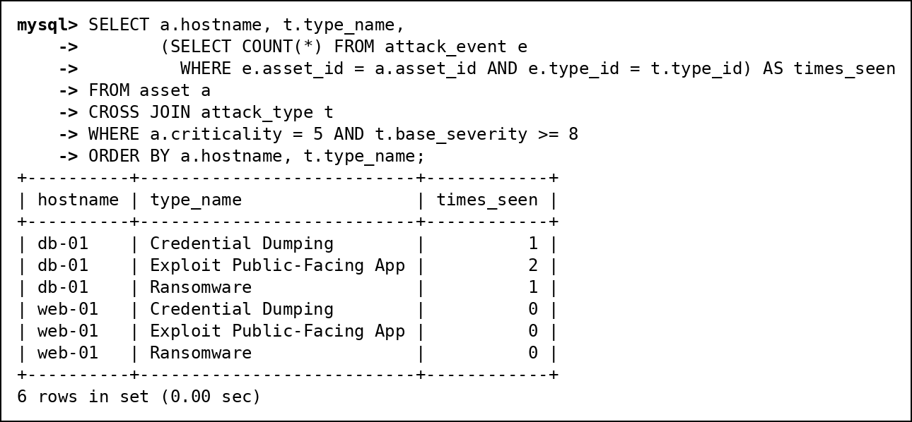
Fig. 44 C6: CROSS JOIN: hardening checklist of every criticality-5 asset against every severe attack type

11.4 D. Subqueries
D1. Scalar subquery: CVEs scoring above the average CVSS
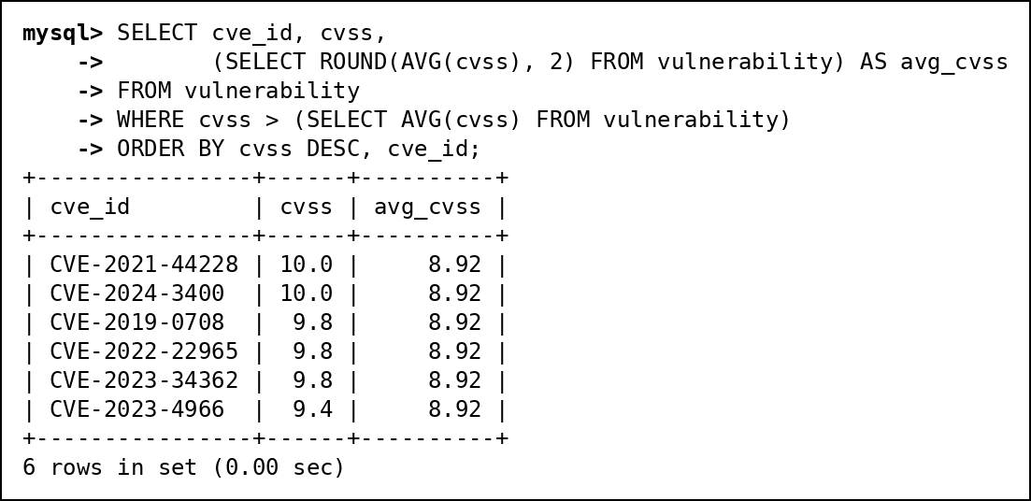
Fig. 45 D1: Scalar subquery: CVEs scoring above the average CVSS
D2. Single-row subquery: the analyst who owns the most recently opened incident
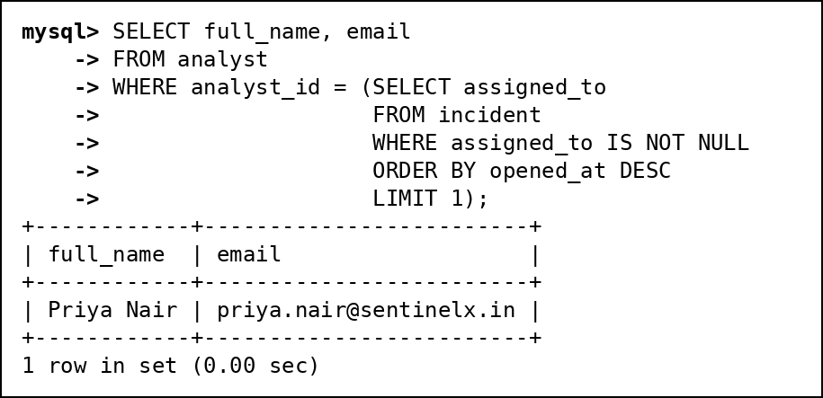
Fig. 46 D2: Single-row subquery: the analyst who owns the most recently opened incident
D3. Multi-row subquery with IN: assets that have been hit by ransomware
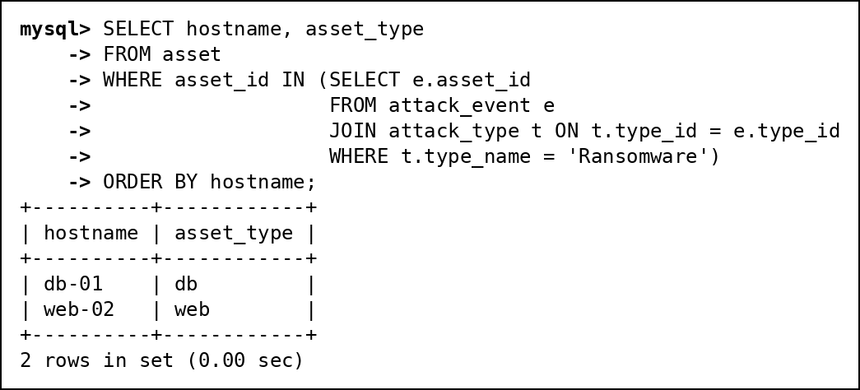
Fig. 47 D3: Multi-row subquery with IN: assets that have been hit by ransomware
D4. Multi-row subquery with ALL: CVEs scoring higher than every CVE on web-02 and mail-01
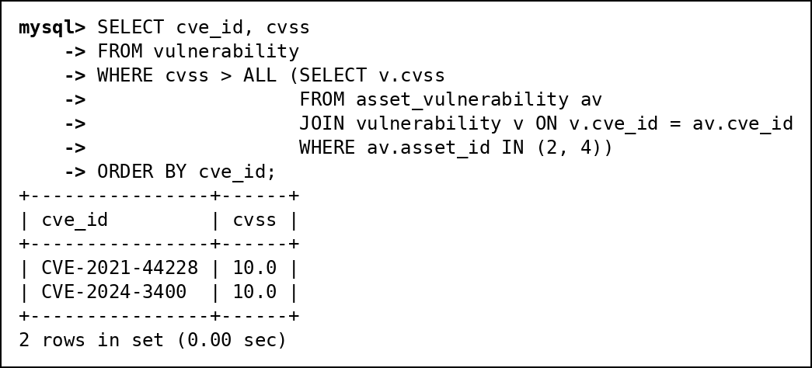
Fig. 48 D4: Multi-row subquery with ALL: CVEs scoring higher than every CVE on web-02 and mail-01
D5. Multi-row subquery with ANY: CVEs scoring higher than at least one CVE used by Russian sources
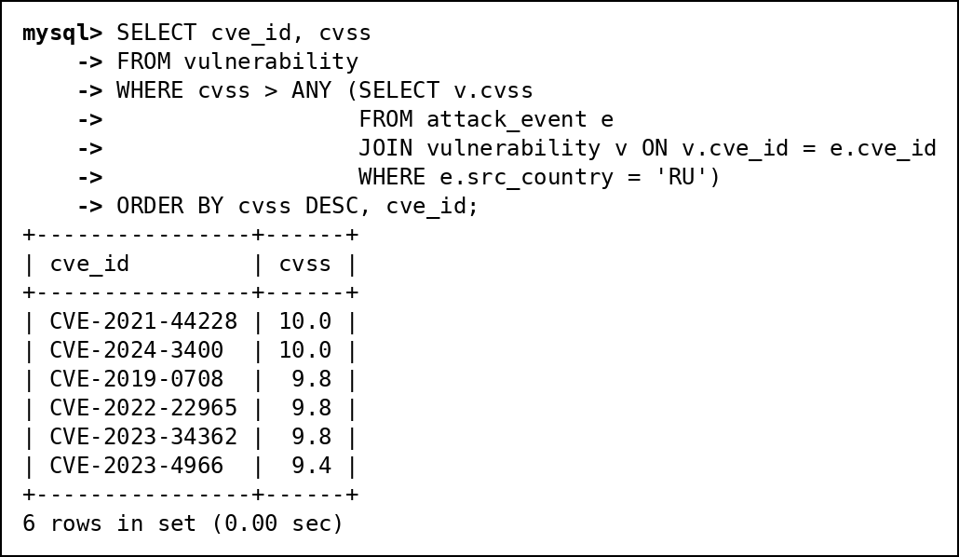
Fig. 49 D5: Multi-row subquery with ANY: CVEs scoring higher than at least one CVE used by Russian sources
D6. Correlated subquery: the worst attack(s) on each asset
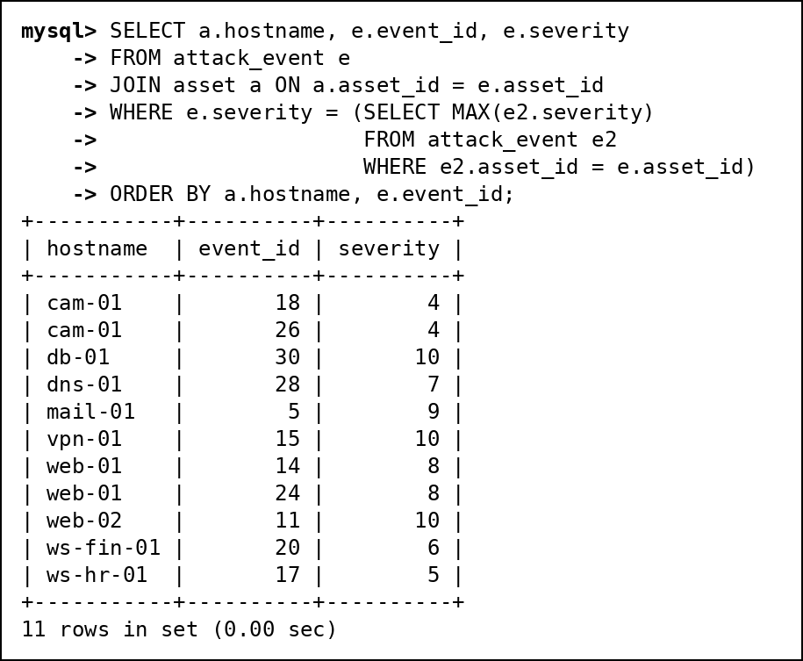
Fig. 50 D6: Correlated subquery: the worst attack(s) on each asset
D7. EXISTS: threat actors with at least one attack that was not blocked
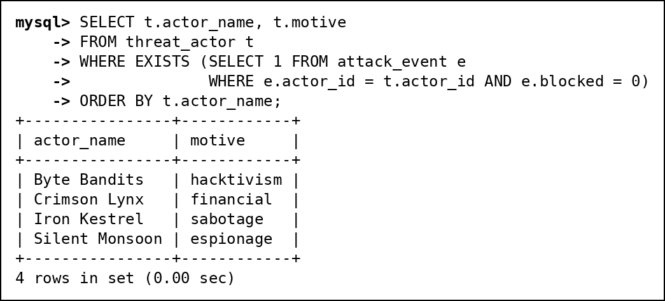
Fig. 51 D7: EXISTS: threat actors with at least one attack that was not blocked
D8. NOT EXISTS: assets that have never been attacked
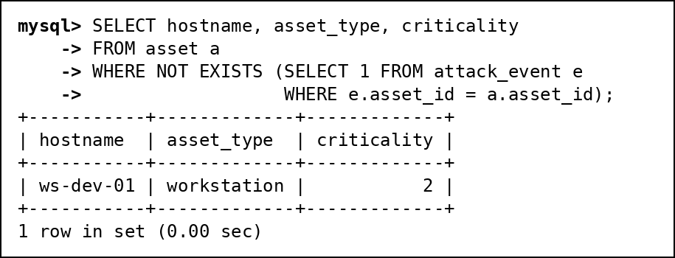
Fig. 52 D8: NOT EXISTS: assets that have never been attacked
D9. NOT IN and the NULL pitfall: threat actors with no malware
The NULL pitfall: malware.actor_id contains a NULL (OrphanMiner). x NOT IN (..., NULL) is never TRUE, so the first query returns no rows at all. Filtering out NULLs in the subquery (or using NOT EXISTS) gives the correct answer, Byte Bandits.
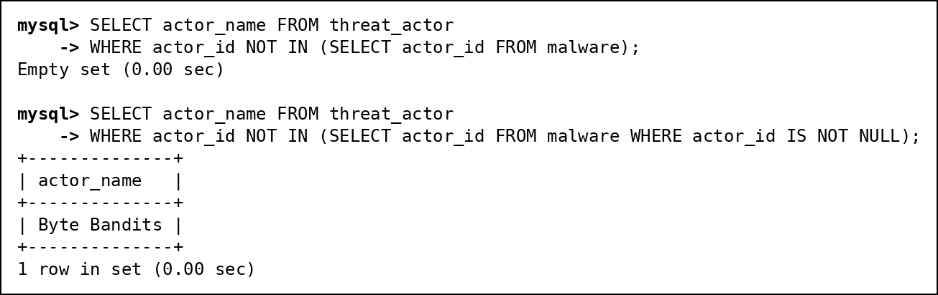
Fig. 53 D9: NOT IN and the NULL pitfall: threat actors with no malware

11.5 E. Set operations
E1. UNION: every country we know about, as an attack source or as an attacker's origin
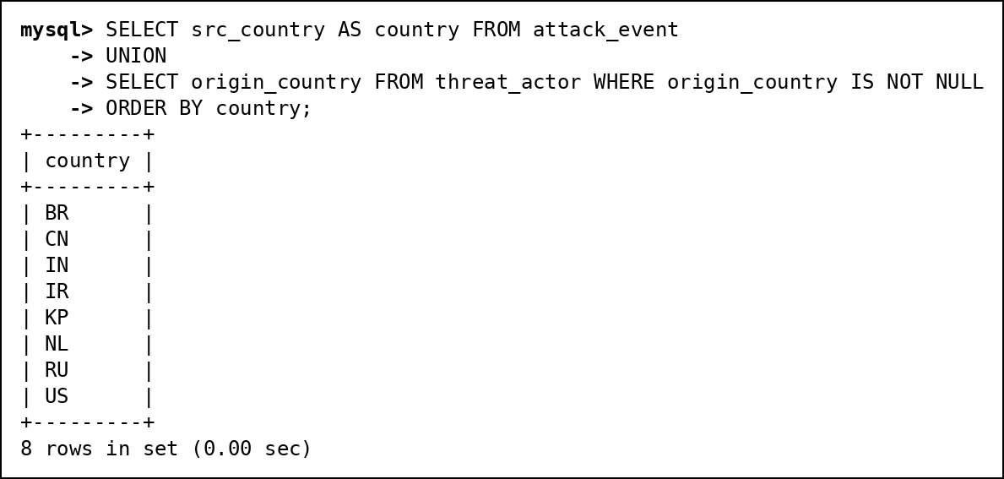
Fig. 54 E1: UNION: every country we know about, as an attack source or as an attacker's origin
E2. UNION ALL: full activity timeline of 198.51.100.45 across attacks and raw logs
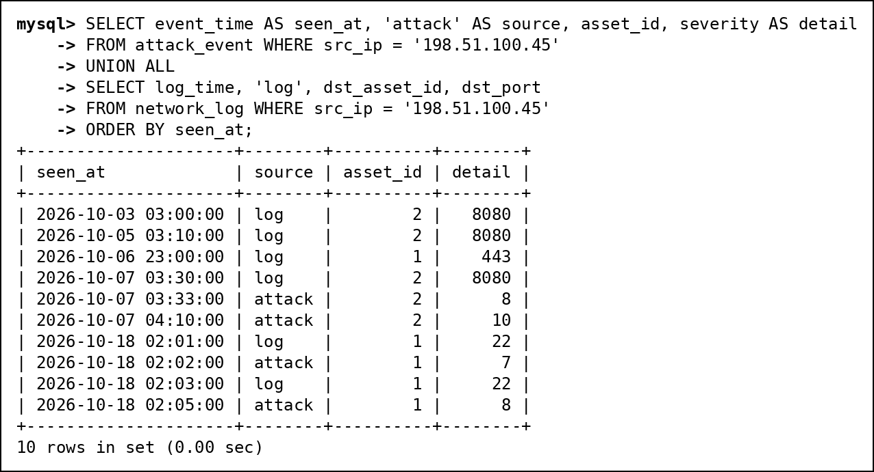
Fig. 55 E2: UNION ALL: full activity timeline of 198.51.100.45 across attacks and raw logs
E3. INTERSECT: attack sources that are also known bad IPs
INTERSECT and EXCEPT are native in MySQL 8.0.31 and later; we ran them on 8.0.46.
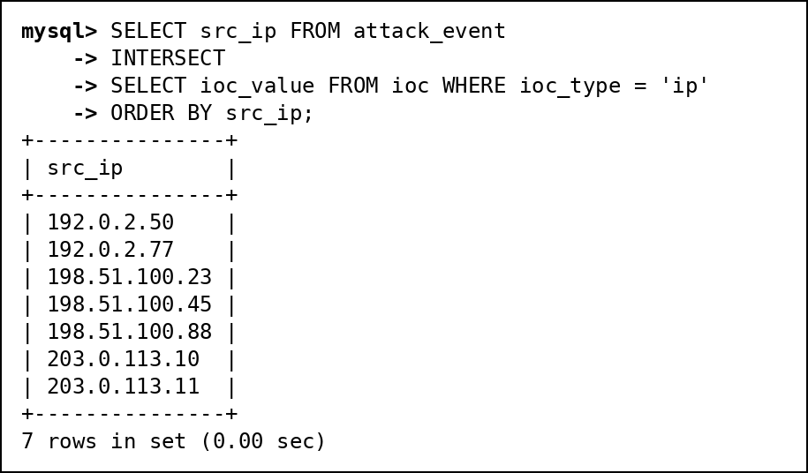
Fig. 56 E3: INTERSECT: attack sources that are also known bad IPs
E4. EXCEPT: attack sources that are not on the indicator list yet
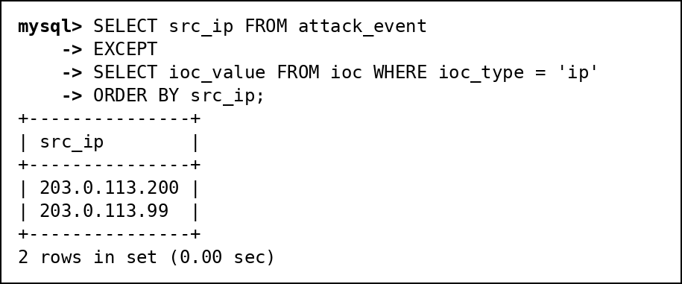
Fig. 57 E4: EXCEPT: attack sources that are not on the indicator list yet

11.6 F. Advanced functions
F1. CASE: severity label from CVSS score
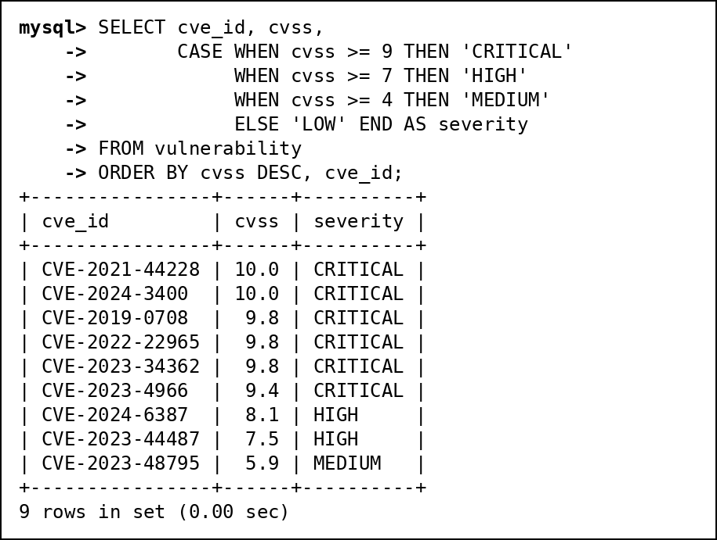
Fig. 58 F1: CASE: severity label from CVSS score
F2. COALESCE: recent attacks with 'Unattributed' instead of a missing actor
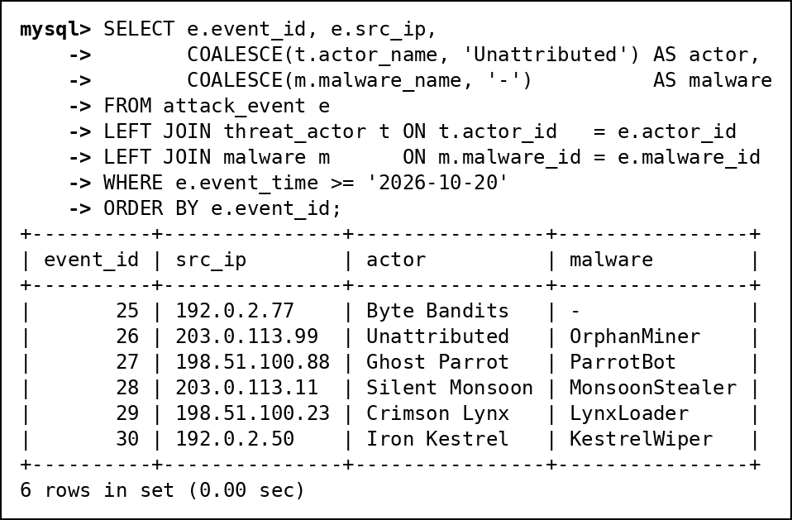
Fig. 59 F2: COALESCE: recent attacks with 'Unattributed' instead of a missing actor
F3. NULLIF: share of blocked attacks per asset without dividing by zero
NULLIF turns a zero count into NULL, so ws-dev-01 (never attacked) shows NULL instead of a division-by-zero.
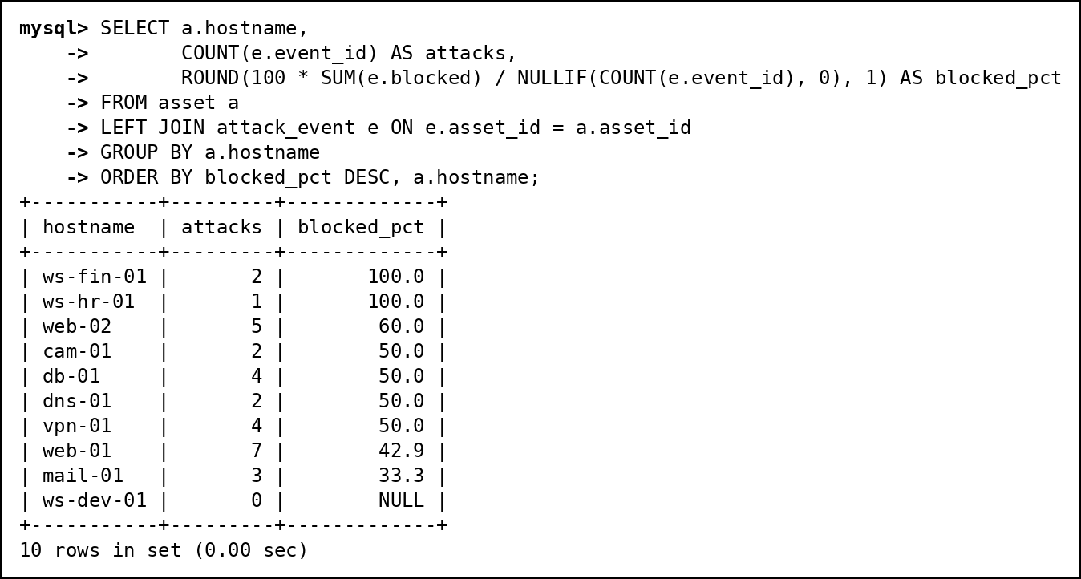
Fig. 60 F3: NULLIF: share of blocked attacks per asset without dividing by zero
F4. Date and time functions: how long each incident has been or was open
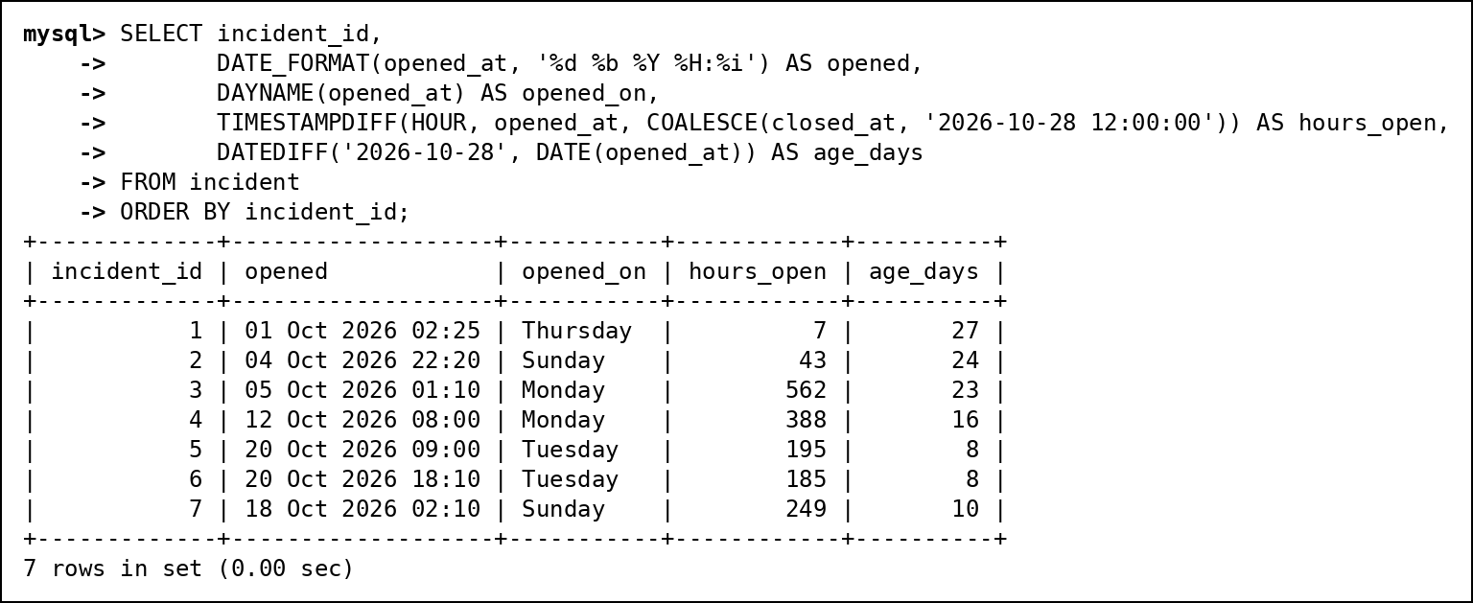
Fig. 61 F4: Date and time functions: how long each incident has been or was open
F5. String functions: analyst user names and short names
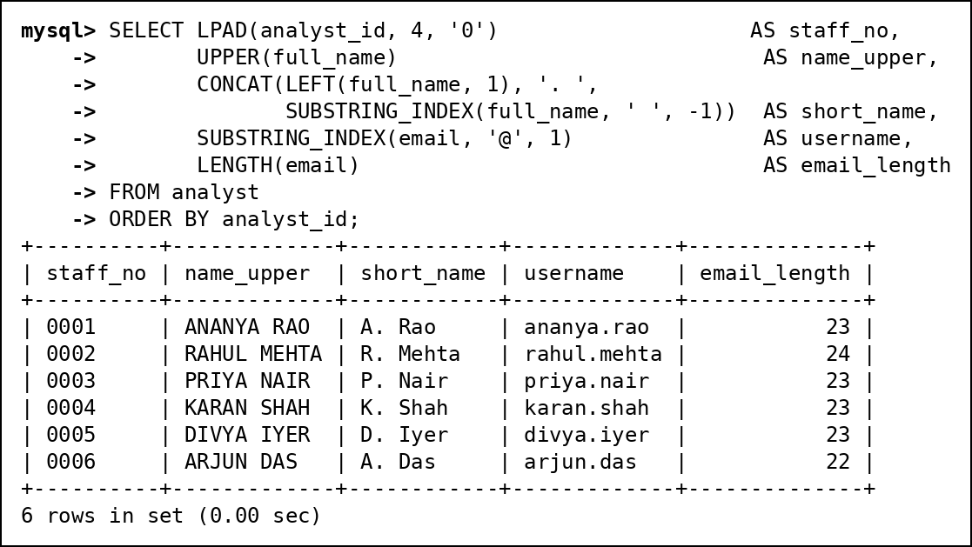
Fig. 62 F5: String functions: analyst user names and short names
F6. Numeric functions on CVSS scores
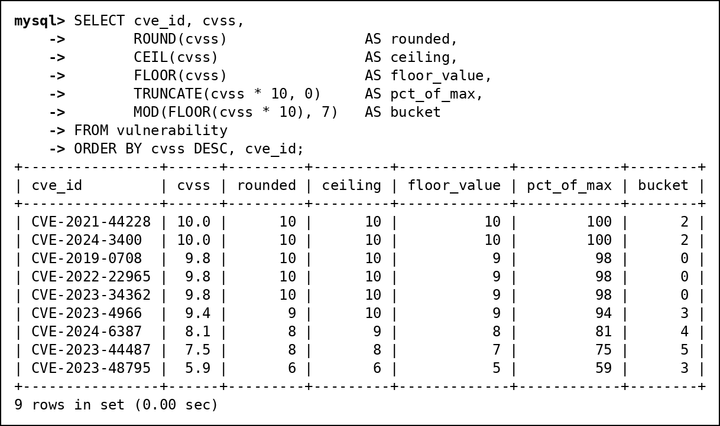
Fig. 63 F6: Numeric functions on CVSS scores

11.7 G. Window functions
G1. RANK, DENSE_RANK and ROW_NUMBER: assets ranked by number of attacks
RANK leaves gaps after ties (3, 3, 5), DENSE_RANK does not (3, 3, 4), and ROW_NUMBER is always unique.
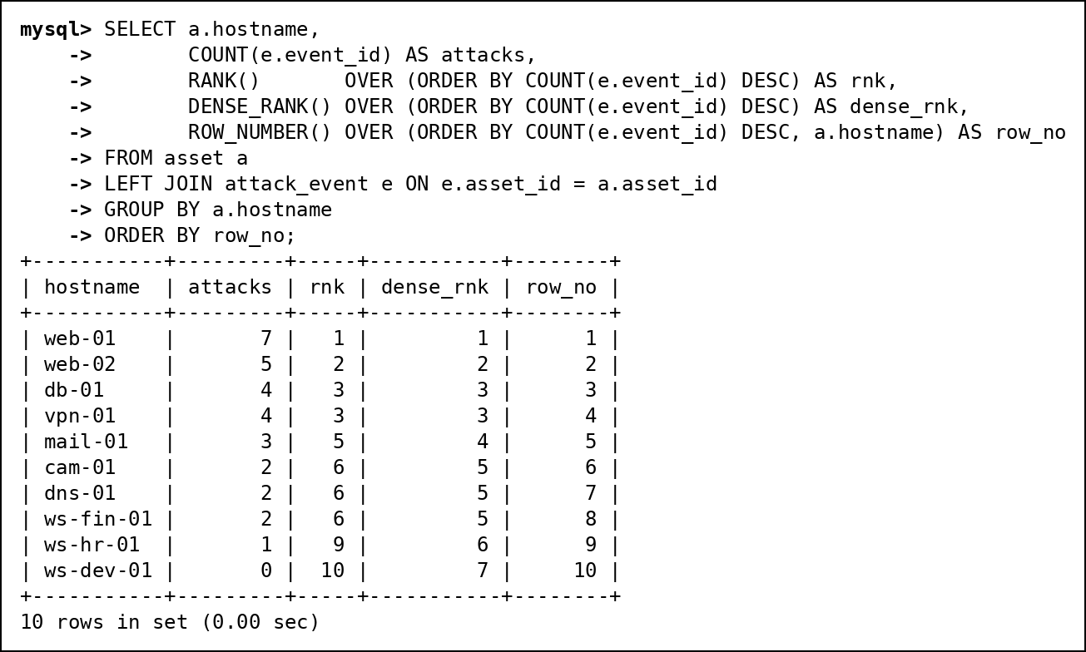
Fig. 64 G1: RANK, DENSE_RANK and ROW_NUMBER: assets ranked by number of attacks
G2. Running total of attacks per day for the first ten days of October
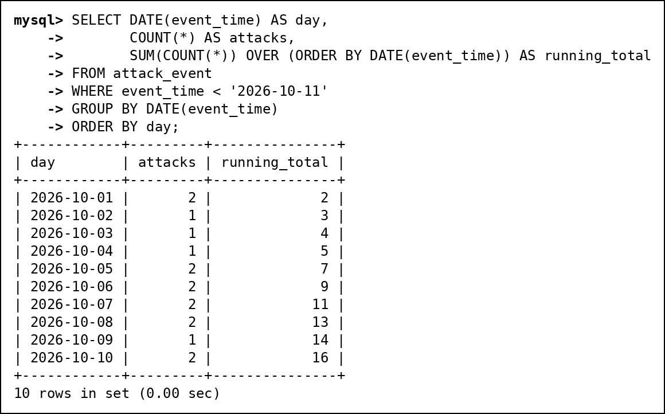
Fig. 65 G2: Running total of attacks per day for the first ten days of October
G3. LAG and LEAD: minutes between attacks from the same Russian source IP
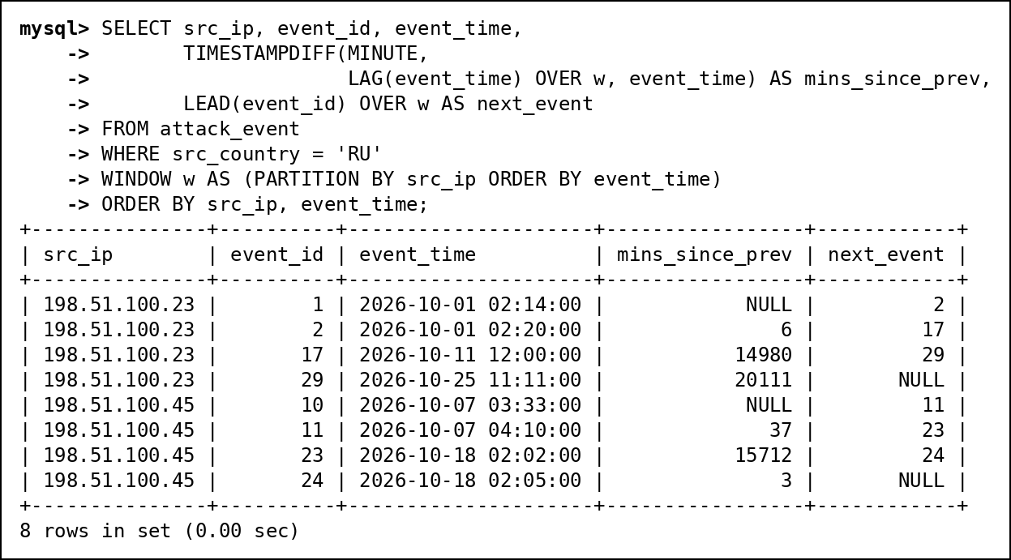
Fig. 66 G3: LAG and LEAD: minutes between attacks from the same Russian source IP

12. Advanced SQL Implementation

12.1 Complex Business Queries
Each query uses at least three tables or a nested or analytic construct. The expected output was worked out by hand from the test data before running; the actual output is the screenshot. All 11 matched.
CQ-01
Field | Content
ID | CQ-01
Business question | Which threat actor is behind the most serious attacks (severity 8+) on our important assets (criticality 4+)?
SQL | SELECT t.actor_name, t.motive,  COUNT(*) AS serious_attacks,  COUNT(DISTINCT e.asset_id) AS assets_hit,  MAX(e.severity) AS worst  FROM attack_event e  JOIN threat_actor t ON t.actor_id = e.actor_id  JOIN asset a ON a.asset_id = e.asset_id  WHERE e.severity >= 8 AND a.criticality >= 4  GROUP BY t.actor_id, t.actor_name, t.motive  ORDER BY serious_attacks DESC, t.actor_name;
Expected output | 4 rows. Crimson Lynx first with 4 serious attacks on 3 assets (events 10, 11, 24, 29); Iron Kestrel 3 on db-01; Silent Monsoon 3 on 2 assets; Byte Bandits 1. Ghost Parrot is absent because its worst attack is severity 7.
Actual output screenshot | Below (Fig. 67)
Explanation | Three tables: attack_event joined to threat_actor (drops unattributed attacks) and to asset. WHERE keeps severity 8+ on criticality 4+ assets before grouping by actor; COUNT(DISTINCT asset_id) counts assets, not attacks.
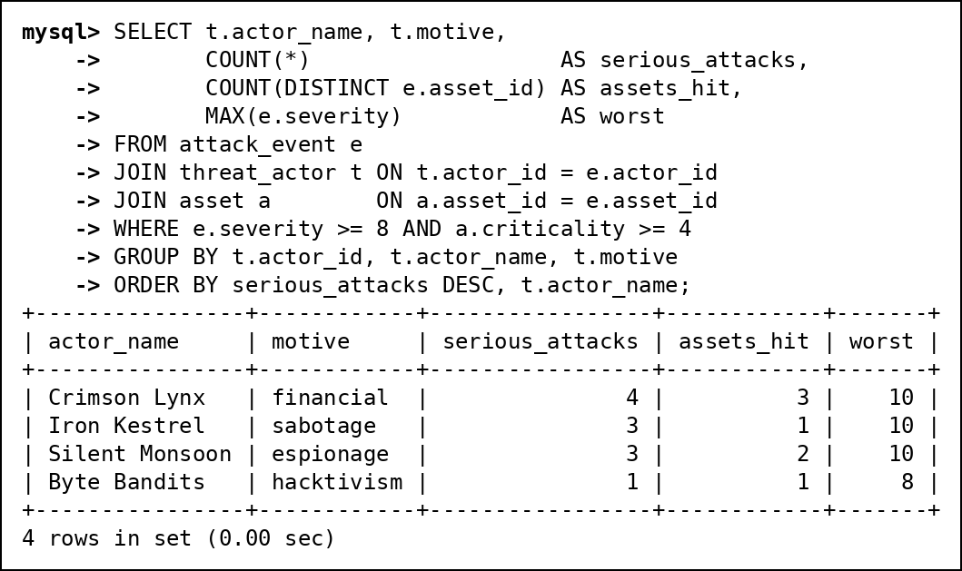
Fig. 67 CQ-01 actual output
CQ-02
Field | Content
ID | CQ-02
Business question | What does the board of incidents that are still not closed look like?
SQL | SELECT i.incident_id, i.priority, i.status,  COALESCE(an.full_name, 'Unassigned') AS owner,  COUNT(*) AS attacks,  MAX(e.severity) AS worst,  GROUP_CONCAT(DISTINCT a.hostname ORDER BY a.hostname) AS assets  FROM incident i  JOIN incident_event ie ON ie.incident_id = i.incident_id  JOIN attack_event e ON e.event_id = ie.event_id  JOIN asset a ON a.asset_id = e.asset_id  LEFT JOIN analyst an ON an.analyst_id = i.assigned_to  WHERE i.status <> 'CLOSED'  GROUP BY i.incident_id, i.priority, i.status, an.full_name  ORDER BY FIELD(i.priority, 'CRITICAL', 'HIGH', 'MEDIUM', 'LOW'), i.incident_id;
Expected output | 5 incidents (all except the closed 1 and 2): 4 and 5 CRITICAL, 3 and 7 HIGH, 6 MEDIUM. Incident 5 has no owner; incident 6 covers web-01 and web-02 with 5 attacks.
Actual output screenshot | Below (Fig. 68)
Explanation | Five tables. incident to incident_event to attack_event to asset gives the attacks and hosts; LEFT JOIN analyst keeps the unassigned incident and COALESCE prints "Unassigned". FIELD() sorts by priority order instead of alphabetically.
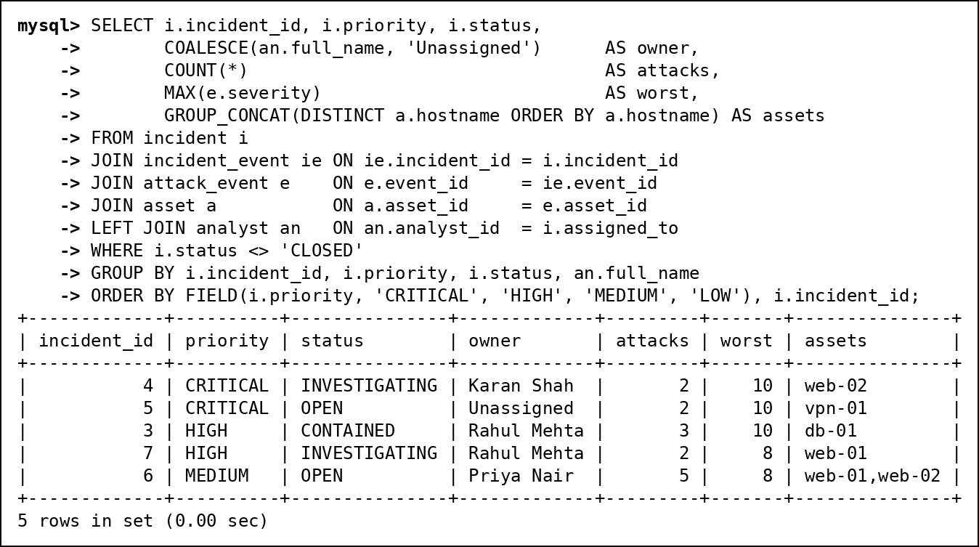
Fig. 68 CQ-02 actual output
CQ-03
Field | Content
ID | CQ-03
Business question | Which assets were attacked through a CVE they still have not patched?
SQL | SELECT a.hostname, e.event_id, e.cve_id, v.cvss, av.detected_at,  DATEDIFF('2026-10-28', av.detected_at) AS days_unpatched  FROM attack_event e  JOIN asset_vulnerability av ON av.asset_id = e.asset_id  AND av.cve_id = e.cve_id  AND av.patched_at IS NULL  JOIN vulnerability v ON v.cve_id = e.cve_id  JOIN asset a ON a.asset_id = e.asset_id  ORDER BY v.cvss DESC, a.hostname;
Expected output | 5 rows: vpn-01 (CVE-2024-3400), web-02, mail-01, web-01, dns-01. db-01 (MOVEit) and vpn-01 (regreSSHion) must not appear because they were patched before the attack.
Actual output screenshot | Below (Fig. 69)
Explanation | The join to asset_vulnerability uses both asset_id and cve_id plus patched_at IS NULL in the ON clause, so an attack only matches if that exact asset still had that exact CVE open. DATEDIFF gives days since detection.
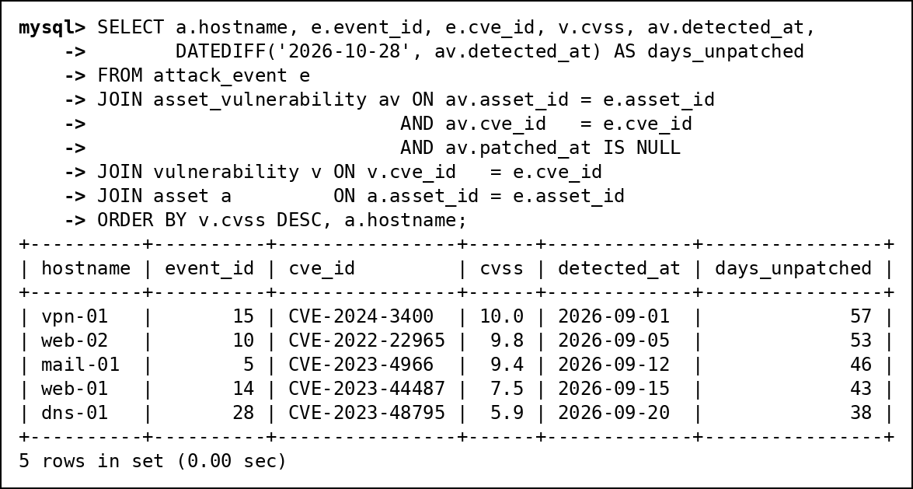
Fig. 69 CQ-03 actual output
CQ-04
Field | Content
ID | CQ-04
Business question | Which malware families cause the most attacks, and who uses them?
SQL | SELECT m.family,  COUNT(*) AS attacks,  GROUP_CONCAT(DISTINCT COALESCE(t.actor_name, 'Unknown')) AS used_by,  ROUND(100 * COUNT(*) / (SELECT COUNT(*) FROM attack_event  WHERE malware_id IS NOT NULL), 1) AS pct_of_malware_attacks  FROM attack_event e  JOIN malware m ON m.malware_id = e.malware_id  LEFT JOIN threat_actor t ON t.actor_id = m.actor_id  GROUP BY m.family  ORDER BY attacks DESC, m.family;
Expected output | 7 families. Botnet (ParrotBot) leads with 4 of the 18 malware attacks, about 22%. Miner is "Unknown" because OrphanMiner has no actor.
Actual output screenshot | Below (Fig. 70)
Explanation | attack_event, malware and threat_actor (LEFT JOIN keeps the actor-less malware). The scalar subquery in the SELECT gives the denominator, the count of attacks that carried any malware.
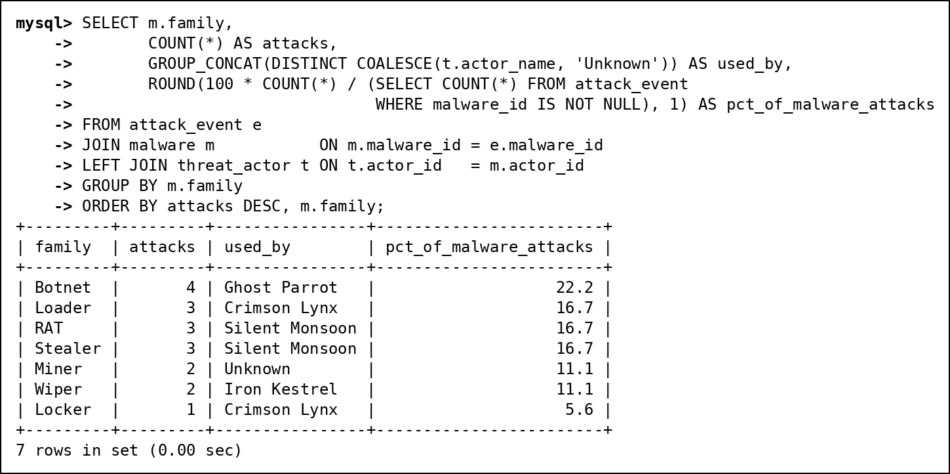
Fig. 70 CQ-04 actual output
CQ-05
Field | Content
ID | CQ-05
Business question | Time machine: how many attacks matched an indicator we already knew about at the time, and how late were we for the rest?
SQL | SELECT CASE WHEN i.recorded_from <= e.event_time THEN 'known at attack time'  ELSE 'recognised later' END AS knowledge,  COUNT(*) AS matches,  COUNT(DISTINCT e.event_id) AS attacks,  ROUND(AVG(CASE WHEN i.recorded_from > e.event_time  THEN TIMESTAMPDIFF(HOUR, e.event_time, i.recorded_from) / 24  END), 1) AS avg_days_late  FROM attack_event e  JOIN event_ioc ei ON ei.event_id = e.event_id  JOIN ioc i ON i.ioc_version_id = ei.ioc_version_id  GROUP BY knowledge  ORDER BY knowledge;
Expected output | 27 attack-indicator matches: 18 known at attack time (17 attacks) and 9 recognised later (8 attacks), on average about 5 days late.
Actual output screenshot | Below (Fig. 71)
Explanation | Joins attack_event to event_ioc to ioc and compares recorded_from (when we learned) with event_time. The CASE in AVG returns NULL for "known" rows so only late rows are averaged. Hours / 24 keeps fractions of a day.
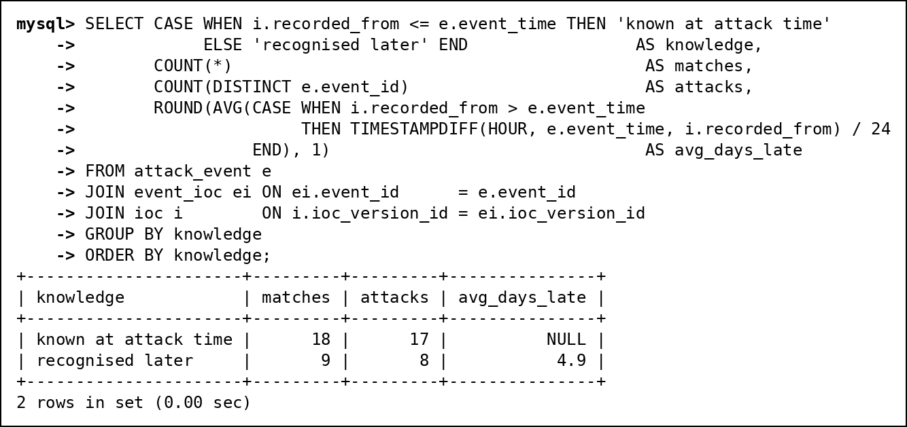
Fig. 71 CQ-05 actual output
CQ-06
Field | Content
ID | CQ-06
Business question | What did each retro-hunt find, and what happened to the incident it opened?
SQL | SELECT r.run_id, i.ioc_value, r.started_at,  COUNT(h.log_id) AS logs_matched,  COUNT(DISTINCT l.dst_asset_id) AS assets_touched,  MIN(l.log_time) AS first_contact,  inc.status AS incident_status  FROM retro_hunt_run r  JOIN ioc i ON i.ioc_version_id = r.ioc_version_id  LEFT JOIN retro_hit h ON h.run_id = r.run_id  LEFT JOIN network_log l ON l.log_id = h.log_id  LEFT JOIN incident inc ON inc.incident_id = r.incident_id  GROUP BY r.run_id, i.ioc_value, r.started_at, inc.status  ORDER BY r.run_id;
Expected output | 2 runs. Run 1 (198.51.100.45) found 4 old log lines on 2 assets, incident INVESTIGATING; run 2 (203.0.113.11) found 4 lines on 2 assets, incident OPEN.
Actual output screenshot | Below (Fig. 72)
Explanation | Five tables. LEFT JOINs to retro_hit and network_log keep runs with zero hits; COUNT(h.log_id) counts hits and COUNT(DISTINCT dst_asset_id) counts assets. This is the same logic as v_retro_hunt_summary.
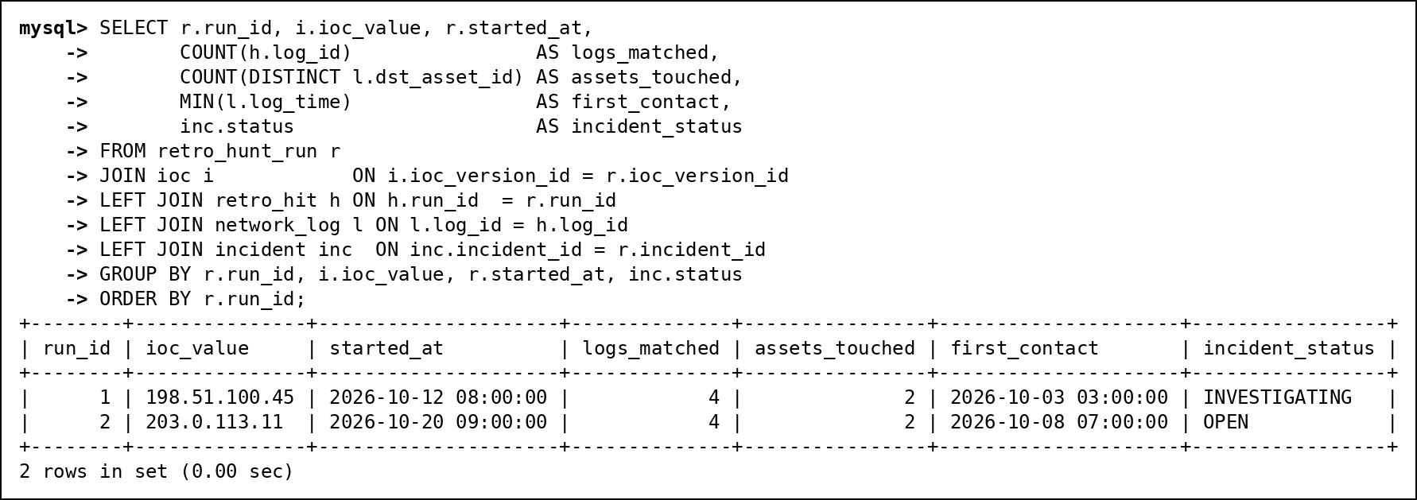
Fig. 72 CQ-06 actual output
CQ-07
Field | Content
ID | CQ-07
Business question | What is the response playbook for the attack type that hits web-01 most often?
SQL | SELECT t.type_name, m.step_no, m.action  FROM mitigation m  JOIN attack_type t ON t.type_id = m.type_id  WHERE m.type_id = (SELECT e.type_id  FROM attack_event e  JOIN asset a ON a.asset_id = e.asset_id  WHERE a.hostname = 'web-01'  GROUP BY e.type_id  ORDER BY COUNT(*) DESC  LIMIT 1)  ORDER BY m.step_no;
Expected output | Brute Force (4 of web-01's 7 attacks), with its 3 steps: block the IP, lock the accounts, enforce MFA.
Actual output screenshot | Below (Fig. 73)
Explanation | Nested: the subquery groups web-01's attacks by type, orders by count and keeps the top type; the outer query joins mitigation to attack_type for that type.
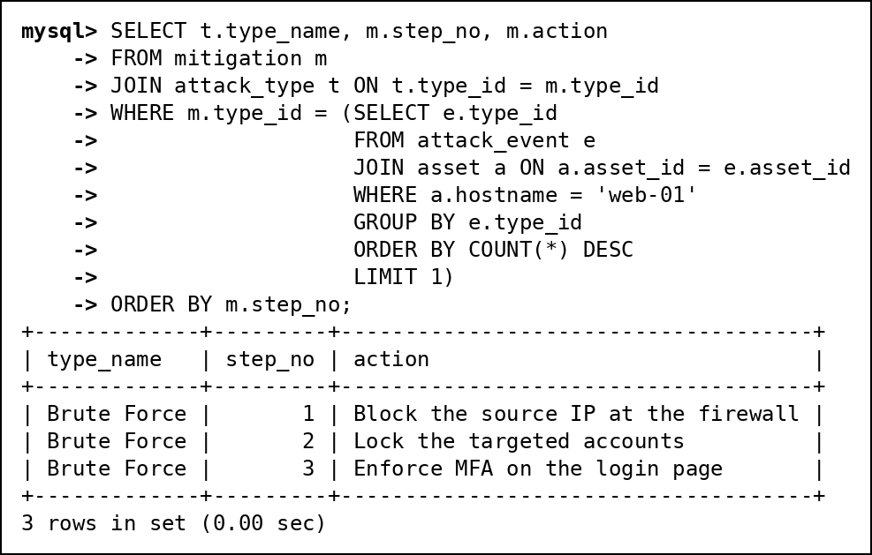
Fig. 73 CQ-07 actual output
CQ-08
Field | Content
ID | CQ-08
Business question | How is the open-incident workload spread across analysts?
SQL | SELECT an.full_name,  COUNT(i.incident_id) AS open_incidents,  COALESCE(SUM(i.priority = 'CRITICAL'), 0) AS critical,  RANK() OVER (ORDER BY COUNT(i.incident_id) DESC) AS workload_rank  FROM analyst an  LEFT JOIN incident i ON i.assigned_to = an.analyst_id  AND i.status <> 'CLOSED'  WHERE an.role = 'analyst'  GROUP BY an.analyst_id, an.full_name  ORDER BY workload_rank, an.full_name;
Expected output | Rahul 2 open incidents (rank 1), Karan and Priya 1 each (rank 2, Karan's is critical), Arjun 0 (rank 4, because RANK skips after the tie).
Actual output screenshot | Below (Fig. 74)
Explanation | Analytic: LEFT JOIN with status <> CLOSED inside the ON clause keeps Arjun with zero. SUM(priority = 'CRITICAL') counts TRUE as 1. RANK() runs after GROUP BY.
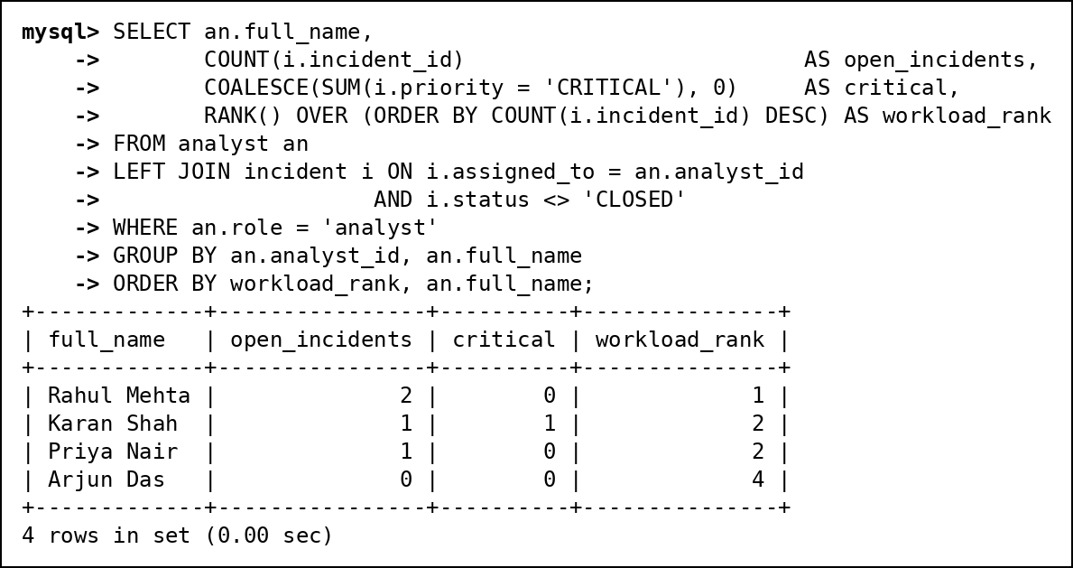
Fig. 74 CQ-08 actual output
CQ-09
Field | Content
ID | CQ-09
Business question | Which countries do attacks come from, what share does each have, and what is each country's most common attack type?
SQL | SELECT c.src_country, c.attacks,  ROUND(100 * c.attacks / SUM(c.attacks) OVER (), 1) AS pct,  (SELECT t.type_name  FROM attack_event e2  JOIN attack_type t ON t.type_id = e2.type_id  WHERE e2.src_country = c.src_country  GROUP BY t.type_name  ORDER BY COUNT(*) DESC, t.type_name  LIMIT 1) AS top_type  FROM (SELECT src_country, COUNT(*) AS attacks  FROM attack_event  GROUP BY src_country) AS c  ORDER BY c.attacks DESC, c.src_country;
Expected output | 7 countries. RU 8 (26.7%), CN 6 (20.0%), BR/KP/US 4 each (13.3%), IN/NL 2 each (6.7%). RU's top type is Brute Force; KP has a 4-way tie, broken alphabetically to Credential Dumping.
Actual output screenshot | Below (Fig. 75)
Explanation | A derived table counts per country; SUM(...) OVER () gives the total for the percentage without a second query. A correlated subquery finds each country's most common type.
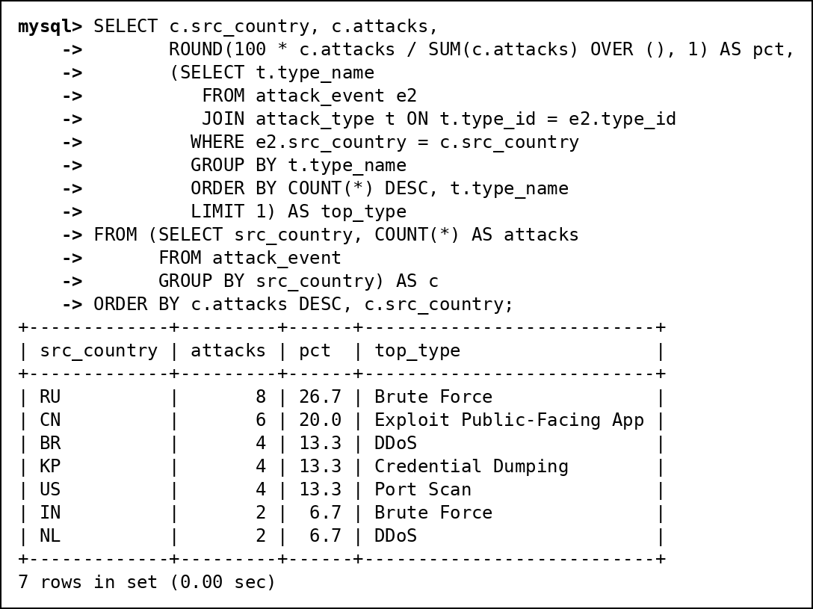
Fig. 75 CQ-09 actual output
CQ-10
Field | Content
ID | CQ-10
Business question | Which assets with an unpatched critical CVE (CVSS 9+) have been attacked by an espionage group?
SQL | SELECT DISTINCT a.hostname, av.cve_id, v.cvss, t.actor_name  FROM asset_vulnerability av  JOIN vulnerability v ON v.cve_id = av.cve_id  JOIN asset a ON a.asset_id = av.asset_id  JOIN attack_event e ON e.asset_id = av.asset_id  JOIN threat_actor t ON t.actor_id = e.actor_id  WHERE av.patched_at IS NULL  AND v.cvss >= 9  AND t.motive = 'espionage'  ORDER BY v.cvss DESC, a.hostname;
Expected output | 2 rows: vpn-01 with CVE-2024-3400 (10.0) and mail-01 with CVE-2023-4966 (9.4), both attacked by Silent Monsoon.
Actual output screenshot | Below (Fig. 76)
Explanation | Five tables. Starts from unpatched exposures with CVSS 9+, then joins attacks on the same asset by espionage groups. DISTINCT removes duplicates when a group attacked the asset more than once.
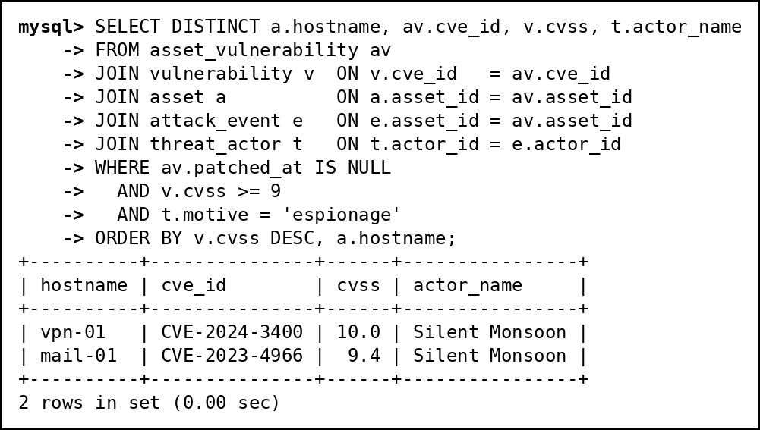
Fig. 76 CQ-10 actual output
CQ-11
Field | Content
ID | CQ-11
Business question | Which source IPs launched a follow-up attack within one hour (attack bursts)?
SQL | SELECT src_ip, prev_event, event_id, gap_minutes, hostname  FROM (SELECT e.src_ip, e.event_id, a.hostname,  LAG(e.event_id) OVER w AS prev_event,  TIMESTAMPDIFF(MINUTE, LAG(e.event_time) OVER w, e.event_time) AS gap_minutes  FROM attack_event e  JOIN asset a ON a.asset_id = e.asset_id  WINDOW w AS (PARTITION BY e.src_ip ORDER BY e.event_time)) AS x  WHERE gap_minutes <= 60  ORDER BY gap_minutes, src_ip;
Expected output | 7 bursts. The fastest is 2 minutes (203.0.113.200 scanning two hosts), the slowest within the hour is 45 minutes (192.0.2.50 on db-01).
Actual output screenshot | Below (Fig. 77)
Explanation | LAG over a window partitioned by source IP gives each attack's previous attack from the same IP; the outer query keeps gaps of 60 minutes or less. The filter needs a derived table because window results cannot be used in WHERE.
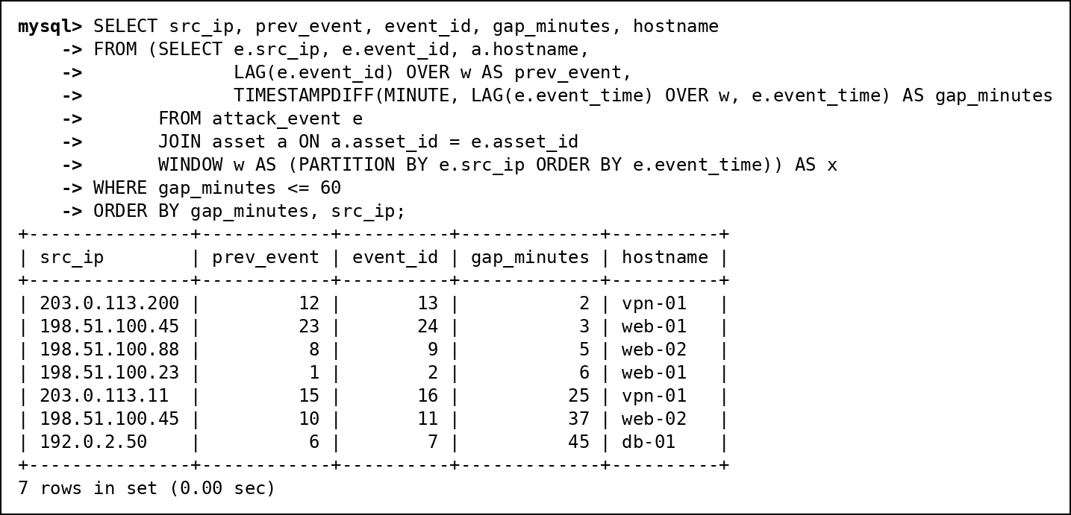
Fig. 77 CQ-11 actual output

12.2 Views
Three new views, plus the two Review 1 views (v_vulnerability for CVE severity and v_retro_hunt_summary for retro-hunt counts) that replaced stored columns.
v_attack_details (joins 5 tables)
Field | Content
Purpose | One flat row per attack with host, type, actor and malware names, so the dashboard and search pages need no joins.
CREATE VIEW statement, query using the view and screenshot | Fig. 78 below
Why useful | Abstraction and simplification: pages query one object. Not updatable: information_schema reports IS_UPDATABLE = NO because it uses outer joins, and the DELETE in the screenshot is refused (ERROR 1288). We only grant SELECT on it.
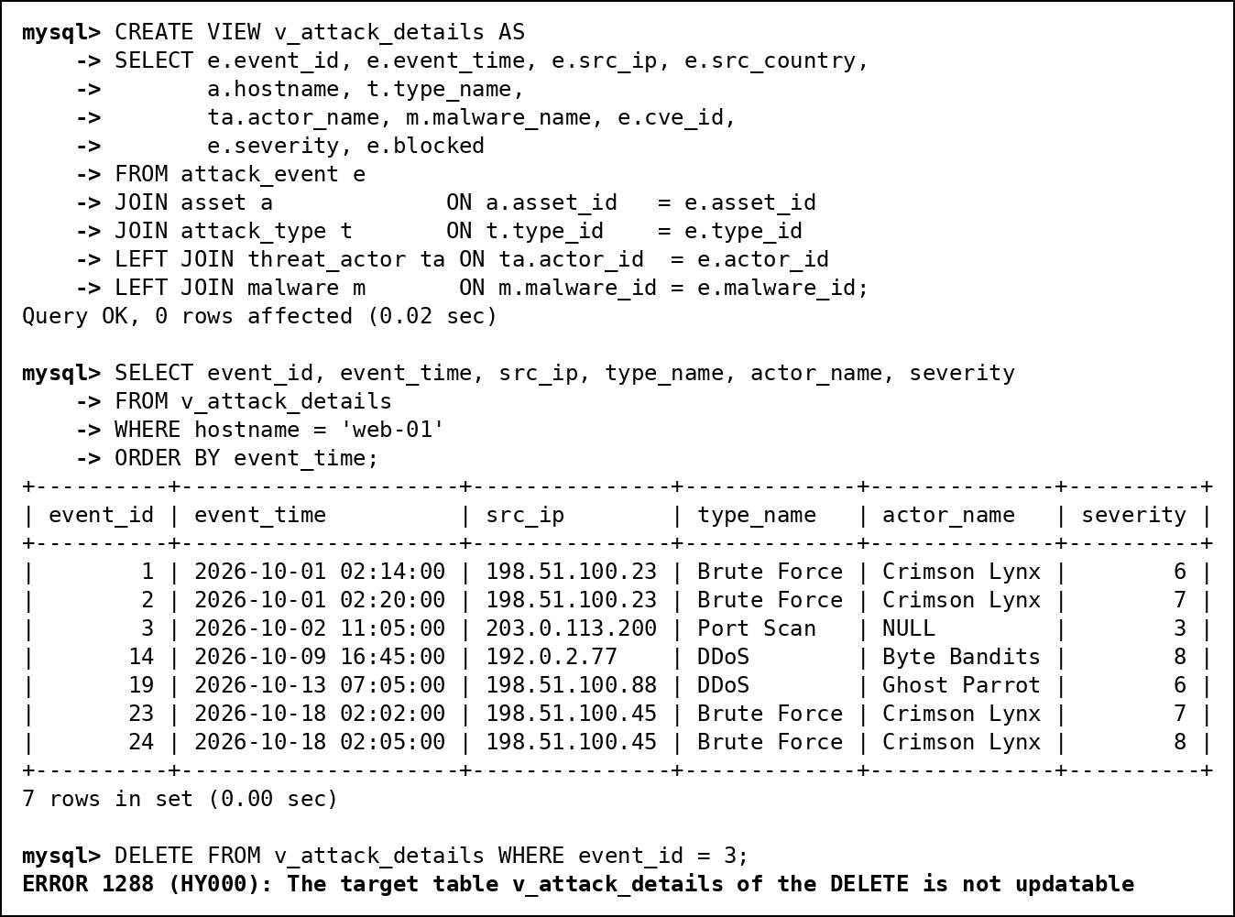
Fig. 78 v_attack_details: CREATE VIEW, query using it, and update test
v_asset_risk (aggregated)
Field | Content
Purpose | Per asset: attacks, attacks not blocked, worst severity and open vulnerabilities, for the risk panel.
CREATE VIEW statement, query using the view and screenshot | Fig. 79 below
Why useful | Simplification: the aggregation is written once. Not updatable because of GROUP BY and COUNT/SUM; MySQL refuses the UPDATE (ERROR 1288). The viewer role can read it without any access to the base tables.
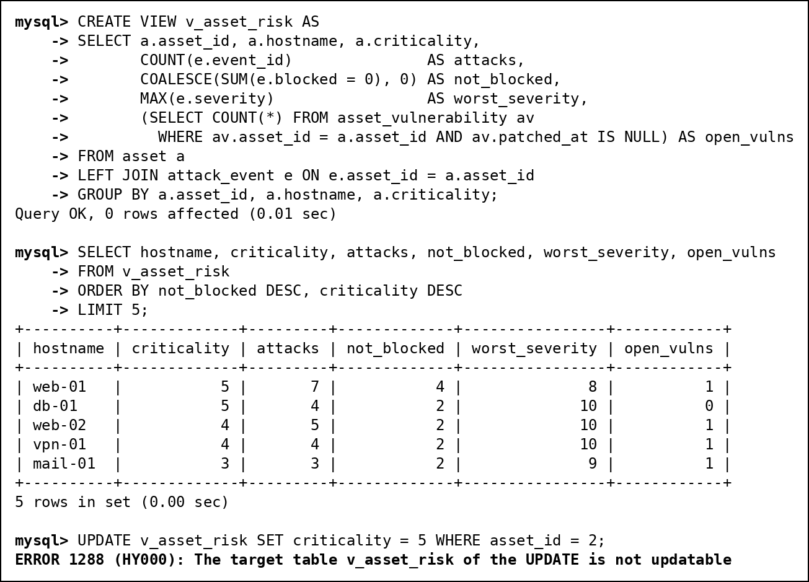
Fig. 79 v_asset_risk: CREATE VIEW, query using it, and update test
v_my_incidents (security, row-restricting)
Field | Content
Purpose | Shows each analyst only the incidents assigned to them, by matching the MySQL login (USER()) to the analyst's email.
CREATE VIEW statement, query using the view and screenshot | Fig. 80 below
Why useful | Security: analysts have no privilege on the incident table, only on this view. Updatable (IS_UPDATABLE = YES): it reads one table with no aggregation or join. WITH CHECK OPTION blocks changes that would move a row out of the view, such as reassigning an incident to someone else (section 12.7). As root it shows 0 rows, because root is not an analyst.
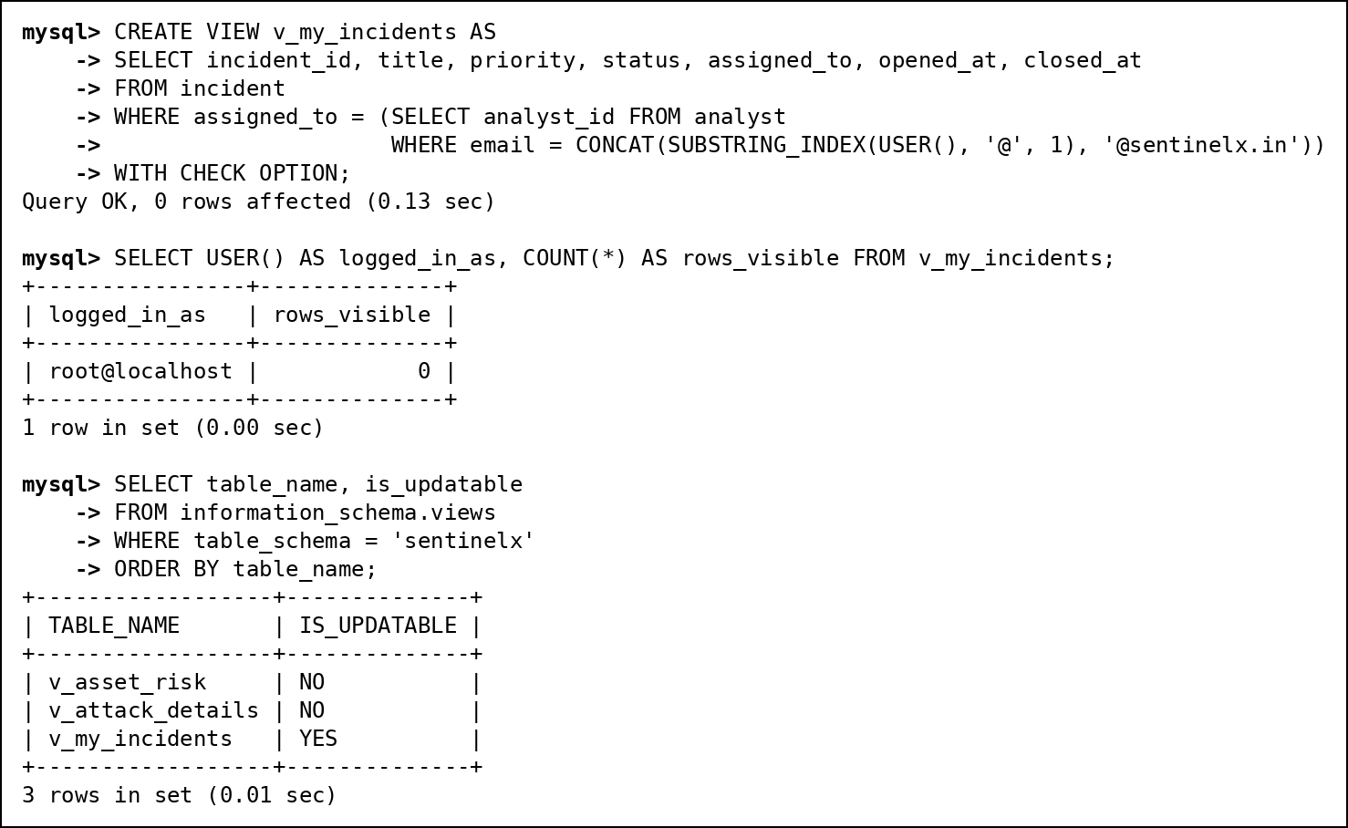
Fig. 80 v_my_incidents: CREATE VIEW, query using it, and update test
Review 1 views
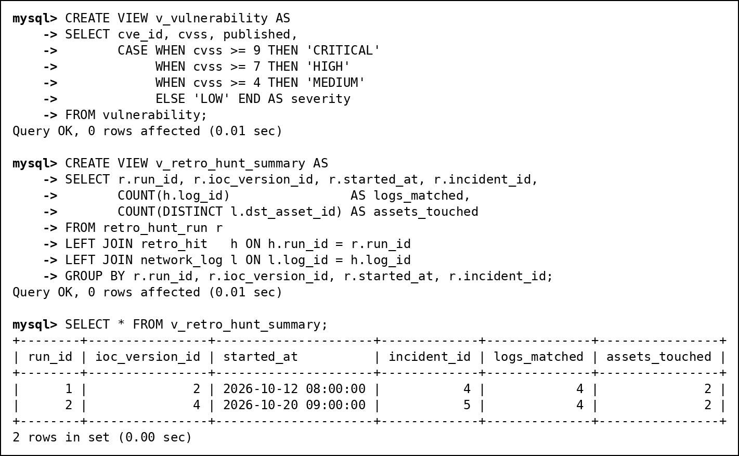
Fig. 81 v_vulnerability and v_retro_hunt_summary

12.3 Stored Procedures
sp_assign_incident(incident, analyst) assigns an incident inside a transaction. It locks the incident row with SELECT ... FOR UPDATE, so two analysts cannot claim it at the same moment, and rejects closed incidents and viewer accounts with SIGNAL. Any error rolls the transaction back and is passed to the caller (RESIGNAL).
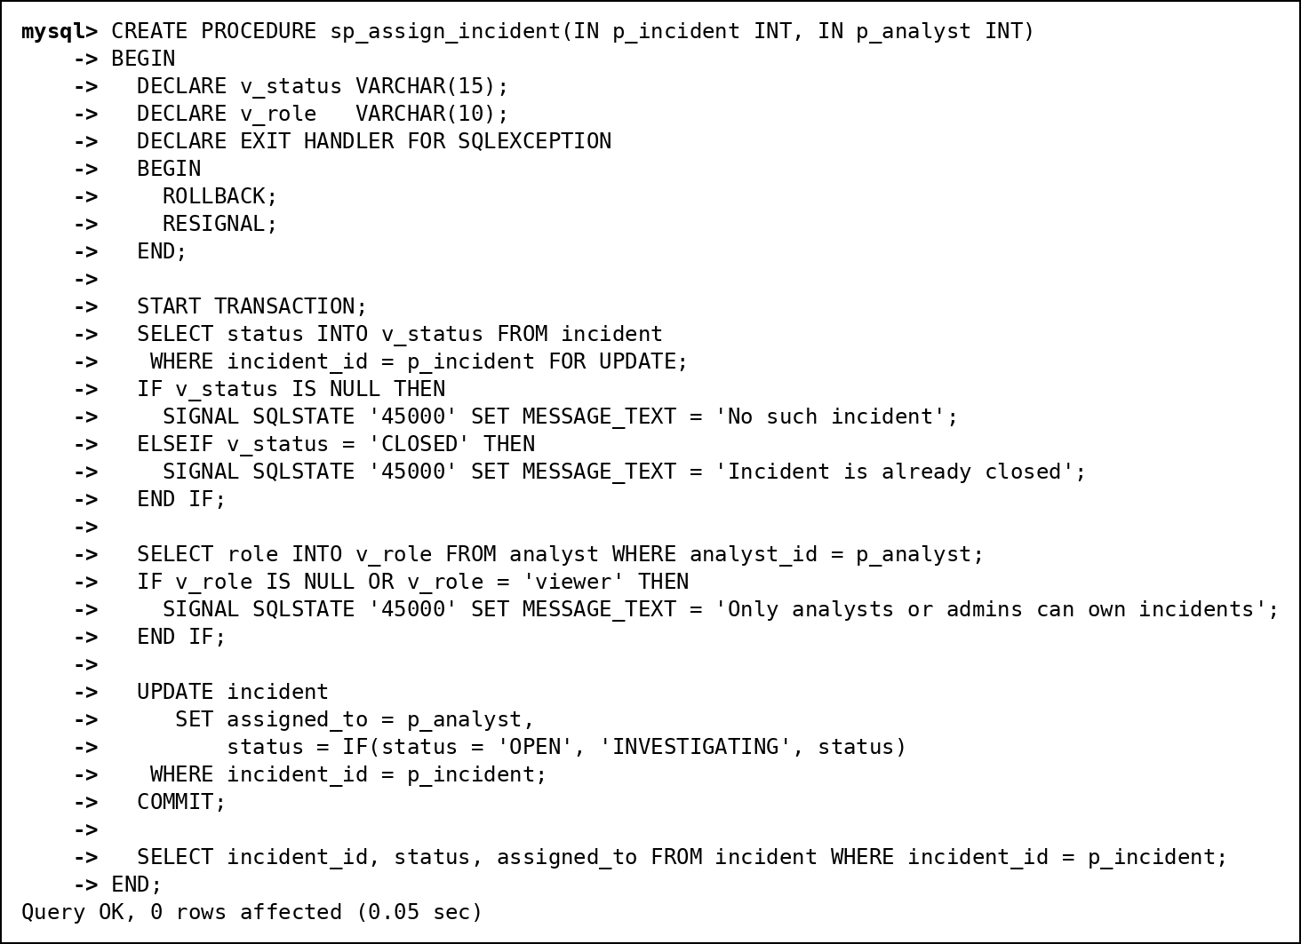
Fig. 82 sp_assign_incident: definition, then one successful and two rejected calls (1 of 2)
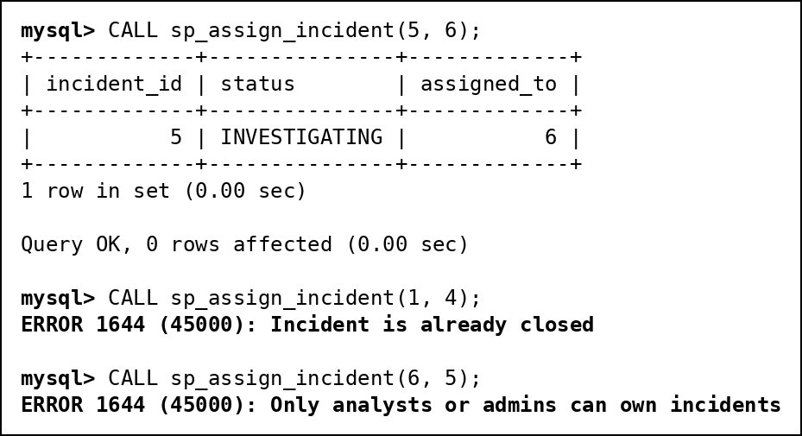
Fig. 83 sp_assign_incident: definition, then one successful and two rejected calls (2 of 2)
sp_attack_report(from, to) returns the attack summary by type for a date range. The viewer role gets EXECUTE on it instead of access to the attack table.
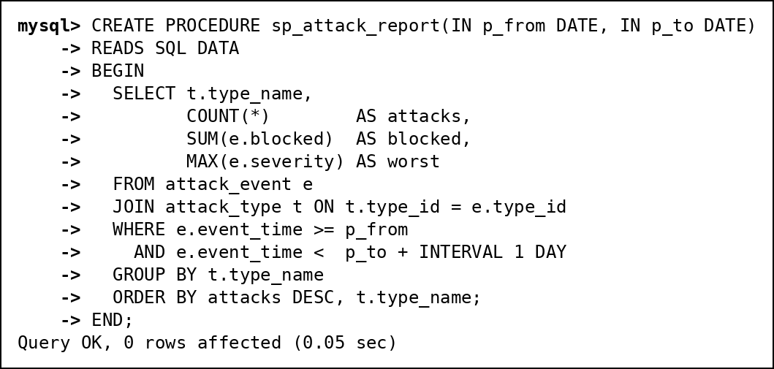
Fig. 84 sp_attack_report: definition and call (1 of 2)
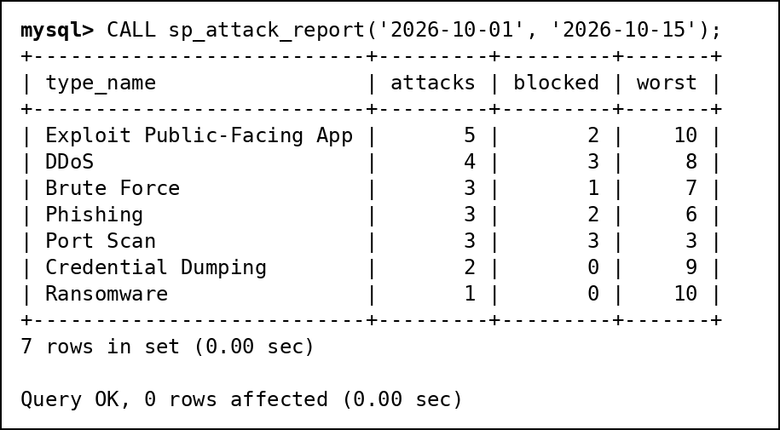
Fig. 85 sp_attack_report: definition and call (2 of 2)

12.4 User-Defined Functions
fn_severity_label(cvss) is DETERMINISTIC and turns a CVSS score into LOW, MEDIUM, HIGH or CRITICAL. fn_asset_risk(asset_id) reads three tables and returns criticality x 10 + open vulnerabilities x 5 + attacks not blocked x 2.
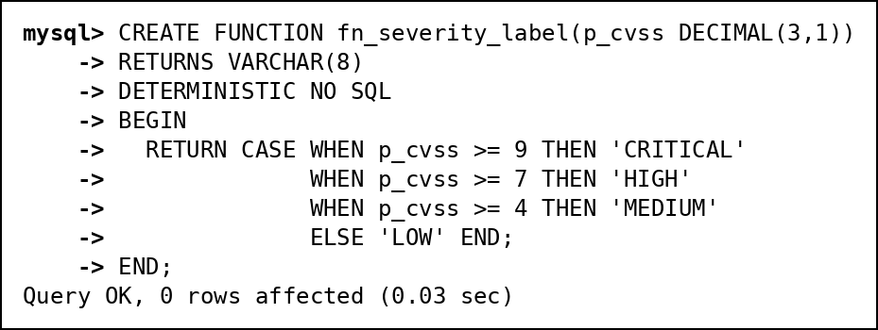
Fig. 86 fn_severity_label: definition and use (1 of 2)
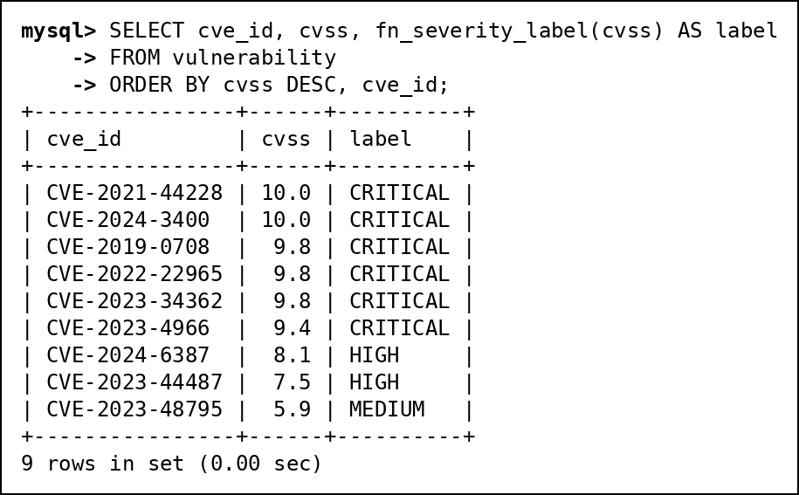
Fig. 87 fn_severity_label: definition and use (2 of 2)
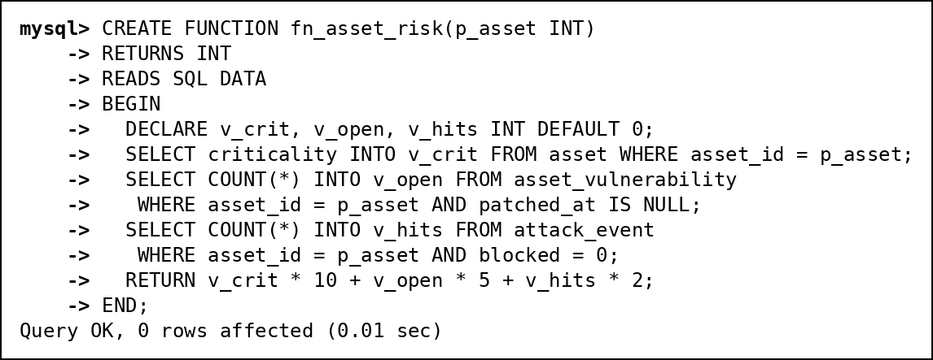
Fig. 88 fn_asset_risk: definition and top 5 assets by risk (1 of 2)
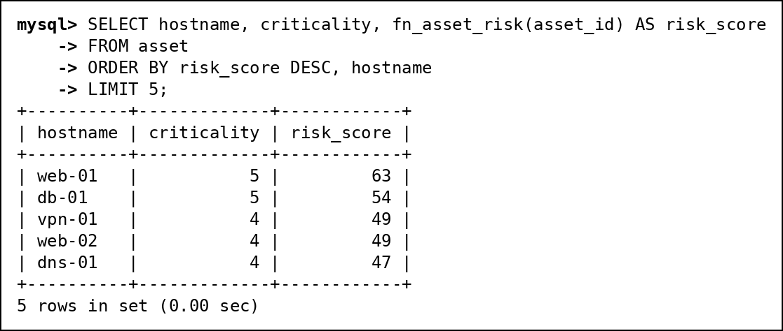
Fig. 89 fn_asset_risk: definition and top 5 assets by risk (2 of 2)

12.5 Triggers
trg_attack_auto_incident (AFTER INSERT on attack_event) opens an incident for any attack of severity 8 or more. If the same asset already has an open incident for the same attack type from the last hour, the attack joins it instead. In the demo three attacks are inserted: the first (severity 9) opens incident 8, the second (severity 8, twenty minutes later) is added to it, and the third (severity 3) is ignored.
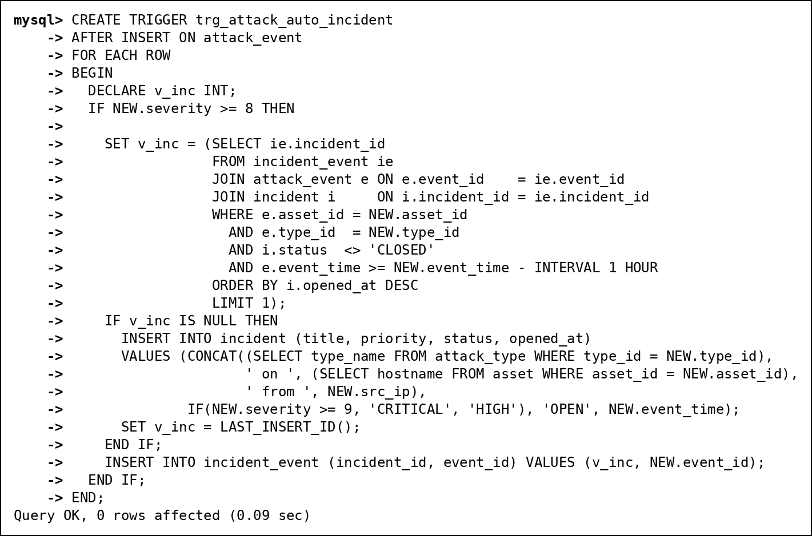
Fig. 90 trg_attack_auto_incident: definition and demonstration (1 of 2)
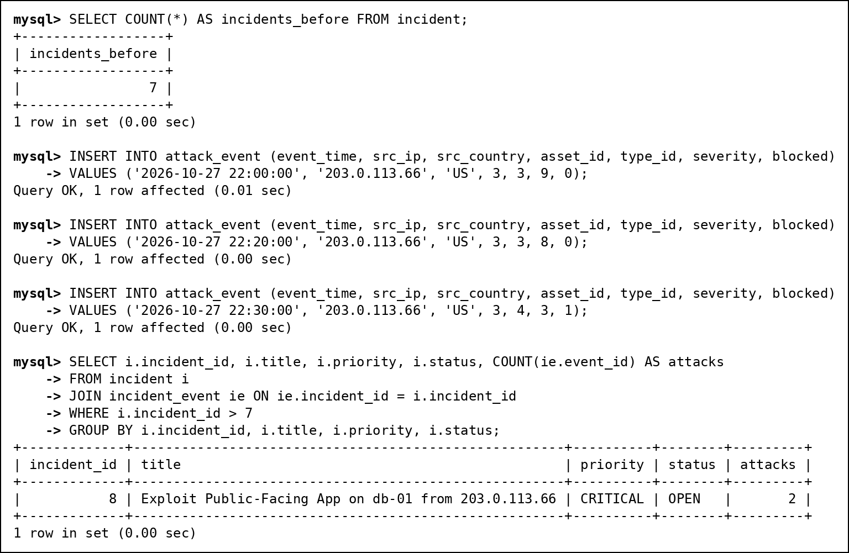
Fig. 91 trg_attack_auto_incident: definition and demonstration (2 of 2)
Three triggers on ioc: trg_ioc_no_overlap (BEFORE INSERT) rejects a new version whose valid period overlaps an existing one, trg_ioc_no_delete (BEFORE DELETE) keeps the history append-only, and trg_ioc_retro_hunt (AFTER INSERT) runs the retro-hunt.
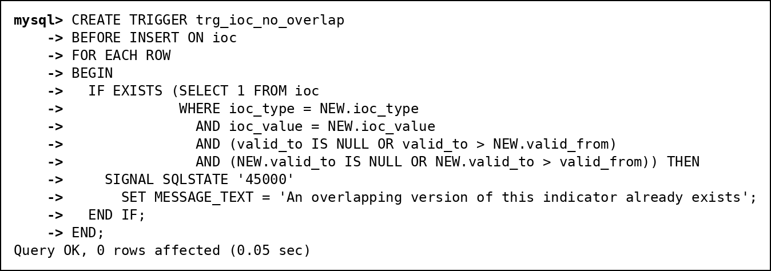
Fig. 92 The three triggers on ioc (1 of 3)
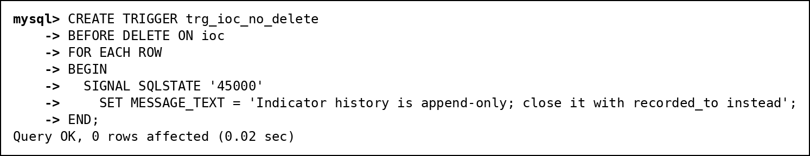
Fig. 93 The three triggers on ioc (2 of 3)
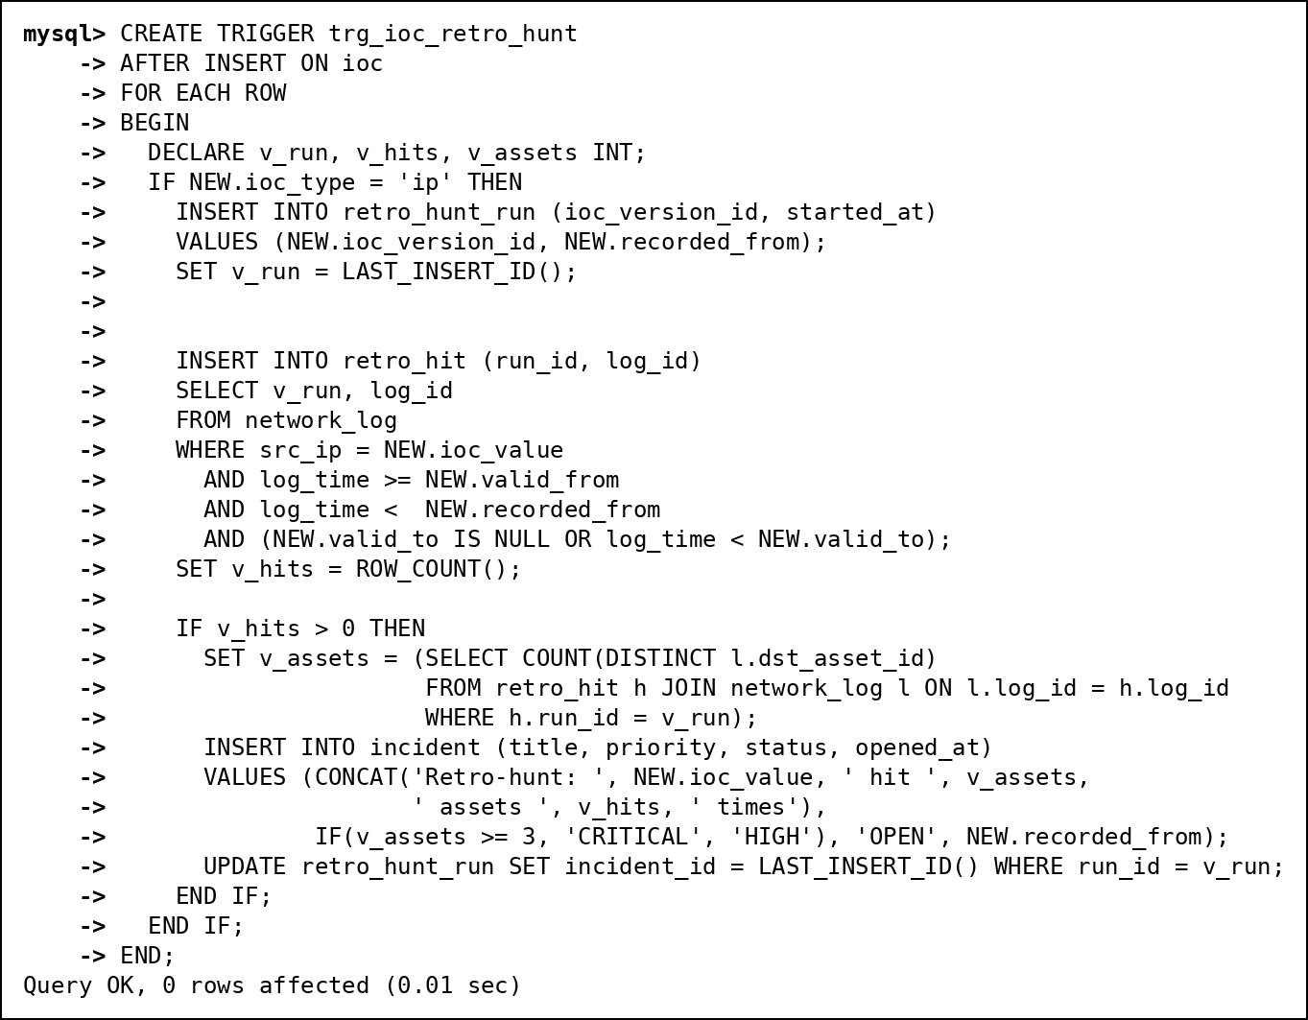
Fig. 94 The three triggers on ioc (3 of 3)
In the demonstration, 198.51.100.77 is added as a bad IP that was hostile from 15 September. The trigger finds the 8 old log lines it sent to 3 assets before anyone knew, and opens a CRITICAL incident. The overlapping second version and the DELETE are both refused.
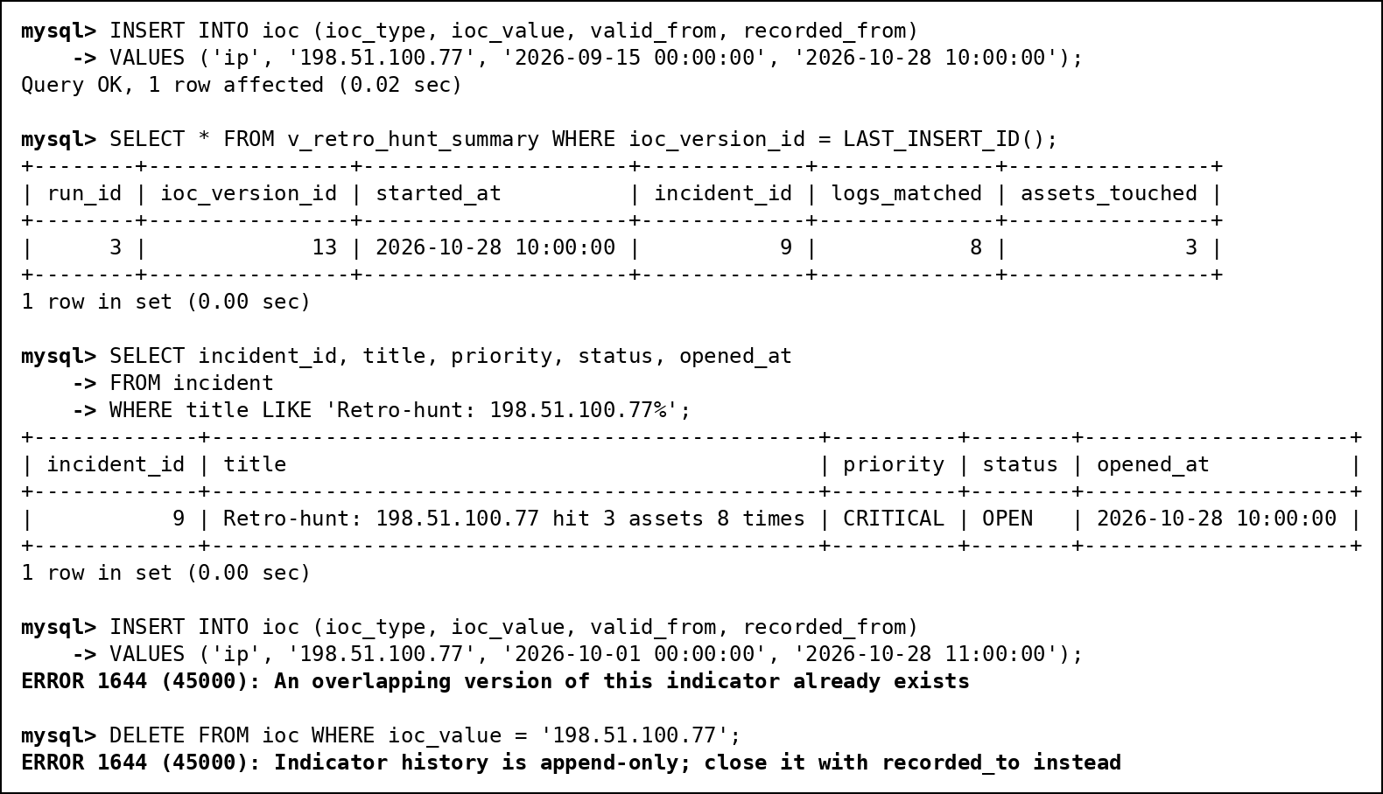
Fig. 95 Retro-hunt trigger in action

12.6 Cursors
sp_escalate_incidents walks through every incident that is not closed with a cursor, and raises its priority when its worst attack demands it: to CRITICAL for severity 10, and from LOW or MEDIUM to HIGH for severity 8. It escalated incident 3 (HIGH to CRITICAL, because of attack 30) and incident 6 (MEDIUM to HIGH).
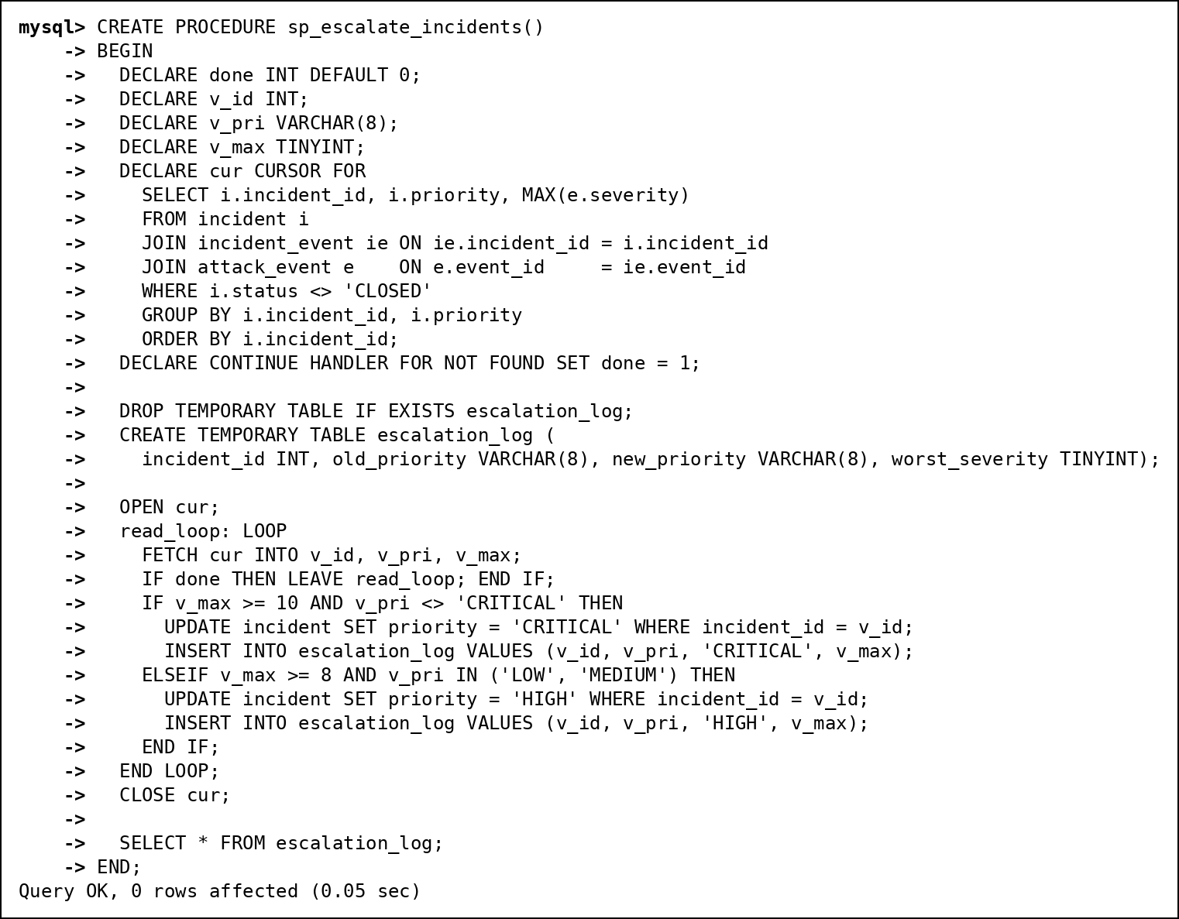
Fig. 96 Cursor 1: sp_escalate_incidents (1 of 2)
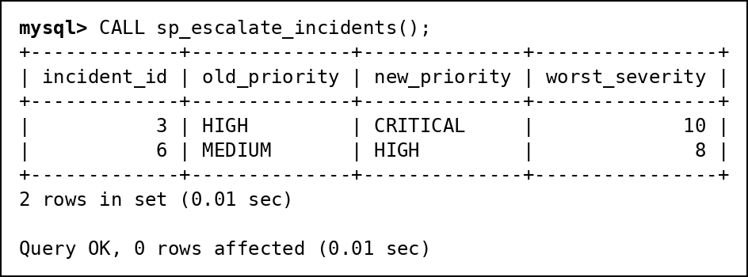
Fig. 97 Cursor 1: sp_escalate_incidents (2 of 2)
sp_asset_risk_report loops over all assets with a cursor, calls fn_asset_risk for each, puts the score into a temporary table with a band (HIGH 60+, MEDIUM 30+, LOW) and returns it sorted.
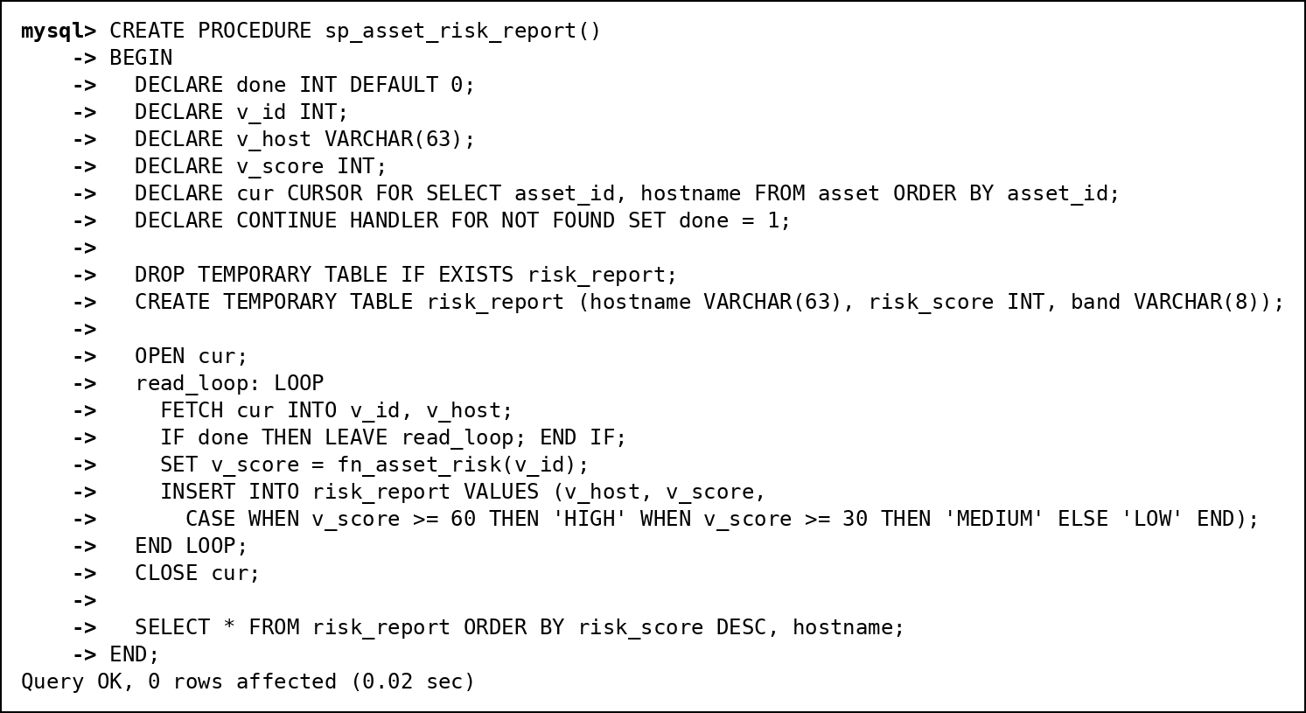
Fig. 98 Cursor 2: sp_asset_risk_report (1 of 2)
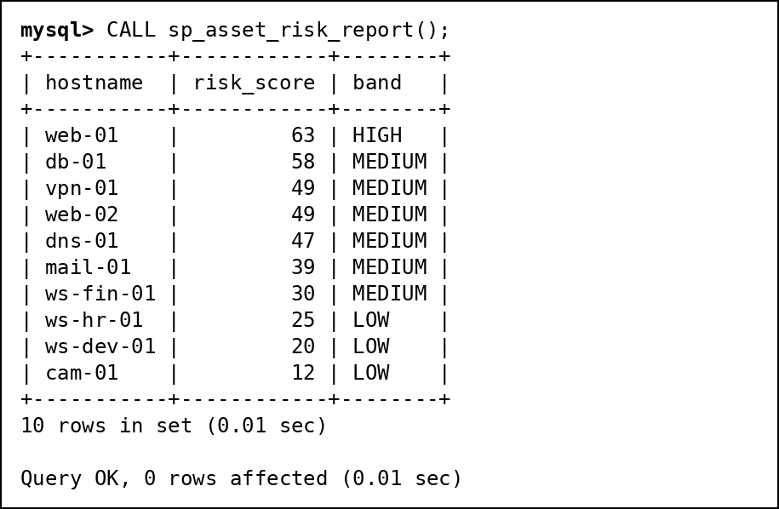
Fig. 99 Cursor 2: sp_asset_risk_report (2 of 2)

12.7 SQL Security Implementation
Three roles carry the privileges and each user gets one role by default. Restricted roles reach data only through views and procedures, which run with their definer's rights.
Object | sx_admin | sx_analyst | sx_viewer
All tables | ALL | SELECT on 10 tables (not incident, analyst, network_log or retro tables) | -
ioc | ALL | SELECT, INSERT | -
v_my_incidents | ALL | SELECT, UPDATE (own rows only) | -
v_attack_details | ALL | SELECT | -
v_asset_risk | ALL | - | SELECT
sp_assign_incident | ALL | EXECUTE | -
sp_attack_report | ALL | - | EXECUTE
User (default role) | ananya.rao | rahul.mehta | divya.iyer

Task | Evidence
Create 3 or more users/roles | CREATE ROLE and CREATE USER script with default roles (Fig. 100)
GRANT privileges per role matrix | GRANT script and SHOW GRANTS output (Fig. 100, 101)
REVOKE demonstration | SHOW GRANTS before and after REVOKE (Fig. 102)
Least privilege proof | Viewer and analyst log in and try forbidden operations: ERROR 1142 and ERROR 1369 (Fig. 103, 104)
Secure exposure | Viewer reads v_asset_risk and calls sp_attack_report but cannot read attack_event; analyst works on incidents only through v_my_incidents (Fig. 103, 104)
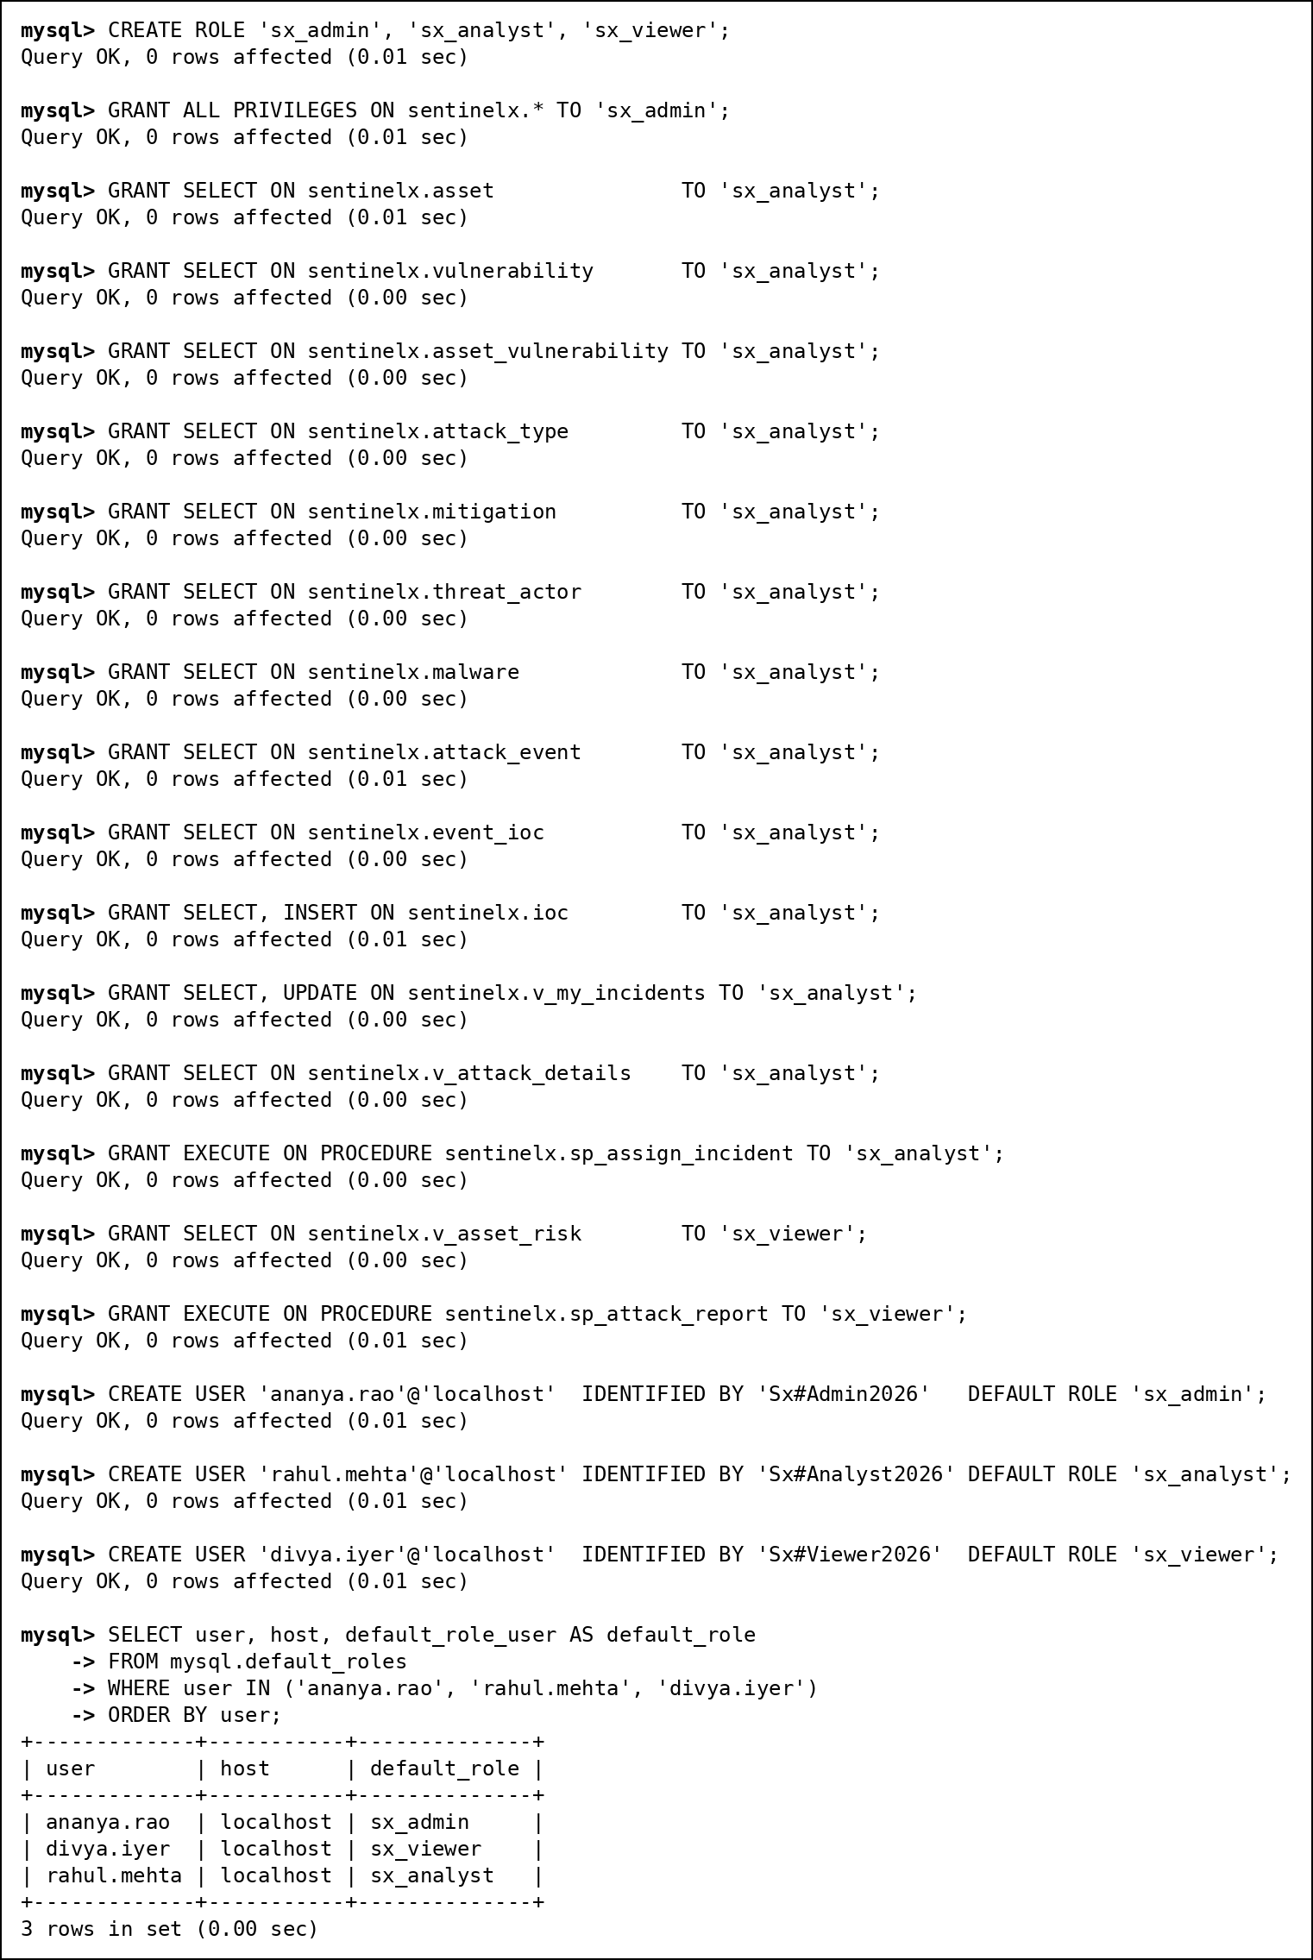
Fig. 100 Roles, grants and users
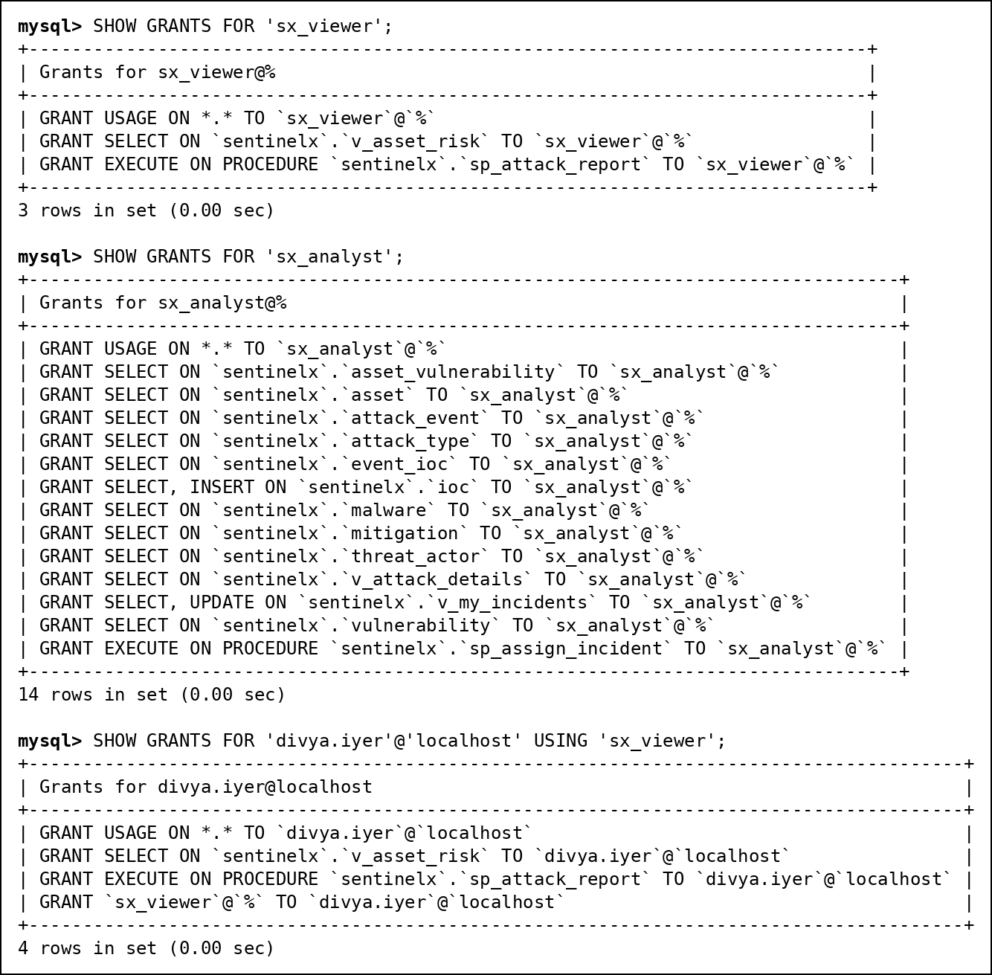
Fig. 101 SHOW GRANTS for the roles and for a user
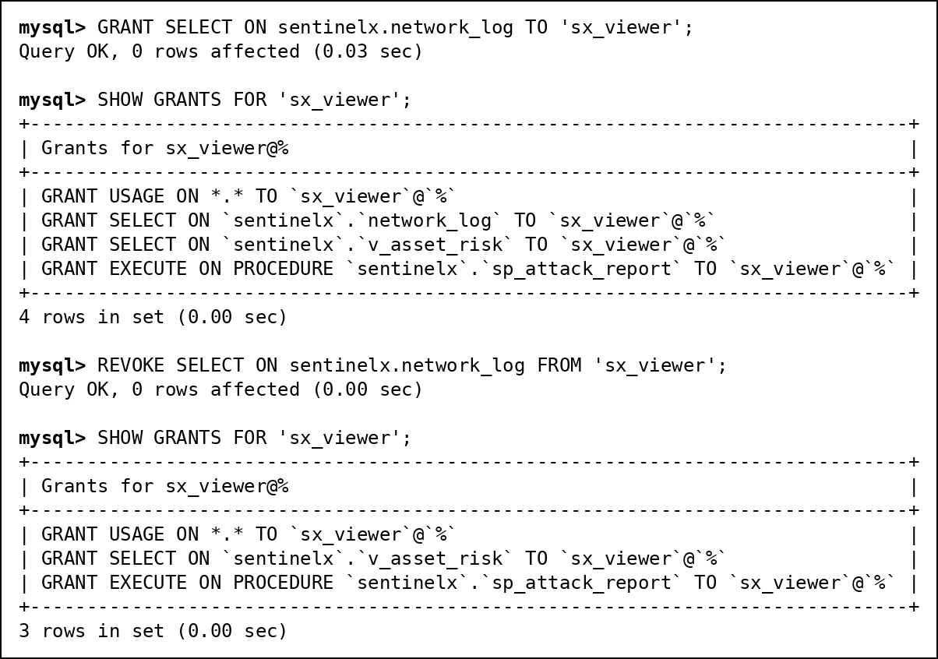
Fig. 102 REVOKE: before and after
Logged in as the viewer, divya.iyer:
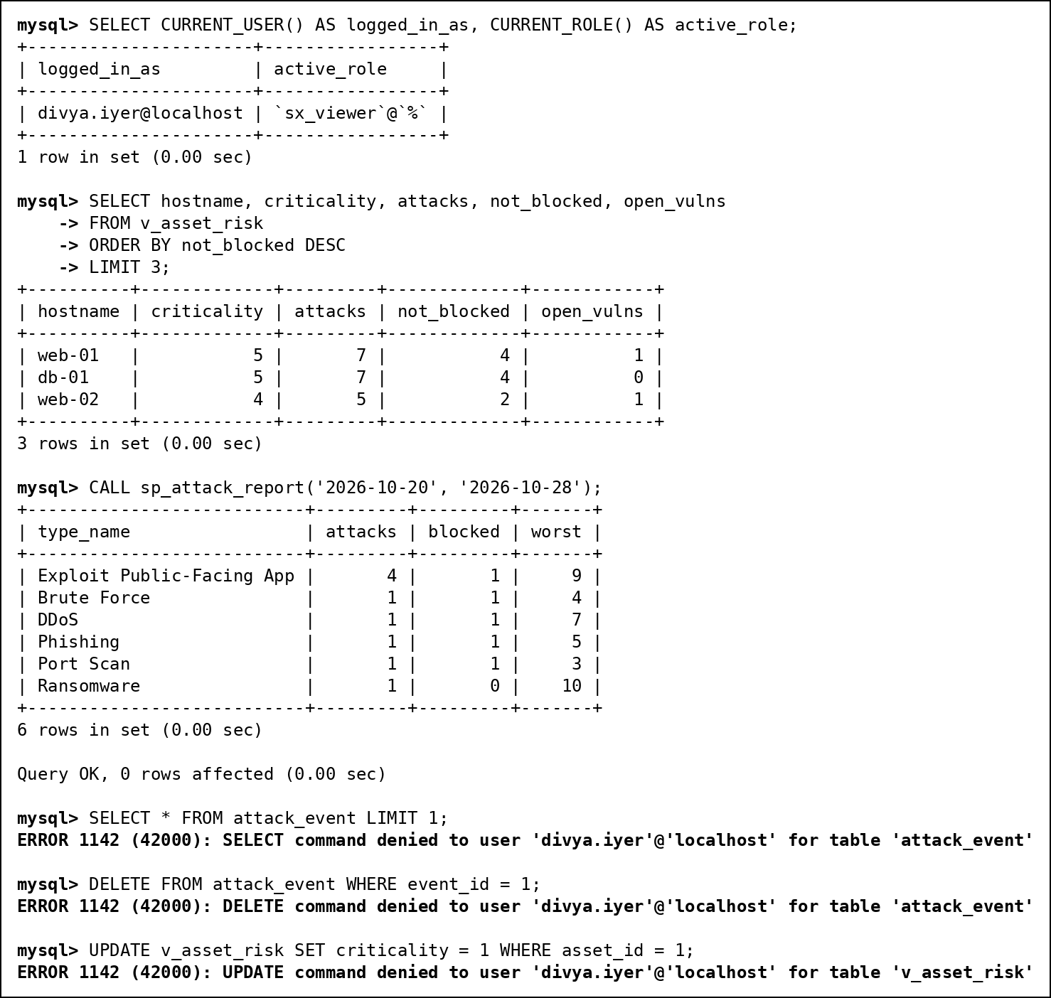
Fig. 103 Least privilege as divya.iyer (viewer)
Logged in as the analyst, rahul.mehta. He sees only his 3 incidents, can update their status through the view, cannot reassign one to another analyst (CHECK OPTION), and cannot read the incident table or drop tables:
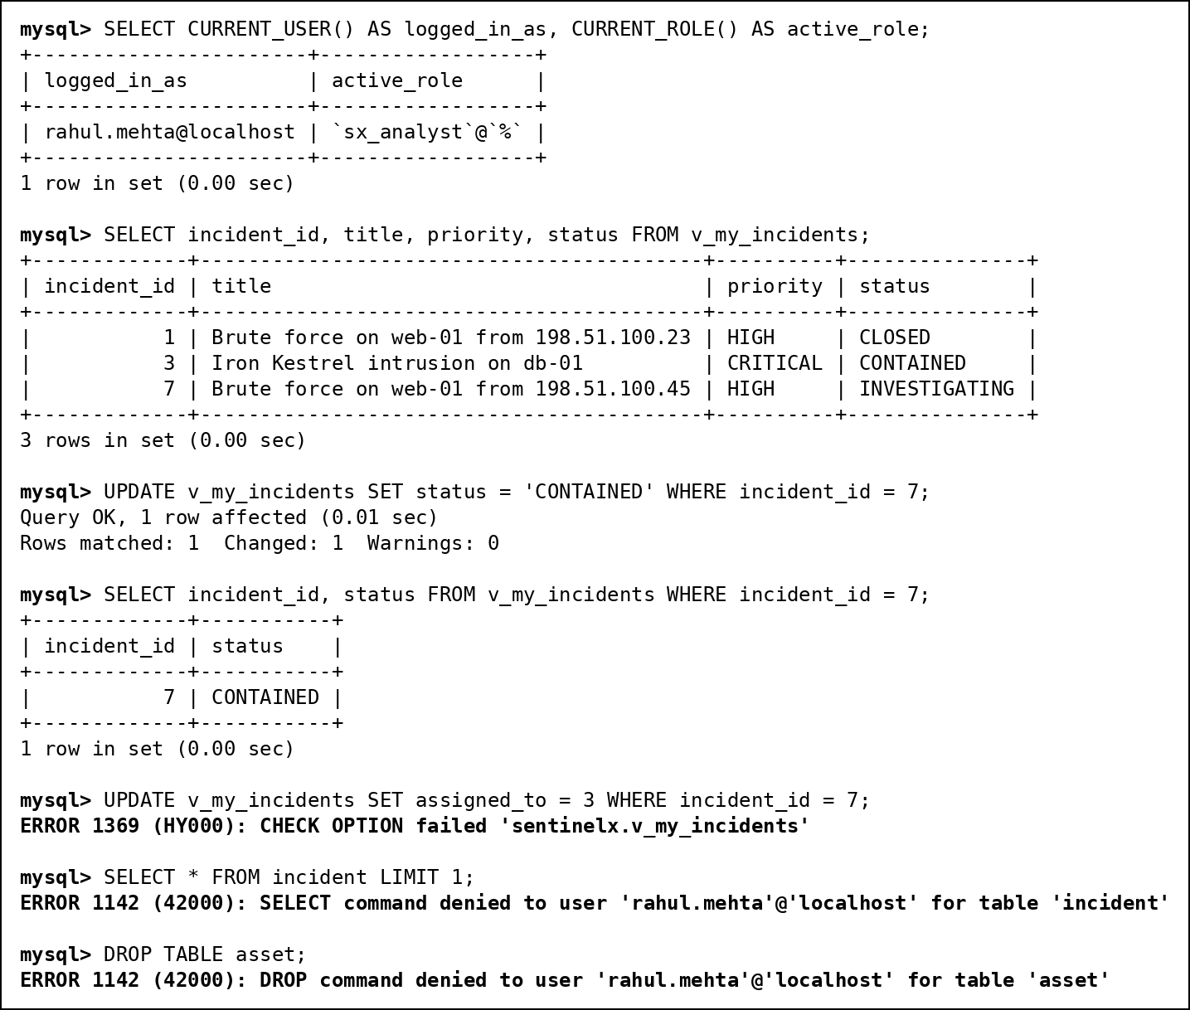
Fig. 104 Least privilege as rahul.mehta (analyst)
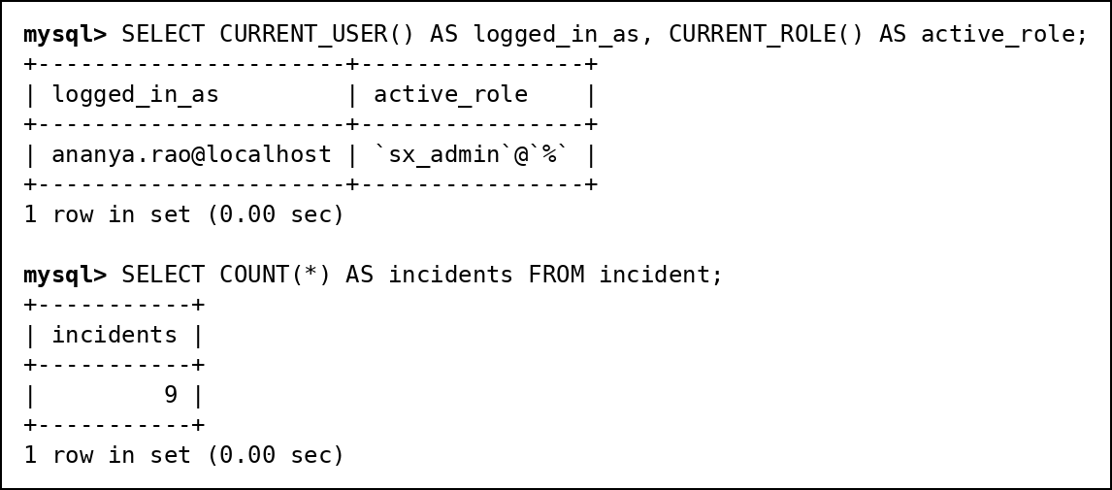
Fig. 105 Admin login as ananya.rao

13. Transactions
SAVEPOINT and COMMIT. A new indicator is inserted and a savepoint is set. A wrong priority change follows, is rolled back to the savepoint, and the transaction is committed. The indicator is kept and the priority change is not.
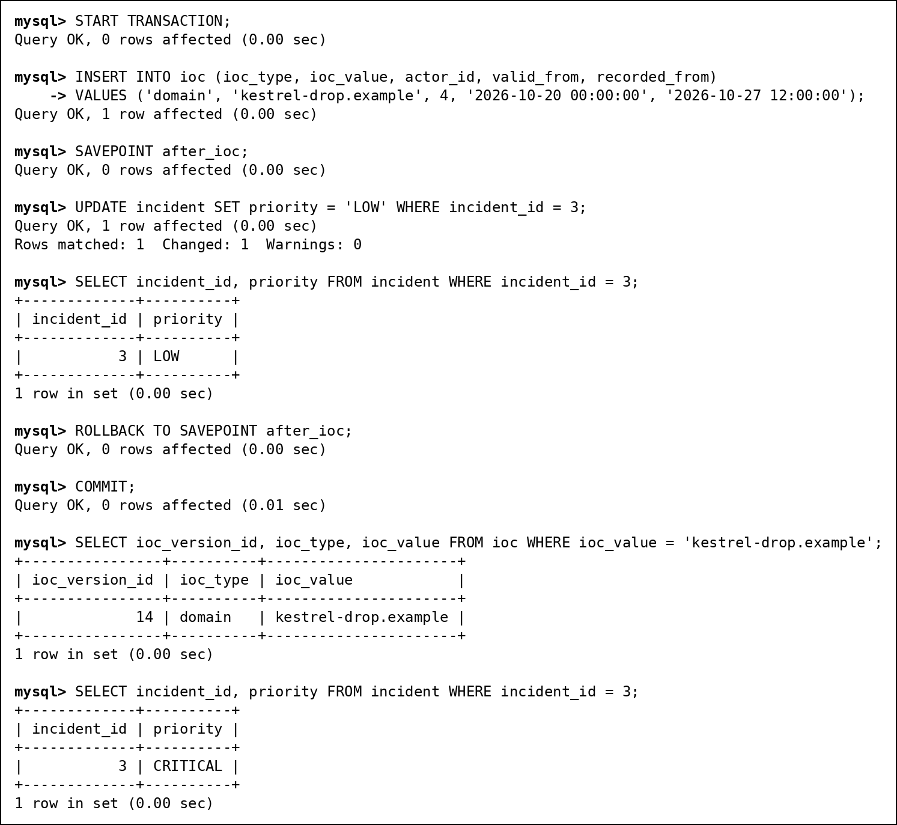
Fig. 106 START TRANSACTION, SAVEPOINT, ROLLBACK TO SAVEPOINT and COMMIT
ROLLBACK. This is how log batches are loaded: the second line of the batch points to an asset that does not exist, so the whole batch is rolled back and the log count is unchanged (50,021 before and after).
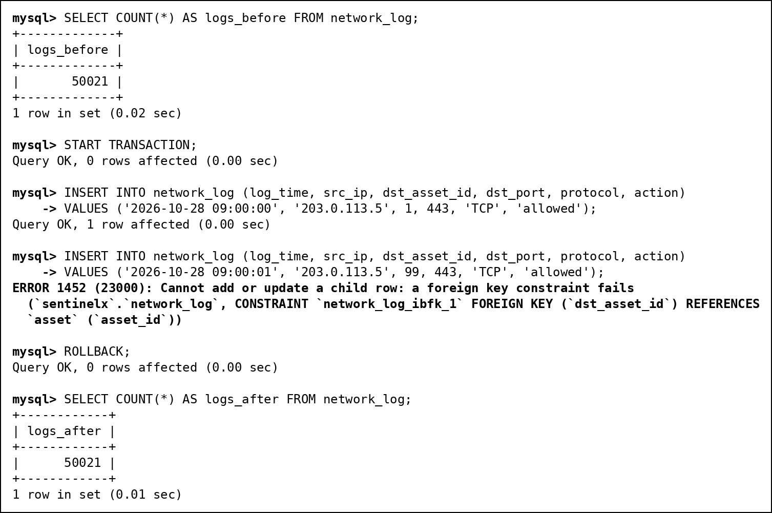
Fig. 107 Failed batch rolled back as a whole

14. Indexes and EXPLAIN
Besides the primary keys and the indexes MySQL creates for foreign keys, we added three: idx_src_time (src_ip, log_time) on network_log for retro-hunts, and idx_time and idx_src on attack_event for the dashboard and search.
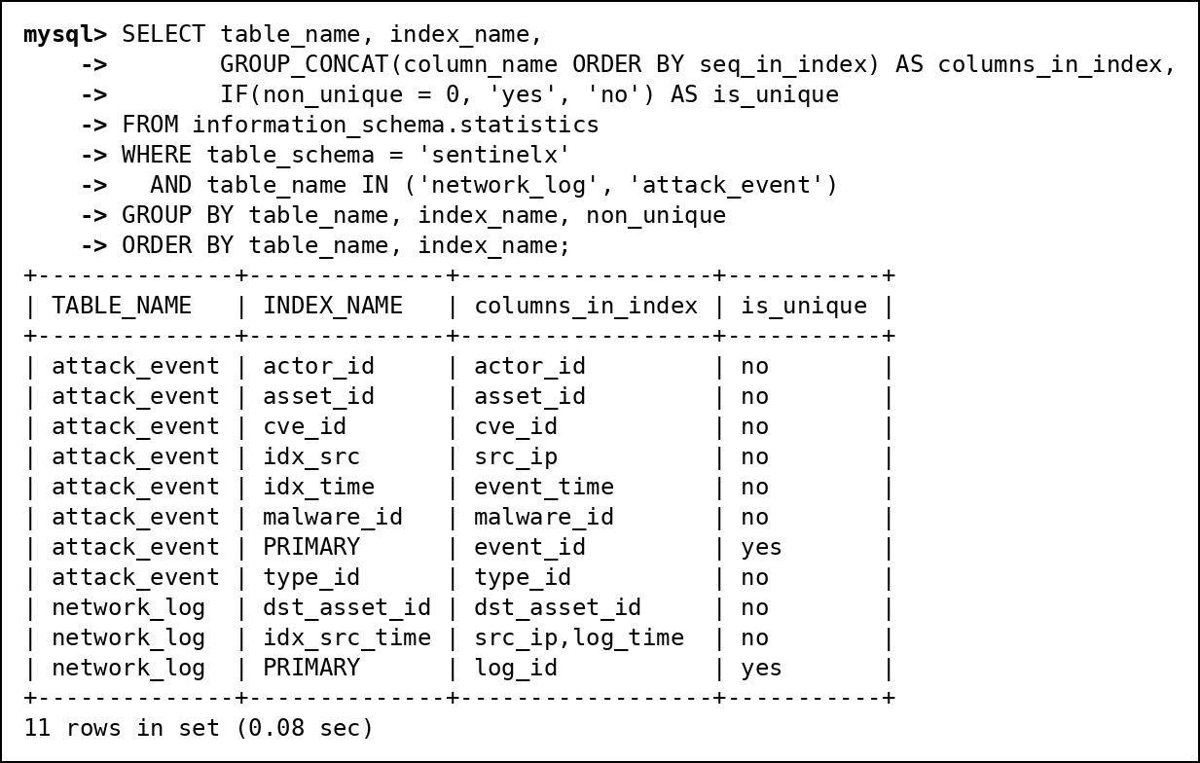
Fig. 108 Indexes on network_log and attack_event
To measure idx_src_time we dropped it, ran EXPLAIN on the retro-hunt lookup, then created it again and repeated the EXPLAIN.
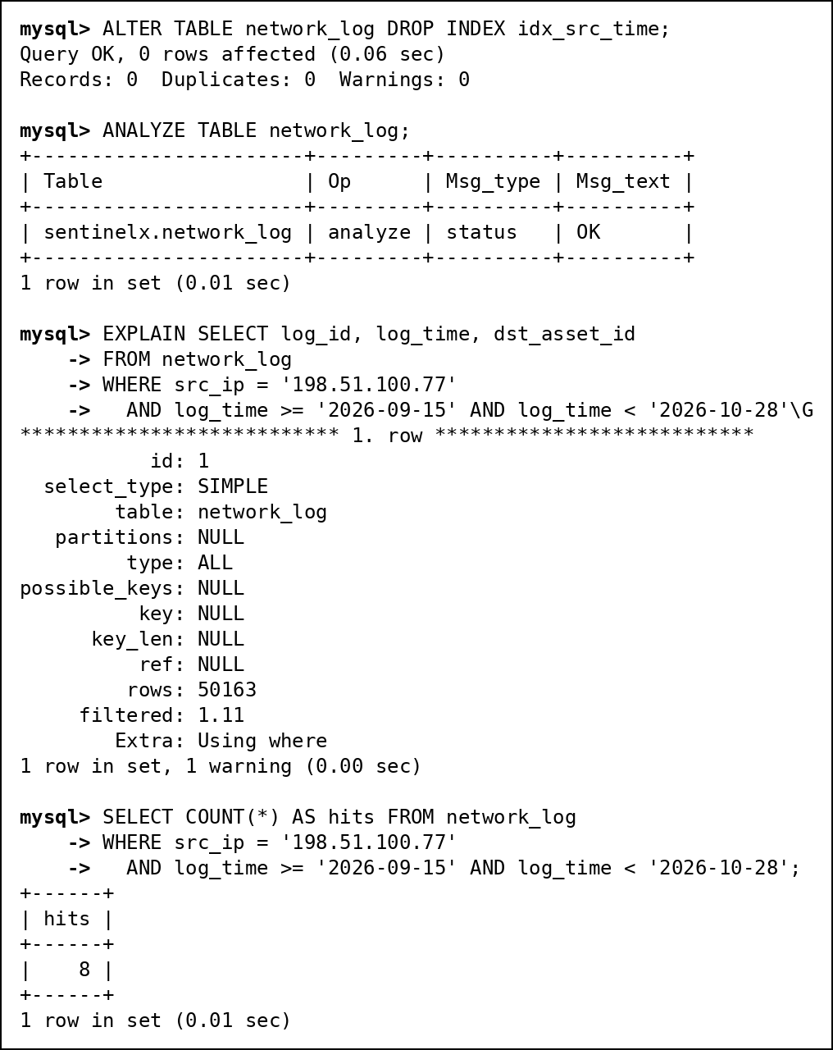
Fig. 109 Without the index: full table scan
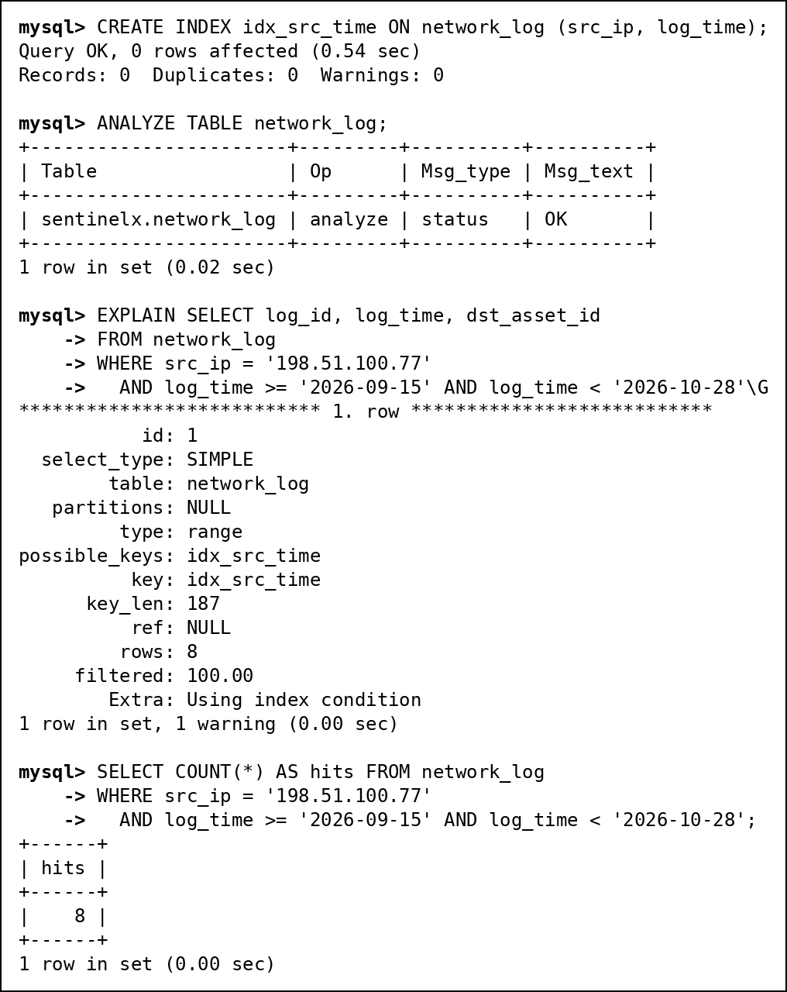
Fig. 110 With the index: range scan
 | Without idx_src_time | With idx_src_time
Access type | ALL (full table scan) | range
Index used | none | idx_src_time
Rows examined (estimate) | 50,163 | 8
Rows actually matching | 8 | 8

The index lets MySQL jump straight to the 8 lines from that IP instead of reading all 50,021 rows. With 50,000 rows both runs still finish in about 0.01 seconds, but a full scan grows with the size of the table while the range scan only reads the matching rows, so the gap widens as logs accumulate.

15. Design Changes since Review 1
The professor's feedback on Review 1 was that the ER diagram was cluttered. These are all the changes made since then, with the reason for each.
# | Change | Reason
1 | ER diagram redrawn with no crossing lines, grouped by area, strict Chen notation | Review 1 feedback: the diagram was hard to read
2 | 23 attributes removed (for example asset.os, department, country_code; vulnerability.vendor, product, description; ioc.confidence, source) | No query, trigger or page used them
3 | vulnerability.severity and malware.category removed | Transitive dependencies (cvss -> severity, family -> category) broke 3NF
4 | retro_hunt_run.logs_matched and assets_touched removed; view v_retro_hunt_summary added | They were counts of rows in retro_hit and could go out of sync
5 | PostgreSQL 16 replaced by MySQL 8.0 | Course lab uses MySQL; all DDL rewritten
6 | Monthly partitioning of logs and attacks replaced by indexes | MySQL does not allow foreign keys on partitioned tables; section 14 shows the index is enough
7 | tstzrange periods on ioc became valid_from/valid_to and recorded_from/recorded_to | MySQL has no range types
8 | Exclusion constraint on ioc replaced by trigger trg_ioc_no_overlap | MySQL has no exclusion constraints
9 | INET columns became VARCHAR(45); fixed lists became ENUM | MySQL has no INET type; ENUM uses 1 byte and rejects other values
10 | Link tables reference attacks and logs by event_id and log_id alone | Their keys no longer include the partition time column
11 | Added v_attack_details, v_asset_risk, v_my_incidents; 2 functions; 4 procedures (2 with cursors); 4 triggers; 3 roles and users | Review 2 requirements, and least-privilege access for analysts and viewers

Normalisation steps
Step | What we did
Starting point | One flat row per attack with time, source IP, host details, attack name, attacker, malware, CVE and score, and a list of IOCs like "198.51.100.23, evil-1.example".
1NF | Split the IOC list so each row holds one indicator.
2NF | Attack details depend only on the event and indicator details only on the indicator, so they went into ATTACK_EVENT, IOC and the link table EVENT_IOC.
3NF | Host, attacker, malware, CVE, attack type and analyst details each moved to their own table; the two transitive dependencies in change 3 were removed.

16. Review 2 Requirements Checklist
# | Mandatory component | Evidence | Where | Status
1 | CREATE TABLE scripts + all constraints | 01_ddl.sql runs cleanly on MySQL 8.0.46: 16 tables, no errors | Section 9 | Done
2 | INSERT, UPDATE, DELETE | 02_dml.sql, row-count table (50,021 logs, 30 attacks) | Section 10 | Done
3 | Basic, aggregate, join, subquery, set-operation queries | 40 queries (A1-G3), 20+ required | Section 11 | Done
4 | Views | 5 views (3 new + 2 from Review 1) | 12.2 | Done
5 | Transactions (COMMIT/ROLLBACK/SAVEPOINT) | Savepoint demo and failed-batch rollback | Section 13 | Done
6 | Procedures / functions | 4 procedures, 2 functions, all called successfully | 12.3, 12.4 | Done
7 | Triggers | 4 triggers, each shown firing | 12.5 | Done
8 | Indexes + one EXPLAIN comparison | ALL / 50,163 rows vs range / 8 rows | Section 14 | Done
9 | Execution screenshots | Every screenshot is the real mysql client output, with its SQL | Throughout | Done
10 | Design changes since Review 1 | Change log with reasons | Section 15 | Done
+ | Complex business queries (10+) | 11 queries with expected vs actual output | 12.1 | Done
+ | Cursors (2+) and SQL security | 2 cursors; 3 roles, 3 users, GRANT/REVOKE, least-privilege errors | 12.6, 12.7 | Done

17. Limitations and Future Scope
- The data is a test set, not real traffic. Attacker IPs come from documentation-only address ranges and the attacker and malware names are made up; the CVE IDs are real.
- Retro-hunts only work for IP addresses. Domains and file hashes would need DNS and file logs.
- MySQL has no exclusion constraint, so the rule that indicator versions never overlap lives in a trigger.
- Very high log volumes would need a streaming pipeline (for example Kafka) and archive tables for old logs.

18. Conclusion
Review 1 gave us a clean 3NF design; Review 2 shows it working. Every statement in this report ran on MySQL 8.0.46 and the screenshots are its real output. Doing that taught us things the design alone did not: the NOT IN query that silently returns nothing because of one NULL, the index that turns a 50,163-row scan into an 8-row range read, and the CHECK OPTION that stops an analyst from handing an incident to someone else. Our two own ideas, retro-hunting and the time machine, turned out to be one trigger and two pairs of date columns, which is a good reminder that careful table design does most of the work.

19. Work Break Down
Team Member Registration Number | Name | Work Assigned
24BCI0061 | Shlok Gupta | Retro-hunt and IOC triggers, indexes and EXPLAIN, transactions, FastAPI backend
24BCI0086 | Shreya Bhushan | ER diagram, normalisation, DDL and constraints, views, stored procedures and cursors, SQL security
24BDS0158 | Yashneil | Test data and DML, SQL queries A-G, complex business queries, functions, React dashboard, this report

20. Review Evaluation
COMPONENT | MARKS | SHLOK GUPTA | SHREYA BHUSHAN | YASHNEIL
TOTAL | 10 MARKS

