SENTINELX: CYBER ATTACK INTELLIGENCE AND
THREAT HUNTING PLATFORM
PROJECT REPORT (REVIEW 3: FINAL)
Submitted by
Shlok Gupta (24BCI0061)
Shreya Bhushan (24BCI0086)
Yashneil Purkayastha (24BDS0158)
Prepared For
DATABASE SYSTEMS (BCSE302P) - Lab PROJECT
Submitted To
Dr. Anand Bihari
School of Computer Science and Engineering


Abstract
Most organisations already collect a lot of security data, such as firewall logs, intrusion alerts and lists of known bad IP addresses from threat feeds. The problem is that this data sits in different places, and news about a bad IP usually arrives days after that IP has already been probing the network. SentinelX is a small Security Operations Centre (SOC) built around one relational database, so that all of this is stored once, linked properly and searched with plain SQL.
The database has 16 tables in Third Normal Form (3NF) and an append-only audit trail, on MySQL 8.0.46. Review 1 covered the design and Review 2 showed it working. This final report brings both together and adds what Review 3 asks for: a security layer in which restricted users reach data only through views and procedures, an audit trail of every change to an incident, a demonstration of SQL injection and its fix, transactions under concurrency (lost update, row locking, deadlock and isolation levels), query optimisation with EXPLAIN and EXPLAIN ANALYZE, backup with point-in-time recovery, and 49 automatic tests that run as four different users. While testing our own design we found and fixed four real defects, including a privilege escalation through a stored procedure; they are described where they occur. Every statement in this report was run on MySQL 8.0.46 and every screenshot is its real output.
We also narrowed the scope. The application layer (FastAPI, React) and the machine-learning parts described in Review 2 were never built and have been removed; section 17 lists every change and the reason for it.

Abstract 2
1. Introduction 5
2. Objectives 5
3. Project Scope 5
4. Key Contacts and Stakeholders 6
5. Project Resource Requirements 6
5.1 Hardware Resource Requirements 6
5.2 Software Resource Requirements 6
6. System Architecture 7
7. Module-wise Functional Description 7
8. ER Diagram 9
9. Tables and Constraints 12
10. Data Population (INSERT, UPDATE, DELETE) 24
11. SQL Implementation 27
11.1 A. Basic queries 27
11.2 B. Aggregate queries 30
11.3 C. Joins 33
11.4 D. Subqueries 36
11.5 E. Set operations 39
11.6 F. Advanced functions 41
11.7 G. Window functions 44
12. Advanced SQL Implementation 46
12.1 Complex Business Queries 46
12.2 Views 57
12.3 Stored Procedures 61
12.4 User-Defined Functions 64
12.5 Triggers 65
12.6 Cursors 71
12.7 SQL Security Implementation 73
13. Transactions and Concurrency 85
13.1 Concurrency 88
14. Indexing and Query Optimisation 93
14.1 When an index is not used 96
15. Backup and Point-in-Time Recovery 99
16. Testing 101
17. Scope Revision and Design Changes since Review 2 105
18. Review 3 Requirements Checklist 107
19. Live Demonstration Plan 107
20. Limitations and Future Scope 108
21. Conclusion 108
22. Work Break Down 109
23. Review Evaluation 109

1. Introduction
Anyone who has seen how a small security team works knows the routine. An alert fires, someone opens the firewall console, then the IDS, then a spreadsheet of known bad IPs, and tries to match timestamps by hand. Each tool keeps its own copy of the facts, so the same attacker or server shows up in several places with slightly different details. Threat feeds also tend to be late. By the time an IP address appears on a blocklist it has often been scanning people for weeks, and nobody goes back to check last month's logs.
We picked this topic for our DBMS lab project because it fits a relational database very naturally. There are clear entities (servers, attackers, malware, vulnerabilities, incidents), clear relationships between them (an attack hits one server, an incident can group many attacks) and good reasons to use constraints, triggers, transactions and indexes. Checking old logs for a newly reported bad IP is still a manual job in most tools, so we made the database do that part by itself, and that became the main idea of the project.
Review 3 is about turning that working design into something we can defend: every rule enforced by the database, every user limited to what they need, every change traceable, every mistake recoverable, and every claim backed by a test that passes.

2. Objectives
- Design a normalised relational schema in Third Normal Form (3NF) for a security operations centre that avoids update, insert and delete problems.
- Draw a clean ER diagram that keeps only the attributes we really use, and make sure it matches the tables we actually built.
- Keep every column only as large as it needs to be and back every rule with a constraint.
- Let the database do routine work by itself, like opening incidents for serious attacks and checking old logs when a new bad IP is added.
- Prove the design with real execution: queries, views, routines, triggers, transactions and security, each with a screenshot of its output (Review 2).
- Secure the database itself: least privilege, row-level access, an audit trail that even the administrator cannot erase, protection against SQL injection, and recovery from mistakes.
- Back every claim with an automatic test that prints PASS or FAIL.

3. Project Scope
- Basic data about servers and devices (assets), CVEs, attack types mapped to MITRE ATT&CK, attacker groups and malware.
- Storing raw network logs and detected attacks, with indexes on time and source IP so searches over the large tables stay fast.
- Search and reporting views over attacks, assets and risk.
- Incident handling: automatic creation, assigning an analyst safely, escalation and closing.
- Retro-hunting and the time machine for indicators of compromise.
- User roles (admin, analyst, viewer) with least-privilege access: restricted users reach data only through views and procedures.
- An append-only audit trail of incident changes, and backup with point-in-time recovery.
Out of scope: real-time detection of attacks, a user interface and machine-learning models. Attacks arrive as data, as they would from a firewall or IDS, and people use the mysql client or MySQL Workbench.

4. Key Contacts and Stakeholders
Name | Registration Number | Role | Phone Number / Email
Shlok Gupta | 24BCI0061 | Team Member
Shreya Bhushan | 24BCI0086 | Team Member
Yashneil Purkayastha | 24BDS0158 | Team Member
Dr. Anand Bihari |  | Faculty Guide

5. Project Resource Requirements

5.1 Hardware Resource Requirements
- A laptop or desktop with an Intel i5 (8th gen) or Ryzen 5 and at least 8 GB RAM.
- About 3 GB of free disk space for MySQL, the tools and the database.

5.2 Software Resource Requirements
- Windows 11 (the machine all screenshots were taken on).
- MySQL Community Server 8.0.46 with the mysql command-line client. INTERSECT and EXCEPT need 8.0.31 or later; CHECK constraints are enforced from 8.0.16.
- MySQL Workbench for browsing the schema.
- Python 3 for the scripts in tools/ that generate the test data, the step files, the screenshots and two of the diagrams.
- Windows PowerShell for the one-click runner (runner/RUN_ME.bat).
- draw.io for planning the ER diagram, and Git with a shared GitHub repository.
- An AI assistant (Claude, by Anthropic) was used to review our SQL for defects and to help draft parts of the Review 3 scripts and this report. Every script was run on MySQL 8.0.46 and every output shown is the real result.

6. System Architecture
The database is the whole system. Test data is loaded in batches, each batch as one transaction. Everything that must never be skipped (opening incidents, retro-hunts, protecting indicator history, recording who changed an incident) is a constraint or trigger inside MySQL. People connect with their own MySQL accounts, and what they can do is decided by the role on their account: the administrator works with the data, the analyst and the viewer only through views and procedures. Backups use mysqldump and the binary log.
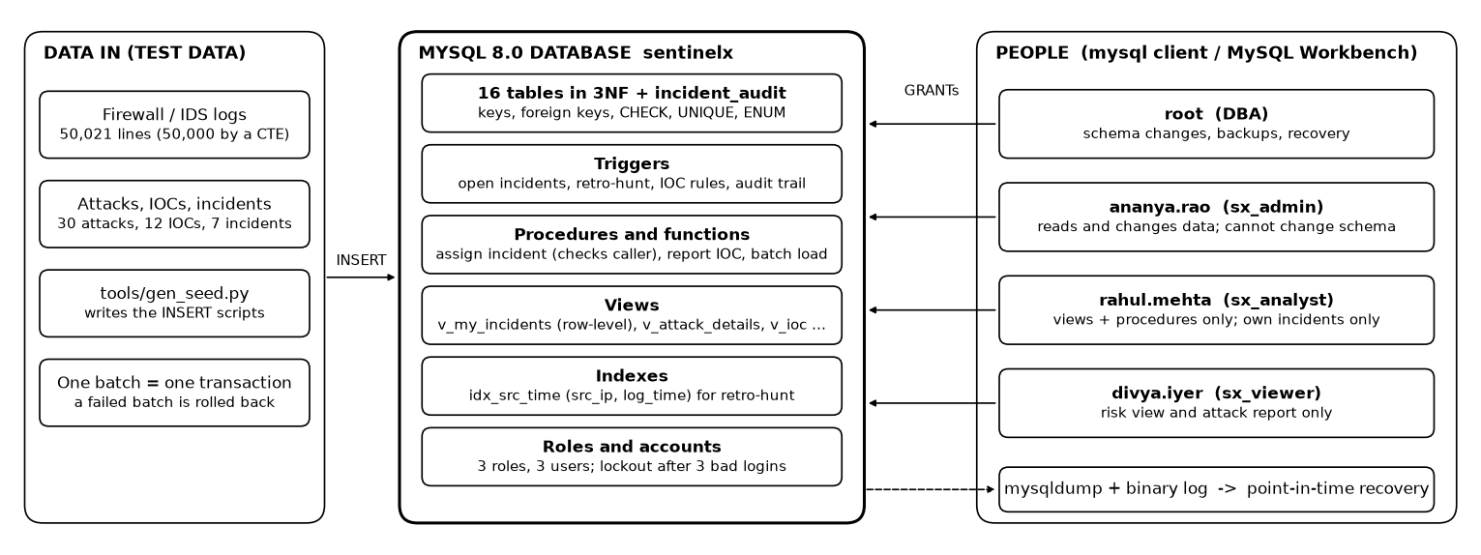
Fig. 1 System architecture

7. Module-wise Functional Description
Module | What it does | Database objects behind it
Search and reporting | Attacks per asset, open vulnerabilities, risk, and attack search by IP, country, type, malware, CVE, severity and date | v_attack_details, v_asset_risk, fn_asset_risk, queries in section 11
Incident handling | Opens an incident for any attack of severity 8 or more, groups repeat attacks within an hour, assigns analysts safely, escalates priority | trg_attack_auto_incident, sp_assign_incident, sp_escalate_incidents
Retro-hunt | When a new bad IP is added, searches old logs from the time it was already hostile but not yet known, and opens an incident if it finds anything | trg_ioc_retro_hunt, retro_hunt_run, retro_hit, v_retro_hunt_summary
Time machine | Every indicator keeps when it was hostile and when we learned about it, so results can be split into "known then" and "learned later" | ioc.valid_from/valid_to, recorded_from/recorded_to, trg_ioc_no_overlap, trg_ioc_no_delete, CQ-05
Reports | Attack summary by type for any date range | sp_attack_report, sp_asset_risk_report
Roles and security | Admins work with the data but cannot change the schema; analysts work only on their own incidents, through views and procedures; viewers only see reports. Accounts lock after three wrong passwords. | roles sx_admin, sx_analyst, sx_viewer; v_my_incidents, v_ioc; sp_assign_incident, sp_report_ioc
Audit trail | Records who changed which incident, when, and the old and new status, priority and owner. Nobody but the DBA can remove it. | incident_audit, trg_incident_audit_update/delete, trg_audit_no_update/delete
Backup and recovery | Nightly dump plus the binary log restore the database to just before a mistake. | mysqldump, binary log, mysqlbinlog (section 15)

8. ER Diagram
The ER diagram on the next page is drawn in Chen notation and is unchanged from the revised Review 1. Rectangles are entities, diamonds are relationships and ovals are attributes, with the primary key underlined. MITIGATION is a weak entity (double rectangle) whose partial key step_no has a dashed underline, and its identifying relationship HAS_STEP is a double diamond. detected_at and patched_at belong to the EXPOSED_TO relationship itself. A double line means total participation, for example every attack must target an asset. There are 12 entities and 17 relationships: 12 one-to-many (one identifying), 4 many-to-many and 1 one-to-one.
Entity | What it represents
ASSET | A server or device we are protecting
VULNERABILITY | A published weakness (CVE) with its CVSS score
NETWORK_LOG | One raw line from the firewall or IDS
ATTACK_EVENT | One detected attack against an asset
ATTACK_TYPE | A kind of attack, mapped to a MITRE ATT&CK technique
MITIGATION (weak) | One response step for an attack type
THREAT_ACTOR | An attacker group
MALWARE | A piece of malicious software
IOC | An indicator of compromise: a bad IP, domain, file hash or URL
RETRO_HUNT_RUN | One automatic search of old logs for a newly added bad IP
INCIDENT | An investigation that groups related attacks
ANALYST | A person who uses the system

Relationship | Between | Type | Linked by
TARGETS | ASSET, ATTACK_EVENT | 1 : N | attack_event.asset_id (NOT NULL)
CLASSIFIED_AS | ATTACK_TYPE, ATTACK_EVENT | 1 : N | attack_event.type_id (NOT NULL)
ATTRIBUTED_TO | THREAT_ACTOR, ATTACK_EVENT | 1 : N | attack_event.actor_id
DELIVERS | MALWARE, ATTACK_EVENT | 1 : N | attack_event.malware_id
EXPLOITS | VULNERABILITY, ATTACK_EVENT | 1 : N | attack_event.cve_id
EXPOSED_TO | ASSET, VULNERABILITY | M : N | link table asset_vulnerability
DESTINED_FOR | ASSET, NETWORK_LOG | 1 : N | network_log.dst_asset_id (NOT NULL)
HAS_STEP | ATTACK_TYPE, MITIGATION | 1 : N (identifying) | mitigation key (type_id, step_no)
DEVELOPS | THREAT_ACTOR, MALWARE | 1 : N | malware.actor_id
LINKED_TO | THREAT_ACTOR, IOC | 1 : N | ioc.actor_id
INDICATES | MALWARE, IOC | 1 : N | ioc.malware_id
MATCHES | ATTACK_EVENT, IOC | M : N | link table event_ioc
TRIGGERS | IOC, RETRO_HUNT_RUN | 1 : N | retro_hunt_run.ioc_version_id (NOT NULL)
HITS | RETRO_HUNT_RUN, NETWORK_LOG | M : N | link table retro_hit
OPENS | RETRO_HUNT_RUN, INCIDENT | 1 : 1 | retro_hunt_run.incident_id (UNIQUE)
GROUPS | INCIDENT, ATTACK_EVENT | M : N | link table incident_event
ASSIGNED_TO | ANALYST, INCIDENT | 1 : N | incident.assigned_to

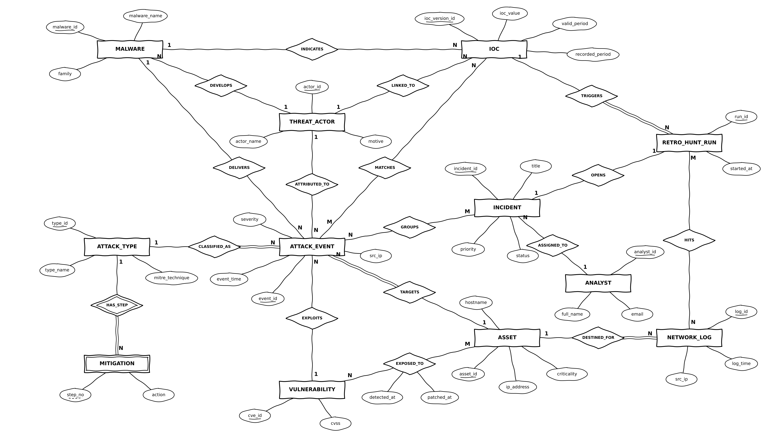
Fig. 2 ER diagram of SentinelX (Chen notation)
The relational schema below is drawn by a script (tools/draw_relational_schema.py) straight from sentinelx_schema.sql, so it always matches the tables MySQL actually creates. It replaces the hand-drawn Review 2 version, which still showed the old partition keys (event_time and log_time inside primary keys) that Review 2 had already removed. incident_audit appears as a separate table with no relationship line: it is an implementation table for accountability, not part of the conceptual model, and it deliberately has no foreign key so that its rows survive the deletion of the incident they describe.
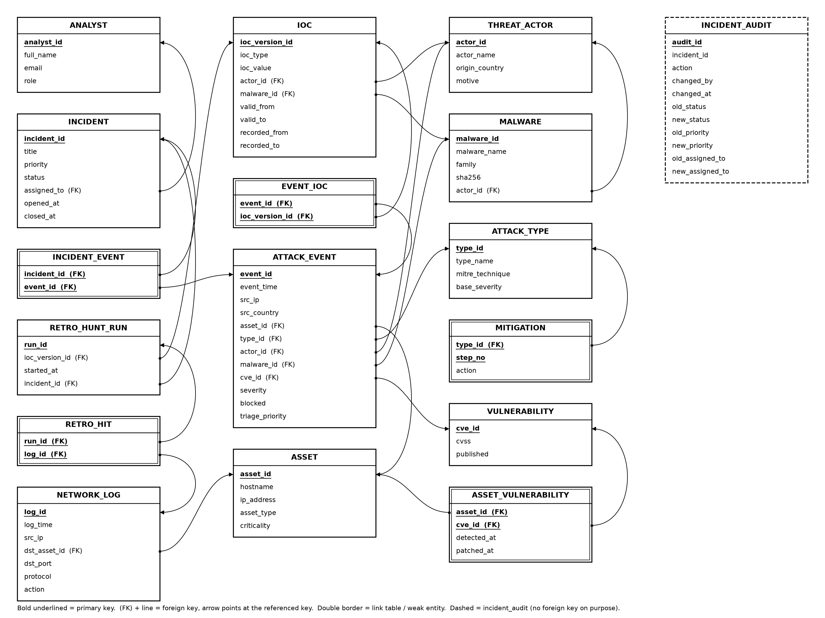
Fig. 3 Relational schema generated from the DDL

9. Tables and Constraints
All 16 tables, and the audit table added in Review 3, are in Third Normal Form: in every table each non-key column depends on the key, the whole key and nothing but the key. Every column that decides another column is itself a candidate key, so the tables also meet BCNF. The normalisation steps and the 23 attributes removed after review are in section 15. For each table below we give a short description, its attributes with data types and constraints, the CREATE TABLE statement as MySQL ran it, and the normal form. MySQL echoes statements without comments, so the screenshots show the definitions without them.
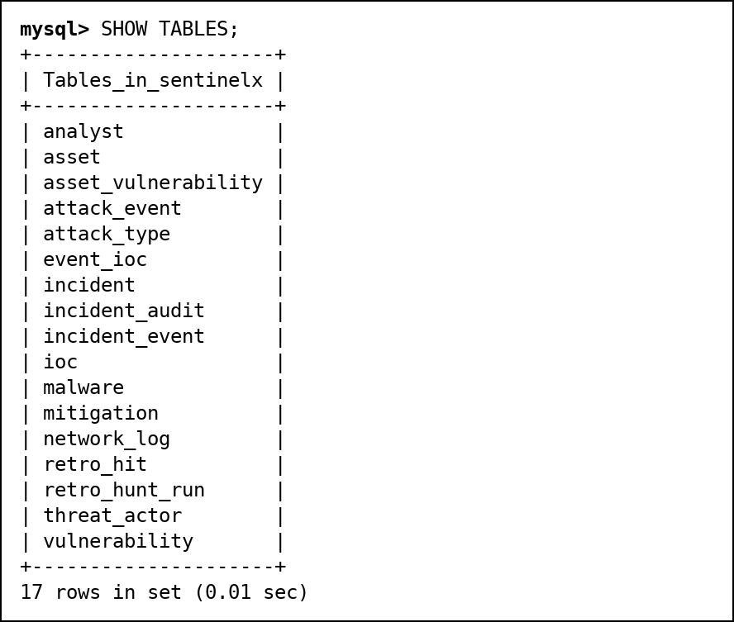
Fig. 4 SHOW TABLES after running the 17 CREATE TABLE statements

Table: asset
Every server or device we protect. hostname and ip_address are unique too.
Attribute | Data Type | Constraint
asset_id | INT | PRIMARY KEY, AUTO_INCREMENT
hostname | VARCHAR(63) | NOT NULL UNIQUE
ip_address | VARCHAR(45) | NOT NULL UNIQUE
asset_type | ENUM('web','db','mail','dns','workstation','iot','vpn') | NOT NULL
criticality | TINYINT | NOT NULL CHECK (criticality BETWEEN 1 AND 5)

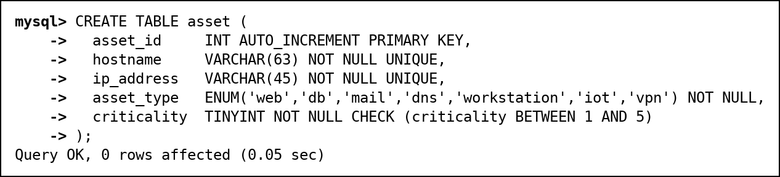
Fig. 5 CREATE TABLE asset executed in MySQL
Normal form: Every column depends only on asset_id (hostname and ip_address are also candidate keys). 3NF.

Table: vulnerability
Published CVEs. cve_id must look like CVE-2024-3400. Severity is not stored; the view v_vulnerability works it out from cvss.
Attribute | Data Type | Constraint
cve_id | VARCHAR(16) | PRIMARY KEY CHECK (cve_id REGEXP '^CVE-[0-9]{4}-[0-9]{4,7}$')
cvss | DECIMAL(3,1) | NOT NULL CHECK (cvss BETWEEN 0 AND 10)
published | DATE | NOT NULL

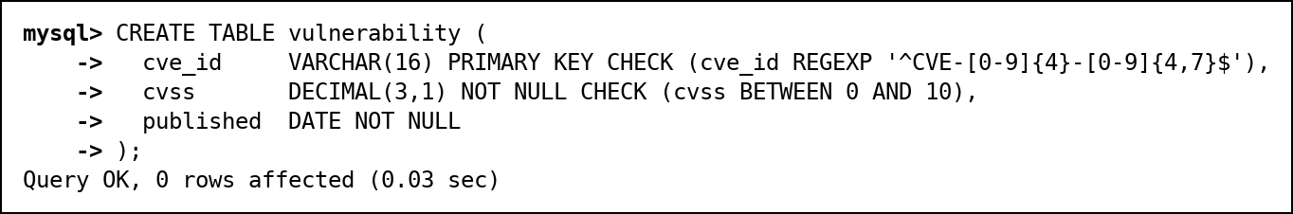
Fig. 6 CREATE TABLE vulnerability executed in MySQL
Normal form: cvss and published depend only on cve_id. Storing severity would add the transitive dependency cve_id -> cvss -> severity. 3NF.

Table: asset_vulnerability
Link table for EXPOSED_TO (M:N between assets and CVEs), with when the CVE was found and patched.
Attribute | Data Type | Constraint
asset_id | INT | NOT NULL; Part of composite PRIMARY KEY (asset_id, cve_id); FOREIGN KEY to asset(asset_id), on delete cascade
cve_id | VARCHAR(16) | NOT NULL; Part of composite PRIMARY KEY (asset_id, cve_id); FOREIGN KEY to vulnerability(cve_id)
detected_at | DATE | NOT NULL; CHECK (patched_at IS NULL OR patched_at >= detected_at)
patched_at | DATE | NULL allowed

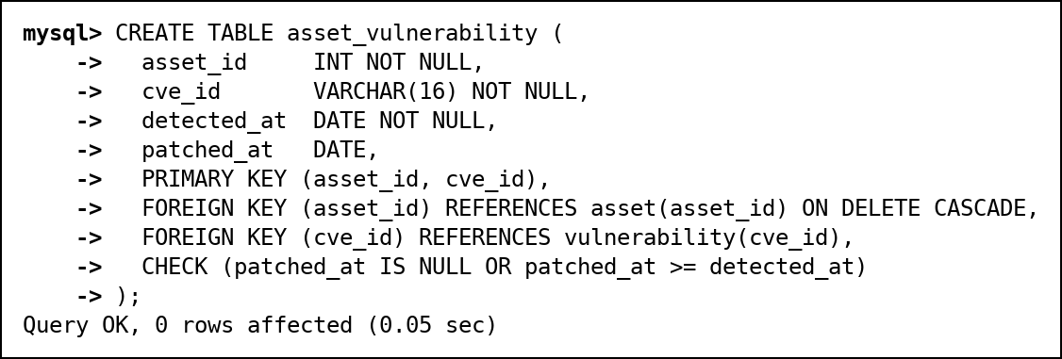
Fig. 7 CREATE TABLE asset_vulnerability executed in MySQL
Normal form: detected_at and patched_at depend on the whole key (asset_id, cve_id). 3NF.

Table: network_log
Raw log lines from the firewall and IDS. The index on (src_ip, log_time) serves the retro-hunt (section 14).
Attribute | Data Type | Constraint
log_id | BIGINT | PRIMARY KEY, AUTO_INCREMENT
log_time | DATETIME | NOT NULL
src_ip | VARCHAR(45) | NOT NULL; Indexed (idx_src_time: src_ip, log_time)
dst_asset_id | INT | NOT NULL; FOREIGN KEY to asset(asset_id)
dst_port | SMALLINT UNSIGNED | NOT NULL
protocol | ENUM('TCP','UDP','ICMP') | NOT NULL
action | ENUM('allowed','blocked') | NOT NULL

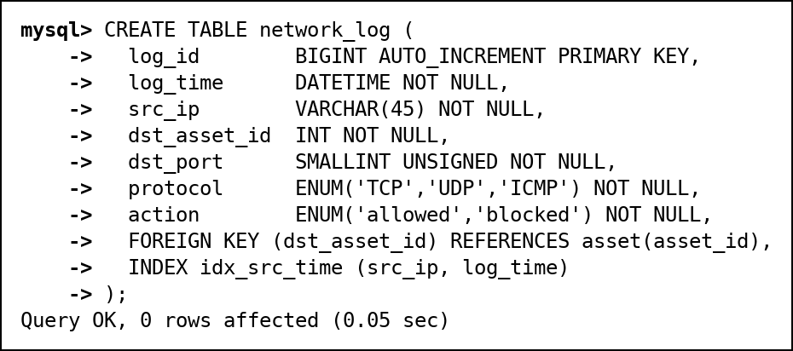
Fig. 8 CREATE TABLE network_log executed in MySQL
Normal form: Everything depends on log_id. 3NF.

Table: attack_type
Kinds of attack with their MITRE ATT&CK technique ID.
Attribute | Data Type | Constraint
type_id | INT | PRIMARY KEY, AUTO_INCREMENT
type_name | VARCHAR(40) | NOT NULL UNIQUE
mitre_technique | VARCHAR(9) | NOT NULL UNIQUE CHECK (mitre_technique REGEXP '^T[0-9]{4}([.][0-9]{3})?$')
base_severity | TINYINT | NOT NULL CHECK (base_severity BETWEEN 1 AND 10)

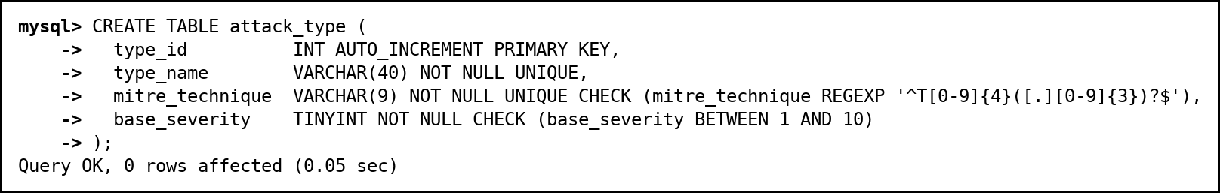
Fig. 9 CREATE TABLE attack_type executed in MySQL
Normal form: Everything depends on type_id; type_name and mitre_technique are candidate keys. 3NF.

Table: mitigation
Weak entity: numbered response steps for each attack type, deleted together with the type.
Attribute | Data Type | Constraint
type_id | INT | NOT NULL; Part of composite PRIMARY KEY (type_id, step_no); FOREIGN KEY to attack_type(type_id), on delete cascade
step_no | TINYINT | NOT NULL CHECK (step_no > 0); Part of composite PRIMARY KEY (type_id, step_no)
action | VARCHAR(100) | NOT NULL

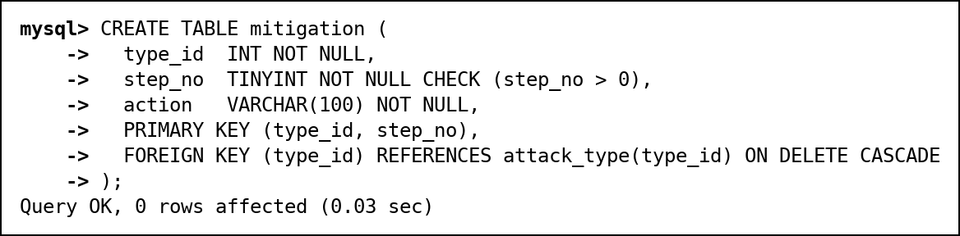
Fig. 10 CREATE TABLE mitigation executed in MySQL
Normal form: action depends on the full key (type_id, step_no). 3NF.

Table: threat_actor
Attacker groups with country and motive. The names are made up.
Attribute | Data Type | Constraint
actor_id | INT | PRIMARY KEY, AUTO_INCREMENT
actor_name | VARCHAR(50) | NOT NULL UNIQUE
origin_country | CHAR(2) | CHECK (origin_country REGEXP '^[A-Z]{2}$')
motive | ENUM('financial','espionage','hacktivism','sabotage','unknown') | NOT NULL

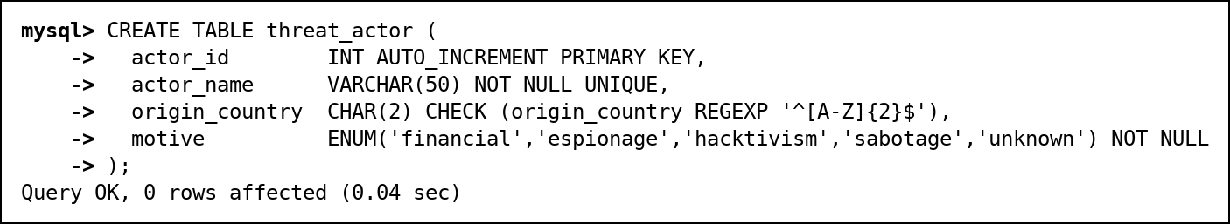
Fig. 11 CREATE TABLE threat_actor executed in MySQL
Normal form: Everything depends on actor_id. 3NF.

Table: malware
Malware samples. actor_id becomes NULL if the group is deleted.
Attribute | Data Type | Constraint
malware_id | INT | PRIMARY KEY, AUTO_INCREMENT
malware_name | VARCHAR(50) | NOT NULL UNIQUE
family | VARCHAR(30) | NOT NULL
sha256 | CHAR(64) | NOT NULL UNIQUE CHECK (sha256 REGEXP '^[0-9a-f]{64}$')
actor_id | INT | FOREIGN KEY to threat_actor(actor_id), on delete set null

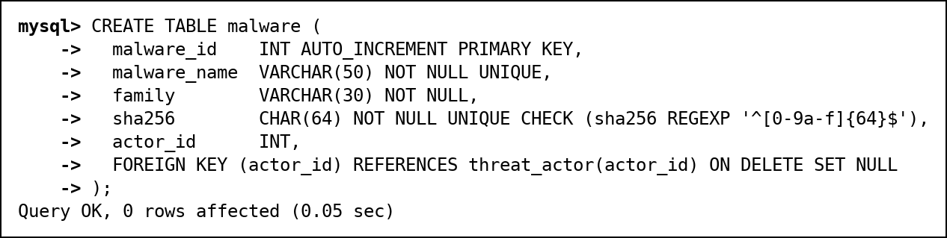
Fig. 12 CREATE TABLE malware executed in MySQL
Normal form: Everything depends on malware_id. category was removed because family decides it. 3NF.

Table: attack_event
One row per detected attack. Asset and type are required; attacker, malware and CVE are optional. triage_priority is set by an analyst and stays NULL until the attack has been triaged.
Attribute | Data Type | Constraint
event_id | BIGINT | PRIMARY KEY, AUTO_INCREMENT
event_time | DATETIME | NOT NULL; Indexed (idx_time: event_time)
src_ip | VARCHAR(45) | NOT NULL; Indexed (idx_src: src_ip)
src_country | CHAR(2) | NOT NULL CHECK (src_country REGEXP '^[A-Z]{2}$')
asset_id | INT | NOT NULL; FOREIGN KEY to asset(asset_id)
type_id | INT | NOT NULL; FOREIGN KEY to attack_type(type_id)
actor_id | INT | FOREIGN KEY to threat_actor(actor_id)
malware_id | INT | FOREIGN KEY to malware(malware_id)
cve_id | VARCHAR(16) | FOREIGN KEY to vulnerability(cve_id)
severity | TINYINT | NOT NULL CHECK (severity BETWEEN 1 AND 10)
blocked | BOOLEAN | NOT NULL
triage_priority | ENUM('LOW','MEDIUM','HIGH','CRITICAL') | NULL allowed

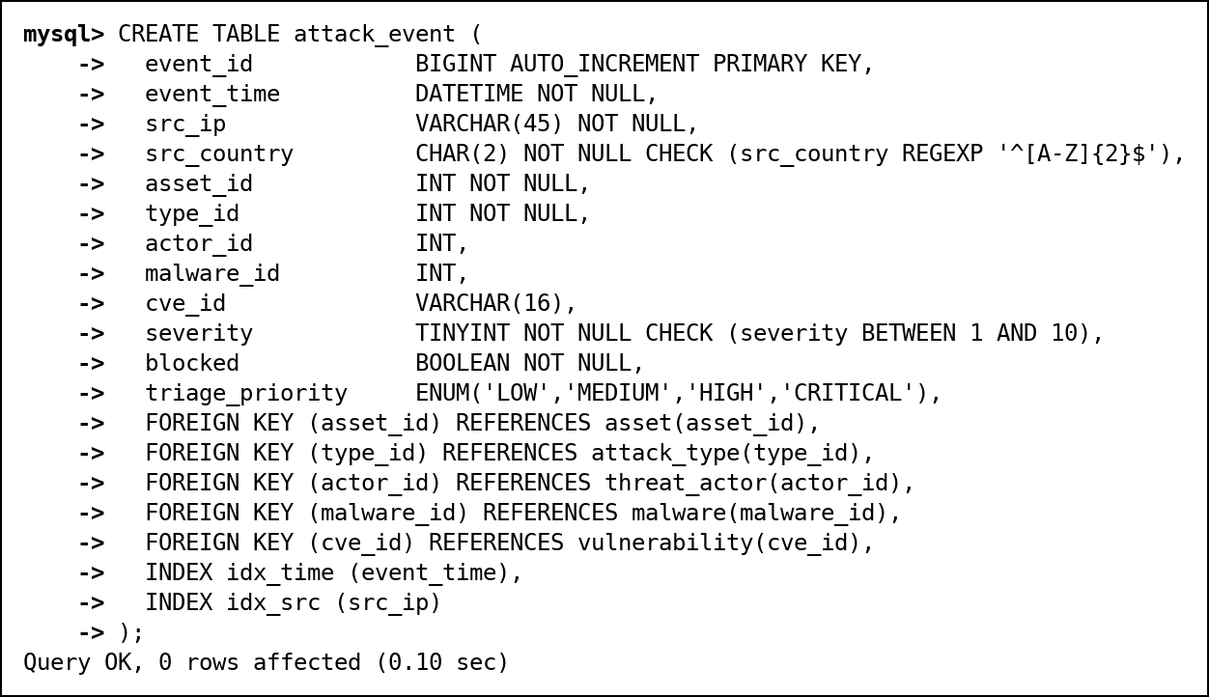
Fig. 13 CREATE TABLE attack_event executed in MySQL
Normal form: Everything depends on event_id. triage_priority is an analyst decision, not a function of severity (events 5 and 6 both have severity 9 but are CRITICAL and HIGH), so there is no transitive dependency. src_country stays because an IP's location changes over time; actor_id stays because malware is shared between groups. 3NF.

Table: analyst
People who use the system. email is unique and checked to look like an email address.
Attribute | Data Type | Constraint
analyst_id | INT | PRIMARY KEY, AUTO_INCREMENT
full_name | VARCHAR(50) | NOT NULL
email | VARCHAR(50) | NOT NULL UNIQUE CHECK (email REGEXP '^[^@ ]+@[^@ ]+[.][A-Za-z]{2,}$')
role | ENUM('admin','analyst','viewer') | NOT NULL

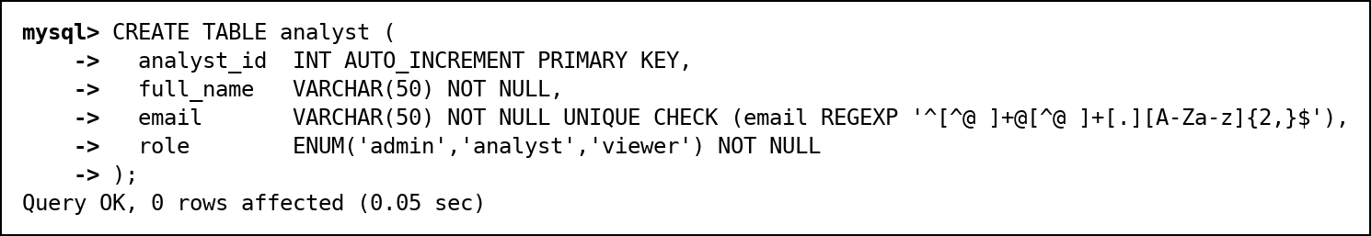
Fig. 14 CREATE TABLE analyst executed in MySQL
Normal form: Everything depends on analyst_id; email is also a candidate key. 3NF.

Table: incident
An investigation. closed_at is filled in only when the status is CLOSED.
Attribute | Data Type | Constraint
incident_id | INT | PRIMARY KEY, AUTO_INCREMENT
title | VARCHAR(100) | NOT NULL
priority | ENUM('LOW','MEDIUM','HIGH','CRITICAL') | NOT NULL
status | ENUM('OPEN','INVESTIGATING','CONTAINED','CLOSED') | NOT NULL DEFAULT 'OPEN'; CHECK ((status = 'CLOSED') = (closed_at IS NOT NULL))
assigned_to | INT | FOREIGN KEY to analyst(analyst_id)
opened_at | DATETIME | NOT NULL DEFAULT CURRENT_TIMESTAMP; CHECK (closed_at IS NULL OR closed_at >= opened_at)
closed_at | DATETIME | NULL allowed

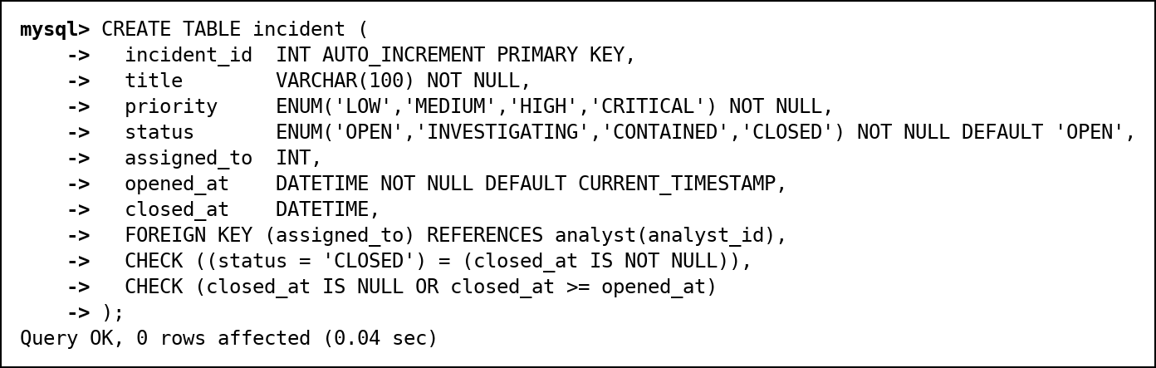
Fig. 15 CREATE TABLE incident executed in MySQL
Normal form: Everything depends on incident_id. 3NF.

Table: incident_event
Link table for GROUPS (M:N between incidents and attacks).
Attribute | Data Type | Constraint
incident_id | INT | NOT NULL; Part of composite PRIMARY KEY (incident_id, event_id); FOREIGN KEY to incident(incident_id), on delete cascade
event_id | BIGINT | NOT NULL; Part of composite PRIMARY KEY (incident_id, event_id); FOREIGN KEY to attack_event(event_id), on delete cascade

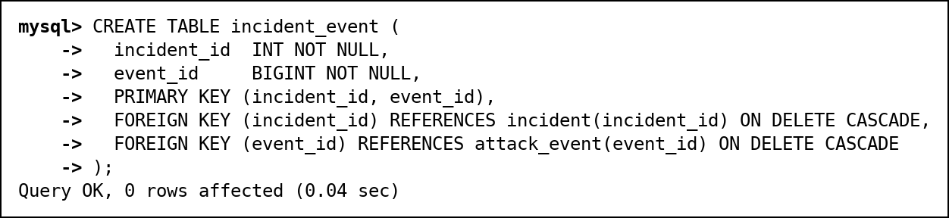
Fig. 16 CREATE TABLE incident_event executed in MySQL
Normal form: All-key table. 3NF.

Table: ioc
Indicators of compromise. valid_from/valid_to say when it was hostile and recorded_from/recorded_to say when we knew. Triggers keep the history append-only.
Attribute | Data Type | Constraint
ioc_version_id | BIGINT | PRIMARY KEY, AUTO_INCREMENT
ioc_type | ENUM('ip','domain','hash','url') | NOT NULL; CHECK (ioc_type <> 'ip' OR ioc_value REGEXP '^[0-9]{1,3}([.][0-9]{1,3}){3}$')
ioc_value | VARCHAR(255) | NOT NULL; Indexed (idx_value: ioc_value)
actor_id | INT | FOREIGN KEY to threat_actor(actor_id)
malware_id | INT | FOREIGN KEY to malware(malware_id)
valid_from | DATETIME | NOT NULL; CHECK (valid_to IS NULL OR valid_to > valid_from)
valid_to | DATETIME | NULL allowed
recorded_from | DATETIME | NOT NULL DEFAULT CURRENT_TIMESTAMP; CHECK (recorded_to IS NULL OR recorded_to > recorded_from)
recorded_to | DATETIME | NULL allowed

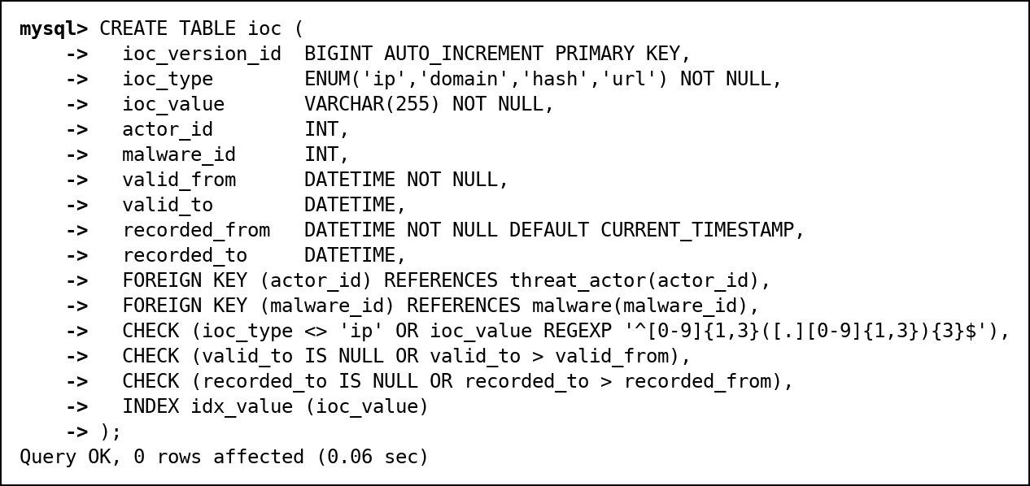
Fig. 17 CREATE TABLE ioc executed in MySQL
Normal form: Everything depends on ioc_version_id. 3NF.

Table: event_ioc
Link table for MATCHES (M:N between attacks and indicators).
Attribute | Data Type | Constraint
event_id | BIGINT | NOT NULL; Part of composite PRIMARY KEY (event_id, ioc_version_id); FOREIGN KEY to attack_event(event_id), on delete cascade
ioc_version_id | BIGINT | NOT NULL; Part of composite PRIMARY KEY (event_id, ioc_version_id); FOREIGN KEY to ioc(ioc_version_id)

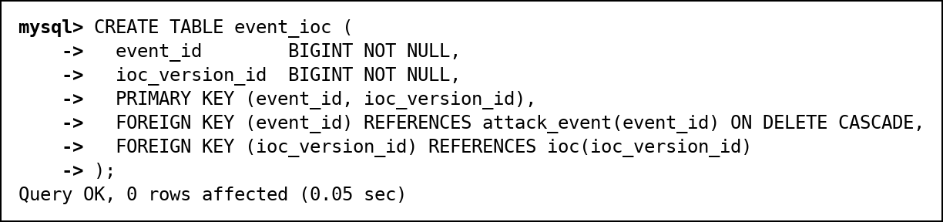
Fig. 18 CREATE TABLE event_ioc executed in MySQL
Normal form: All-key table. 3NF.

Table: retro_hunt_run
One row per automatic search of old logs. incident_id is UNIQUE (1:1 OPENS).
Attribute | Data Type | Constraint
run_id | INT | PRIMARY KEY, AUTO_INCREMENT
ioc_version_id | BIGINT | NOT NULL; FOREIGN KEY to ioc(ioc_version_id)
started_at | DATETIME | NOT NULL DEFAULT CURRENT_TIMESTAMP
incident_id | INT | UNIQUE; FOREIGN KEY to incident(incident_id)

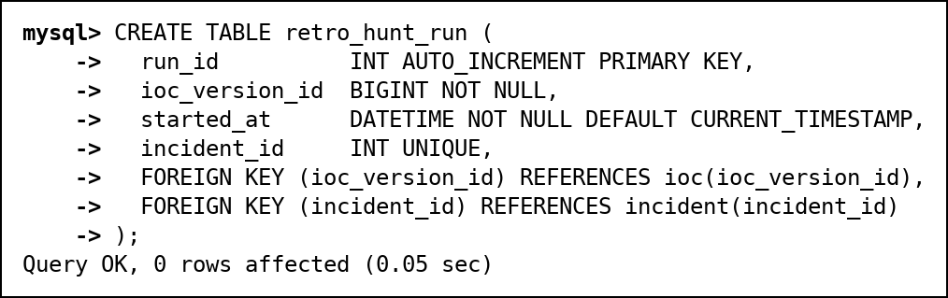
Fig. 19 CREATE TABLE retro_hunt_run executed in MySQL
Normal form: Everything depends on run_id; counts come from v_retro_hunt_summary instead of being stored. 3NF.

Table: retro_hit
Link table for HITS: the old log lines a retro-hunt found.
Attribute | Data Type | Constraint
run_id | INT | NOT NULL; Part of composite PRIMARY KEY (run_id, log_id); FOREIGN KEY to retro_hunt_run(run_id), on delete cascade
log_id | BIGINT | NOT NULL; Part of composite PRIMARY KEY (run_id, log_id); FOREIGN KEY to network_log(log_id)

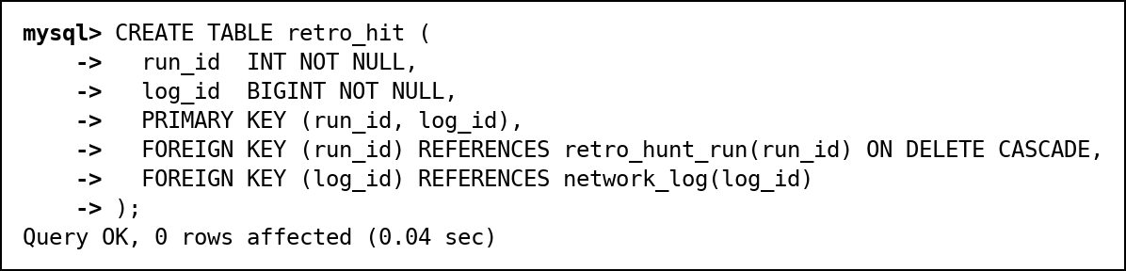
Fig. 20 CREATE TABLE retro_hit executed in MySQL
Normal form: All-key table. 3NF.

Table: incident_audit
Added in Review 3. One row per change to an incident, written by triggers: who made it (USER()), when, and the old and new status, priority and owner. It has no foreign key on purpose, so the trail outlives a deleted incident, and two more triggers make it append-only.
Attribute | Data Type | Constraint
audit_id | BIGINT | PRIMARY KEY, AUTO_INCREMENT
incident_id | INT | NOT NULL; Indexed (idx_incident: incident_id, changed_at)
action | ENUM('UPDATE','DELETE') | NOT NULL
changed_by | VARCHAR(288) | NOT NULL
changed_at | DATETIME(6) | NOT NULL DEFAULT CURRENT_TIMESTAMP(6)
old_status | ENUM('OPEN','INVESTIGATING','CONTAINED','CLOSED') | NULL allowed
new_status | ENUM('OPEN','INVESTIGATING','CONTAINED','CLOSED') | NULL allowed
old_priority | ENUM('LOW','MEDIUM','HIGH','CRITICAL') | NULL allowed
new_priority | ENUM('LOW','MEDIUM','HIGH','CRITICAL') | NULL allowed
old_assigned_to | INT | NULL allowed
new_assigned_to | INT | NULL allowed

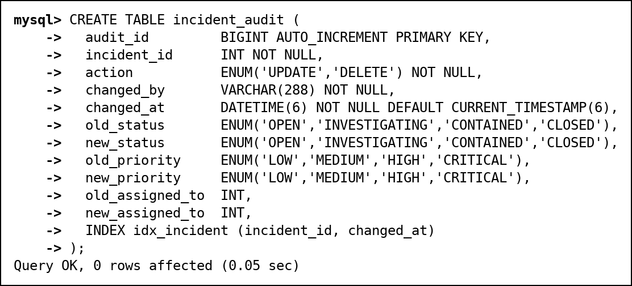
Fig. 21 CREATE TABLE incident_audit executed in MySQL
Normal form: Everything depends on audit_id; the old and new values describe one change. 3NF.

10. Data Population (INSERT, UPDATE, DELETE)
The data is a hand-made test set, small enough to check every result by hand, plus 50,000 generated background log lines so the index comparison in section 14 is meaningful. Attacker IPs come from the address ranges reserved for documentation (192.0.2.0/24, 198.51.100.0/24, 203.0.113.0/24), so no real address is marked as bad. The CVE IDs are real. The full script is 02_dml.sql; one INSERT per table type is shown here.

INSERT
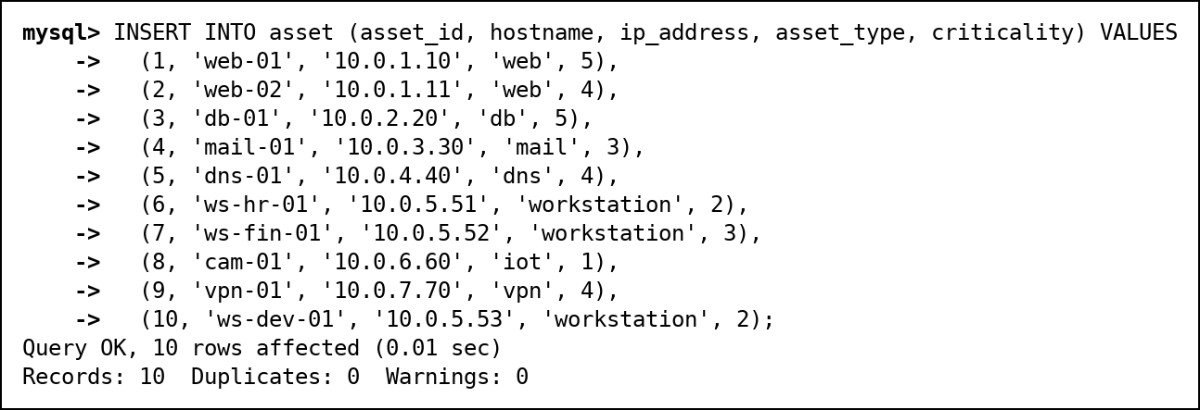
Fig. 22 INSERT of the 10 assets
The other 14 tables are filled the same way, with explicit keys so the links between tables are predictable. The background log lines are generated with a recursive CTE in one statement:
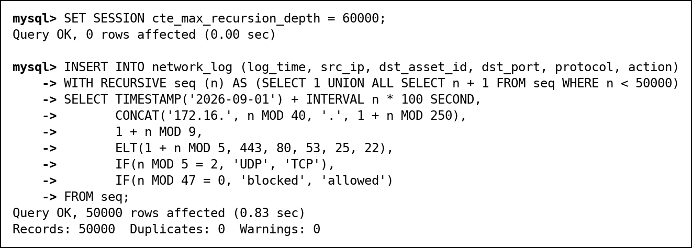
Fig. 23 Generating 50,000 background log lines with a recursive CTE

UPDATE
Attacks 25 and 26 have not been triaged yet. An analyst sets their triage priority: attack 25 has severity 7 but was blocked, so it becomes MEDIUM; attack 26 (severity 4, blocked) becomes LOW.
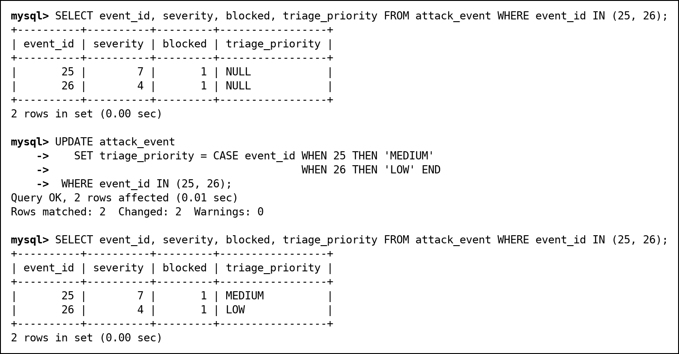
Fig. 24 UPDATE of triage_priority, before and after

DELETE
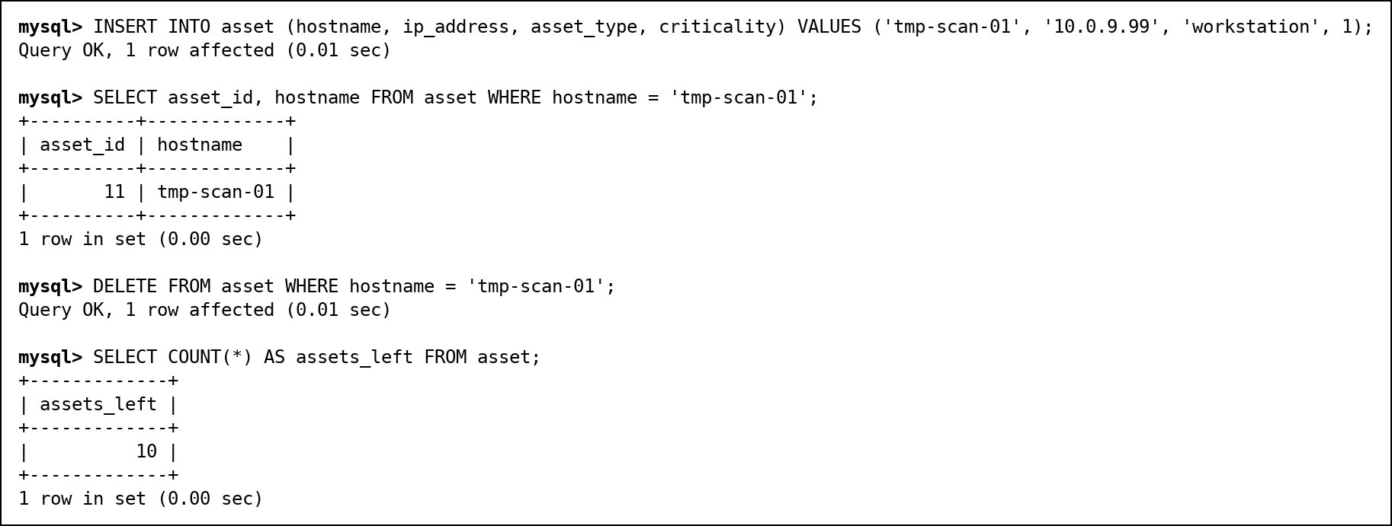
Fig. 25 INSERT and DELETE of a temporary asset

Constraints in action
Each statement below breaks one rule on purpose, and MySQL rejects it: a CHECK (criticality 9), a UNIQUE (duplicate hostname), a FOREIGN KEY on insert (type 99 does not exist), a FOREIGN KEY on delete (web-01 still has attacks), and the table-level CHECK that only closed incidents have a closed_at.
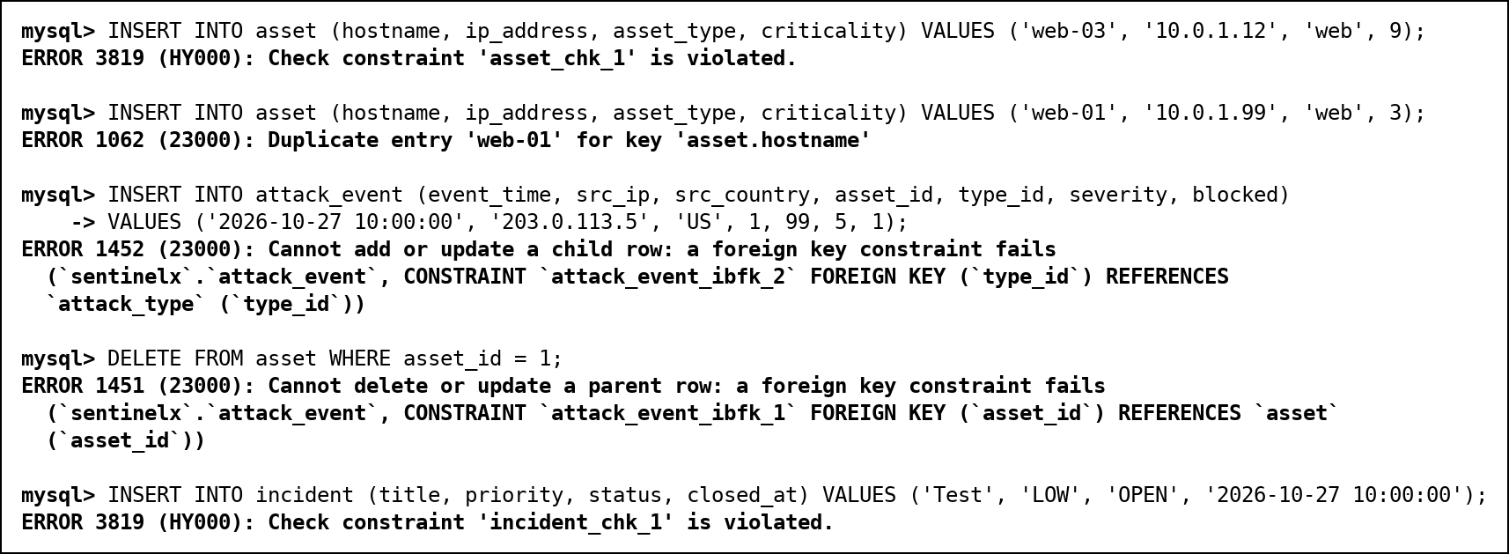
Fig. 26 Five rejected statements, one per constraint

Row counts
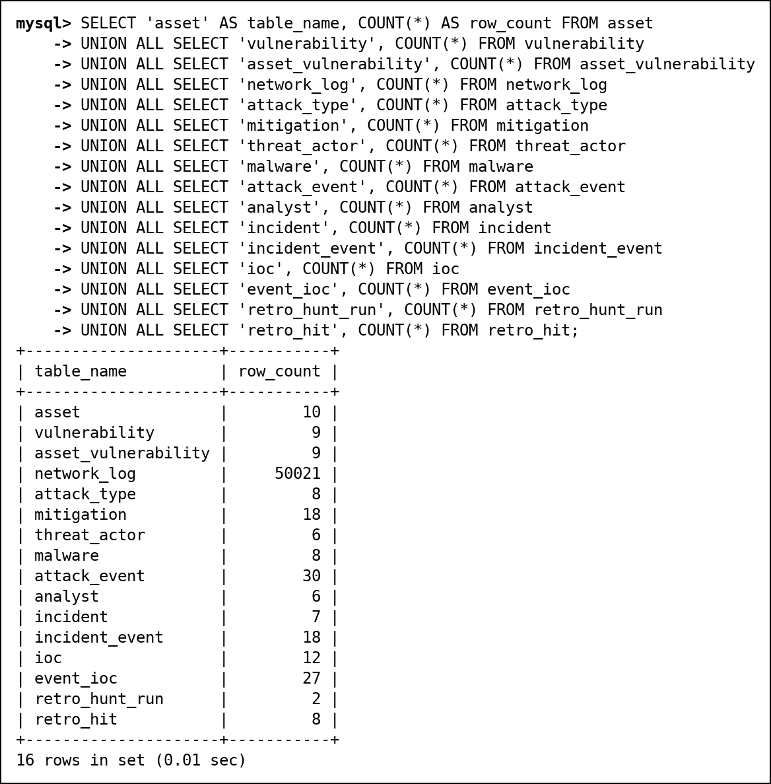
Fig. 27 Row count of every table after loading

11. SQL Implementation
Every query below was run on the loaded database, and each screenshot shows the statement together with its real output. The table shows how the 40 queries cover what the review requires.
Category | Required coverage | Min | Done | Query IDs
A. Basic queries | SELECT, WHERE, ORDER BY, DISTINCT, BETWEEN, IN, LIKE, IS NULL | 6 | 7 | A1, A2, A3, A4, A5, A6, A7
B. Aggregate queries | COUNT, SUM, AVG, MIN, MAX, GROUP BY, HAVING (WHERE vs HAVING in B5) | 5 | 6 | B1, B2, B3, B4, B5, B6
C. Joins | INNER, LEFT, RIGHT, FULL OUTER (emulated with UNION), SELF, CROSS | 6 | 6 | C1, C2, C3, C4, C5, C6
D. Subqueries | Scalar, single-row, multi-row (IN, ANY, ALL), correlated, EXISTS, NOT EXISTS, NOT IN with the NULL pitfall | 6 | 9 | D1, D2, D3, D4, D5, D6, D7, D8, D9
E. Set operations | UNION, UNION ALL, INTERSECT, EXCEPT | 4 | 4 | E1, E2, E3, E4
F. Advanced functions | CASE, COALESCE, NULLIF, date/time, string and numeric functions | 6 | 6 | F1, F2, F3, F4, F5, F6
G. Window functions | RANK, DENSE_RANK, ROW_NUMBER, running total, LAG, LEAD | 2 | 3 | G1, G2, G3

11.1 A. Basic queries
A1. Critical assets (criticality 4 or 5), most critical first
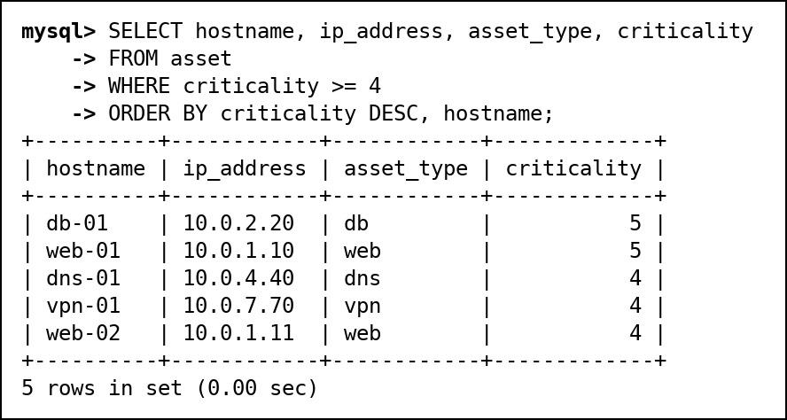
Fig. 28 A1: Critical assets (criticality 4 or 5), most critical first
A2. Countries that attacks came from (DISTINCT)
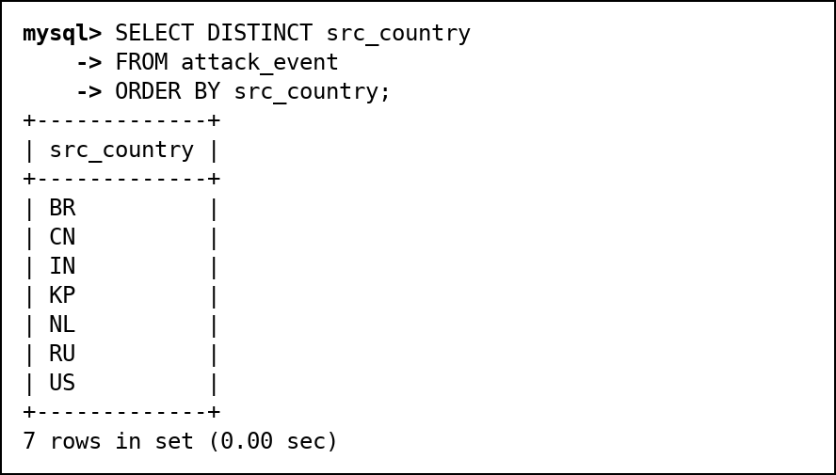
Fig. 29 A2: Countries that attacks came from (DISTINCT)
A3. Attacks between 10 and 14 October (BETWEEN)
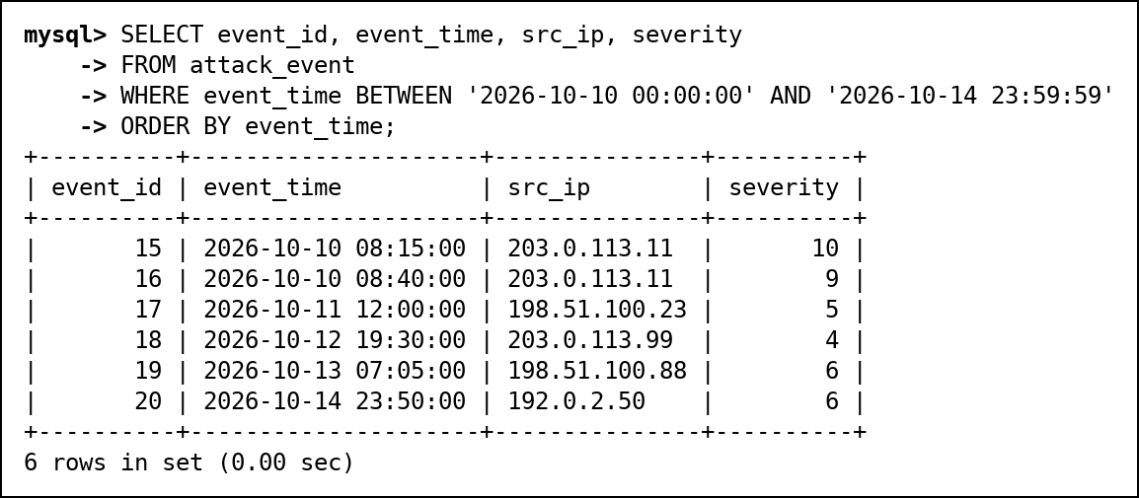
Fig. 30 A3: Attacks between 10 and 14 October (BETWEEN)
A4. Internet-facing servers: web, db and vpn assets (IN)
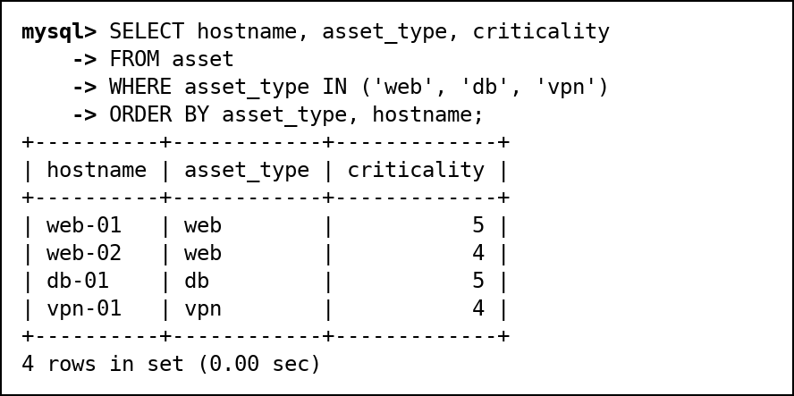
Fig. 31 A4: Internet-facing servers: web, db and vpn assets (IN)
A5. CVEs published in 2023 (LIKE)
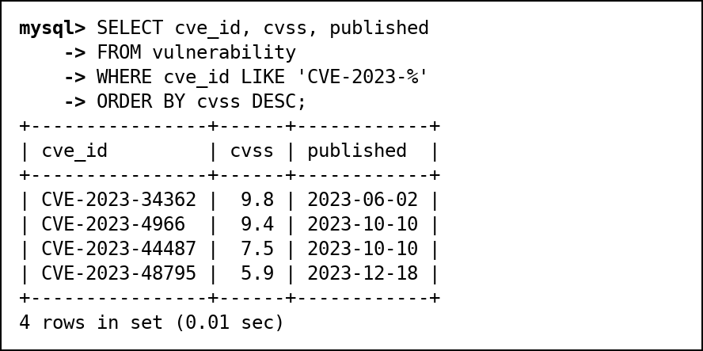
Fig. 32 A5: CVEs published in 2023 (LIKE)
A6. Incidents nobody owns yet (IS NULL)
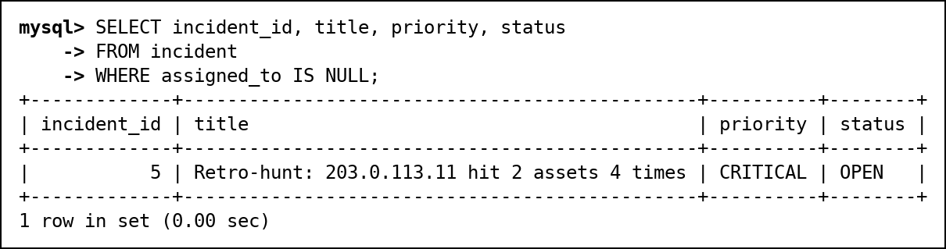
Fig. 33 A6: Incidents nobody owns yet (IS NULL)
A7. Attacks no analyst has triaged yet (IS NULL)
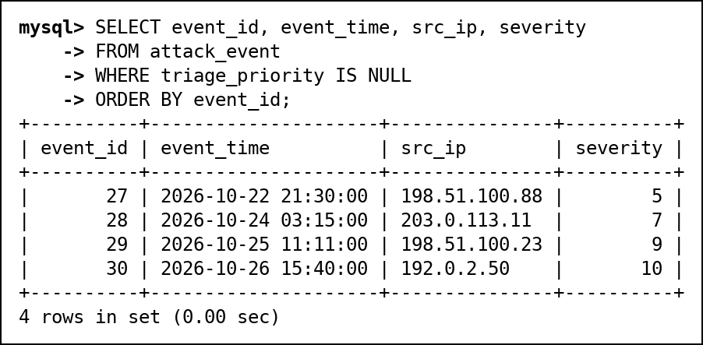
Fig. 34 A7: Attacks no analyst has triaged yet (IS NULL)

11.2 B. Aggregate queries
B1. Number of attacks per attack type (COUNT, GROUP BY)
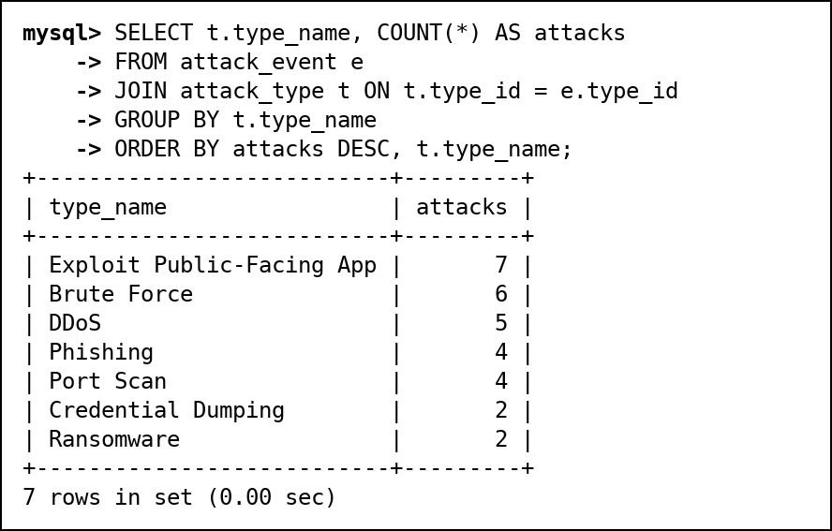
Fig. 35 B1: Number of attacks per attack type (COUNT, GROUP BY)
B2. Attacks, blocked attacks and average severity per asset (SUM, AVG)
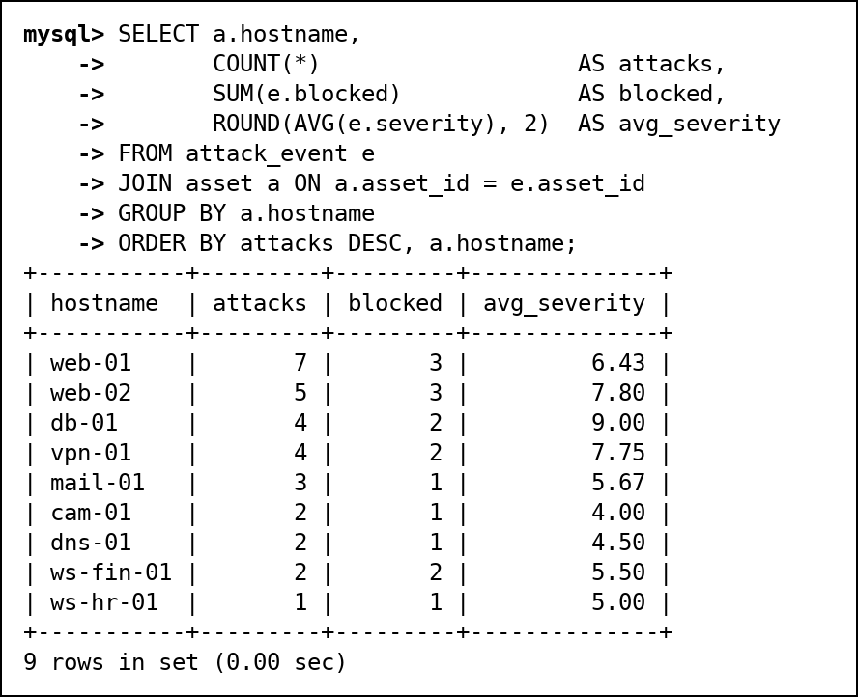
Fig. 36 B2: Attacks, blocked attacks and average severity per asset (SUM, AVG)
B3. First and last attack and worst severity per source country (MIN, MAX)
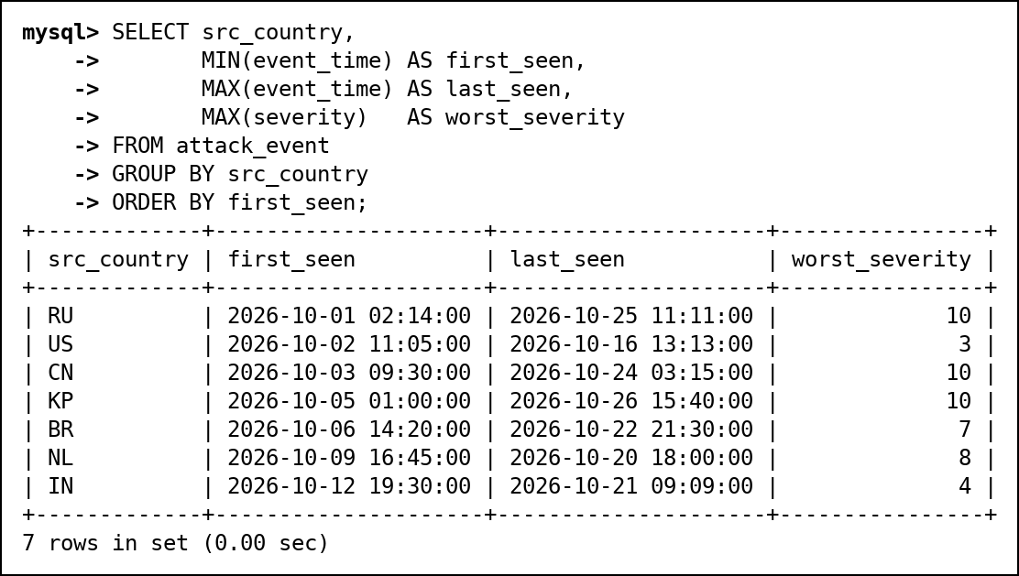
Fig. 37 B3: First and last attack and worst severity per source country (MIN, MAX)
B4. Source IPs with more than 3 attacks (HAVING)
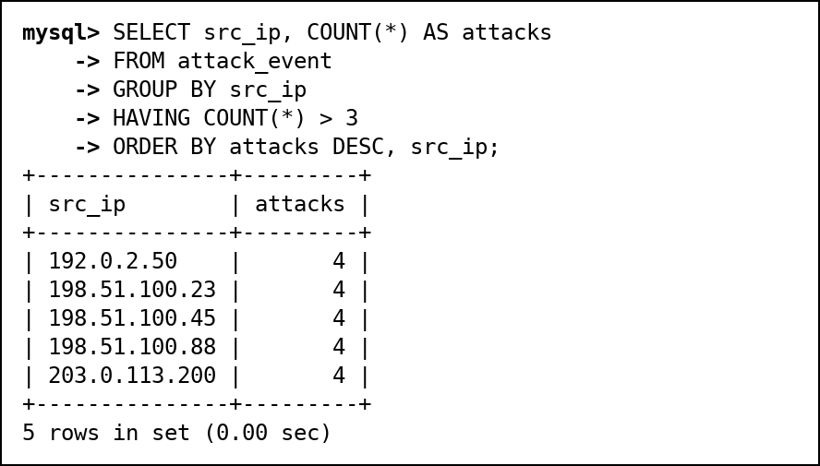
Fig. 38 B4: Source IPs with more than 3 attacks (HAVING)
B5. WHERE vs HAVING: assets with 2 or more serious attacks
WHERE removes attacks below severity 7 before any grouping happens; HAVING then removes whole groups (assets) that end up with fewer than 2 rows. Moving the severity filter into HAVING would not work, because severity is not a group-level value.
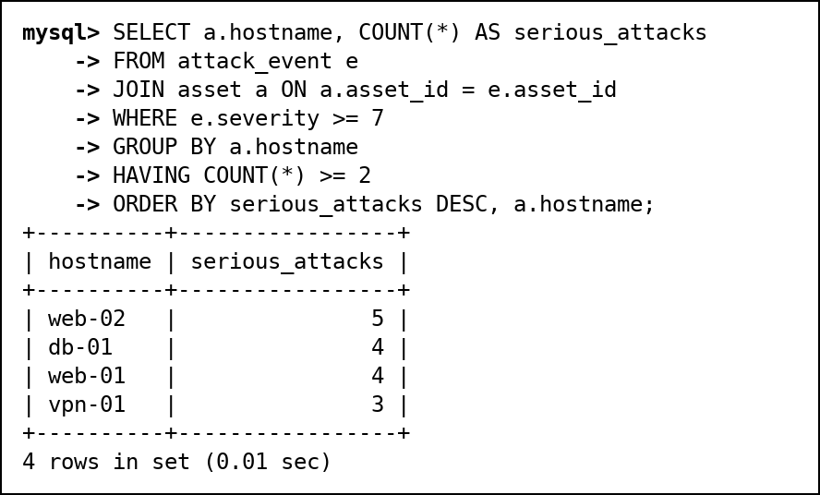
Fig. 39 B5: WHERE vs HAVING: assets with 2 or more serious attacks
B6. CVSS statistics by year of publication
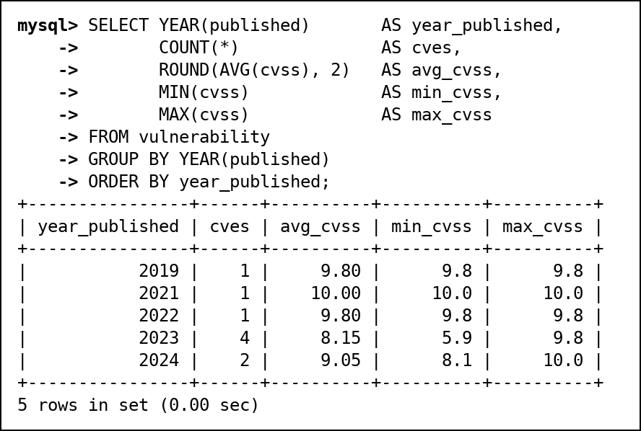
Fig. 40 B6: CVSS statistics by year of publication

11.3 C. Joins
C1. INNER JOIN: attacks of severity 9 or more with asset and attack type
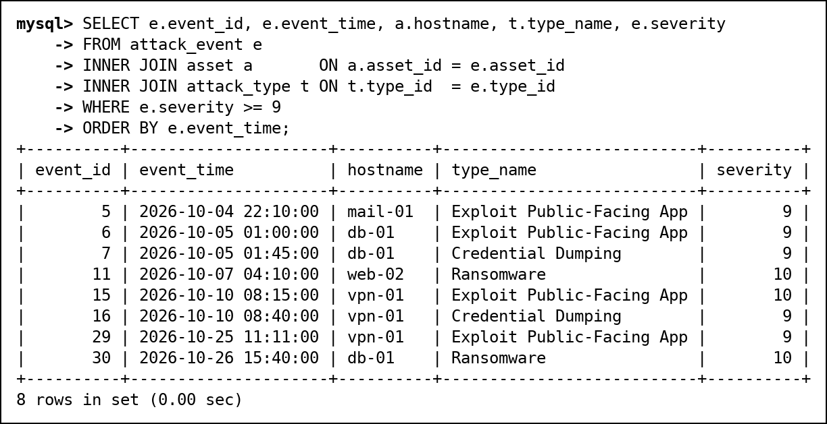
Fig. 41 C1: INNER JOIN: attacks of severity 9 or more with asset and attack type
C2. LEFT JOIN: every asset with its number of attacks, including assets never attacked
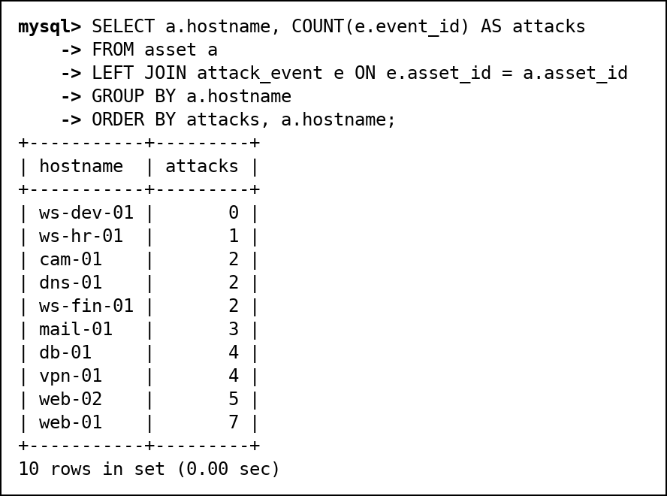
Fig. 42 C2: LEFT JOIN: every asset with its number of attacks, including assets never attacked
C3. RIGHT JOIN: every analyst with the incidents they own, including analysts with none
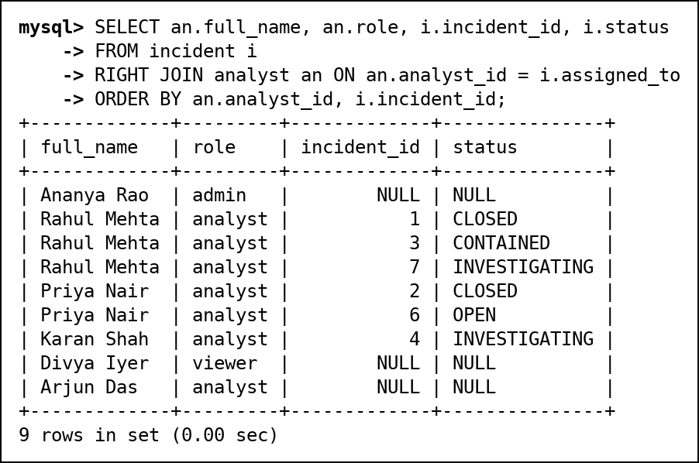
Fig. 43 C3: RIGHT JOIN: every analyst with the incidents they own, including analysts with none
C4. FULL OUTER JOIN emulation: threat actors and malware, keeping both unmatched sides
MySQL has no FULL OUTER JOIN, so it is emulated as LEFT JOIN UNION RIGHT JOIN. The result keeps Byte Bandits (no malware) and OrphanMiner (no known actor).
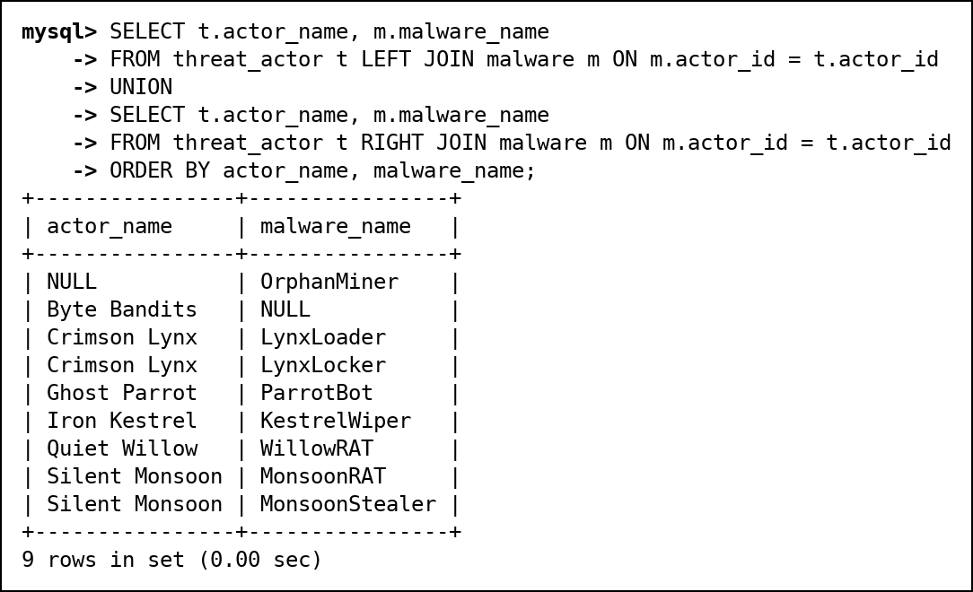
Fig. 44 C4: FULL OUTER JOIN emulation: threat actors and malware, keeping both unmatched sides
C5. SELF JOIN: pairs of malware used by the same threat actor
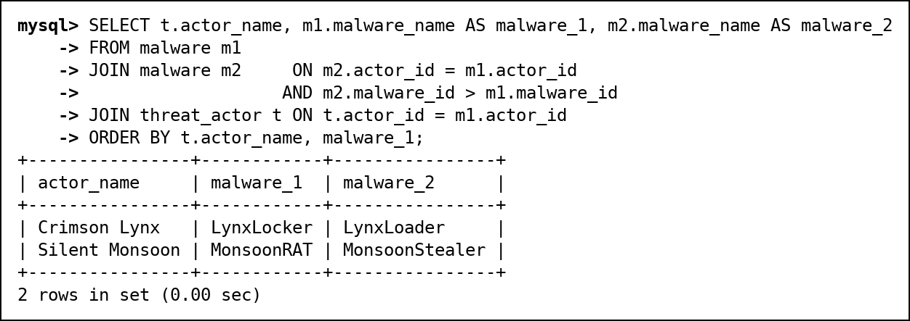
Fig. 45 C5: SELF JOIN: pairs of malware used by the same threat actor
C6. CROSS JOIN: hardening checklist of every criticality-5 asset against every severe attack type
A meaningful CROSS JOIN: every criticality-5 asset is paired with every attack type of base severity 8 or more, to produce a hardening checklist. Zero means the combination has not been seen yet.
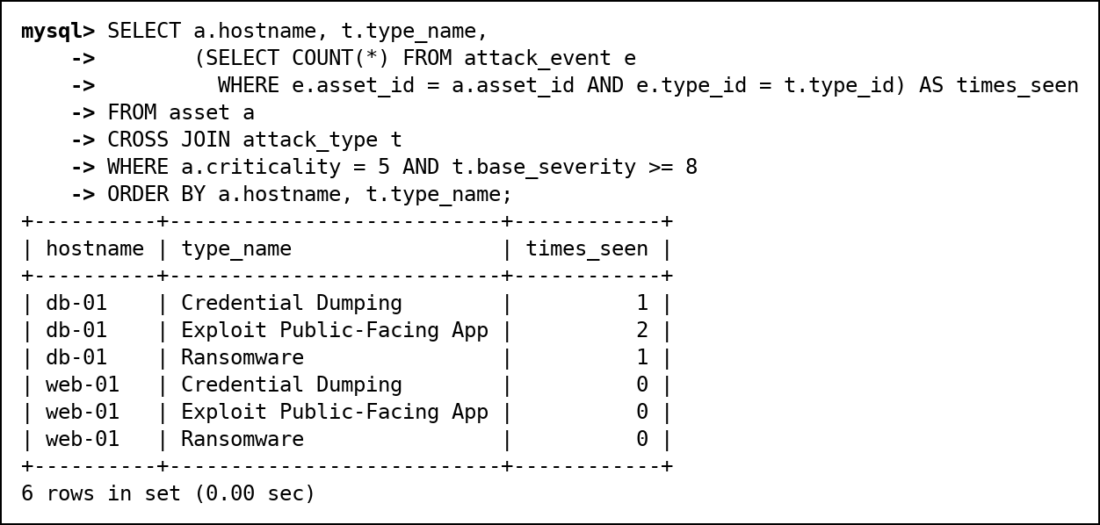
Fig. 46 C6: CROSS JOIN: hardening checklist of every criticality-5 asset against every severe attack type

11.4 D. Subqueries
D1. Scalar subquery: CVEs scoring above the average CVSS
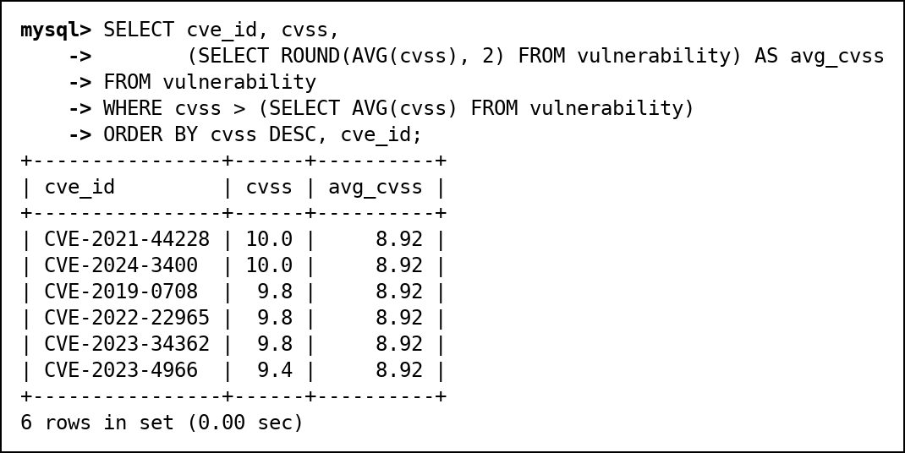
Fig. 47 D1: Scalar subquery: CVEs scoring above the average CVSS
D2. Single-row subquery: the analyst who owns the most recently opened incident
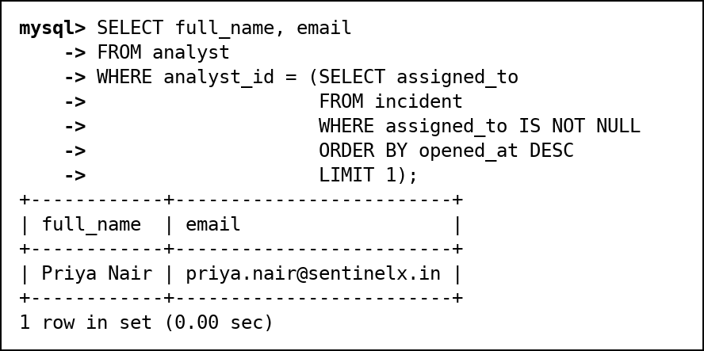
Fig. 48 D2: Single-row subquery: the analyst who owns the most recently opened incident
D3. Multi-row subquery with IN: assets that have been hit by ransomware
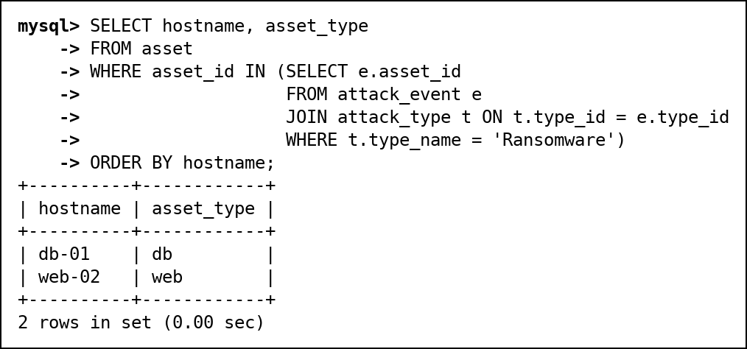
Fig. 49 D3: Multi-row subquery with IN: assets that have been hit by ransomware
D4. Multi-row subquery with ALL: CVEs scoring higher than every CVE on web-02 and mail-01
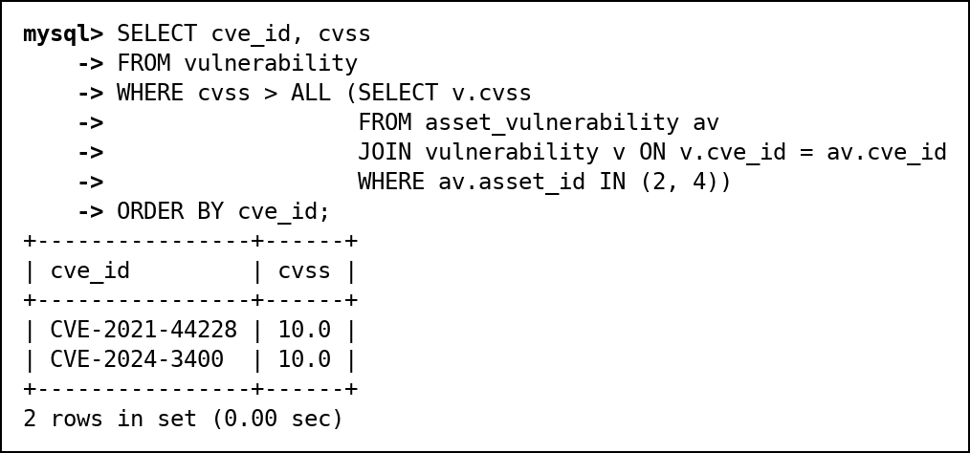
Fig. 50 D4: Multi-row subquery with ALL: CVEs scoring higher than every CVE on web-02 and mail-01
D5. Multi-row subquery with ANY: CVEs scoring higher than at least one CVE used by Russian sources
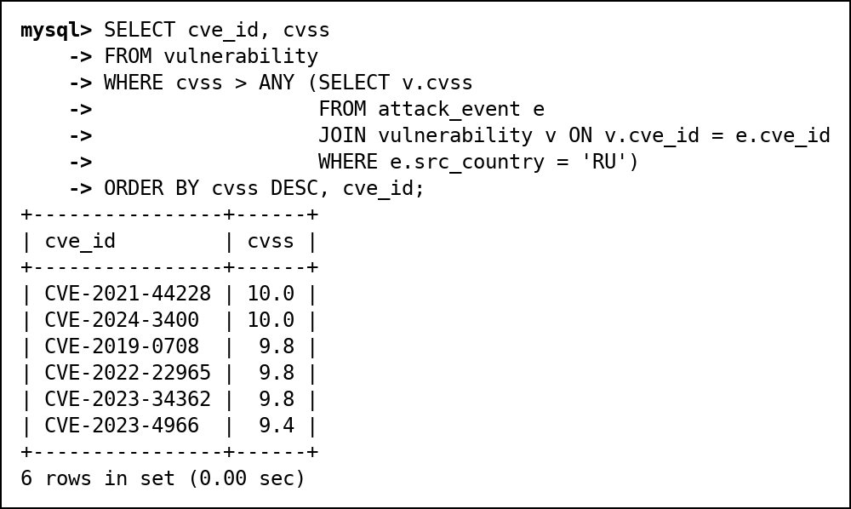
Fig. 51 D5: Multi-row subquery with ANY: CVEs scoring higher than at least one CVE used by Russian sources
D6. Correlated subquery: the worst attack(s) on each asset
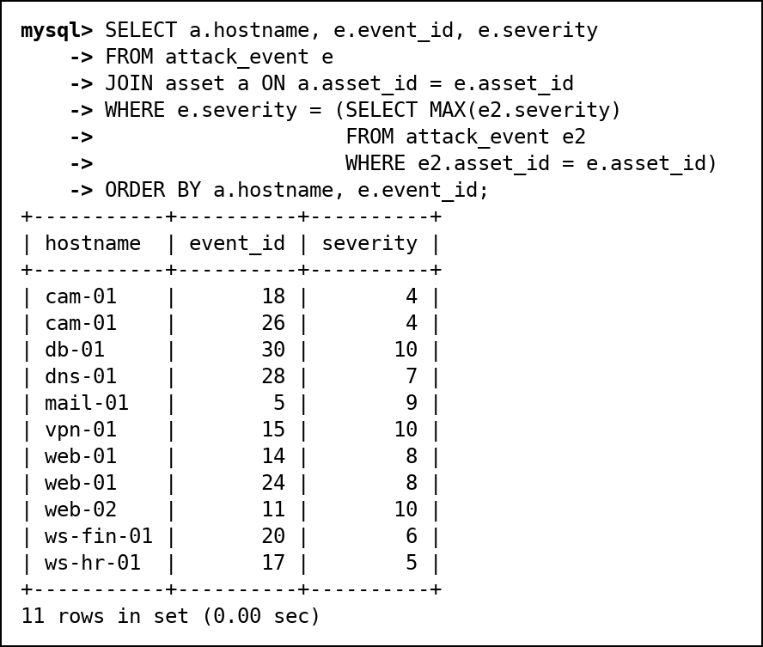
Fig. 52 D6: Correlated subquery: the worst attack(s) on each asset
D7. EXISTS: threat actors with at least one attack that was not blocked
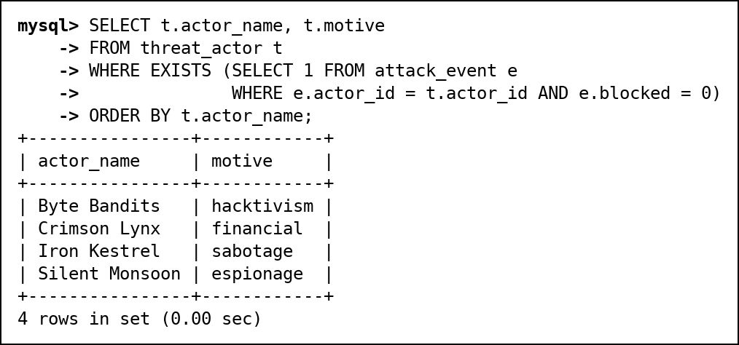
Fig. 53 D7: EXISTS: threat actors with at least one attack that was not blocked
D8. NOT EXISTS: assets that have never been attacked
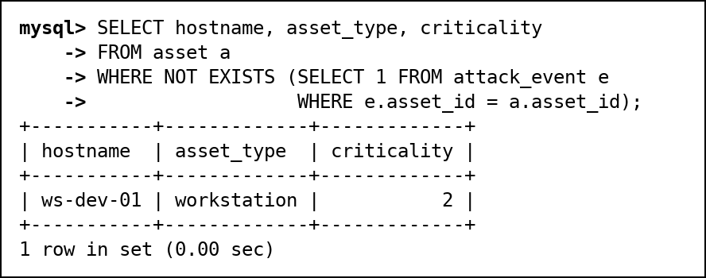
Fig. 54 D8: NOT EXISTS: assets that have never been attacked
D9. NOT IN and the NULL pitfall: threat actors with no malware
The NULL pitfall: malware.actor_id contains a NULL (OrphanMiner). x NOT IN (..., NULL) is never TRUE, so the first query returns no rows at all. Filtering out NULLs in the subquery (or using NOT EXISTS) gives the correct answer, Byte Bandits.
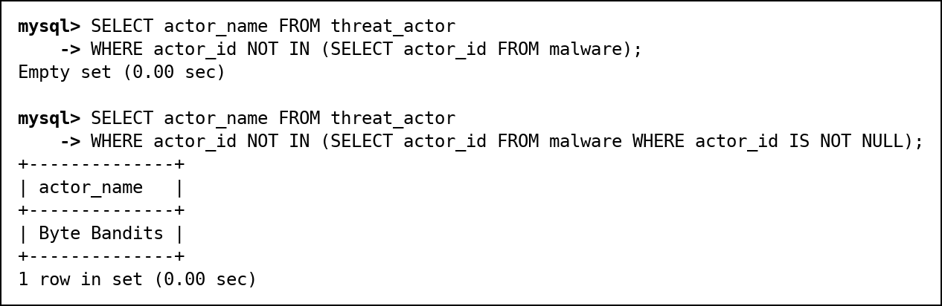
Fig. 55 D9: NOT IN and the NULL pitfall: threat actors with no malware

11.5 E. Set operations
E1. UNION: every country we know about, as an attack source or as an attacker's origin
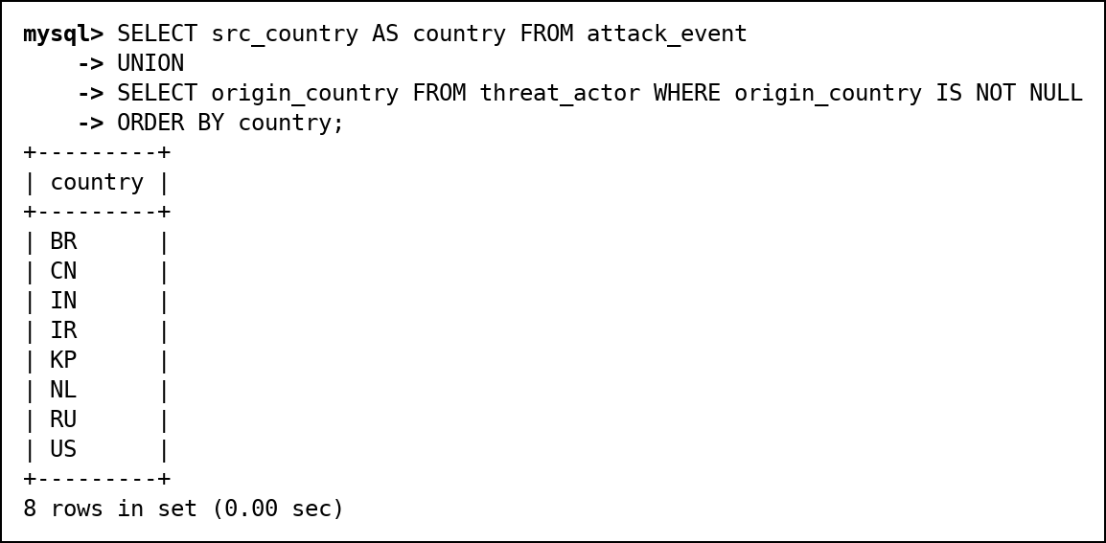
Fig. 56 E1: UNION: every country we know about, as an attack source or as an attacker's origin
E2. UNION ALL: full activity timeline of 198.51.100.45 across attacks and raw logs
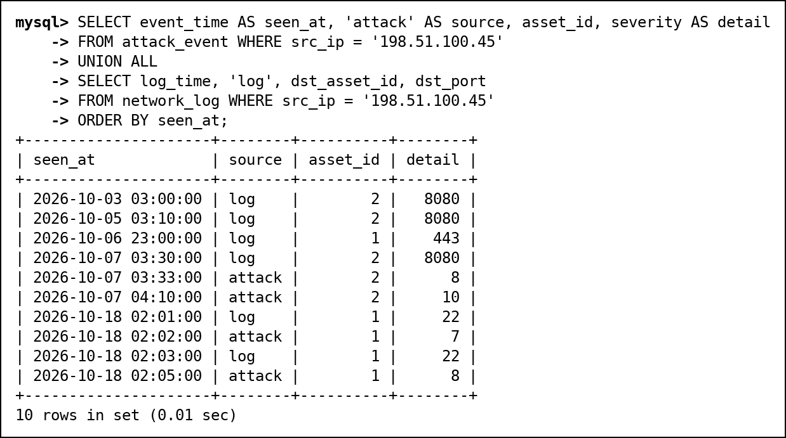
Fig. 57 E2: UNION ALL: full activity timeline of 198.51.100.45 across attacks and raw logs
E3. INTERSECT: attack sources that are also known bad IPs
INTERSECT and EXCEPT are native in MySQL 8.0.31 and later; we ran them on 8.0.46.
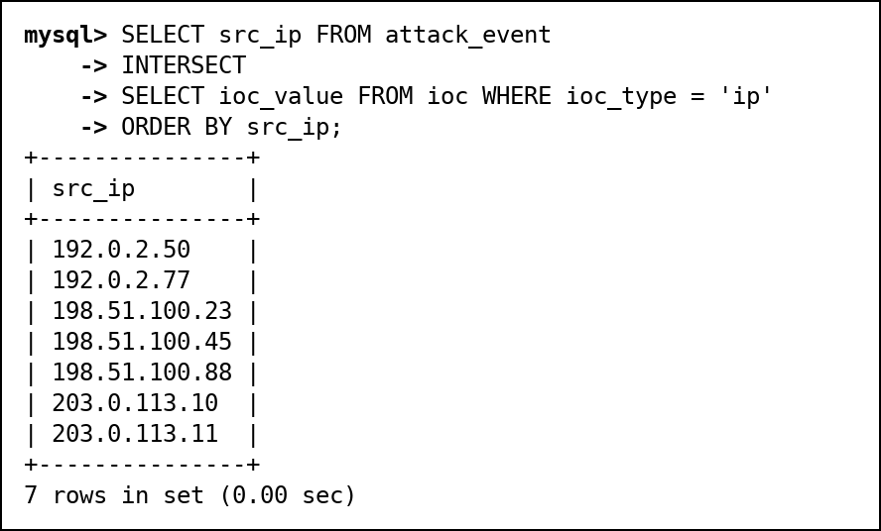
Fig. 58 E3: INTERSECT: attack sources that are also known bad IPs
E4. EXCEPT: attack sources that are not on the indicator list yet
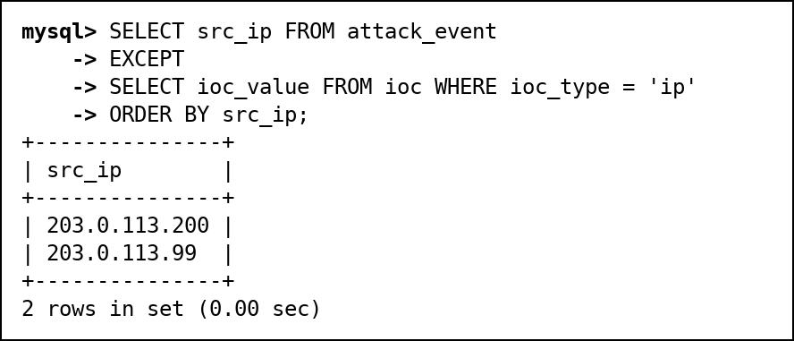
Fig. 59 E4: EXCEPT: attack sources that are not on the indicator list yet

11.6 F. Advanced functions
F1. CASE: severity label from CVSS score
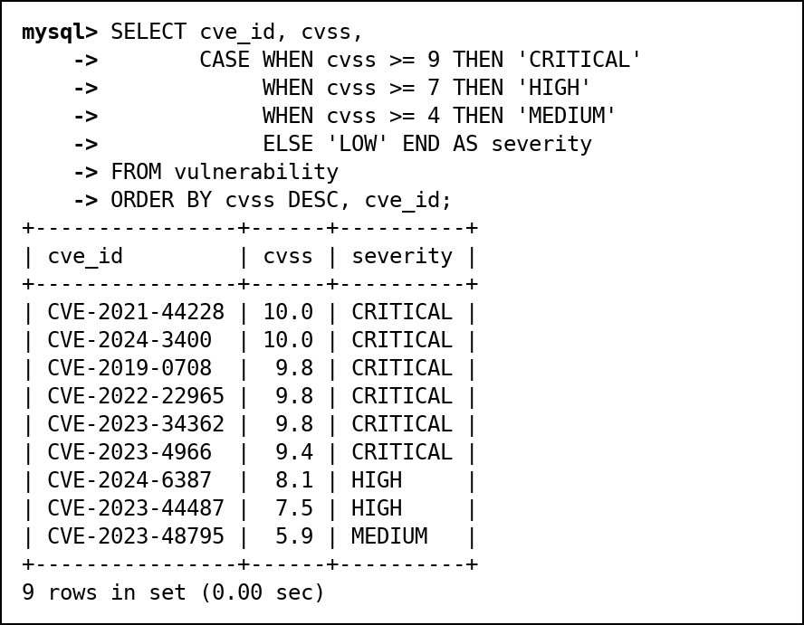
Fig. 60 F1: CASE: severity label from CVSS score
F2. COALESCE: recent attacks with 'Unattributed' instead of a missing actor
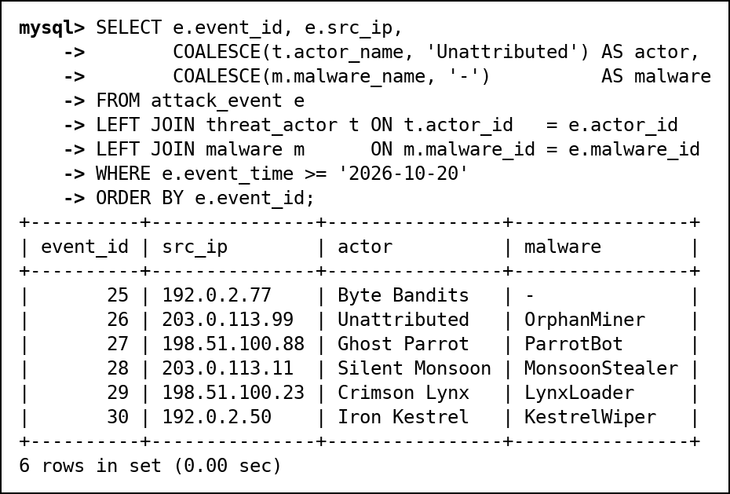
Fig. 61 F2: COALESCE: recent attacks with 'Unattributed' instead of a missing actor
F3. NULLIF: share of blocked attacks per asset without dividing by zero
NULLIF turns a zero count into NULL, so ws-dev-01 (never attacked) shows NULL instead of a division-by-zero.
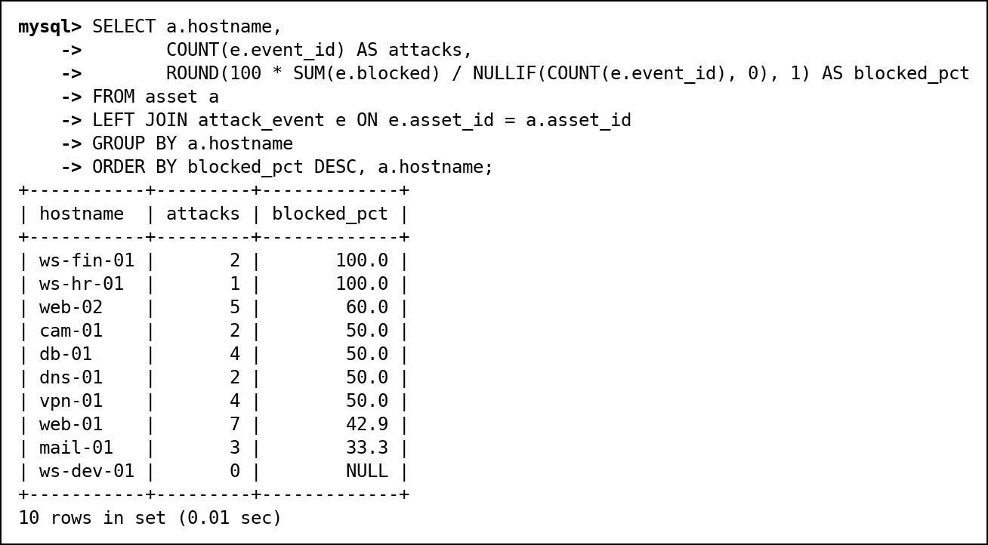
Fig. 62 F3: NULLIF: share of blocked attacks per asset without dividing by zero
F4. Date and time functions: how long each incident has been or was open
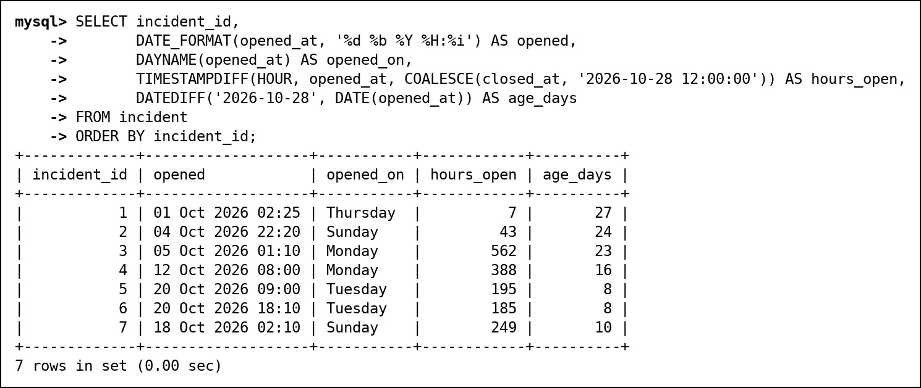
Fig. 63 F4: Date and time functions: how long each incident has been or was open
F5. String functions: analyst user names and short names
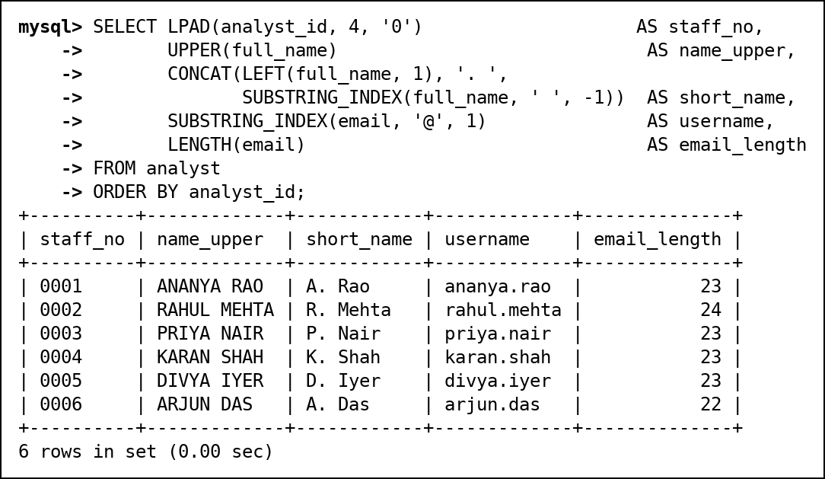
Fig. 64 F5: String functions: analyst user names and short names
F6. Numeric functions on CVSS scores
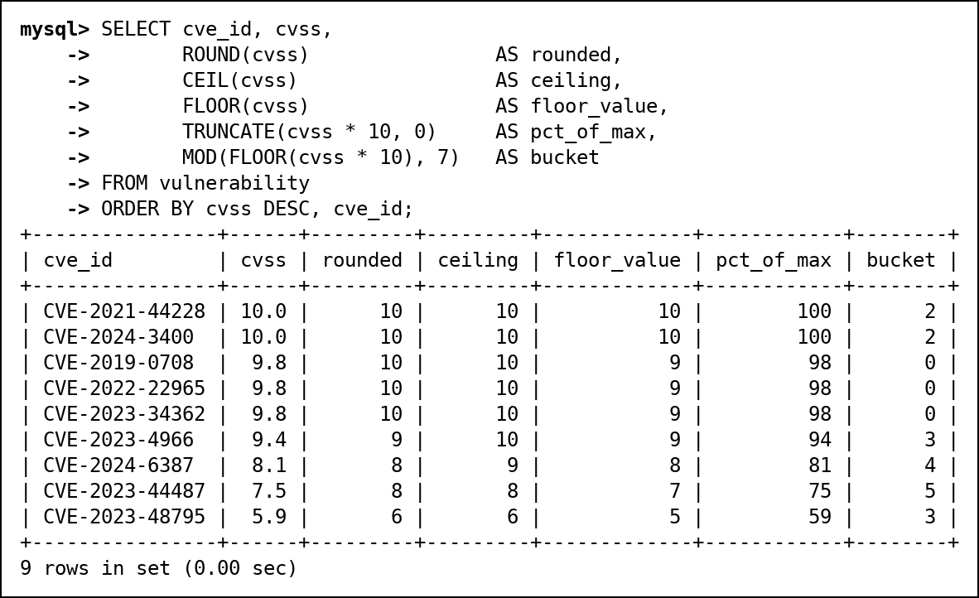
Fig. 65 F6: Numeric functions on CVSS scores

11.7 G. Window functions
G1. RANK, DENSE_RANK and ROW_NUMBER: assets ranked by number of attacks
RANK leaves gaps after ties (3, 3, 5), DENSE_RANK does not (3, 3, 4), and ROW_NUMBER is always unique.
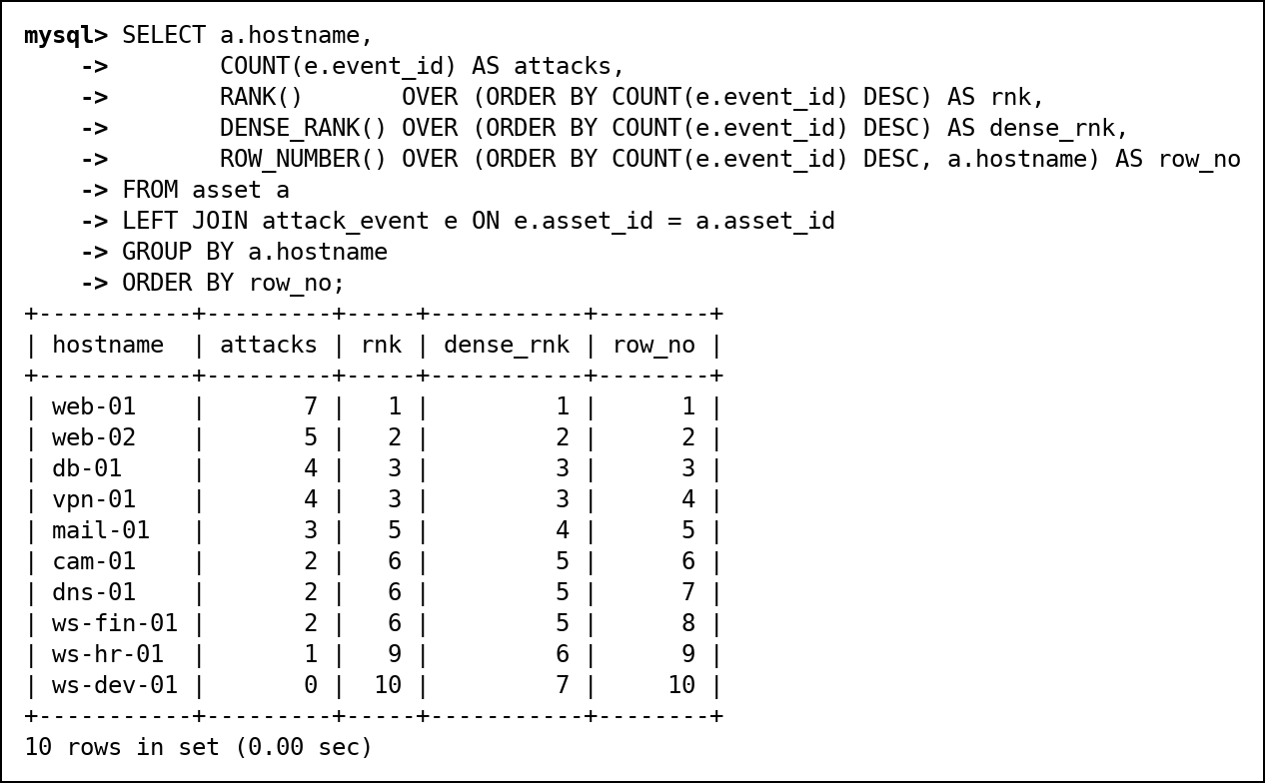
Fig. 66 G1: RANK, DENSE_RANK and ROW_NUMBER: assets ranked by number of attacks
G2. Running total of attacks per day for the first ten days of October
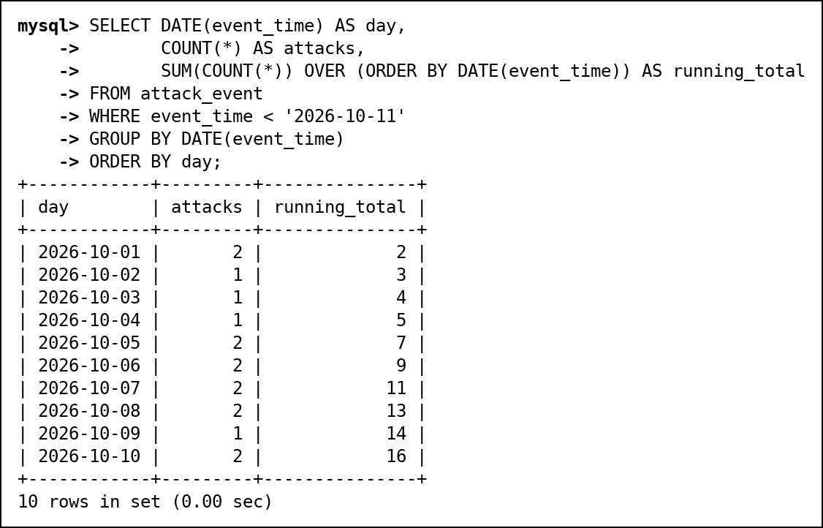
Fig. 67 G2: Running total of attacks per day for the first ten days of October
G3. LAG and LEAD: minutes between attacks from the same Russian source IP
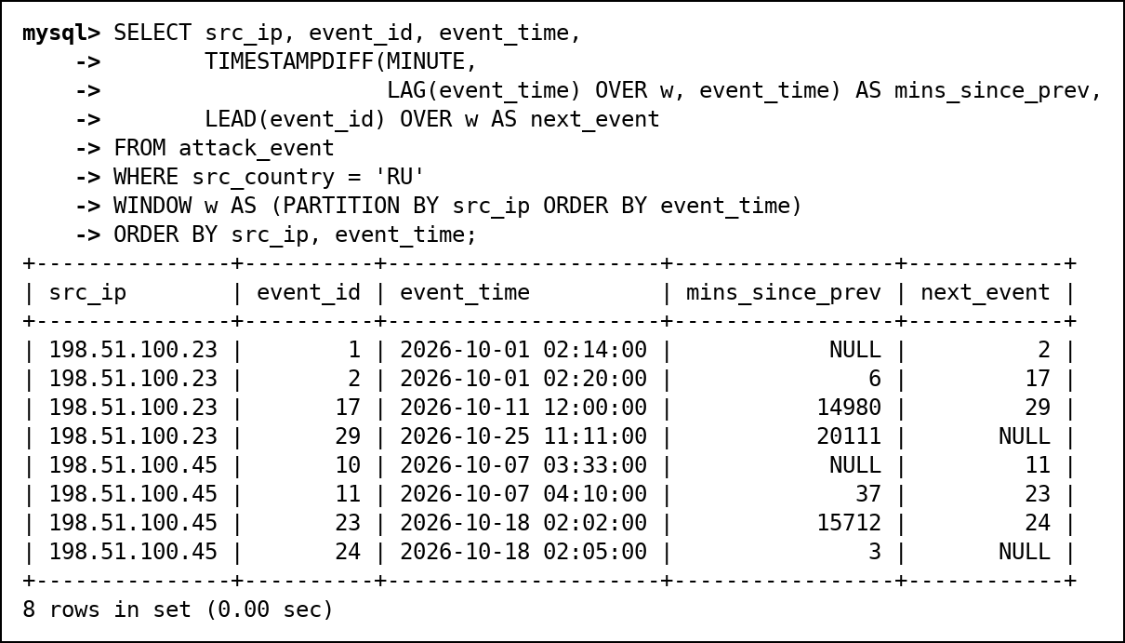
Fig. 68 G3: LAG and LEAD: minutes between attacks from the same Russian source IP

12. Advanced SQL Implementation

12.1 Complex Business Queries
Each query uses at least three tables or a nested or analytic construct. The expected output was worked out by hand from the test data before running; the actual output is the screenshot. All 11 matched.
CQ-01
Field | Content
ID | CQ-01
Business question | Which threat actor is behind the most serious attacks (severity 8+) on our important assets (criticality 4+)?
SQL | SELECT t.actor_name, t.motive,  COUNT(*) AS serious_attacks,  COUNT(DISTINCT e.asset_id) AS assets_hit,  MAX(e.severity) AS worst  FROM attack_event e  JOIN threat_actor t ON t.actor_id = e.actor_id  JOIN asset a ON a.asset_id = e.asset_id  WHERE e.severity >= 8 AND a.criticality >= 4  GROUP BY t.actor_id, t.actor_name, t.motive  ORDER BY serious_attacks DESC, t.actor_name;
Expected output | 4 rows. Crimson Lynx first with 4 serious attacks on 3 assets (events 10, 11, 24, 29); Iron Kestrel 3 on db-01; Silent Monsoon 3 on 2 assets; Byte Bandits 1. Ghost Parrot is absent because its worst attack is severity 7.
Actual output screenshot | Below (Fig. 69)
Explanation | Three tables: attack_event joined to threat_actor (drops unattributed attacks) and to asset. WHERE keeps severity 8+ on criticality 4+ assets before grouping by actor; COUNT(DISTINCT asset_id) counts assets, not attacks.

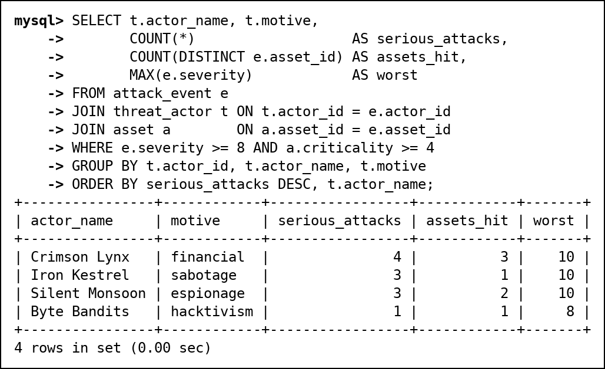
Fig. 69 CQ-01 actual output

CQ-02
Field | Content
ID | CQ-02
Business question | What does the board of incidents that are still not closed look like?
SQL | SELECT i.incident_id, i.priority, i.status,  COALESCE(an.full_name, 'Unassigned') AS owner,  COUNT(*) AS attacks,  MAX(e.severity) AS worst,  GROUP_CONCAT(DISTINCT a.hostname ORDER BY a.hostname) AS assets  FROM incident i  JOIN incident_event ie ON ie.incident_id = i.incident_id  JOIN attack_event e ON e.event_id = ie.event_id  JOIN asset a ON a.asset_id = e.asset_id  LEFT JOIN analyst an ON an.analyst_id = i.assigned_to  WHERE i.status <> 'CLOSED'  GROUP BY i.incident_id, i.priority, i.status, an.full_name  ORDER BY FIELD(i.priority, 'CRITICAL', 'HIGH', 'MEDIUM', 'LOW'), i.incident_id;
Expected output | 5 incidents (all except the closed 1 and 2): 4 and 5 CRITICAL, 3 and 7 HIGH, 6 MEDIUM. Incident 5 has no owner; incident 6 covers web-01 and web-02 with 5 attacks.
Actual output screenshot | Below (Fig. 70)
Explanation | Five tables. incident to incident_event to attack_event to asset gives the attacks and hosts; LEFT JOIN analyst keeps the unassigned incident and COALESCE prints "Unassigned". FIELD() sorts by priority order instead of alphabetically.

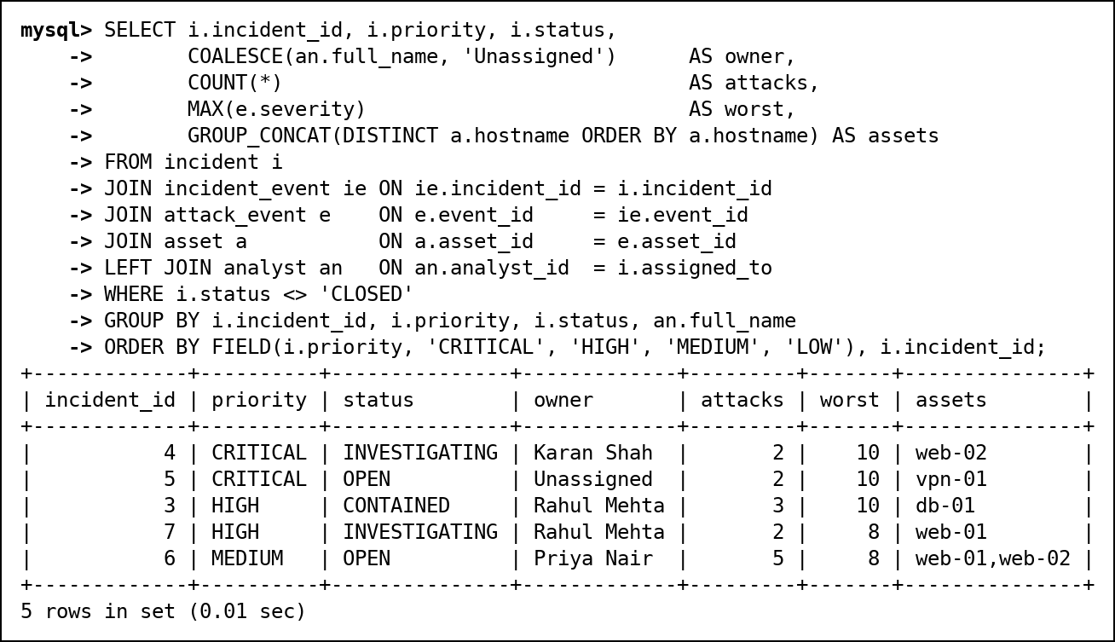
Fig. 70 CQ-02 actual output

CQ-03
Field | Content
ID | CQ-03
Business question | Which assets were attacked through a CVE they still have not patched?
SQL | SELECT a.hostname, e.event_id, e.cve_id, v.cvss, av.detected_at,  DATEDIFF('2026-10-28', av.detected_at) AS days_unpatched  FROM attack_event e  JOIN asset_vulnerability av ON av.asset_id = e.asset_id  AND av.cve_id = e.cve_id  AND av.patched_at IS NULL  JOIN vulnerability v ON v.cve_id = e.cve_id  JOIN asset a ON a.asset_id = e.asset_id  ORDER BY v.cvss DESC, a.hostname;
Expected output | 5 rows: vpn-01 (CVE-2024-3400), web-02, mail-01, web-01, dns-01. db-01 (MOVEit) and vpn-01 (regreSSHion) must not appear because they were patched before the attack.
Actual output screenshot | Below (Fig. 71)
Explanation | The join to asset_vulnerability uses both asset_id and cve_id plus patched_at IS NULL in the ON clause, so an attack only matches if that exact asset still had that exact CVE open. DATEDIFF gives days since detection.

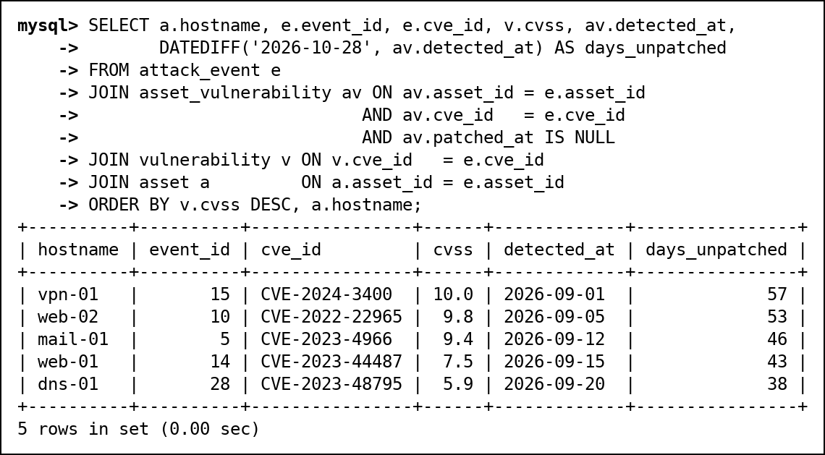
Fig. 71 CQ-03 actual output

CQ-04
Field | Content
ID | CQ-04
Business question | Which malware families cause the most attacks, and who uses them?
SQL | SELECT m.family,  COUNT(*) AS attacks,  GROUP_CONCAT(DISTINCT COALESCE(t.actor_name, 'Unknown')) AS used_by,  ROUND(100 * COUNT(*) / (SELECT COUNT(*) FROM attack_event  WHERE malware_id IS NOT NULL), 1) AS pct_of_malware_attacks  FROM attack_event e  JOIN malware m ON m.malware_id = e.malware_id  LEFT JOIN threat_actor t ON t.actor_id = m.actor_id  GROUP BY m.family  ORDER BY attacks DESC, m.family;
Expected output | 7 families. Botnet (ParrotBot) leads with 4 of the 18 malware attacks, about 22%. Miner is "Unknown" because OrphanMiner has no actor.
Actual output screenshot | Below (Fig. 72)
Explanation | attack_event, malware and threat_actor (LEFT JOIN keeps the actor-less malware). The scalar subquery in the SELECT gives the denominator, the count of attacks that carried any malware.

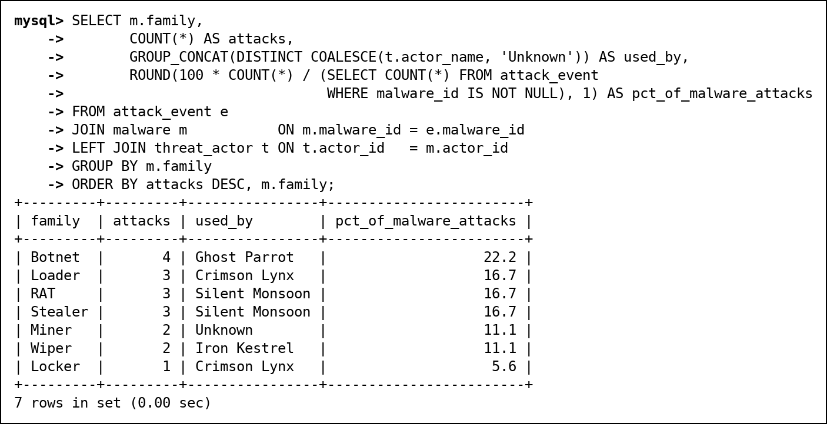
Fig. 72 CQ-04 actual output

CQ-05
Field | Content
ID | CQ-05
Business question | Time machine: how many attacks matched an indicator we already knew about at the time, and how late were we for the rest?
SQL | SELECT CASE WHEN i.recorded_from <= e.event_time THEN 'known at attack time'  ELSE 'recognised later' END AS knowledge,  COUNT(*) AS matches,  COUNT(DISTINCT e.event_id) AS attacks,  ROUND(AVG(CASE WHEN i.recorded_from > e.event_time  THEN TIMESTAMPDIFF(HOUR, e.event_time, i.recorded_from) / 24  END), 1) AS avg_days_late  FROM attack_event e  JOIN event_ioc ei ON ei.event_id = e.event_id  JOIN ioc i ON i.ioc_version_id = ei.ioc_version_id  GROUP BY knowledge  ORDER BY knowledge;
Expected output | 27 attack-indicator matches: 18 known at attack time (17 attacks) and 9 recognised later (8 attacks), on average about 5 days late.
Actual output screenshot | Below (Fig. 73)
Explanation | Joins attack_event to event_ioc to ioc and compares recorded_from (when we learned) with event_time. The CASE in AVG returns NULL for "known" rows so only late rows are averaged. Hours / 24 keeps fractions of a day.

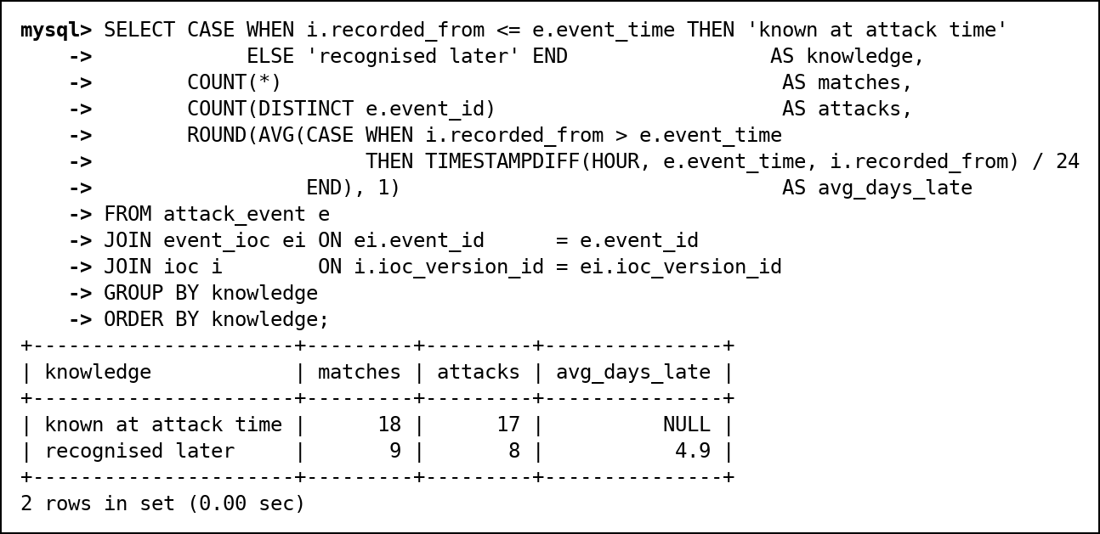
Fig. 73 CQ-05 actual output

CQ-06
Field | Content
ID | CQ-06
Business question | What did each retro-hunt find, and what happened to the incident it opened?
SQL | SELECT r.run_id, i.ioc_value, r.started_at,  COUNT(h.log_id) AS logs_matched,  COUNT(DISTINCT l.dst_asset_id) AS assets_touched,  MIN(l.log_time) AS first_contact,  inc.status AS incident_status  FROM retro_hunt_run r  JOIN ioc i ON i.ioc_version_id = r.ioc_version_id  LEFT JOIN retro_hit h ON h.run_id = r.run_id  LEFT JOIN network_log l ON l.log_id = h.log_id  LEFT JOIN incident inc ON inc.incident_id = r.incident_id  GROUP BY r.run_id, i.ioc_value, r.started_at, inc.status  ORDER BY r.run_id;
Expected output | 2 runs. Run 1 (198.51.100.45) found 4 old log lines on 2 assets, incident INVESTIGATING; run 2 (203.0.113.11) found 4 lines on 2 assets, incident OPEN.
Actual output screenshot | Below (Fig. 74)
Explanation | Five tables. LEFT JOINs to retro_hit and network_log keep runs with zero hits; COUNT(h.log_id) counts hits and COUNT(DISTINCT dst_asset_id) counts assets. This is the same logic as v_retro_hunt_summary.

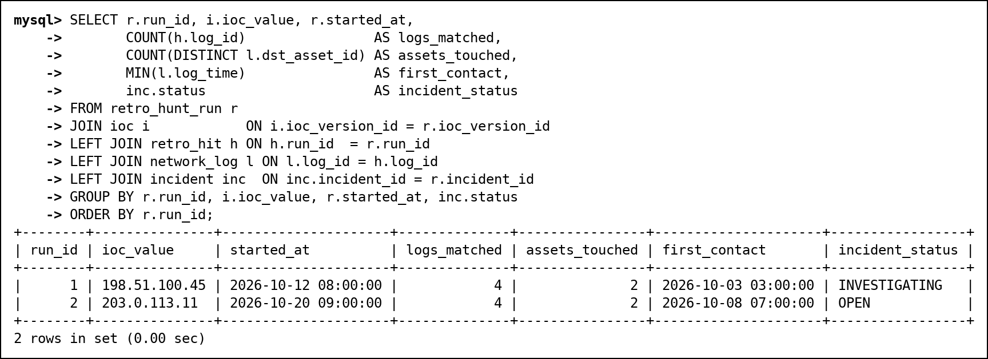
Fig. 74 CQ-06 actual output

CQ-07
Field | Content
ID | CQ-07
Business question | What is the response playbook for the attack type that hits web-01 most often?
SQL | SELECT t.type_name, m.step_no, m.action  FROM mitigation m  JOIN attack_type t ON t.type_id = m.type_id  WHERE m.type_id = (SELECT e.type_id  FROM attack_event e  JOIN asset a ON a.asset_id = e.asset_id  WHERE a.hostname = 'web-01'  GROUP BY e.type_id  ORDER BY COUNT(*) DESC  LIMIT 1)  ORDER BY m.step_no;
Expected output | Brute Force (4 of web-01's 7 attacks), with its 3 steps: block the IP, lock the accounts, enforce MFA.
Actual output screenshot | Below (Fig. 75)
Explanation | Nested: the subquery groups web-01's attacks by type, orders by count and keeps the top type; the outer query joins mitigation to attack_type for that type.

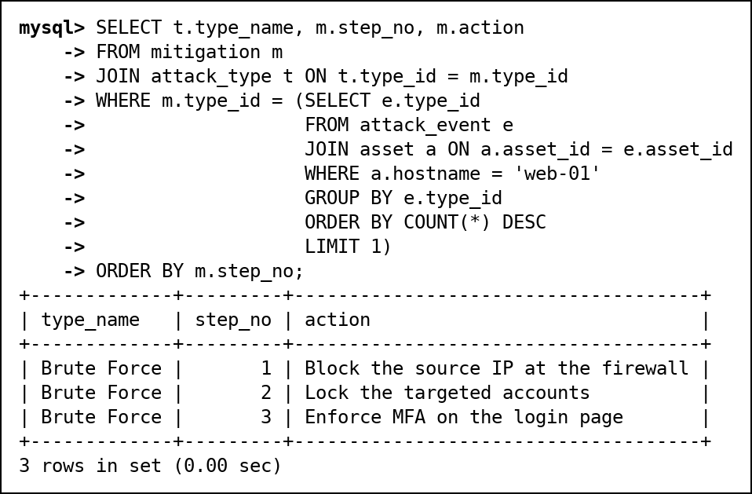
Fig. 75 CQ-07 actual output

CQ-08
Field | Content
ID | CQ-08
Business question | How is the open-incident workload spread across analysts?
SQL | SELECT an.full_name,  COUNT(i.incident_id) AS open_incidents,  COALESCE(SUM(i.priority = 'CRITICAL'), 0) AS critical,  RANK() OVER (ORDER BY COUNT(i.incident_id) DESC) AS workload_rank  FROM analyst an  LEFT JOIN incident i ON i.assigned_to = an.analyst_id  AND i.status <> 'CLOSED'  WHERE an.role = 'analyst'  GROUP BY an.analyst_id, an.full_name  ORDER BY workload_rank, an.full_name;
Expected output | Rahul 2 open incidents (rank 1), Karan and Priya 1 each (rank 2, Karan's is critical), Arjun 0 (rank 4, because RANK skips after the tie).
Actual output screenshot | Below (Fig. 76)
Explanation | Analytic: LEFT JOIN with status <> CLOSED inside the ON clause keeps Arjun with zero. SUM(priority = 'CRITICAL') counts TRUE as 1. RANK() runs after GROUP BY.

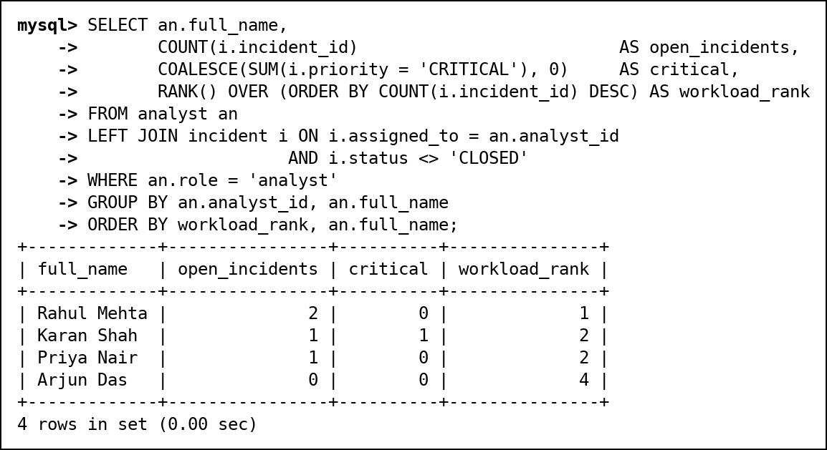
Fig. 76 CQ-08 actual output

CQ-09
Field | Content
ID | CQ-09
Business question | Which countries do attacks come from, what share does each have, and what is each country's most common attack type?
SQL | SELECT c.src_country, c.attacks,  ROUND(100 * c.attacks / SUM(c.attacks) OVER (), 1) AS pct,  (SELECT t.type_name  FROM attack_event e2  JOIN attack_type t ON t.type_id = e2.type_id  WHERE e2.src_country = c.src_country  GROUP BY t.type_name  ORDER BY COUNT(*) DESC, t.type_name  LIMIT 1) AS top_type  FROM (SELECT src_country, COUNT(*) AS attacks  FROM attack_event  GROUP BY src_country) AS c  ORDER BY c.attacks DESC, c.src_country;
Expected output | 7 countries. RU 8 (26.7%), CN 6 (20.0%), BR/KP/US 4 each (13.3%), IN/NL 2 each (6.7%). RU's top type is Brute Force; KP has a 4-way tie, broken alphabetically to Credential Dumping.
Actual output screenshot | Below (Fig. 77)
Explanation | A derived table counts per country; SUM(...) OVER () gives the total for the percentage without a second query. A correlated subquery finds each country's most common type.

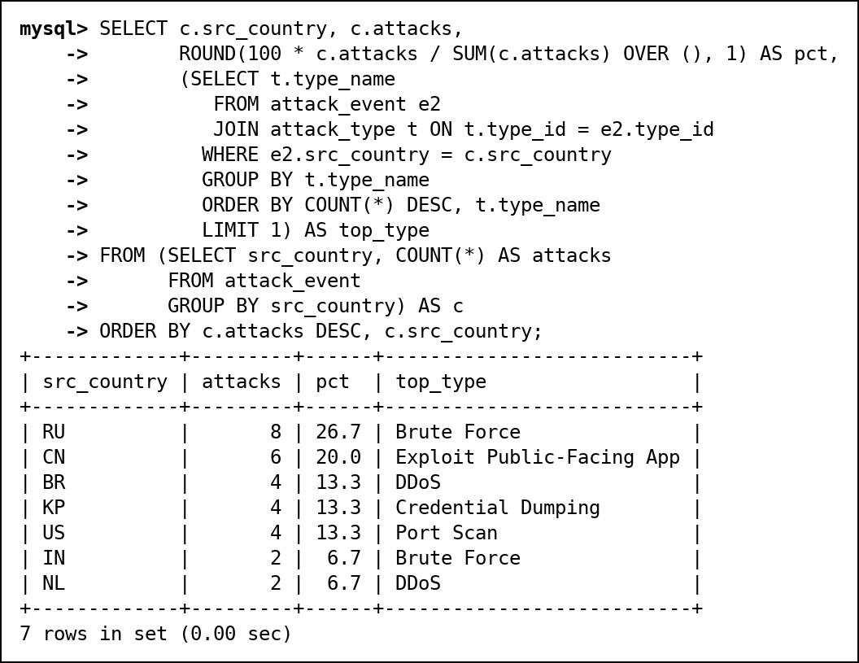
Fig. 77 CQ-09 actual output

CQ-10
Field | Content
ID | CQ-10
Business question | Which assets with an unpatched critical CVE (CVSS 9+) have been attacked by an espionage group?
SQL | SELECT DISTINCT a.hostname, av.cve_id, v.cvss, t.actor_name  FROM asset_vulnerability av  JOIN vulnerability v ON v.cve_id = av.cve_id  JOIN asset a ON a.asset_id = av.asset_id  JOIN attack_event e ON e.asset_id = av.asset_id  JOIN threat_actor t ON t.actor_id = e.actor_id  WHERE av.patched_at IS NULL  AND v.cvss >= 9  AND t.motive = 'espionage'  ORDER BY v.cvss DESC, a.hostname;
Expected output | 2 rows: vpn-01 with CVE-2024-3400 (10.0) and mail-01 with CVE-2023-4966 (9.4), both attacked by Silent Monsoon.
Actual output screenshot | Below (Fig. 78)
Explanation | Five tables. Starts from unpatched exposures with CVSS 9+, then joins attacks on the same asset by espionage groups. DISTINCT removes duplicates when a group attacked the asset more than once.

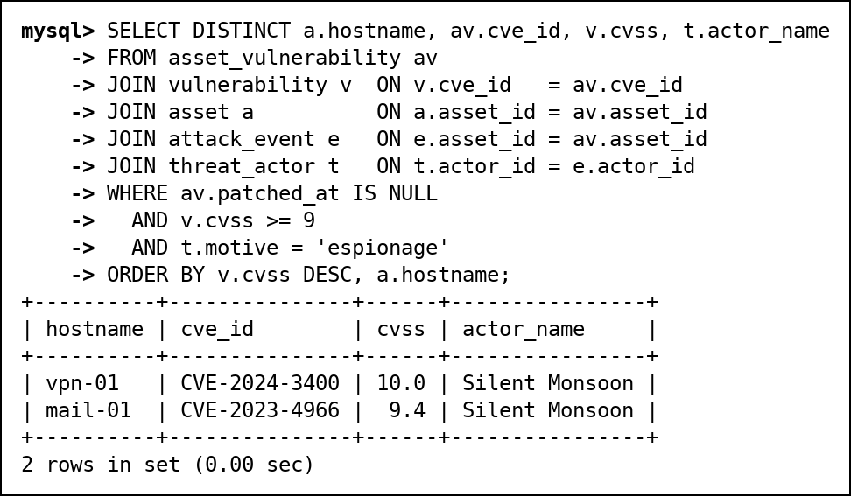
Fig. 78 CQ-10 actual output

CQ-11
Field | Content
ID | CQ-11
Business question | Which source IPs launched a follow-up attack within one hour (attack bursts)?
SQL | SELECT src_ip, prev_event, event_id, gap_minutes, hostname  FROM (SELECT e.src_ip, e.event_id, a.hostname,  LAG(e.event_id) OVER w AS prev_event,  TIMESTAMPDIFF(MINUTE, LAG(e.event_time) OVER w, e.event_time) AS gap_minutes  FROM attack_event e  JOIN asset a ON a.asset_id = e.asset_id  WINDOW w AS (PARTITION BY e.src_ip ORDER BY e.event_time)) AS x  WHERE gap_minutes <= 60  ORDER BY gap_minutes, src_ip;
Expected output | 7 bursts. The fastest is 2 minutes (203.0.113.200 scanning two hosts), the slowest within the hour is 45 minutes (192.0.2.50 on db-01).
Actual output screenshot | Below (Fig. 79)
Explanation | LAG over a window partitioned by source IP gives each attack's previous attack from the same IP; the outer query keeps gaps of 60 minutes or less. The filter needs a derived table because window results cannot be used in WHERE.

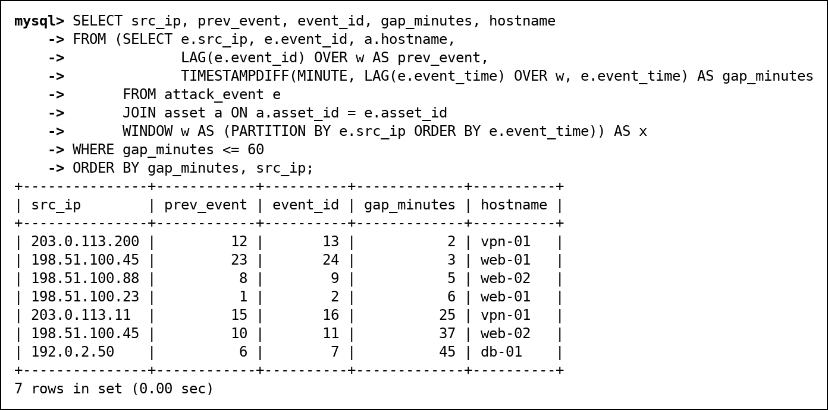
Fig. 79 CQ-11 actual output

12.2 Views
Four views written for the project, plus the two Review 1 views (v_vulnerability for CVE severity and v_retro_hunt_summary for retro-hunt counts) that replaced stored columns. In Review 3 v_ioc was added so that analysts no longer need any access to the ioc table.
v_attack_details (joins 5 tables)
Field | Content
Purpose | One flat row per attack with host, type, actor and malware names, so searches and reports need no joins.
CREATE VIEW statement, query using the view and screenshot | Fig. 80 below
Why useful | Abstraction and simplification: queries use one object. Not updatable: information_schema reports IS_UPDATABLE = NO because it uses outer joins, and the DELETE in the screenshot is refused (ERROR 1288). We only grant SELECT on it.

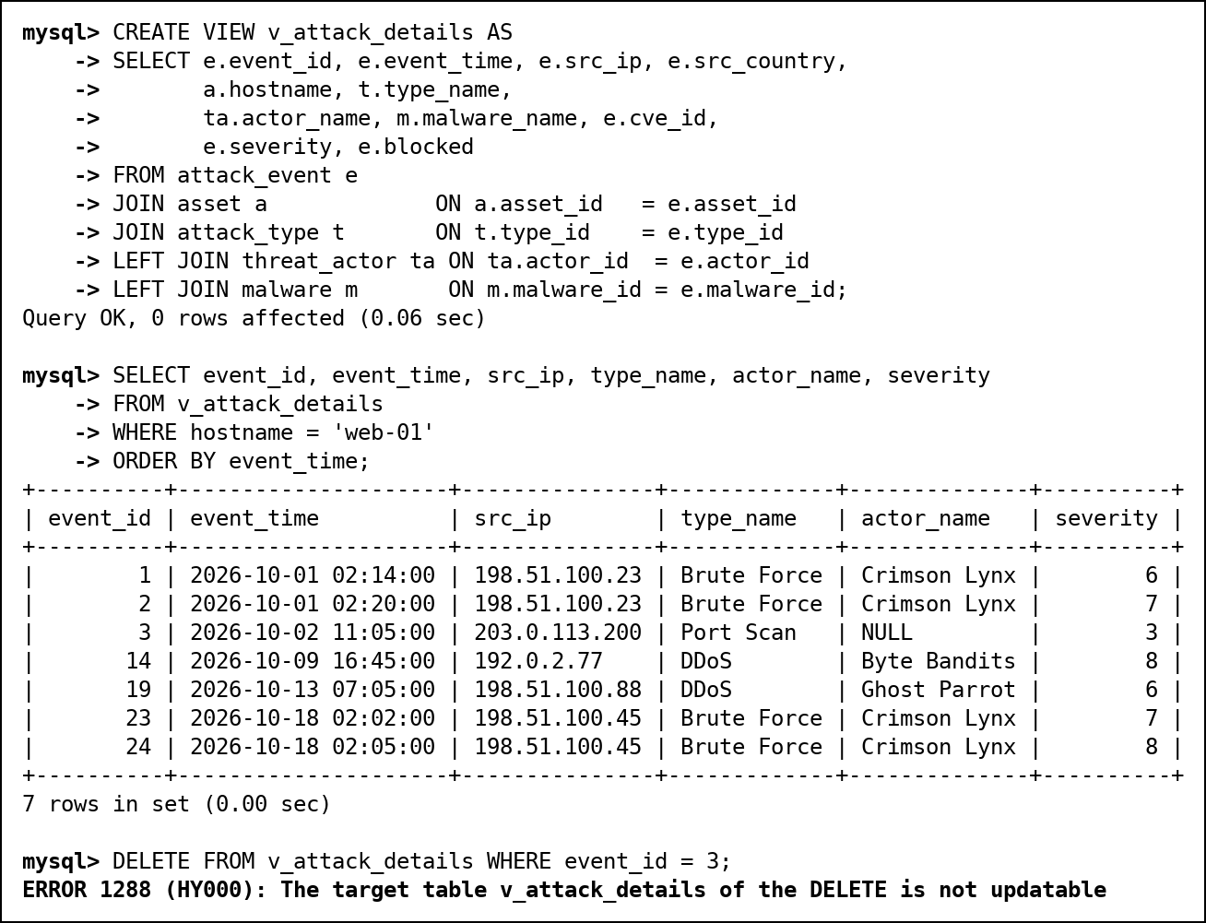
Fig. 80 v_attack_details: definition, use and updatability
v_asset_risk (aggregated)
Field | Content
Purpose | Per asset: attacks, attacks not blocked, worst severity and open vulnerabilities, for the risk panel.
CREATE VIEW statement, query using the view and screenshot | Fig. 81 below
Why useful | Simplification: the aggregation is written once. Not updatable because of GROUP BY and COUNT/SUM; MySQL refuses the UPDATE (ERROR 1288). The viewer role can read it without any access to the base tables.

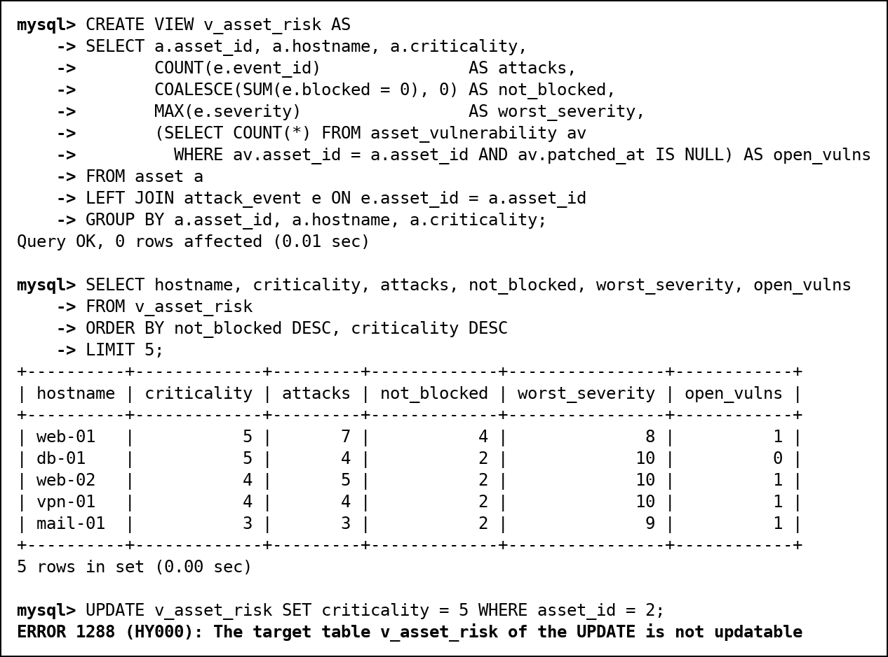
Fig. 81 v_asset_risk: definition, use and updatability
v_my_incidents (security, row-restricting)
Field | Content
Purpose | Shows each analyst only the incidents assigned to them, by matching the MySQL login (USER()) to the analyst's email.
CREATE VIEW statement, query using the view and screenshot | Fig. 82 below
Why useful | Security: analysts have no privilege on the incident table, only on this view. Updatable (IS_UPDATABLE = YES): it reads one table with no aggregation or join. WITH CHECK OPTION blocks changes that would move a row out of the view, such as reassigning an incident to someone else (section 12.7). As root it shows 0 rows, because root is not an analyst.

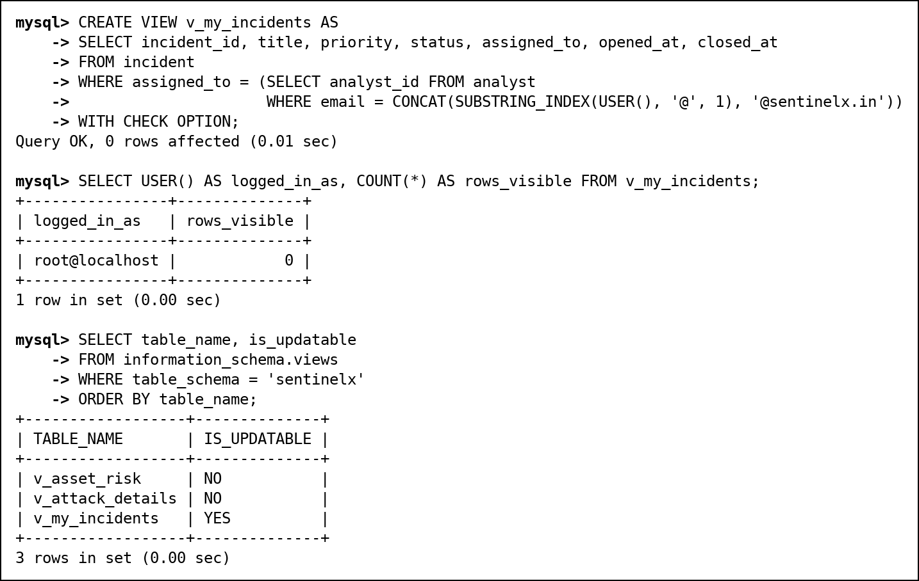
Fig. 82 v_my_incidents: definition, use and updatability
v_ioc (security, Review 3)
Field | Content
Purpose | The indicator versions we currently believe (recorded_to IS NULL), so analysts can read indicators without any privilege on the ioc table.
CREATE VIEW statement, query using the view and screenshot | Fig. 83 below
Why useful | Security and simplification: hides superseded versions and the base table. Updatable in principle (one table, no aggregation), but analysts only get SELECT; new indicators go through sp_report_ioc.

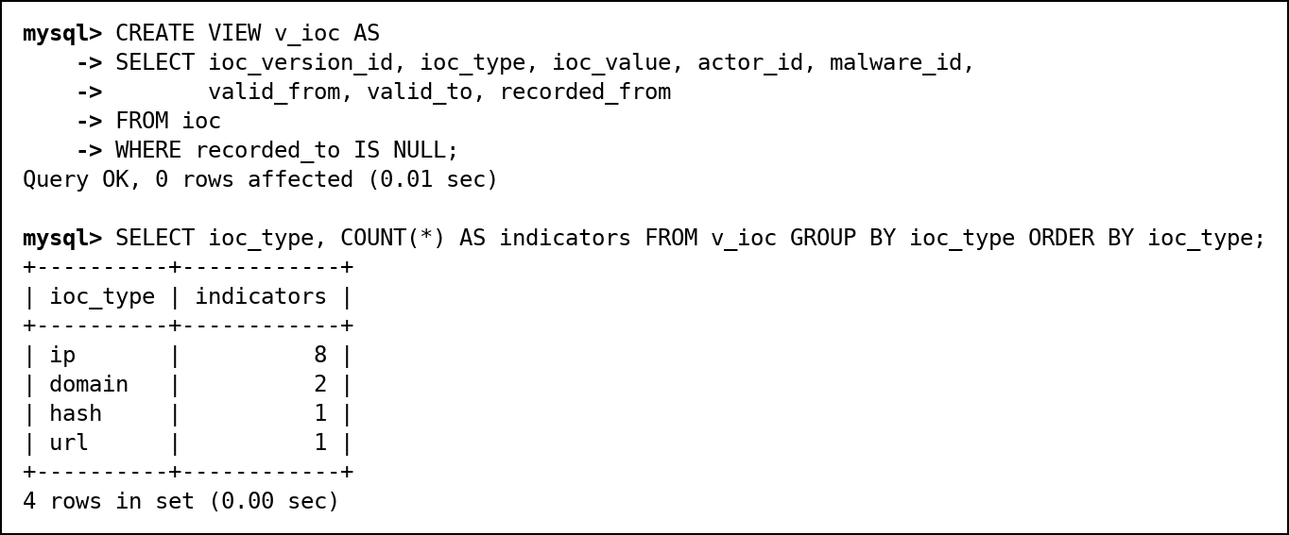
Fig. 83 v_ioc: definition and use
Review 1 views
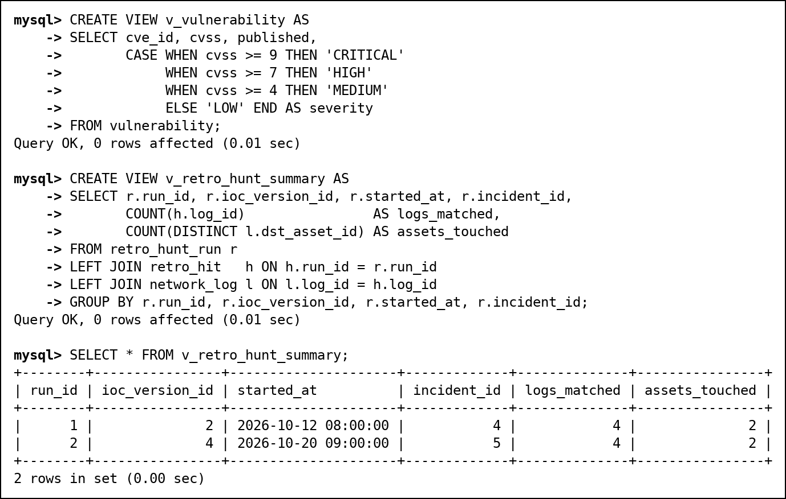
Fig. 84 v_vulnerability and v_retro_hunt_summary

12.3 Stored Procedures
sp_assign_incident(incident, analyst) assigns an incident inside a transaction. It locks the incident row with SELECT ... FOR UPDATE, so two analysts cannot claim it at the same moment, and rejects closed incidents and viewer accounts with SIGNAL. Any error rolls the transaction back and is passed to the caller (RESIGNAL). Fixed in Review 3: the procedure runs with its definer's (root's) rights, and in Review 2 it never checked who called it, so an analyst could use it to give his incident to a colleague or take a colleague's incident, which is exactly what WITH CHECK OPTION stops on v_my_incidents. It now maps USER() (the caller; inside a DEFINER routine CURRENT_USER() is the definer) to an analyst, and analysts may only claim unassigned incidents for themselves.
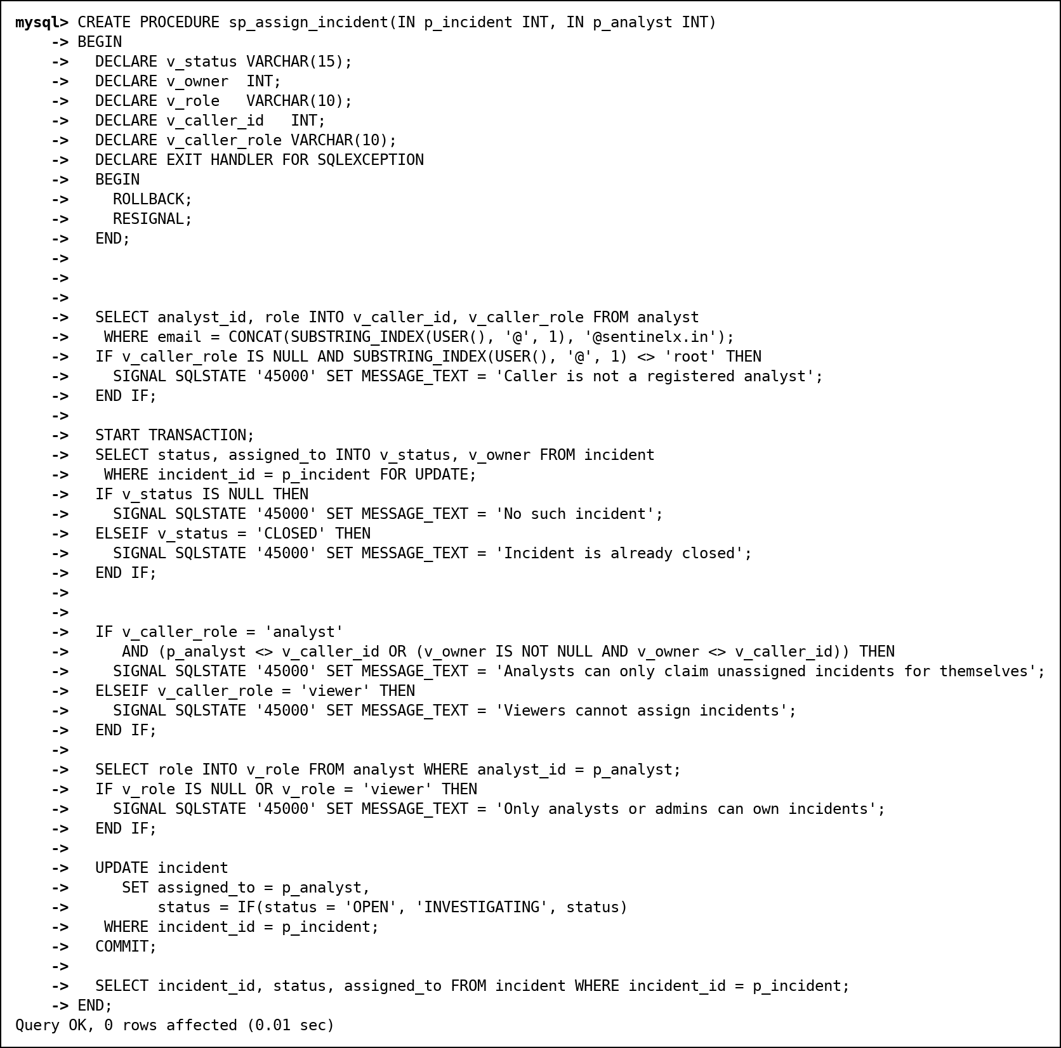
Fig. 85 CREATE PROCEDURE sp_assign_incident
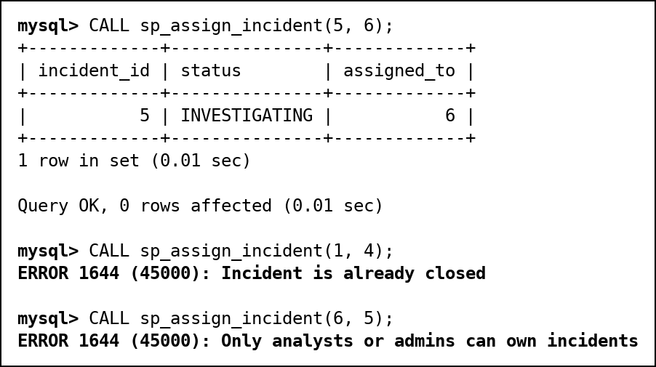
Fig. 86 sp_assign_incident: a valid call, a closed incident and a viewer rejected
sp_attack_report(from, to) returns the attack summary by type for a date range. The viewer role gets EXECUTE on it instead of access to the attack table.
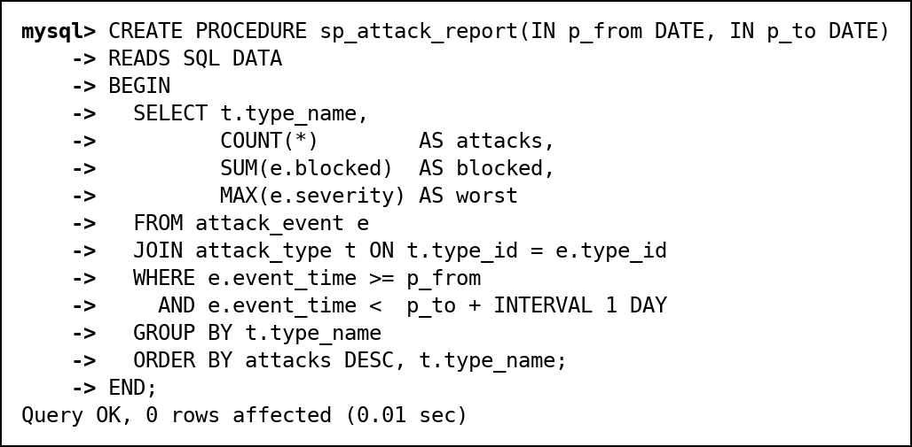
Fig. 87 CREATE PROCEDURE sp_attack_report
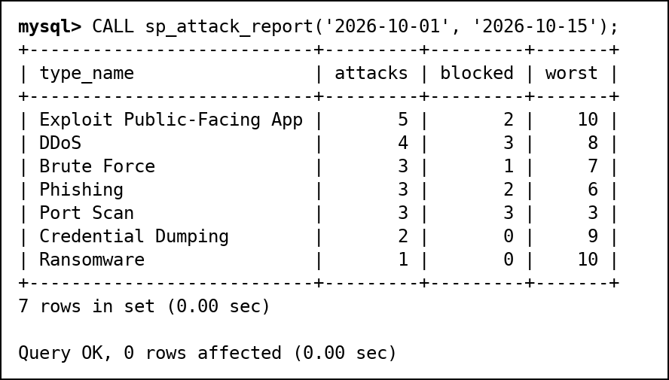
Fig. 88 sp_attack_report called for 1 to 15 October
sp_report_ioc and sp_whoami (Review 3). sp_report_ioc is the only way an analyst can add an indicator; it always sets recorded_from to the current time, so nobody can backdate when we learned about it. sp_whoami returns USER() and CURRENT_USER() side by side, which makes the difference between the caller and the definer visible.
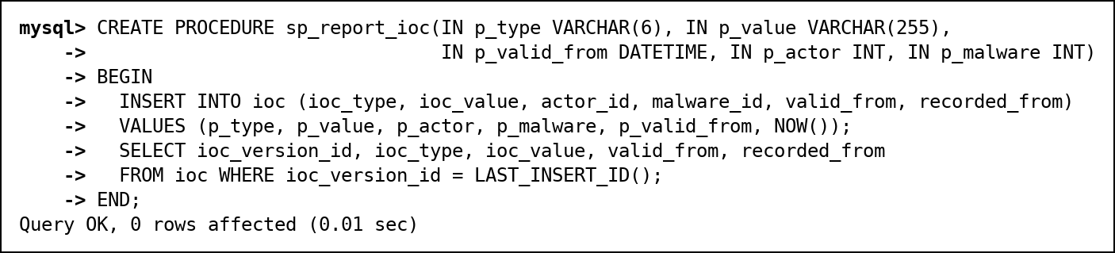
Fig. 89 CREATE PROCEDURE sp_report_ioc
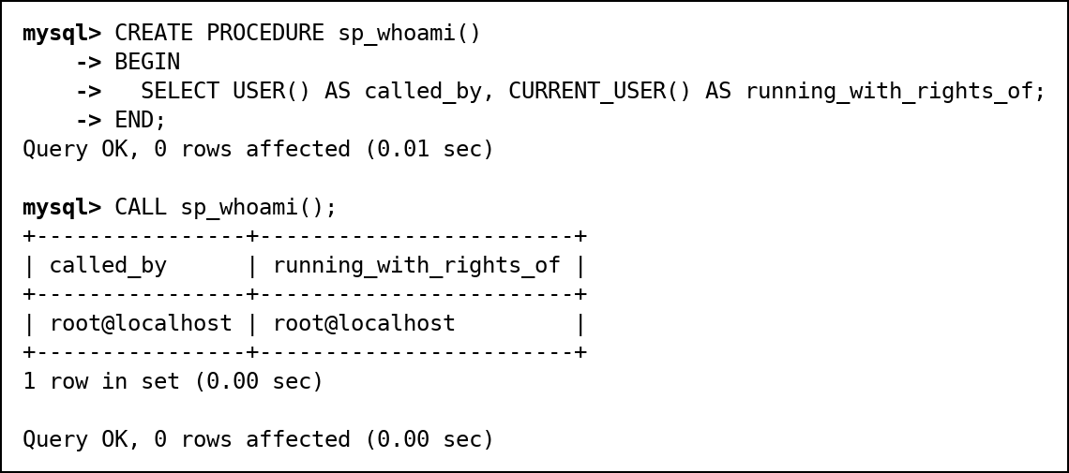
Fig. 90 sp_whoami, and a call by root (both functions return root)
sp_load_log_batch, the batch loader with an exit handler, is shown with the transactions in section 13.

12.4 User-Defined Functions
fn_severity_label(cvss) is DETERMINISTIC and turns a CVSS score into LOW, MEDIUM, HIGH or CRITICAL. fn_asset_risk(asset_id) reads three tables and returns criticality x 10 + open vulnerabilities x 5 + attacks not blocked x 2.
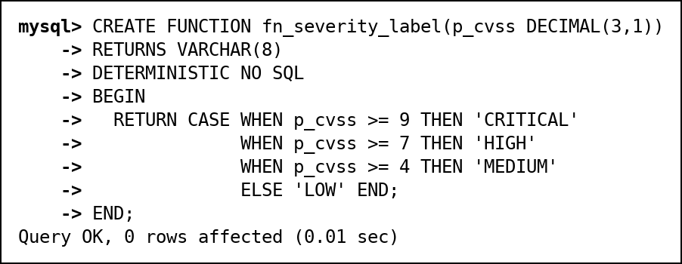
Fig. 91 fn_severity_label
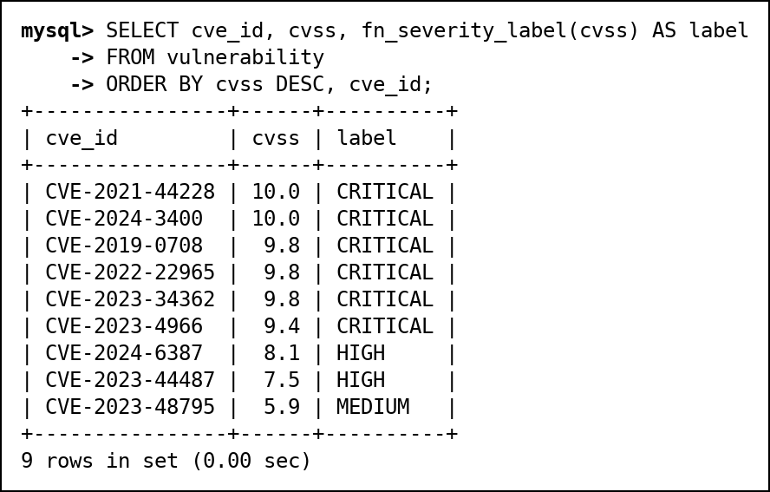
Fig. 92 fn_severity_label used in a SELECT
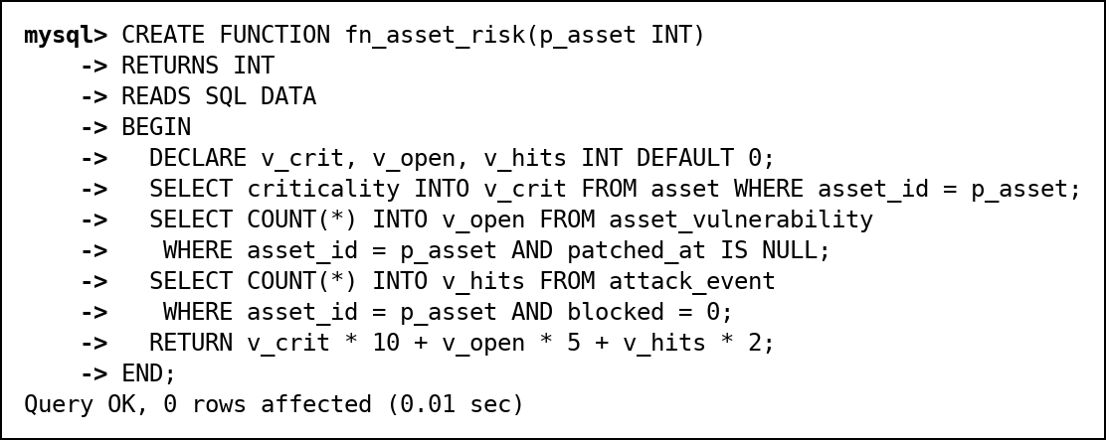
Fig. 93 fn_asset_risk
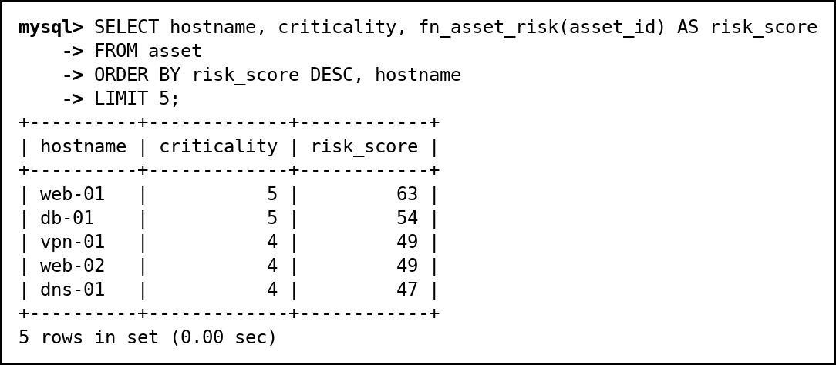
Fig. 94 fn_asset_risk used in a SELECT

12.5 Triggers
trg_attack_auto_incident (AFTER INSERT on attack_event) opens an incident for any attack of severity 8 or more. If the same asset already has an open incident for the same attack type from the last hour, the attack joins it instead. In the demo three attacks are inserted: the first (severity 9) opens incident 8, the second (severity 8, twenty minutes later) is added to it, and the third (severity 3) is ignored.
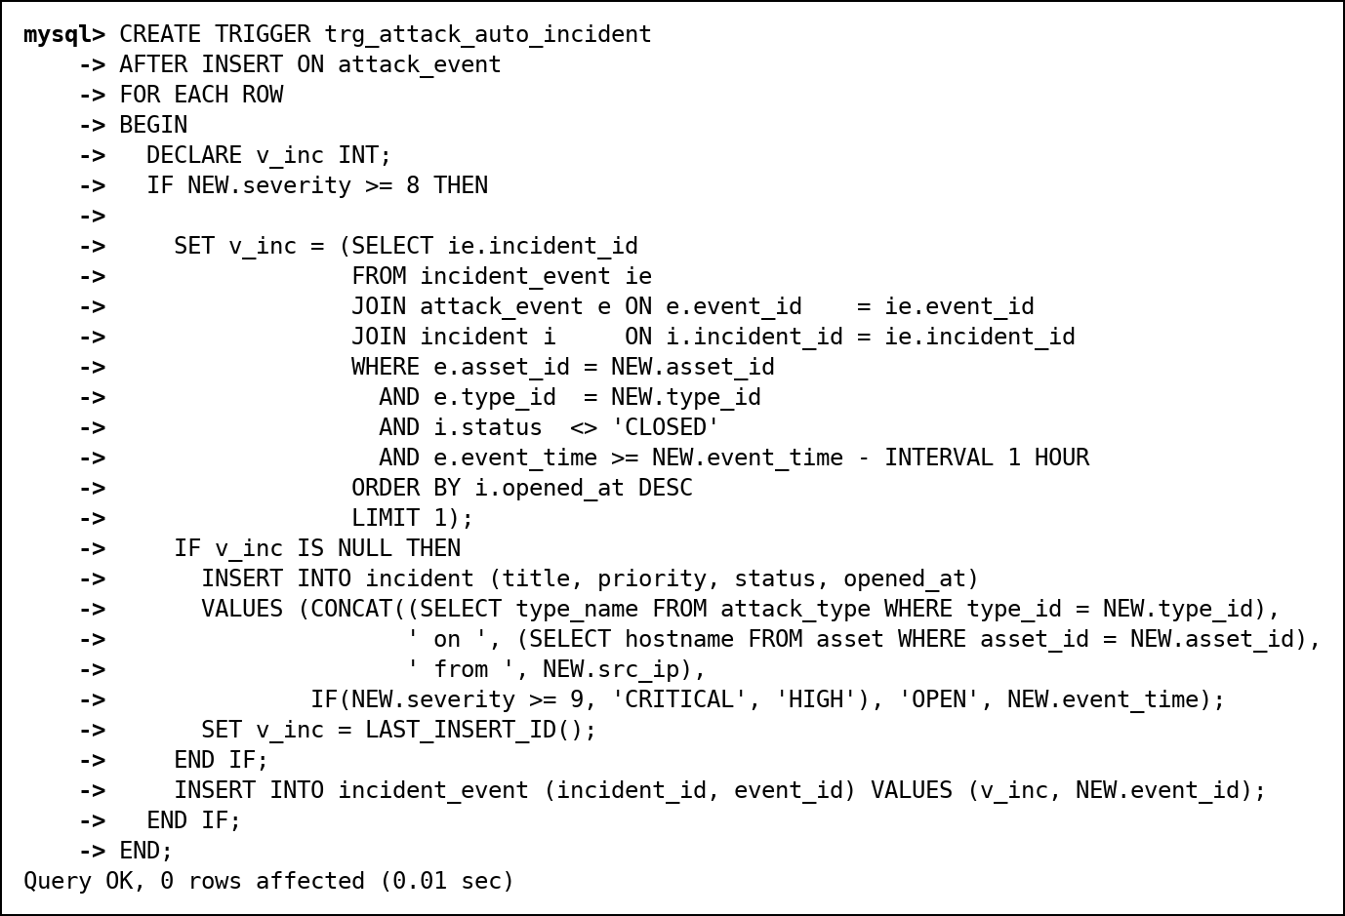
Fig. 95 trg_attack_auto_incident
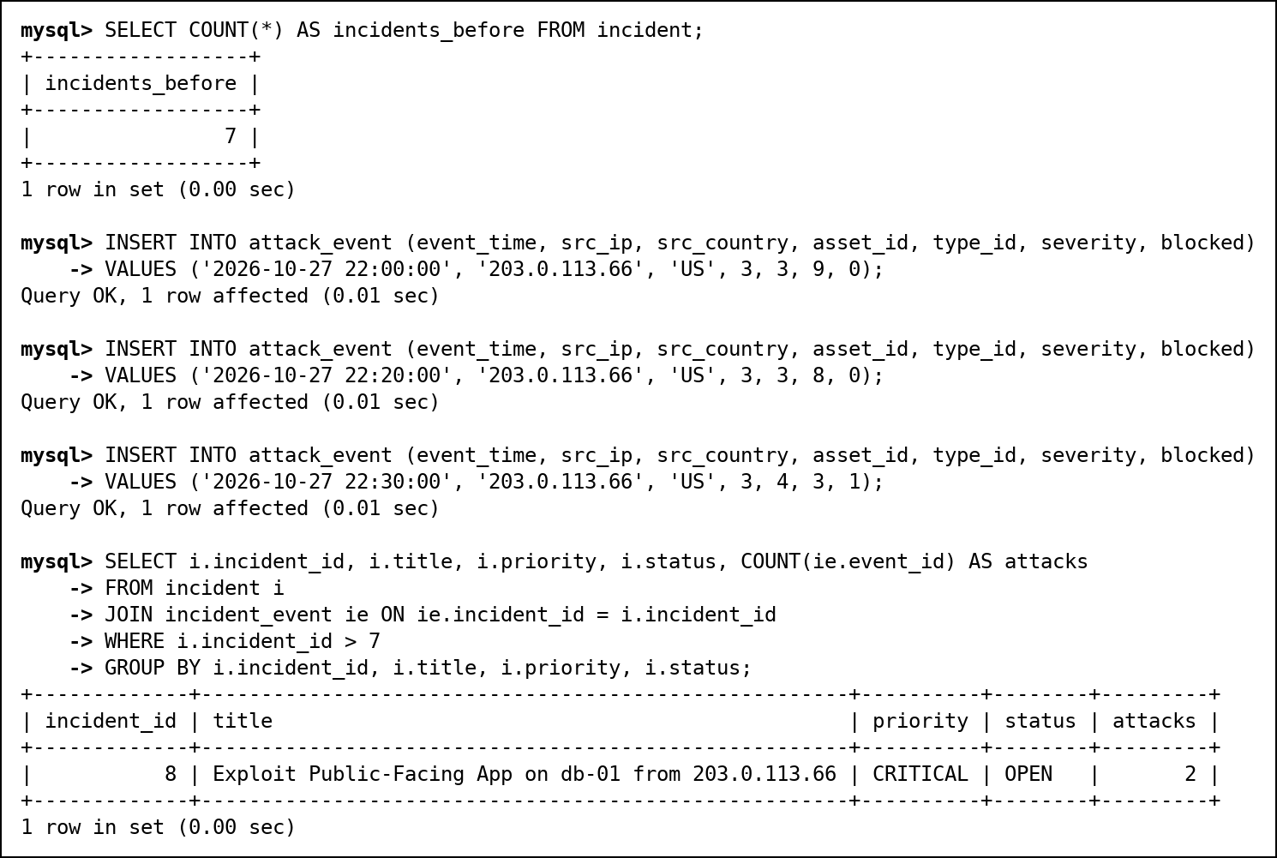
Fig. 96 trg_attack_auto_incident firing on three new attacks
Three triggers on ioc: trg_ioc_no_overlap (BEFORE INSERT) rejects a new version whose valid period overlaps an existing one, trg_ioc_no_delete (BEFORE DELETE) keeps the history append-only, and trg_ioc_retro_hunt (AFTER INSERT) runs the retro-hunt. Fixed in Review 3: trg_ioc_no_overlap now ignores versions that were closed with recorded_to. trg_ioc_no_delete tells users to close a version that way, but the overlap check still counted closed versions, so a corrected version could never be added (test T28).
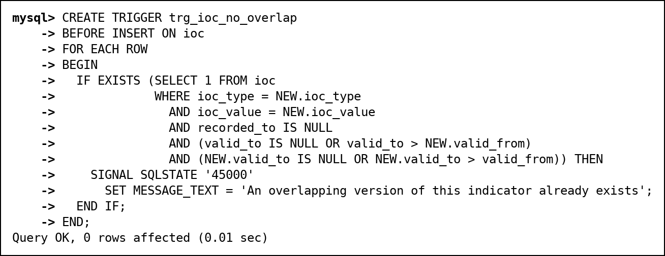
Fig. 97 trg_ioc_no_overlap
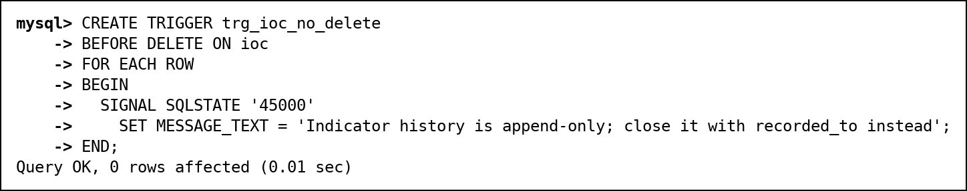
Fig. 98 trg_ioc_no_delete
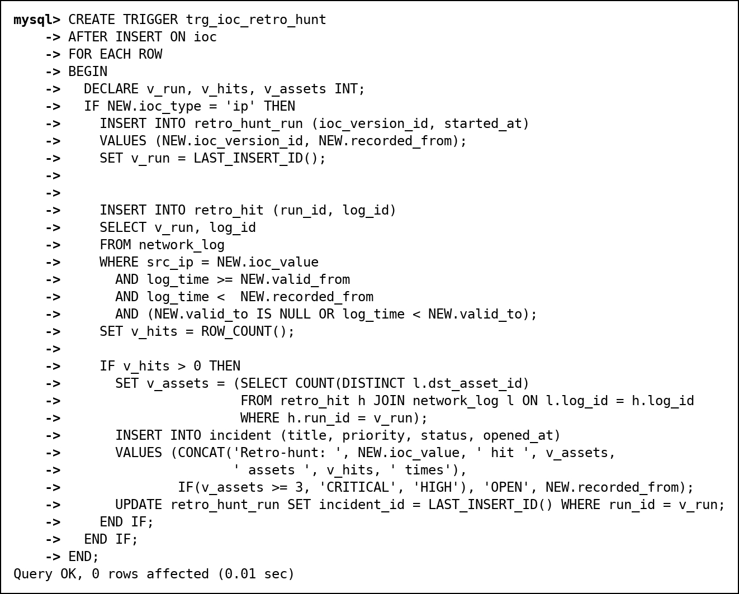
Fig. 99 trg_ioc_retro_hunt
In the demonstration, 198.51.100.77 is added as a bad IP that was hostile from 15 September. The trigger finds the 8 old log lines it sent to 3 assets before anyone knew, and opens a CRITICAL incident. The overlapping second version and the DELETE are both refused.
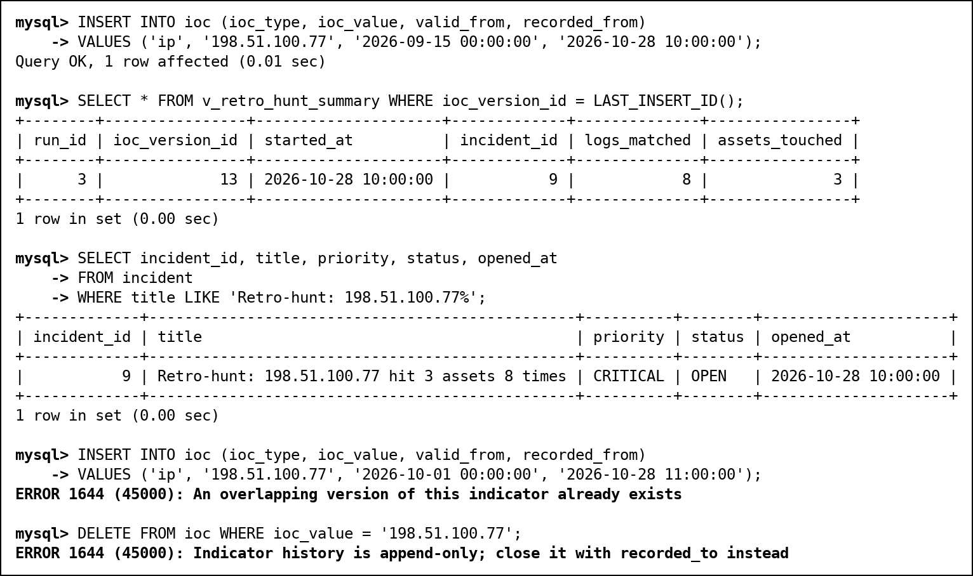
Fig. 100 Retro-hunt demonstration, then the two refused changes
Audit triggers (Review 3). trg_incident_audit_update and trg_incident_audit_delete (AFTER UPDATE / AFTER DELETE on incident) write one row to incident_audit for every change, so it is recorded whether the change came through a view, a procedure or a direct statement. They record USER(), not CURRENT_USER(): inside a trigger CURRENT_USER() is the trigger's definer (root), which would make every row look the same. trg_audit_no_update and trg_audit_no_delete make the trail append-only. TRUNCATE does not fire triggers, which is why no role except root has the DROP privilege that TRUNCATE needs.
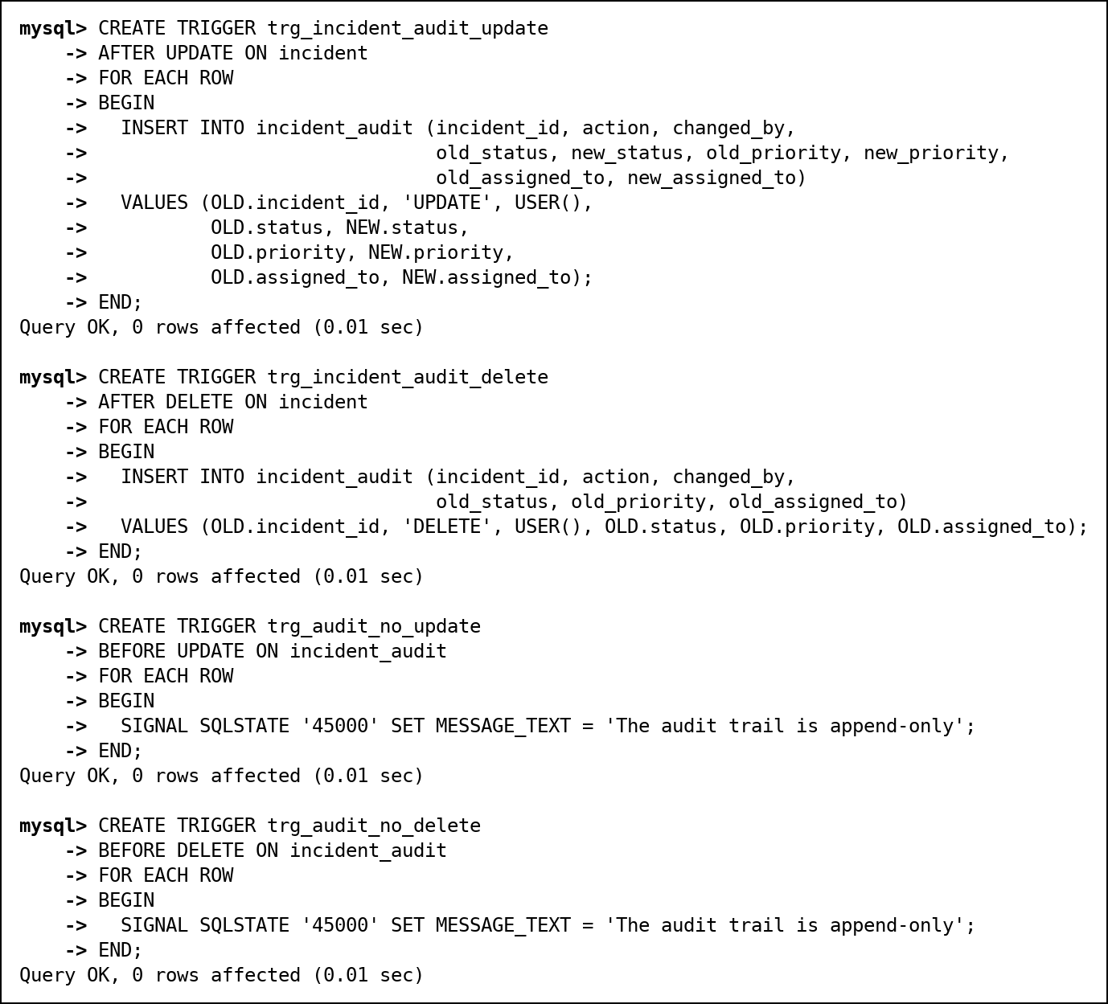
Fig. 101 The four audit triggers
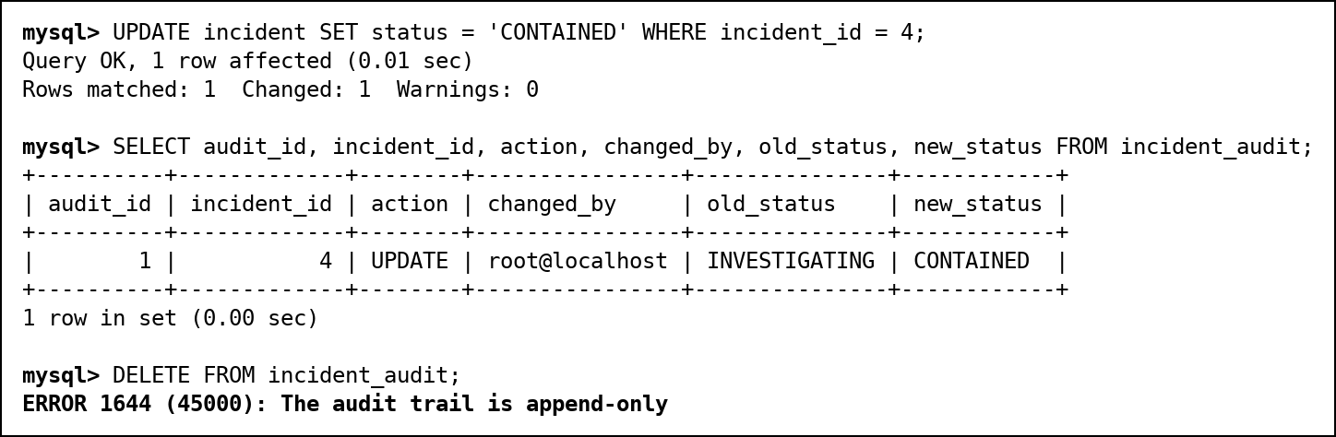
Fig. 102 An UPDATE is recorded; deleting audit rows is refused

12.6 Cursors
sp_escalate_incidents walks through every incident that is not closed with a cursor, and raises its priority when its worst attack demands it: to CRITICAL for severity 10, and from LOW or MEDIUM to HIGH for severity 8. It escalated incident 3 (HIGH to CRITICAL, because of attack 30) and incident 6 (MEDIUM to HIGH).
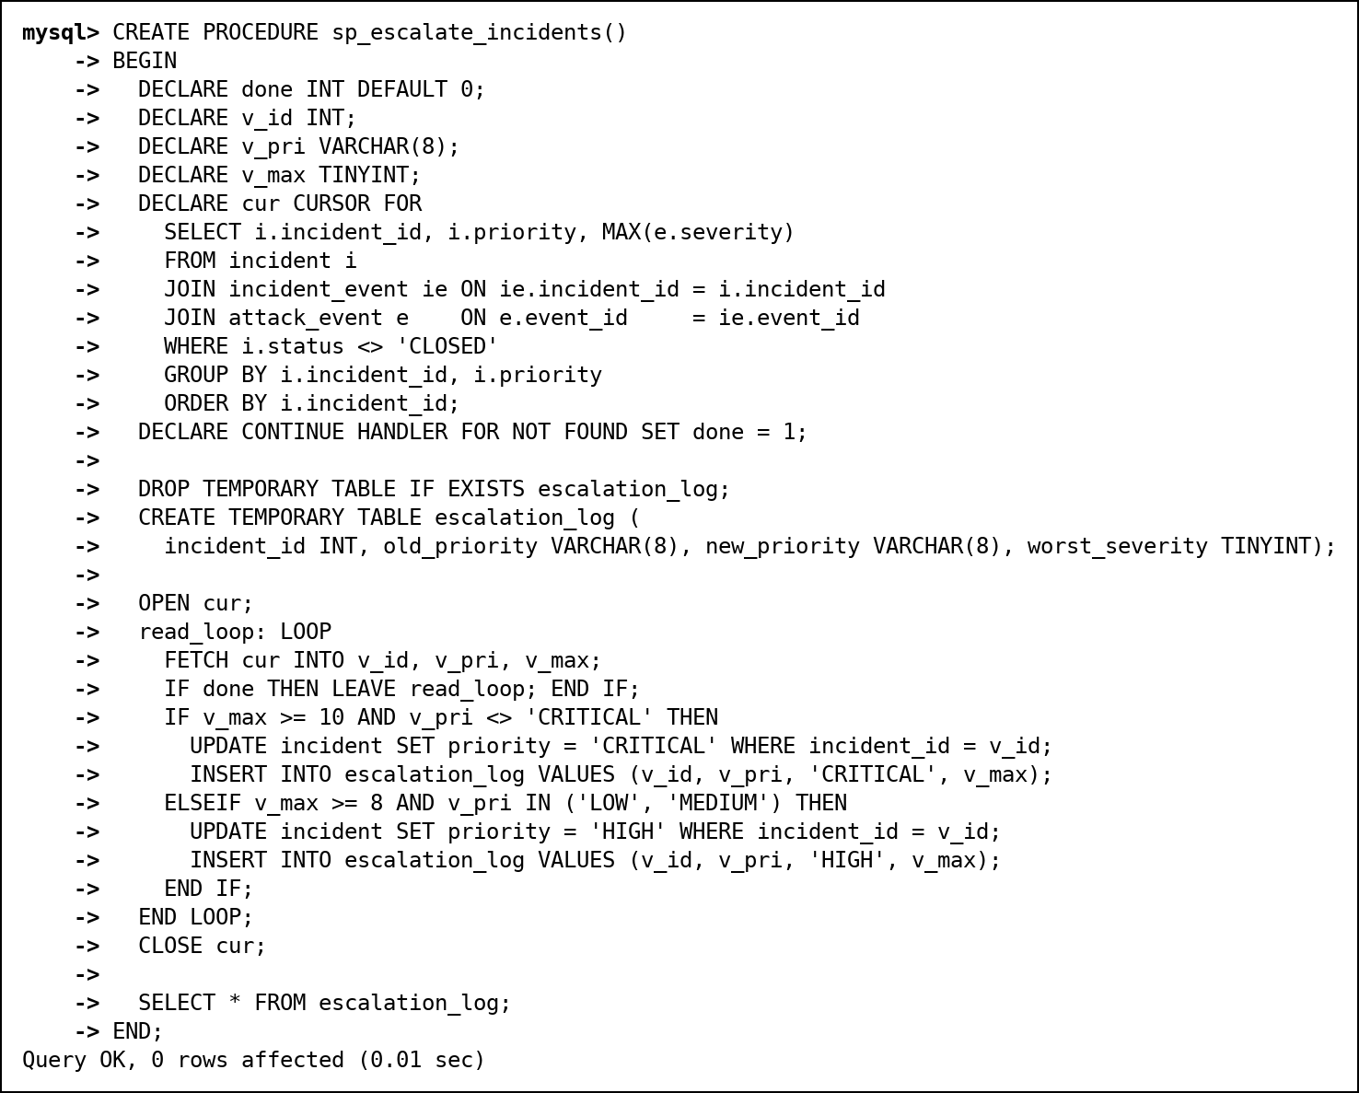
Fig. 103 sp_escalate_incidents (cursor)
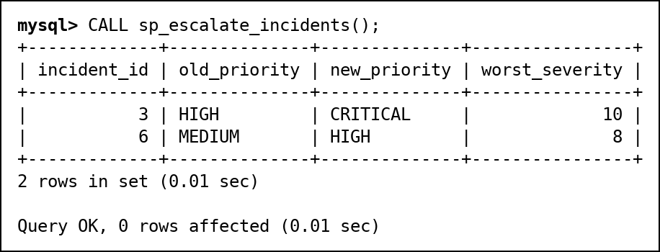
Fig. 104 sp_escalate_incidents called
sp_asset_risk_report loops over all assets with a cursor, calls fn_asset_risk for each, puts the score into a temporary table with a band (HIGH 60+, MEDIUM 30+, LOW) and returns it sorted.
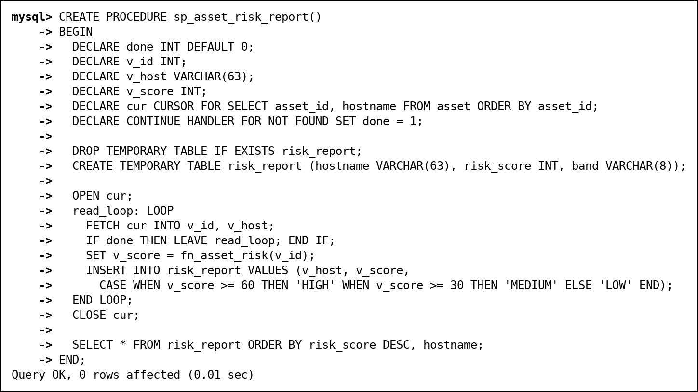
Fig. 105 sp_asset_risk_report (cursor)
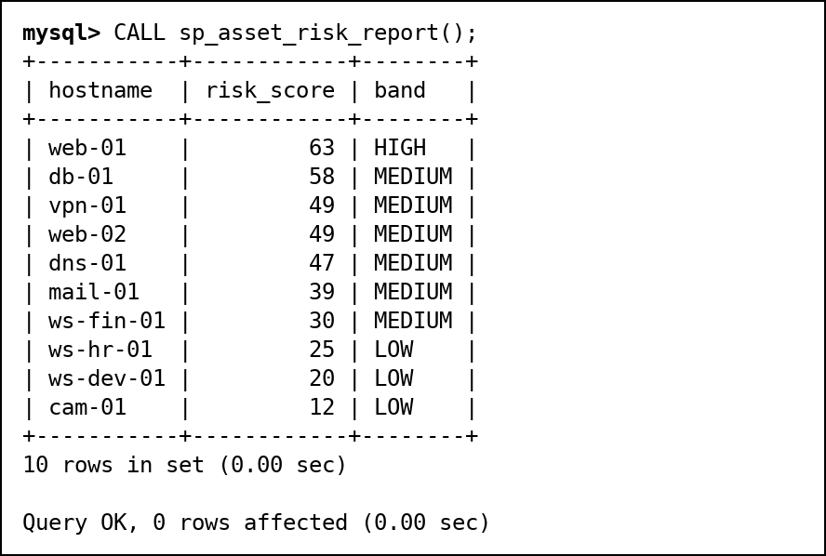
Fig. 106 sp_asset_risk_report called
A cursor works one row at a time. The same escalation rule can be written as one set-based UPDATE with a join to the worst severity per incident, which is faster on large tables; the cursor is kept because it also writes a per-row log of what it changed.

12.7 SQL Security Implementation
Security is layered. From the outside in: an account locks after three wrong passwords; each account gets one role; restricted roles reach data only through views and procedures; the view v_my_incidents limits analysts to their own rows; procedures that run with the definer's rights check who called them; every change to an incident is written to an audit trail that nobody but the DBA can remove; and the binary log makes mistakes recoverable (section 15). Passwords are not stored in our tables at all: users log in as MySQL accounts, whose passwords MySQL keeps as salted SHA-256 hashes with 5,000 rounds (caching_sha2_password).
Object | sx_admin | sx_analyst | sx_viewer
All 17 base tables | SELECT, INSERT, UPDATE, DELETE | - | -
Schema changes (CREATE, ALTER, DROP, TRIGGER, GRANT) | - (root, the DBA, only) | - | -
v_my_incidents | SELECT, UPDATE | SELECT, UPDATE (own rows only) | -
v_attack_details, v_vulnerability, v_retro_hunt_summary, v_ioc | SELECT | SELECT | -
v_asset_risk | SELECT | SELECT | SELECT
sp_assign_incident | EXECUTE | EXECUTE (claims for himself only) | -
sp_report_ioc, sp_whoami, sp_search_incidents | EXECUTE | EXECUTE | -
sp_attack_report | EXECUTE | EXECUTE | EXECUTE
incident_audit | SELECT (append-only) | - | -
Login | Locked for 1 day after 3 wrong passwords | Same | Same
User (default role) | ananya.rao | rahul.mehta | divya.iyer

Task | Evidence
Create 3 or more users/roles | CREATE ROLE and CREATE USER with default roles and lockout (Fig. 107)
GRANT privileges per role matrix | GRANT script (Fig. 107) and SHOW GRANTS output (Fig. 108, 109)
REVOKE demonstration | SHOW GRANTS before and after REVOKE (Fig. 110)
Least privilege proof | Viewer, analyst and admin log in and try forbidden operations: ERROR 1142, 1369 and 1644 (Fig. 112, 114, 115, 116); tests S01-S11, V01-V05, A01-A05 (section 16)
Secure exposure | Analyst and viewer have no privilege on any base table; they use views and procedures only. The analyst's procedures check the caller (Fig. 115)
Audit and recovery (beyond the template) | incident_audit (Fig. 116), SQL injection (Fig. 118-120), point-in-time recovery (section 15)

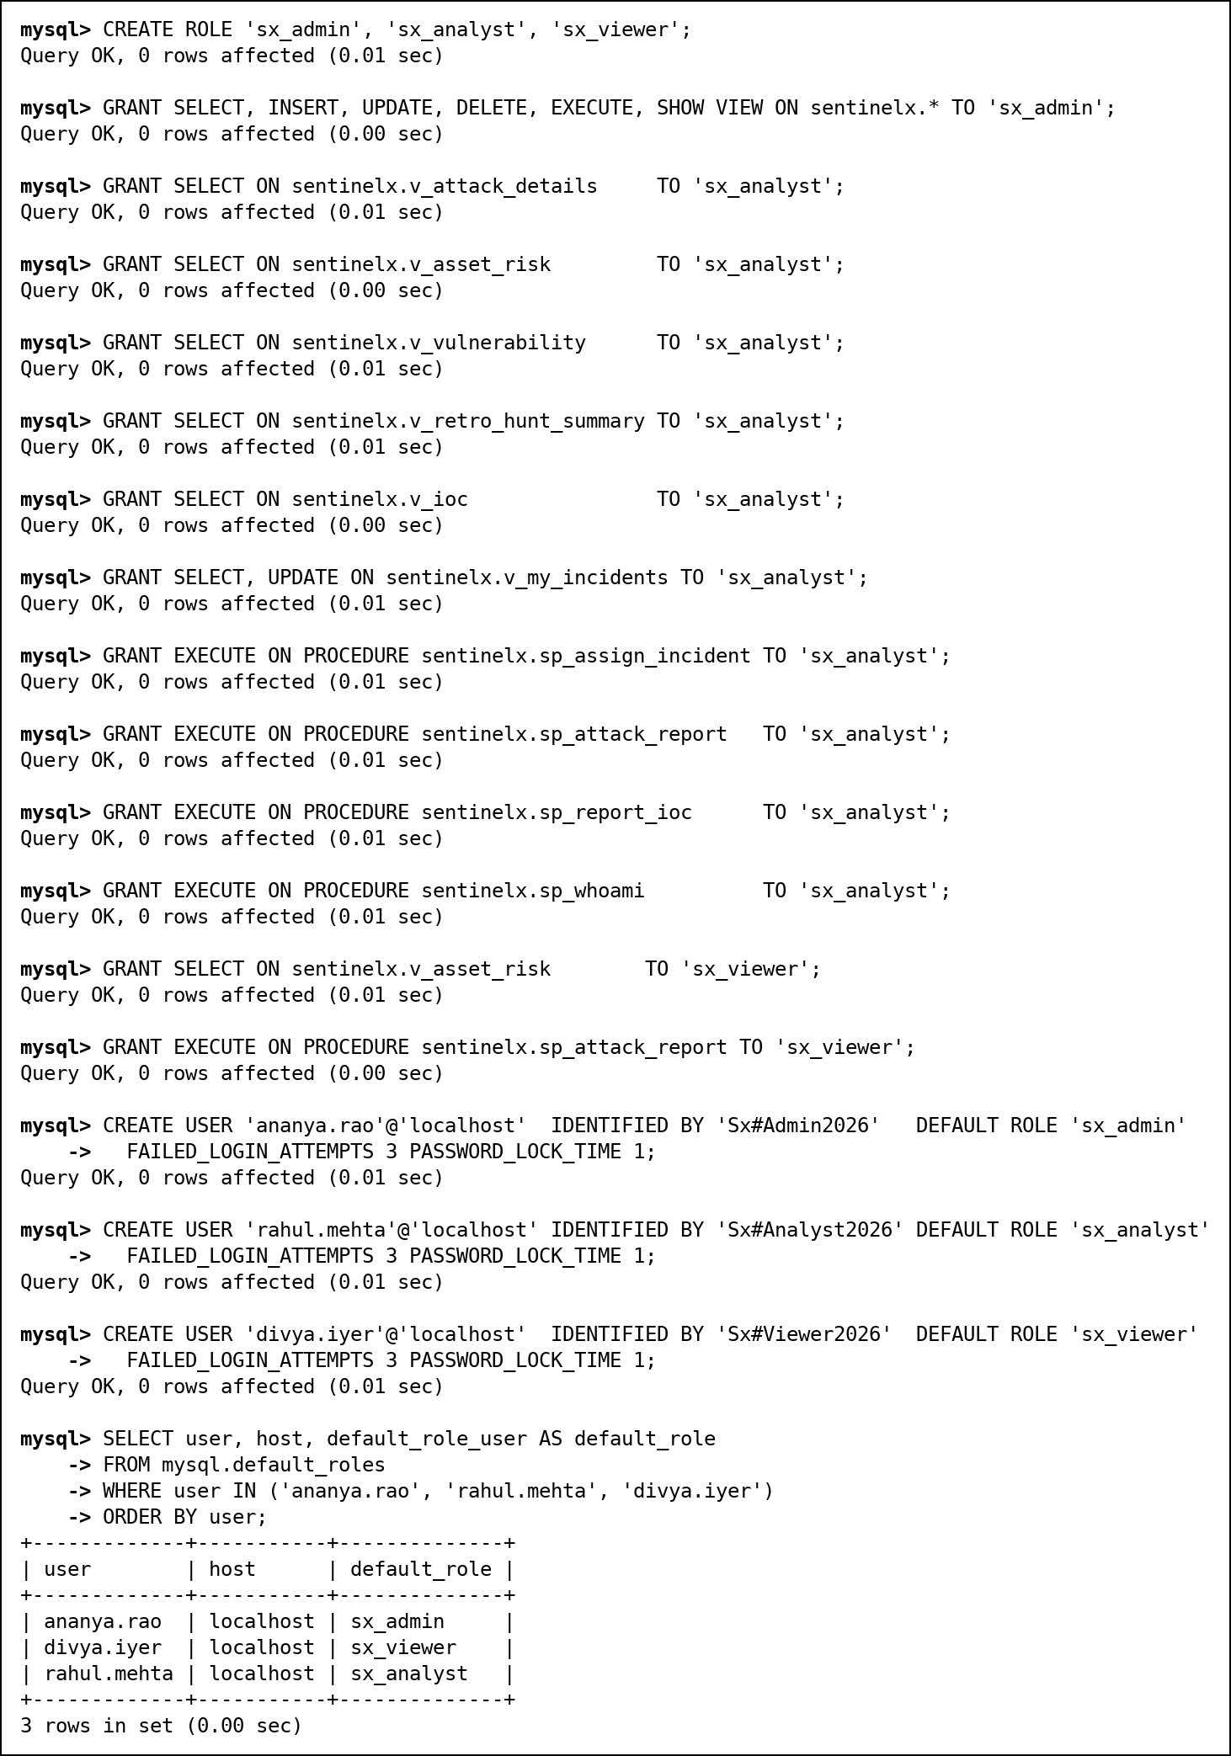
Fig. 107 Roles, grants and users
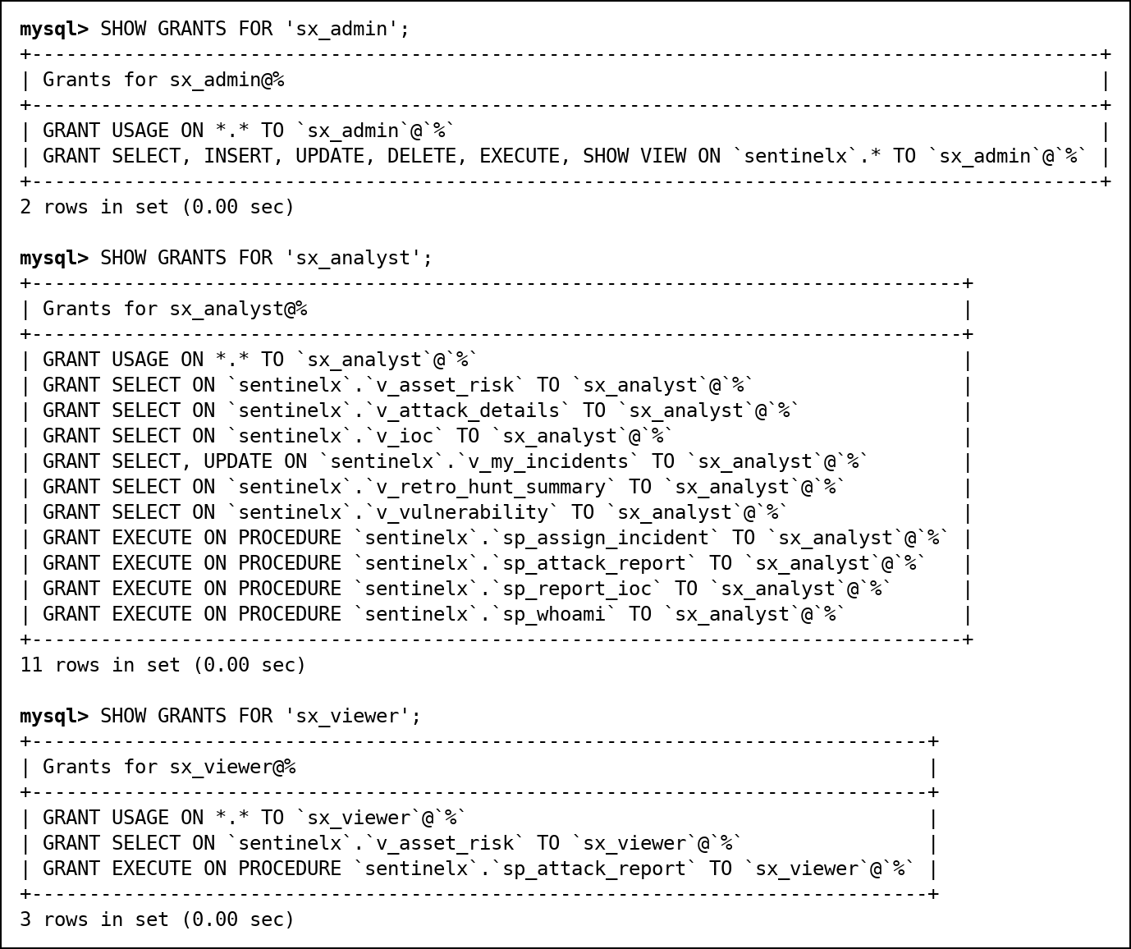
Fig. 108 SHOW GRANTS for the three roles
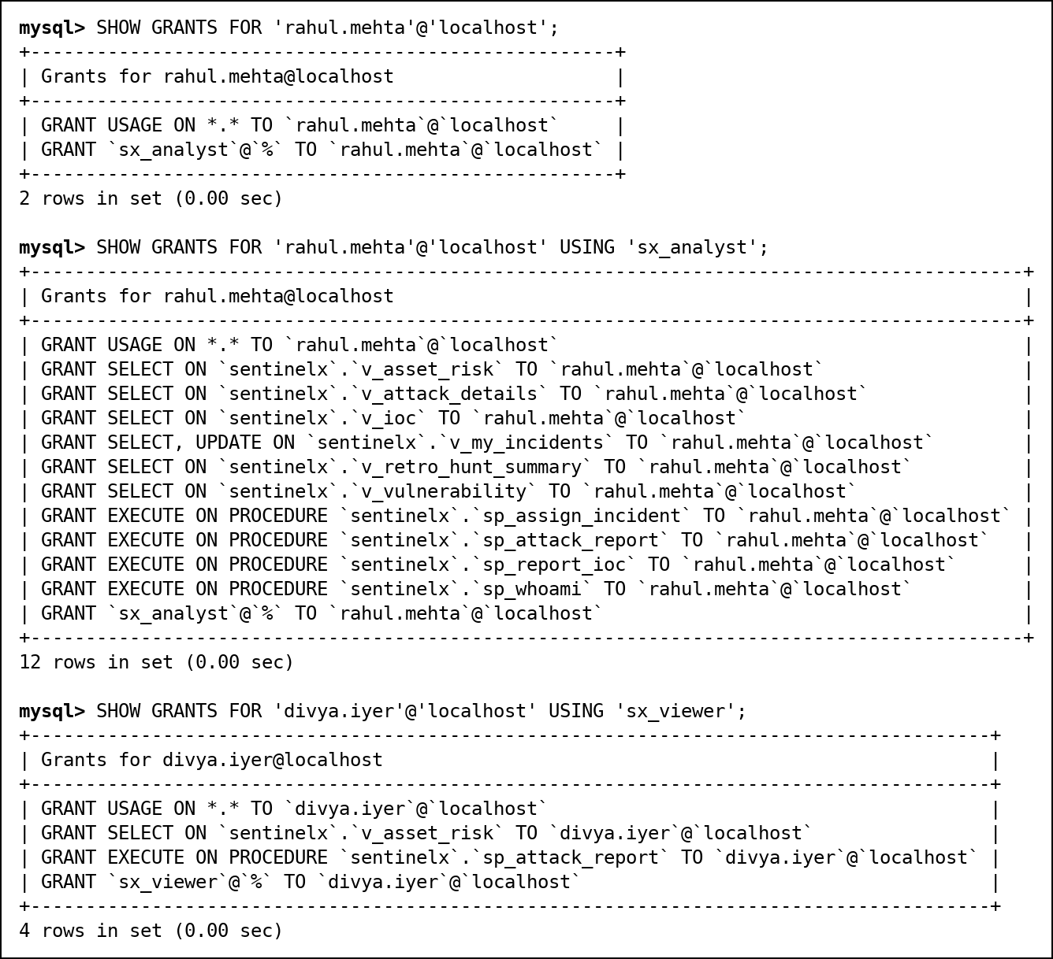
Fig. 109 A user's grants show only the role; USING expands it
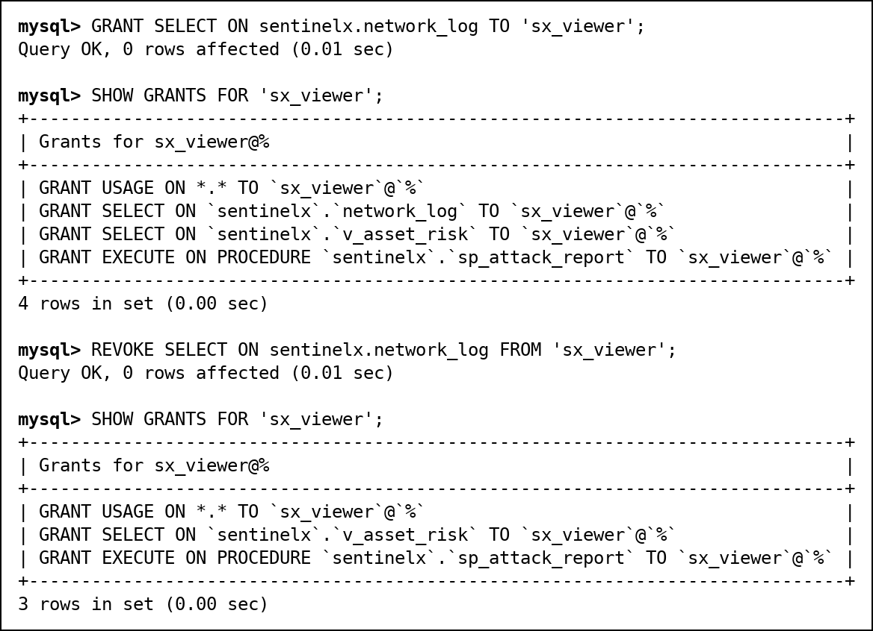
Fig. 110 GRANT, then REVOKE, with SHOW GRANTS before and after
Logged in as the viewer, divya.iyer: reports work, everything else is refused.
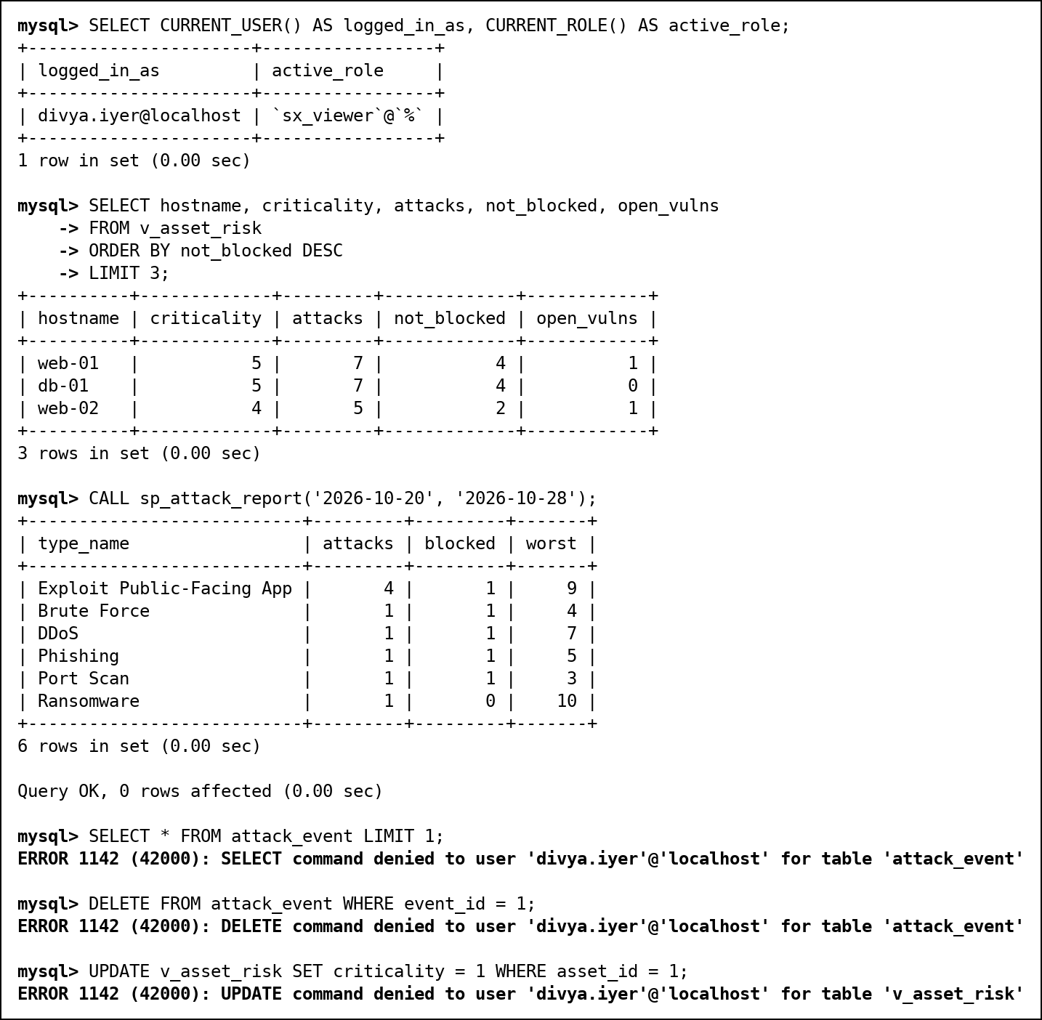
Fig. 112 Viewer: allowed and forbidden operations
Logged in as the analyst, rahul.mehta. He sees only his 3 incidents, can update their status through the view, cannot reassign one to another analyst (CHECK OPTION), and cannot read the incident table or drop tables:
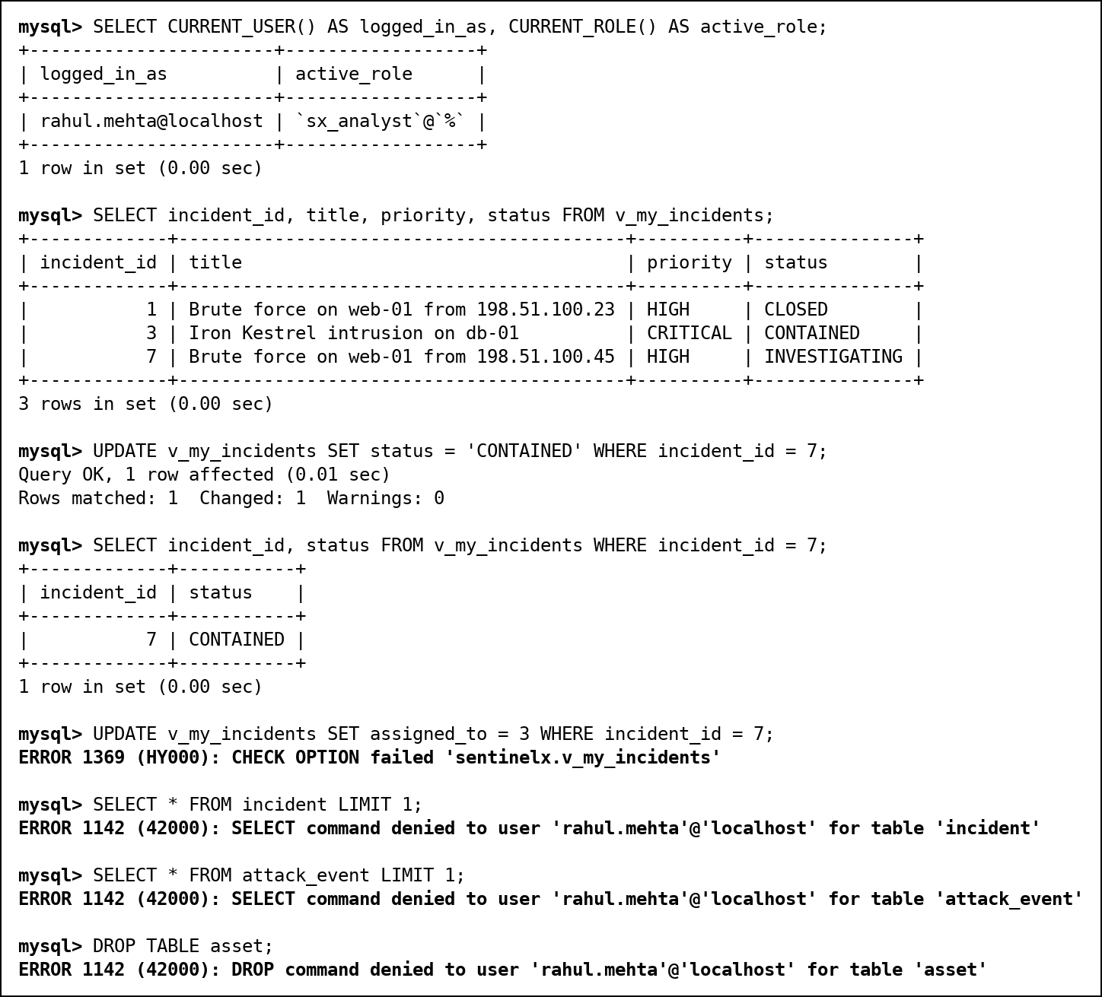
Fig. 114 Analyst: own incidents only; tables and DDL refused
The privilege-escalation fix: sp_whoami shows that rahul calls it but it runs with root's rights, so sp_assign_incident must check the caller itself. Giving his incident away and taking a colleague's are refused; claiming an unassigned incident works. Writing to ioc directly is refused, but reporting a compromised internal host through sp_report_ioc works, and the retro-hunt trigger finds its 24 old log lines on 9 assets.
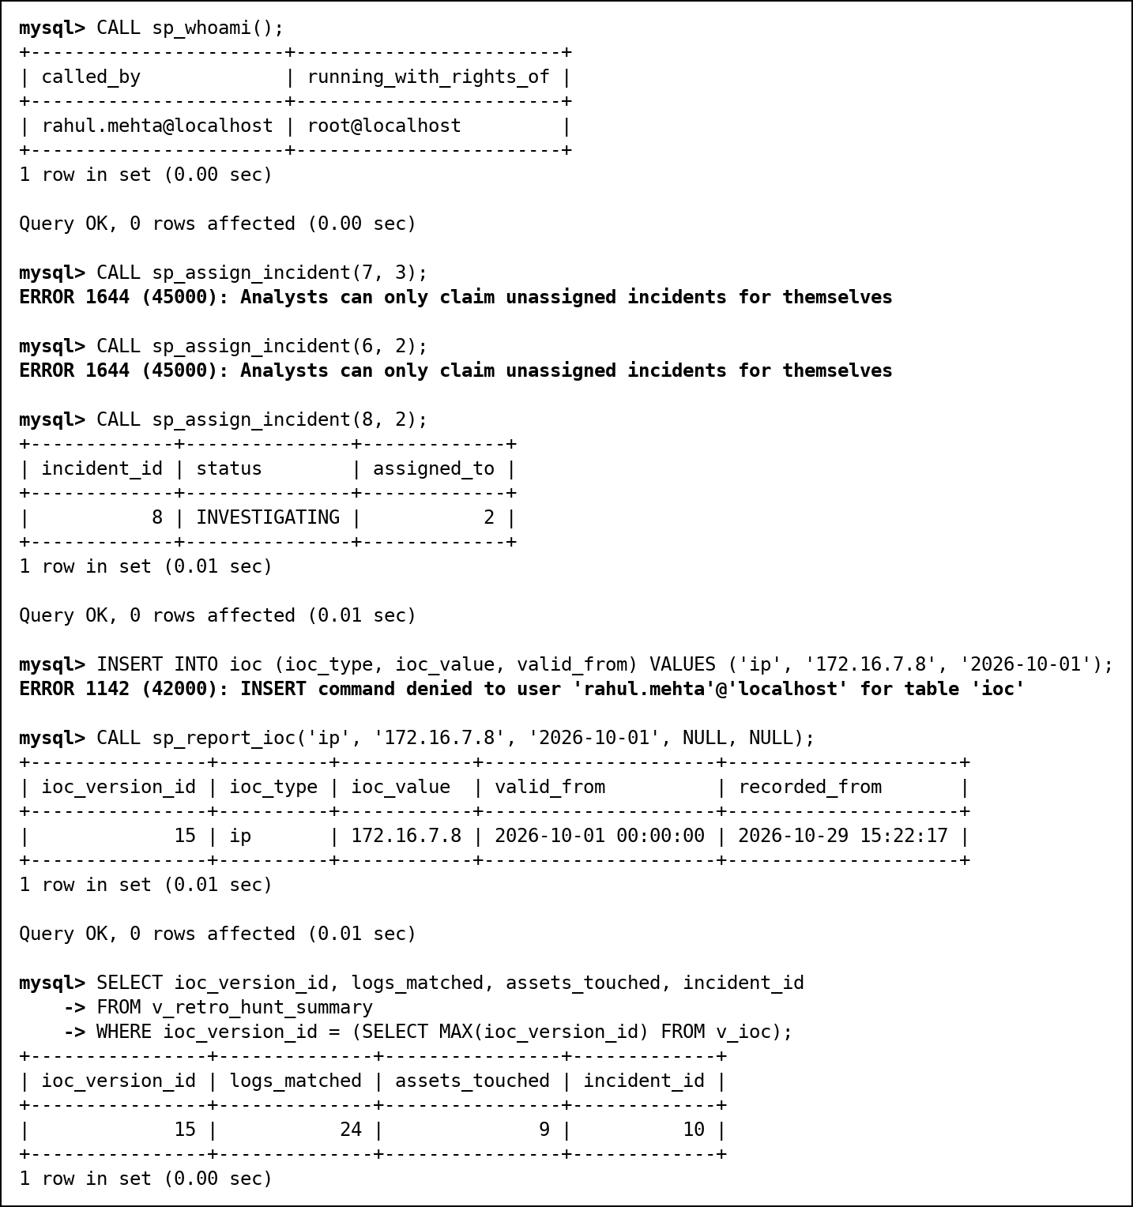
Fig. 115 Analyst: the procedure checks its caller; IOCs only through a procedure
Logged in as the admin, ananya.rao: the audit trail names rahul for the changes he made through the view and through the procedure, and even the admin cannot delete it, truncate it or drop its trigger.
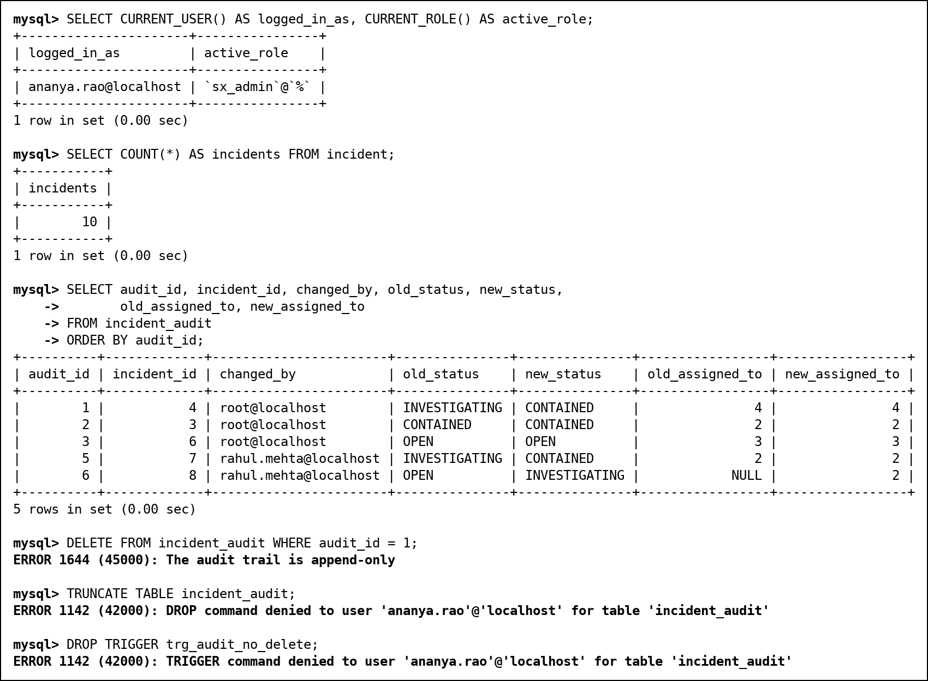
Fig. 116 Admin: the audit trail, and attempts to erase it

SQL injection: why GRANT alone does not protect
Two procedures let an analyst search his own incidents by title. The unsafe one pastes the search text into the SQL with CONCAT; the safe one passes it as a parameter (?). Both run with the definer's rights.
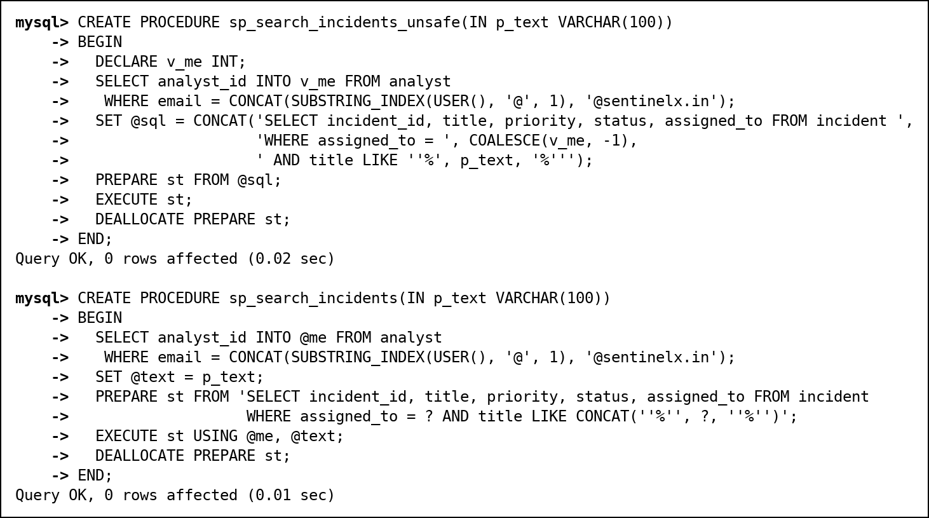
Fig. 118 The unsafe (CONCAT) and the safe (parameterised) search procedure
Rahul only has EXECUTE on the procedure. The text %' OR 1=1 -- turns the WHERE clause into "(... AND title LIKE '%%') OR 1=1", so every incident comes back, read with root's rights; a UNION returns every analyst's email from a table he cannot read. Stacked statements are refused, because PREPARE accepts one statement only. The parameterised procedure treats the same text as data and returns nothing.
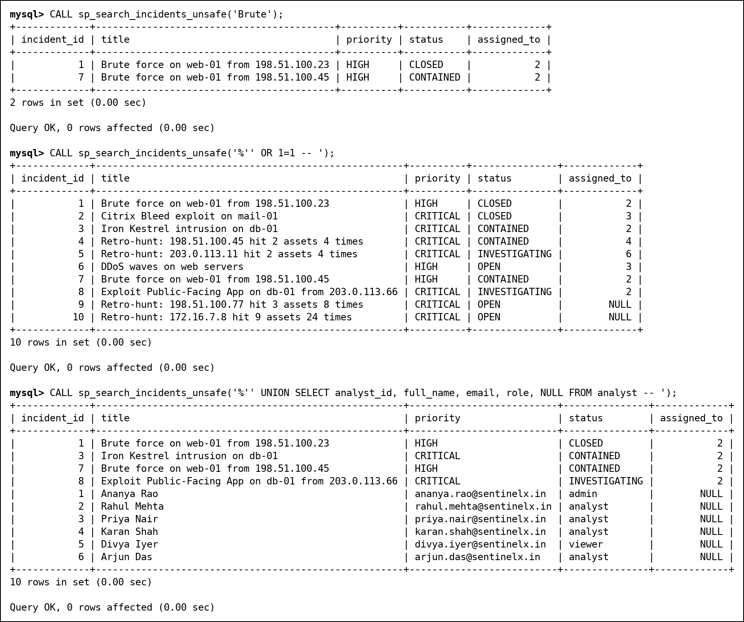
Fig. 119 Injection through the unsafe procedure
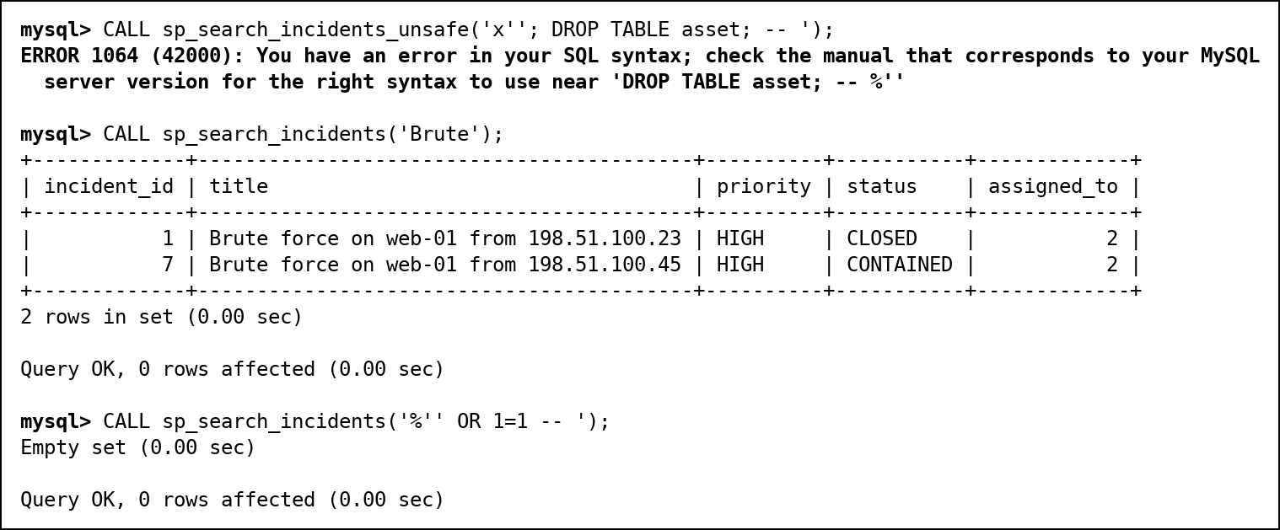
Fig. 120 Stacked statement refused; the safe procedure is not injectable
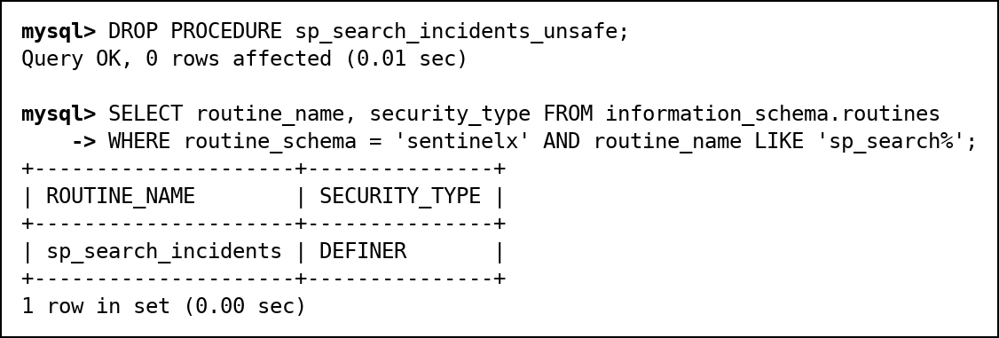
Fig. 121 The vulnerable procedure is dropped after the demonstration
Defences, in order of importance: never build SQL from user text (use parameters or static SQL); give code only the rights it needs (an INVOKER procedure, or a low-privilege definer instead of root); validate input. GRANT cannot help, because the injected SQL runs with whatever rights the vulnerable code has.

13. Transactions and Concurrency
SAVEPOINT and COMMIT. A new indicator is inserted and a savepoint is set. A wrong priority change follows, is rolled back to the savepoint, and the transaction is committed. The indicator is kept and the priority change is not.
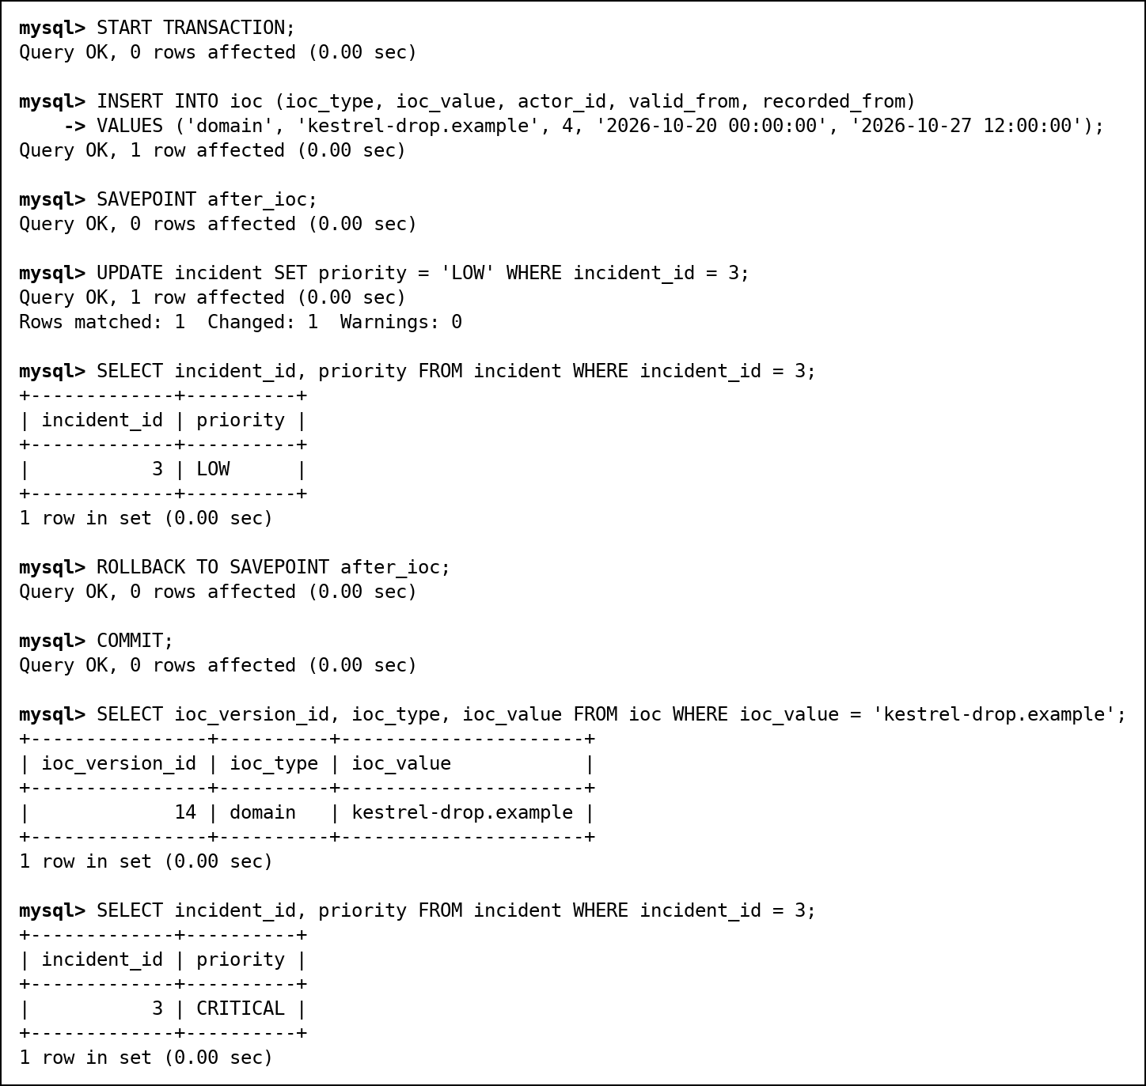
Fig. 122 SAVEPOINT, ROLLBACK TO SAVEPOINT and COMMIT
ROLLBACK. The second line of the batch points to an asset that does not exist. The script then calls ROLLBACK, so the log count is unchanged (50,021 before and after).
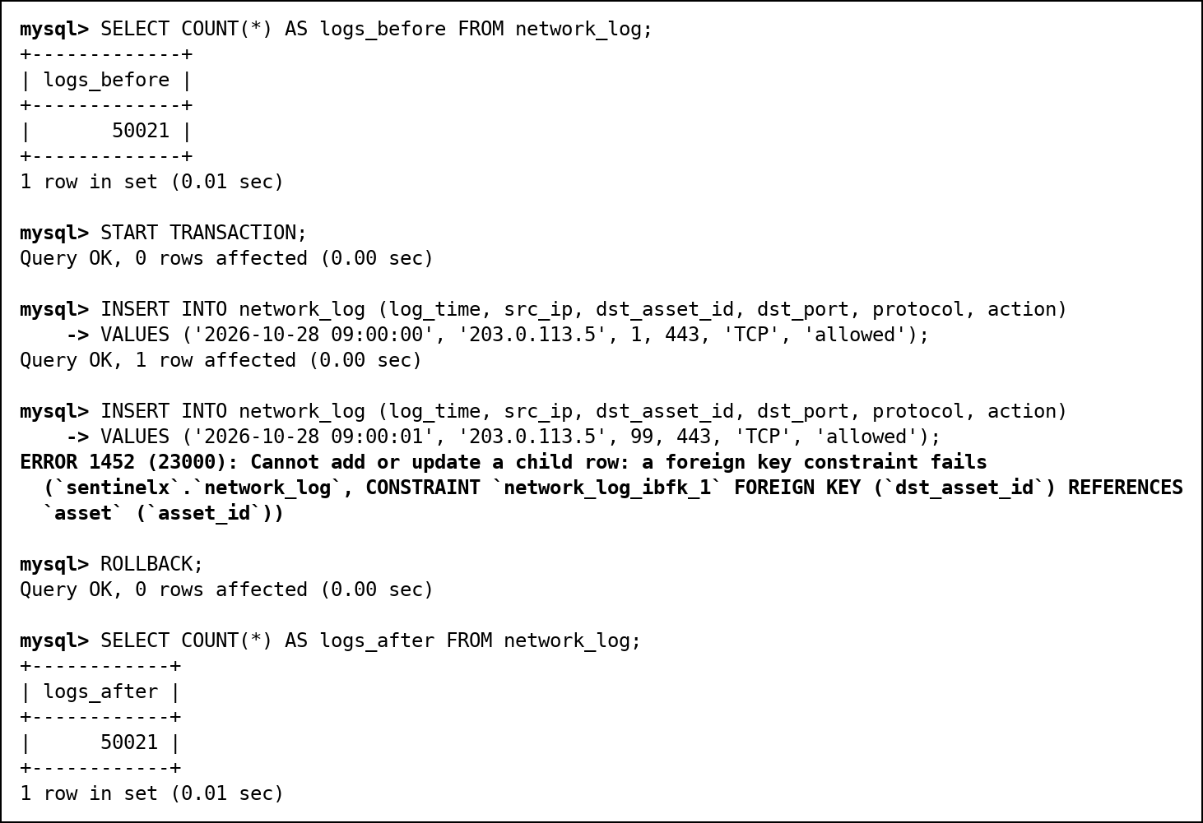
Fig. 123 A failed batch, rolled back explicitly
A failed statement does not roll back the transaction (found in Review 3). MySQL undoes only the statement that failed. If the script had said COMMIT instead of ROLLBACK, the good first line would have been kept and the batch would be half loaded. The Review 2 demonstration only worked because the script rolled back by hand.
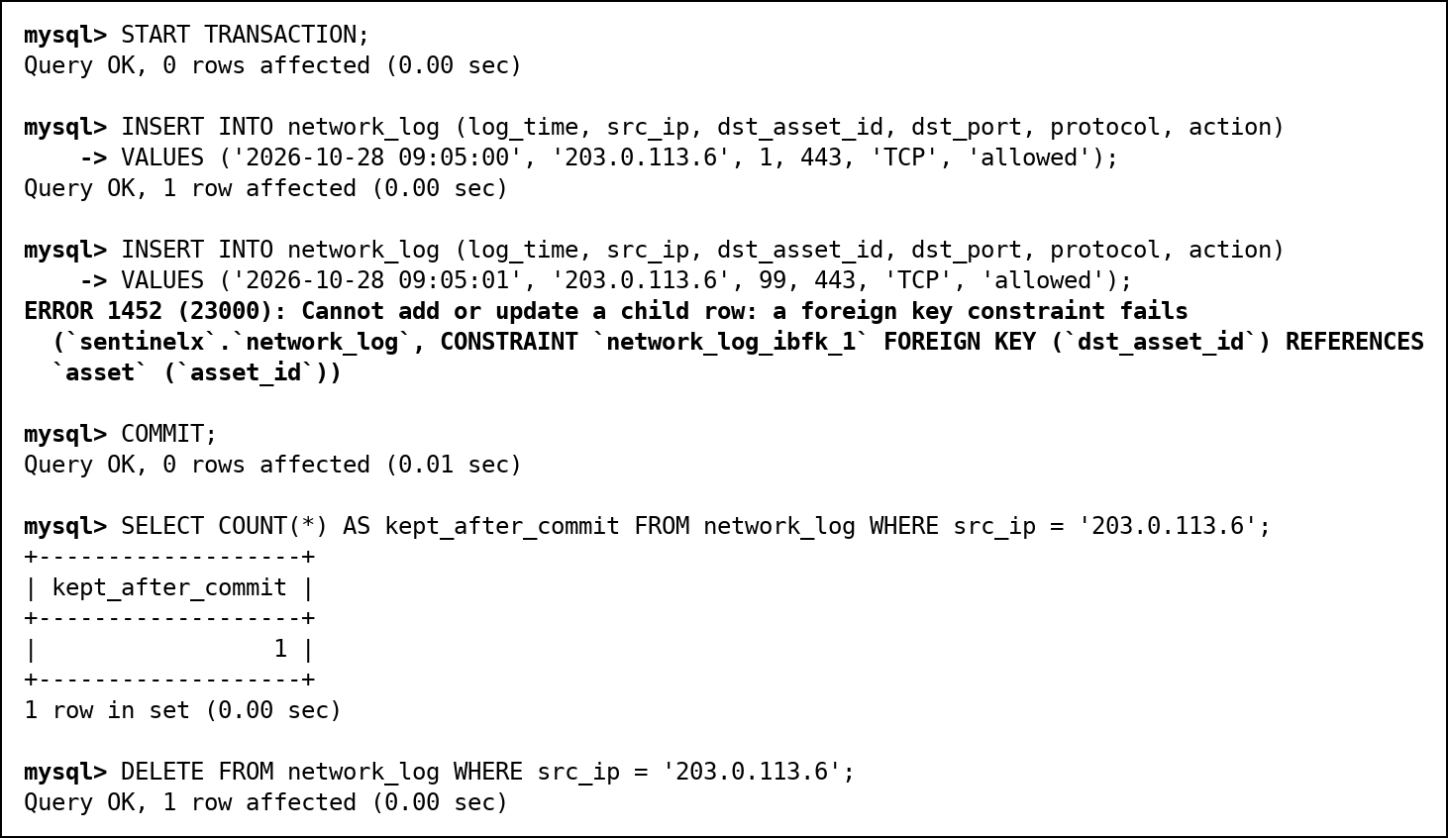
Fig. 124 One INSERT fails, COMMIT keeps the other: half a batch
The loader therefore handles it itself: sp_load_log_batch declares an EXIT HANDLER FOR SQLEXCEPTION that rolls back and re-raises the error. A bad batch leaves no rows; a good batch commits all three.
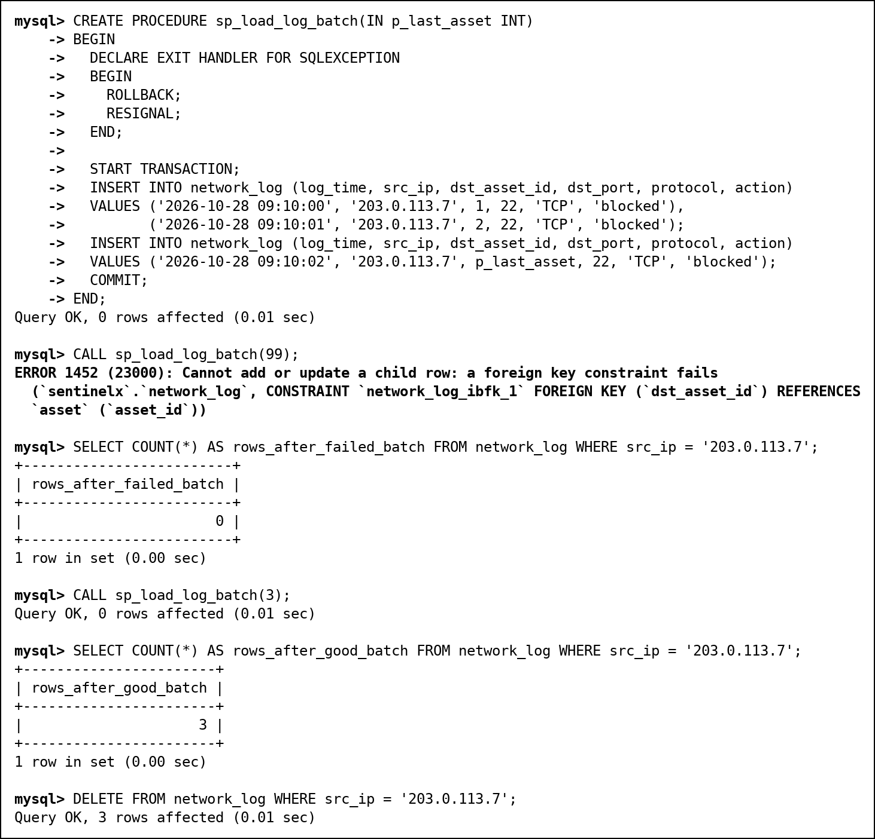
Fig. 125 sp_load_log_batch: the handler rolls back the whole batch

13.1 Concurrency
Each scenario uses two mysql sessions at the same time: terminal A (root) and terminal B (ananya.rao, the admin). In the rehearsal the sessions were timed with DO SLEEP() so that B's statements land between A's; in the live demonstration they are typed step by step (demo/06_concurrency.md).
Lost update. Both sessions read incident 6 as MEDIUM and each raises it "one level" to HIGH. Two escalations happened, but the result is HIGH, not CRITICAL: B overwrote A's change. The audit trail proves it: the second row says old_priority HIGH, new_priority HIGH.
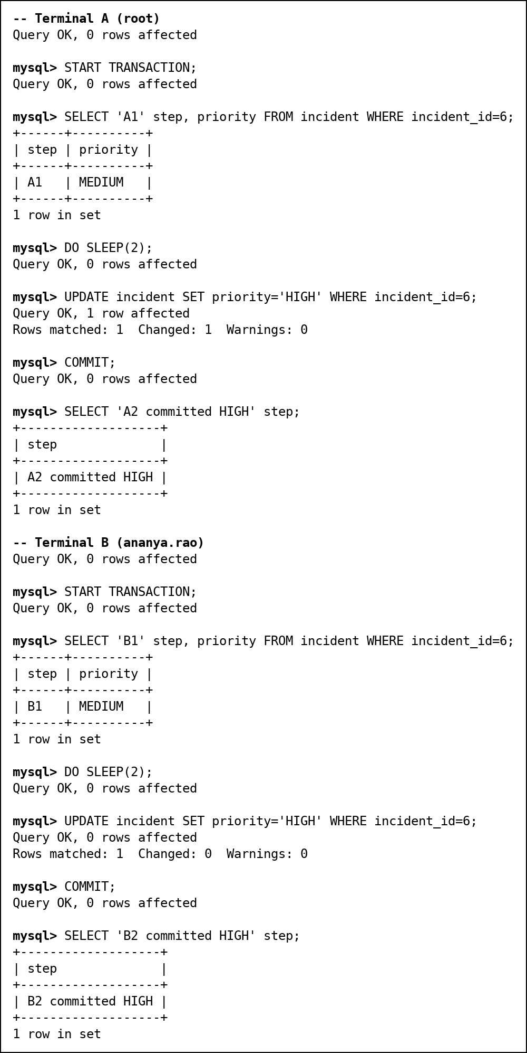
Fig. 126 Lost update: both sessions write HIGH
Who | old_priority | new_priority
root | MEDIUM | HIGH
ananya.rao | HIGH | HIGH

The fix: lock the row when you read it. With SELECT ... FOR UPDATE, B waits until A commits, then reads HIGH and sets CRITICAL. Other fixes are optimistic versioning (a version column checked in the UPDATE's WHERE clause) or an atomic UPDATE that computes the new value from the current one.
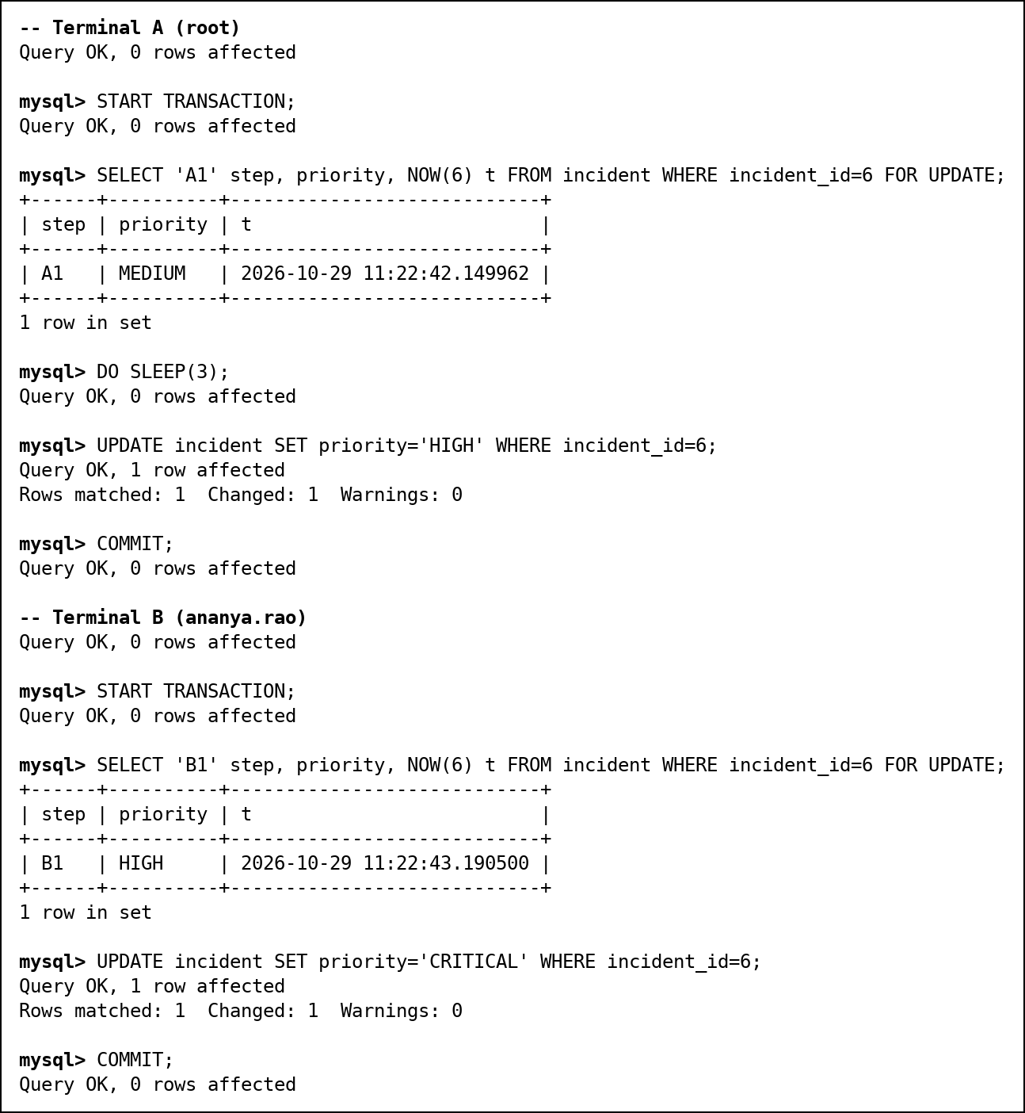
Fig. 127 FOR UPDATE: B waits, reads HIGH, writes CRITICAL
Deadlock. A locks incident 3 then wants 6; B locks 6 then wants 3. InnoDB detects the cycle, rolls back B with ERROR 1213 and lets A finish. Prevention: lock rows in one fixed order (lowest incident_id first, as sp_escalate_incidents does) and retry on 1213.
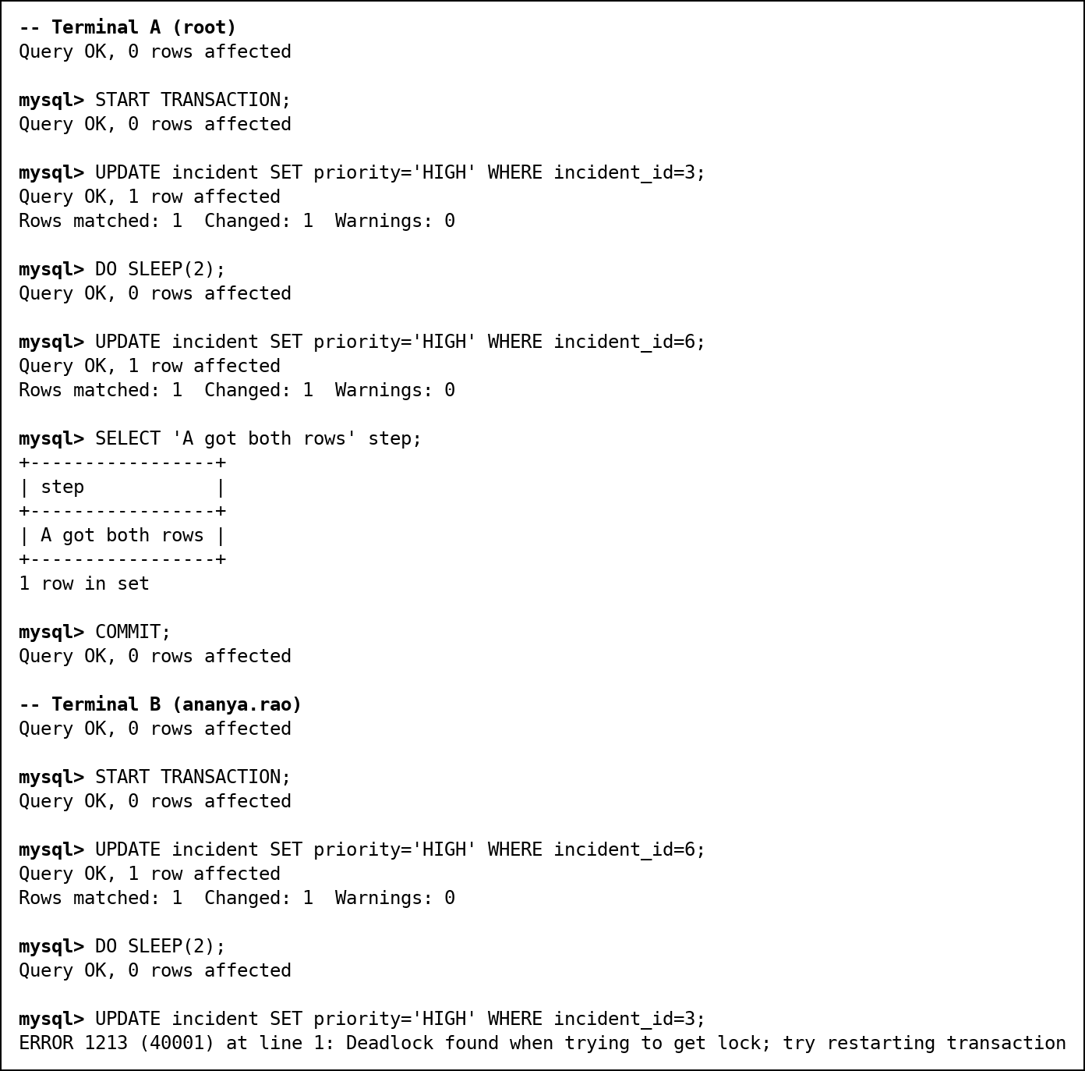
Fig. 128 Deadlock detected; B is rolled back
Isolation levels. In READ COMMITTED, A read incident 6 as OPEN, B changed it to INVESTIGATING, and A's second read inside the same transaction said INVESTIGATING (a non-repeatable read). In REPEATABLE READ, MySQL's default, the second read still said OPEN, because the transaction reads from its own snapshot.
Isolation level | Dirty read | Non-repeatable read | Phantom read
READ UNCOMMITTED | possible | possible | possible
READ COMMITTED | prevented | possible (shown) | possible
REPEATABLE READ (default) | prevented | prevented (shown) | prevented for plain reads (snapshot); locking reads use next-key locks
SERIALIZABLE | prevented | prevented | prevented

Our own triggers are safe under concurrency. When two sessions insert the same bad IP at the same moment, the second waits about 3 seconds and is then rejected by trg_ioc_no_overlap: the SELECT inside a trigger fired by an INSERT is a locking read, so it sees the first row once that commits. Two simultaneous severity-9 attacks on the same asset were grouped into one incident in the same way.

14. Indexing and Query Optimisation
Besides the primary keys and the indexes MySQL creates for foreign keys, we added three: idx_src_time (src_ip, log_time) on network_log for retro-hunts, and idx_time and idx_src on attack_event for the dashboard and search.
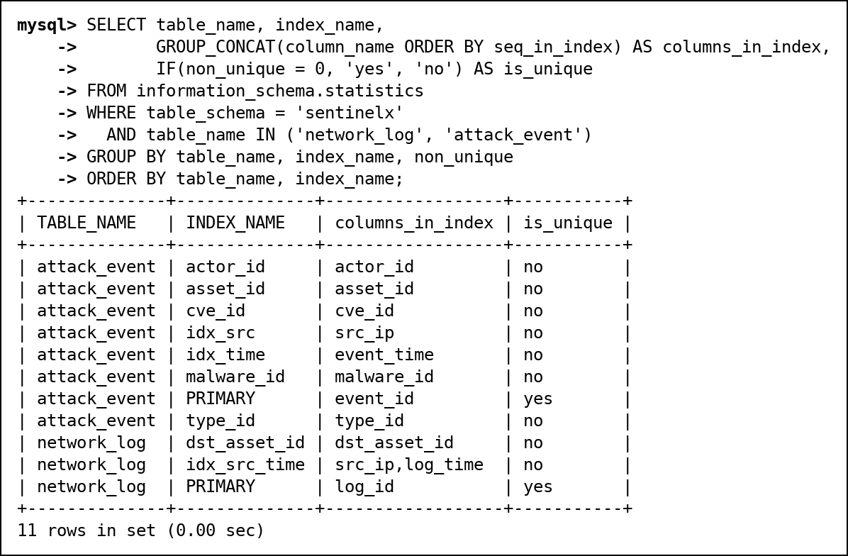
Fig. 129 Indexes on network_log and attack_event
To measure idx_src_time we dropped it, ran EXPLAIN on the retro-hunt lookup, then created it again and repeated the EXPLAIN.
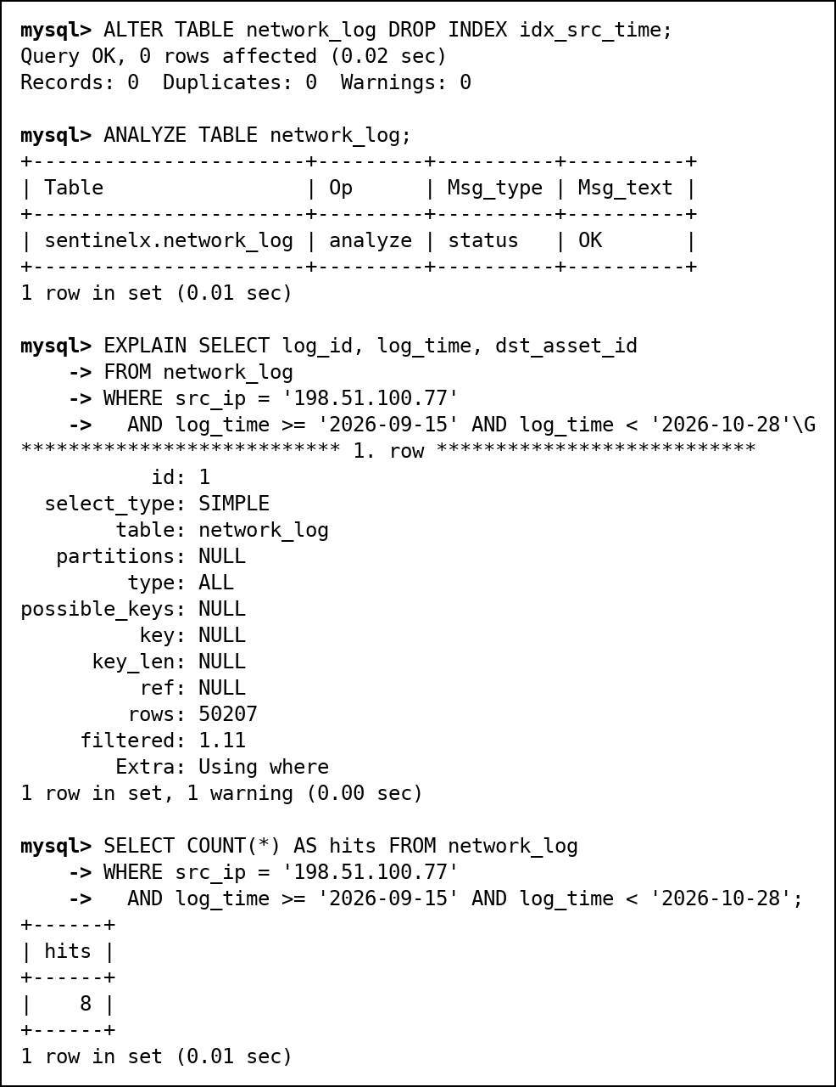
Fig. 130 EXPLAIN without idx_src_time: full table scan
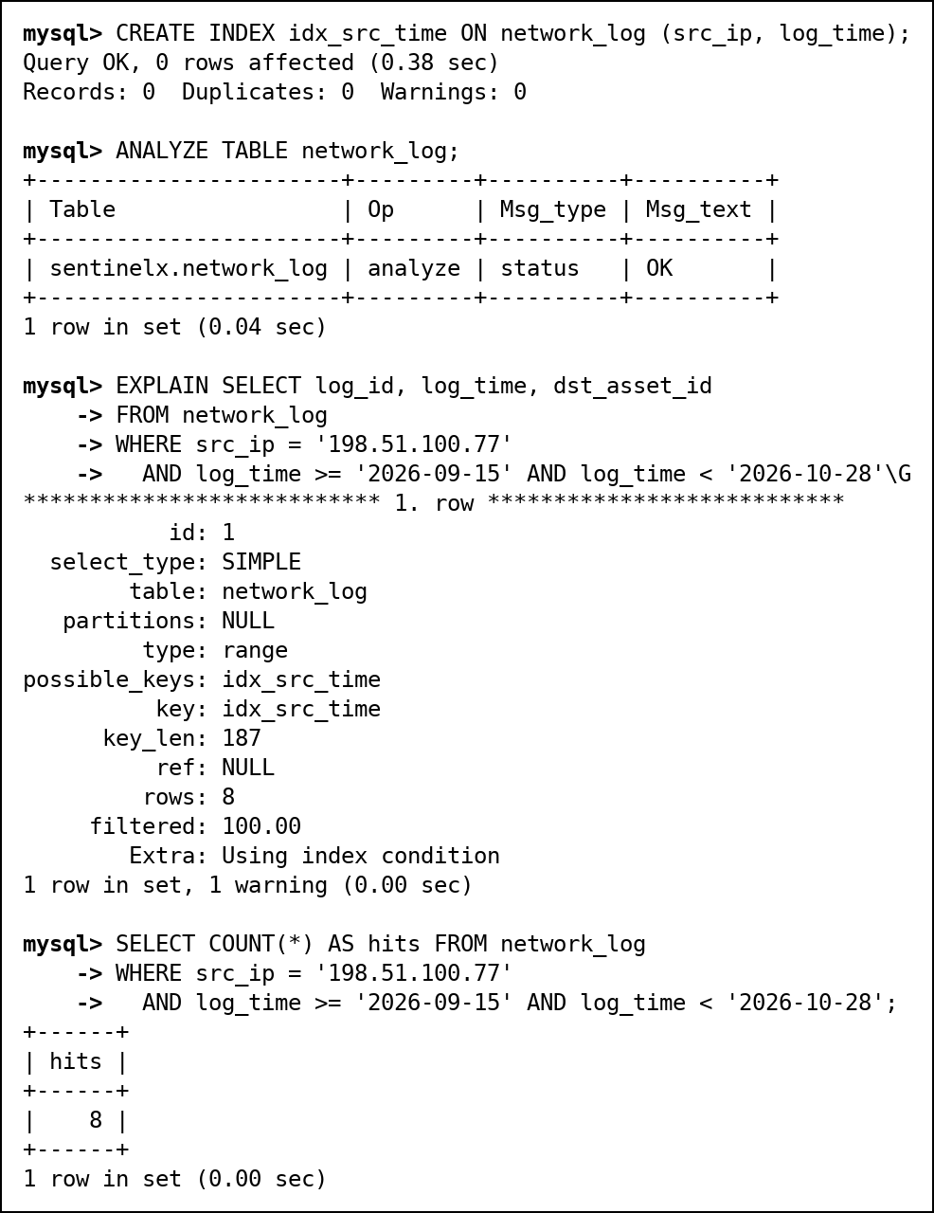
Fig. 131 EXPLAIN with idx_src_time: range read of 8 rows
 | Without idx_src_time | With idx_src_time
Access type | ALL (full table scan) | range
Index used | none | idx_src_time
Rows examined (estimate) | 50,163 | 8
Rows actually matching | 8 | 8

The index lets MySQL jump straight to the 8 lines from that IP instead of reading all 50,021 rows. With 50,000 rows both runs still finish in about 0.01 seconds, but a full scan grows with the size of the table while the range scan only reads the matching rows, so the gap widens as logs accumulate.

14.1 When an index is not used
idx_src_time is (src_ip, log_time). A filter on log_time alone cannot seek it, because the index is sorted by src_ip first (the leftmost-prefix rule). With skip scan switched off MySQL reads the whole index; MySQL 8.0.13 and later can instead skip-scan it, doing one range read for each of the 1,004 distinct source IPs.
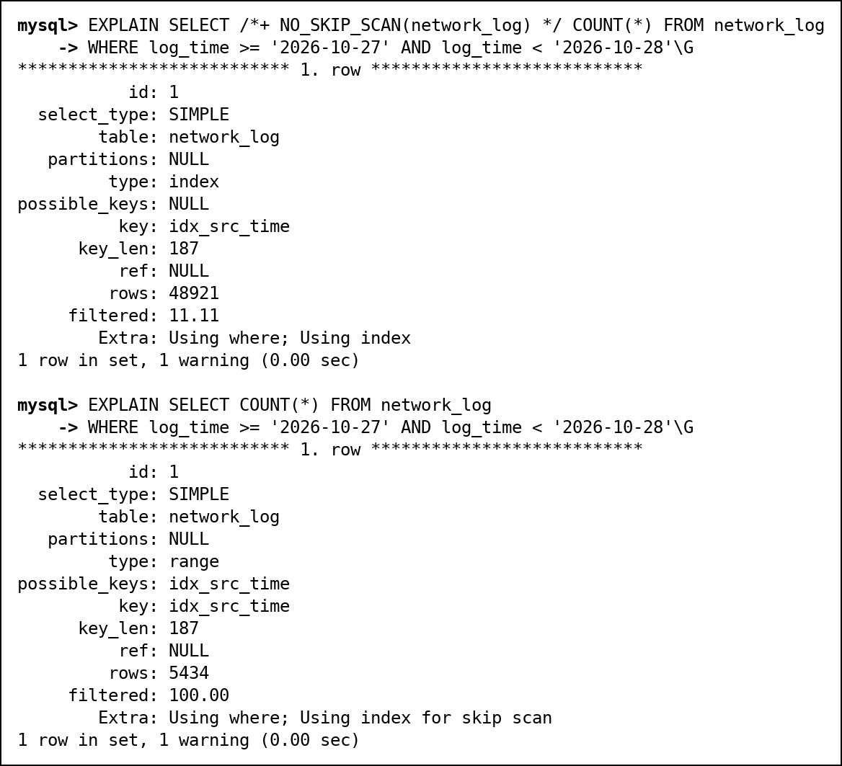
Fig. 132 Leftmost prefix: full index scan, or skip scan
A function on the indexed column hides it from the optimiser: SUBSTRING_INDEX(src_ip, ...) reads the whole index, while the same filter written as a prefix LIKE becomes a range read of about 16 rows.
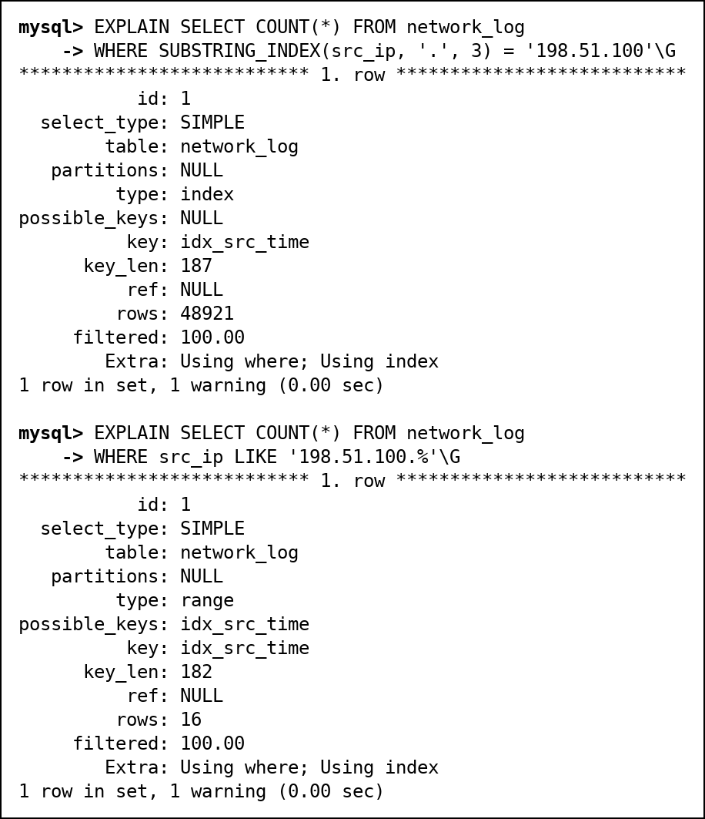
Fig. 133 A function hides the index; a prefix LIKE uses it
EXPLAIN ANALYZE runs the query and reports real times and row counts next to the estimates: 8 rows, read in about 0.1 ms through idx_src_time.
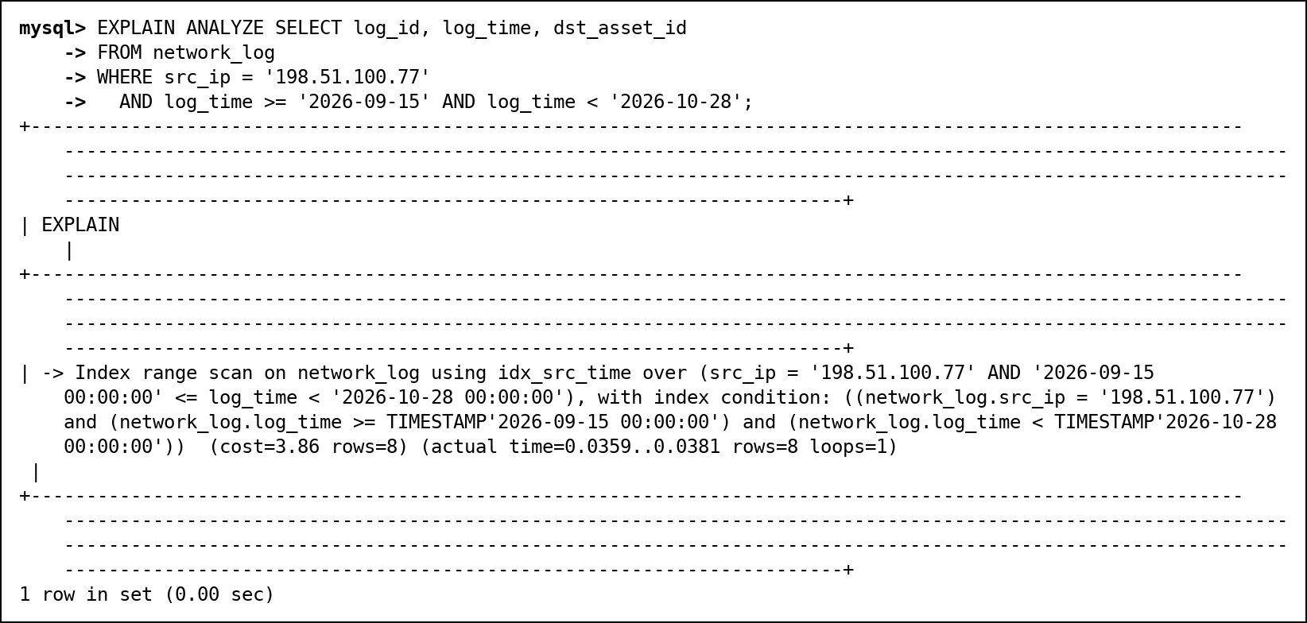
Fig. 134 EXPLAIN ANALYZE of the retro-hunt lookup
Indexes are not free: every INSERT into network_log must also update each index, and they take disk and memory. On a 10-row table such as asset an index brings nothing, because the whole table is one page.

15. Backup and Point-in-Time Recovery
A full backup is a snapshot of one moment. The binary log records every change after it, in order, each at a numbered position. To undo a mistake made at 3:15 PM we restore the snapshot and replay the binary log from the snapshot's position up to the position just before the bad statement. We stop at a position, not a time: --stop-datetime has one-second resolution, and the bad statement may share its second with good ones. This was rehearsed on a separate MySQL 8.0.46 server, not run live.
Step | Command or statement | Result
1. Nightly full backup | mysqldump --single-transaction --source-data=2  --routines --triggers --events  --databases sentinelx --result-file=sentinelx_full.sql | Consistent snapshot; the file records binlog.000002 position 16453827
2. Work after the backup | INSERT INTO attack_event ... '203.0.113.123' ...  UPDATE incident SET status = 'INVESTIGATING'  WHERE incident_id = 6; | Must survive the recovery
3. The accident | DELETE FROM asset_vulnerability; | All 9 patch records gone
4. Find it | SHOW BINLOG EVENTS IN 'binlog.000002'  FROM 16453827; | The bad transaction starts at position 16454920
5. Restore and replay | mysql --init-command="SET sql_log_bin=0"  -e "source sentinelx_full.sql"  mysqlbinlog --read-from-remote-server  --start-position=16453827  --stop-position=16454920 --disable-log-bin  --result-file=replay.sql binlog.000002  mysql -e "source replay.sql" | Snapshot back, then the two good transactions replayed
6. Check | SELECT COUNT(*) FROM asset_vulnerability; | 9 rows back; the post-backup attack and status change are present; triggers restored

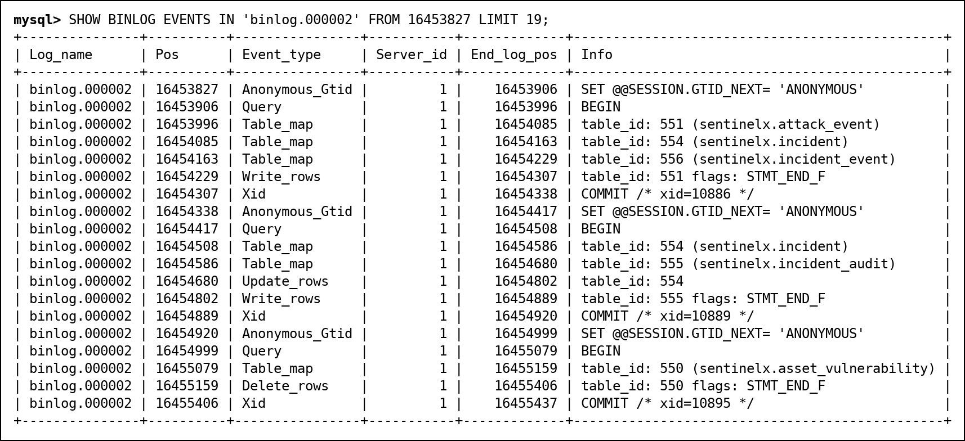
Fig. 135 The binary log after the backup: two good transactions, then the DELETE at 16454920
Durability after a power failure is a different mechanism: InnoDB writes every change to its redo log and flushes it to disk at each COMMIT (innodb_flush_log_at_trx_commit = 1), the doublewrite buffer protects against half-written pages, and after a crash InnoDB replays the redo log. A committed DELETE is durable too; only a backup and the binary log can undo it. Users and grants live in the mysql schema and are re-created by 12_security.sql rather than by this dump.

16. Testing
13_tests.sql holds 49 automatic tests. Each one states a claim made in this report and checks it: either a value (sp_check) or the exact error number a statement must raise (sp_expect_error, which runs the statement as dynamic SQL and catches the error). Both helpers are SQL SECURITY INVOKER, so a test never runs with more rights than the user running it. The runner executes them as root and then logged in as the analyst, the viewer and the admin.
ID | Run as | What it checks | Expected | Actual | Result
T01 | root | 16 tables plus incident_audit | 17 | 17 | PASS
T02 | root | network_log is fully loaded | 50021 | 50021 | PASS
T03 | root | CHECK rejects criticality 9 | 3819 | 3819 | PASS
T04 | root | UNIQUE rejects a second web-01 | 1062 | 1062 | PASS
T05 | root | FK rejects an unknown attack type | 1452 | 1452 | PASS
T06 | root | FK blocks deleting an attacked asset | 1451 | 1451 | PASS
T07 | root | CHECK: CLOSED needs closed_at | 3819 | 3819 | PASS
T08 | root | ENUM rejects priority URGENT (strict mode) | 1265 | 1265 | PASS
T09 | root | ON DELETE CASCADE clears incident_event | 0 | 0 | PASS
T10 | root | aggregated view is not updatable | 1288 | 1288 | PASS
T11 | root | severity 9 attack opens an incident | 11 | 11 | PASS
T12 | root | repeat within 1 hour joins that incident | 11 | 11 | PASS
T13 | root | retro-hunt found 8 old logs for 198.51.100.77 | 8 | 8 | PASS
T14 | root | overlapping IOC version is rejected | 1644 | 1644 | PASS
T15 | root | IOC history is append-only | 1644 | 1644 | PASS
T16 | root | fn_severity_label(9.8), (6.5) | CRITICAL/MEDIUM | CRITICAL/MEDIUM | PASS
T17 | root | cannot assign a closed incident | 1644 | 1644 | PASS
T18 | root | cannot assign an incident to a viewer | 1644 | 1644 | PASS
T19 | root | bad log batch raises the FK error | 1452 | 1452 | PASS
T20 | root | ... and leaves none of its rows behind | 0 | 0 | PASS
T21 | root | savepoint kept the IOC, undid the priority change | 1/CRITICAL | 1/CRITICAL | PASS
T22 | root | NOT IN over a NULL returns nothing | 0 | 0 | PASS
T23 | root | audit trail names rahul for his claim of incident 8 | rahul.mehta | rahul.mehta | PASS
T24 | root | audit trail is append-only (DELETE) | 1644 | 1644 | PASS
T25 | root | audit trail is append-only (UPDATE) | 1644 | 1644 | PASS
T26 | root | injectable procedure was removed | 0 | 0 | PASS
T27 | root | admin role has no CREATE/ALTER/DROP/TRIGGER | 0 | 0 | PASS
T28 | root | a closed IOC version can be replaced by a new one | 0 | 0 | PASS
S01 | rahul (analyst) | analyst cannot read a base table | 1142 | 1142 | PASS
S02 | rahul (analyst) | analyst can read through the view | 0 | 0 | PASS
S03 | rahul (analyst) | analyst cannot run DDL | 1142 | 1142 | PASS
S04 | rahul (analyst) | v_my_incidents shows only his own rows | 0 | 0 | PASS
S05 | rahul (analyst) | WITH CHECK OPTION blocks handing an incident over | 1369 | 1369 | PASS
S06 | rahul (analyst) | procedure blocks giving his incident away | 1644 | 1644 | PASS
S07 | rahul (analyst) | procedure blocks taking a colleague's incident | 1644 | 1644 | PASS
S08 | rahul (analyst) | procedure lets him claim an unassigned incident | 0 | 0 | PASS
S09 | rahul (analyst) | analyst cannot write the ioc table directly | 1142 | 1142 | PASS
S10 | rahul (analyst) | analyst reports an IOC through the procedure | 0 | 0 | PASS
S11 | rahul (analyst) | analyst cannot read the audit trail | 1142 | 1142 | PASS
V01 | divya (viewer) | viewer can read the risk view | 0 | 0 | PASS
V02 | divya (viewer) | viewer cannot read a base table | 1142 | 1142 | PASS
V03 | divya (viewer) | viewer cannot delete | 1142 | 1142 | PASS
V04 | divya (viewer) | viewer cannot run the assign procedure | 1370 | 1370 | PASS
V05 | divya (viewer) | viewer cannot update the risk view | 1142 | 1142 | PASS
A01 | ananya (admin) | admin can change incident data | 0 | 0 | PASS
A02 | ananya (admin) | ... and the audit trail names the admin | ananya.rao | ananya.rao | PASS
A03 | ananya (admin) | admin cannot delete audit rows | 1644 | 1644 | PASS
A04 | ananya (admin) | admin cannot TRUNCATE the audit trail | 1142 | 1142 | PASS
A05 | ananya (admin) | admin cannot change the schema | 1142 | 1142 | PASS

Error numbers: 1062 duplicate key, 1142 privilege denied, 1265 ENUM value rejected, 1288 view not updatable, 1369 CHECK OPTION failed, 1370 EXECUTE denied, 1451/1452 foreign key, 1644 SIGNAL from our triggers and procedures, 3819 CHECK constraint; 0 means the statement had to succeed.
Run as | Passed | Failed
root | 28 | 0
rahul (analyst) | 11 | 0
divya (viewer) | 5 | 0
ananya (admin) | 5 | 0
Total | 49 | 0

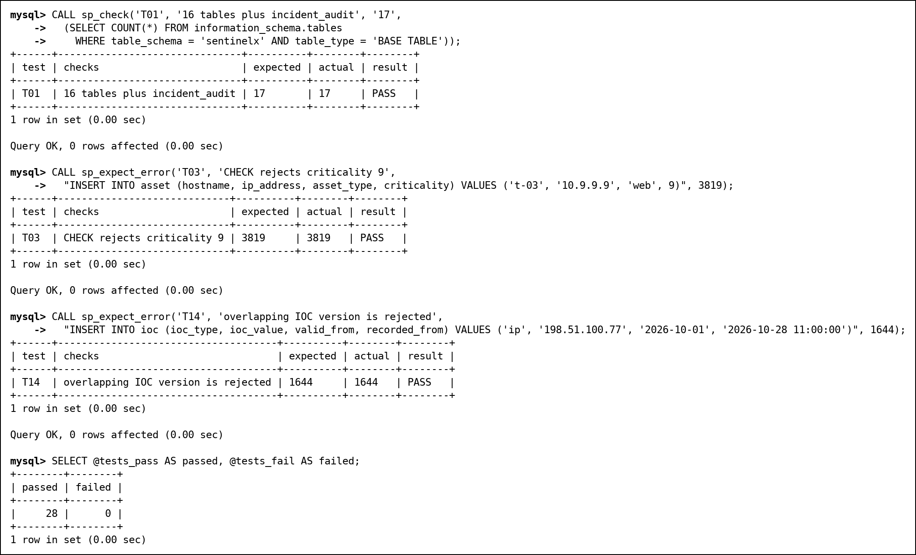
Fig. 136 Four of the root tests and the root summary
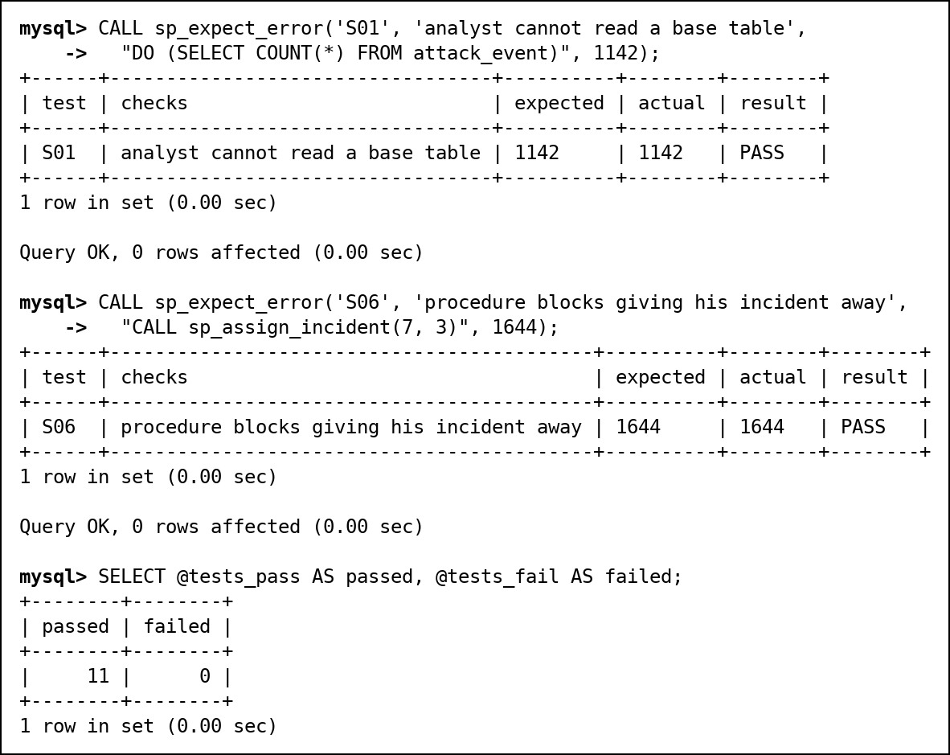
Fig. 137 Analyst tests (two shown) and the analyst summary

17. Scope Revision and Design Changes since Review 2
The Review 2 report described more than the project contains. Sections 5.2, 6 and 19 and Fig. 1 listed a FastAPI backend, a React dashboard and machine-learning jobs written with pandas and scikit-learn. These were planned but never built, and none of them are in the repository. Fig. 1 also showed a Python ingestion pipeline and a dataset of 600,000 logs and 115,000 events. The only Python in the project generates the test data and the step files, and the dataset is 50,021 log lines and 30 attacks. We should have marked these parts as planned work, and we are correcting that here.
For Review 3 we have narrowed the scope to what a DBMS project should be judged on: the database design, the SQL, and the security of the database itself. The database was always the core of SentinelX. Every rule that matters already runs inside MySQL as a constraint, trigger, procedure or privilege, so removing the application layer removes no behaviour. Users work through the mysql client and MySQL Workbench, and what each user can do is decided by their role, not by an application.
Removed | Where Review 2 claimed it | Review 3 status
FastAPI backend | 5.2, 6, 19 | Removed. Roles, views and procedures are the access layer (12.7).
React SOC dashboard | 5.2, 7, 19, Fig. 1 | Removed. The "dashboard" module is the views v_attack_details and v_asset_risk.
scikit-learn ML jobs | 5.2, 6, 9, 10, A7, C5 | Removed. The two columns they were meant to fill were changed (changes 12 and 13).
Python ingestion / ETL | Fig. 1 | Never built. Test data comes from tools/gen_seed.py and a recursive CTE.

Design changes since Review 2 (numbering continues from the Review 2 change log):
# | Change | Reason
12 | attack_event.predicted_severity renamed to triage_priority: a priority an analyst sets, NULL until triaged | No ML job exists to predict anything. The column now records an analyst's decision, which is not a function of severity: events 5 and 6 both have severity 9 but are CRITICAL and HIGH, because event 6 was blocked. So there is no transitive dependency event_id → severity → triage_priority, and the table stays in 3NF.
13 | malware.cluster_id dropped | Only the ML job would have filled it. Query C5 now self-joins malware on actor_id (pairs of malware used by the same threat actor).
14 | 01_ddl.sql selects the database again after re-creating it | Run on its own, the script dropped the database it was using and stopped with ERROR 1046 at the first CREATE TABLE. Our runner hid this because it always passed --database.
15 | sp_assign_incident checks who is calling it | Our own testing found a privilege escalation. The procedure runs with its definer's rights, so an analyst could call it to hand his incident to a colleague, or take a colleague's incident. That is the change WITH CHECK OPTION blocks on v_my_incidents. The procedure now maps USER() (the caller, not CURRENT_USER(), which is the definer) to an analyst, and analysts may only claim unassigned incidents for themselves.
16 | Analyst role reads only views and runs only procedures | Review 2 granted analysts SELECT on ten base tables, plus INSERT on ioc, so views were not the only access path. Analysts now read indicators through the new view v_ioc and report them through the new procedure sp_report_ioc, which always sets recorded_from to the current time, so nobody can backdate when we learned about an indicator.
17 | Accounts lock after 3 wrong passwords (FAILED_LOGIN_ATTEMPTS 3 PASSWORD_LOCK_TIME 1) | Before this, any number of wrong passwords could be tried.
18 | New procedure sp_load_log_batch with an exit handler that rolls back | MySQL undoes only the failed statement, not the transaction. The Review 2 demo worked only because the script called ROLLBACK itself. Step 172 shows both behaviours.
19 | Four more EXPLAIN plans (step 183) | They show the leftmost-prefix rule (full index scan, and MySQL 8's skip scan as the alternative), a function on the column that hides the index, the same filter rewritten as a range read, and EXPLAIN ANALYZE with real timings.
20 | 13_tests.sql: 49 automatic tests | 28 run as root, 11 as the analyst, 5 as the viewer and 5 as the admin. Each prints PASS or FAIL, and all 49 pass on a clean build.
21 | New table incident_audit with triggers on incident | Every UPDATE or DELETE of an incident is recorded with the account that made it (USER()), the time, and the old and new status, priority and owner. This happens whether the change came through a view, a procedure or a direct statement. CURRENT_USER() would always record root, the trigger's definer. The table has no foreign key, so the trail survives the incident being deleted. Two more triggers make it append-only.
22 | sx_admin lost CREATE, ALTER, DROP and TRIGGER | Review 2 gave the admin role ALL PRIVILEGES, which included dropping the audit triggers or truncating the audit table (TRUNCATE does not fire triggers). Schema changes now stay with root, the DBA.
23 | SQL-injection demonstration (steps 196–198) | A search procedure built with CONCAT lets the analyst read every incident and every analyst's email, although he only holds EXECUTE: the injected SQL runs with the procedure's rights. The parameterised version is safe. The vulnerable procedure is dropped after the demonstration.
24 | trg_ioc_no_overlap ignores versions closed with recorded_to | Found while building the demo. trg_ioc_no_delete tells users to close a version with recorded_to, but the overlap check still counted closed versions, so a corrected version could never be added.
25 | Backup and point-in-time recovery runbook (demo/07_backup_recovery.md) | Rehearsed with mysqldump and the binary log, stopping at the binlog position of the bad DELETE.
26 | Architecture figure redrawn (tools/draw_architecture.py) | The old Fig. 1 showed components that do not exist.
27 | Relational schema diagram redrawn from the DDL (tools/draw_relational_schema.py) | The hand-drawn Review 2 version still showed event_time and log_time inside primary keys, removed in Review 2 (change 10), and the two ML columns.

18. Review 3 Requirements Checklist
Requirement | Evidence | Where | Status
Complete database with all tables populated | 17 tables, 50,021 log lines, 30 attacks, row counts | 9, 10 | Done
Full scripts, re-runnable from scratch | 01_ddl.sql to 13_tests.sql run cleanly on an empty server; one-click runner; fixed ERROR 1046 | 10, 17 | Done
Advanced SQL | 40 queries in 7 categories; 11 complex queries with expected and actual output | 11, 12.1 | Done
Views (2-3 minimum) | 6 views: 5-table join, aggregated, row-restricting, v_ioc, two Review 1 views | 12.2 | Done
Stored procedures (at least 2) | sp_assign_incident, sp_attack_report, sp_report_ioc, sp_whoami, sp_load_log_batch, search pair | 12.3, 12.7, 13 | Done
User-defined functions (at least 2) | fn_severity_label, fn_asset_risk | 12.4 | Done
Triggers (at least 2) | 8 triggers: auto-incident, retro-hunt, IOC rules, audit trail | 12.5 | Done
Cursors (at least 2) | sp_escalate_incidents, sp_asset_risk_report | 12.6 | Done
Transactions and concurrency | SAVEPOINT, ROLLBACK, exit-handler rollback; lost update, FOR UPDATE, deadlock, isolation levels | 13 | Done
Indexing and query optimisation | EXPLAIN before/after (50,163 rows to 8); leftmost prefix, skip scan, function on column, EXPLAIN ANALYZE | 14 | Done
Security implementation | 3 roles, 3 users, GRANT/REVOKE, least privilege, secure exposure, lockout, audit trail, SQL injection | 12.7 | Done
Testing (15 or more cases) | 49 tests run as four users, 49 pass | 16 | Done
Backup and recovery | mysqldump plus binary log, rehearsed to the position before a DELETE | 15 | Done
Final report | This document | - | Done
Live demonstration and viva | Run sheet and rerunnable segment files (demo/), viva map (docs/viva_map.md) | 19 | Ready

19. Live Demonstration Plan
The demonstration follows the order in the faculty template. Every segment is a separate file in demo/ that can be run again on its own if the examiner asks to see something twice.
Time | Step | What is shown | File
0:30 | 1. Clean build | Runner drops and rebuilds everything; row counts; 49/49 tests | runner/RUN_ME.bat, demo/01_build_check.sql
1:30 | 2. Role-based access | Role matrix, REVOKE before/after, ERROR 1142 and 1369, the escalation fix, the audit trail, SQL injection | demo/02a to 02g
5:30 | 3. Transaction with failure | Half a batch kept by COMMIT; the handler rolls back the whole batch; savepoint | demo/03_transaction.sql
6:30 | 4. Triggers firing | Severity-9 attack opens an incident; a reported IP is retro-hunted; IOC rules refuse changes | demo/04_triggers.sql
7:30 | 5. Optimisation | EXPLAIN without and with idx_src_time; EXPLAIN ANALYZE; an index hidden by a function | demo/05_optimisation.sql
8:30 | 6. Concurrency | Lost update in two terminals, then the FOR UPDATE fix | demo/06_concurrency.md

20. Limitations and Future Scope
- There is no application or user interface. The project is the database: users connect with the mysql client.
- There is no automatic detection or prediction. Attacks and their severity are recorded as input, as they would come from a firewall or IDS, and analysts set the triage priority.
- The data is a hand-made test set, not real traffic. Attacker IPs come from documentation-only address ranges, and the attacker and malware names are made up. The CVE IDs are real.
- Retro-hunts only work for IP addresses. Domains and file hashes would need DNS and file logs.
- MySQL has no exclusion constraint, so the rule that indicator versions never overlap lives in a trigger.
- Triggers record only changes that succeed. Failed logins and denied privileges need the server's error log or an audit plugin, which MySQL Community does not include.
- Future: run the procedures under a dedicated low-privilege definer account instead of root, so that a mistake in one procedure cannot reach the whole database.
- Future: very high log volumes would need archive tables or partitioning for old logs, and a streaming loader.

21. Conclusion
Review 1 gave us a clean 3NF design and Review 2 showed it working. Review 3 made it defensible. Testing our own work found four real defects: a script that only ran because our runner hid its mistake, a stored procedure that let an analyst bypass the row-level security we were proud of, a rollback demonstration that relied on a manual ROLLBACK, and a trigger that made closed indicators permanent. Each is fixed and has a test. The database now enforces its own rules, limits every user to what they need, records who changed what, survives concurrent use and accidental deletes, and proves all of this with 49 tests that pass on a clean build. The biggest lesson was that a security feature is only as strong as the code that runs with more rights than its caller.

22. Work Break Down
Registration Number | Name | Work Assigned (Reviews 1 and 2) | Review 3 demonstration
24BCI0061 | Shlok Gupta | Retro-hunt and IOC triggers, indexes and EXPLAIN, transactions | Live demo: steps 1 and 4, introduction and close
24BCI0086 | Shreya Bhushan | ER diagram, normalisation, DDL and constraints, views, stored procedures and cursors, SQL security | Live demo: step 2 (role-based access) and concurrency terminal A
24BDS0158 | Yashneil Purkayastha | Test data and DML, SQL queries A-G, complex business queries, functions, this report | Live demo: SQL injection, steps 3 and 5, concurrency terminal B

23. Review Evaluation
COMPONENT | MARKS | SHLOK GUPTA | SHREYA BHUSHAN | YASHNEIL PURKAYASTHA
Project work with screenshot | 5
Viva | 5
TOTAL | 10 MARKS

