**Hands on 1**

**Create a Spring Web Project using Maven**

Solution-

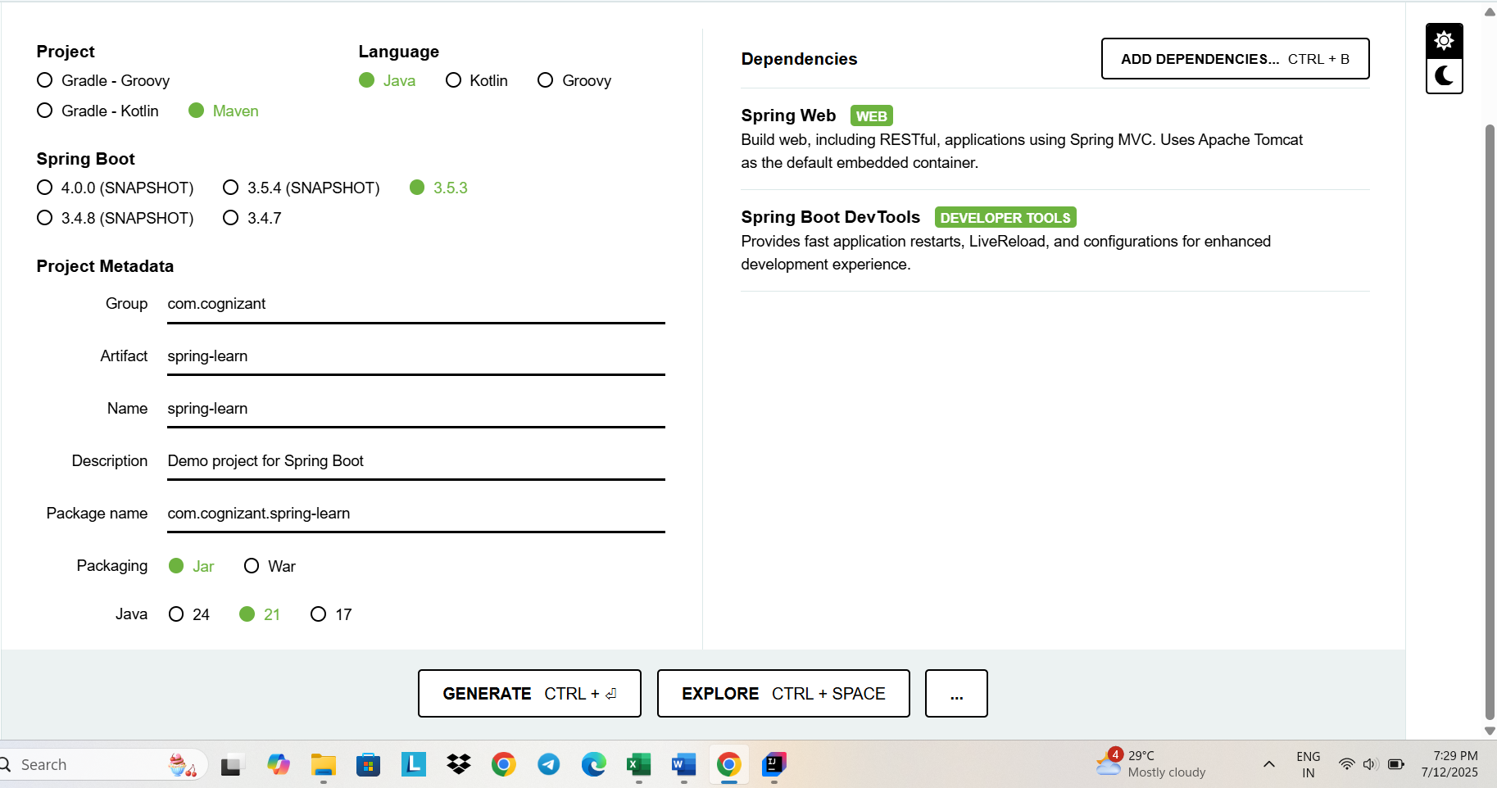1. Created root folder using Spring Initializr

2. Included logs to verify main() method of SpringLearnApplication.

package com.cognizant.spring_learn;  
  
import org.slf4j.Logger;  
import org.slf4j.LoggerFactory;  
import org.springframework.boot.SpringApplication;  
import org.springframework.boot.autoconfigure.SpringBootApplication;  
  
@SpringBootApplication  
public class SpringLearnApplication {  
  
 private static final Logger *log* = LoggerFactory.*getLogger*(SpringLearnApplication.class);  
  
 public static void main(String[] args) {  
 *log*.info("=== Entering SpringLearnApplication.main() ===");  
 SpringApplication.*run*(SpringLearnApplication.class, args);  
 }  
}

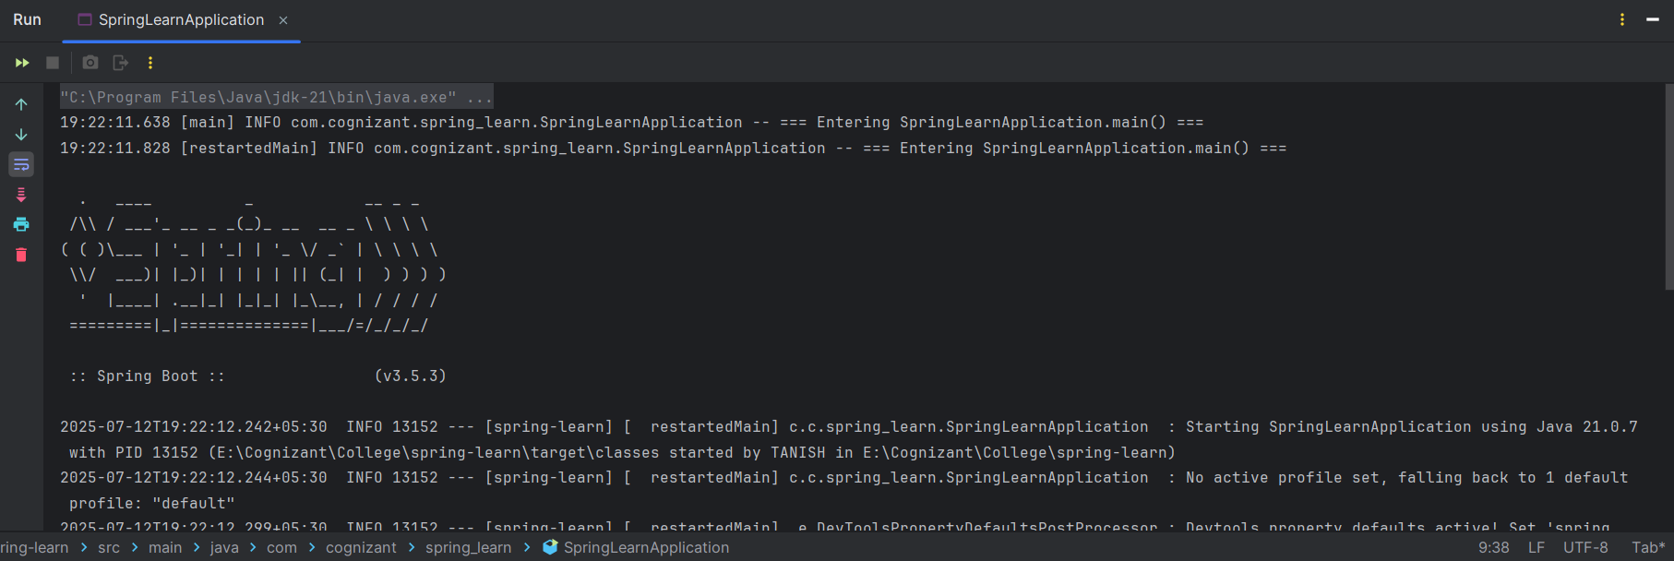Output-

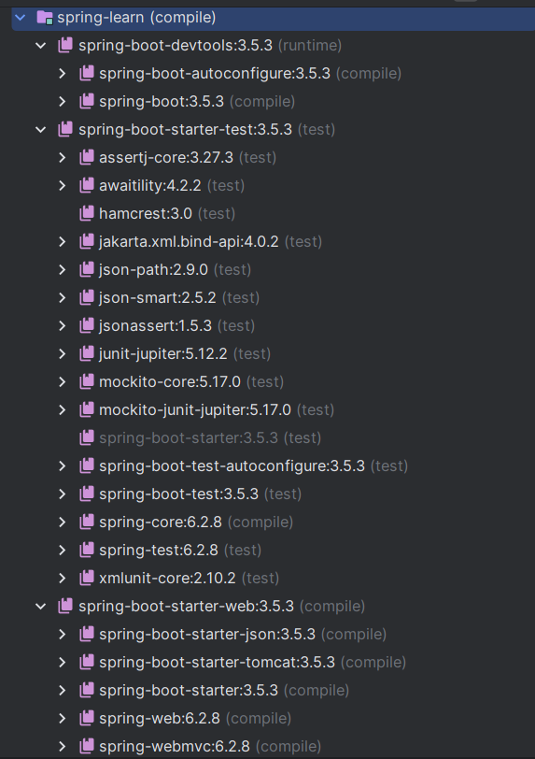3. Dependency Hierarchy