**Hands on**

**Hello World RESTful Web Service**

Solution-

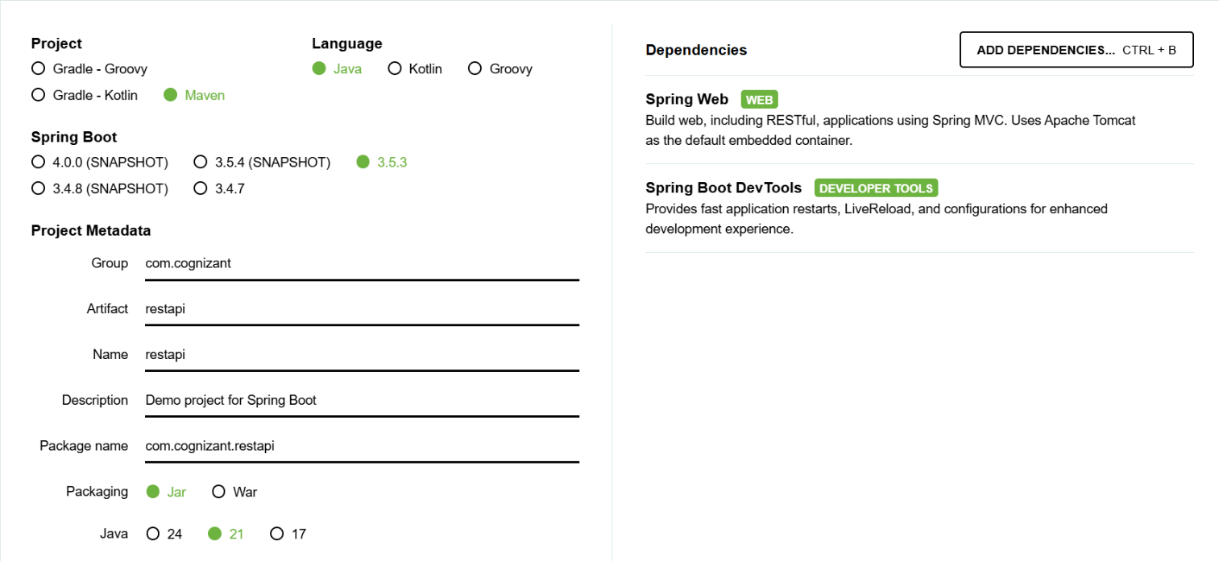1. Configured basic project

2. Created Controller class: com.cognizant.restapi.controller.HelloController.java

HelloController-

package com.cognizant.restapi.controller;  
  
import org.slf4j.Logger;  
import org.slf4j.LoggerFactory;  
import org.springframework.web.bind.annotation.GetMapping;  
import org.springframework.web.bind.annotation.RestController;  
  
@RestController  
public class HelloController {  
  
 private static final Logger *LOGGER* = LoggerFactory.*getLogger*(HelloController.class);  
  
 @GetMapping("/hello")  
 public String sayHello() {  
 *LOGGER*.debug("START sayHello()");  
 String message = "Hello World!!";  
 *LOGGER*.debug("END sayHello()");  
 return message;  
 }  
}

Slightly modified application properties-

spring.application.name=restapi  
server.port=8083  
logging.level.com.cognizant.restapi=DEBUG

3. Run the application

Output-

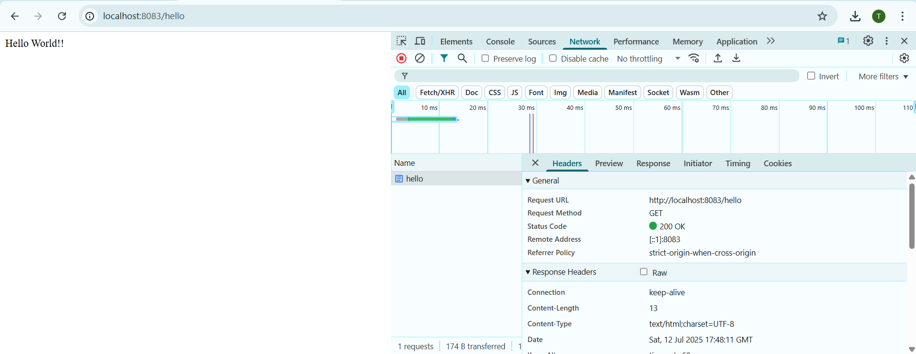On port(with HTTP header details received)

On console-