**Creating Microservices for account and loan**

**Solution:**

**1.Account Microservice**

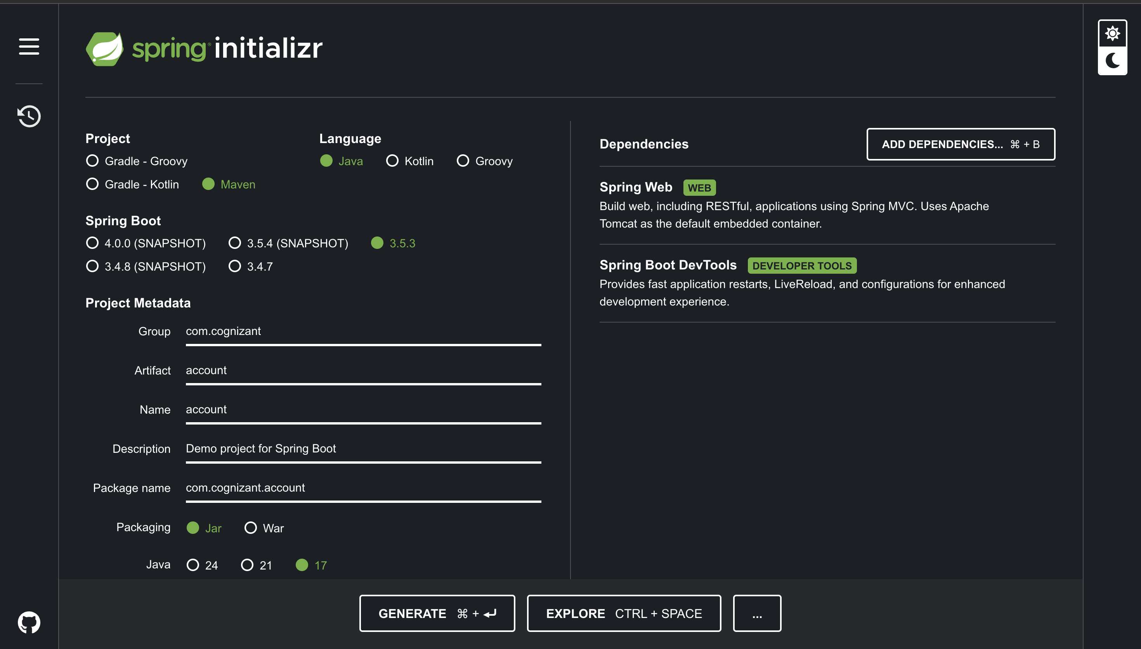

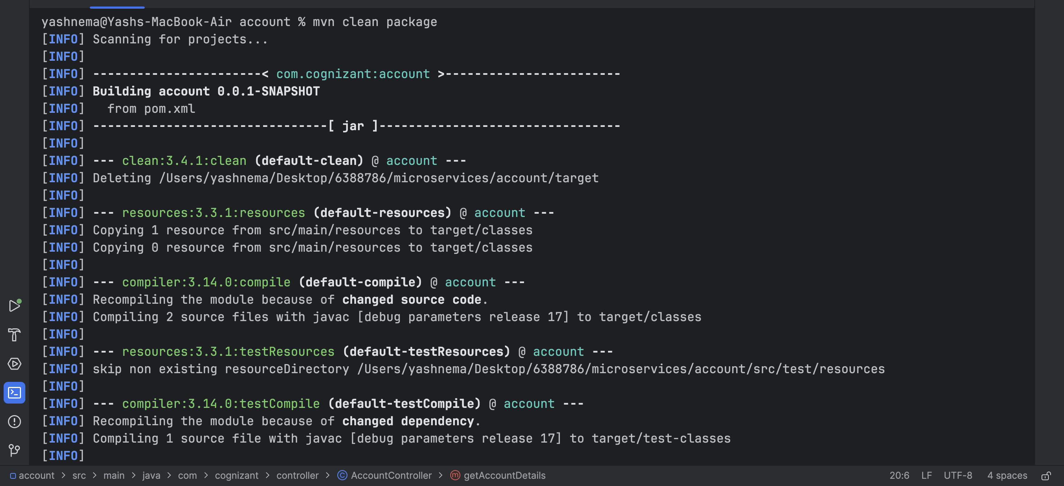

**AccountController class:**

package com.cognizant.controller;

import org.springframework.web.bind.annotation.GetMapping;

import org.springframework.web.bind.annotation.PathVariable;

import org.springframework.web.bind.annotation.RestController;

import java.util.Map;

@RestController

public class AccountController {

@GetMapping("/accounts/{number}")

public Map<String,Object> getAccountDetails(@PathVariable String number){

return Map.of(

"number",number,

"type","savings",

"balance",234343

);

}

}

**Output:**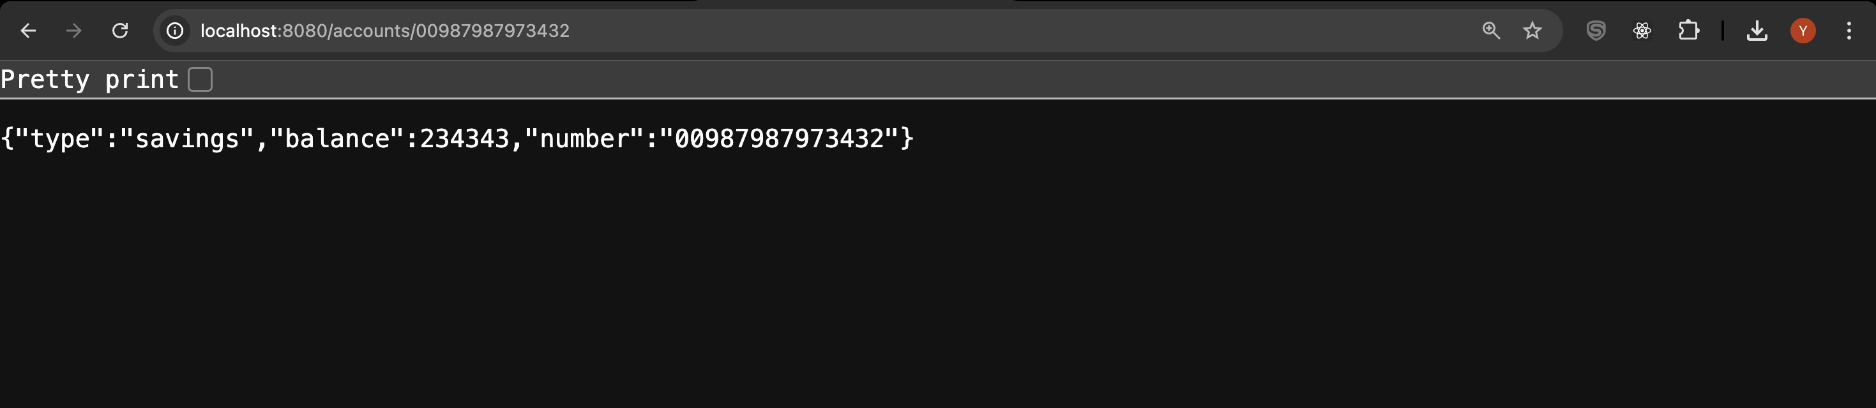

**Project Structure:**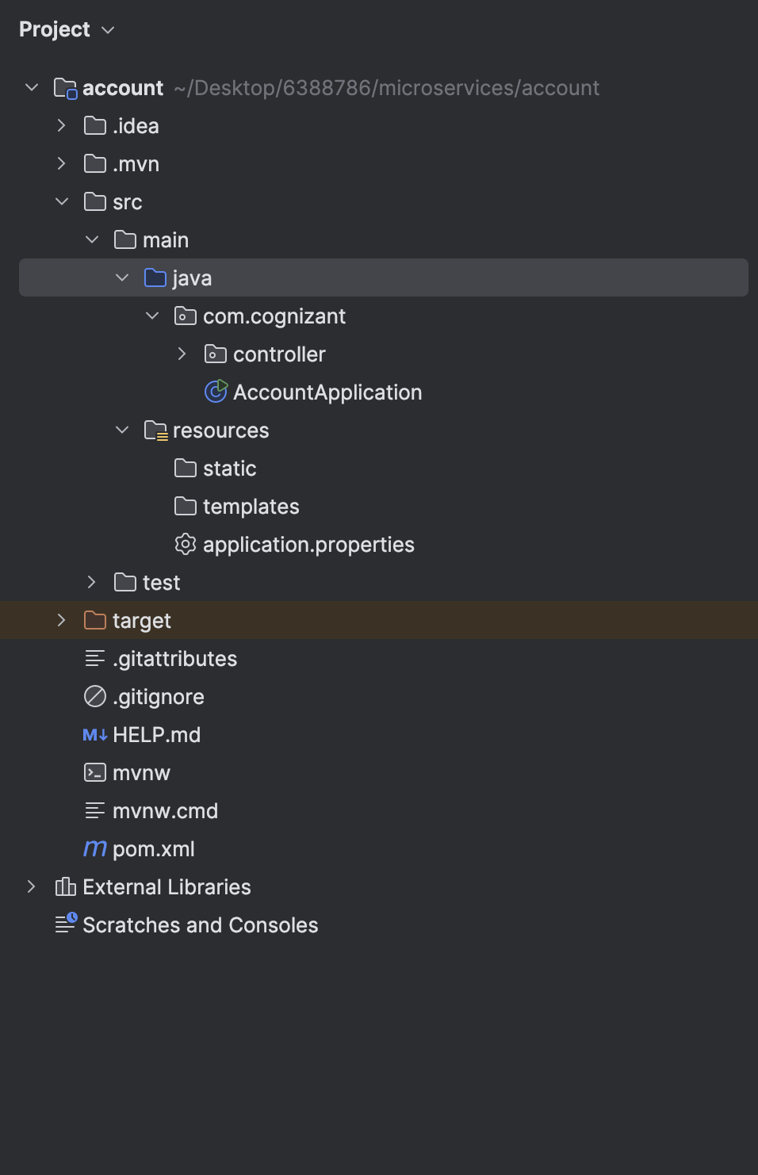

**2.Loan Microservice**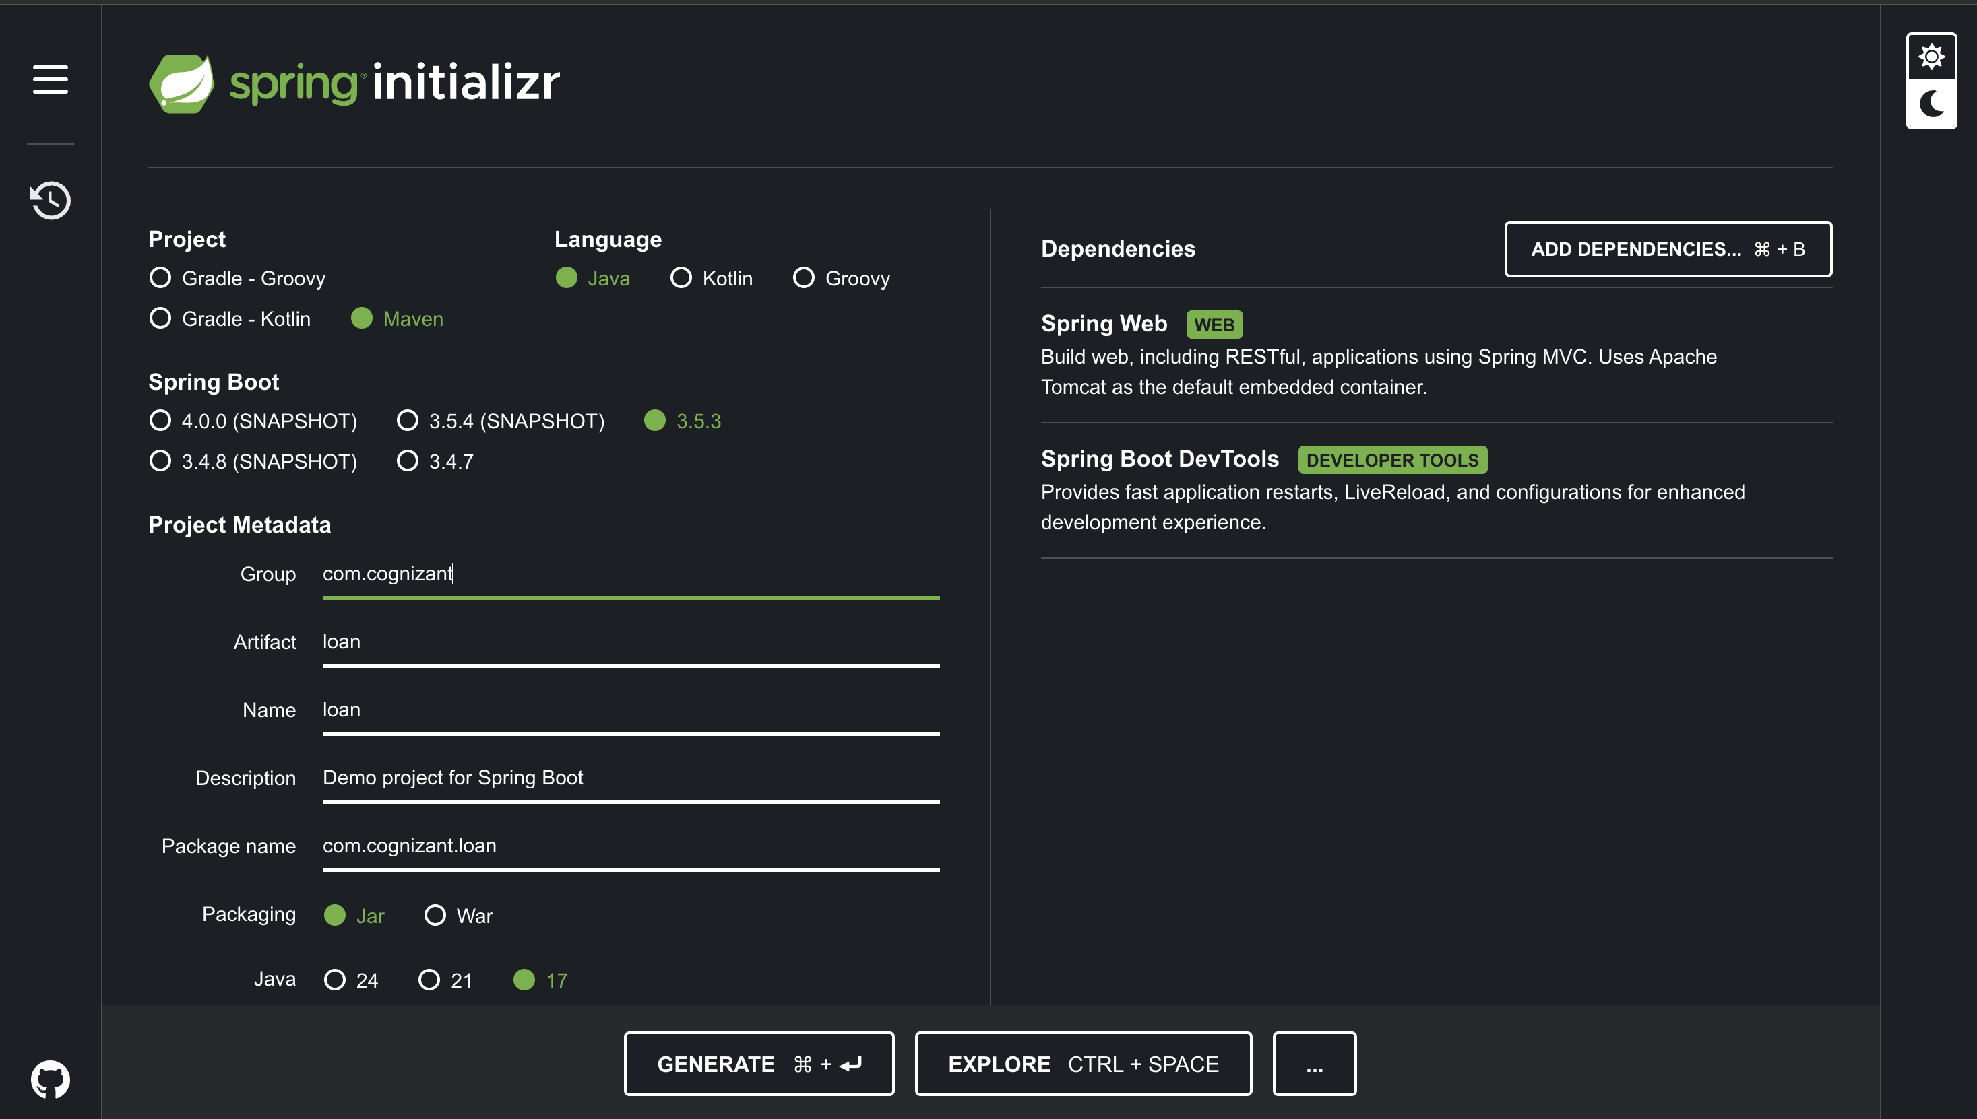

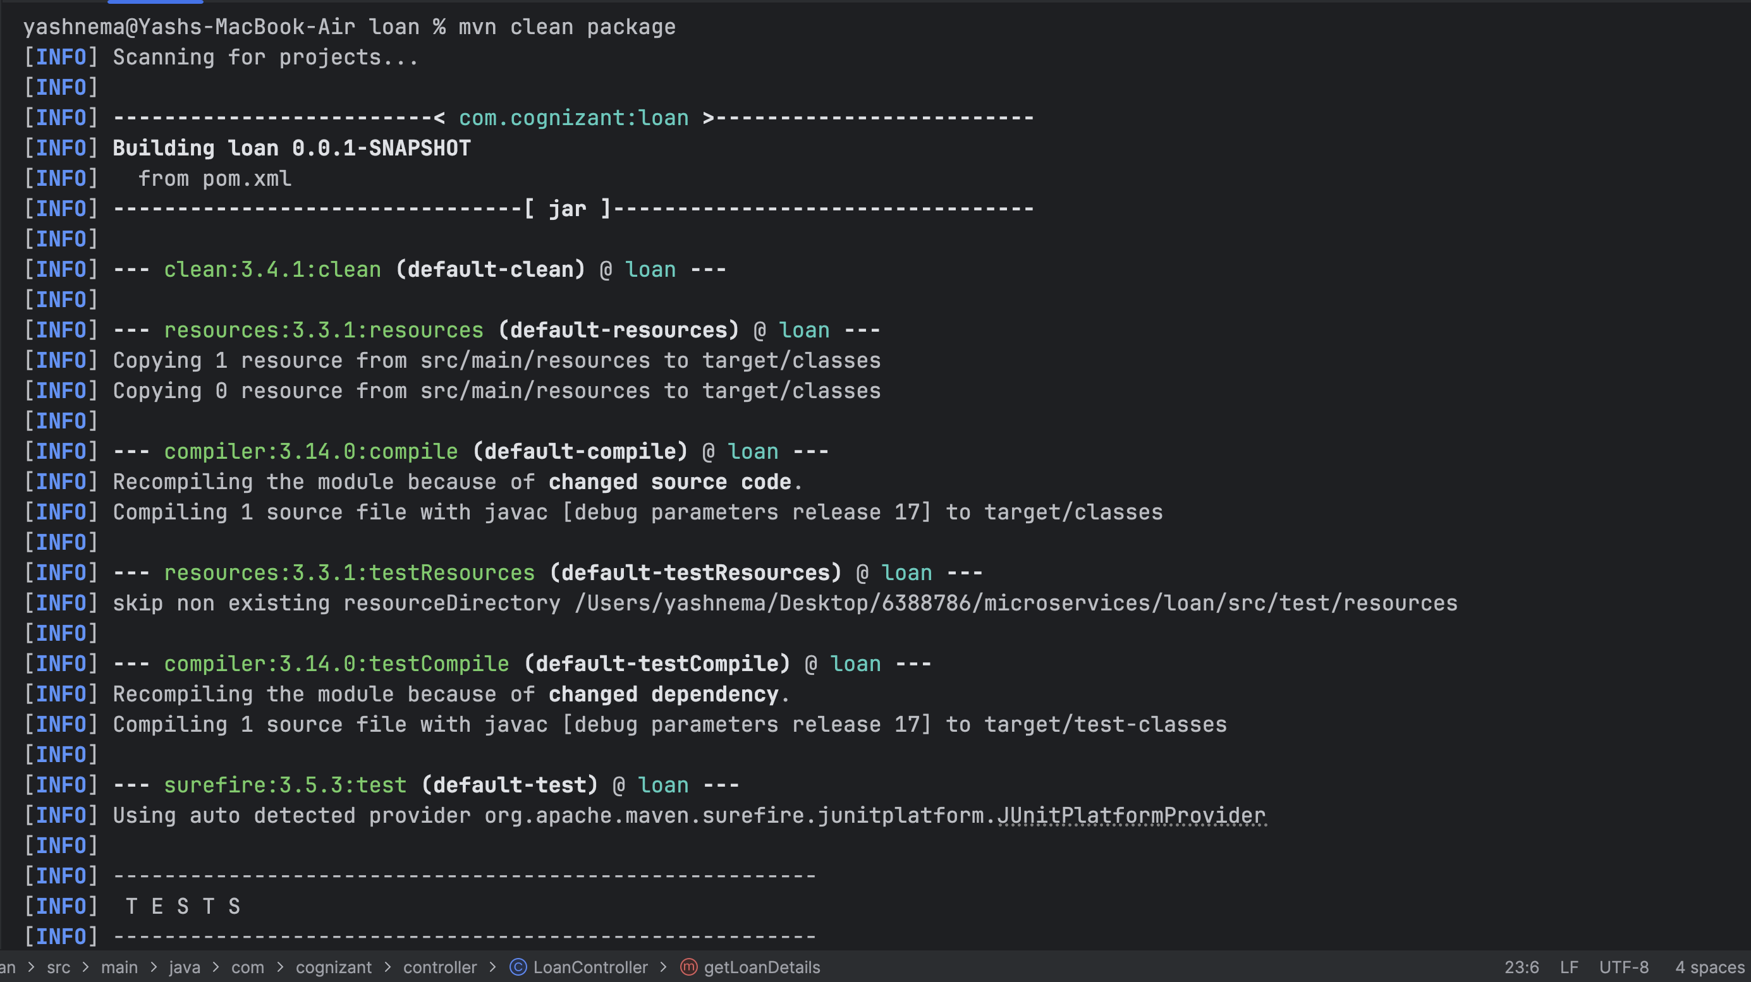

**LoanController class**

package com.cognizant.controller;

import org.springframework.web.bind.annotation.GetMapping;

import org.springframework.web.bind.annotation.PathVariable;

import org.springframework.web.bind.annotation.RestController;

import java.util.Map;

@RestController

public class LoanController {

@GetMapping("/loans/{number}")

public Map<String, Object> getLoanDetails(@PathVariable String number) {

return Map.of(

"number", number,

"type", "car",

"loan", 400000,

"emi", 3258,

"tenure", 18

);

}

}

**application.properties**

**Ou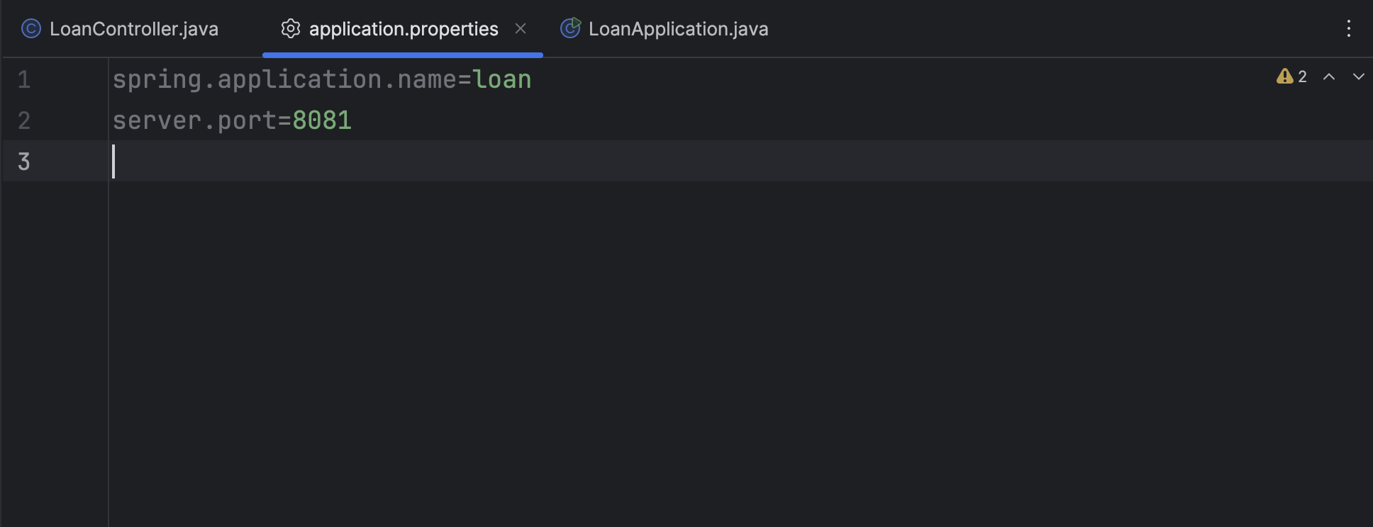tput:**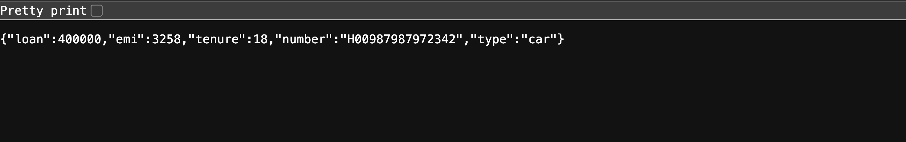

**Project Structure:**