**Objectives**

Familiar with Git commands like git init, git status, git add, git commit, git push, and git pull.

In this hands-on lab, you will learn how to

* Setup your machine with Git Configuration
* Integrate notepad++.exe to Git and make it a default editor

Add a file to source code repository

**Step 1-**

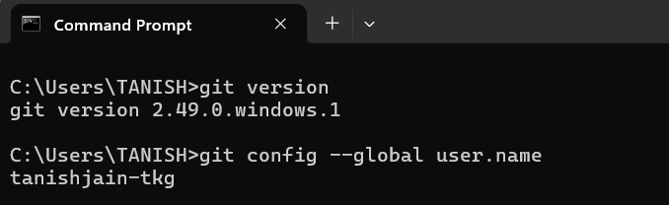**Setup your machine with Git Configuration**

**Step 2-**

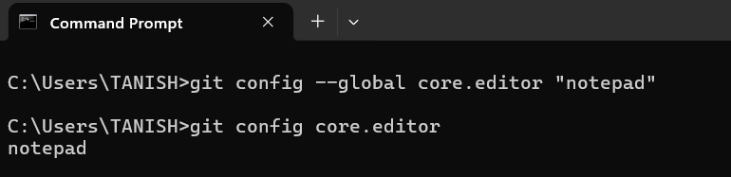**Integrate notepad.exe to Git and make it a default editor**

**Step 3-**

**Add a file to source code repository**



