**Objectives**

In this hands-on lab, you will learn how to:

* Implement git ignore command to ignore unwanted files and folders

**Step 1-**

**Create .log file and folder in GitDemo**

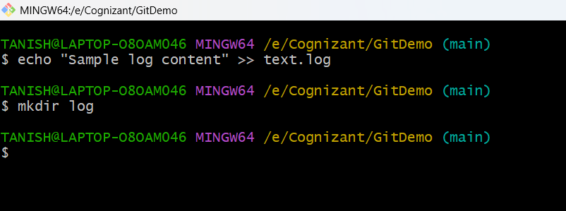

**Step 2-**

**Create .gitignore file**

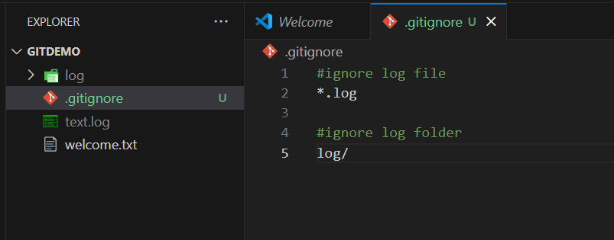

**Step 3-**

**Verify with git status then stage and commit**

