**Objectives**

In this hands-on lab, you will learn how to:

* Construct a branch, do some changes in the branch, and merge it with master (or trunk)

**Step 1-**

**Branching**

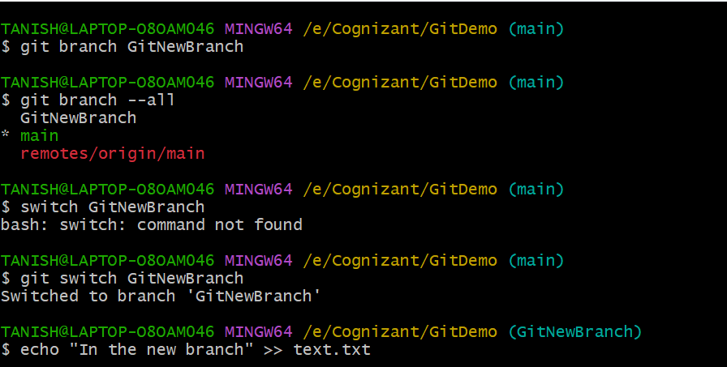

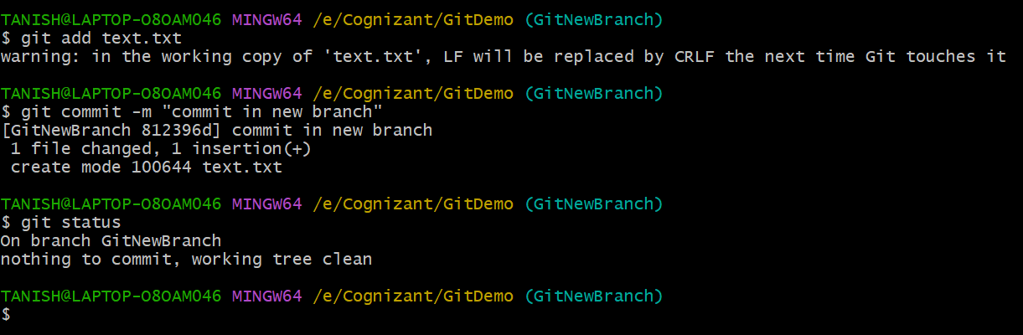

**Step 2-**

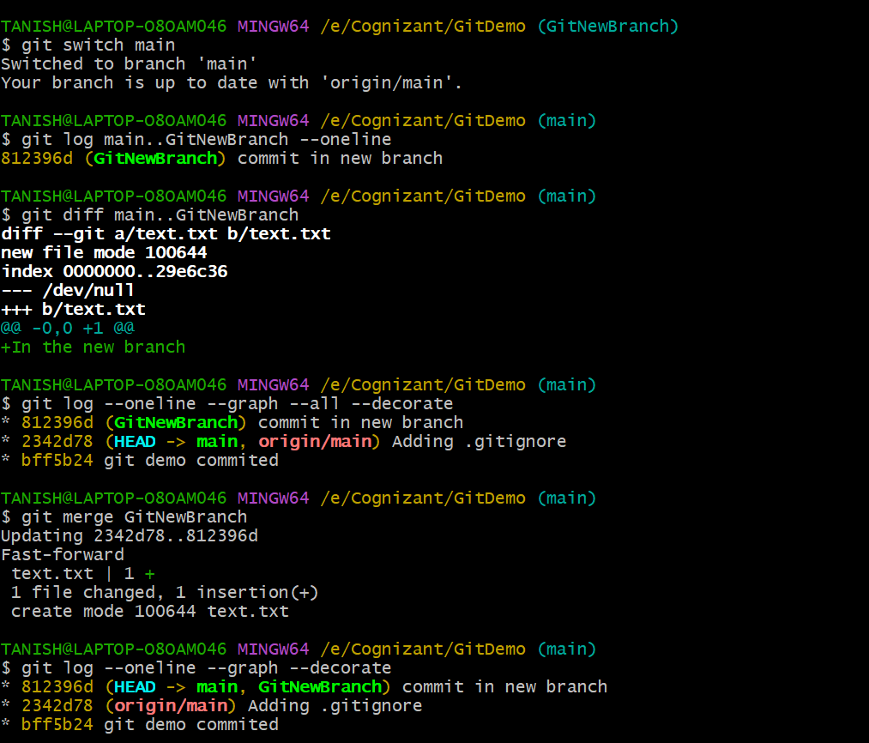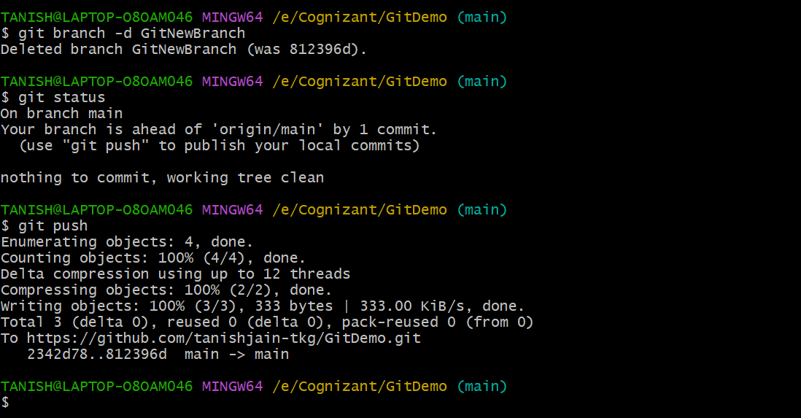**Merging**