**Objectives**

In this hands-on lab, you will learn how to:

* Implement conflict resolution when multiple users are updating the trunk (or master) in such a way that it results into a conflict with the branch’s modification.

**Step 1-**

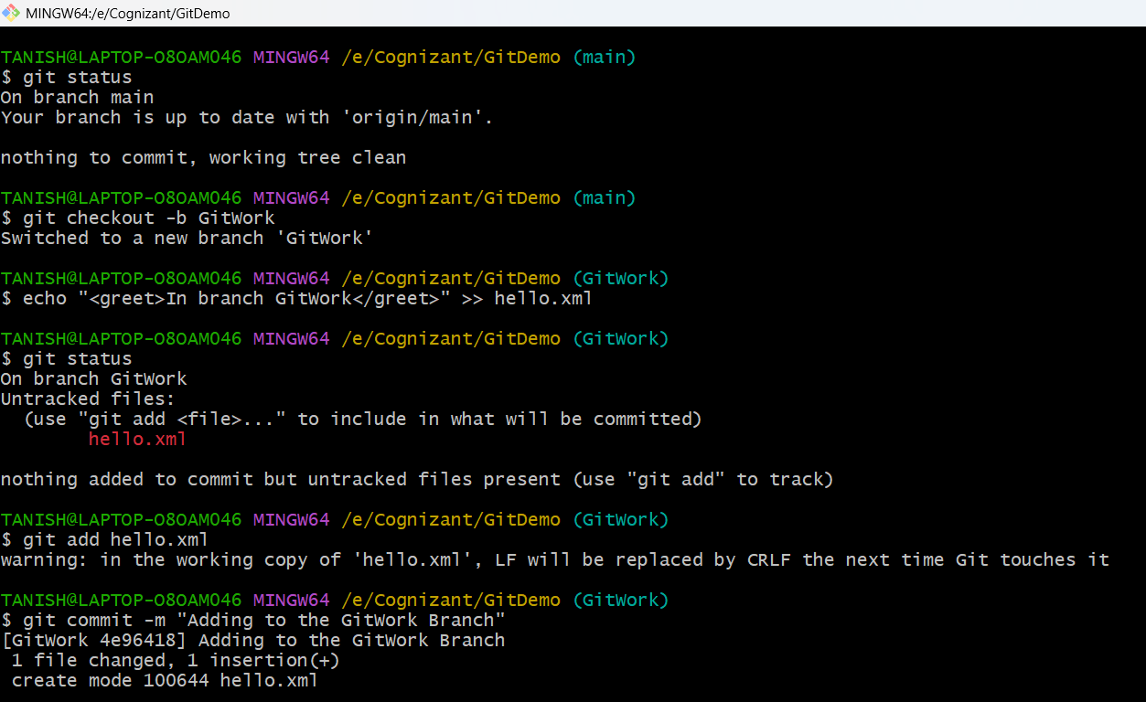**Creating branch GitWork and adding hello.xml**

**Step 2-**

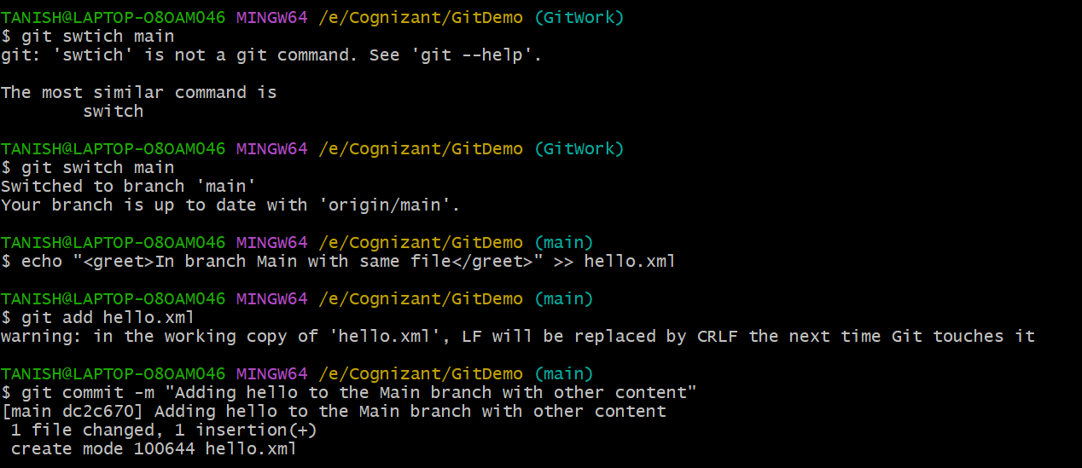**Creating hello.xml in ‘main’ brach with different content to implement a conflict situation**

**Step 3-**

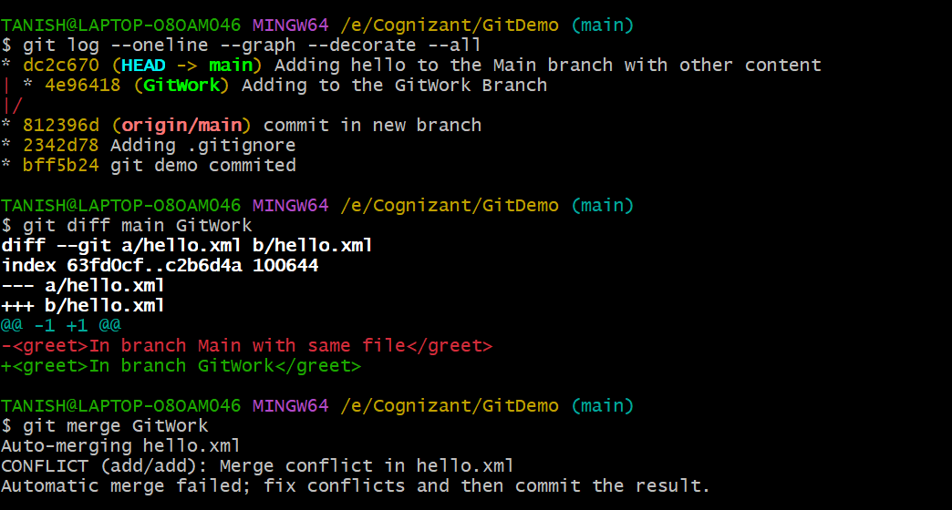**Visualize the difference and merge both branch**

**Step 4-**

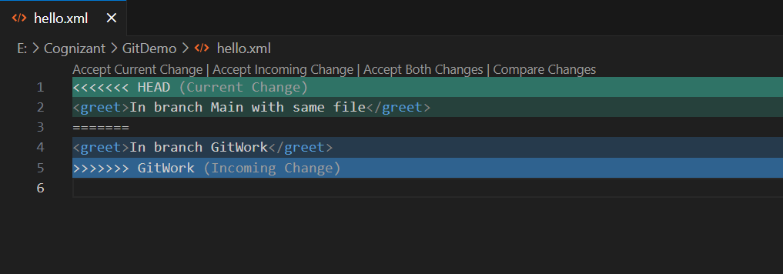**Use 3-way merge tool to resolve the conflict**

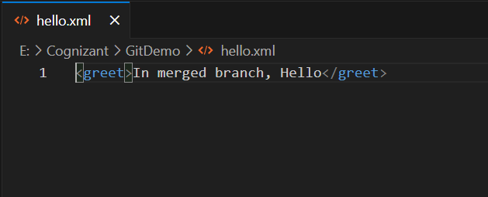

**Step 5-**

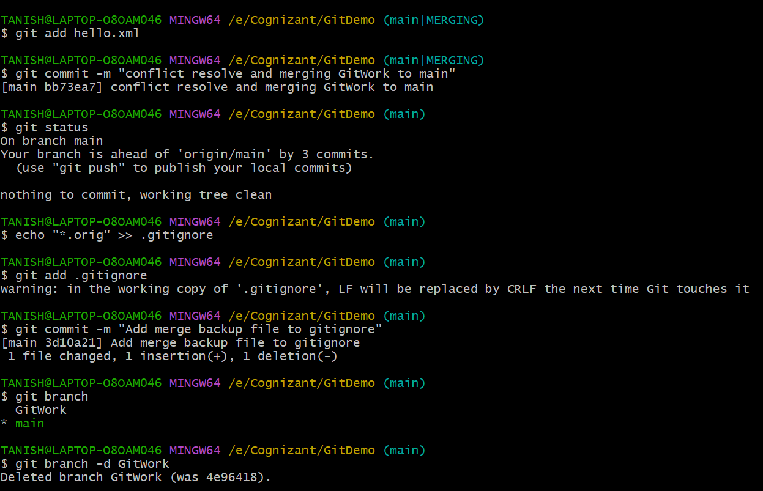**Commit the changes and delete the branch GitWork**

**Final Graph-**

