**Objectives**

In this hands-on lab, you will learn how to:

* Execute steps involving clean up and push back to remote Git.

**Step 0-**

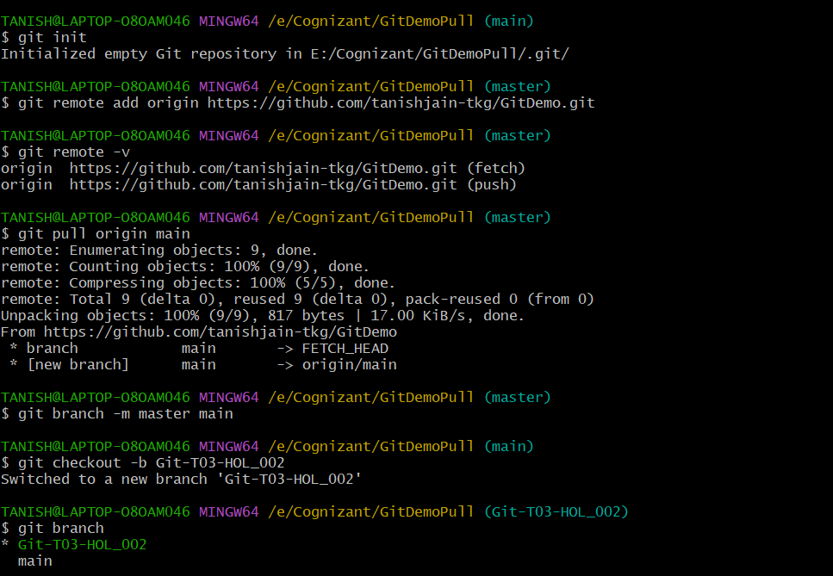**Setup**

**Step 1-**

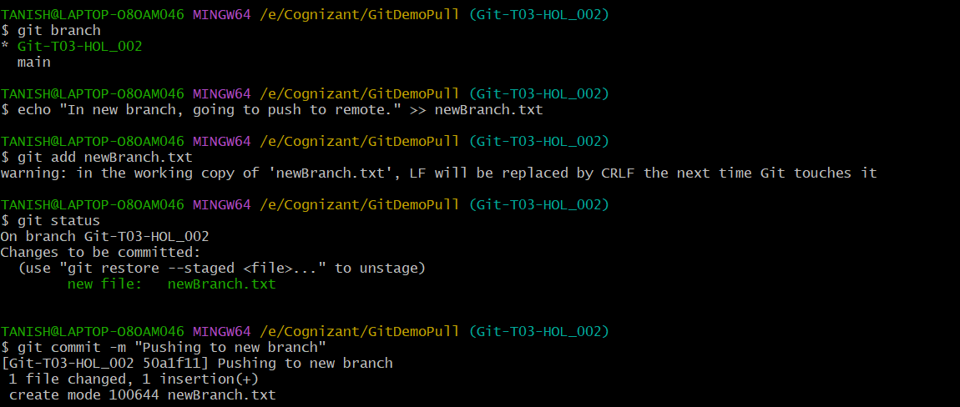**Making changes in new branch and pushing to remote repo**

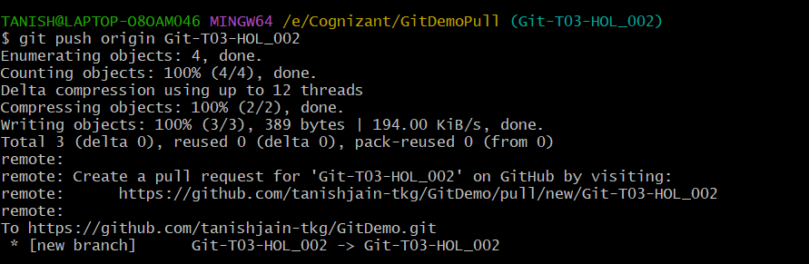

**Step 2-**

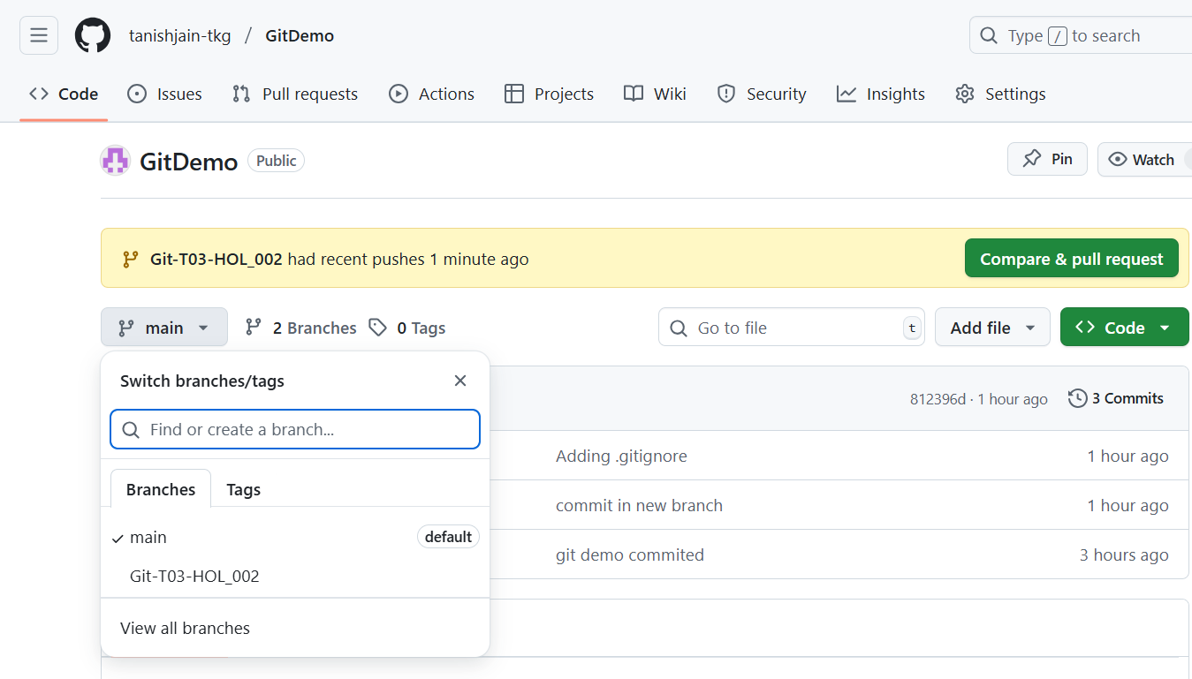**Observing changes in remote repo**