Exercise 1: Control Structures

Scenario 1: The bank wants to apply a discount to loan interest rates for customers above 60 years old.
  - Question: Write a PL/SQL block that loops through all customers, checks their age, and if they are above 60, apply a 1% discount to their current loan interest rates.
Scenario 2: A customer can be promoted to VIP status based on their balance.
  - Question: Write a PL/SQL block that iterates through all customers and sets a flag IsVIP to TRUE for those with a balance over $10,000.
Scenario 3: The bank wants to send reminders to customers whose loans are due within the next 30 days.
  - Question: Write a PL/SQL block that fetches all loans due in the next 30 days and prints a reminder message for each customer.

Solution-

Scenario 1:
BEGIN
FOR res IN (
SELECT c.name, c.customerID, l.loanID, l.interestRate
FROM loans l
JOIN customers c ON l.customerID = c.customerID
WHERE TRUNC(MONTHS_BETWEEN(SYSDATE, c.dob) / 12) > 60
) LOOP
UPDATE loans
SET interestRate = res.interestRate - 1
WHERE loanID = res.loanID;
END LOOP;
END;
/

Output-
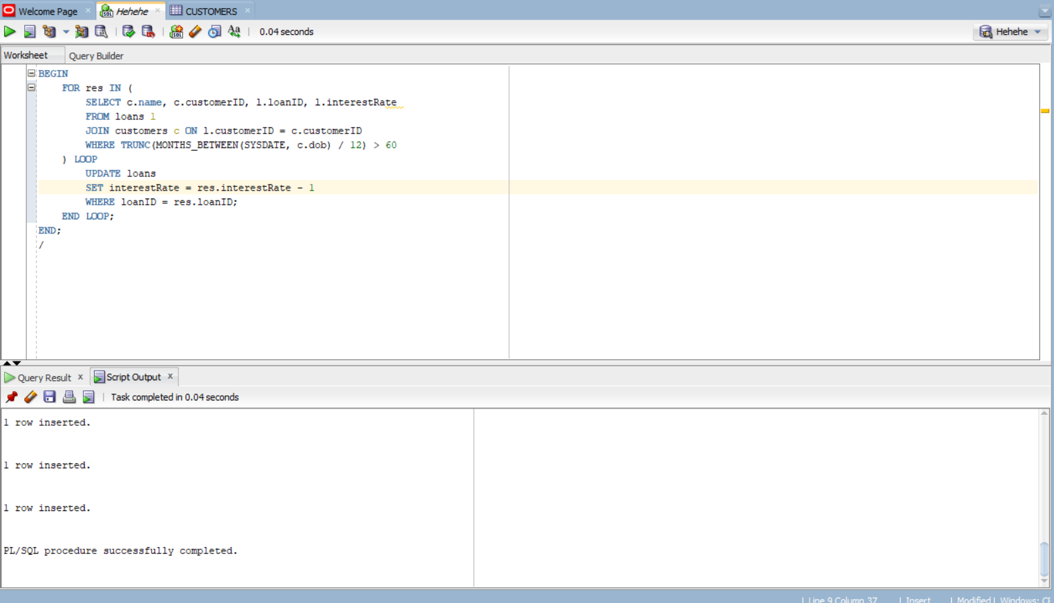

Scenario 2:
ALTER TABLE Customers ADD IsVIP VARCHAR2(1);
-- Use 'Y' for TRUE, 'N' for FALSE
-- Alternatively, use a BOOLEAN column in PL/SQL logic only
UPDATE Customers SET IsVIP = 'N';

BEGIN
FOR cust IN (
SELECT CustomerID, Balance
FROM Customers
) LOOP
IF cust.Balance > 10000 THEN
UPDATE Customers
SET IsVIP = 'Y'
WHERE CustomerID = cust.CustomerID;
END IF;
END LOOP;

DBMS_OUTPUT.PUT_LINE('VIP status updated.');
END;
/

Output-
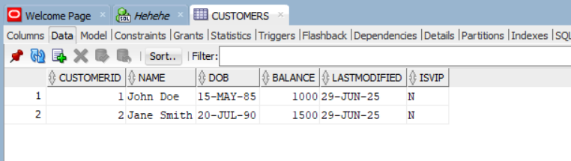
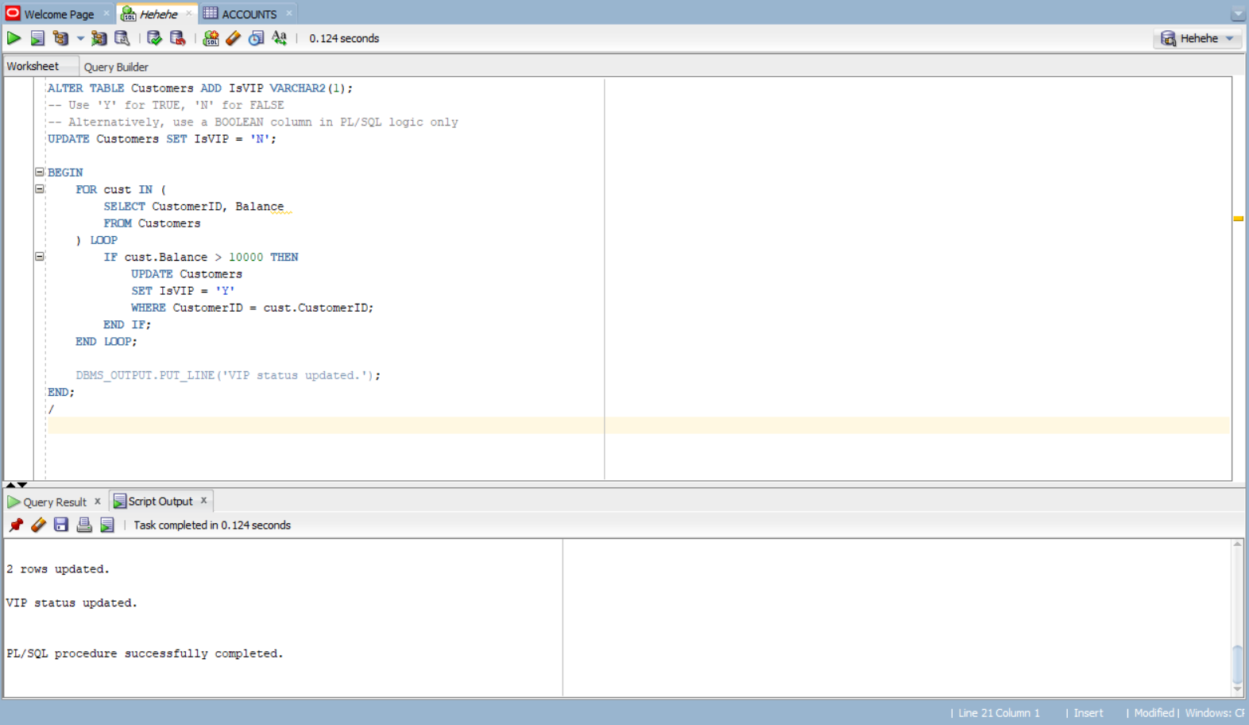
Scenario 3:
set SERVEROUTPUT on;
INSERT INTO loans (loanID, customerID, loanAmount, interestRate, startDate, endDate)
VALUES (2, 2, 10000, 8, SYSDATE - 10, SYSDATE + 5);
BEGIN
for res in (
select c.name, c.customerID, l.loanID, l.enddate from loans l
join customers c on l.customerid = c.customerid
where l.enddate between sysdate and sysdate+30
) loop
dbms_output.put_line(res.name || ' Your loan is due ' || 'Pay within the enddate: ' || res.enddate);
end loop;
END;
/

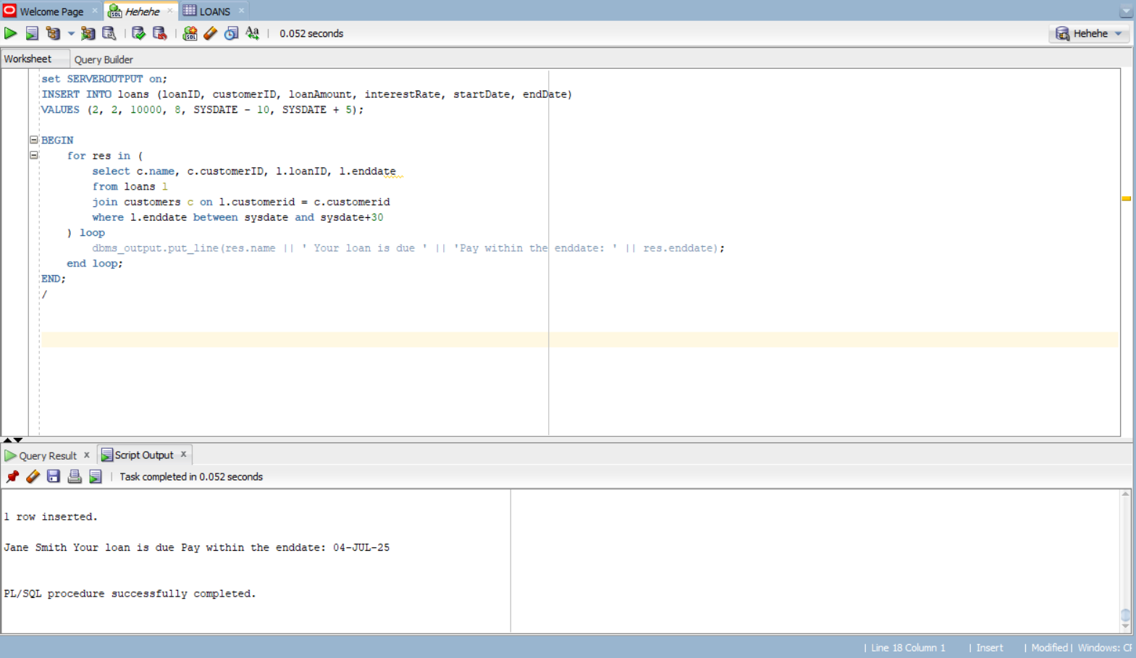
Output-
Exercise 3: Stored Procedures

Scenario 1: The bank needs to process monthly interest for all savings accounts.
  - Question: Write a stored procedure ProcessMonthlyInterest that calculates and updates the balance of all savings accounts by applying an interest rate of 1% to the current balance.

Scenario 2: The bank wants to implement a bonus scheme for employees based on their performance.
  - Question: Write a stored procedure UpdateEmployeeBonus that updates the salary of employees in a given department by adding a bonus percentage passed as a parameter.

Scenario 3: Customers should be able to transfer funds between their accounts.
  - Question: Write a stored procedure TransferFunds that transfers a specified amount from one account to another, checking that the source account has sufficient balance before making the transfer.

Solution-

Scenario 1:
create or replace procedure ProcessMonthlyInterest is
begin
update Accounts
set Balance = Balance + Balance*0.01
where AccountType = 'Savings';
end;
/

begin
ProcessMonthlyInterest;
end;
/
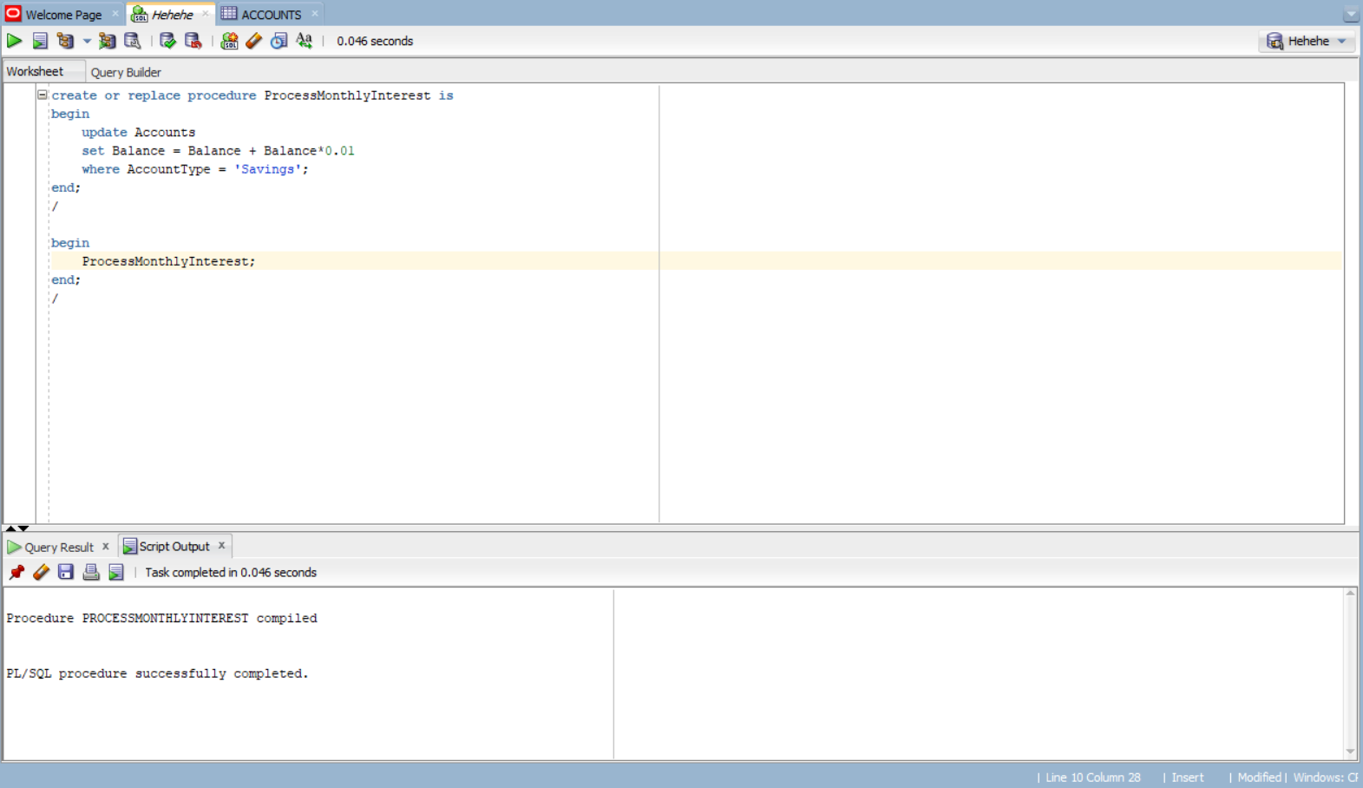
Output-
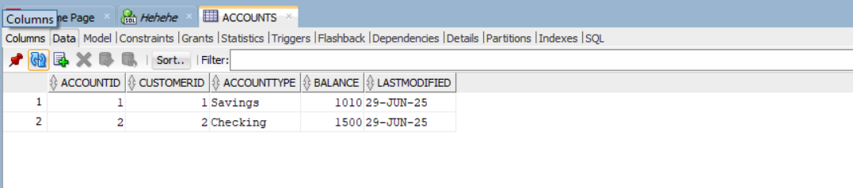

Scenario 2:
CREATE OR REPLACE PROCEDURE UpdateEmployeeBonus(
dept IN VARCHAR2,
bonus IN NUMBER
) IS
rows_updated NUMBER := 0;
BEGIN
-- Update salaries for the given department
UPDATE Employees
SET salary = salary + (salary * bonus / 100)
WHERE department = dept;

rows_updated := SQL%ROWCOUNT;

DBMS_OUTPUT.PUT_LINE(rows_updated || ' employee(s) updated in department ' || dept);

EXCEPTION
WHEN OTHERS THEN
DBMS_OUTPUT.PUT_LINE('Error occurred: ' || SQLERRM);
END;
/

BEGIN
UpdateEmployeeBonus('HR', 10);
END;
/

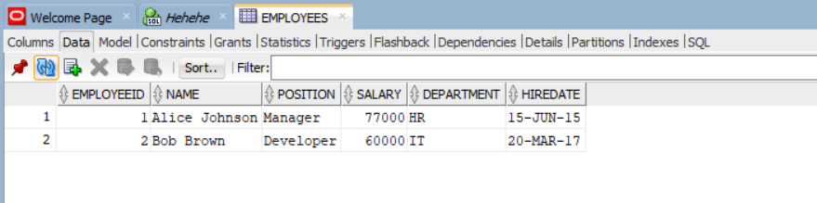
Output-

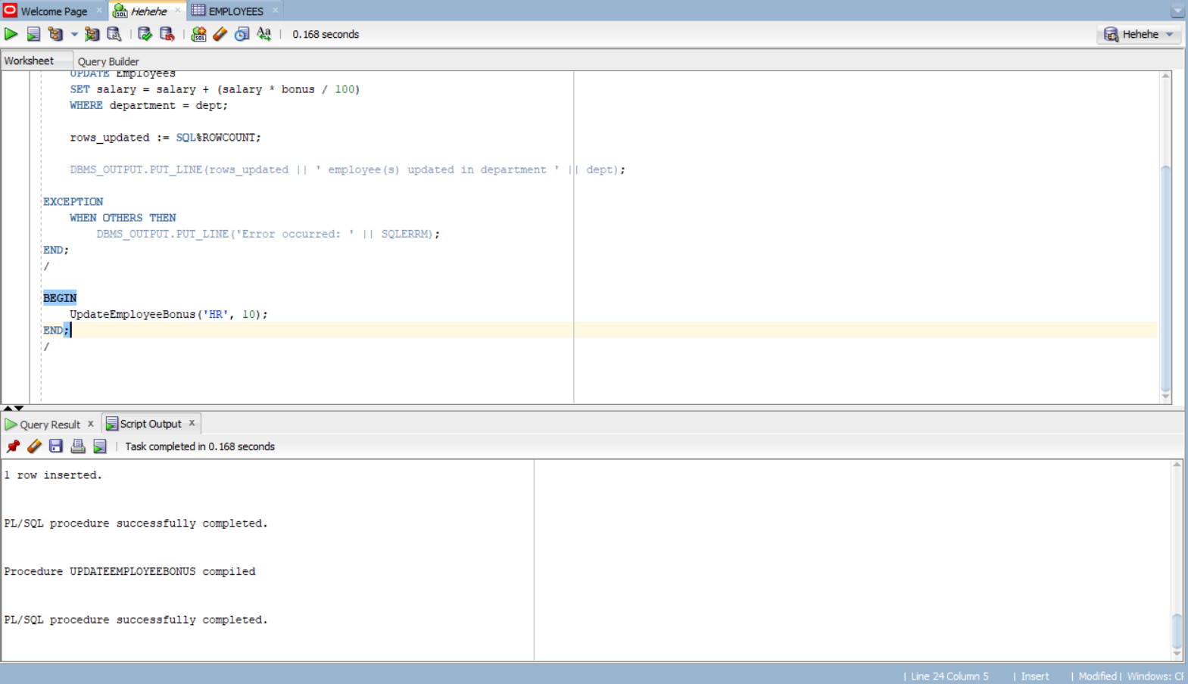
Scenario 3:
create or replace procedure TransferFunds(
from_acc IN number, to_acc IN number, amount IN number
) is

v_balance number;

begin
select balance into v_balance
from accounts
where accountid = from_acc

for update;

if v_balance < amount then
raise_application_error(-20001, 'Insufficient Balance');
end if;

update accounts
set balance = balance + amount, lastModified = sysdate
where accountid = to_acc;

update accounts
set balance = balance - amount, lastModified = sysdate
where accountid = from_acc;
end;
/

begin
TransferFunds(1,2,255);
end;
/

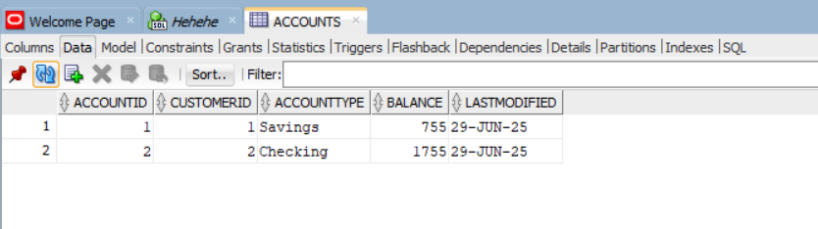
Output-

