FACTORY-TO-CUSTOMER SHIPPING ROUTE EFFICIENCY ANALYSIS FOR NASSAU CANDY DISTRIBUTOR

An Exploratory Data Analytics Approach for Route Performance, Delay Analysis, and Geographic Bottleneck Identification

A Research Paper
Submitted in partial fulfillment of the requirements for the degree of
Bachelor of Engineering
in
Computer Science and Engineering

Prepared by
Yash Nikhade

Bachelor of Engineering – Computer Science and Engineering
Academic Session: 2026–2027

TABLE OF CONTENTS
Sr. No. | Section | Page No.
1 | Introduction | 2
2 | Problem Statement | 3
3 | Objectives | 4
4 | Dataset Description | 5
5 | Methodology | 7
6 | Results and Findings | 20
7 | Streamlit Dashboard | 28
8 | Business Insights and Recommendations | 33
9 | Limitations of the Study | 36
10 | Future Scope | 39
11 | Conclusion | 43
12 | References | 45

List of Tables
Sr. No. | Table | Page No.
1. | Dataset Attributes | 5
2. | Product-to-Factory Mapping | 10
3. | Derived Analytical Features | 11
4. | Route Efficiency Metrics | 14
5. | Ship Mode Performance | 24
6. | Key Analytical Findings | 26

List of Figures
Sr. No. | Figures | Page No.
1. | Overall Research Methodology Workflow | 7
2. | Factory-to-Customer Route Concept | 9
3. | Route Efficiency Analysis Framework | 14
4. | Geographic Bottleneck Identification Process | 16
5. | Streamlit Dashboard Architecture | 24
6. | Distribution of Shipping Lead Time Across Shipments | 29

ABSTRACT
Efficient transportation and timely delivery are important factors in supply chain management because shipping delays and inefficient routes can increase operational costs and affect customer satisfaction. This research presents a data-driven analysis of factory-to-customer shipping routes for Nassau Candy Distributor. The study focuses on evaluating route performance, shipping lead time, delay frequency, geographic shipping patterns, and the performance of different shipping modes.
The analysis was performed using a shipment dataset containing 10,194 records and 18 original attributes. Data preprocessing was carried out to validate the dataset, standardize date information, map products to their corresponding factories, and derive analytical features such as Shipping Lead Time, Factory-to-Customer Route, and Region Route. Exploratory data analysis was then used to understand shipment distributions across regions, states, factories, products, and shipping modes.
Route-level performance was evaluated using shipment volume, average lead time, delay frequency, and a normalized Route Efficiency Score. Geographic analysis was used to identify potential bottleneck states based on shipment volume, average lead time, and delay frequency. Ship mode performance was also compared using lead time, delay frequency, cost, and sales measures.
An interactive Streamlit dashboard was developed to present the analysis through key performance indicators, route analysis, geographic visualization, ship mode comparison, and route-level drill-down features. The study provides a structured analytical approach for identifying shipping performance patterns and supporting data-based operational decision-making.

Keywords: Supply Chain Analytics, Route Efficiency, Shipping Lead Time, Delay Analysis, Geographic Bottleneck, Ship Mode, Exploratory Data Analysis, Streamlit Dashboard, Data Analytics.

1. INTRODUCTION
In modern supply chain operations, efficient transportation plays an important role in ensuring that products are delivered to customers within an acceptable time. A distribution network generally involves the movement of products from manufacturing or production facilities to customers located across different geographic regions. The efficiency of these movements can be affected by factors such as shipping routes, delivery lead time, shipment volume, geographic location, and shipping mode.
Nassau Candy Distributor operates a distribution network in which products are shipped from different factories to customers across multiple states and regions. Understanding the performance of these factory-to-customer movements can help identify routes that require further investigation, locations experiencing relatively high shipping times, and shipping modes with different performance characteristics.
Traditional examination of shipment records can make it difficult to identify patterns across a large number of transactions. Data analytics provides a systematic approach for examining such datasets by combining data preprocessing, exploratory analysis, aggregation, visualization, and performance measurement. In this study, shipment records are analyzed to calculate Shipping Lead Time, evaluate factory-to-customer routes, measure delay frequency, and identify potential geographic bottlenecks.
The study also develops a Route Efficiency Score based on the relative average shipping lead time of the analyzed routes. Geographic analysis is performed at the state level by considering shipment volume, average lead time, and delay frequency. In addition, different shipping modes are compared to understand their observed performance in terms of lead time, delays, cost, and sales.
To make the analytical results accessible and interactive, a Streamlit-based dashboard is developed. The dashboard provides key performance indicators, route efficiency analysis, geographic visualization, ship mode comparison, and route-level drill-down functionality. Overall, this research demonstrates how exploratory data analytics can be applied to shipping data to identify performance patterns and provide data-based insights for operational decision-making.

2. PROBLEM STATEMENT
Efficient transportation is an important part of a distribution network because shipping performance directly affects delivery time, operational planning, and customer satisfaction. When a large number of shipment records are generated across different factories, states, regions, and shipping modes, it can become difficult to identify which routes consistently perform efficiently and which routes require further investigation.
The Nassau Candy Distributor shipment dataset contains information about orders, products, factories, customer locations, shipping modes, sales, cost, and shipment dates. However, the raw shipment records do not directly provide a consolidated measure of route efficiency or a clear identification of geographic areas with potentially poor shipping performance.
Therefore, the problem addressed in this study is to analyze the available shipment data and identify patterns in factory-to-customer route performance. The study focuses on calculating shipping lead time, analyzing route-level shipment volume and delay frequency, developing a relative route efficiency score, identifying potential geographic bottlenecks, and comparing different shipping modes.
The analysis aims to transform the available shipment records into meaningful analytical information that can be presented through an interactive dashboard and used to support data-based understanding of shipping operations.

3. OBJECTIVES
The main objective of this study is to analyze factory-to-customer shipping data and evaluate route efficiency using data analytics techniques. The specific objectives of the study are:
- To inspect and understand the shipment dataset and identify its important attributes, categories, and data characteristics.
- To clean and validate the shipment data by checking date formats, missing values, duplicate records, and invalid shipping lead times.
- To map products to their respective factories in order to establish the factory location associated with each shipment.
- To calculate Shipping Lead Time using the difference between the order date and ship date.
- To analyze factory-to-customer routes based on shipment volume, average lead time, and lead-time variation.
- To develop a Route Efficiency Score that provides a relative measure of route performance based on average shipping lead time.
- To analyze shipment delays using a data-driven lead-time benchmark and identify routes with relatively high delay frequency.
- To identify potential geographic bottlenecks by analyzing shipment volume, average lead time, and delay frequency at the state level.
- To compare different shipping modes based on shipment volume, lead time, delay frequency, cost, and sales.
- To develop an interactive Streamlit dashboard for presenting route efficiency, geographic performance, ship mode comparison, and route-level details.
- To generate data-based business insights that can help understand shipping performance and support operational decision-making.

4. DATASET DESCRIPTION
The study uses a shipment dataset provided for the Nassau Candy Distributor project. The dataset contains 10,194 shipment records and 18 original attributes. Each record represents a shipment/order transaction and contains information related to the order, customer location, product, shipping method, sales, cost, and profit.
The original dataset contains the following attributes:
No. | Attribute | Description
1 | Row ID | Unique identifier for the dataset record
2 | Order ID | Identifier associated with the customer order
3 | Order Date | Date on which the order was placed
4 | Ship Date | Date on which the shipment was made
5 | Ship Mode | Shipping method used for the order
6 | Customer ID | Identifier of the customer
7 | Country/Region | Country or geographical region of the customer
8 | City | Customer city
9 | State/Province | Customer state or province
10 | Postal Code | Postal code associated with the customer location
11 | Division | Business or geographic division
12 | Region | Customer region
13 | Product ID | Identifier of the product
14 | Product Name | Name of the shipped product
15 | Sales | Recorded sales value of the order
16 | Units | Number of units associated with the order
17 | Gross Profit | Gross profit recorded for the order
18 | Cost | Recorded cost associated with the order

4.1 Dataset Characteristics
The dataset contains four shipping modes: Standard Class, Second Class, First Class, and Same Day. Customer shipment records cover multiple states and regions, allowing the study to examine geographic differences in shipping performance.
The original dataset does not contain a direct Factory attribute. Therefore, a product-to-factory mapping was created during the analysis based on the product information provided for the project. This mapping was used to associate each shipment with its corresponding factory.
4.2 Derived Attributes
Additional attributes were created during the data preparation and feature engineering stages to support route analysis:
- Factory – The factory associated with the shipped product.
- Shipping Lead Time – Number of days between Order Date and Ship Date.
- Route – Factory-to-customer-state route.
- Region Route – Factory-to-customer-region route.
These derived attributes transformed the original shipment records into a structure suitable for route efficiency, delay, geographic, and shipping-mode analysis.
4.3 Dataset Use in the Study
The dataset was used throughout the analysis to identify shipping patterns and evaluate route performance. The original data was retained as the source data, while processed versions were created for subsequent analysis. The final analytical dataset contained 22 attributes, including the original fields and the derived features used in the study.

5. METHODOLOGY
The methodology followed in this study consists of a sequence of data preparation, analytical, and visualization stages. The process begins with inspection of the shipment dataset and continues through data cleaning, factory mapping, feature engineering, exploratory data analysis, route efficiency analysis, geographic analysis, ship mode analysis, and dashboard development.
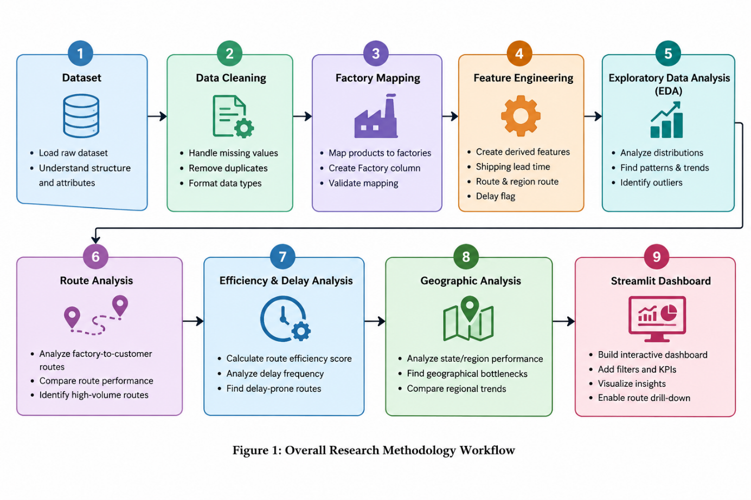
The overall workflow followed in the study is:
Dataset Inspection → Data Cleaning and Validation → Factory Mapping → Feature Engineering → Exploratory Data Analysis → Route Efficiency Analysis → Efficiency Score and Delay Analysis → Geographic Bottleneck Analysis → Ship Mode Performance Analysis → Streamlit Dashboard
Each stage is described in the following subsections.
5.1 DATASET INSPECTION
The first stage of the analysis involved inspecting the shipment dataset to understand its structure and characteristics. The dataset dimensions, column names, data types, missing values, duplicate records, descriptive statistics, and categorical distributions were examined.
The inspection included checking the number of rows and columns, identifying the types of variables present, examining unique values and category frequencies, and calculating descriptive statistics for numerical attributes. Important categorical variables such as Ship Mode, Region, State/Province, Factory, and Product Name were also examined to understand the distribution of shipments.
This initial inspection helped establish the quality and structure of the data before performing subsequent preprocessing and analytical operations.
5.2 DATA CLEANING AND VALIDATION
The second stage involved cleaning and validating the shipment data to make it suitable for analysis. The Order Date and Ship Date fields were converted into proper date formats so that shipping lead time could be calculated accurately.
The date values were validated by examining their ranges and checking the relationship between order and shipment dates. Missing values and duplicate records were also checked to identify potential data-quality issues. Shipping lead times were later examined to ensure that no negative values were present.
The original shipment records were retained during preprocessing. The analysis identified unusually large differences between some order and ship dates. Since these values were present in the original dataset, they were not removed solely because of their magnitude. Instead, the resulting lead-time values were retained and considered when interpreting the analytical results.
This approach ensured that the analysis was based on the provided dataset without introducing unsupported changes to the original records.
5.3 FACTORY MAPPING
The original dataset did not contain a direct factory-location attribute. Since route analysis requires knowledge of the product's originating factory, a product-to-factory mapping was created using the product information provided for the project.
Each product was associated with its corresponding factory. The resulting Factory attribute was added to the shipment dataset. The mapping was then validated by checking whether any product records remained without a factory assignment.

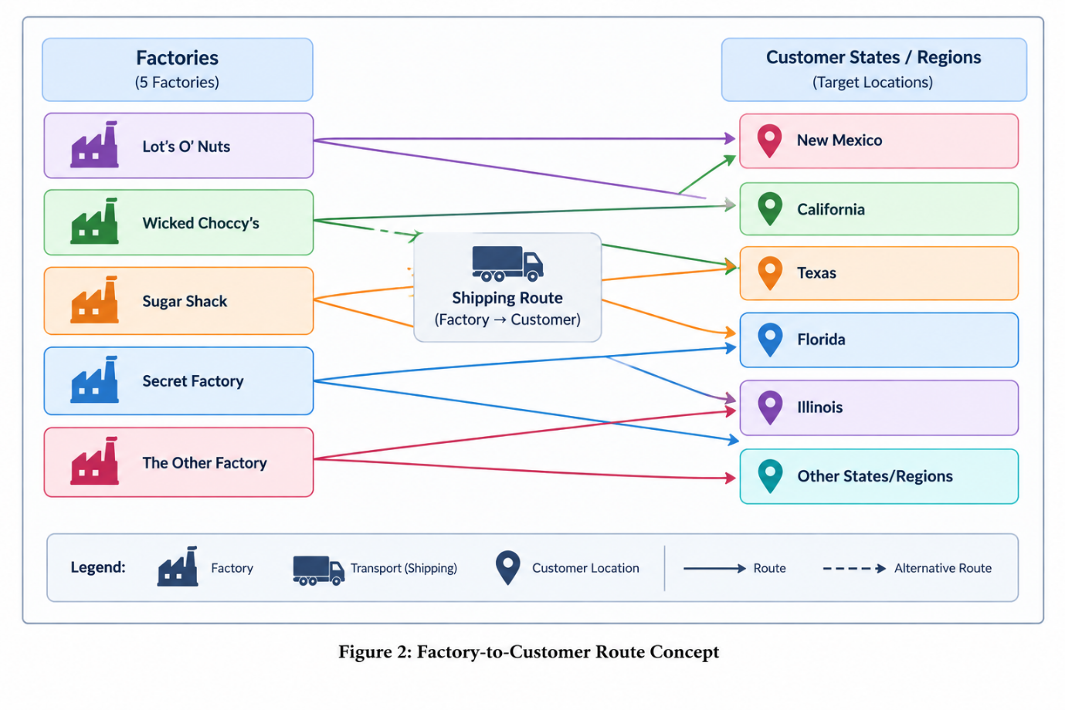
The mapping resulted in every shipment being associated with a factory, enabling the construction of factory-to-customer routes for subsequent analysis.
The factories considered in the study were:
- Lot's O' Nuts
- Wicked Choccy's
- Sugar Shack
- Secret Factory
- The Other Factory
This factory mapping formed the basis for the route-level analysis performed in later stages.
No. | Product Name | Product Category | Assigned Factory
1 | Wonka Bar - Nutty Crunch Surprise | Chocolate | Lot's O' Nuts
2 | Wonka Bar - Fudge Mallows | Chocolate | Lot's O' Nuts
3 | Wonka Bar - Scrumdiddlyumptious | Chocolate | Lot's O' Nuts
4 | Wonka Bar - Milk Chocolate | Chocolate | Wicked Choccy's
5 | Wonka Bar - Triple Dazzle Caramel | Chocolate | Wicked Choccy's
6 | Laffy Taffy | Sugar | Sugar Shack
7 | SweeTARTS | Sugar | Sugar Shack
8 | Nerds | Sugar | Sugar Shack
9 | Fun Dip | Sugar | Sugar Shack
10 | Fizzy Lifting Drinks | Other | Sugar Shack
11 | Everlasting Gobstopper | Sugar | Secret Factory
12 | Lickable Wallpaper | Other | Secret Factory
13 | Wonka Gum | Other | Secret Factory
14 | Hair Toffee | Sugar | The Other Factory
15 | Kazookles | Other | The Other Factory
Table 2. Product-to-Factory Mapping
5.4 FEATURE ENGINEERING
Feature engineering was performed to create variables required for evaluating shipping performance. The primary derived feature was Shipping Lead Time, calculated as the difference between the Ship Date and Order Date.
The calculation can be represented as:
Shipping Lead Time = Ship Date − Order Date
The resulting value represents the number of days between the placement of an order and its shipment.
Two route-related features were also created. The Route attribute represents the movement from a factory to a customer's state or province, while Region Route represents the movement from a factory to the customer's region.
The derived features were defined as:
Route = Factory → Customer State/Province
Region Route = Factory → Customer Region
These features enabled the shipment records to be grouped and analyzed according to specific factory-to-customer routes and broader regional movements.
No. | Derived Feature | Calculation / Definition | Purpose
1 | Factory | Product Name → Factory mapping | Identifies the factory associated with each product
2 | Shipping Lead Time | Ship Date − Order Date | Measures the number of days between order placement and shipment
3 | Route | Factory → State/Province | Represents the factory-to-customer state/province route
4 | Region Route | Factory → Region | Represents the factory-to-customer regional route
5 | Delayed | Shipping Lead Time > 75th-percentile benchmark | Identifies shipments with comparatively high lead times
6 | Delay Frequency | Delayed Shipments ÷ Total Shipments × 100 | Measures the percentage of delayed shipments
7 | Efficiency Score | Reversed Min-Max normalization of Average Lead Time | Provides a relative 0–100 measure for comparing route efficiency
Table 3. Derived Analytical Features

5.5 EXPLORATORY DATA ANALYSIS
Exploratory Data Analysis (EDA) was performed to understand the distribution and characteristics of shipments before conducting detailed route and performance analysis. Both numerical summaries and visualizations were used to examine the shipment data.
The distribution of shipments across different shipping modes was analyzed to understand the usage of Standard Class, Second Class, First Class, and Same Day shipping. Regional and factory-level shipment distributions were also examined to identify differences in shipment volume.
Shipping Lead Time was analyzed using descriptive statistics and a histogram to understand its distribution and identify the range and concentration of lead-time values. State-level shipment volumes were examined to identify locations receiving a relatively large number of shipments. Product-level shipment frequencies were also analyzed to understand the distribution of shipments across different products.
Average Shipping Lead Time was calculated separately for customer regions and factories to compare their observed shipping performance. In addition, factory-by-region shipment counts and average lead times were examined to understand how factory locations and customer regions interact.
The EDA stage provided an overall understanding of the dataset and helped identify patterns that were further investigated during route efficiency, delay, geographic, and ship mode analyses.
5.6 ROUTE EFFICIENCY ANALYSIS
Route-level analysis was performed to evaluate the shipping performance of individual factory-to-customer routes. The Route attribute created during feature engineering was used to group shipment records according to their originating factory and customer state or province.
For each route, the number of shipments and shipping lead-time statistics were calculated. The main measures considered were shipment volume, average lead time, minimum lead time, and maximum lead time.
The route performance was calculated using the following aggregation:
- Shipment Volume: Total number of shipments associated with a route.
- Average Lead Time: Mean Shipping Lead Time for all shipments on the route.
- Minimum Lead Time: Lowest observed Shipping Lead Time for the route.
- Maximum Lead Time: Highest observed Shipping Lead Time for the route.
Routes were initially examined based on shipment volume and average lead time. Routes with a very small number of shipments can produce less stable averages; therefore, a minimum shipment-volume criterion of 10 shipments was used to create a reliable-route subset for detailed comparison.
Within this subset, routes were compared according to their average shipping lead time. Routes with lower average lead times were considered relatively faster within the analyzed dataset, while routes with higher average lead times were identified for further investigation.
This analysis provided the foundation for the subsequent efficiency scoring and delay analysis.
5.7 ROUTE EFFICIENCY SCORE
To provide a standardized comparison of route performance, a Route Efficiency Score was calculated for the reliable routes. The score is based on the average Shipping Lead Time of each route.
Since a lower average lead time represents relatively faster shipping, the normalization was reversed so that routes with lower average lead times receive higher efficiency scores.
The Route Efficiency Score was calculated using the following formula:
Efficiency Score = 100 × [1 − (Route Average Lead Time − Minimum Average Lead Time) / (Maximum Average Lead Time − Minimum Average Lead Time)]
The resulting score ranges from 0 to 100 within the analyzed route dataset. A higher score indicates that a route has a relatively lower average shipping lead time compared with the other analyzed routes, while a lower score indicates a relatively higher average lead time.
After calculating the score, routes were sorted according to their Efficiency Score. The highest-scoring and lowest-scoring routes were examined to identify routes that showed relatively different levels of shipping performance.
The efficiency score is a relative analytical measure for this dataset and should not be interpreted as an absolute industry-standard performance rating. It is intended to support comparison among the routes included in the study.
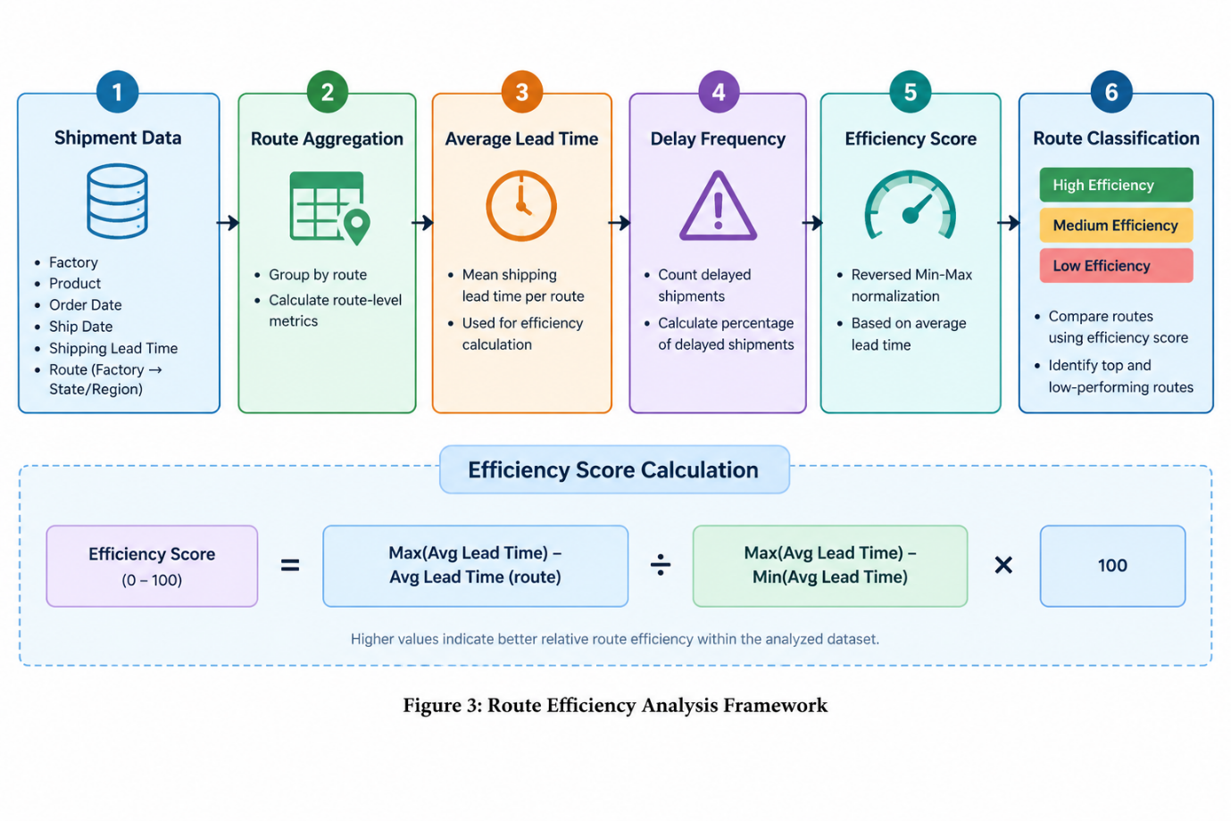
No. | Metric | Description | Interpretation
1 | Shipment Volume | Total number of shipments recorded for a route | Indicates the level of route activity
2 | Average Lead Time | Mean Shipping Lead Time for a route | Lower values indicate shorter observed shipping times
3 | Minimum Lead Time | Smallest Shipping Lead Time observed on a route | Represents the shortest observed lead time
4 | Maximum Lead Time | Largest Shipping Lead Time observed on a route | Represents the longest observed lead time
5 | Delayed Shipments | Number of shipments exceeding the selected delay benchmark | Indicates the number of comparatively high lead-time shipments
6 | Delay Frequency | Delayed Shipments ÷ Shipment Volume × 100 | Indicates the percentage of shipments classified as delayed
7 | Efficiency Score | Reversed Min-Max normalization based on Average Lead Time | Higher values indicate better relative route efficiency within the analyzed dataset
Table 4. Route Efficiency Metrics
5.8 DELAY ANALYSIS
Delay analysis was performed to identify shipments with relatively high Shipping Lead Time and to determine the frequency of such shipments across different routes.
Initially, a five-day threshold was examined as a possible delay criterion. However, this threshold classified all shipments as delayed because the Shipping Lead Time values in the dataset were substantially higher than five days. Therefore, using this threshold would not provide meaningful differentiation between normal and relatively high lead-time shipments.
A data-driven benchmark was subsequently selected using the 75th percentile of Shipping Lead Time. The 75th percentile represents the value below which approximately 75% of the observed lead-time values fall, while the remaining observations have higher values. For this dataset, the calculated benchmark was 1,638 days.
A shipment was classified as delayed when its Shipping Lead Time exceeded this benchmark:
Delayed = Shipping Lead Time > 75th Percentile Benchmark
For each route, the number of delayed shipments and the percentage of delayed shipments were calculated. Delay Frequency was calculated as:
Delay Frequency (%) = (Number of Delayed Shipments / Total Shipments) × 100
Routes were then compared based on their delay frequency. Routes with higher delay frequencies were identified for further investigation, particularly when they also had a sufficient shipment volume.
The 75th-percentile threshold is used as an analytical benchmark derived from this dataset and should not be interpreted as an official delivery-time standard or industry Service Level Agreement (SLA).

5.9 GEOGRAPHIC BOTTLENECK ANALYSIS
Geographic analysis was performed to identify customer states or provinces that may require further investigation because of their shipment volume and shipping performance. The analysis was conducted at the state or province level using three main measures: shipment volume, average Shipping Lead Time, and Delay Frequency.
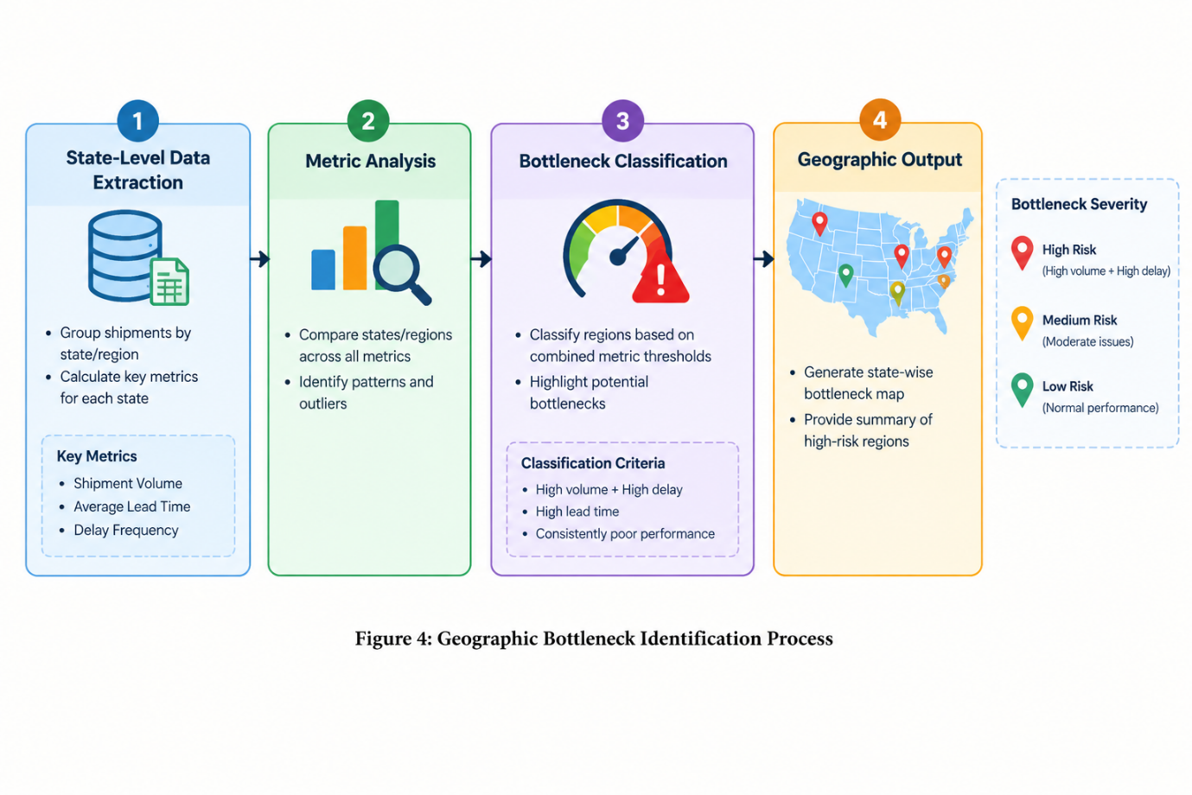
First, the total number of shipments associated with each state or province was calculated to measure shipment volume. The average Shipping Lead Time was then calculated for each location to determine its observed shipping performance. Delay Frequency was also calculated to measure the proportion of shipments whose lead time exceeded the data-driven delay benchmark.
To identify locations with potentially significant performance concerns, median values were calculated for shipment volume, average lead time, and delay frequency. These median values were used as relative benchmarks for classifying geographic performance.
A state or province was classified as a Potential Geographic Bottleneck when it simultaneously satisfied the following conditions:
- Shipment Volume was at or above the median shipment volume.
- Average Lead Time was at or above the median average lead time.
- Delay Frequency was at or above the median delay frequency.
Locations with high shipment volume combined with either high average lead time or high delay frequency were classified as High-Volume Performance Concerns.
The geographic classifications are intended to identify locations that warrant further investigation. They do not establish that a particular state or province is the direct cause of shipping delays or operational bottlenecks. The classifications represent patterns observed within the available dataset.
5.10 SHIP MODE PERFORMANCE ANALYSIS
The performance of different shipping modes was analyzed to understand how shipment methods differ in terms of shipping time, delay frequency, shipment volume, cost, and sales. The dataset contains four shipping modes: Standard Class, Second Class, First Class, and Same Day.
For each shipping mode, the following measures were calculated:
- Shipment Volume: Total number of shipments using the shipping mode.
- Average Lead Time: Mean Shipping Lead Time for the shipping mode.
- Minimum Lead Time: Lowest observed Shipping Lead Time.
- Maximum Lead Time: Highest observed Shipping Lead Time.
- Delayed Shipments: Number of shipments exceeding the selected delay benchmark.
- Delay Frequency: Percentage of shipments exceeding the delay benchmark.
- Average Cost: Mean recorded cost associated with shipments using the shipping mode.
- Average Sales: Mean recorded sales value associated with shipments using the shipping mode.
The shipping modes were compared using these measures to identify differences in their observed performance. Average lead time and delay frequency were used to evaluate shipping-time characteristics, while shipment volume provided information about the frequency of each shipping mode.
Cost and sales were included as additional descriptive measures to examine the relationship between shipping modes and the financial attributes available in the dataset. The recorded Cost attribute was treated as a dataset cost measure and was not assumed to represent a dedicated transportation or shipping charge.
The comparison provides a descriptive view of shipping-mode performance and helps identify patterns that may require further operational investigation.
5.11 STREAMLIT DASHBOARD DEVELOPMENT
An interactive web-based dashboard was developed using Streamlit to present the results of the shipping route analysis in an accessible and interactive format. Streamlit was selected because it allows Python-based data analysis and visualization to be integrated into an interactive dashboard.
The dashboard was designed around the major analytical components of the study. Key performance indicators were provided to summarize the selected shipment records, including total shipments, number of routes, average shipping lead time, delay frequency, average cost, and average sales.
Interactive filters were implemented to allow users to examine the dataset according to different conditions. These filters include region, state or province, shipping mode, order-date range, and maximum shipping lead time.
The dashboard contains several analytical sections:
- Route Efficiency Overview: Displays route-level efficiency scores and performance information.
- Geographic Shipping Map: Visualizes shipment volume and average lead time across customer states.
- Ship Mode Comparison: Compares shipping modes using lead time, delay frequency, shipment volume, cost, and sales.
- Route Drill-Down: Allows users to select an individual route and examine its detailed performance.
- Geographic Bottleneck Analysis: Highlights locations that meet the analytical criteria for potential geographic bottlenecks.
The dashboard also includes validation and error-handling features to ensure that appropriate messages are displayed when selected filters produce no matching records. Dashboard outputs were tested using different combinations of filters and compared with the underlying analytical results to verify consistency.
The completed dashboard provides an interactive interface for exploring the shipping dataset and understanding route, geographic, and shipping-mode performance.

6. RESULTS AND FINDINGS
6.1 ROUTE PERFORMANCE ANALYSIS
The route-level analysis was performed to evaluate the observed shipping performance of factory-to-customer routes. Each route was represented as a combination of the originating factory and the customer's state or province. Shipment volume and shipping lead-time measures were used to compare route performance.
The analysis showed that shipment volumes varied considerably across the identified routes. Some factory-to-customer routes handled a substantially larger number of shipments, while other routes had relatively few observations. To improve the reliability of route comparisons, routes with at least 10 shipments were selected as the reliable-route subset for detailed analysis.
For the reliable routes, average Shipping Lead Time was used as the primary measure of shipping-time performance. Minimum and maximum lead times were also examined to understand the range of observed shipping times for individual routes.
The analysis identified variation in average lead time across the reliable routes. For example, among the routes displayed in the final route analysis, Wicked Choccy's → Nevada had an average lead time of approximately 1,182.25 days, while Lot's O' Nuts → Virginia had a substantially larger shipment volume of 109 shipments with an average lead time of approximately 1,229.49 days.
The results demonstrate that route performance cannot be evaluated using shipment volume alone. A route may handle a large number of shipments while still exhibiting relatively high lead times, while a route with fewer shipments may show a different lead-time pattern. Therefore, shipment volume and lead-time measures were considered together during the subsequent efficiency and delay analyses.
The route analysis provided the basis for calculating the Route Efficiency Score and identifying routes requiring further investigation.

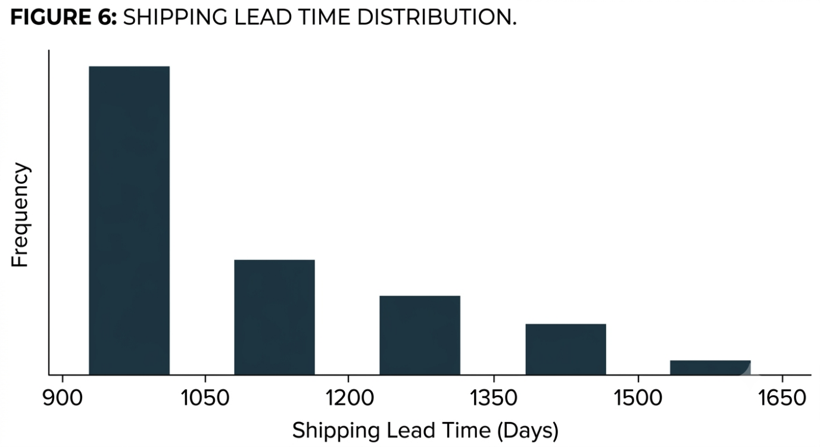
Figure 6: Distribution of Shipping Lead Time Across Shipments
6.2 DELAY ANALYSIS
The delay analysis was conducted to identify shipments with relatively high Shipping Lead Time and to examine how frequently such shipments occurred across different routes.
An initial five-day delay threshold was tested during the analysis. However, because all shipment records had Shipping Lead Time values greater than five days, this threshold resulted in a delay frequency of 100% and therefore did not provide meaningful differentiation between shipments.
To obtain a benchmark based on the distribution of the available data, the 75th percentile of Shipping Lead Time was selected. The resulting benchmark was 1,638 days. Shipments with a Shipping Lead Time greater than 1,638 days were classified as delayed for the purpose of the analysis.
The delay frequency was then calculated for each route as the percentage of shipments exceeding this benchmark. The analysis showed that delay frequency varied across routes. Among the reliable routes, Wicked Choccy's → New Mexico recorded a delay frequency of approximately 64.71%, with 11 delayed shipments out of 17 shipments. Lot's O' Nuts → New Mexico recorded a delay frequency of approximately 55.56%, with 10 delayed shipments out of 18 shipments.
Other routes also showed relatively high delay frequencies. For example, The Other Factory → New York recorded a delay frequency of 50.00%, with 7 delayed shipments out of 14 shipments. Wicked Choccy's → Indiana recorded approximately 42.59%, with 23 delayed shipments out of 54 shipments.
These findings indicate that delay frequency differs across factory-to-customer routes. Routes with both sufficient shipment volume and relatively high delay frequency can therefore be selected for further investigation.
It is important to note that the 1,638-day benchmark is a data-driven analytical threshold derived from the 75th percentile of this dataset. It does not represent an official delivery standard, contractual service-level agreement, or industry benchmark.
6.3 GEOGRAPHIC FINDINGS
The geographic analysis was conducted at the state or province level to examine differences in shipment volume, average Shipping Lead Time, and Delay Frequency. These measures were combined to identify locations that showed multiple indicators of relatively poor shipping performance.
Shipment volume was first analyzed to determine which states or provinces handled a relatively large number of shipments. Average Shipping Lead Time was then calculated for each location to measure the observed shipping-time pattern. Delay Frequency was calculated using the same 75th-percentile benchmark of 1,638 days used in the route-level delay analysis.
To identify potential geographic bottlenecks, the median values of shipment volume, average lead time, and delay frequency across the analyzed locations were used as relative benchmarks. A location was classified as a Potential Geographic Bottleneck when it had shipment volume at or above the median, average lead time at or above the median, and delay frequency at or above the median.
Locations satisfying only some of these conditions were treated as High-Volume Performance Concerns or other geographic classifications depending on their observed characteristics.
The geographic analysis provides a way to distinguish locations that may require further investigation from locations with relatively lower shipment volumes or better observed performance. Combining shipment volume with lead-time and delay measures is useful because a location with high shipment volume and poor performance may have greater operational significance than a location with very few shipments.
However, these classifications represent patterns observed in the available shipment data and should not be interpreted as proof that a particular state or province causes shipping delays. Further operational information, such as transportation networks, warehouse capacity, carrier information, traffic conditions, and actual delivery dates, would be required to establish causal relationships.
6.4 SHIP MODE FINDINGS
The performance of the four shipping modes available in the dataset—Standard Class, Second Class, First Class, and Same Day—was analyzed using shipment volume, average Shipping Lead Time, delayed shipments, Delay Frequency, recorded Cost, and Sales.
The shipment distribution showed that Standard Class accounted for the largest number of shipments, followed by Second Class, First Class, and Same Day. The observed shipment volumes were 6,120 for Standard Class, 1,979 for Second Class, 1,548 for First Class, and 547 for Same Day.
Average Shipping Lead Time was compared across the four shipping modes to examine differences in observed shipping-time performance. Delay Frequency was also calculated using the same 1,638-day data-driven benchmark used in the route and geographic analyses.
In addition to shipping-time measures, the analysis included average recorded Cost and average Sales for each shipping mode. These measures provide additional descriptive information for comparing the financial characteristics associated with the different shipping modes.
The results demonstrate that shipping modes have different shipment volumes and observed performance characteristics. However, the differences should be interpreted in the context of the available dataset. In particular, the recorded Cost attribute was treated as the cost measure provided in the dataset and was not assumed to represent a dedicated transportation or shipping charge.
The ship mode analysis therefore provides a descriptive comparison of the available shipping methods rather than determining that one shipping mode is universally preferable. Decisions regarding shipping mode would require additional information such as service requirements, actual transportation charges, delivery commitments, and customer priorities.

No. | Ship Mode | Shipment Volume | Average Lead Time | Average Cost | Average Sales
1 | Standard Class | 6,120 | 1314.33 | 4.75 | 13.97
2 | Second Class | 1,979 | 1323.85 | 4.83 | 14.08
3 | First Class | 1,548 | 1338.28 | 4.72 | 13.77
4 | Same Day | 547 | 1333.44 | 4.41 | 13
Table 5. Ship Mode Performance
6.5 ROUTE EFFICIENCY SCORE FINDINGS
The Route Efficiency Score was used to provide a standardized comparison of the reliable factory-to-customer routes. The score was calculated from the average Shipping Lead Time of each route using reversed Min-Max normalization, with scores ranging from 0 to 100.
A higher Efficiency Score indicates a relatively lower average Shipping Lead Time compared with the other reliable routes included in the analysis. Conversely, a lower score indicates a relatively higher average Shipping Lead Time.
The calculated scores were used to arrange the routes from relatively higher to relatively lower efficiency. The analysis also considered Delay Frequency alongside the Efficiency Score to avoid evaluating route performance using average lead time alone.
This comparison showed that route efficiency and delay frequency represent different aspects of shipping performance. A route may have a relatively high Efficiency Score while still having a noticeable frequency of shipments exceeding the delay benchmark. Similarly, a route with a relatively lower Efficiency Score may have a different delay pattern.
Therefore, the study considered both Efficiency Score and Delay Frequency when examining route performance. Shipment volume was also retained as an important contextual measure because routes with very small numbers of shipments may provide less stable performance estimates.
The Route Efficiency Score should be interpreted as a relative measure within the analyzed dataset. It does not represent an absolute quality rating or an industry-standard efficiency value. Its primary purpose is to provide a consistent numerical measure for comparing the analyzed routes.
6.6 KEY FINDINGS SUMMARY
The analysis of the Nassau Candy Distributor shipment dataset produced several findings related to route performance, shipping delays, geographic patterns, and shipping modes.
First, the route analysis showed that shipping performance varied across factory-to-customer routes. Shipment volume also differed considerably between routes, making it important to consider both route volume and lead-time measures when evaluating performance.
Second, the initial five-day delay threshold was found to be unsuitable for this dataset because it classified all shipments as delayed. A data-driven threshold based on the 75th percentile of Shipping Lead Time was therefore used. The resulting benchmark was 1,638 days, and routes were compared according to the frequency of shipments exceeding this value.
Third, the Route Efficiency Score provided a standardized method for comparing reliable routes based on average Shipping Lead Time. The score made it possible to distinguish routes with relatively lower and higher average lead times while maintaining a consistent 0–100 scale.
Fourth, the geographic analysis showed that shipment volume, average lead time, and delay frequency can be considered together to identify locations requiring further investigation. Locations satisfying all three benchmark conditions were classified as Potential Geographic Bottlenecks.
Finally, the ship mode analysis showed differences in shipment volume and observed shipping performance among Standard Class, Second Class, First Class, and Same Day. Cost and sales were also examined as additional descriptive measures.
Overall, the findings demonstrate that combining route-level, geographic, delay, and shipping-mode analysis provides a broader understanding of shipping performance than examining any single metric independently.

No. | Analysis Area | Key Finding | Analytical Significance
1 | Dataset | 10,194 shipment records with 18 original attributes | Provides the primary dataset for the shipping analysis
2 | Factory Mapping | All 15 products were successfully mapped to 5 factories | Enables factory-to-customer route analysis
3 | Feature Engineering | Shipping Lead Time, Route, and Region Route were created | Provides derived measures required for transportation analysis
4 | Route Analysis | Routes were analyzed using shipment volume, average lead time, and lead-time range | Enables comparison of route-level shipping performance
5 | Reliable Routes | Routes with at least 10 shipments were used for reliable route comparisons | Reduces the influence of very low-volume routes
6 | Delay Analysis | The initial 5-day threshold classified all shipments as delayed | Demonstrated that the threshold was unsuitable for this dataset
7 | Delay Benchmark | 75th-percentile Shipping Lead Time = 1,638 days | Provides a relative data-driven benchmark for delay analysis
8 | Route Delay | Wicked Choccy's → New Mexico had 11 delayed shipments out of 17 (64.71%) | Identifies a route requiring further investigation
9 | Route Delay | Lot's O' Nuts → New Mexico had 10 delayed shipments out of 18 (55.56%) | Indicates comparatively high delay frequency on the route
10 | Route Efficiency | Efficiency Score uses a relative 0–100 scale based on average lead time | Supports comparison of route efficiency within the dataset
11 | Geographic Analysis | States were evaluated using shipment volume, average lead time, and delay frequency | Helps identify potential geographic performance concerns
12 | Ship Mode Analysis | Four shipping modes were compared: Standard Class, Second Class, First Class, and Same Day | Enables descriptive comparison of shipping-mode performance
13 | Dashboard | An interactive Streamlit dashboard was developed | Provides an accessible interface for exploring analytical results
Table 6. Key Analytical Findings

7. STREAMLIT DASHBOARD
To make the analytical results accessible and interactive, a web-based dashboard was developed using Streamlit. The dashboard integrates the processed shipment data and analytical outputs into a single interface, allowing users to explore shipping performance using different filters and analytical views.
The dashboard was developed using Python along with data analysis and visualization libraries. It provides an interactive interface through which users can examine key shipment indicators, route performance, geographic patterns, shipping-mode characteristics, and potential geographic bottlenecks.
7.1 Dashboard Overview
The dashboard presents a consolidated view of the Nassau Candy Distributor shipping analysis. The main sections of the dashboard include:
- KPI Overview
- Route Efficiency Overview
- Geographic Shipping Map
- Ship Mode Performance Comparison
- Route Drill-Down
- Potential Geographic Bottleneck Analysis
These sections allow the user to move from a high-level overview of the shipment data to more detailed route and geographic analysis.
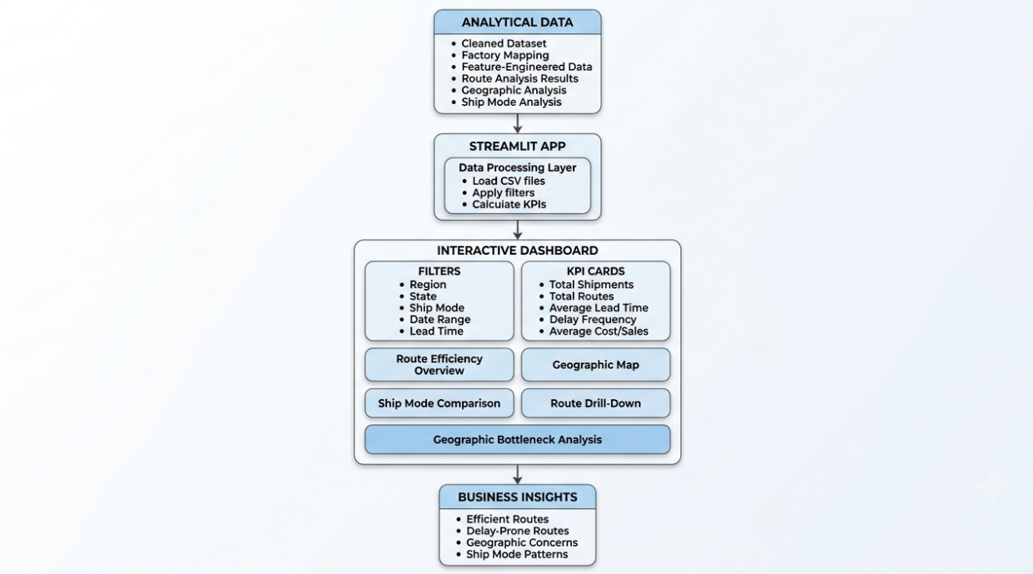
Figure 5: Streamlit Dashboard Architecture/Layout
7.2 Interactive Filters
Interactive filters were implemented through the dashboard sidebar to allow users to analyze selected portions of the shipment dataset.
The available filters include:
- Region
- State or Province
- Ship Mode
- Order Date Range
- Maximum Shipping Lead Time
The filters allow users to dynamically narrow the displayed shipment records and examine how the selected conditions affect the analytical results.
A reset option was also included to restore the dashboard to its default filter state.
7.3 KPI Overview
The dashboard provides key performance indicators to summarize the currently selected shipment records. The main KPIs include:
- Total Shipments
- Total Routes
- Average Shipping Lead Time
- Delay Frequency
- Average Cost
- Average Sales
These indicators provide a quick overview of the selected data before examining the detailed analytical sections.
7.4 Route Efficiency Overview
The Route Efficiency Overview presents route-level performance information using the Route Efficiency Score and related measures.
The section allows users to examine routes according to their efficiency score and view associated measures such as shipment volume, average lead time, delayed shipments, and delay frequency.
This provides a more detailed view of factory-to-customer route performance and helps users identify routes that may require further investigation.
7.5 Geographic Shipping Map
A geographic visualization was included to display shipment patterns across customer states.
The map represents state-level shipment information and provides an additional way of examining geographic differences in shipment volume and average Shipping Lead Time.
A geographic performance table is also provided to complement the map and allow users to examine the underlying values.
7.6 Ship Mode Performance Comparison
The dashboard includes a comparison of the four shipping modes available in the dataset:
- Standard Class
- Second Class
- First Class
- Same Day
The comparison presents measures such as average Shipping Lead Time, Delay Frequency, shipment volume, recorded Cost, and Sales.
This allows users to examine differences between shipping modes from multiple descriptive perspectives.
7.7 Route Drill-Down
A route drill-down feature was implemented to provide detailed information for an individual route.
After selecting a route, the dashboard displays important route-level indicators, including:
- Shipment Volume
- Average Lead Time
- Delay Frequency
- Efficiency Score
A detailed route table is also provided to support closer examination of the selected route.
7.8 Geographic Bottleneck Analysis
The dashboard includes a section for examining potential geographic bottlenecks. The geographic classification developed during the analysis is used to identify states or provinces that satisfy the analytical criteria for a potential bottleneck.
The dashboard presents the relevant shipment volume, average lead time, delay frequency, and geographic classification to help users understand why a location was selected for further investigation.
7.9 Dashboard Validation
The dashboard and its underlying analytical outputs were validated using automated data-quality and consistency checks. The validation process checked dataset dimensions, required columns, factory mappings, negative lead times, route values, shipping-mode counts, efficiency-score ranges, delay-frequency ranges, route volumes, and duplicate records.
The dashboard was also manually tested using different combinations of filters to verify that the interface responded correctly and that appropriate messages were displayed when no records matched the selected conditions.
The validation process helped ensure that the dashboard was consistent with the analytical results generated during the earlier stages of the project.

8. BUSINESS INSIGHTS AND RECOMMENDATIONS
The analysis of shipment records, route performance, delays, geographic patterns, and shipping modes provides several useful insights into the shipping operations of Nassau Candy Distributor. These findings can support data-based monitoring of transportation performance and help identify areas that require further investigation.
The recommendations presented in this section are based on patterns observed in the available dataset. They should therefore be considered as analytical recommendations rather than definitive conclusions about the operational causes of delays.
8.1 Route Performance Insights
The route analysis shows that shipping performance varies across factory-to-customer routes. Some routes have lower average Shipping Lead Time, while others have comparatively higher values.
Shipment volume is also an important factor when interpreting route performance. A route with a small number of shipments may show an extreme average that is less representative than a route with a larger shipment volume.
Therefore, route performance should be evaluated using multiple measures, including:
- Shipment Volume
- Average Shipping Lead Time
- Delay Frequency
- Efficiency Score
Considering these measures together provides a more balanced view of route performance.
8.2 Delay Analysis Insights
The initial five-day delay threshold was not suitable for this dataset because all observed shipments had Shipping Lead Times greater than five days. Using this threshold would therefore classify every shipment as delayed.
A data-driven benchmark based on the 75th percentile was subsequently used. The resulting benchmark was 1,638 days. Shipments with a Shipping Lead Time greater than this value were classified as delayed for the analytical comparison.
This approach provides a relative method for identifying unusually high lead times within the dataset. However, the 1,638-day value should not be interpreted as an official delivery-service-level agreement or industry-standard delay threshold.
8.3 Geographic Performance Insights
The state-level analysis demonstrates that shipment volume, average Shipping Lead Time, and Delay Frequency vary across geographic locations.
States with high shipment volumes and comparatively poor performance were identified as potential geographic bottlenecks using median-based analytical benchmarks.
These locations can be prioritized for additional investigation because they combine relatively high operational activity with comparatively weaker shipping performance.
However, the analysis identifies potential bottlenecks, not proven causes of delays. Additional information such as actual transportation routes, carrier information, warehouse capacity, traffic conditions, and delivery distance would be required to determine the underlying causes.
8.4 Ship Mode Insights
The dataset contains four shipping modes: Standard Class, Second Class, First Class, and Same Day.
The analysis compares these modes using shipment volume, average Shipping Lead Time, Delay Frequency, recorded Cost, and Sales.
This comparison provides a descriptive view of how shipping performance differs across the available modes. It can help identify patterns that may require further operational investigation.
The recorded Cost variable was treated as the cost available in the dataset. It was not assumed to represent a dedicated shipping charge because the dataset documentation does not establish that interpretation.
8.5 Route Efficiency Score as a Monitoring Measure
The Route Efficiency Score provides a normalized measure for comparing routes within the dataset.
The score is based on average Shipping Lead Time, with routes having lower average lead times receiving higher relative scores. The score ranges from 0 to 100 within the analyzed route dataset.
This measure can be used as a monitoring indicator to simplify route comparisons and identify routes that deserve additional attention.
Because the score is calculated relative to the observed dataset, it should not be interpreted as an absolute industry performance rating.
8.6 Recommended Areas for Operational Monitoring
Based on the analysis, the following areas can be considered for continued monitoring:
- High-volume routes: Frequently used routes should be monitored because performance issues on these routes can affect a larger number of shipments.
- High-delay routes: Routes with comparatively high Delay Frequency can be examined to determine whether recurring operational factors are involved.
- Potential geographic bottlenecks: States identified through the geographic analysis can receive additional investigation.
- Route efficiency: Efficiency Scores can be monitored over time to identify changes in route performance.
- Ship mode performance: Shipping modes can be compared regularly using lead time, delay frequency, volume, and recorded cost.
- Data quality: Shipment and date records should continue to be validated so that future analyses are based on reliable information.
8.7 Data-Driven Decision Support
The combination of route analysis, delay analysis, geographic analysis, and ship mode comparison provides a structured approach to transportation performance monitoring.
Instead of relying only on individual shipment records, decision-makers can use aggregated indicators to identify patterns across routes, locations, and shipping modes.
The Streamlit dashboard further supports this process by allowing users to interactively filter the data and examine specific parts of the distribution network.
Overall, the project demonstrates how exploratory data analytics can transform shipment records into structured information that can support operational monitoring and further investigation.
9. LIMITATIONS OF THE STUDY
Although the project provides a structured analysis of factory-to-customer shipping performance, several limitations should be considered when interpreting the results. These limitations mainly relate to the available dataset, the analytical assumptions, and the scope of the study.
9.1 Dataset Limitations
The analysis is based on the shipment records provided for the project. The dataset contains information about orders, products, customers, shipping dates, locations, sales, units, gross profit, and cost. However, it does not contain all operational information that may influence transportation performance.
For example, detailed information about carriers, actual transportation distance, vehicle type, warehouse capacity, traffic conditions, weather conditions, and specific delivery events is not available in the dataset.
Therefore, the analysis can identify patterns in the available shipment records but cannot determine the exact operational causes behind those patterns.
9.2 Unusual Date and Lead-Time Values
The dataset contains unusually large differences between some Order Dates and Ship Dates. As a result, the calculated Shipping Lead Time includes values that are considerably larger than typical delivery periods.
These values were retained because they are present in the original dataset and were not identified as invalid solely on the basis of their magnitude.
Consequently, the lead-time results should be interpreted as characteristics of the supplied dataset rather than as direct representations of normal real-world delivery durations.
9.3 Delay Benchmark Limitation
An initial five-day delay threshold was tested but resulted in all shipments being classified as delayed. Therefore, a data-driven 75th-percentile benchmark of 1,638 days was used for the delay analysis.
This benchmark is useful for relative comparison within the dataset, but it is not an official operational Service Level Agreement (SLA) or an industry-standard delivery threshold.
A real-world implementation would require an agreed delivery-time target based on business requirements, customer expectations, and shipping policies.
9.4 Factory Mapping Limitation
The original dataset does not contain a direct Factory column. Factory information was therefore derived by mapping products to their corresponding factories.
This mapping enables factory-to-customer route analysis, but its accuracy depends on the correctness of the provided product-to-factory relationships.
9.5 Route Definition Limitation
For this study, a route is defined as:
Factory → Customer State/Province
This definition is useful for comparing factory-to-customer geographic patterns, but it does not represent the complete physical transportation path.
Actual transportation routes may involve multiple warehouses, distribution centers, carriers, or intermediate locations that are not represented in the dataset.
9.6 Efficiency Score Limitation
The Route Efficiency Score is a normalized measure based on the average Shipping Lead Time of the analyzed routes.
Because the score is calculated relative to the minimum and maximum average lead times in the dataset, it is suitable for comparison within this study but should not be interpreted as a universal measure of logistics efficiency.
Changes in the dataset or the addition of new records could change the minimum, maximum, and consequently the calculated scores.
9.7 Geographic Bottleneck Limitation
Geographic bottlenecks were identified using shipment volume, average Shipping Lead Time, and Delay Frequency together with median-based benchmarks.
A state classified as a potential geographic bottleneck does not necessarily cause shipping delays. The classification indicates that the location exhibits a combination of relatively high shipment activity and weaker performance according to the selected analytical criteria.
Additional operational data would be required to establish causality.
9.8 Cost Interpretation Limitation
The dataset contains a Cost field, but the available project information does not establish that this variable represents a dedicated transportation or shipping cost.
Therefore, the analysis treats Cost as the recorded cost variable rather than assuming that it represents the complete logistics cost of a shipment.
9.9 Scope of the Study
The study focuses primarily on descriptive and exploratory data analysis. It identifies patterns, comparisons, and potential areas for investigation but does not develop a predictive model for future shipment delays.
Future studies could incorporate additional operational variables and predictive techniques to estimate delivery delays and support more advanced logistics planning.

10. FUTURE SCOPE
The current project provides an exploratory analysis of factory-to-customer shipping performance using historical shipment data. The developed methodology and dashboard can be further extended to support more advanced logistics monitoring, prediction, and decision-making.
10.1 Predictive Delay Analysis
A future version of the project could use machine learning techniques to predict whether a shipment is likely to experience a delay.
Features such as order date, shipping mode, factory, customer location, product category, shipment volume, and historical route performance could be used as input variables for a predictive model.
Such a system could provide an estimated delay risk before or during the shipment process.
10.2 Real-Time Shipment Monitoring
The current analysis is based on historical shipment records. A future system could integrate real-time shipment information from logistics or transportation systems.
Real-time data could allow the dashboard to display current shipment status, estimated delivery information, and emerging delays.
This would transform the dashboard from a historical analytical tool into a more continuous monitoring system.
10.3 Advanced Route Optimization
The current project analyzes routes based on factory and customer state or region. Future work could incorporate actual geographic coordinates, transportation distance, road networks, and intermediate distribution locations.
Route optimization algorithms could then be used to identify potentially more efficient transportation paths while considering factors such as distance, travel time, and transportation constraints.

10.4 Carrier Performance Analysis
Carrier information was not available in the current dataset. If carrier-level data becomes available, future analysis could compare transportation providers using measures such as delivery time, delay frequency, reliability, and cost.
This could provide additional information for evaluating transportation operations.
10.5 Time-Series Analysis
Future versions could analyze how shipping performance changes over time.
Monthly, quarterly, or yearly trends could be studied to identify changes in:
- Average Shipping Lead Time
- Shipment Volume
- Delay Frequency
- Route Efficiency
- Ship Mode Usage
Time-series analysis could help identify seasonal patterns and long-term changes in transportation performance.
10.6 Advanced Geographic Analysis
The geographic component could be expanded from state-level analysis to more detailed geographic visualization.
Future improvements could include:
- Interactive route maps
- Factory-to-customer distance analysis
- Regional heat maps
- Geographic clustering
- Distribution center analysis
- State-to-state route visualization
These additions could provide a more detailed understanding of geographic transportation patterns.
10.7 Dynamic Efficiency Benchmarking
The current Route Efficiency Score is calculated relative to the analyzed dataset. Future implementations could introduce business-defined benchmarks or continuously updated benchmarks.
This would allow route performance to be evaluated against predefined operational targets rather than only against other routes in the dataset.
10.8 Cost Optimization
Future analysis could investigate the relationship between transportation performance and operational cost using more detailed cost information.
If actual shipping costs become available, the system could analyze the trade-off between delivery speed and transportation cost and support cost-efficient shipping decisions.
10.9 Automated Alerts
The dashboard could be extended with automated alerts for routes or locations showing unusual performance.
For example, an alert could be generated when:
- Delay Frequency exceeds a predefined threshold.
- Average Lead Time increases significantly.
- A high-volume route experiences declining performance.
- A geographic area shows a sudden increase in delays.
Such alerts could help users identify issues without manually checking the dashboard.
10.10 Integration with Business Systems
The analytical system could eventually be integrated with enterprise systems such as order management, warehouse management, transportation management, or customer service platforms.
This would allow shipment data to be updated automatically and provide a more complete view of the supply chain.
10.11 Advanced Decision-Support System
The ultimate extension of the project could be a comprehensive logistics decision-support system combining historical analysis, predictive modeling, geographic analysis, route optimization, real-time monitoring, and automated alerts.
Such a system could provide decision-makers with a centralized platform for monitoring transportation performance and identifying areas that require operational attention.

11. CONCLUSION
This project presented a data-driven analysis of factory-to-customer shipping route efficiency for Nassau Candy Distributor. The study used historical shipment records to examine transportation performance from multiple perspectives, including shipping lead time, route performance, delays, geographic patterns, and shipping modes.
The analysis began with dataset inspection and data validation, followed by product-to-factory mapping and feature engineering. Shipping Lead Time was calculated from the difference between Ship Date and Order Date, while factory-to-state and factory-to-region routes were created to support route-level analysis.
Exploratory Data Analysis was then performed to understand shipment distributions, shipping modes, factories, regions, states, products, and lead-time patterns. Route-level analysis was used to compare shipment volume and average lead time, while a Route Efficiency Score was developed to provide a normalized measure for comparing route performance.
Delay analysis demonstrated the importance of selecting an appropriate benchmark. The initial five-day threshold classified all shipments as delayed and was therefore unsuitable for this dataset. A 75th-percentile benchmark of 1,638 days was subsequently used as a relative analytical benchmark for identifying higher lead-time shipments.
Geographic analysis examined shipment volume, average lead time, and delay frequency at the state or province level. Locations satisfying the selected analytical criteria were classified as potential geographic bottlenecks for further investigation. The study also compared Standard Class, Second Class, First Class, and Same Day shipping modes using multiple performance measures.
The analytical results were integrated into an interactive Streamlit dashboard. The dashboard provides KPI summaries, interactive filters, route efficiency analysis, geographic visualization, ship mode comparison, route drill-down, and potential geographic bottleneck analysis. Validation procedures were also performed to check the consistency and quality of the analytical outputs.
Overall, the project demonstrates how exploratory data analytics can transform historical shipment records into structured information for transportation performance monitoring. While the analysis does not establish the causal reasons for shipping delays, it provides a systematic approach for identifying routes, locations, and shipping patterns that may require further operational investigation.
The project can serve as a foundation for future development involving predictive delay modeling, real-time shipment monitoring, route optimization, advanced geographic analysis, automated alerts, and integration with business systems.

REFERENCES
[1] J. Han, M. Kamber, and J. Pei, Data Mining: Concepts and Techniques, 3rd ed. Morgan Kaufmann, 2011.
[2] W. McKinney, Python for Data Analysis: Data Wrangling with pandas, NumPy, and Jupyter, 3rd ed. O'Reilly Media, 2022.
[3] W. S. Cleveland, Visualizing Data. Hobart Press, 1993.
[4] M. T. Ribeiro, S. Singh, and C. Guestrin, “Why Should I Trust You? Explaining the Predictions of Any Classifier,” in Proceedings of the 22nd ACM SIGKDD International Conference on Knowledge Discovery and Data Mining, 2016, pp. 1135–1144.
[5] Streamlit, “Streamlit Documentation,” Streamlit. [Online]. Available: https://docs.streamlit.io/
[6] pandas development team, “pandas Documentation,” pandas. [Online]. Available: https://pandas.pydata.org/docs/
[7] Plotly Technologies Inc., “Plotly Python Graphing Library Documentation,” Plotly. [Online]. Available: https://plotly.com/python/
[8] Python Software Foundation, “Python Documentation,” Python. [Online]. Available: https://docs.python.org/3/
[9] S. Chopra and P. Meindl, Supply Chain Management: Strategy, Planning, and Operation, 7th ed. Pearson, 2019.
[10] D. Simchi-Levi, P. Kaminsky, and E. Simchi-Levi, Designing and Managing the Supply Chain: Concepts, Strategies, and Case Studies, 3rd ed. McGraw-Hill/Irwin, 2008.

