**A Project Report on**

**Under Water Image Enhancement**

Submitted to Prof. Rupali Tornekar

**Vishwakarma Institute of Technology, Pune**

(An Autonomous Institute Affiliated to Savitribai Phule Pune University)

In partial fulfillment of the requirements of B.Tech.

In

Electronics and Telecommunication Engineering

By

|  |  |  |
| --- | --- | --- |
| Name | Roll-no | Gr-no |
| Aayush Mehta | 06 | 11811173 |
| Shivani Metangale | 08 | 11810493 |
| Nanditha Naik | 12 | 11811233 |
| Yash Nikhare | 13 | 11810940 |
| Sameeran Pandey | 16 | 11810951 |



Academic Year 2020-21 / SEM I

TY B.Tech ET B

Problem Statement:

Images captured in underwater scenes can be highly degraded due to poor lighting conditions. These images can have low dynamic ranges with high noise levels that affect the overall performance of computer vision algorithms. To make computer vision algorithms robust in low-light conditions, use low-light image enhancement to improve the visibility of an image. The histogram of pixel-wise inversion of low-light images or HDR images is very similar to the histogram of hazy images. Thus, you can use haze removal techniques to enhance low-light images.

Using haze removal techniques to enhance low-light images comprises three steps:

• Step 1: Histogram Equalization.

• Step 2: Apply the haze removal algorithm low-light image.

• Step 3: low light enhancement.

Technique :

Histogram Equalization is a computer image processing technique used to improve contrast in images. It accomplishes this by effectively spreading out the most frequent intensity values, i.e. stretching out the intensity range of the image. This method usually increases the global contrast of images when its usable data is represented by close contrast values. This allows for areas of lower local contrast to gain a higher contrast.

Histogram equalizer basically make histogram more enhanced contrast levels, it reduces the skewness of the histogram of the gray scale’s values of given image. In turn its effects the image by levelling the brightness in the image.

PDF - Probability of occurrence of gray level.

CDF-summation of p at each gray level

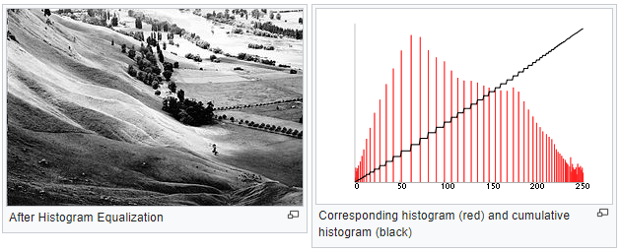

A color histogram of an image represents the number of pixels in each type of color component. Histogram equalization cannot be applied separately to the Red, Green and Blue components of the image as it leads to dramatic changes in the image’s color balance. However, if the image is first converted to another color space, like HSL/HSV color space, then the algorithm can be applied to the luminance or value channel without resulting in changes to the hue and saturation of the image.

**Low Light Enhancement**

Low-light is a challenging environment for image processing and computer vision tasks, either in contrast enhancement for better visibility and quality, or application-oriented tasks such as detection. We found that the current trend of low-light enhancement research is heavily on quality improvement. In this work, we aim to shift the focus towards a more functional direction, that is enhancement.

**Haze Removal**

Haze attenuates the reflected light from the scenes and blends it with additive light in atmosphere. Haze removal techniques tend to improve this reflected light (i.e. scene colors) from mixed light. The constancy and strength of the visual system can also be improved by using this effective haze removal of image. There are many methods available to remove haze from image like polarization independent component analysis, dark channel prior etc. prioritizes feature retrieval.

**Reduction of color distortion by using a different color space**

In this we have used different color space to reduce the color distortion in the image so that we can get clear picture. Firstly, we have changed the rgb into lab color is more accurate color space. It uses 3 axes. A green to red B axis blue to yellow Lightness axis

First, we are inverting a single channel and applying dehazing function to it. Then combining it by increasing a saturation

**Output:**

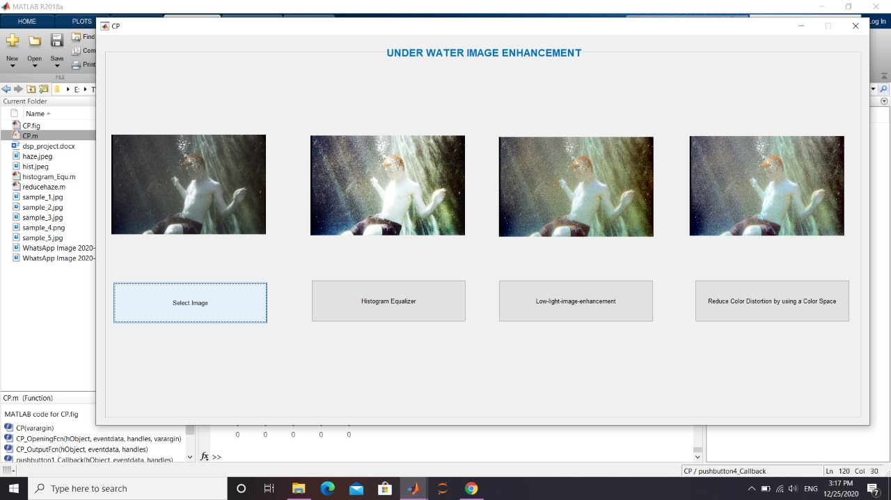

References:

<https://in.mathworks.com/help/images/low-light-image-enhancement.html>

<https://towardsdatascience.com/histogram-equalization-5d1013626e64>

<https://www.ijarcce.com/upload/2016/may-16/IJARCCE%20164.pdf>