## Front End Engineering-II

Project Report

Semester-IV (Batch-2022)

**BIKING CLUB**

**Supervised By: Submitted By:**

Faculty Name : Raveesh Samkaria Name : Yashnoor Kaur

Roll Number-2210990982

Group : G-14

**Department of Computer Science and Engineering**

## Chitkara University Institute of Engineering & Technology,

## Chitkara University, Punjab

## ****ABSTRACT :****

The biking club project endeavours to revolutionize the biking experience through a user-friendly web application built using **HTML, and React.js**. This platform serves as a bridge between restaurants and customers, offering intuitive features such as menu browsing and reservation booking. With a keen emphasis on user-centric design and optimal performance, Biking club aims to redefine the digital dining landscape. It prioritizes usability and scalability to meet the evolving needs of both restaurant owners and customers. Through innovative features and seamless user experience, Biking club sets out to establish new standards in online dining platforms.

By integrating technology and creativity, Biking club promises to deliver a hassle-free and enjoyable dining experience for all users. It seeks to provide accessibility and engagement, ensuring satisfaction in every dining interaction.

**TABLE OF CONTENTS :**

1. Introduction

1.1 Background

1.2 Objectives

1.3 Significance

2. Problem Definition and Requirements

2.1 Problem Statement

2.2 Requirements

2.2.1 Software Requirements

2.2.2 Hardware Requirements

3. Proposed Design / Methodology

3.1 File Structure

3.2 Algorithms Used

4. Results

4.1 Screenshots

5. References

1. **INTRODUCTION**

**1.1 Background:**

The biking industry is undergoing a digital transformation, with an increasing number of customers preferring online platforms for browsing menus, making reservations, and exploring dining options. Recognizing this trend, the Fusion Fare project aims to develop a feature-rich web application that caters to the evolving needs of customers, utilizing **HTML, and React.js.**

**1.2 Objectives:**

The primary objectives of the Fusion Fare project include:

* Implementing interactive features such as menu browsing, reservation booking, and recipe exploration using React.js components.
* Optimizing performance to ensure fast load times and smooth user experience across devices, with HTML for semantic markup.
* Conducting comprehensive testing to ensure reliability, functionality, and responsiveness across different screen sizes.

**1.3 Significance:**

Biking club holds significant potential to transform the way users interact with restaurant websites, enhancing convenience, accessibility, and overall dining experience. By offering a user-friendly platform that integrates seamlessly with restaurant operations, Fusion Fare aims to revolutionize the digital dining landscape using HTML, Tailwind CSS, and React.js.

**2.PROBLEM DEFINITION AND REQUIREMENTS**

**2.1 Problem Statement:**

The Biking club project addresses the need for a modern, user-friendly web application that streamlines the process of browsing menus, making reservations, and exploring special recipes for restaurant customers, employing HTML,and React.js.

**2.2 Requirements :**

**2.2.1 Software Requirements:**

The software requirements for the project include:

* Web browser (Chrome, Firefox)
* Text editor (Visual Studio Code)
* ReactJS
* HTML

**2.2.2 Hardware Requirements:**

Computer: A desktop or laptop computer capable of running a text editor and web browser is necessary for developing the website.

Internet Connection: An internet connection will be needed for accessing online resources, testing the website on different devices, and deploying updates.

**3.PROPOSED DESIGN / METHODOLOGY**

**3.1 File Structure:**

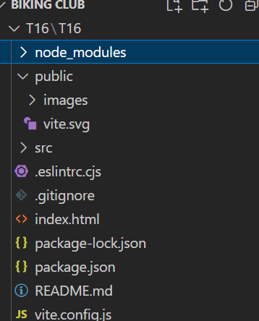

**3.2 Algorithms Used :**

Biking club utilizes React Router for efficient page navigation, ensuring smooth transitions between different sections. This integration enhances user experience by providing seamless browsing without full-page reloads, contributing to a more engaging and interactive website.

**CODE :**

**App.jsx :**

import './App.css'

import Header from './components/Header'

import Group1 from './components/Group1'

import Group2 from './components/Group2'

import Group3 from './components/Group3'

import Group4 from './components/Group4'

import Group5 from './components/Group5'

import Group6 from './components/Group6'

import Group7 from './components/Group7'

import Footer from './components/Footer'

function App() {

return (

<>

<Header />

<Group1 />

<Group2 />

<Group3 />

<Group4 />

<Group5 />

<Group6 />

<Group7 />

<Footer />

</>

);

}

export default App

**Header.jsx**

const Header = () => {

return (

<>

<header>

<div className="relative w-full">

<img

className="absolute top-0 z-10 hidden h-40 left-11 xl:block"

src="/img/rectangle_10.png"

alt=""

/>

<img

className="absolute z-20 hidden h-16 top-3 left-36 xl:block"

src="/img/layer_95.png"

alt=""

/>

<div className="flex items-center justify-between h-8 px-16 text-sm bg-white z-2">

<div className="left-0 right-0 justify-center hidden mx-auto pl-44 md:flex">

<div className="flex items-center space-x-2">

<img className="h-3.5 w-3.5" src="/img/image_2.png" alt="" />

<p>Order Foods 24/7</p>

</div>

<div className="flex items-center ml-8 space-x-2">

<img className="h-3.5 w-3.5" src="/img/image.png" alt="" />

<p>061 9876 5432</p>

</div>

</div>

<div className="flex items-center ml-auto space-x-2">

<img className="share-bts h-3.5 w-3.5" src="/img/image_6.png" alt="" />

<img className="share-bts h-3.5 w-3.5" src="/img/image_10.png" alt="" />

<img className="share-bts h-3.5 w-3.5" src="/img/image_9.png" alt="" />

<img className="share-bts h-3.5 w-3.5" src="/img/image_8.png" alt="" />

<img className="share-bts h-3.5 w-3.5" src="/img/image_7.png" alt="↑" />

<img className="share-bts h-3.5 w-3.5" src="/img/image_5.png" alt="" />

<img className="share-bts h-3.5 w-3.5" src="/img/image_4.png" alt="" />

<img className="share-bts h-3.5 w-3.5" src="/img/image_3.png" alt="" />

</div>

</div>

<div className="relative bg-black z-2 bg-opacity-70">

<nav className="flex items-center justify-between text-sm md:justify-center">

<ul className="flex items-center md:justify-center space-x-7">

<span className="items-center justify-center hidden md:flex space-x-7">

<li className="ml-4">

<a href="#home" className="text-white">

Home

</a>

</li>

<li>

<a href="#menu" className="text-white">

Menu

</a>

</li>

<li>

<a href="#about-us" className="text-white">

About Us

</a>

</li>

<li>

<a href="#special-recipes" className="text-white">

Recipes

</a>

</li>

<li>

<a href="#contact" className="text-white">

Contact

</a>

</li>

</span>

<li>

<button className="px-5 py-2 mx-2 my-3 text-yellow-500 border border-white rounded-md">

Table Booking

</button>

</li>

</ul>

<div className="md:hidden pr-7">

<div onClick="openMobileNavigation()" className="hamburger">

<svg

xmlns="http://www.w3.org/2000/svg"

width="32px"

height="32px"

viewBox="0 0 24 24"

fill="none"

>

<path

d="M4 18L20 18"

stroke="#ffffff"

strokeWidth={2}

strokeLinecap="round"

/>

<path

d="M4 12L20 12"

stroke="#ffffff"

strokeWidth={2}

strokeLinecap="round"

/>

<path

d="M4 6L20 6"

stroke="#ffffff"

strokeWidth={2}

strokeLinecap="round"

/>

</svg>

</div>

</div>

<div

id="mob-nav"

className="fixed inset-0 hidden bg-black bg-opacity-90 z-3"

>

<div

onClick="closeMobileNavigation()"

className="absolute z-10 p-5 text-white right-2 top-6"

>

<svg

xmlns="http://www.w3.org/2000/svg"

className="svg-icon"

style={{

width: "2rem",

height: "2rem",

verticalAlign: "middle",

fill: "currentColor",

overflow: "hidden"

}}

viewBox="0 0 1024 1024"

version="1.1"

>

<path d="M810.65984 170.65984q18.3296 0 30.49472 12.16512t12.16512 30.49472q0 18.00192-12.32896 30.33088l-268.67712 268.32896 268.67712 268.32896q12.32896 12.32896 12.32896 30.33088 0 18.3296-12.16512 30.49472t-30.49472 12.16512q-18.00192 0-30.33088-12.32896l-268.32896-268.67712-268.32896 268.67712q-12.32896 12.32896-30.33088 12.32896-18.3296 0-30.49472-12.16512t-12.16512-30.49472q0-18.00192 12.32896-30.33088l268.67712-268.32896-268.67712-268.32896q-12.32896-12.32896-12.32896-30.33088 0-18.3296 12.16512-30.49472t30.49472-12.16512q18.00192 0 30.33088 12.32896l268.32896 268.67712 268.32896-268.67712q12.32896-12.32896 30.33088-12.32896z" />

</svg>

</div>

<nav className="absolute flex flex-col items-center justify-center w-full h-full text-white">

<ul className="flex flex-col items-center justify-center space-y-5 text-3xl font-bold">

<li>

<a href="#">Home</a>

</li>

<li>

<a href="#">Product</a>

</li>

<li>

<a href="#">Promo</a>

</li>

<li>

<a href="#">About</a>

</li>

<li>

<a href="#">Contact</a>

</li>

</ul>

</nav>

</div>

</nav>

</div>

</div>

</header>

</>

);

}

export default Header;

**Group1.jsx :**

const Group1 = () => {

return (

<>

<div id="home" className="flex justify-center items-center h-screen overflow-hidden bg-[url('/img/layer_69.png')] bg-black bg-no-repeat bg-cover -mt-16 -z-1 bg-center">

<div className="inset-0 flex flex-col items-center justify-center max-w-3xl px-4 text-center text-white">

<p className=" text-8xl font-pacifico">Foody Love</p>

<p className="py-6 text-lg">

Sed ut perspiciatis unde omnis iste natus error sit voluptatem accusantium

doloremque laudantium, totam rem aperiam, eaque ipsa quae ab illo

inventore veritatis et quasi.

</p>

<button className="px-5 py-2 mx-2 my-3 text-center text-white border border-white rounded-md w-44">

Click here

</button>

</div>

</div>

</>

);

}

export default Group1;

**Group2.jsx :**

const Group2 = () => {

return (

<>

<div id="about-us" className="relative flex justify-center text-center overflow-hidden px-10 bg-[url('/img/rectangle_2.jpg')] bg-black bg-no-repeat bg-cover">

<div className="relative flex flex-col items-center justify-center max-w-4xl md:flex-row py-14">

<div className="relative max-w-72">

<img

className="absolute border-8 border-white shadow-2xl -rotate-12 -z-1 right-4"

src="/img/rectangle_3_copy.jpg"

alt=""

/>

<img

className="relative border-8 border-white shadow-lg"

src="/img/rectangle_3_copy.jpg"

alt=""

/>

</div>

<div className="flex flex-col w-full p-8 mt-12 text-left md:mt-0 md:w-2/4">

<div className="flex flex-col">

<p className="text-2xl font-pacifico">About us</p>

<p className="pb-3 text-3xl font-semibold">WE ARE TASTY</p>

</div>

<div className="flex flex-col text-sm">

<p>

Lorem Ipsum is simply dummy text of the printing and typesetting

industry. Lorem Ipsum has been the industry's stan

<br />

<span className="text-style-2">&nbsp;</span>

<br />

dard dummy text ever since the 1500s,when an unknown printer took a

galley of type and scrambled it to make a type specimen book. It has

survived not only five centuries, but also the leap into electronic

typesettingdard dummy text ever since the 1500s,when an unknown

printer took a galley of type and scrambled it to make a type specimen

book. It has survived not only five centuries, but also the leap into

electronic typesetting

</p>

<button className="w-40 px-4 py-2 mx-2 my-3 text-center text-white bg-yellow-500 border rounded-md">

Click here

</button>

</div>

</div>

</div>

<img

className="absolute bottom-0 right-0 h-56"

src="/img/image-2.png"

alt=""

/>

</div>

</>

);

}

export default Group2;

**Group-3 :**

const Group3 = () => {

return (

<>

<div id="special-recipes" className="relative bg-[url('/img/Layer78.png')] h-screen bg-black overflow-hidden bg-no-repeat bg-cover bg-center">

<div className="flex justify-center px-10 py-32">

<div className="flex items-center justify-center">

<div className="relative z-10 flex flex-col p-6 bg-white md:w-2/5">

<div className="flex flex-col">

<p className="text-2xl font-pacifico">Special Recipes</p>

<p className="pb-3 text-3xl font-semibold uppercase">Taste of Precious</p>

</div>

<p className="text-sm">

Lorem Ipsum is simply dummy text of the printing and typesetting

industry. Lorem Ipsum has been the industry's stan

<br />

<span className="text-style-2">&nbsp;</span>

<br />

dard dummy text ever since the 1500s,when an unknown printer took a

galley of type and scrambled it to make a type specimen book. It has

survived not only five centuries, but also the leap into electronic

typesettingdard dummy text ever since the 1500s,when an unknown

printer took a galley of type and scrambled it to make a type specimen

book. It has survived not only five centuries, but also the leap into

electronic typesetting

</p>

<button className="w-40 px-4 py-2 my-3 text-center text-white bg-yellow-500 border rounded-md">

Click here

</button>

</div>

<img

className="relative w-3/5 max-w-[34rem] hidden md:flex -z-3 -ml-4"

src="/img/rectangle_5_copy.jpg"

alt=""

/>

</div>

</div>

</div>

</>

);

}

export default Group3;

**Group4.jsx :**

const Group4 = () => {

return (

<>

<div className="relative flex flex-col p-10">

<img

className="absolute left-0 z-10 h-56 -top-28"

src="/img/side1.png"

alt=""

/>

<div className="">

<p className="text-3xl text-center font-pacifico">Delightful</p>

<p className="text-4xl font-semibold text-center uppercase">Experience</p>

</div>

<div className="flex flex-col items-center justify-center p-10 space-y-11">

<div className="flex flex-wrap items-center justify-center">

<img className="h-60 w-60" src="/img/1-1.jpg" alt="" />

<img className="w-60 h-60" src="/img/1-2.png" alt="" />

<img className="w-60 h-60" src="/img/1-3.png" alt="" />

<img className="w-60 h-60" src="/img/1-4.jpg" alt="" />

</div>

<div className="flex flex-wrap items-center justify-center">

<img className="w-60 h-60" src="/img/2-1.jpg" alt="" />

<img className="w-60 h-60" src="/img/2-2.png" alt="" />

<img className="w-60 h-60" src="/img/2-3.png" alt="" />

<img className="w-60 h-60" src="/img/2-4.jpg" alt="" />

</div>

</div>

<img

className="absolute right-0 z-10 h-56 -bottom-28"

src="/img/side2.png"

alt=""

/>

</div>

</>

);

}

export default Group4;

**Group-5 :**

import Card from "./Card";

const Group5 = () => {

return (

<>

<div id="menu" className="bg-cover h-full relative justify-center text-center pt-14 flex flex-col bg-[url('/img/g-5-bg.png')] bg-black bg-no-repeat bg-center ">

<div>

<p className="text-3xl text-white font-pacifico">amazing</p>

<p className="text-4xl font-bold text-white uppercase pb-9">Delicious</p>

</div>

<div className="flex flex-col pb-16 space-y-14">

<Card title="Drinks" image="/img/5-1.jpg" />

<div className="flex items-center justify-center">

<div className="relative z-10 flex flex-col p-6 bg-white md:w-2/5">

<div className="flex flex-col">

<p className="pb-5 text-2xl text-justify font-pacifico">Main course</p>

</div>

{/* <p class="text-sm"> */}

<div className="flex text-sm">

<img className="w-10 h-10" src="/img/layer_73_copy_9.png" alt="" />

<p className="text-19">

<span>Tuna Roast Source</span>

........................................................

<strong className="text-style">$24.5</strong>

</p>

</div>

<div className="flex text-sm">

<img className="w-10 h-10" src="/img/layer_73_copy_9.png" alt="" />

<p className="text-19">

<span>Tuna Roast Source</span>

........................................................

<strong className="text-style">$24.5</strong>

</p>

</div>

<div className="flex text-sm">

<img className="w-10 h-10" src="/img/layer_73_copy_9.png" alt="" />

<p className="text-19">

<span>Tuna Roast Source</span>

........................................................

<strong className="text-style">$24.5</strong>

</p>

</div>

<div className="flex text-sm">

<img className="w-10 h-10" src="/img/layer_73_copy_9.png" alt="" />

<p className="text-19">

<span>Tuna Roast Source</span>

........................................................

<strong className="text-style">$24.5</strong>

</p>

</div>

<div className="flex text-sm">

<img className="w-10 h-10" src="/img/layer_73_copy_9.png" alt="" />

<p className="text-19">

<span>Tuna Roast Source</span>

........................................................

<strong className="text-style">$24.5</strong>

</p>

</div>

</div>

<img

className="relative w-3/5 max-w-[34rem] hidden md:flex -z-3 -ml-4"

src="/img/5-2.jpg"

alt=""

/>

</div>

<Card title="Desserts" image="/img/5-3.jpg" />

</div>

<img className="absolute bottom-0 left-0 h-64" src="/img/side3.png" alt="" />

</div>

</>

);

}

export default Group5;

**Group-6 :**

const Group6 = () => {

return (

<>

<div id="mobile-app" className="justify-center bg-no-repeat bg-cover flex bg-black bg-[url('/img/rectangle9.png')] bg-center">

<div className="flex flex-col justify-center p-20 text-white space-x-9 z-2 md:flex-row ">

<img className="h-[502px] w-[277px]" src="/img/phone.png" alt="" />

<div className="flex flex-col justify-center space-y-6 sm:text-start">

<p className="text-3xl font-pacifico ">Happy to announce</p>

<div className="flex flex-col space-y-2 ">

<p className="text-5xl font-bold uppercase ">Mobile App</p>

<p className="font-semibold uppercase ">

is Available in every OS platform.

</p>

</div>

<div className="flex flex-col items-baseline space-y-3 md:flex-row md:space-x-3">

<img className="h-[67px] w-[194px]" src="/img/layer_93.png" alt="" />

<img className="h-[67px] w-[194px] " src="/img/layer_94.png" alt="" />

</div>

</div>

</div>

</div>

</>

);

}

export default Group6;

**Group-7 :**

const Group7 = () => {

return (

<>

<div id="contact" className="relative bg-[url('/img/rectangle11.jpg')] -z-1 bg-black bg-center bg-no-repeat bg-cover">

<div className="flex flex-col items-center justify-center p-10 space-y-12 text-center text-white -z-1 md:p-14 md:flex-row md:items-baseline ">

<div className="flex flex-col items-center justify-center w-1/3 space-y-6 text-center">

<p className="text-2xl font-pacifico">Take it easy with location</p>

<p className="text-sm ">

112-Legere ancillae vix ne.

<br />

Te elit putent propriae eum,

<br />

aliquip nominati

<br />

<br />

phone: 00 000 000

<br />

Email: support@templatemela.com

</p>

<div className="flex justify-center space-x-1 text-center">

<img className="w-5 h-5" src="/img/copy.png" alt="" />

<img className="w-5 h-5" src="/img/copy_2.png" alt="" />

<img className="w-5 h-5" src="/img/copy_3.png" alt="" />

<img className="w-5 h-5" src="/img/copy_5.png" alt="" />

<img className="w-5 h-5" src="/img/copy_6.png" alt="" />

<img className="w-5 h-5" src="/img/copy_7.png" alt="" />

<img className="w-5 h-5" src="/img/copy_8.png" alt="" />

<img className="w-5 h-5" src="/img/copy_4.png" alt="" />

</div>

</div>

<div className="flex flex-col items-center justify-center w-1/3 space-y-6 text-center">

<p className="text-2xl font-pacifico ">Working Hours</p>

<p className="text-sm">

<strong>Monday To Friday</strong>

<br />

<br />

8:00am to 10:00pm(Breakfast)

<br />

11:00am to 10:00pm(Lunch/Dinner)

<br />

<br />

<strong>Saturday &amp; Sunday</strong>

<br />

<br />

10:00am to 11:00pm(Brunch)

<br />

11:00am to 12:00pm(Lunch/Dinner)

</p>

</div>

<div className="flex flex-col items-center justify-center w-1/3 text-center">

<div className="w-60 lg:w-72">

<p className="text-2xl font-pacifico ">Feedback form</p>

<form className="flex flex-col space-y-2">

<div>

<input

id="name"

name="name"

type="text"

className="block w-full px-3 py-2 mt-2 text-sm text-gray-500 bg-[rgb(49,50,51)] rounded-md shadow-sm sm:text-sm"

placeholder="Name"

/>

</div>

<div>

<input

id="email"

name="email"

type="email"

className="block w-full px-3 py-2 text-sm bg-[rgb(49,50,51)] text-gray-500 rounded-md shadow-sm sm:text-sm"

placeholder="Email"

/>

</div>

<div>

<input

id="phone"

name="phone"

type="tel"

className="block w-full px-3 py-2 text-sm bg-[rgb(49,50,51)] text-gray-500 rounded-md shadow-sm sm:text-sm"

placeholder="Phone"

/>

</div>

<div>

<textarea

id="message"

name="message"

className="block w-full px-3 py-2 text-sm bg-[rgb(49,50,51)] text-gray-500 rounded-md sm:text-sm"

rows={3}

placeholder="Message"

defaultValue={""}

/>

</div>

<div>

<button

type="submit"

className="w-32 px-3 py-2 mb-3 text-sm text-center text-white bg-yellow-500 rounded-md"

>

Submit

</button>

</div>

</form>

</div>

</div>

</div>

<img

className="absolute left-0 z-10 hidden h-32 lg:block md:h-64 z-1 top-1/3"

src="/img/side4.png"

alt=""

/>

<img

className="absolute right-0 z-10 hidden h-32 lg:block md:h-52 z-1 top-1/3"

src="/img/side5.png"

alt=""

/>

</div>

</>

);

}

export default Group7;

**Footer.jsx :**

const Footer = () => {

return (

<>

<div className="flex justify-center py-3 text-xs text-white bg-black">

Copyright © 2016 PSDFreebies.com

</div>

</>

);

}

export default Footer;

**Card.jsx :**

const Card = ({ image, title }) => {

return (

<div className="flex items-center justify-center">

<img

className="relative w-3/5 max-w-[34rem] hidden md:flex -z-3 -mr-4"

src={image}

alt=""

/>

<div className="relative z-10 flex flex-col p-8 bg-white md:w-2/5">

<div className="flex flex-col">

<p className="pb-5 text-2xl text-justify font-pacifico">{title}</p>

</div>

{/* <p class="text-sm"> */}

<div className="flex text-sm">

<img className="w-10 h-10" src="/img/layer_73_copy_9.png" alt="" />

<p className="text-19">

<span>Tuna Roast Source</span>

........................................................

<strong className="text-style">$24.5</strong>

</p>

</div>

<div className="flex text-sm">

<img className="w-10 h-10" src="/img/layer_73_copy_9.png" alt="" />

<p className="text-19">

<span>Tuna Roast Source</span>

........................................................

<strong className="text-style">$24.5</strong>

</p>

</div>

<div className="flex text-sm">

<img className="w-10 h-10" src="/img/layer_73_copy_9.png" alt="" />

<p className="text-19">

<span>Tuna Roast Source</span>

........................................................

<strong className="text-style">$24.5</strong>

</p>

</div>

<div className="flex text-sm">

<img className="w-10 h-10" src="/img/layer_73_copy_9.png" alt="" />

<p className="text-19">

<span>Tuna Roast Source</span>

........................................................

<strong className="text-style">$24.5</strong>

</p>

</div>

<div className="flex text-sm">

<img className="w-10 h-10" src="/img/layer_73_copy_9.png" alt="" />

<p className="text-19">

<span>Tuna Roast Source</span>

........................................................

<strong className="text-style">$24.5</strong>

</p>

</div>

</div>

</div>

)

}

export default Card

**RESULTS:**

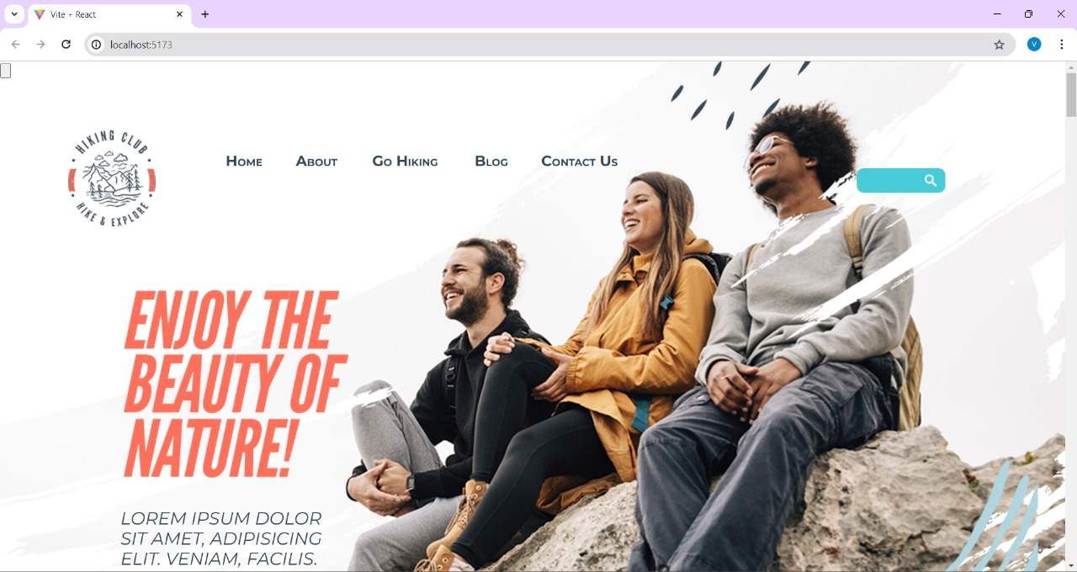

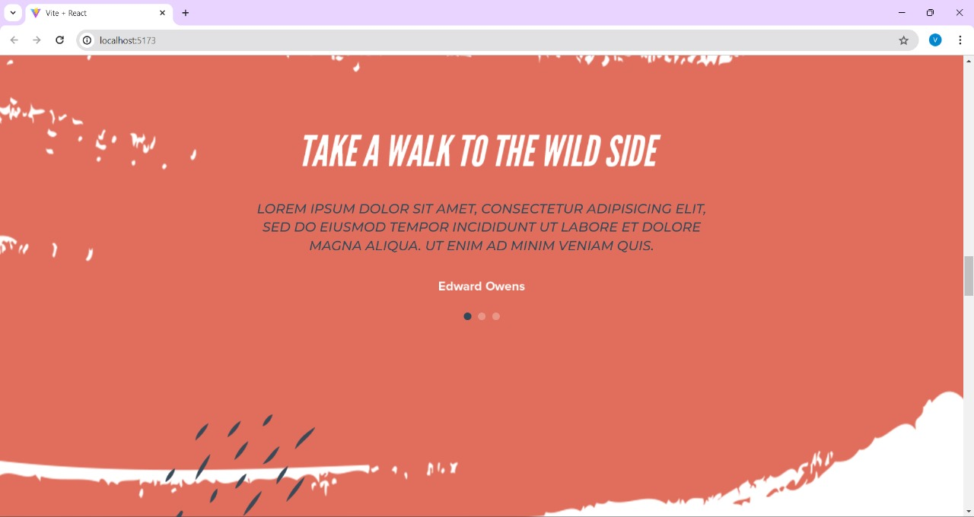

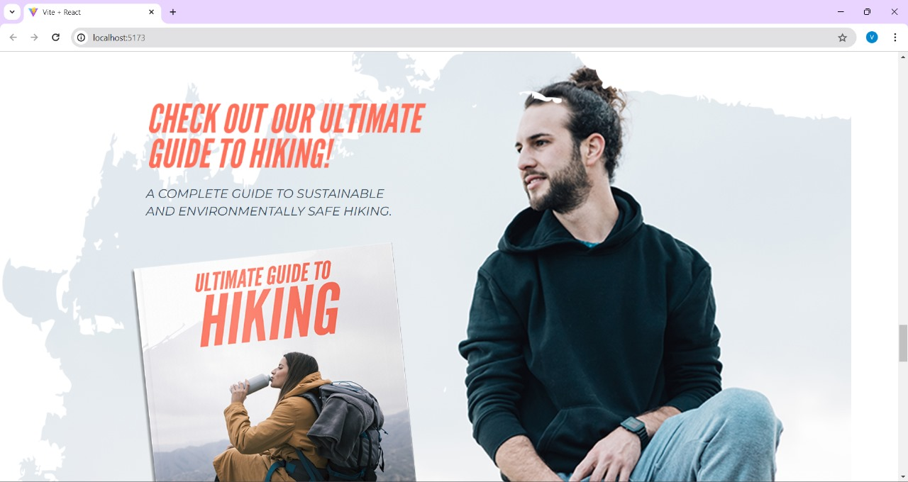

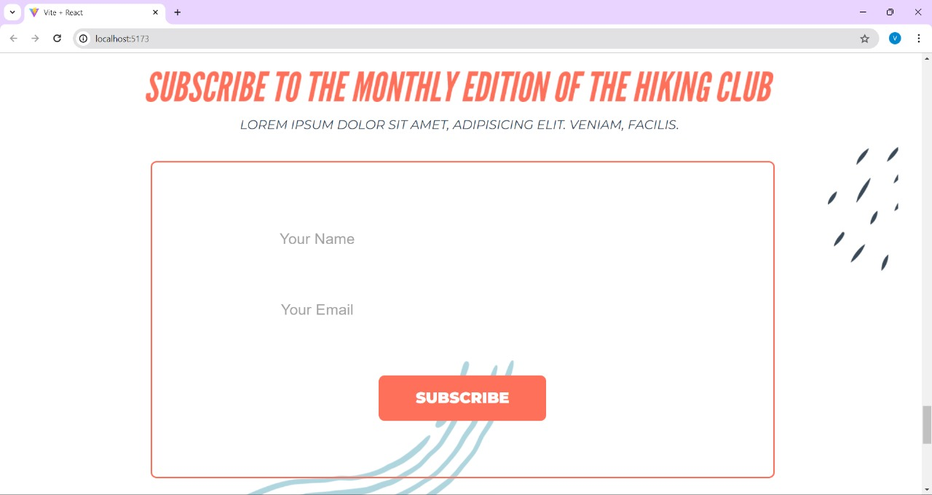

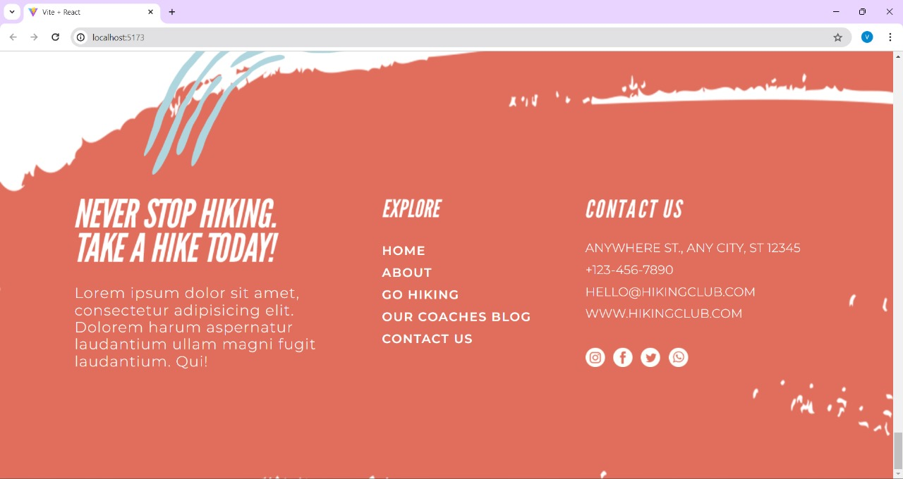

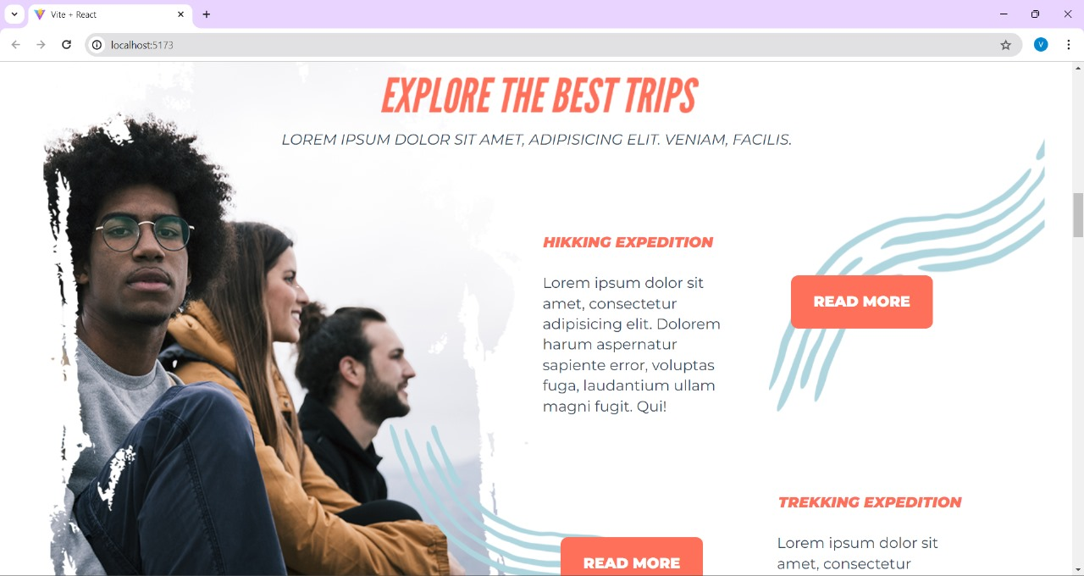

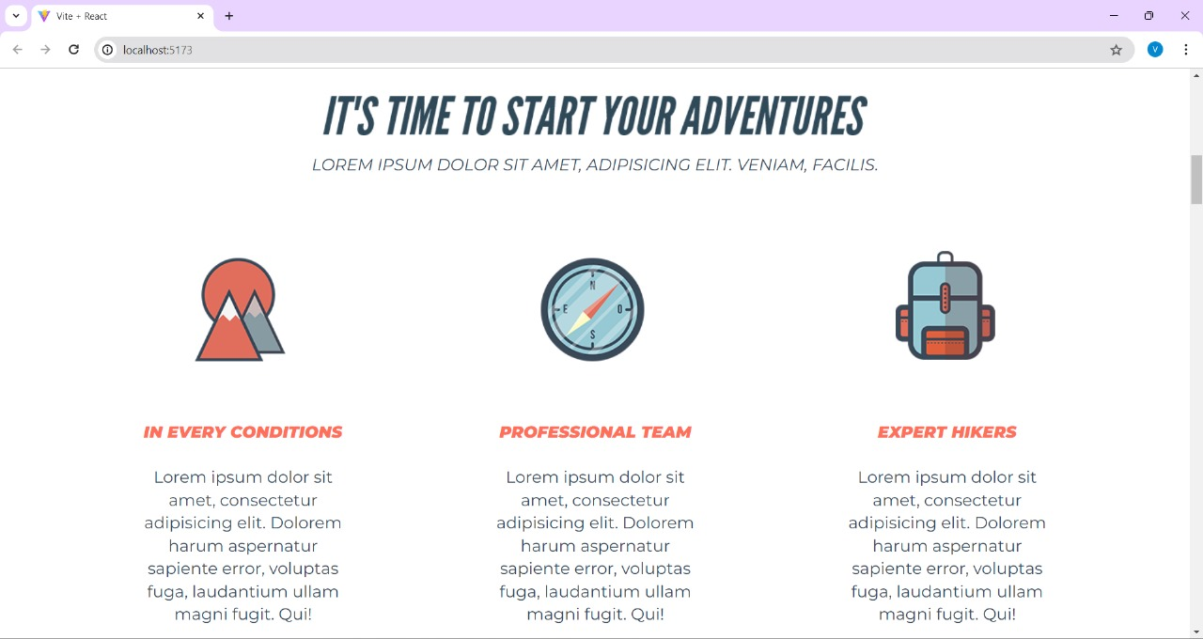

**REFERENCES :**

* ReactJS documentation:

[https://legacy.reactjs.org/docs/getting-started.html]

* Stack Overflow: [https://stackoverflow.com/]