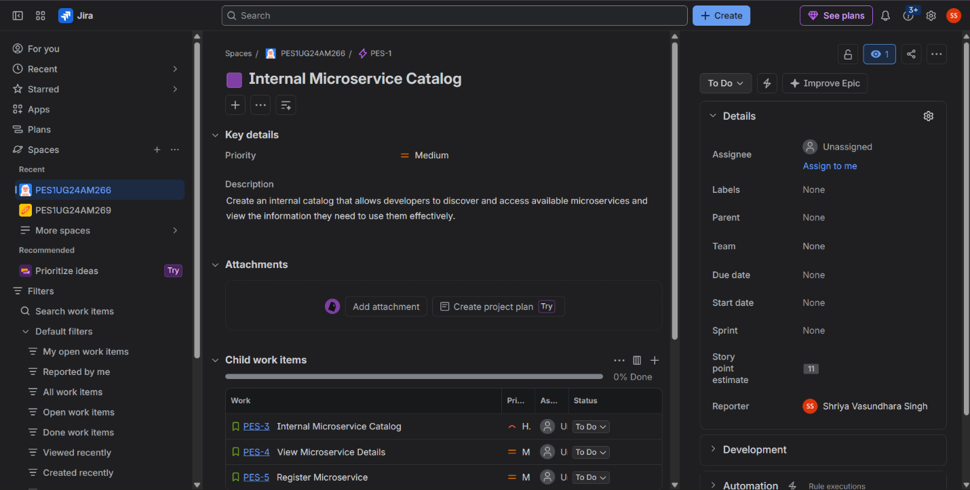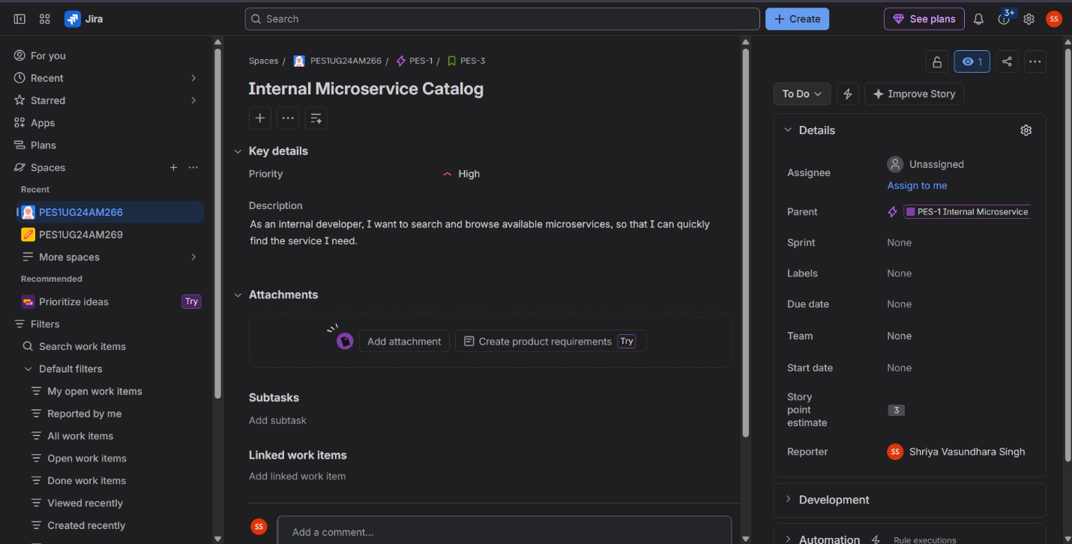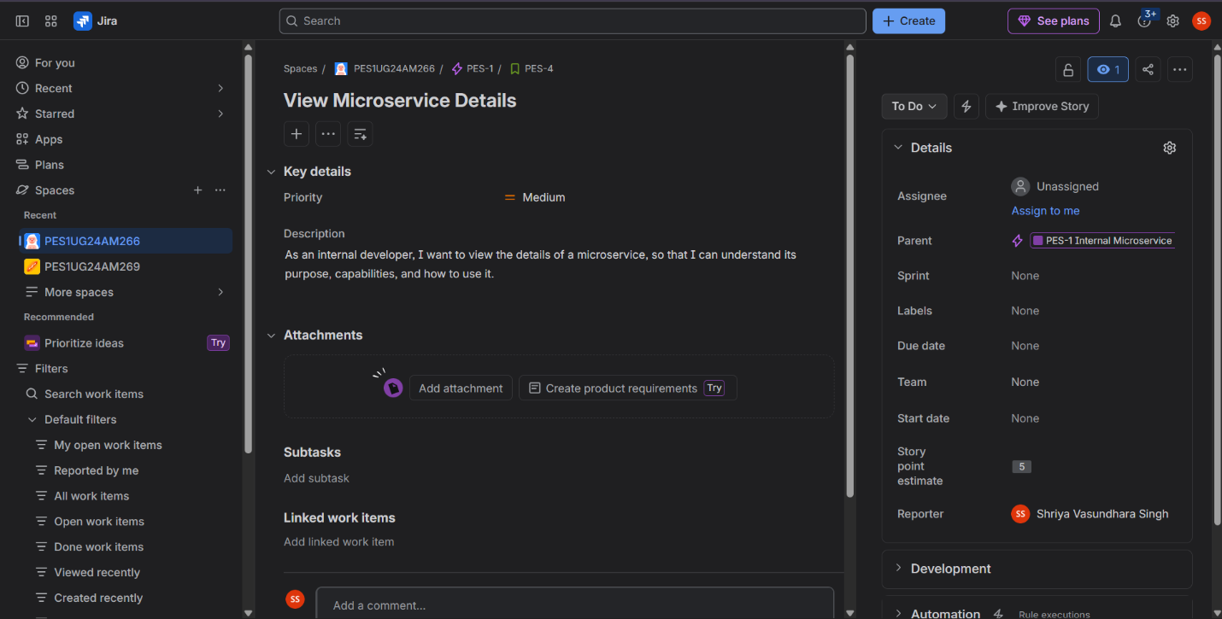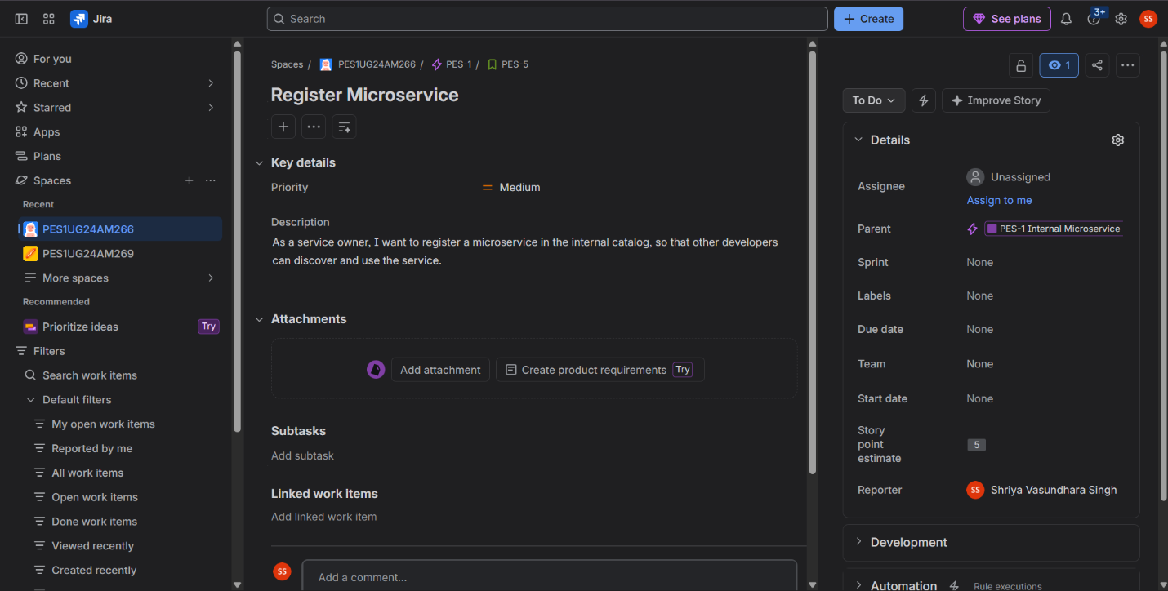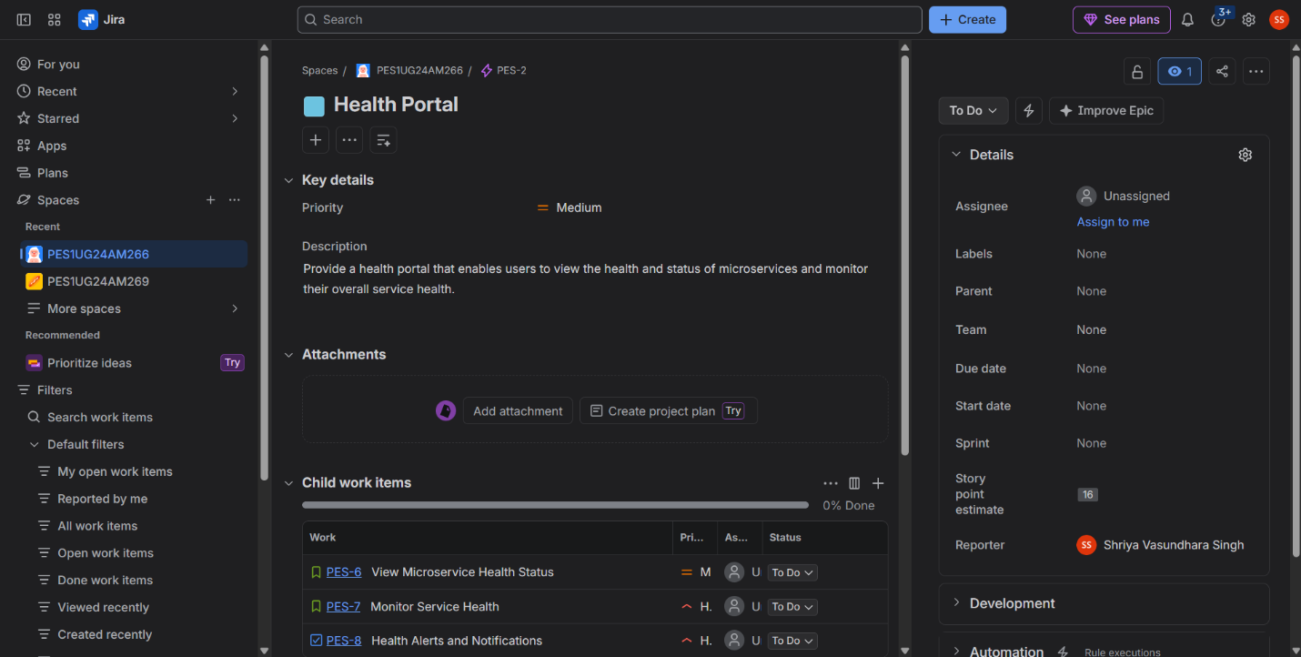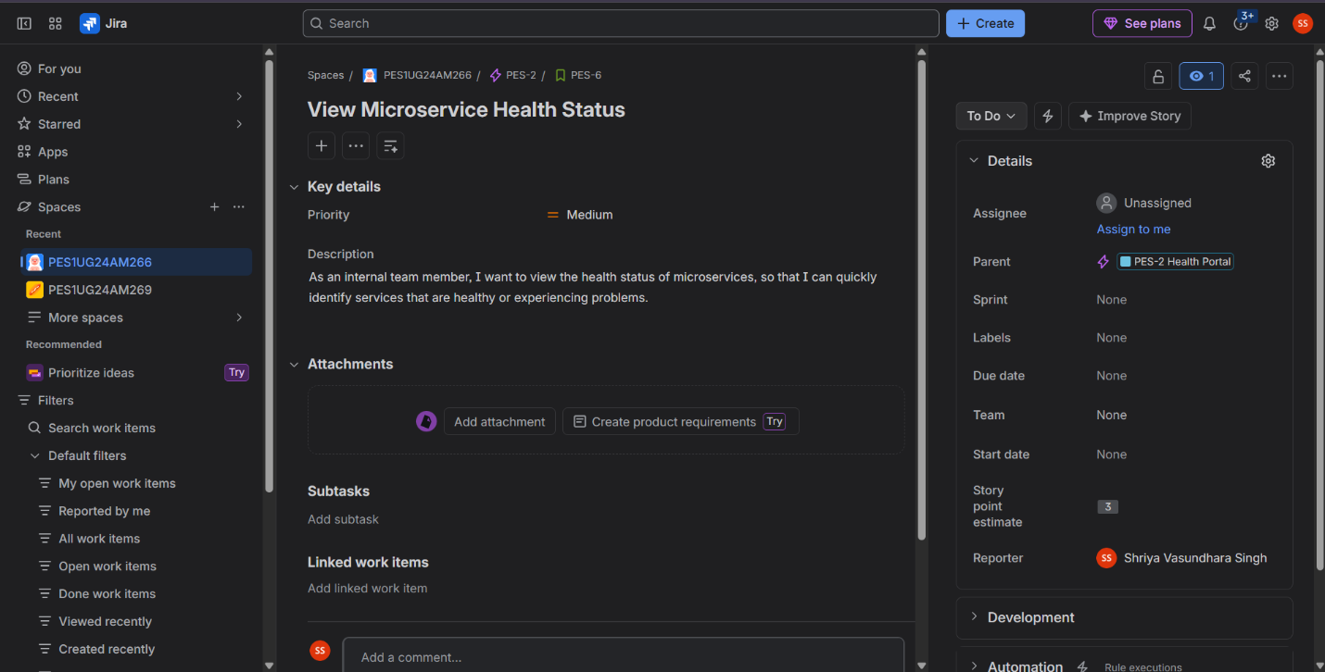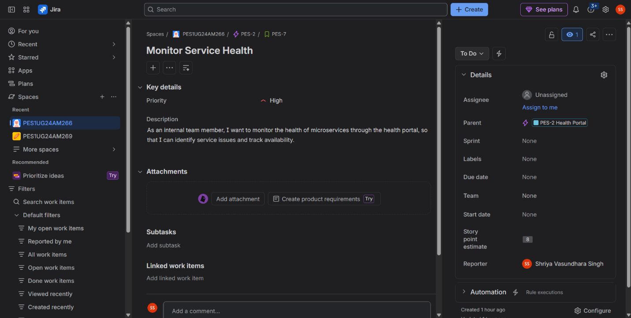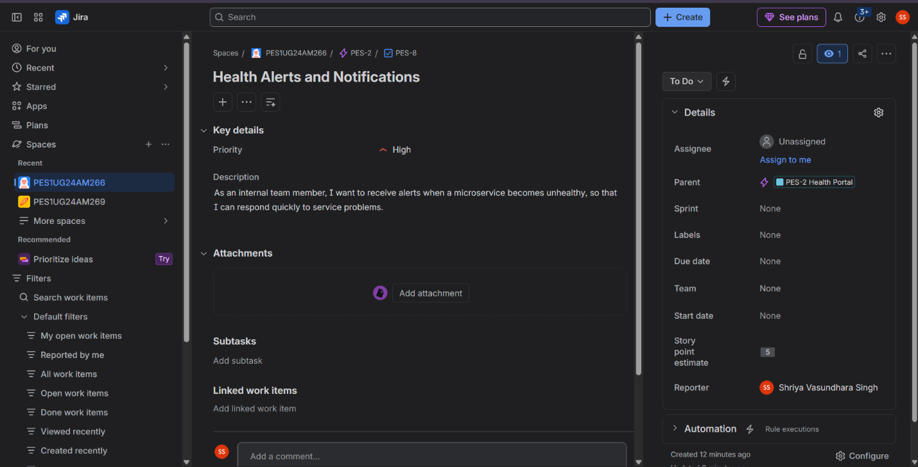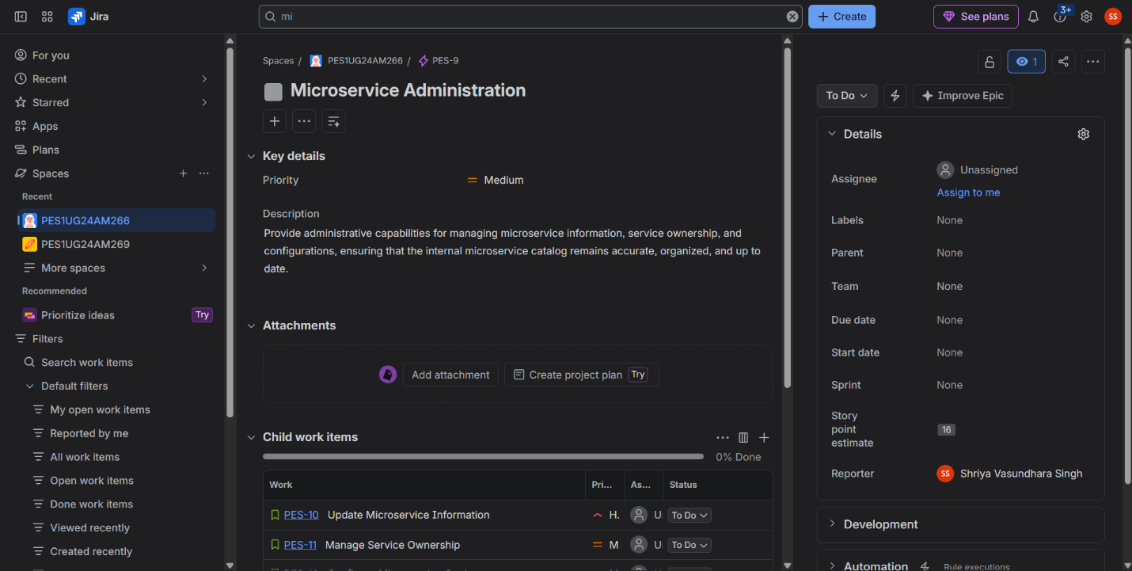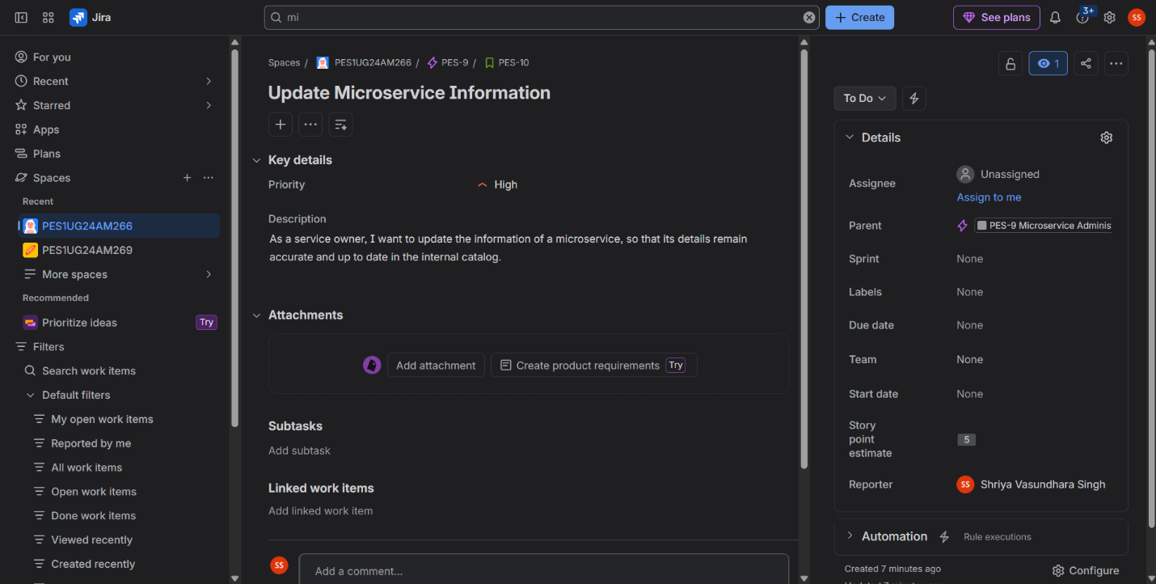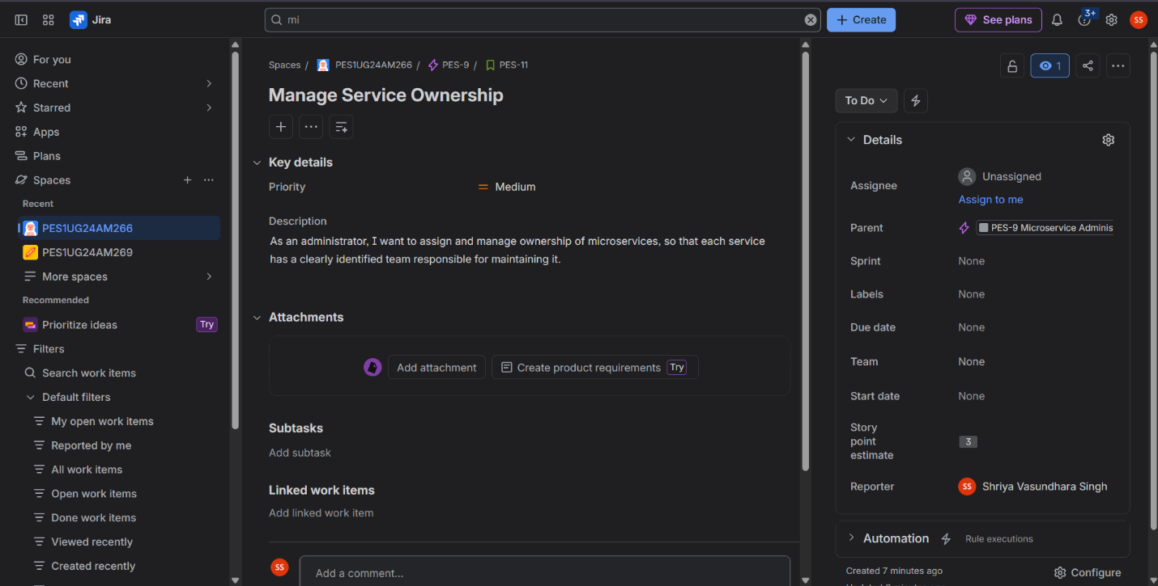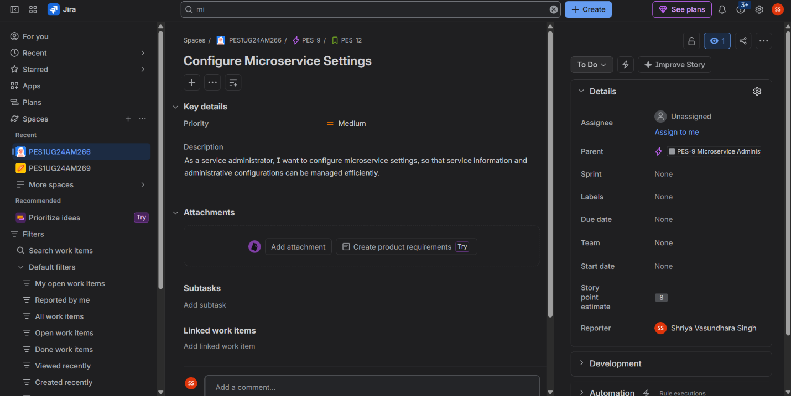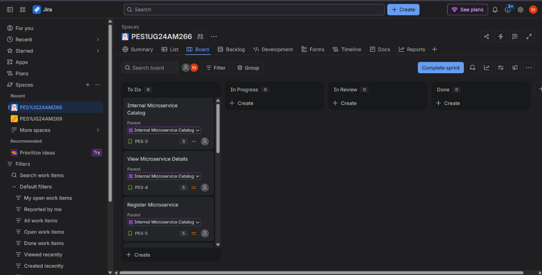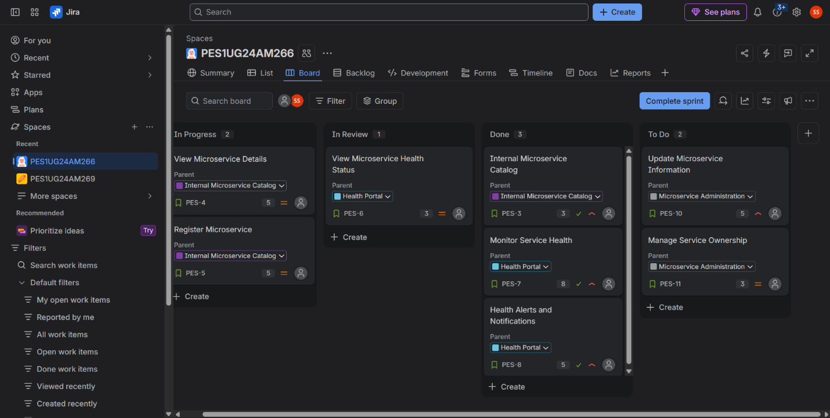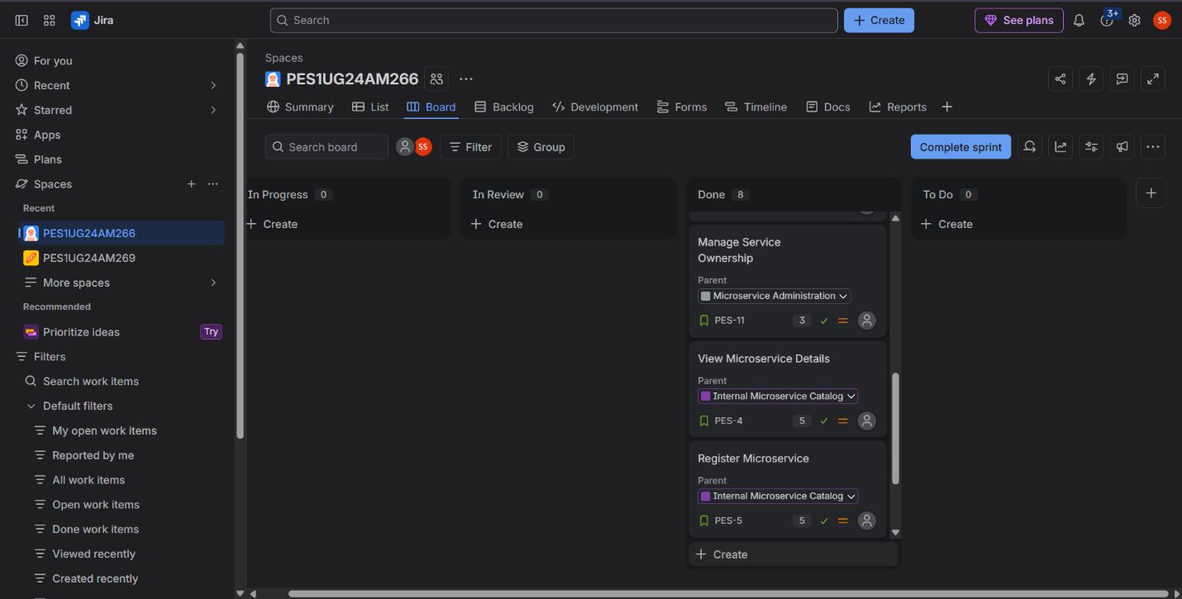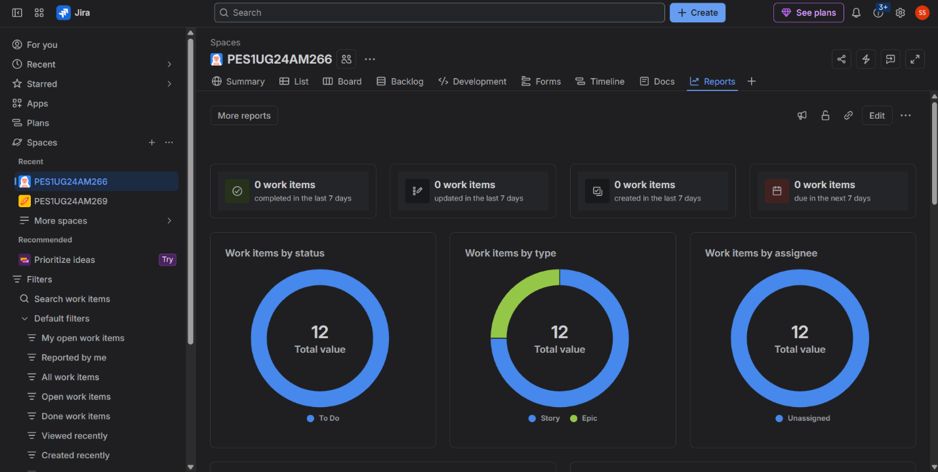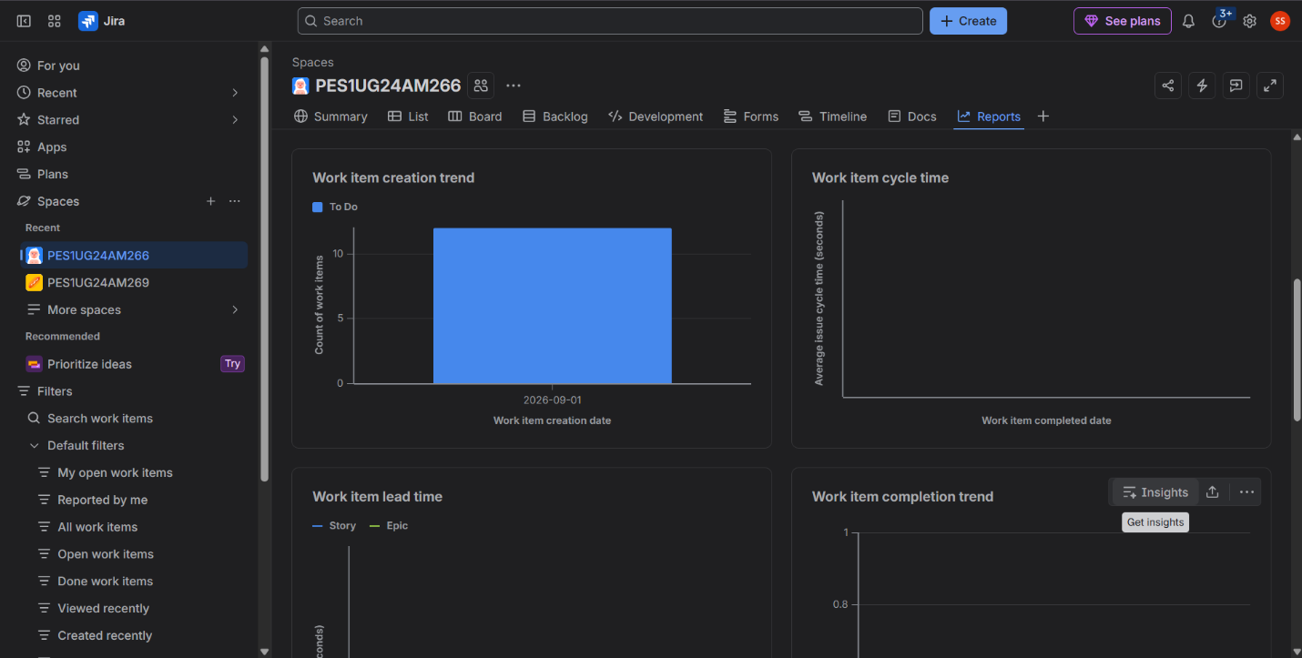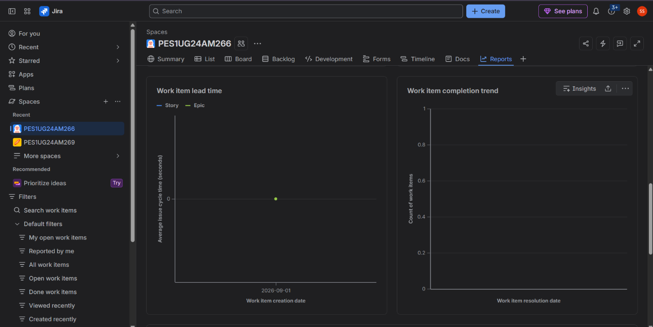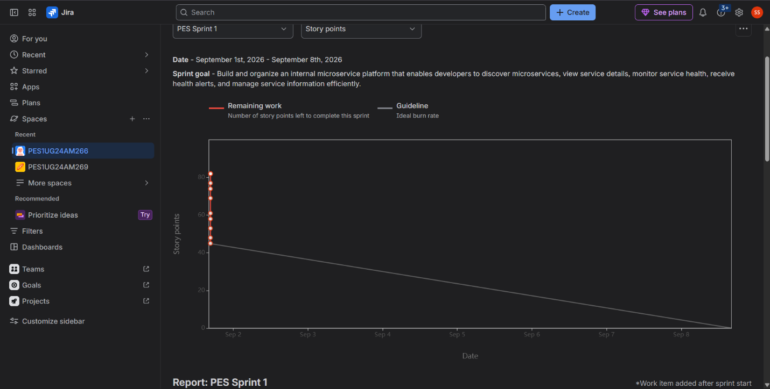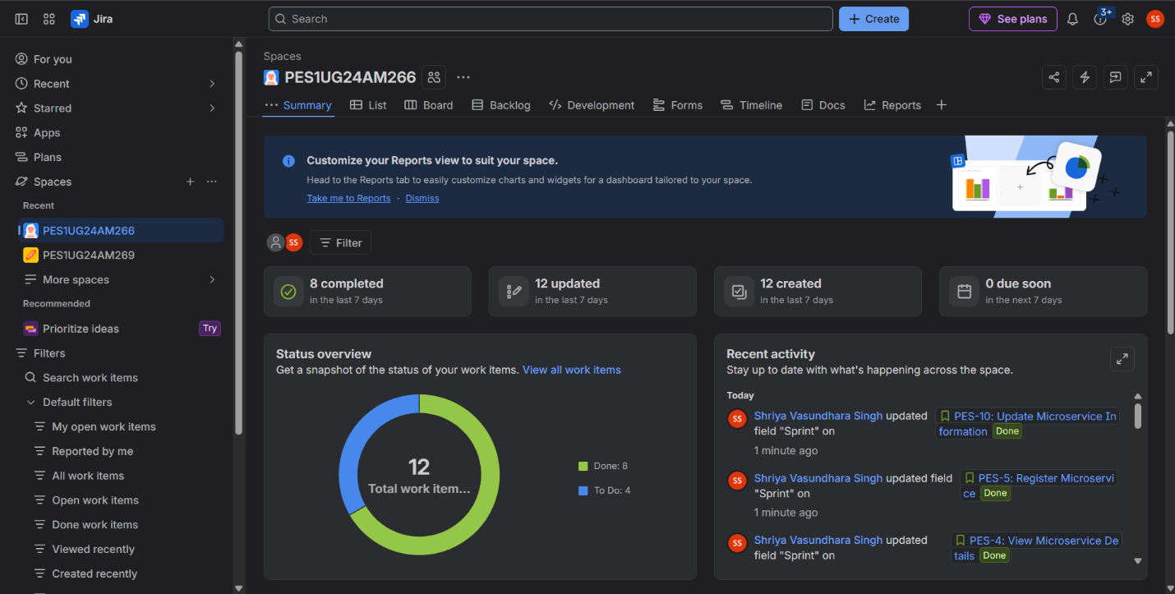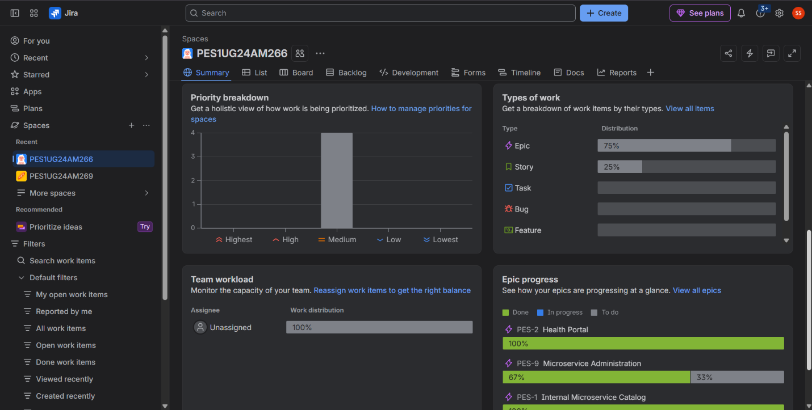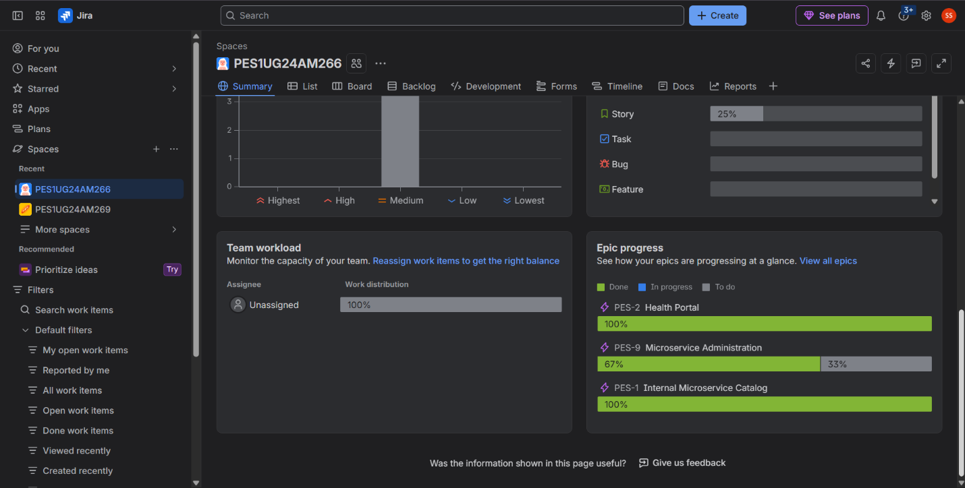
1. Did your estimations reflect the actual effort?
Answer:
Our estimations were reasonably close to the actual effort. The smaller stories were easier to complete, while the more complex stories required more effort. Story points helped us compare the relative difficulty of the work and plan the sprint more effectively. However, some estimates could be improved with more experience.
2. Was your backlog well-prioritized?
Answer:
Yes, our backlog was prioritized according to business value and user needs. We gave higher priority to important features such as microservice discovery, viewing service details, and checking health status. This helped us focus on the most useful functionality first.
3. How did your simulated sprint align with your plan?
Answer:
Our simulated sprint followed the planned workflow. We selected the required stories, assigned story points, and moved the work through To Do → In Progress → Done. The sprint helped us understand how planning and task tracking work in Agile. Completing the stories also showed that the work was organized into manageable tasks.
4. What insights did the burndown chart give about your team’s capacity?
Answer:
The burndown chart showed how much work remained as the sprint progressed. It helped us understand our team's capacity and whether we were completing work at the expected pace. A steady decrease in remaining story points would indicate consistent progress, while a sudden drop or flat line could suggest estimation issues, delays, or uneven work completion.

