**YASHODHA NAIK**

**1NT20IS416**

**C3 BATCH**

**INSERT ONE:**

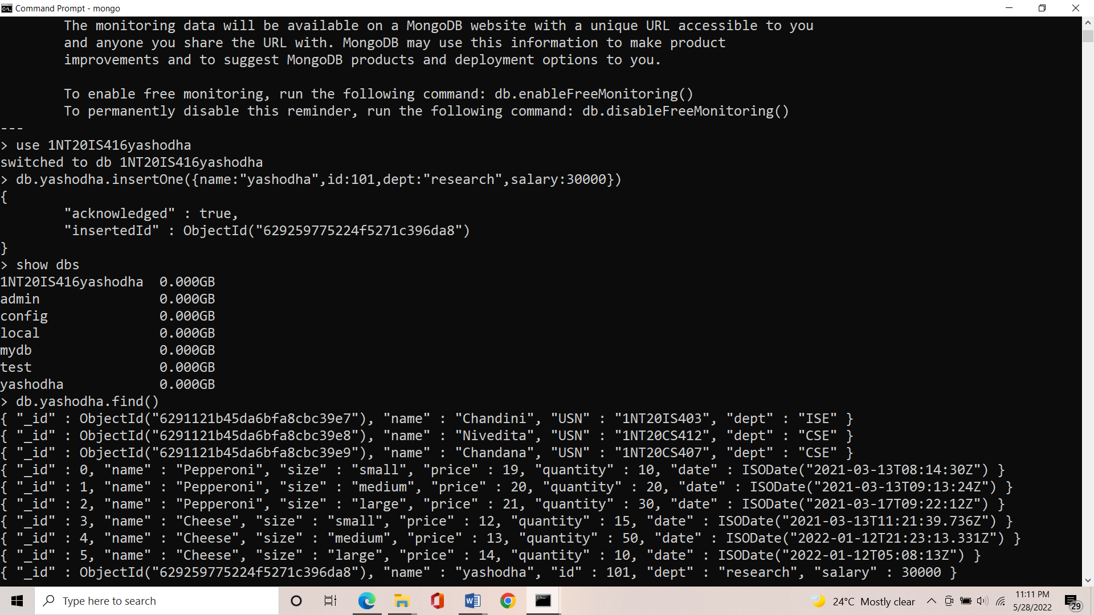

**INSERT MANY:**

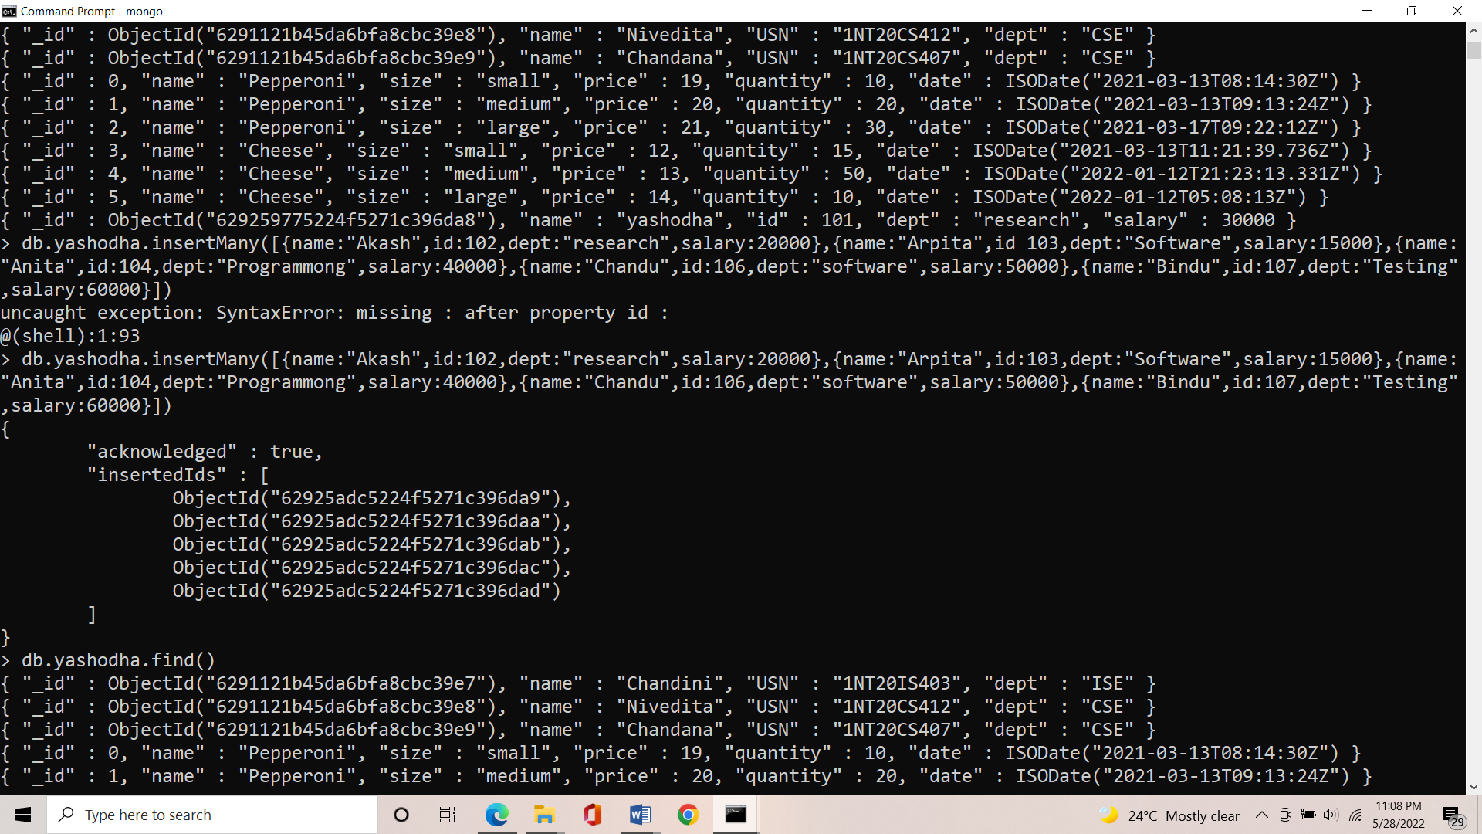

**OUTPUT:**

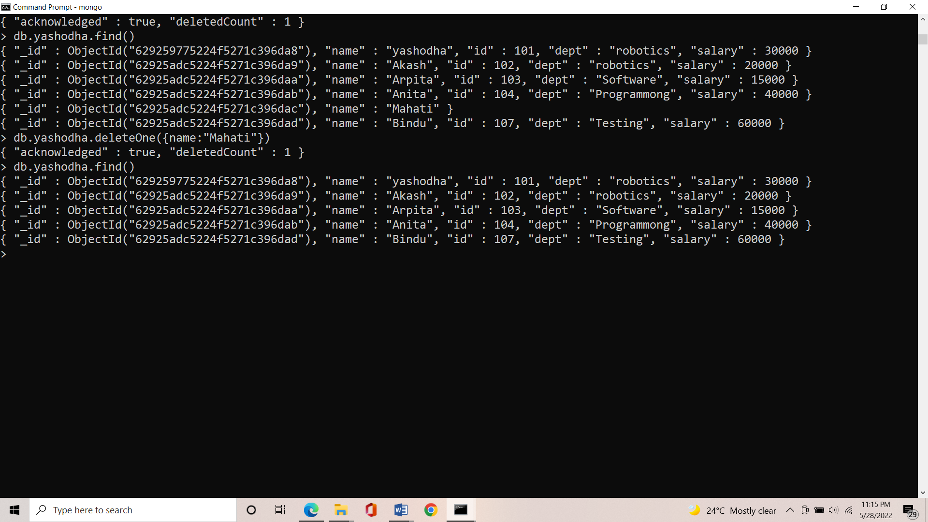

**CRUD OPERATIONS:**

**UPDATE ONE**: Updates only one record at a time.

**SYNTAX**: db.database_name.updateOne

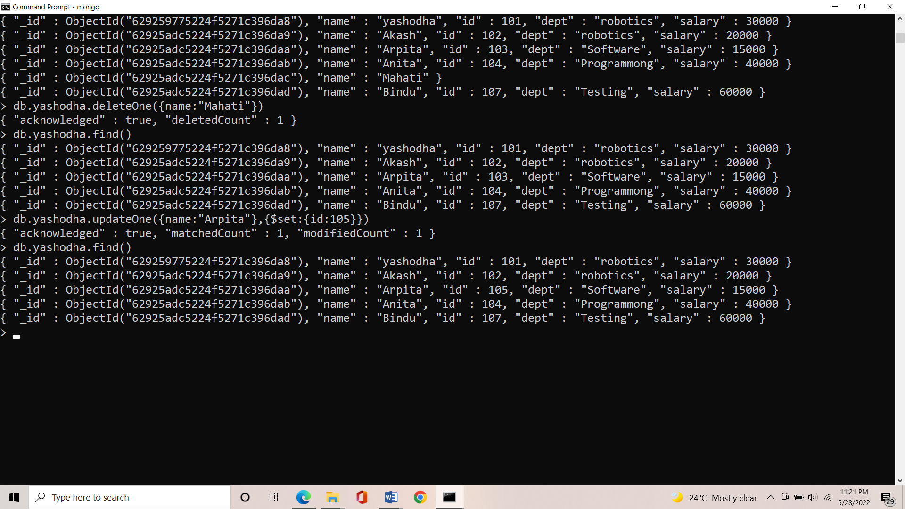

**UPDATE MANY**:Updates only multiple record at a time.

**SYNTAX**: db.database_name.update

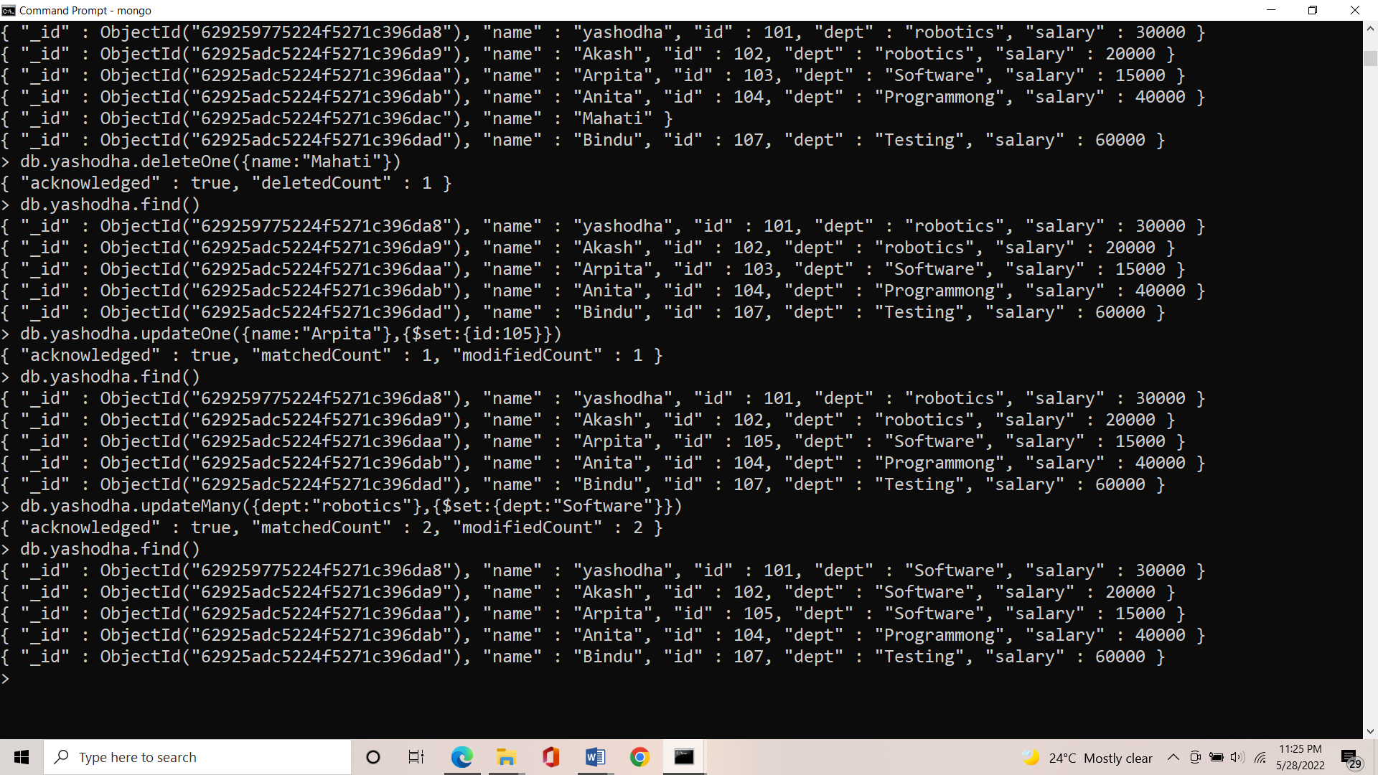

**REPLACE ONE**: Replaces one record with other in a database.

**SYNTAX:** db.database_name.replaceOne

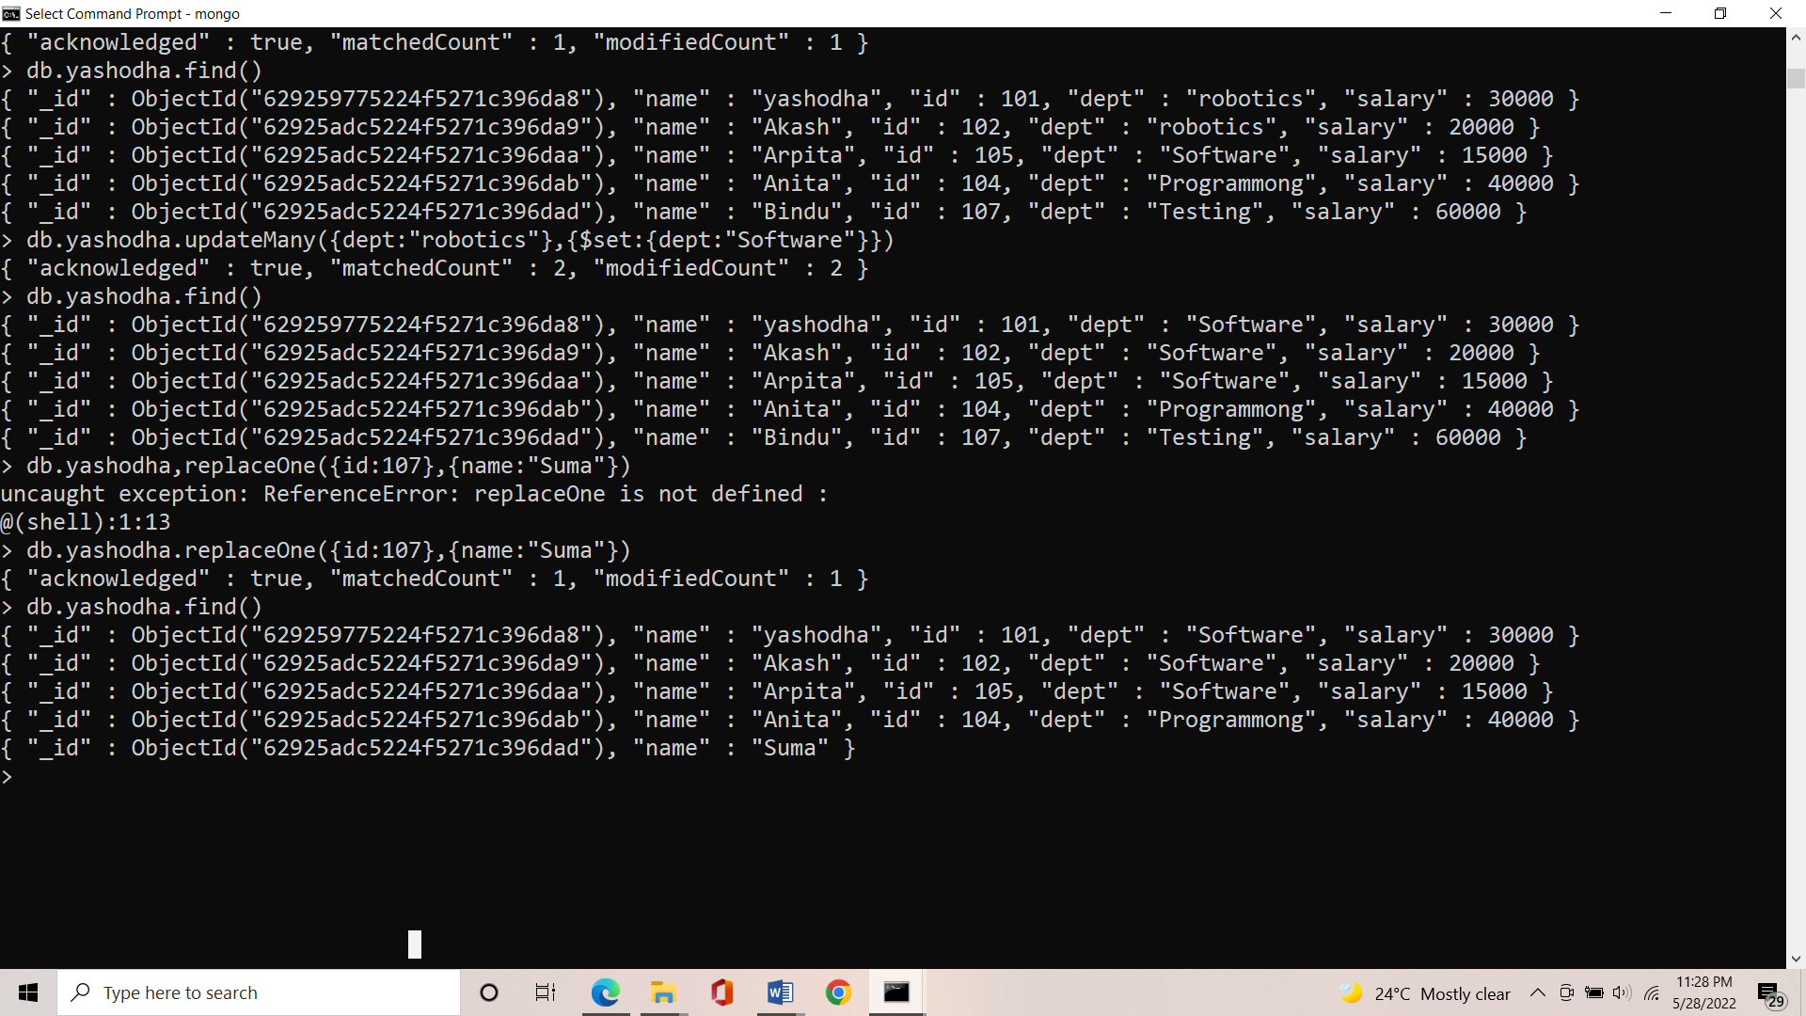

**DELETE ONE:**

**SYNTAX**: db.database_name.deleteOne

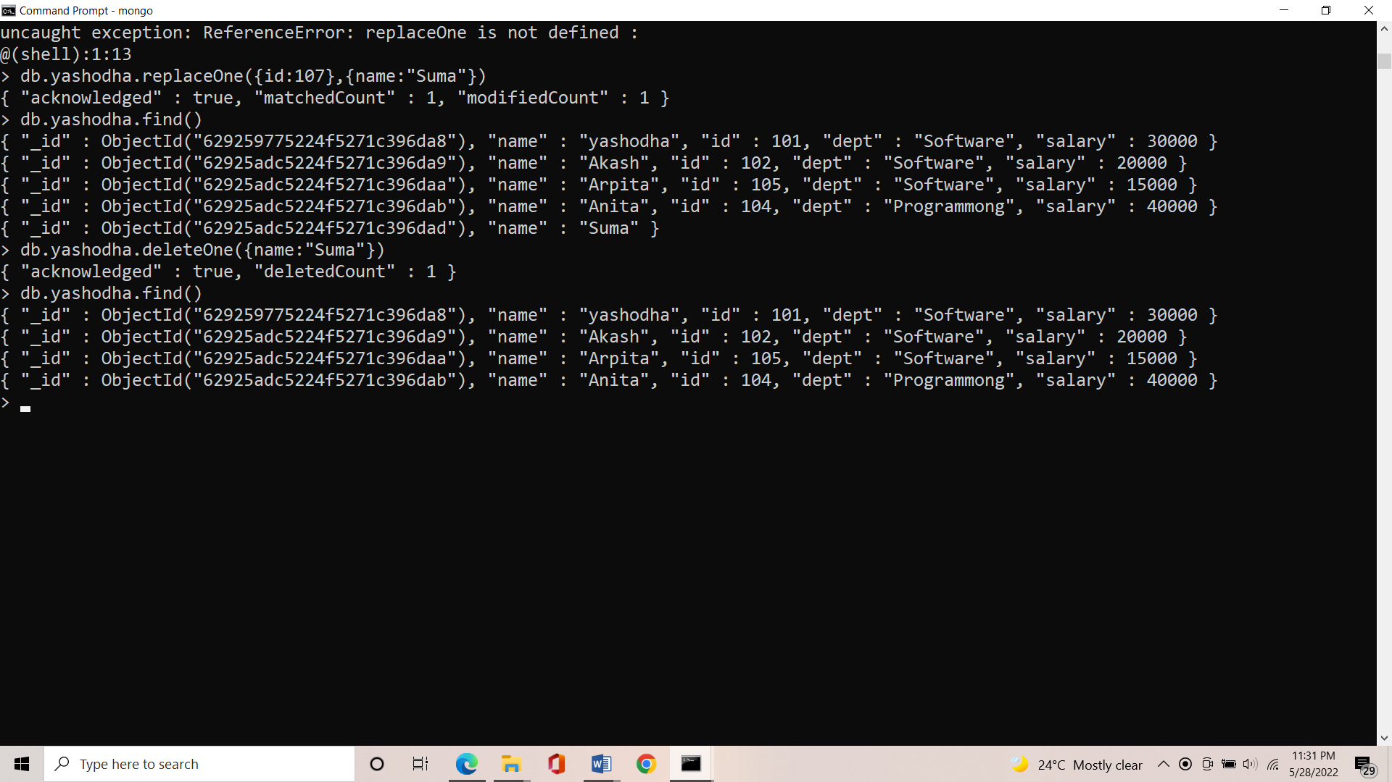

**DELETE MANY**:

**SYNTAX**: db.collection_name followed by deleteMany .

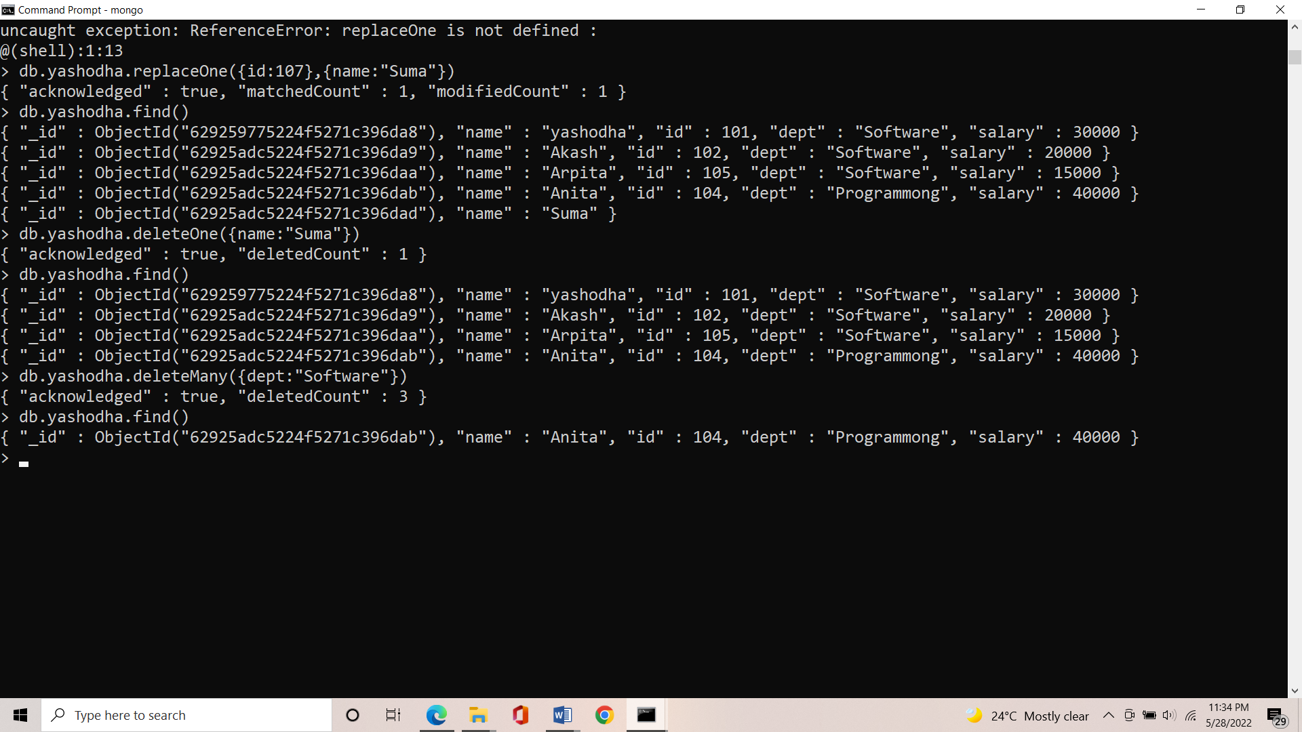

**UNSET:**

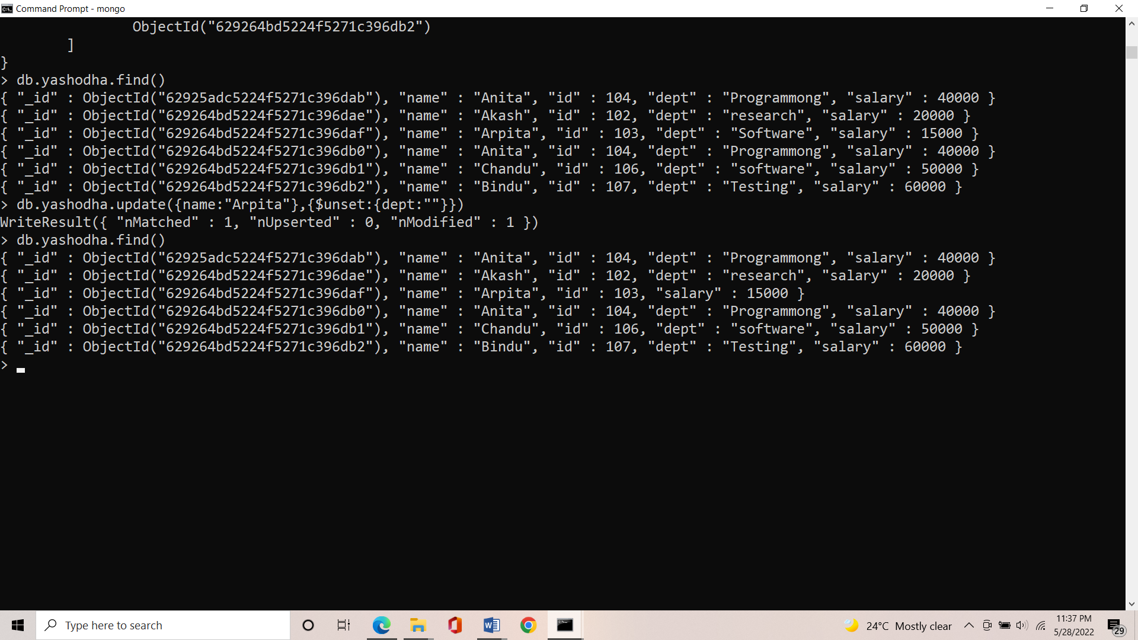

**LOGICAL AND:**

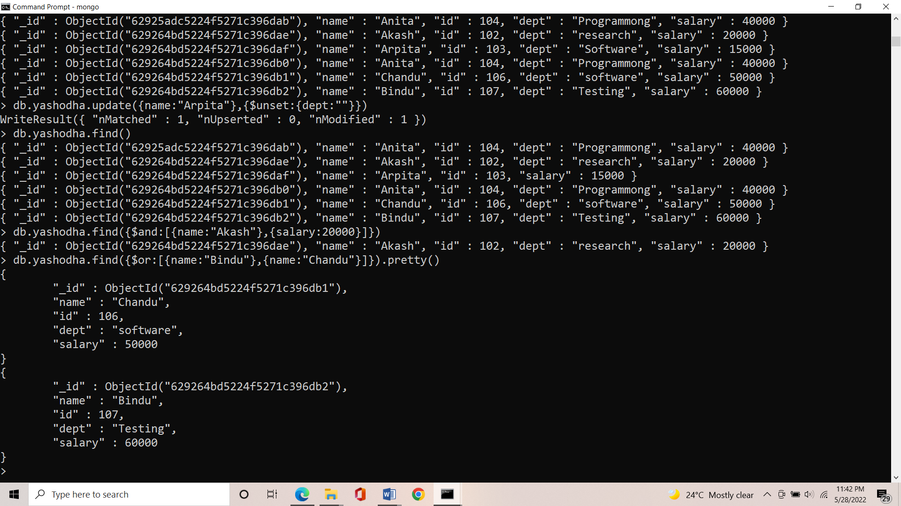

**LOGICAL OR:**

