Name-yashodha Naik
USN-1NT20IS416

HADOOP

Hadoop version

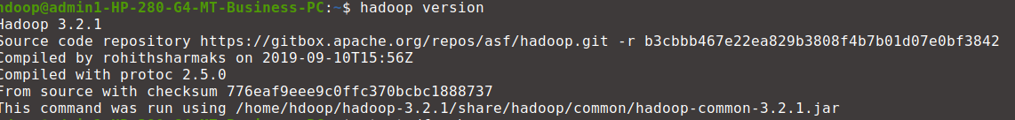
start -dfs.sh
hdoop@admin1-HP-280-G4-MT-Business-PC:~$ start-dfs.sh
Starting namenodes on [localhost]
Starting datanodes
Starting secondary namenodes [admin1-HP-280-G4-MT-Business-PC]
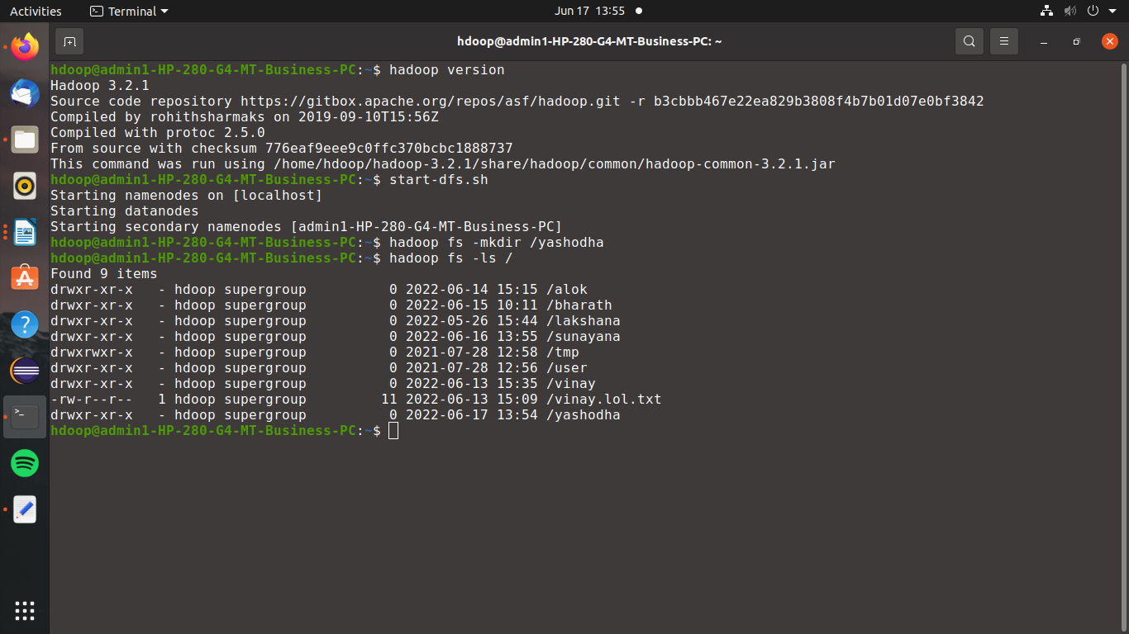

Create a directory named by your name
hdoop@admin1-HP-280-G4-MT-Business-PC:~$ jps
7443 Jps
4727 ResourceManager
4295 DataNode
4154 NameNode
4539 SecondaryNameNode
4877 NodeManager
hdoop@admin1-HP-280-G4-MT-Business-PC:~$ hadoop fs -mkdir yashodha416
mkdir: `yashodha416': File exists
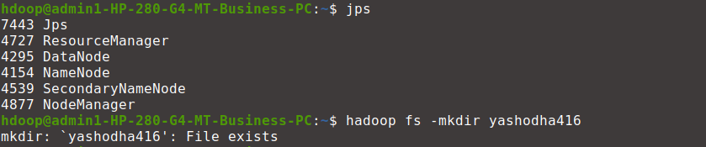
hdoop@admin1-HP-280-G4-MT-Business-PC:~$ hadoop fs-dus

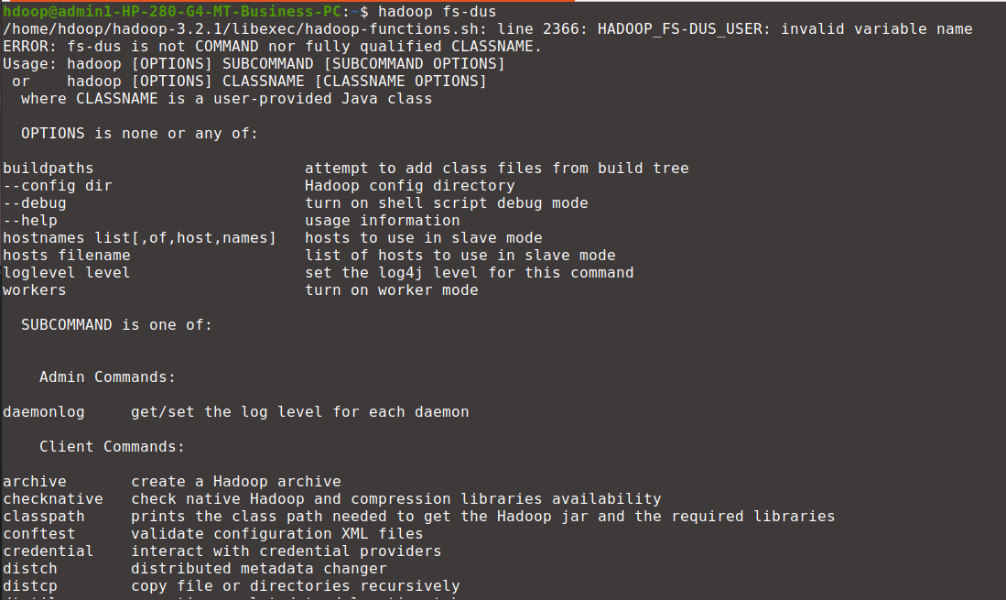
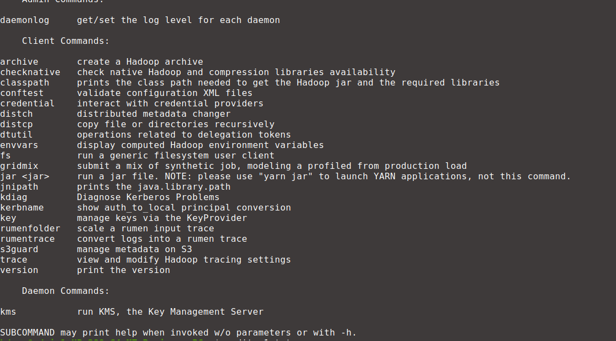

hdoop@admin1-HP-280-G4-MT-Business-PC:~$ gedit a1.txt
hdoop@admin1-HP-280-G4-MT-Business-PC:~$ gedit a2.txt
hdoop@admin1-HP-280-G4-MT-Business-PC:~$ hadoop fs -copyFromLocal a1.txt a2.txt
2022-06-24 14:10:12,279 INFO sasl.SaslDataTransferClient: SASL encryption trust check: localHostTrusted = false, remoteHostTrusted = false
hdoop@admin1-HP-280-G4-MT-Business-PC:~$ hadoop fs -cat a2.txt
2022-06-24 14:12:26,642 INFO sasl.SaslDataTransferClient: SASL encryption trust check: localHostTrusted = false, remoteHostTrusted = false
Hello!!!

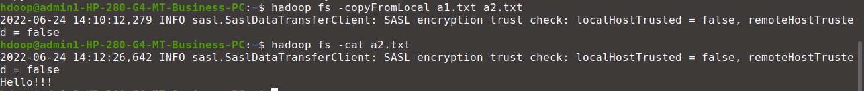
doop@admin1-HP-280-G4-MT-Business-PC:~$ hadoop fs -ls
Found 17 items
drwxr-xr-x - hdoop supergroup 0 2022-06-17 15:05 YashodhaRN
-rw-r--r-- 1 hdoop supergroup 9 2022-06-24 14:10 a2.txt
-rw-r--r-- 1 hdoop supergroup 0 2022-06-15 10:00 bharathj
-rw-r--r-- 1 hdoop supergroup 0 2022-06-17 15:12 dr.txt
-rw-r--r-- 1 hdoop supergroup 0 2022-06-16 09:14 empty.txt
drwxr-xr-x - hdoop supergroup 0 2022-06-15 10:11 jb
-rw-r--r-- 1 hdoop supergroup 0 2022-06-17 14:28 naik.txt
-rw-r--r-- 1 hdoop supergroup 32 2022-06-16 09:55 new.txt
-rw-r--r-- 1 hdoop supergroup 0 2022-06-17 14:26 p.txt
-rw-r--r-- 1 hdoop supergroup 0 2022-06-17 15:06 p1.txt
drwxr-xr-x - hdoop supergroup 0 2022-06-16 09:46 prog2
drwxr-xr-x - hdoop supergroup 0 2022-03-30 11:00 saurabh
drwxr-xr-x - hdoop supergroup 0 2022-05-24 10:20 sonal
-rw-r--r-- 1 hdoop supergroup 19 2022-06-24 10:47 text1.txt
-rw-r--r-- 1 hdoop supergroup 16 2022-05-24 09:36 tt.txt
drwxr-xr-x - hdoop supergroup 0 2022-06-24 13:55 yashodha416
drwxr-xr-x - hdoop supergroup 0 2022-06-17 14:25 yashodhaR
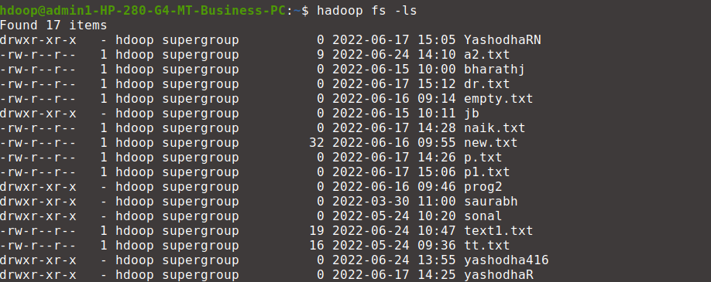

hdoop@admin1-HP-280-G4-MT-Business-PC:~$ hadoop fs -du
0 0 YashodhaRN
9 9 a2.txt
0 0 bharathj
0 0 dr.txt
0 0 empty.txt
0 0 jb
0 0 naik.txt
32 32 new.txt
0 0 p.txt
0 0 p1.txt
32 32 prog2
0 0 saurabh
22 22 sonal
19 19 text1.txt
16 16 tt.txt
0 0 yashodha416
0 0 yashodhaR

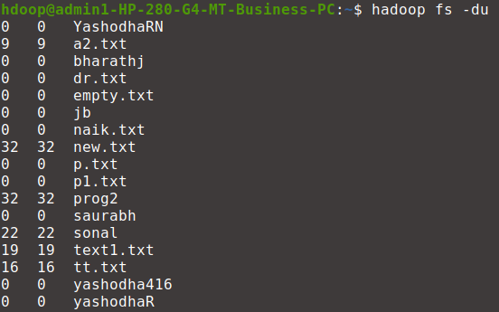

hdoop@admin1-HP-280-G4-MT-Business-PC:~$ hadoop fs -ls
Found 17 items
drwxr-xr-x - hdoop supergroup 0 2022-06-17 15:05 YashodhaRN
-rw-r--r-- 1 hdoop supergroup 9 2022-06-24 14:10 a2.txt
-rw-r--r-- 1 hdoop supergroup 0 2022-06-15 10:00 bharathj
-rw-r--r-- 1 hdoop supergroup 0 2022-06-17 15:12 dr.txt
-rw-r--r-- 1 hdoop supergroup 0 2022-06-16 09:14 empty.txt
drwxr-xr-x - hdoop supergroup 0 2022-06-15 10:11 jb
-rw-r--r-- 1 hdoop supergroup 0 2022-06-17 14:28 naik.txt
-rw-r--r-- 1 hdoop supergroup 32 2022-06-16 09:55 new.txt
-rw-r--r-- 1 hdoop supergroup 0 2022-06-17 14:26 p.txt
-rw-r--r-- 1 hdoop supergroup 0 2022-06-17 15:06 p1.txt
drwxr-xr-x - hdoop supergroup 0 2022-06-16 09:46 prog2
drwxr-xr-x - hdoop supergroup 0 2022-03-30 11:00 saurabh
drwxr-xr-x - hdoop supergroup 0 2022-05-24 10:20 sonal
-rw-r--r-- 1 hdoop supergroup 19 2022-06-24 10:47 text1.txt
-rw-r--r-- 1 hdoop supergroup 16 2022-05-24 09:36 tt.txt
drwxr-xr-x - hdoop supergroup 0 2022-06-24 13:55 yashodha416
drwxr-xr-x - hdoop supergroup 0 2022-06-17 14:25 yashodhaR
hdoop@admin1-HP-280-G4-MT-Business-PC:~$ hadoop fs -rm a2.txt
Deleted a2.txt

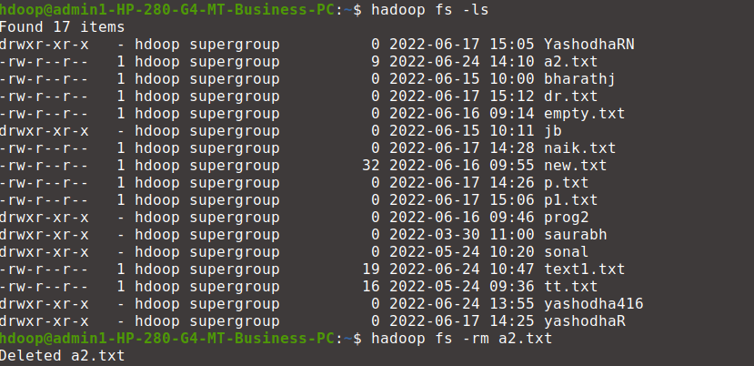

hdoop@admin1-HP-280-G4-MT-Business-PC:~$ hadoop fs -ls
Found 16 items
drwxr-xr-x - hdoop supergroup 0 2022-06-17 15:05 YashodhaRN
-rw-r--r-- 1 hdoop supergroup 0 2022-06-15 10:00 bharathj
-rw-r--r-- 1 hdoop supergroup 0 2022-06-17 15:12 dr.txt
-rw-r--r-- 1 hdoop supergroup 0 2022-06-16 09:14 empty.txt
drwxr-xr-x - hdoop supergroup 0 2022-06-15 10:11 jb
-rw-r--r-- 1 hdoop supergroup 0 2022-06-17 14:28 naik.txt
-rw-r--r-- 1 hdoop supergroup 32 2022-06-16 09:55 new.txt
-rw-r--r-- 1 hdoop supergroup 0 2022-06-17 14:26 p.txt
-rw-r--r-- 1 hdoop supergroup 0 2022-06-17 15:06 p1.txt
drwxr-xr-x - hdoop supergroup 0 2022-06-16 09:46 prog2
drwxr-xr-x - hdoop supergroup 0 2022-03-30 11:00 saurabh
drwxr-xr-x - hdoop supergroup 0 2022-05-24 10:20 sonal
-rw-r--r-- 1 hdoop supergroup 19 2022-06-24 10:47 text1.txt
-rw-r--r-- 1 hdoop supergroup 16 2022-05-24 09:36 tt.txt
drwxr-xr-x - hdoop supergroup 0 2022-06-24 13:55 yashodha416
drwxr-xr-x - hdoop supergroup 0 2022-06-17 14:25 yashodhaR

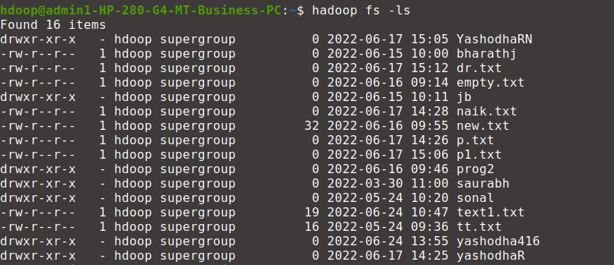
hdoop@admin1-HP-280-G4-MT-Business-PC:~$ hadoop fs -start yashodha416

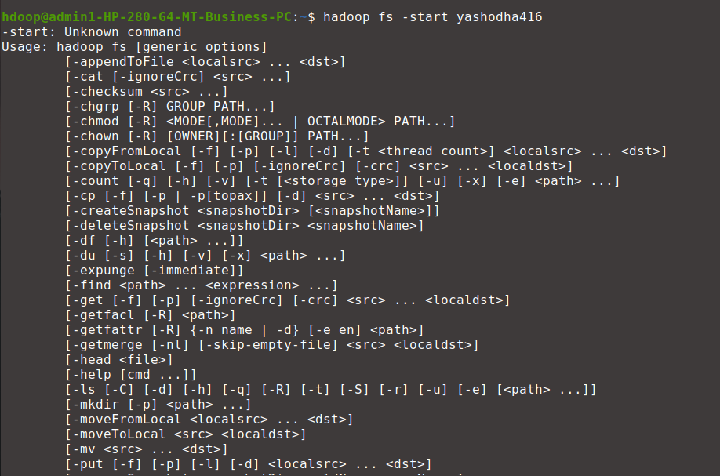

hdoop@admin1-HP-280-G4-MT-Business-PC:~$ hadoop fs -ls
Found 16 items
drwxr-xr-x - hdoop supergroup 0 2022-06-17 15:05 YashodhaRN
-rw-r--r-- 1 hdoop supergroup 0 2022-06-15 10:00 bharathj
-rw-r--r-- 1 hdoop supergroup 0 2022-06-17 15:12 dr.txt
-rw-r--r-- 1 hdoop supergroup 0 2022-06-16 09:14 empty.txt
drwxr-xr-x - hdoop supergroup 0 2022-06-15 10:11 jb
-rw-r--r-- 1 hdoop supergroup 0 2022-06-17 14:28 naik.txt
-rw-r--r-- 1 hdoop supergroup 32 2022-06-16 09:55 new.txt
-rw-r--r-- 1 hdoop supergroup 0 2022-06-17 14:26 p.txt
-rw-r--r-- 1 hdoop supergroup 0 2022-06-17 15:06 p1.txt
drwxr-xr-x - hdoop supergroup 0 2022-06-16 09:46 prog2
drwxr-xr-x - hdoop supergroup 0 2022-03-30 11:00 saurabh
drwxr-xr-x - hdoop supergroup 0 2022-05-24 10:20 sonal
-rw-r--r-- 1 hdoop supergroup 19 2022-06-24 10:47 text1.txt
-rw-r--r-- 1 hdoop supergroup 16 2022-05-24 09:36 tt.txt
drwxr-xr-x - hdoop supergroup 0 2022-06-24 13:55 yashodha416
drwxr-xr-x - hdoop supergroup 0 2022-06-17 14:25 yashodhaR
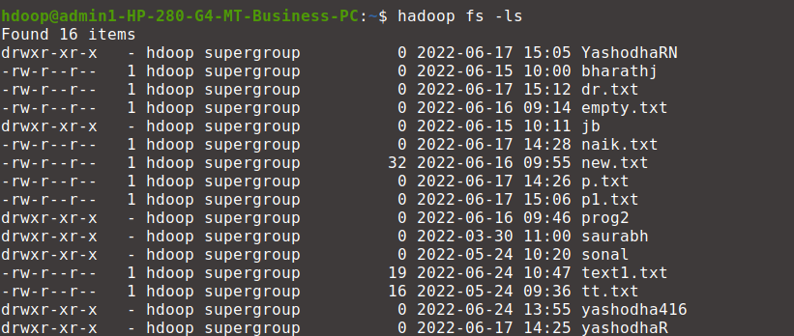

hdoop@admin1-HP-280-G4-MT-Business-PC:~$ hadoop fs -mv naik.txt yashodha416
hdoop@admin1-HP-280-G4-MT-Business-PC:~$ hadoop fs -ls

Found 15 items
drwxr-xr-x - hdoop supergroup 0 2022-06-17 15:05 YashodhaRN
-rw-r--r-- 1 hdoop supergroup 0 2022-06-15 10:00 bharathj
-rw-r--r-- 1 hdoop supergroup 0 2022-06-17 15:12 dr.txt
-rw-r--r-- 1 hdoop supergroup 0 2022-06-16 09:14 empty.txt
drwxr-xr-x - hdoop supergroup 0 2022-06-15 10:11 jb
-rw-r--r-- 1 hdoop supergroup 32 2022-06-16 09:55 new.txt
-rw-r--r-- 1 hdoop supergroup 0 2022-06-17 14:26 p.txt
-rw-r--r-- 1 hdoop supergroup 0 2022-06-17 15:06 p1.txt
drwxr-xr-x - hdoop supergroup 0 2022-06-16 09:46 prog2
drwxr-xr-x - hdoop supergroup 0 2022-03-30 11:00 saurabh
drwxr-xr-x - hdoop supergroup 0 2022-05-24 10:20 sonal
-rw-r--r-- 1 hdoop supergroup 19 2022-06-24 10:47 text1.txt
-rw-r--r-- 1 hdoop supergroup 16 2022-05-24 09:36 tt.txt
drwxr-xr-x - hdoop supergroup 0 2022-06-24 14:23 yashodha416
drwxr-xr-x - hdoop supergroup 0 2022-06-17 14:25 yashodhaR

