**YASHODHA NAIK**

**1NT20IS416**

**C3 BATCH**

**PIPELINE AGGREGATE FUNCTIONS**

db.yashodha.aggregate([{$match:{name:"Chandu"}},{$group:{_id:"$name",count:{$count:{}}}},{$sort:{count:1}},{$limit:1}])

{ "_id" : "Chandu", "count" : 1 }

> db.yashodha.aggregate([{$group:{_id:"$name",count:{$count:{}}}},{$sort:{count:1}},{$limit:1}])

{ "_id" : "Bindu", "count" : 1 }

> db.yashodha.aggregate([{$group:{_id:"$name",count:{$count:{}}}},{$sort:{count:1}},{$limit:4}])

{ "_id" : "Akash", "count" : 1 }

{ "_id" : "Bindu", "count" : 1 }

{ "_id" : "Arpita", "count" : 1 }

{ "_id" : "Chandu", "count" : 1 }

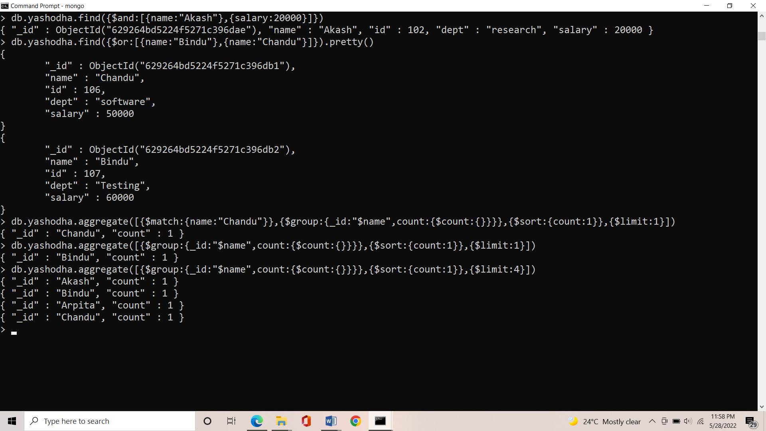

**$MATCH :**

db.yashodha.aggregate({$match:{$and:[{salary:{$eq:40000}},{dept:{$eq:"Programmong"}}]}})

{ "_id" : ObjectId("62925adc5224f5271c396dab"), "name" : "Anita", "id" : 104, "dept" : "Programmong", "salary" : 40000 }

{ "_id" : ObjectId("629264bd5224f5271c396db0"), "name" : "Anita", "id" : 104, "dept" : "Programmong", "salary" : 40000 }

>

