Name: T H LAKSHANA
USN :1NT19IS174
Exercise 1

1) Populate the database with atleast 15 documents
db.emp_laks.insert({"fname":"tangatur","mname":"hariprasad","lname":"lakshana","age":20,"salary":10000,"designation":"professor","role":"team lead"});
db.emp_laks.insert({"fname":"rajesh","mname":"M","lname":"greeshma","age":30,"salary":20000,"designation":"scientist","role":"manager"});
db.emp_laks.insert({"fname":"T","mname":"H","lname":"lavanya","age":20,"salary":30000,"designation":"analyst","role":"software developer"});
db.emp_laks.insert({"fname":"T","mname":"H","lname":"hari","age":20,"salary":40000,"designation":"senior analyst","role":"UI UX developer"});
db.emp_laks.insert({"fname":"T","mname":"kumar","lname":"shashank","age":40,"salary":50000,"designation":"assiociate engineer","role":"tester"});
db.emp_laks.insert({"fname":"T","mname":"karan","lname":"mayank","age":50,"salary":60000,"designation":"engineer","role":"manager"});
db.emp_laks.insert({"fname":"T","mname":"H","lname":"shwetha","age":55,"salary":45000,"designation":"software engineer","role":"tester"});
db.emp_laks.insert({"fname":"T","mname":"H","lname":"madhuri","age":30,"salary":35000,"designation":"software engineer","role":"team lead"});
db.emp_laks.insert({"fname":"rajesh","mname":"H","lname":"madhuri","age":20,"salary":25000,"designation":"scientist","role":"tester"});
db.emp_laks.insert({"fname":"T","mname":"H","lname":"rita","age":65,"salary":45000,"designation":"analyst","role":"manager"});
WriteResult({ "nInserted" : 1 })
db.emp_laks.insert({"fname":"T","mname":"H","lname":"rita","age":65,"salary":45000,"designation":"analyst","role":"manager"});
WriteResult({ "nInserted" : 1 })
db.emp_laks.insert({"fname":"T","mname":"H","lname":"Mita","age":40,"salary":15000,"designation":"analyst","role":"UI UX DEVELOPER"});
db.emp_laks.insert({"fname":"T","mname":"H","lname":"Sita","age":40,"salary":15000,"designation":"analyst","role":"UI UX DEVELOPER"});
db.emp_laks.insert({"fname":"T","mname":"H","lname":"Gita","age":40,"salary":15000,"designation":"analyst","role":"UI UX DEVELOPER"});

2)List all the records having salary in the range of 20000 - 35000(Exclusive)
db.emp_laks.find({"$and":[{"salary":{$gt:20000}},{"salary":{$lt:30000}}]}).pretty();
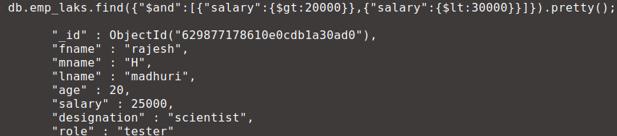

3) List all the Employee whose Middle name is "Kumar"

db.emp_laks.find({"mname":"kumar"}).pretty();
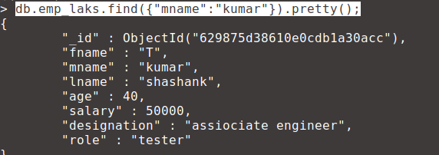

4) Count the number of Employees who has a role "Manager" in the Role

db.emp_laks.aggregate([{$match:{"role":"manager"}},{$count:"No of employees who are managers"}]);

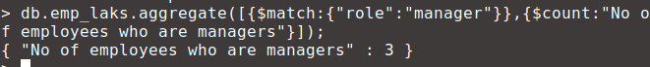
5)ind out all the documents who have age < 35 and salary in the range of 30000-35000
db.emp_laks.find({"$and":[{"age":{$lt:35}},{"salary":{$gt:10000}},{"salary":{$lt:35000}}]}).pretty();

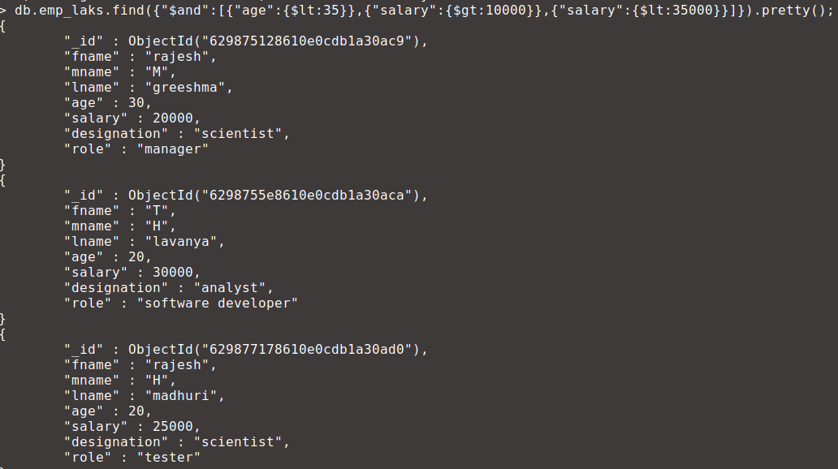

6) Delete an Employee whose "Firstname" is "Rajesh" and having the designation as "Scientist”

db.emp_laks.remove({"$and":[{"fname":"rajesh"},{"designation":"scientist"}]});

7) Update all the Employees whose role is "Team Lead" with a salary of 55650 INR

db.emp_laks.update({"role":"team lead"},{$set:{"salary":55600}});

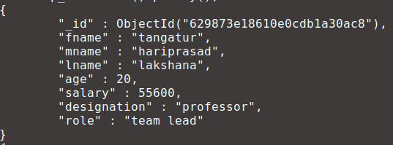
8) db.emp_laks.aggregate([{$match:{}},{$group:{_id:"$age",Average:{$avg:"$salary"}}}])

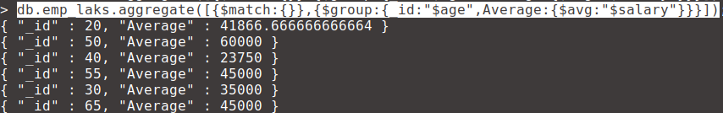
9)Apply the map-reduce to perform the above operation and obtain the results
var mapFunction1 = function(){emit(this.age ,this.salary);};
var reduceFunction1 = function(age ,salary) {
return Array.avg(salary);
};
db.emp_laks.mapReduce(
mapFunction1,
reduceFunction1,
{ out: "test" }
)

