Name: T H LAKSHANA
USN:1NT19IS174
31.03.2022

I.Starting mongoDB

i) Type mongo in terminal
ii) use <database_name>

II.Inserting values in MongoDB

1) db.mycollection.insert({"name":"laks","id":123,"age":20})
2) db.mycollection.insertMany([{ name:"lavanya", id:345, age:50},{name:"hari",id:101,age:54}])

III.Retrieve the data

1)Retrieve all the values
db.mycollection.find().pretty();

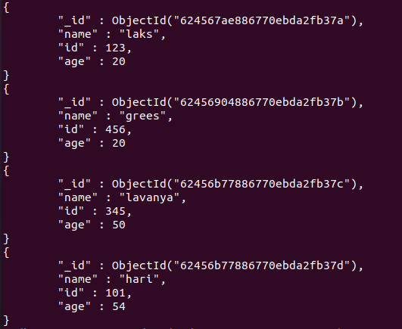
2) db.mycollection.find({name:"hari"}).pretty()

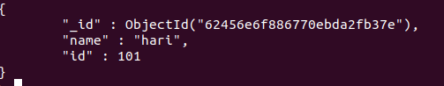
3) db.mycollection.find({age:{$lt :25}})

4)db.mycollection.find({age:{$gt :25}})
> db.mycollection.find({age:{$lte :25}})

III.Update

1) db.mycollection.update({id:101},{$set:{age:55}})

2) db.mycollection.update({name:"hari"}, {$unset:age})

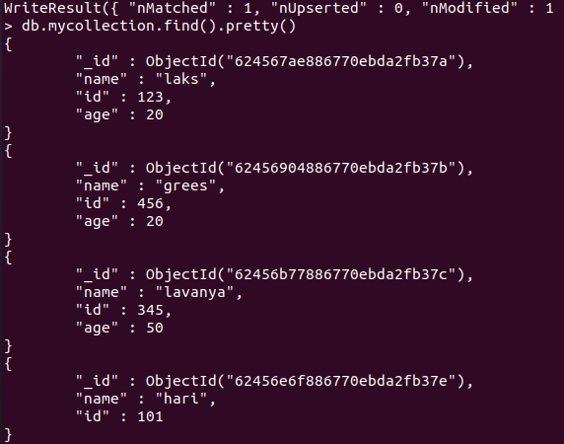

IV.Delete

1) db.mycollection.remove({id:101})

