AutoInsight Project Screenshots
Screenshots of the completed AutoInsight dashboard and visualizations.

1. AutoInsight Home Screen
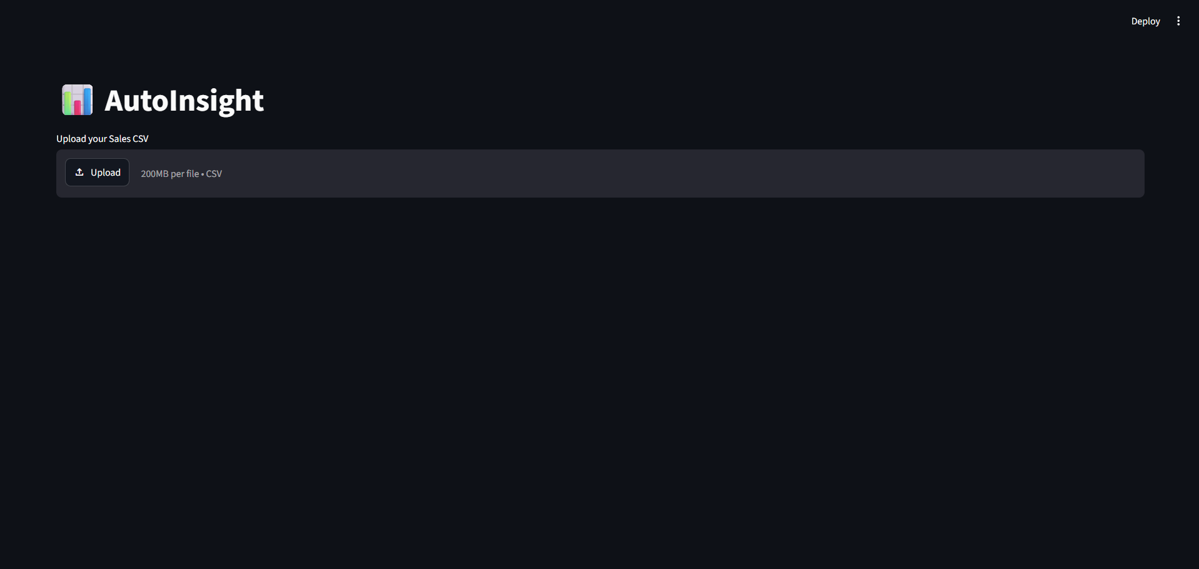

2. Dataset Preview
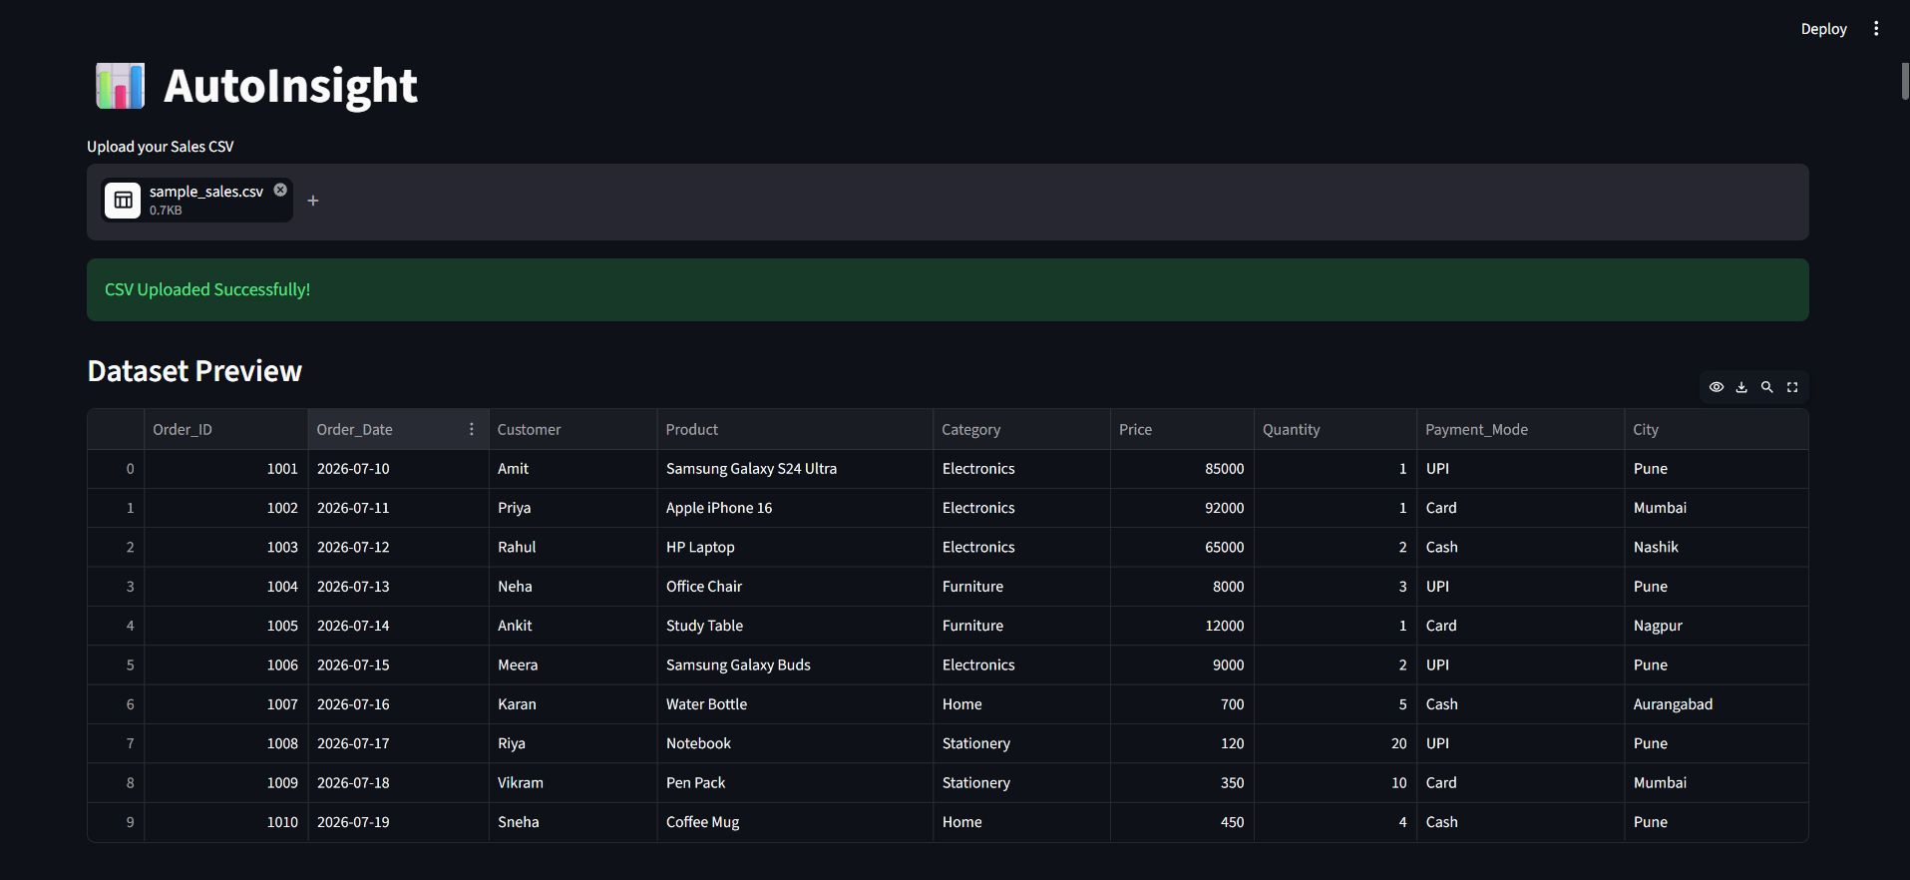

3. Business Insights
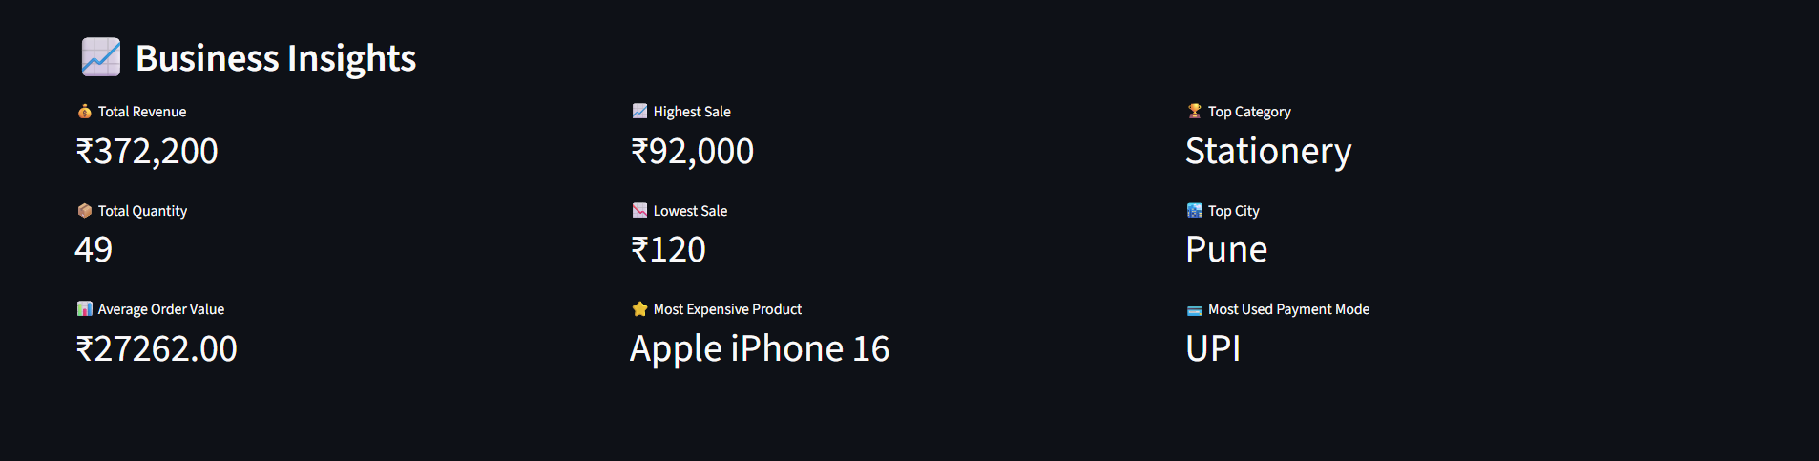

4. Revenue by Category
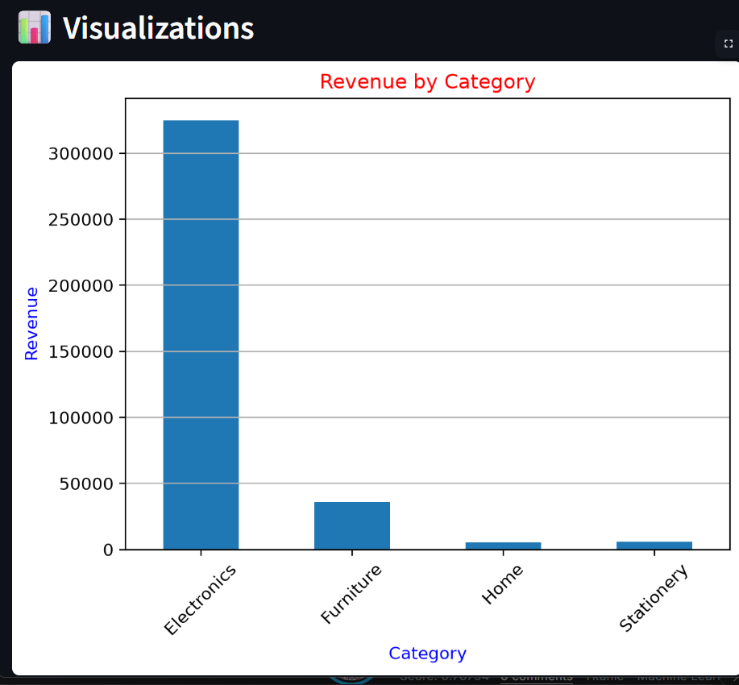

5. Revenue by City
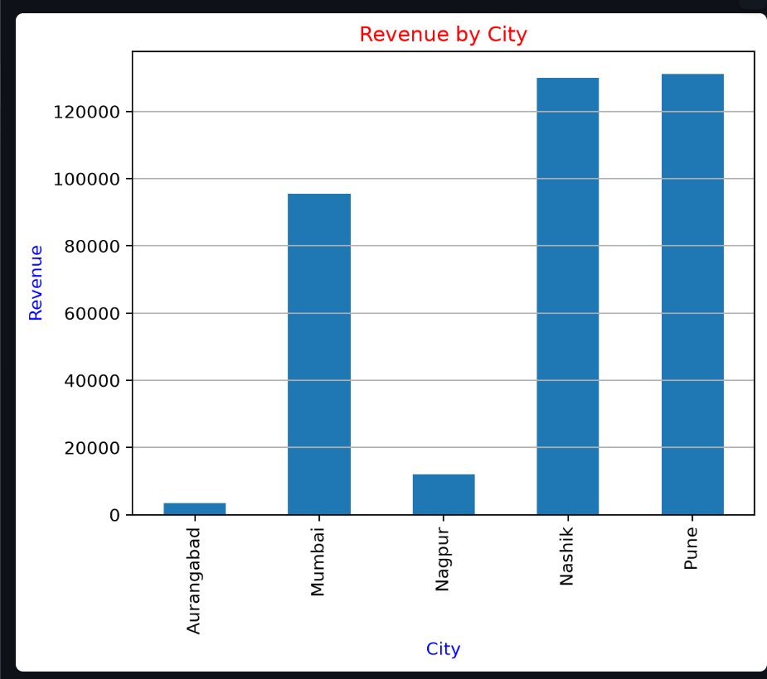

6. Payment Mode Distribution
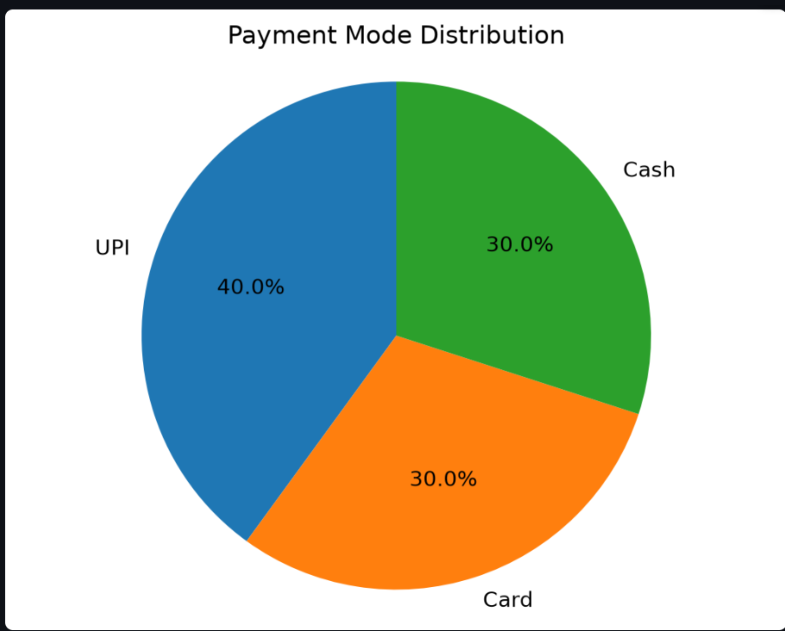

7. Sales Trends Over Time
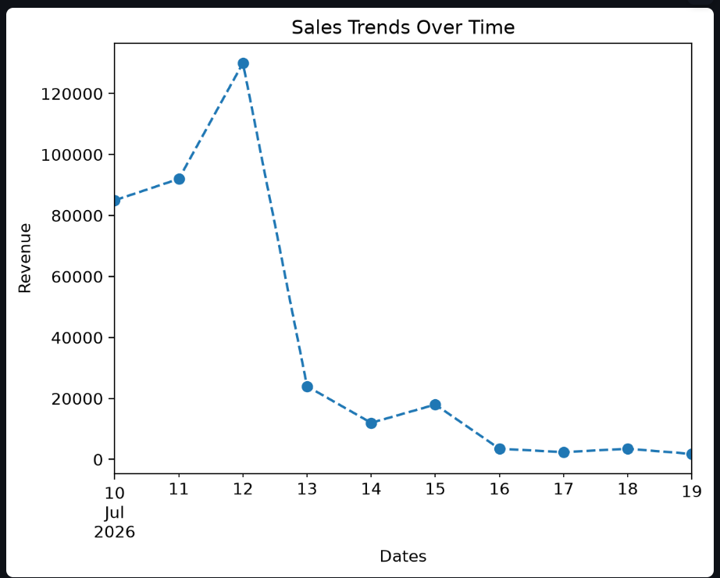

8. Top Revenue Generating Products
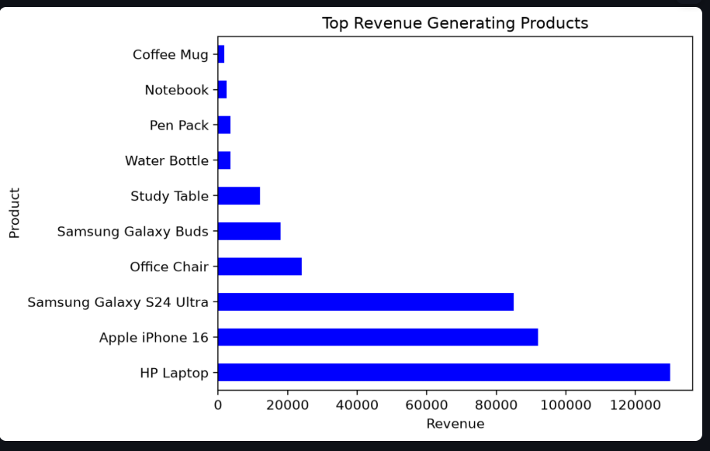

9. Quantity Sold by Category
