DistCart

# Team:

code_2_glory

Yashwanth Somayajula

Ratan Dheeraj Kadirikota

# Problem Statement:

The current scenario, retailers buy products from distributors and pay them through cheques or Demand Drafts, which is a tiresome process as it takes a lot of time to process and everything has to be done manually.

Additionally, retailers can order stock from distributors, but they can only do it via a phone call or manually going to the distributor store.

# Application Idea:

DistCart bridges the gap between the retailers and distributors, distributors can register in our app and display all their products with prices. Retailers can select the distributor and buy their products and pay them via “Razorpay Integration”.

# Advantages:

1. Retailers can place orders easily.
2. Ease of payment.
3. Payments can be managed and tracked.
4. Sales Analytics.

# Niche:

Currently focussed on medical field, but can be extended to any field.

# Tech Stack:

Front-end: React.JS, Tailwind CSS, DaisyUI, Dech.gl, Redux, React Router DOM.

Back-end: Node.JS, Express.JS

Database: MySQL

# Repo Links:

Front-end Repo: <https://github.com/yashone7/rp_ftx_fe>

Back-end Repo: <https://github.com/yashone7/RP_FTX_BE>

# UML Diagram:

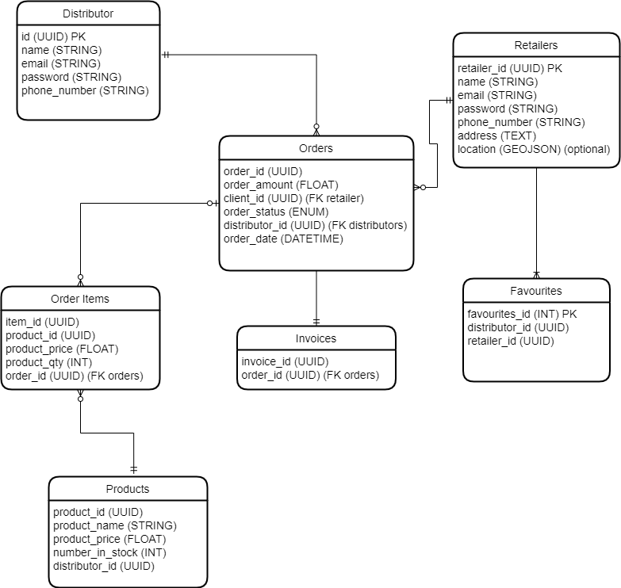

# Application Screenshots:

## Landing Page:



## Features:

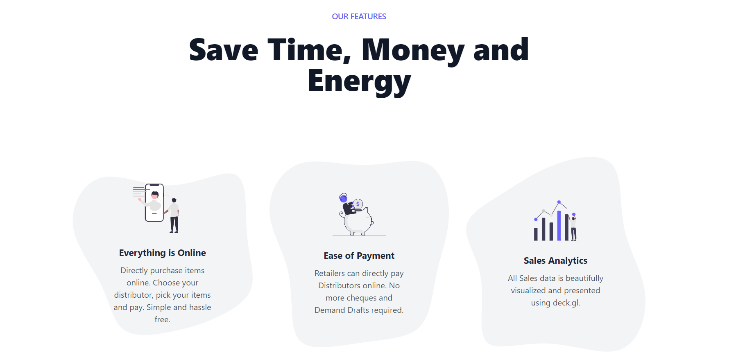

## Login Page:

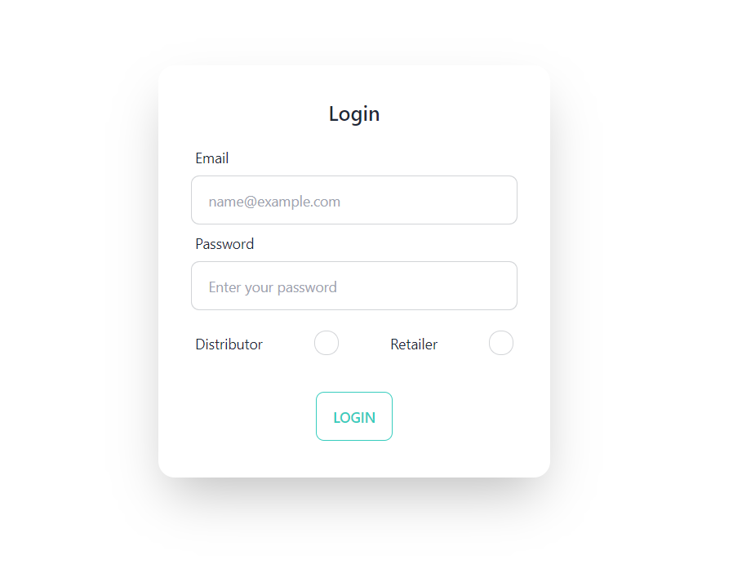

## Registration Page:

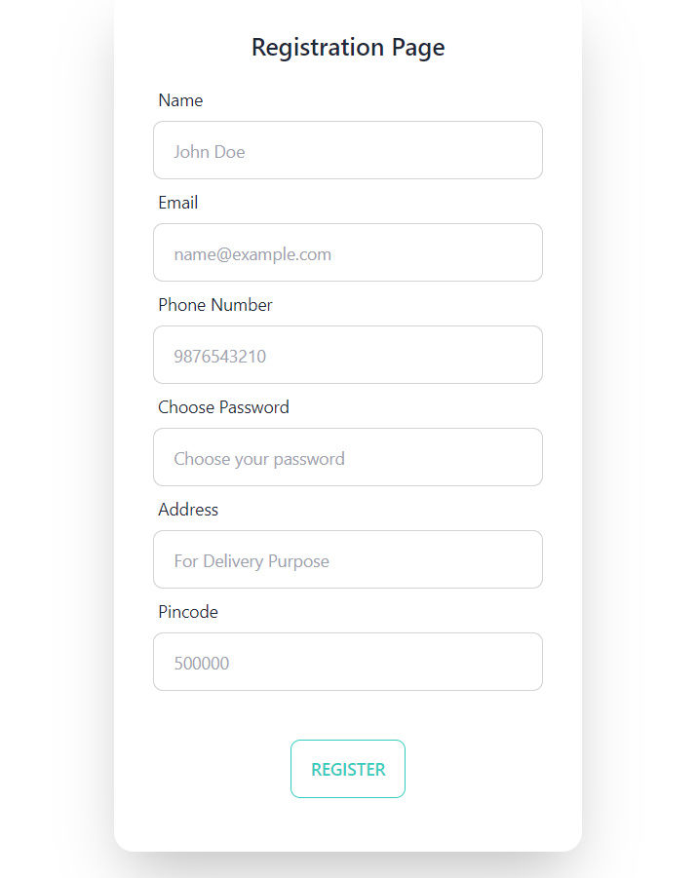

## Retailer Home page:

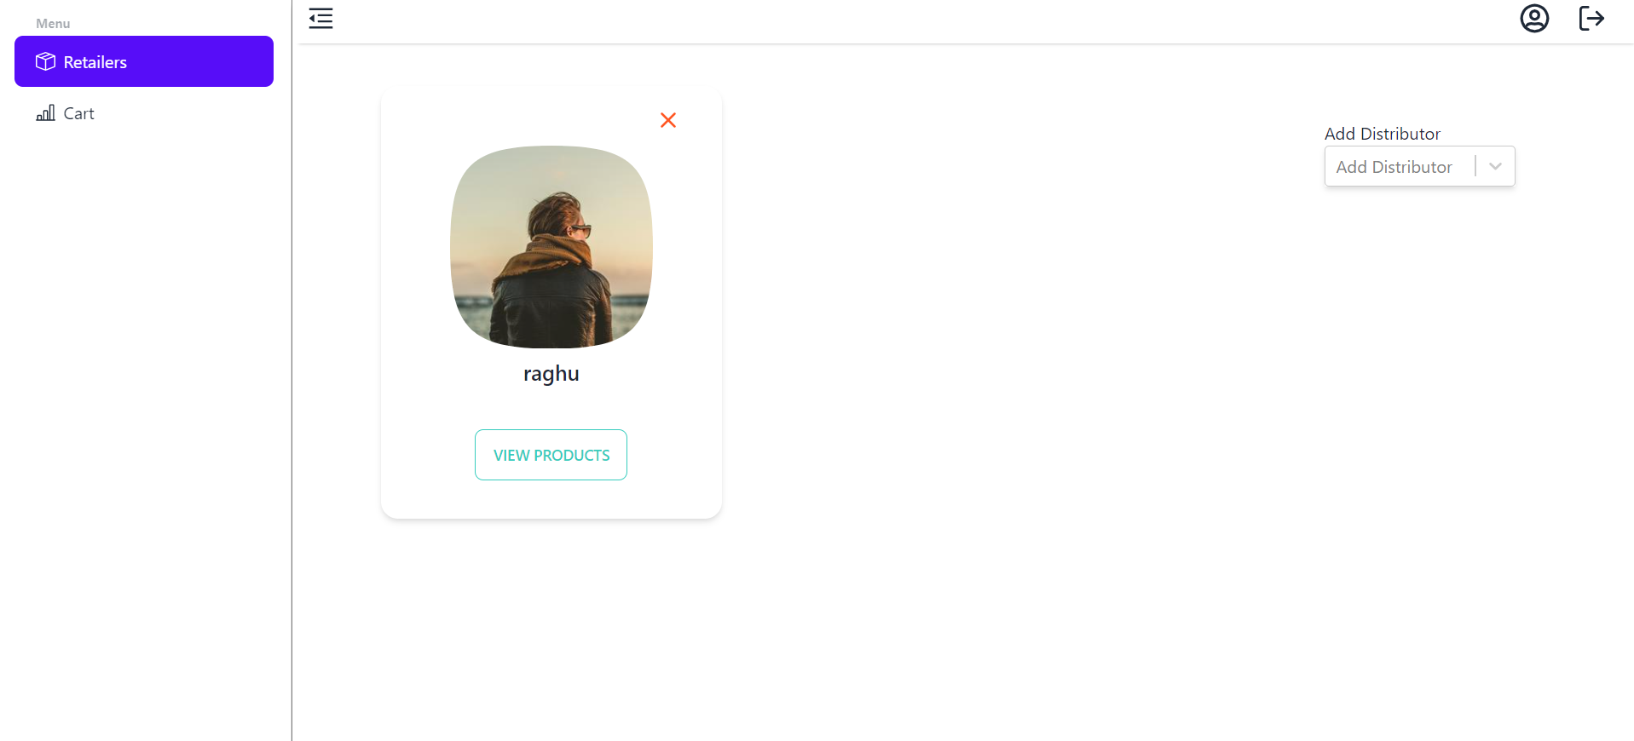

## Products of a Particular distributor:

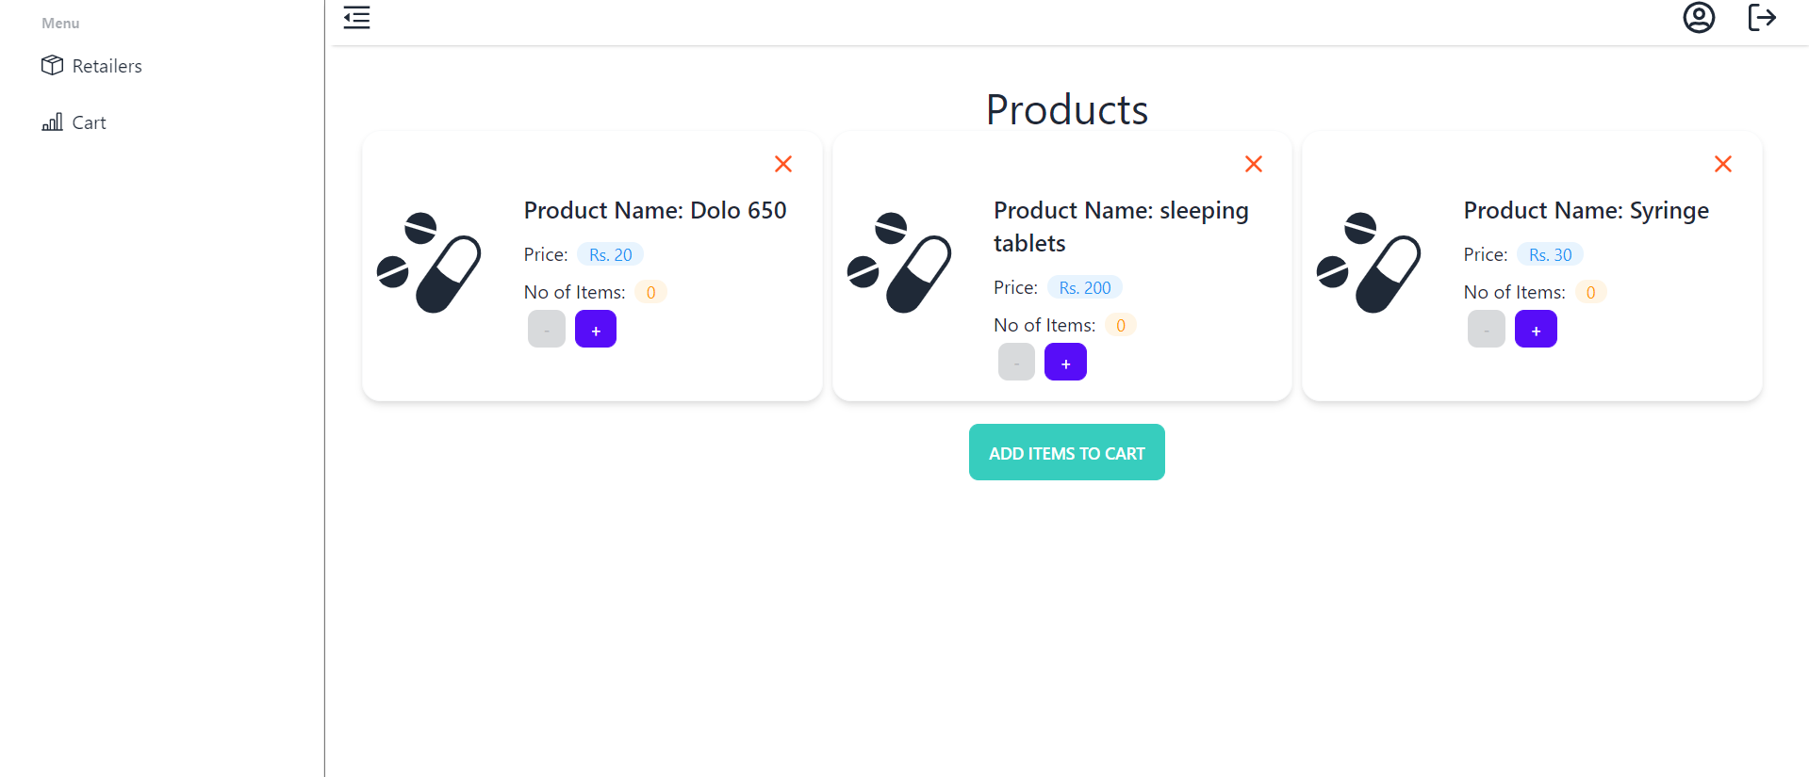

## Cart:

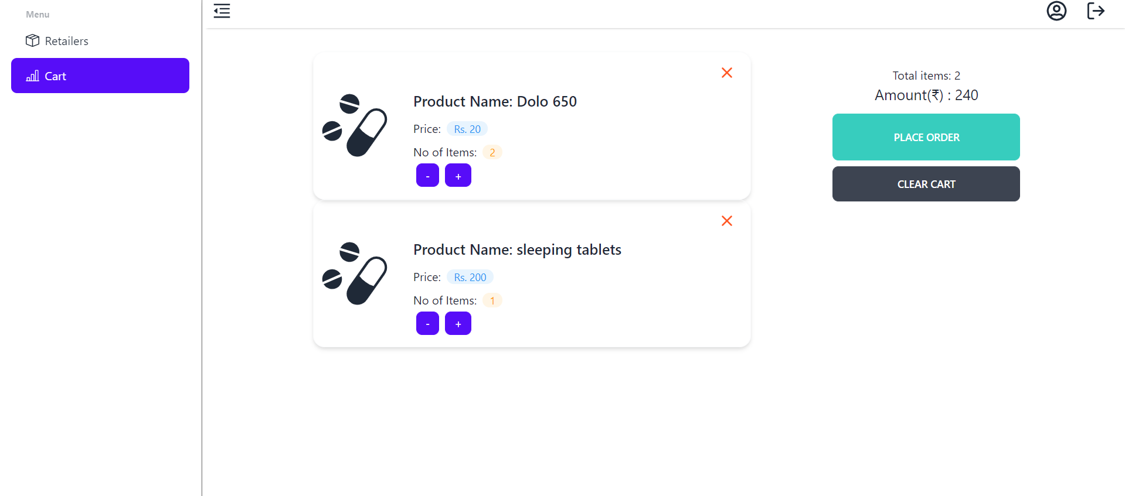

## Order Summary:

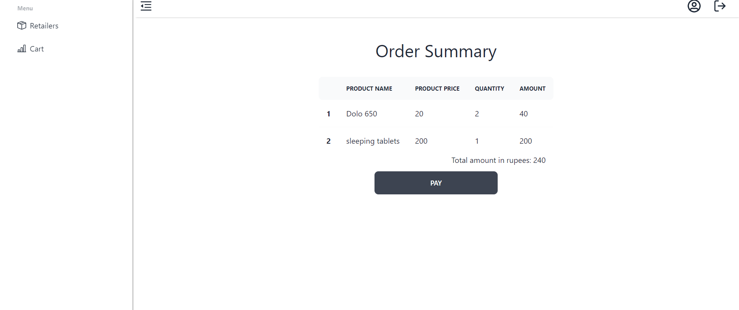

## Razorpay Integration:

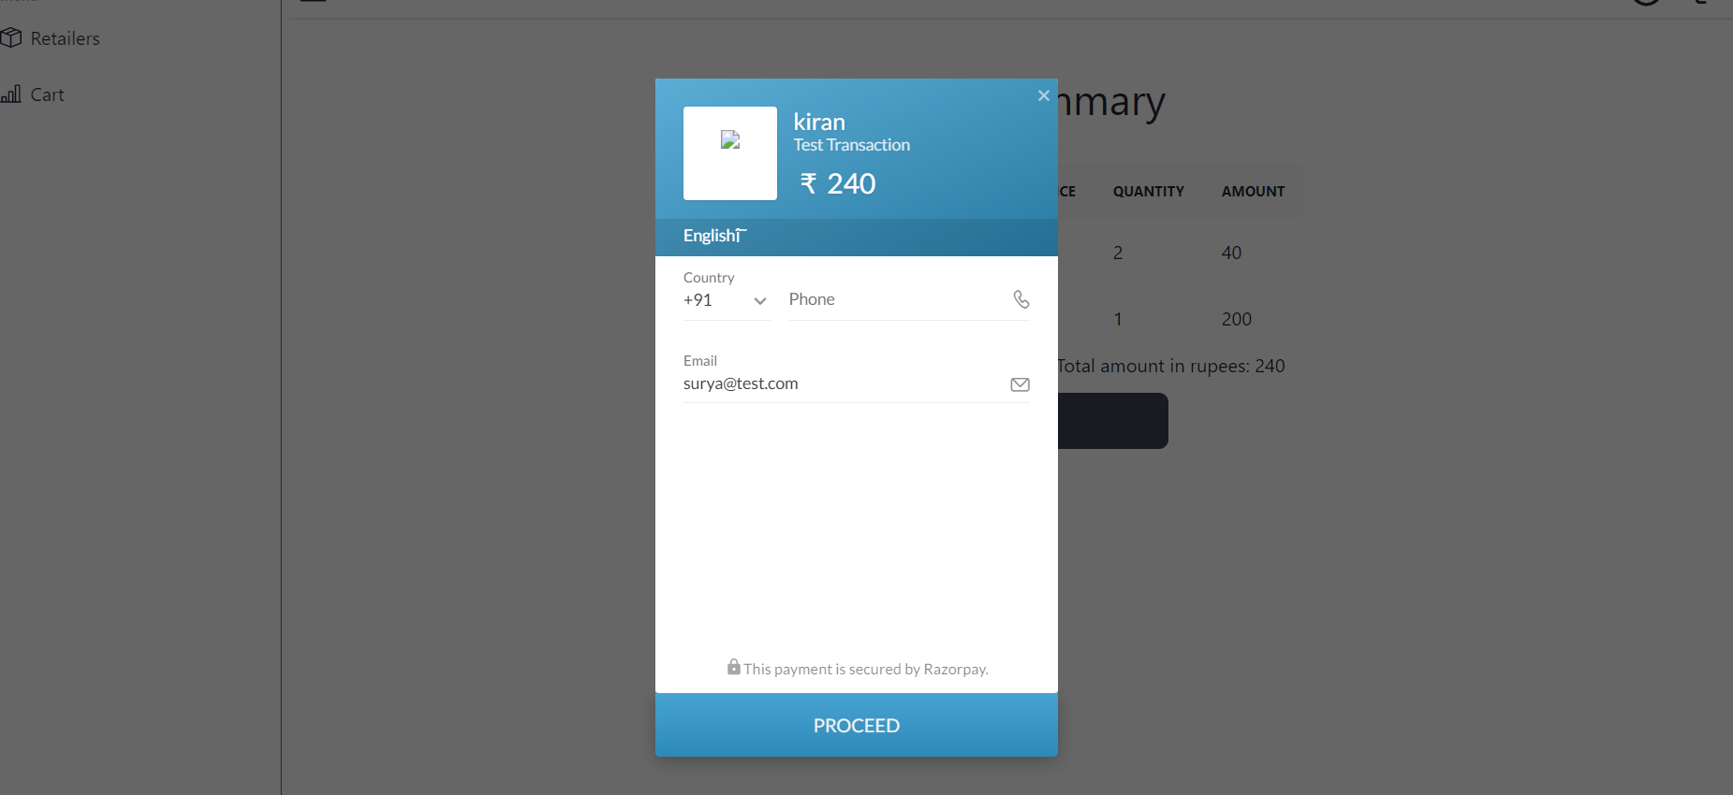

## Retailer Dashboard:

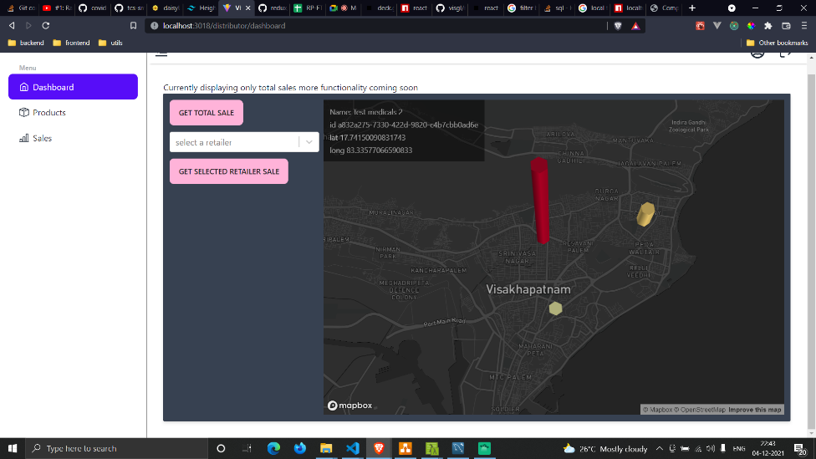

## Distributor Products:

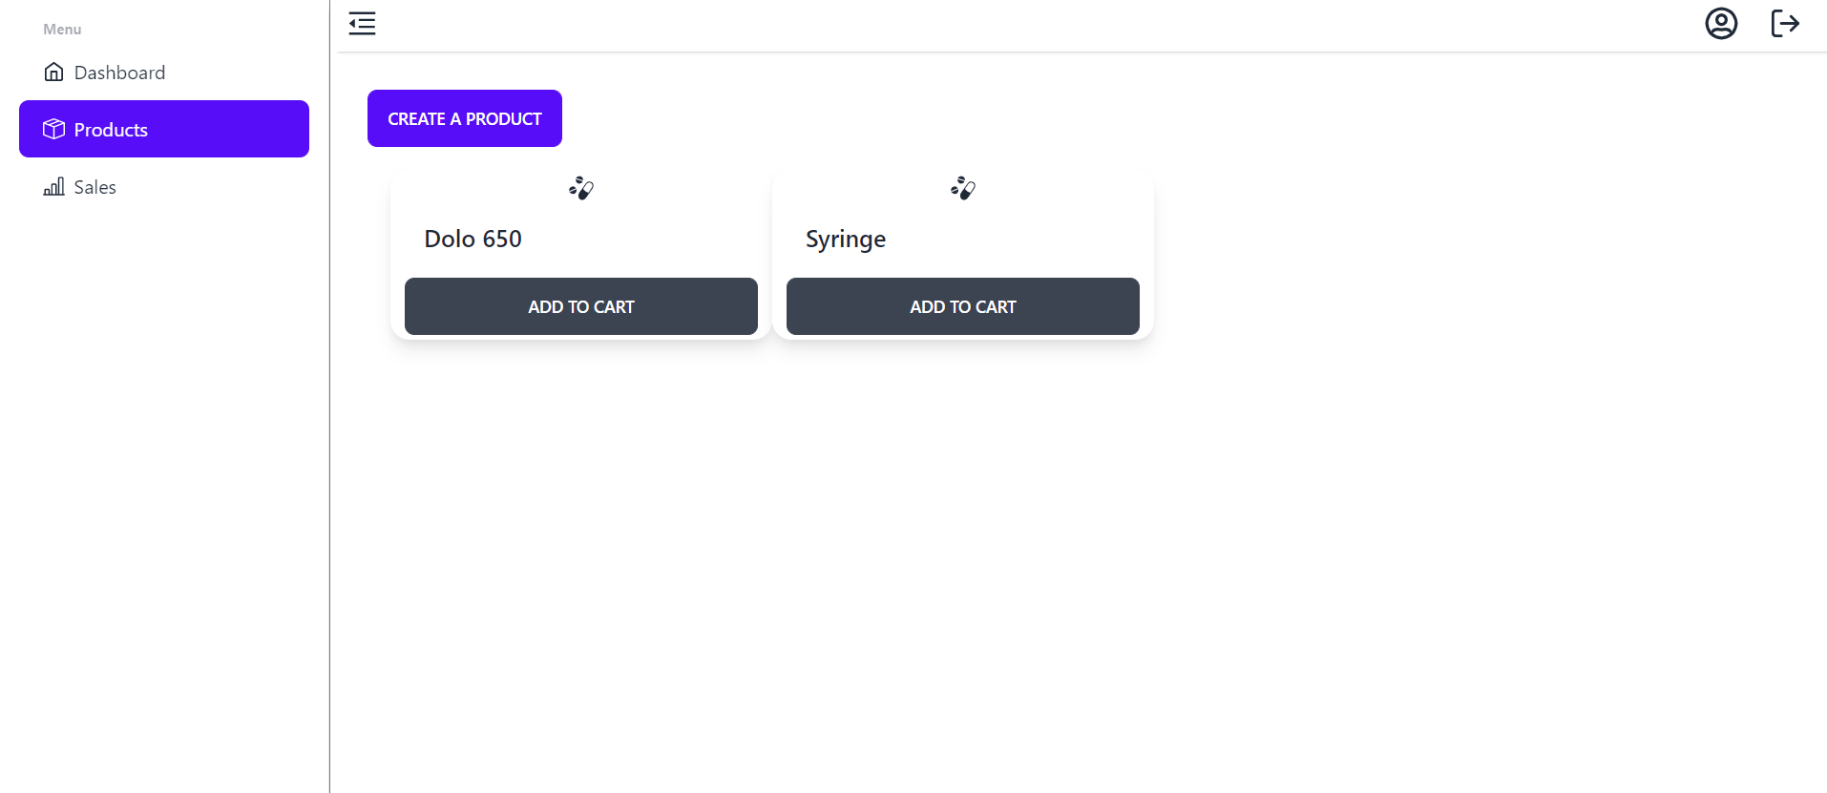

## Distributor Sales: