HR Employee Analytics
Descriptive Analytics Project Report
Field | Detail
Author | Yashovardhan Singh
Dataset | HR Employee Data — 14,999 Records, 11 Features
Tool Stack | Python · Streamlit · Pandas · Plotly
Report Type | Descriptive Analytics
Date | 2024

This report presents complete HR descriptive analytics — covering workforce attrition, salary impact, employee satisfaction, workload patterns, and promotion trends — with data-driven recommendations for HR leadership.

1. EXECUTIVE SUMMARY
This project delivers end-to-end descriptive analytics on 14,999 employee records spanning 10 departments. The organisation faces a critical workforce challenge: an attrition rate of 23.8% — significantly above the ~15% industry benchmark — equivalent to 3,571 employee departures. The analysis reveals that four compounding factors drive this attrition: low employee satisfaction, below-market compensation, extreme workload (both under and over), and a near-absent promotion rate of 2.1%.
The Streamlit dashboard provides HR teams with fully interactive, filter-driven visibility into each of these risk dimensions, enabling faster and more targeted decision-making.
14,999 | 23.8% | 61.3% | 201h | 3.5yr | 2.1%
Total Employees | Attrition Rate | Avg Satisfaction | Avg Monthly Hrs | Avg Tenure | Promotion Rate

2. BUSINESS PROBLEM & OBJECTIVES
Business Problem
The organisation is losing 23.8% of its workforce annually. With 3,571 departures already recorded, every percentage-point reduction in attrition directly reduces recruitment, training, and productivity-loss costs. HR leadership lacks a consolidated, data-driven view of which employee segments are leaving, and why.
Project Objectives
- OBJ 1 — Quantify attrition across departments, salary bands, tenure cohorts and workload levels.
- OBJ 2 — Identify the primary drivers of employee attrition using descriptive statistics.
- OBJ 3 — Surface actionable, prioritised retention recommendations grounded in the data.
- OBJ 4 — Deliver an interactive Streamlit dashboard for ongoing HR monitoring.

3. DATASET & DATA PREPARATION
Dataset Overview
The dataset HR_Employee_Data.csv contains 14,999 records and 11 columns. Key variables include employee satisfaction, performance evaluation scores, monthly working hours, tenure, department, salary band, and a binary attrition flag.
Column | Type | Description
satisfaction_level | Float (0–1) | Self-reported satisfaction score
last_evaluation | Float (0–1) | Most recent performance evaluation score
number_project | Integer | Number of active projects assigned
average_montly_hours | Integer | Average monthly hours worked
time_spend_company | Integer | Years at the company (tenure)
Work_accident | Binary 0/1 | Had a workplace accident
left | Binary 0/1 | TARGET — employee left the company
promotion_last_5years | Binary 0/1 | Promoted in the last 5 years
Department | String | Department name (10 departments)
salary | low / med / high | Salary band category

Data Cleaning Steps
# | Issue | Method Applied
1 | % strings in satisfaction & evaluation columns | str.replace('%','') → astype(float) / 100
2 | Incorrect column / value whitespace | df.columns.str.strip() + df[col].str.strip()
3 | Mixed/object types in numeric columns | pd.to_numeric(errors='coerce') on 6 columns
4 | Duplicate rows | df.drop_duplicates() — all remaining rows are unique
5 | Missing values | Numeric → median imputation; Categorical → mode imputation

Descriptive Statistics — Numeric Features
Metric | Satisfaction | Evaluation | Projects | Monthly Hrs | Tenure
Mean | 61.3% | 71.6% | 3.80 | 201h | 3.5 yr
Std Dev | ±24.9pp | ±17.1pp | ±1.23 | ±49.9h | ±1.5 yr
Min | 9% | 36% | 2 | 96h | 2 yr
Median | 64% | 72% | 4 | 200h | 3 yr
Max | 100% | 100% | 7 | 310h | 10 yr

4. DESCRIPTIVE ANALYSIS & VISUALISATIONS
4.1 Attrition Overview & Department Breakdowne
Of 14,999 employees, 3,571 (23.8%) have left. HR (29.1%) and Accounting (26.6%) are the highest-attrition departments, while Management (14.4%) and R&D (15.4%) retain staff most effectively.
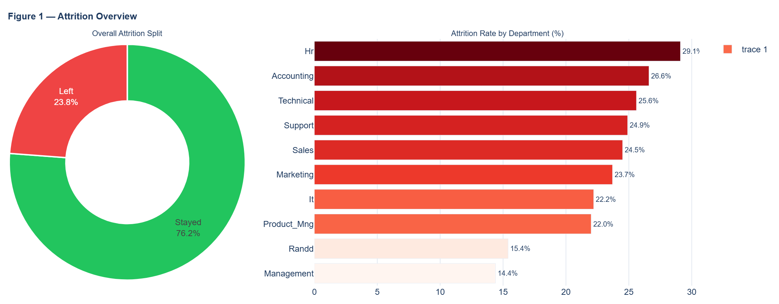

4.2 Salary Band Analysis
48.8% of the workforce is on a low salary. Low-salary employees leave at 29.7% — 4.5× the rate of high-salary employees (6.6%). Medium-salary employees sit at 20.4%.
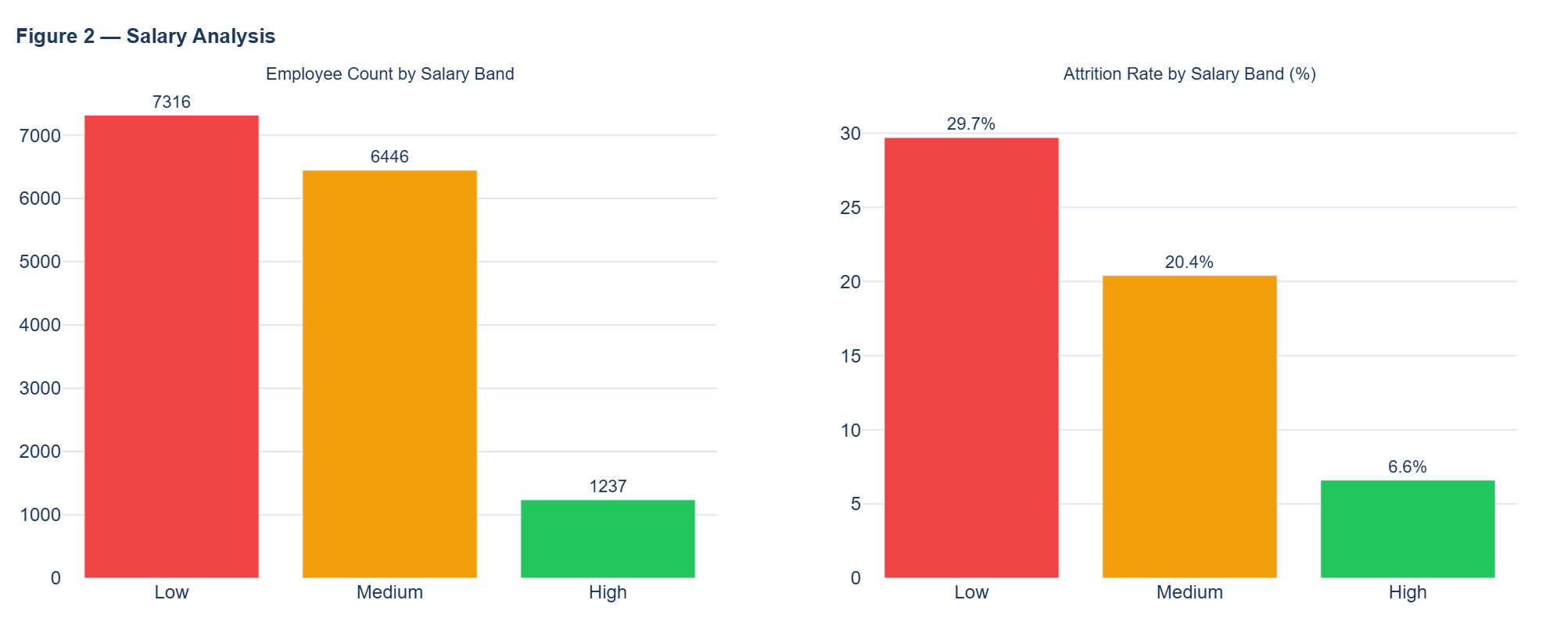

4.3 Satisfaction & Workload Impact
Employees with satisfaction below 30% leave at 48.8% — four times the rate of highly satisfied staff. Workload extremes are equally damaging: both under-utilised (Normal ≤160h, 36.3%) and overloaded employees (>220h, 30.7%) show high attrition; only the 160–220h 'High' band shows a healthy 3.5%.
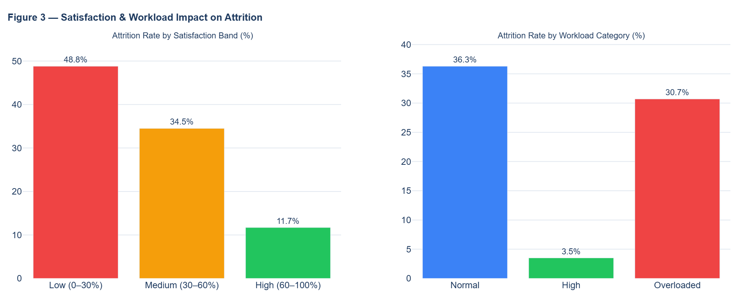

4.4 Attrition by Tenure (Years at Company)
Attrition is negligible at year 2 (1.6%) but escalates sharply — peaking at 56.6% at year 5 before dropping to near-zero for long-tenured staff. Years 3–5 represent the critical intervention window.
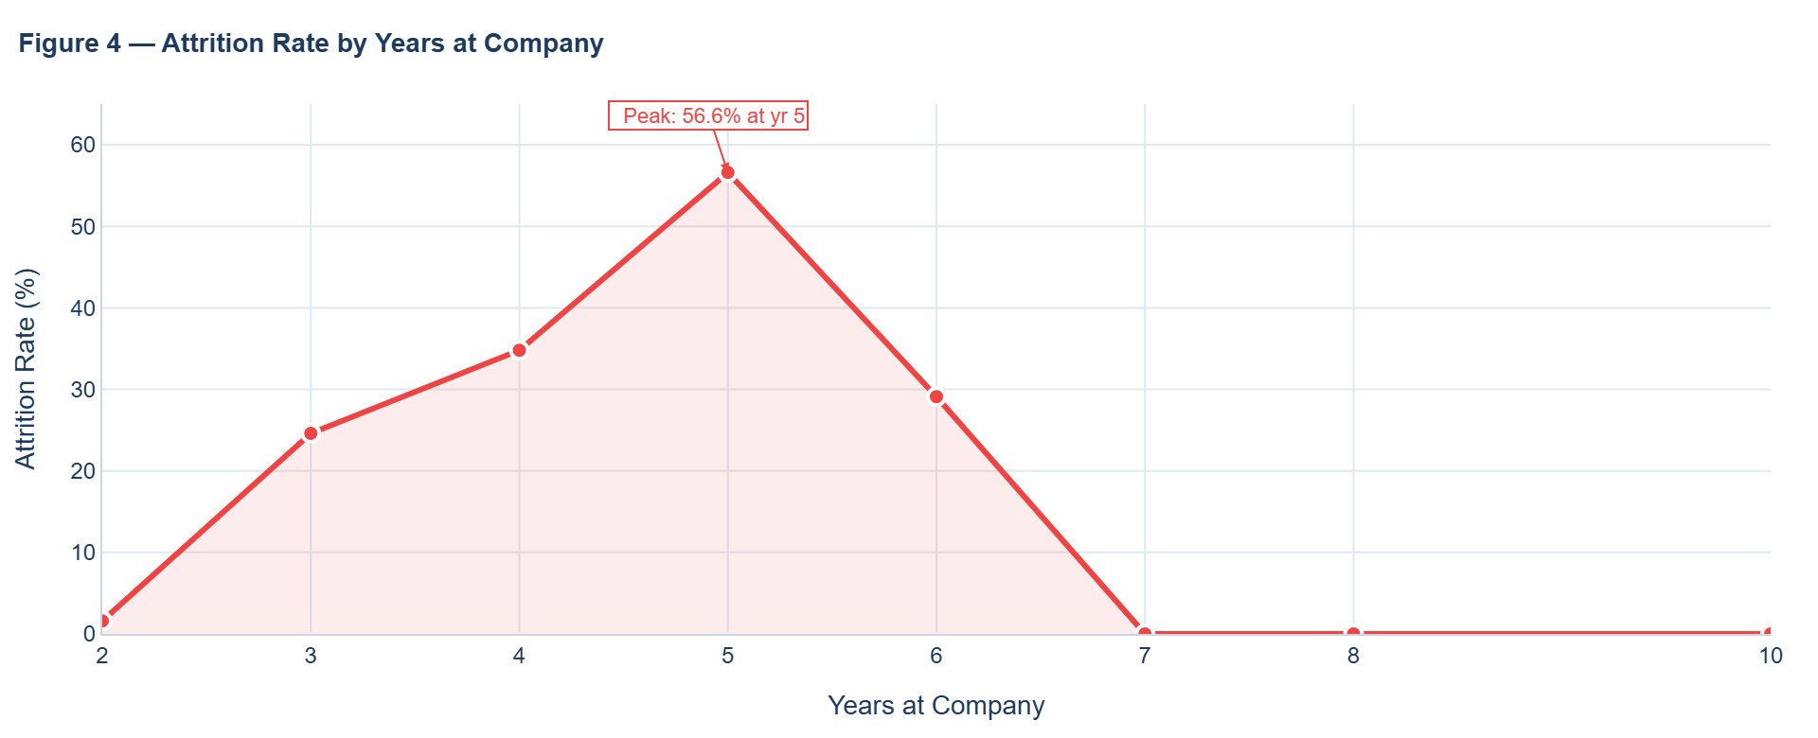

4.5 Number of Projects vs Satisfaction & Attrition
Employees assigned only 2 projects (65.6% attrition, avg satisfaction 47.9%) and those with 7 projects (100% attrition, satisfaction 11.9%) are extreme at-risk groups. The optimal band is 3–4 projects: low attrition (<10%) and highest satisfaction (~69%).
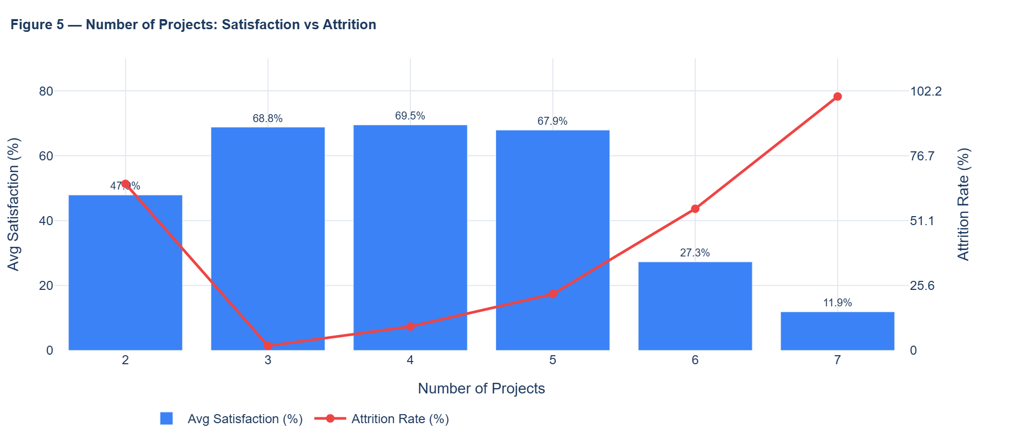

4.6 Attrition by Experience Tier
Junior employees (≤2 yr, 1.6% attrition) are highly stable. Attrition rises sharply through Mid (27.5%) and Senior (47.6%) tiers, then returns to zero for Veterans (>6 yr), confirming that years 3–6 are the highest-risk career phase.
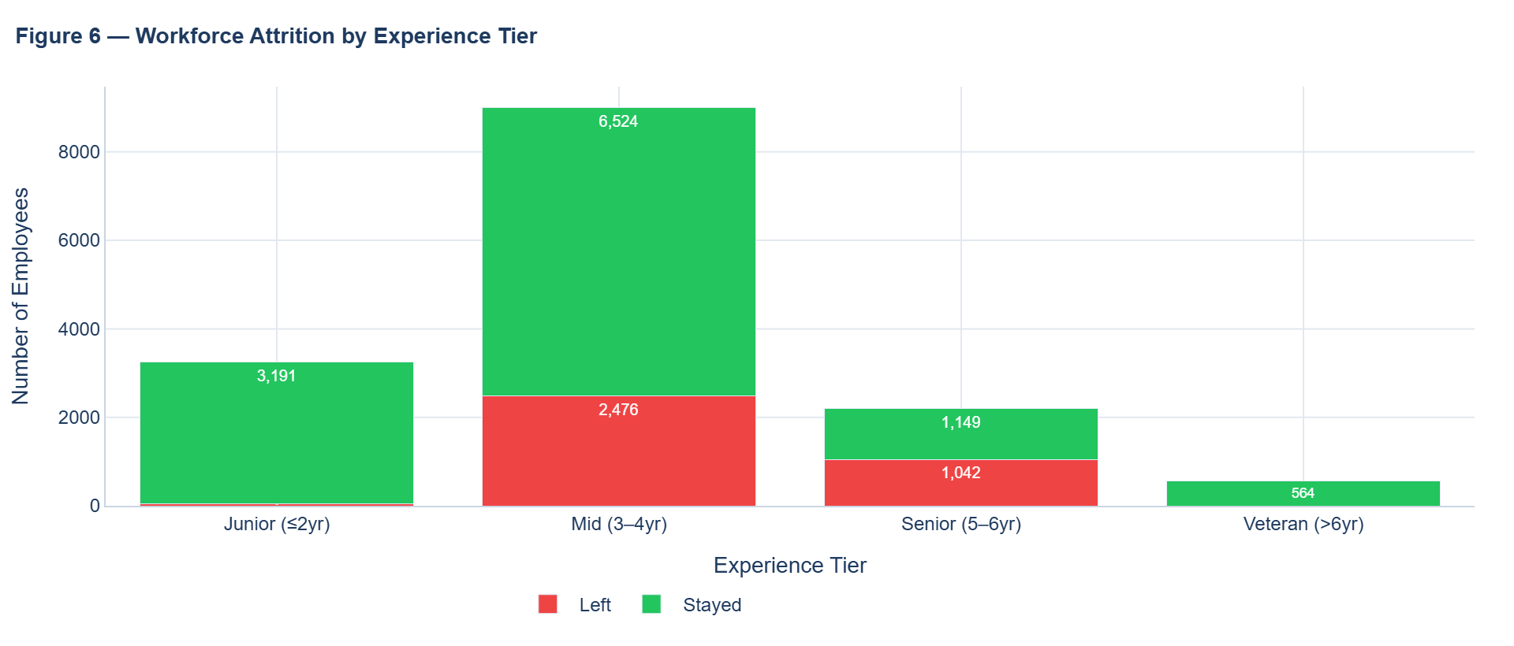

5. KEY FINDINGS & BUSINESS INSIGHTS
⚠ High Attrition (23.8%)
At 23.8%, attrition exceeds the ~15% industry benchmark by 8.8pp, representing 3,571 departed employees and substantial ongoing talent costs.

⚠ Satisfaction is the Primary Driver
Low-satisfaction employees (below 30%) leave at 48.8% — 4× the 11.7% rate of highly satisfied staff. Even high-performers leave when engagement is low.

⚠ Salary Gap Creates Structural Risk
Low-salary employees leave at 29.7% vs 6.6% for high-salary — a 23pp gap. 48.8% of the workforce sits in this high-risk band.

📌 Workload Extremes Drive Attrition Equally
Both underloaded (≤160h: 36.3%) and overloaded (>220h: 30.7%) employees show high attrition. Only the 160–220h band achieves healthy 3.5% retention.

⚠ Promotion Rate is Critically Low
Only 2.1% promoted in 5 years. Promoted employees leave at 6.0% vs 24.2% for non-promoted — career stagnation is a powerful, preventable trigger.

📌 Year-5 Tenure is the Peak Risk Point
Attrition peaks at 56.6% at year 5, rising steeply from 24.6% at year 3. A structured mid-career review at year 4 is the key preventive lever.

6. HR RECOMMENDATIONS
Priority | Recommendation | Data Basis | Expected Impact
🔴 Critical | Salary review & retention bonuses for low-salary cohort | 29.7% attrition in low band | ↓ 15–25% attrition in cohort
🔴 Critical | Targeted engagement for HR & Accounting departments | HR 29.1%, Accounting 26.6% | ↓ 10–20% dept attrition
🟠 High | Structured promotion paths; mid-career review at yr 4 | Promoted: 6% vs 24.2% (non) | ↓ 8–12% overall attrition
🟠 High | Workload rebalancing — enforce 160–220h optimal band | Overloaded: 30.7% attrition | ↓ 10–15% overloaded cohort
🟡 Medium | Stay interviews & personalised engagement at yr 3–5 | Attrition peaks yr 5 at 56.6% | Pre-empt the yr-5 spike
🟡 Medium | Optimal project assignment: 3–4 projects per employee | 2 projects: 65.6%; 7: 100% | ↓ attrition in project extremes
🟢 Ongoing | Quarterly pulse surveys for real-time satisfaction tracking | Satisfaction: primary driver | Early warning system

7. CONCLUSION
This analysis of 14,999 HR records confirms that the organisation's 23.8% attrition rate is driven by four interconnected factors: low satisfaction, inadequate compensation, workload extremes, and stagnated career progression. These are not independent problems — they compound: an underpaid employee with heavy workload and no promotion prospect is almost certain to leave.
The good news is that these are addressable. The analysis shows that promoted employees, correctly loaded employees (160–220h), and high-salary employees all exhibit low attrition. The organisation already has a proven retention formula — it needs to apply it more broadly.
Priority Action: Address the compensation gap for the 48.8% low-salary cohort first. This single intervention has the largest potential attrition reduction and affects nearly half the workforce (7,316 employees).

HR Employee Analytics · Yashovardhan Singh

