5. SYSTEM DESIGN
5.1 SYSTEM APPLICATION DESIGN
5.1.1 Method Pseudo code

Registration

1 Include connection.php for database connection
2 Fill all the fields given in registration form.
3 Check for valid inputs
4 if inputs are valid send a confirmation email
5 show message-you are successfully registered.
Login

1 Include connection.php for database connection
2 Provide userid and password
3 Check for null inputs and invalid inputs
4 Match userid and password from database
5 If matched Login Successful
6 Else show error message and go to step 2

Customer Id Allocation

1 Include connection.php for database connection
2 Select the client
3 Enter a customer id
4 Select the user id from the drop down menu
5 show message-Customer Id successfully allocated.

Add Updates

1 Include connection.php for database connection
2 Fill all the fields given in client’s details form.
3 Check for valid inputs
4 If inputs are valid add the details on the home page.
5 show message-Details successfully added.

Add Rules Signature

1 Include connection.php for database connection
2 Enter a customer id
3 Fill all the fields given in client’s rule configuration form.
4 Check for valid rules signature
5 If inputs are valid add the configuration details on WAF box.
6 show message-Details successfully added.

5.2 DESIGN METHODOLOGY
For this project, I am using the function oriented design approach. The goal of the design phase is to transform the requirements specified in the SRS document into a structure that is suitable for implementation in some programming language. In technical terms, during the design phase the software architecture is derived from the SRS document. Design is an important and essential phase if software development and can be rightly considered as the backbone or base of the implementation phase. It rather acts as a raw material for the manufacturing of the implementation in a short way.
Today, two distinctly different approaches are available: the traditional design approach and the object-oriented design approach.
- Traditional design approach
Traditional design consists of two different activities; first a structured analysis of the requirements specification is carried out where the detailed structure of the problem is examined. This is followed by a structured design activity. During structured design, the results of structured analysis are transformed into the software design.
- Object-oriented design approach
In this technique, various objects that occur in the problem domain and the solution domain are first identified, and the different relationships that exist among these objects are identified. The object structure is further refined to obtain the detailed design.

In the real sense, Software design deals with transforming the customer requirements, as
Described in the SRS document, into a form (a set of documents) that is suitable for implementation in a programming language. A good software design is seldom arrived by using a single step procedure but rather through several iterations through a series of steps. Design activities can be broadly classified into two important parts:

- Preliminary (or high-level) design and
- Detailed design

The meaning and scope of two design activities (i.e. high-level and detailed design) tend to vary considerably from one methodology to another. High-level design means identification of different modules and the control relationships among them and the definition of the interfaces among these modules. The outcome of high-level design is called the program structure or software architecture. Many different types of notations have been used to represent a high-level design. A popular way is to use a tree-like diagram called the structure chart to represent the control hierarchy in a high-level design.
During detailed design, the data structure and the algorithms of the different modules are designed. The outcome of the detailed design stage is usually known as the module-specification document.

The end result of design is to produce a model that will provide a seamless transition to the coding phase, i.e. once the requirements are analyzed and found to be satisfactory, a design model is created which can be easily implemented.
In the function oriented design approach that is used for this project, the system is viewed as something that performs a set of functions. Starting at this high-level view of the system, each function is successively refined into more detailed functions.

Also, the system state is centralized and shared among different functions,

5.1.1 Function oriented design
Function oriented design involves the structured design of the system under consideration on the basis of structured analysis of requirements carried out in the system design earlier i.e. the creation of Data flow diagrams.
The aim of structured design is to transform the results of the structured analysis (i.e. a DFD representation) into a structure chart. Structured design provides two strategies to guide transformation of a DFD into a structure chart.
- Transform analysis
- Transaction analysis
Normally, the level 1 DFD is transformed into a module representation using either the transform or the transaction analysis and then further towards the lower-level DFDs. At each level of transformation, it is important to first determine whether the transform or the transaction analysis is applicable to a particular DFD.

5.1.2 Structure Chart
A structure chart represents the software architecture, i.e. the various modules making up the system, the dependency (which module calls which other modules), and the parameters that are passed among the different modules. Hence, the structure chart representation can be easily implemented using some programming language. Since the main focus in a structure chart representation is on the module structure of the software and the interactions among different modules, the procedural aspects (e.g. how a particular functionality is achieved) are not represented.
The basic building blocks which are used to design structure charts are the following:
- Rectangular boxes: Represents a module.
- Module invocation arrows: Control is passed from one module to another module in the direction of the connecting arrow.
- Data flow arrows: Arrows are annotated with data name; named data passes from one module to another module in the direction of the arrow.
- Library modules: Represented by a rectangle with double edges.
- Selection: Represented by a diamond symbol.
- Repetition: Represented by a loop around the control flow arrow.

For this project, it is essential to employ transform analysis as we have similar processing steps for the data items in consideration as emphasized by the functional requirements of the project.

5.1.3 Transform Analysis
Transform analysis identifies the primary functional components (modules) and the high level inputs and outputs for these components. The first step in transform analysis is to divide the DFD into 3 types of parts:

- Input
- Logical processing
- Output

The input portion of the DFD includes processes that transform input data from physical (e.g. character from terminal) to logical forms (e.g. internal tables, lists, etc.). Each input portion is called an afferent branch.
The output portion of a DFD transforms output data from logical to physical form. Each output portion is called an efferent branch. The remaining portion of a DFD is called the central transform.

In the next step of transform analysis, the structure chart is derived by drawing one functional component for the central transform, and the afferent and efferent branches.

5.3 STRUCTURE CHART
The structure charts using the transform analysis are shown below:
5.3.1Login

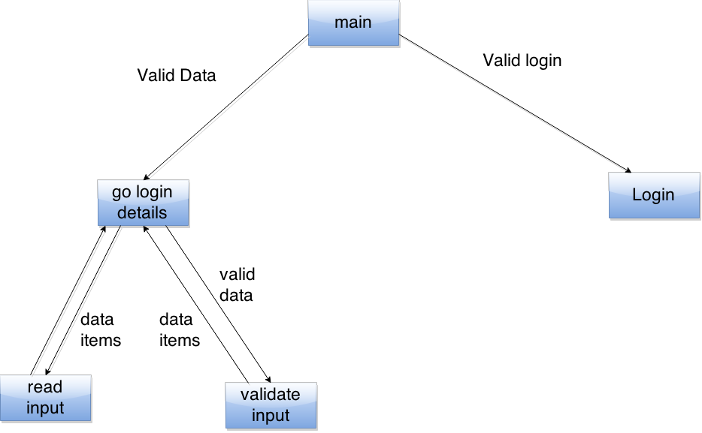

Fig 5.3.1 Login

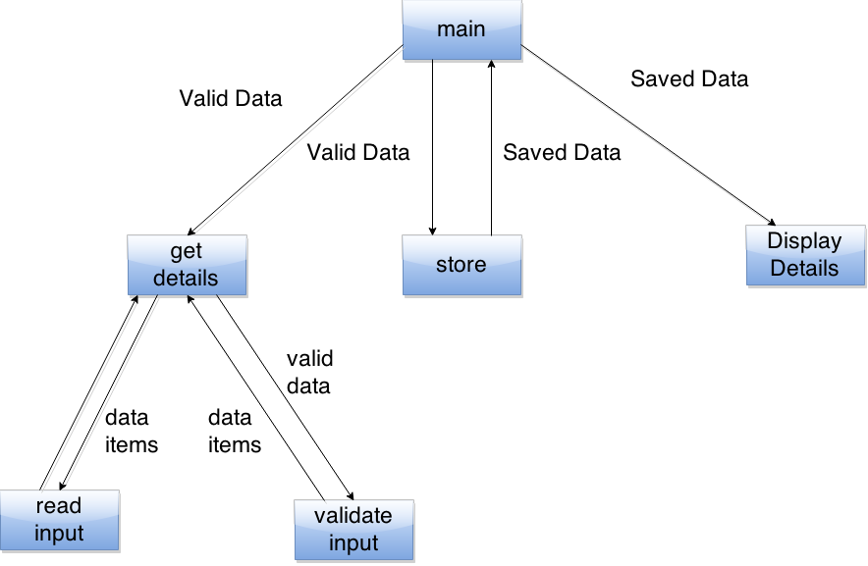
5.3.2 Client Details Manipulation

Fig 5.3.2 Client Details Manipulation

5.3.3 Scaning report of Clients URL

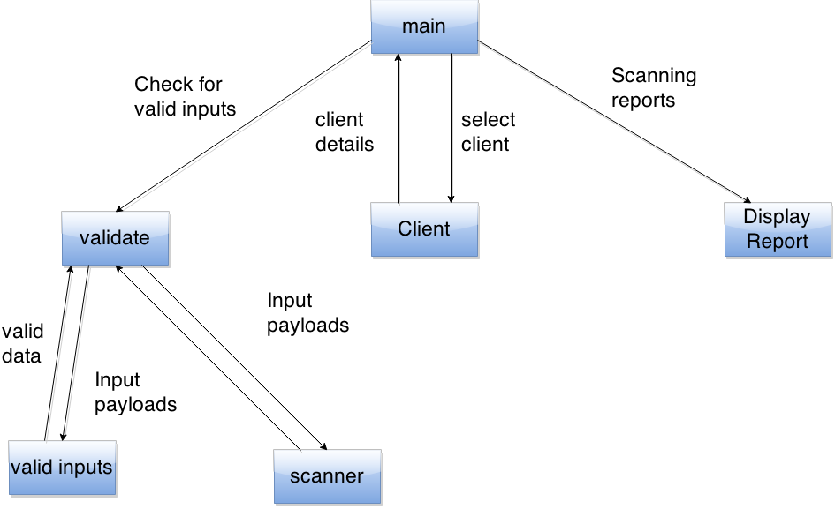

Fig5.3.3 Scaning report of Clients URL

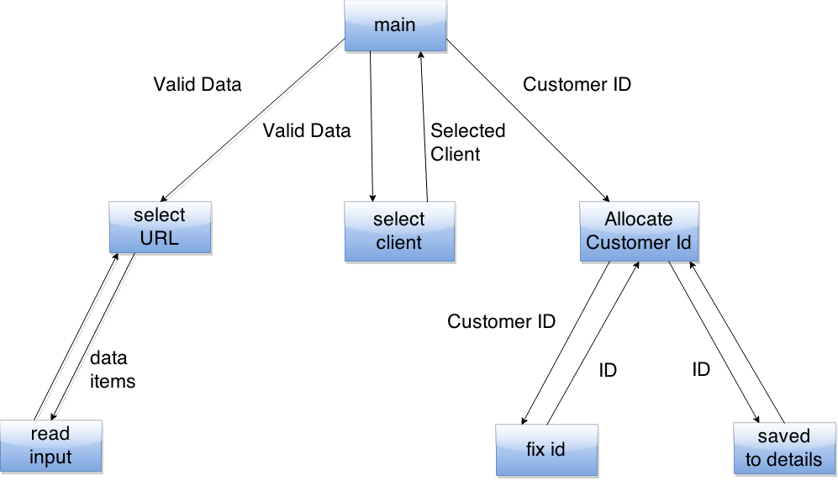
5.3.4 Customer Id Allocation

Fig 5.3.4 Customer Id Allocation


5.4 INPUT/OUTPUT INTERFACE DESIGN

5.4.1 Home Page
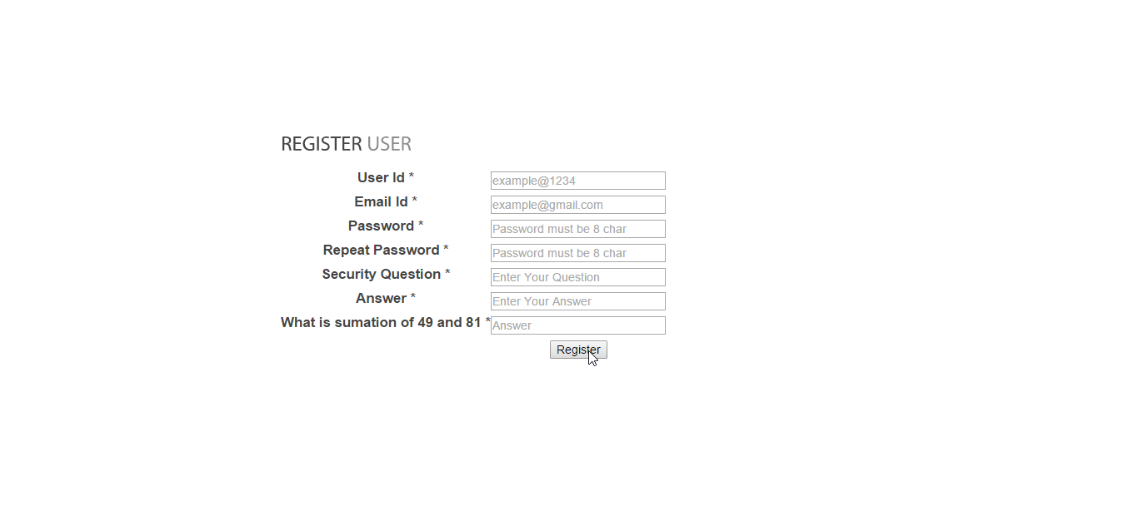
Fig 5.4.1 Home Page
5.4.2 Client Registration
Fig 5.4.2 Client Registration

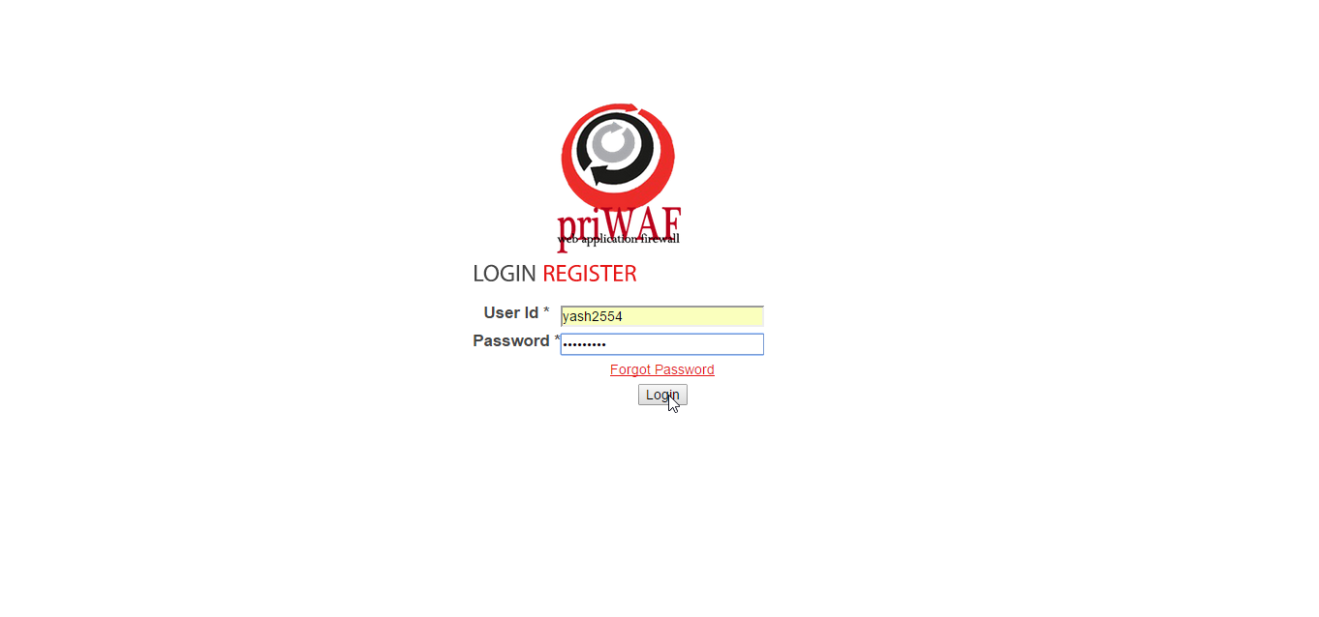
5.4.3 Client Login
Fig 5.4.3 Client login

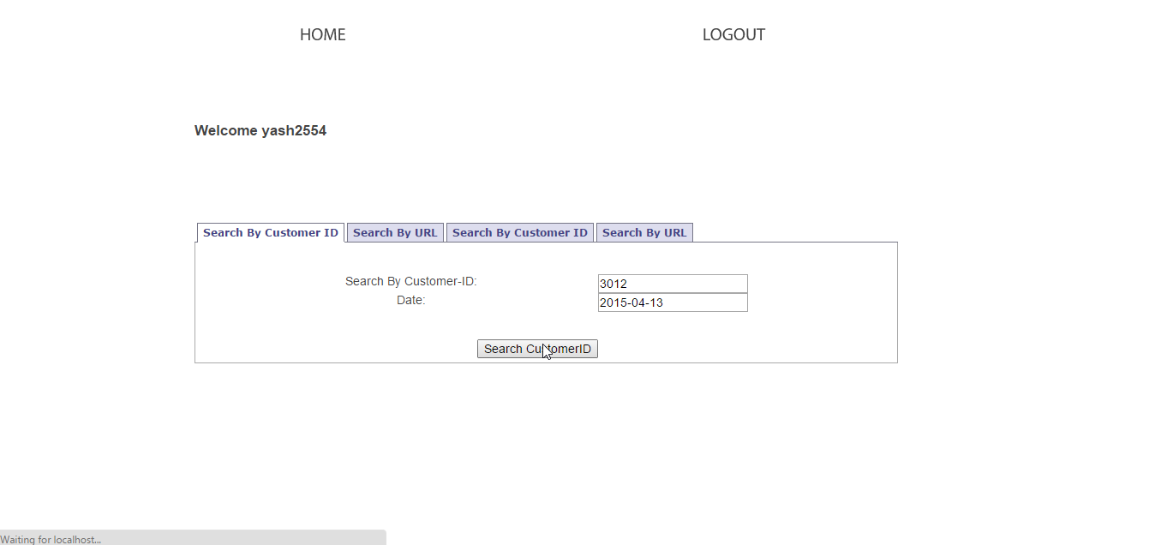
5.4.4 Search Scanning Report

Fig 5.4.4 Search Scanning Report

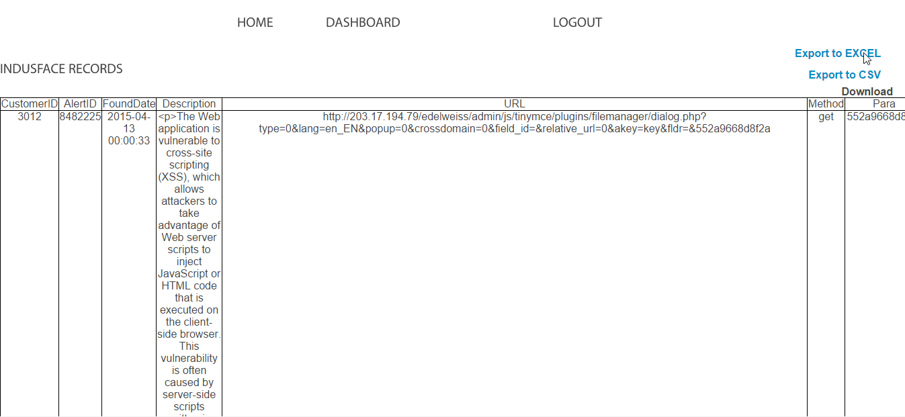
5.4.5 Scanning Report Download

Fig 5.4.5 Scanning Report Download
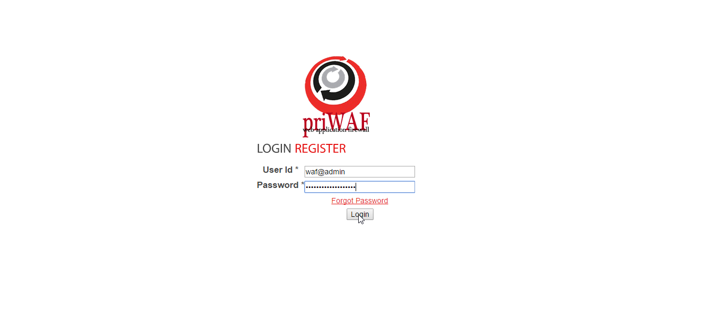
5.4.6 WAF admin Login

Fig 5.4.6 WAF admin Login

5.4.7 WAF admin dashboard
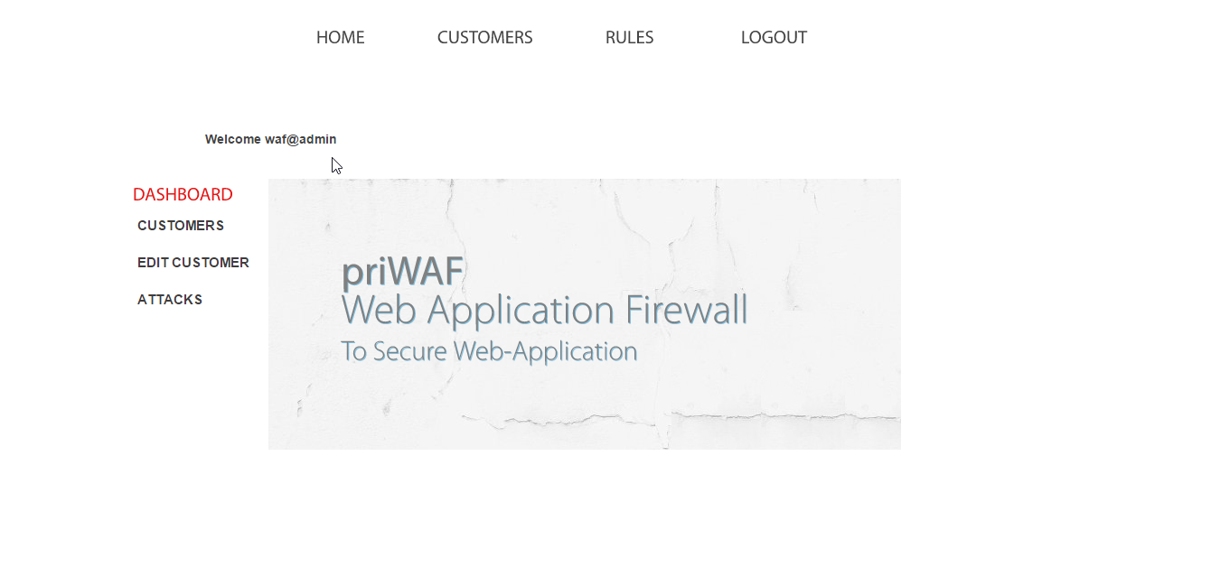
Fig 5.4.7 WAF admin dashboard
5.4.8 Customer Id Allocation
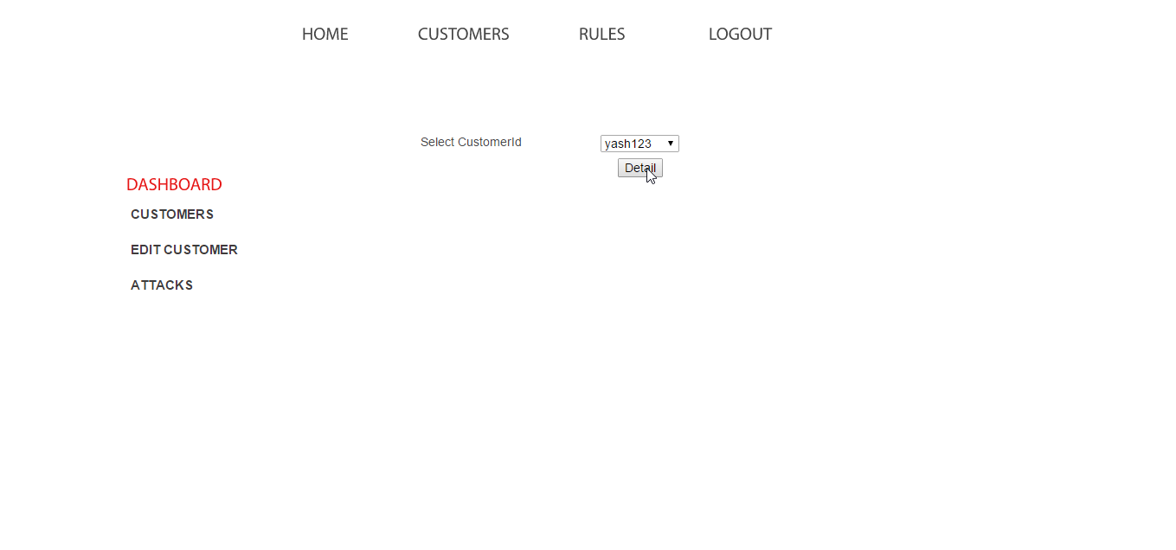

Fig 5.4.8 Customer Id Allocation

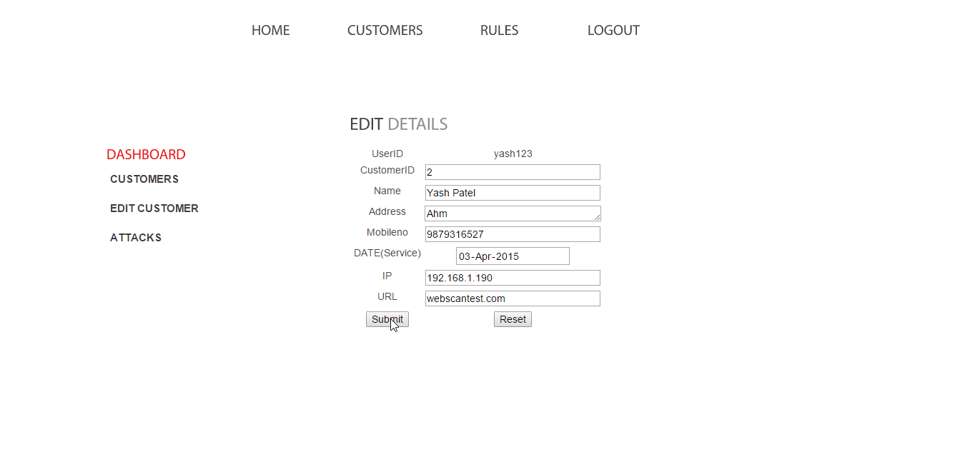
5.4.9 Edit Customer Details

Fig 5.4.9 Edit Customer Details
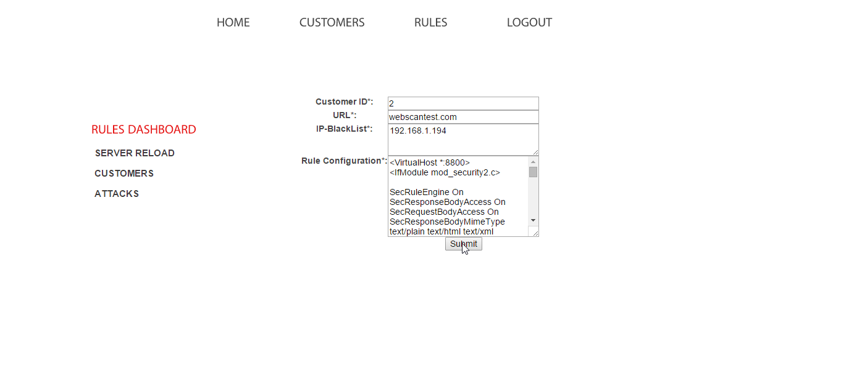
5.4.10 Push Signature Rules of a specific Client

Fig 5.4.10 Push Signature Rules of a specific Client

5.4.11 Server Apache Reload From Admin Panel
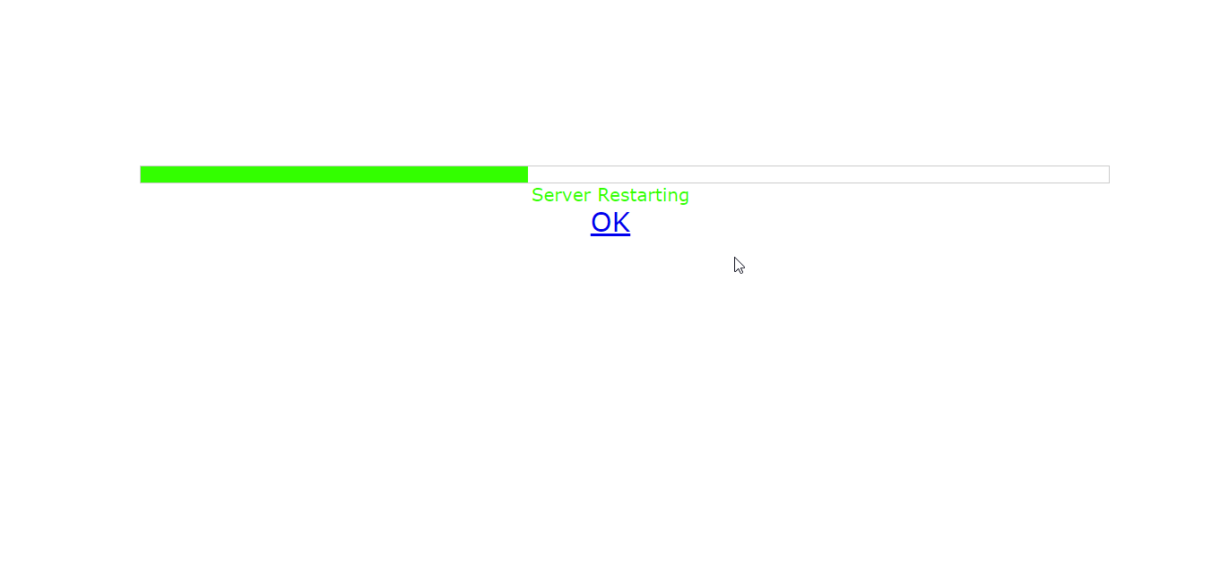
Fig 5.4.11 Server Apache Reload From Admin Panel
5.4.12 Client Attack Details Analysis/Monitoring
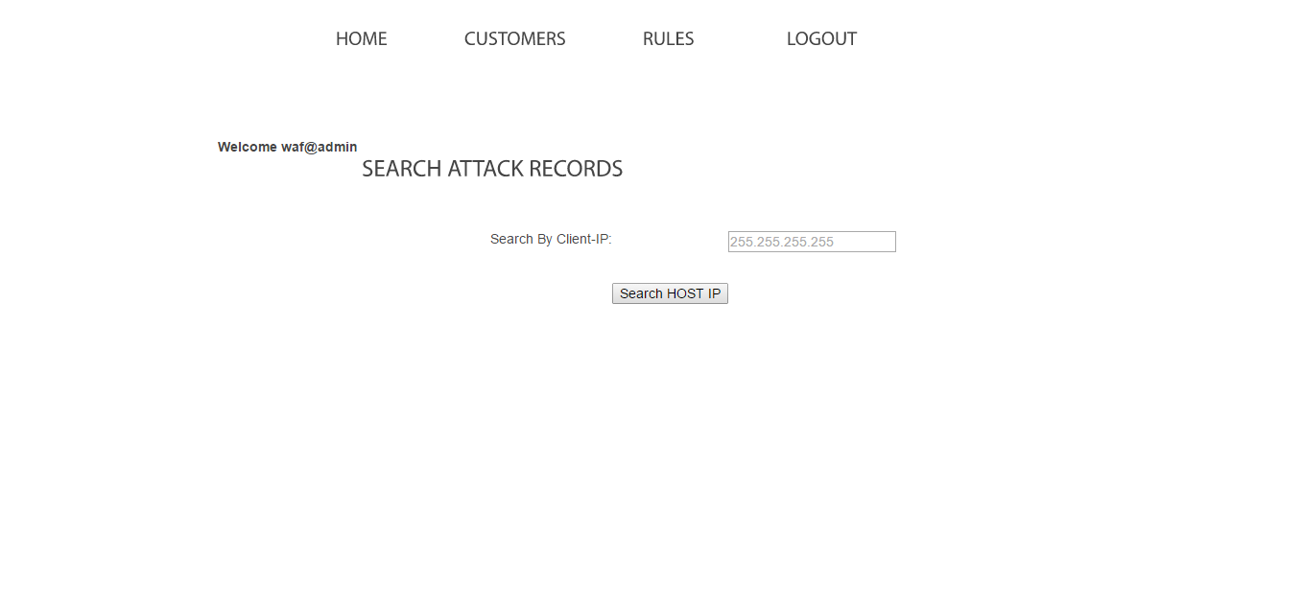

Fig 5.4.12 Client Attack Details Analysis/Monitoring

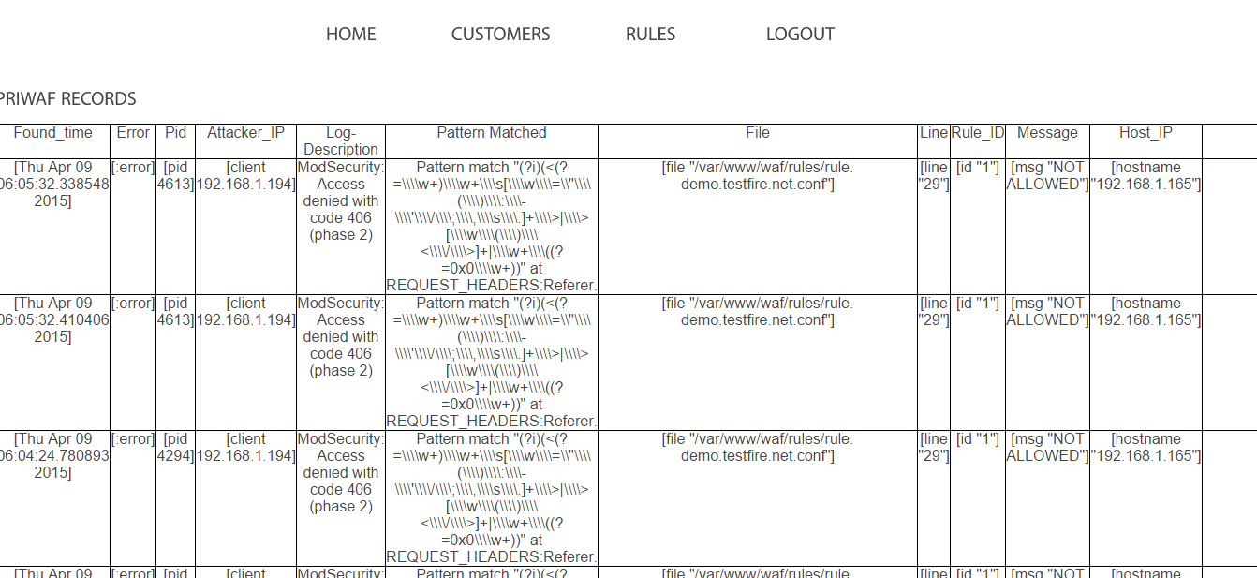
5.4.13 Attack Reports/Logs

Fig 5.4.13 Attack Reports/Logs
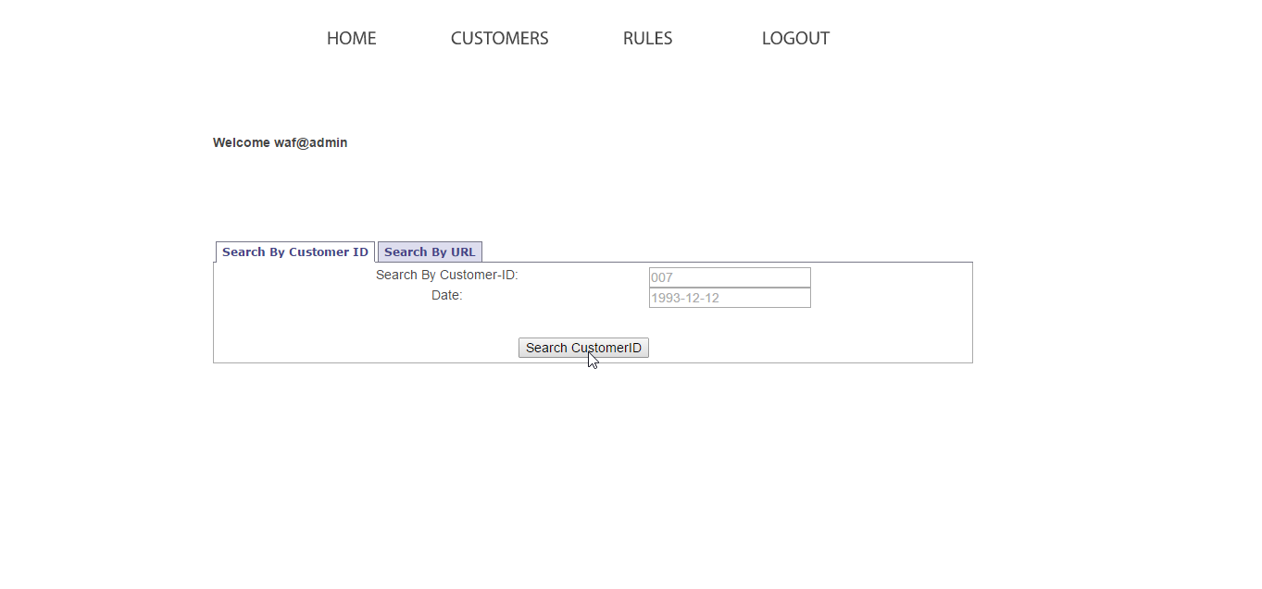
5.4.14 Customer Scanning Reports

Fig 5.4.14 Customer Scanning Reports

Signature Development for Sec Rule (Core Rule set | Custom Rule Set)

Rule configuration (mod security)
Fig 5.4.15 Rule Configuration 1
Fig 5.4.16 Rule Configuration 2
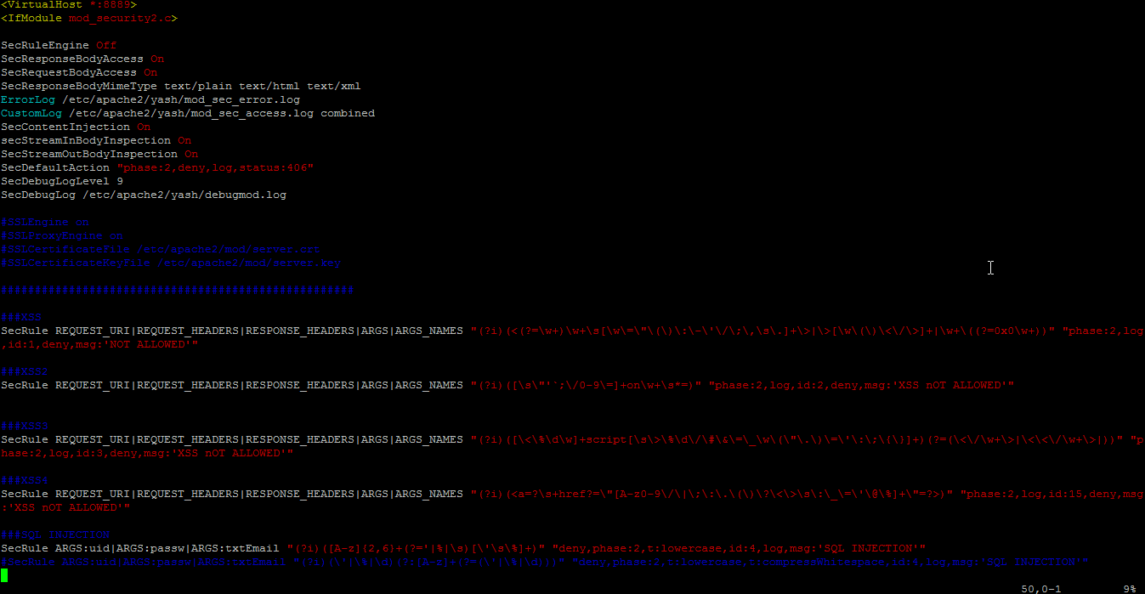
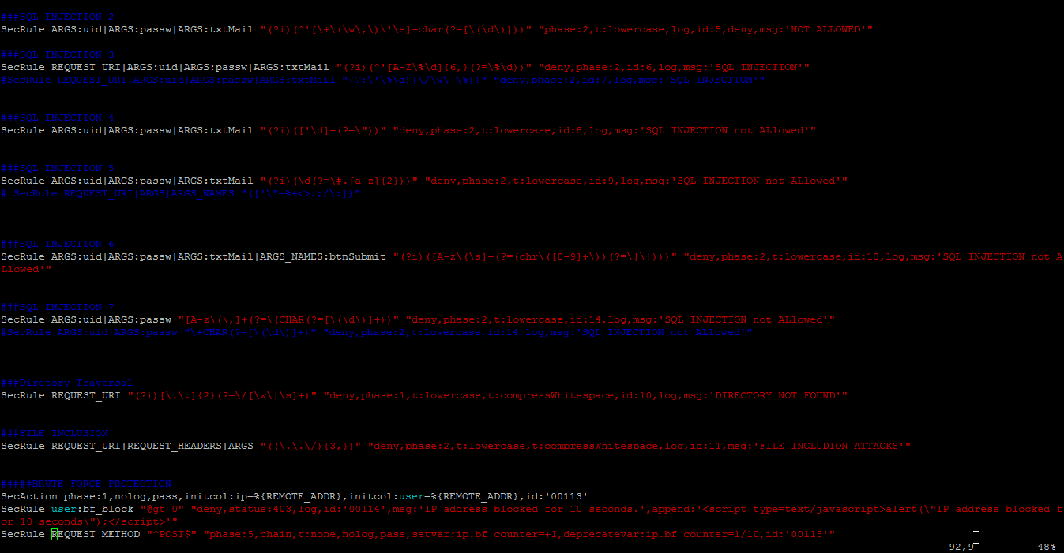

Fig 5.4.17 Rule Configuration 3

