Capstone Project Report on
PLC-Based Dual Pump Control System
Submitted in partial fulfillment of the requirements of the Third Year of
Bachelor of Technology In
Electronics and Computer Science
By
Pavitra Bhadane[EU1247011]
Anushka Dange[EU1247037]
Yash Pale [EU1247042]
Tanvi Raul[EU1247036]

Under the Guidance of

Ms. Hiral Patel
Assistant professor, Department of electronics and computer science,SJCEM



DEPARTMENT OF ELECTRONICS AND COMPUTER SCIENCE ST. JOHN COLLEGE OF ENGINEERING & MANAGEMENT UNIVERSITY OF MUMBAI
2026-2027

CCertificate of Approval
This is to certify that, following students of T. Tech in Electronics and Computer Science Department. They have satisfactorily completed the requirements for the courses Programmable Logic Controllers and SCADA prescribed by ST. JOHN COLLEGE OF ENGINEERING AND MANAGEMENT (An Autonomous
College affiliated to University of Mumbai), while working on “PLC-Based Dual Pump Control System”
Pavitra Bhadane[EU1247011]
Anushka Dange[EU1247037]
Yash Pale [EU1247042]
Tanvi Raul[EU1247036]

Signature:_______________  Name : Ms. Hiral Patel  Ass. Professor | Signature:________________  Name : Dr. Md. Immadudin HOD

Signature: External Signature:
Name: Dr. Kamal Shah Principal,
St. John College of Engineering and Management.

Declaration

I/we declare that this written submission represents my/our ideas in my/our own words and where others ideas or words have been included, I/we have adequately cited and referenced the original sources. I/we also declare that I/we have adhered to all principles of academic honesty and integrity and have not misrepresented or fabricated or falsified any idea/data/fact/source in my/our submission. I/we understand that any violation of the above will be cause for disciplinary action by the Institute and can also evoke penal action from the sources which have thus not been properly cited or from whom proper permission has not been taken when needed.

Signatures:

Pavitra Bhadane [EU1247011]

Anushka Dange [EU1247037]

Yash Pale [EU1247042]

Tanvi Raul [EU1247036]

Date

ACKNOWLEDGEMENT

We sincerely thank our project guide Ms.Hiral Patel for her guidance and support for carrying out our Project. We thank our HOD Dr. Md. Immadudin for his valuable time and provision of departmental facilities. We thank Principal Dr. Kamal Shah for the infrastructure and maintenance. We also thank lab assistants for their help and practical guidance.

Pavitra Bhadane[EU1247011]

Anushka Dange[EU1247037]

Yash Pale [EU1247042]

Tanvi Raul[EU1247036]

Abstract

This project presents a PLC-based tank level control system using two pumps arranged in a Duty + Assist configuration. The objective is to maintain the liquid level within a desired operating range while reducing manual intervention and improving operational reliability. A level sensor arrangement provides the PLC with information about the liquid level. When the level reaches a configured start threshold, the designated duty pump starts. If the level continues to rise or the demand exceeds the capacity of the duty pump, a second assist pump is started at a higher threshold. When the level falls to the stop threshold, the running pumps are stopped according to the selected control strategy.
The PLC processes sensor inputs, applies start/stop logic, monitors overload and emergency-stop signals, and operates the pump contactors through suitable output interfaces. Interlocking and hysteresis are used to reduce rapid switching. An optional alternation feature can rotate the duty assignment after a completed cycle to distribute operating hours more evenly. Indicators or an HMI can display tank level status, pump availability, active pump, and fault conditions.
The proposed system is suitable as an educational model for water storage tanks, industrial process tanks, and utility systems. The report includes the problem definition, literature survey, feasibility study, methodology, system diagrams, I/O allocation, conceptual ladder logic, testing plan, expected results, limitations, and future scope. The final implementation must be adapted to the selected PLC model, sensor type, pump ratings, and site safety requirements.
Keywords: PLC, tank level control, duty pump, assist pump, level sensor, ladder logic, motor interlocking, overload protection.

CONTENTS

Chapter No. | Topic | Page No.
CHAPTER 1 | OVERVIEW | 1
1.1 | Introduction | 1
1.2 | Background | 1
1.3 | Importance of the Project | 1
1.4 | Perspective of Stakeholders and Customers | 2
1.5 | Objectives and Scope of the Project | 2
CHAPTER 2 | LITERATURE SURVEY & PROPOSED | 3
2.1 | WORK | 3
2.2 | Introduction | 3
2.3 | Literature Survey Table | 4
2.4 | Problem Definition | 4
2.5 | Feasibility Study | 4
 | Methodology Used
CHAPTER 3 | ANALYSIS AND PLANNING | 5
3.1 | Introduction | 5
3.2 | Project Planning | 5
CHAPTER 4 | DESIGN & IMPLEMENTATION | 6
4.1 | Data Flow Diagram (DFD) | 6
4.2 | Block Diagram | 6
4.3 | Flow Chart | 7
4.4 | UML & PLC Ladder Diagram | 7
CHAPTER 5 | RESULTS & DISCUSSION | 9
5.1 | Actual Results | 9
5.2 | Future Scope | 9
CHAPTER 6 | CONCLUSION | 10
REFERENCES |  | 11

CHAPTER 1: OVERVIEW

Introduction
Liquid storage tanks are commonly used in residential buildings, industries, water treatment plants, cooling systems, and process plants. Maintaining the tank level within a defined range is important to ensure continuous supply, prevent overflow, and avoid unnecessary pump operation. Manual operation depends on an operator observing the tank and switching pumps on or off. This can lead to overflow, dry running, delayed response, and inconsistent operation.
A Programmable Logic Controller (PLC) can automate the process by reading level switches or a level transmitter and controlling pump motor starters according to a defined program. In a Duty + Assist arrangement, one pump is normally responsible for meeting regular demand. The second pump starts only when additional capacity is required, such as when the level reaches a high threshold or the duty pump cannot recover the level quickly enough.

Background
Pump systems are often designed with more than one pump to improve capacity and operational continuity. A duty pump is the primary pump selected to operate during normal demand. An assist pump supports the duty pump during peak demand. Depending on the application, the pumps may be assigned fixed roles or their duty roles may be alternated after each cycle to balance operating hours.
PLC-based control provides deterministic logic, clear status indication, and the ability to include safety interlocks. The controller can use separate level thresholds for starting and stopping to create hysteresis. This reduces frequent on/off switching caused by small fluctuations around a single threshold.

Importance of the Project
- Automatic Level Regulation: Reduces the need for continuous manual supervision.
- Additional Pumping Capacity: The assist pump provides extra capacity when required.
- Improved Safety: PLC interlocks help prevent operation during emergency-stop or overload conditions.
- Reduced Overflow Risk: Level-based sequencing helps control the liquid level.
- Fault Detection: Fault indication helps identify pump overload, sensor faults, and abnormal level conditions.
- Reduced Pump Cycling: Separate start and stop thresholds help prevent frequent switching.
- Balanced Pump Operation: Optional duty alternation can distribute operating hours between the two pumps.
- Industrial Automation: Demonstrates the application of PLC programming in an industrial process.

Perspective of Stakeholders and Customers
- The system may be useful to building maintenance teams, water-treatment operators, small manufacturing facilities, and laboratory demonstrators.
- Operators: Operators benefit from automatic pump control and clear status indications.
- Maintenance Personnel: Maintenance personnel can identify pump faults and monitor operating conditions.
- Industrial Facilities: Industries benefit from controlled tank levels and additional pumping capacity during high demand.
- Building Management: Automatic control reduces the need for manual switching of water pumps.
- Water Treatment Plants: The system can help maintain the required liquid level in storage and process tanks.

Objectives and Scope of the Project
Objectives
The main objectives of this project are:
- To design an automatic tank-level control system using a PLC and two pumps.
- To operate Pump 1 as the duty pump and Pump 2 as the assist pump based on level thresholds.
- To stop pumps at the defined low/stop level and prevent rapid cycling through hysteresis.
- To include emergency-stop, overload, and pump-availability interlocks.
- To provide clear indication of tank level status, pump operation, and fault conditions.
- To develop a conceptual ladder logic sequence that can be adapted to the selected PLC.
- To reduce manual intervention in tank-level management.
- To improve the reliability of the pumping process.
Scope
The project covers the control logic, sensor inputs, PLC I/O mapping, motor starter outputs, status indication, and a proposed testing plan.
The exact tank size, pump capacity, sensor technology, electrical ratings, and PLC model are to be finalized according to the laboratory or installation requirements.
The system can be developed as a PLC simulation or as a physical prototype using a tank, two pumps, level sensors, motor starters, and suitable protection devices.
The report does not claim measured performance from hardware unless actual tests are completed.

CHAPTER 2: LITERATURE SURVEY & PROPOSED WORK

Introduction
Tank-level control can be implemented using manual switches, relay logic, microcontrollers, or PLCs.
Simple float-switch systems can provide basic ON/OFF control, while PLCs are better suited when multiple pumps, permissives, alarms, operating modes, and fault handling are required.
The Duty + Assist configuration provides a structured method of adding pumping capacity only when necessary.
In a conventional single-pump system, the pump operates according to the tank-level condition. However, when the demand exceeds the capacity of the single pump, the liquid level may not return to the desired operating range quickly enough.
A two-pump arrangement solves this problem by operating one pump during normal demand and starting the second pump when additional capacity is needed.

Literature Survey Table

Sr. No. | Title of Paper / System | Authors & Year | Technology Used | Limitations / Research Gap
1 | Water Level Control System Using PLC and Wireless Sensors | Authors: Check original paper; 2013 | Siemens LOGO! 24RL PLC, RTX-MID-3V wireless transceivers, converters, motor-driven pump and LED indicators | Focuses on wireless water-level monitoring and pump control. Advanced Duty + Assist sequencing and automatic duty alternation are not established in the available abstract.
2 |  | Rishabh Das, Sayantan Dutta, Anusree Sarkar and Kaushik Samanta; 2012 | Siemens S7-300 PLC, level sensors, SCADA and HMI | Focuses on automated tank-level monitoring and control. The available description does not establish advanced two-pump Duty + Assist operation or automatic pump alternation
  Automation of Tank
  Level Using PLC and
  Establishment of HMI
  by SCADA
3 |  | Min Zhao, Cai Yun Ren and Dong Liang Lei; 2013 | PLC, radar level gauge, two AC motors, main and auxiliary pumps, Siemens Smart700 HMI and WinCC | Provides PLC-based liquid-level monitoring with main and auxiliary pumps. The available abstract does not specify detailed duty alternation, overload-based pump changeover or dry-run recovery logic.
  The Study on Liquid
  Level Control System
  Based on PLC and WinCC

2.3Problem Definition

In a manually operated tank system, pump switching may be delayed or inconsistent. A single pump may also be insufficient during peak demand, while running both pumps continuously can waste energy and increase wear. A reliable solution must start the duty pump at the appropriate level, add the assist pump only when needed, stop pumps at a safe level, and prevent operation when a protection input is active.

The key design challenge is to define unambiguous level thresholds and a safe sequence for the two pumps. The logic must also consider overload trips, emergency-stop conditions, unavailable pumps, sensor faults, and restart behavior after a power interruption.

2.4Feasibility Study
Technical Feasibility
The project is technically feasible using a PLC with sufficient digital inputs and outputs, compatible level switches or a level transmitter, two motor starters, overload relays, and indicator devices. If an analog level transmitter is selected, the PLC must support the relevant analog input range, such as 4–20 mA or 0–10 V.
Operational Feasibility
The system is intended to operate automatically after the operator selects Auto mode and confirms that the tank, pumps, sensors, and protection circuits are ready. Manual mode, if provided, should be restricted by safety interlocks and should not bypass emergency-stop or overload protection.
Economic Feasibility
The system can be built as a laboratory prototype using low-voltage level switches and indicator lamps, or as an industrial installation using properly rated pumps, contactors, overload relays, enclosures, and sensors. Total cost depends on the selected PLC, motor ratings, sensor type, and panel requirements.

2.5 Methodology Used
Requirement identification: determine tank use, operating range, pump capacities, and required safety functions.
Sensor selection: choose low-level, duty-start, assist-start, and stop-level signals or a continuous level transmitter.
PLC I/O design: assign input addresses to level and protection signals and outputs to pump starter coils and indicators.
Control logic development: implement duty start, assist start, stop logic, fault interlocks, and optional duty alternation.
Simulation: verify all normal and abnormal sequences in PLC programming software before connecting motor loads.
Commissioning: test sensor states, output logic, overload trips, emergency stop, and recovery behavior under controlled conditions.

CHAPTER 3: ANALYSIS AND PLANNING

Introduction

The successful implementation of a PLC-based tank level control system with two pumps in a Duty + Assist configuration requires systematic planning of the control logic, sensor interfacing, PLC programming, pump operation, and safety mechanisms. The system is designed to monitor the tank water level and control two pumps according to predefined level conditions. The duty pump operates during normal demand, while the assist pump starts when additional pumping capacity is required. Proper planning helps ensure reliable operation, effective pump coordination, and protection against overflow, dry running, and pump overload.

Project Planning
Table 2: Project Planning & Phase Breakdown

Phase | Activity Description | Deliverable | Duration
Phase 1 | Requirement Analysis & Literature Review | Problem Statement & Component Selection | Weeks 1–2
Phase 2 | System Design & Sensor Selection for Tank Level Detection | Tank Level Control Block Diagram, Sensor Arrangement & System Architecture | Weeks 3–4
Phase 3 | PLC I/O Mapping & Ladder Logic Development | PLC Input-Output Allocation Table and Ladder Logic Program for Duty + Assist Control | Weeks 5–7
Phase 4 | Pump Control Logic Implementation & Safety Interlocking | Duty Pump and Assist Pump Sequencing with Overload, Dry-Run and Emergency Stop Protection | Weeks 8–9
Phase 5 | PLC Program Simulation & System Testing | Verified PLC Logic, Pump Switching Tests and Tank Level Response Analysis | Weeks 10–11
Phase 6 | Full System Integration, Fault-Injection Testing & Report | Final Prototype & Capstone Report | Week 12

CHAPTER 4: DESIGN & IMPLEMENTATION

Data Flow Diagram (DFD)
Figure 1: DFD Level 0 & Level 1

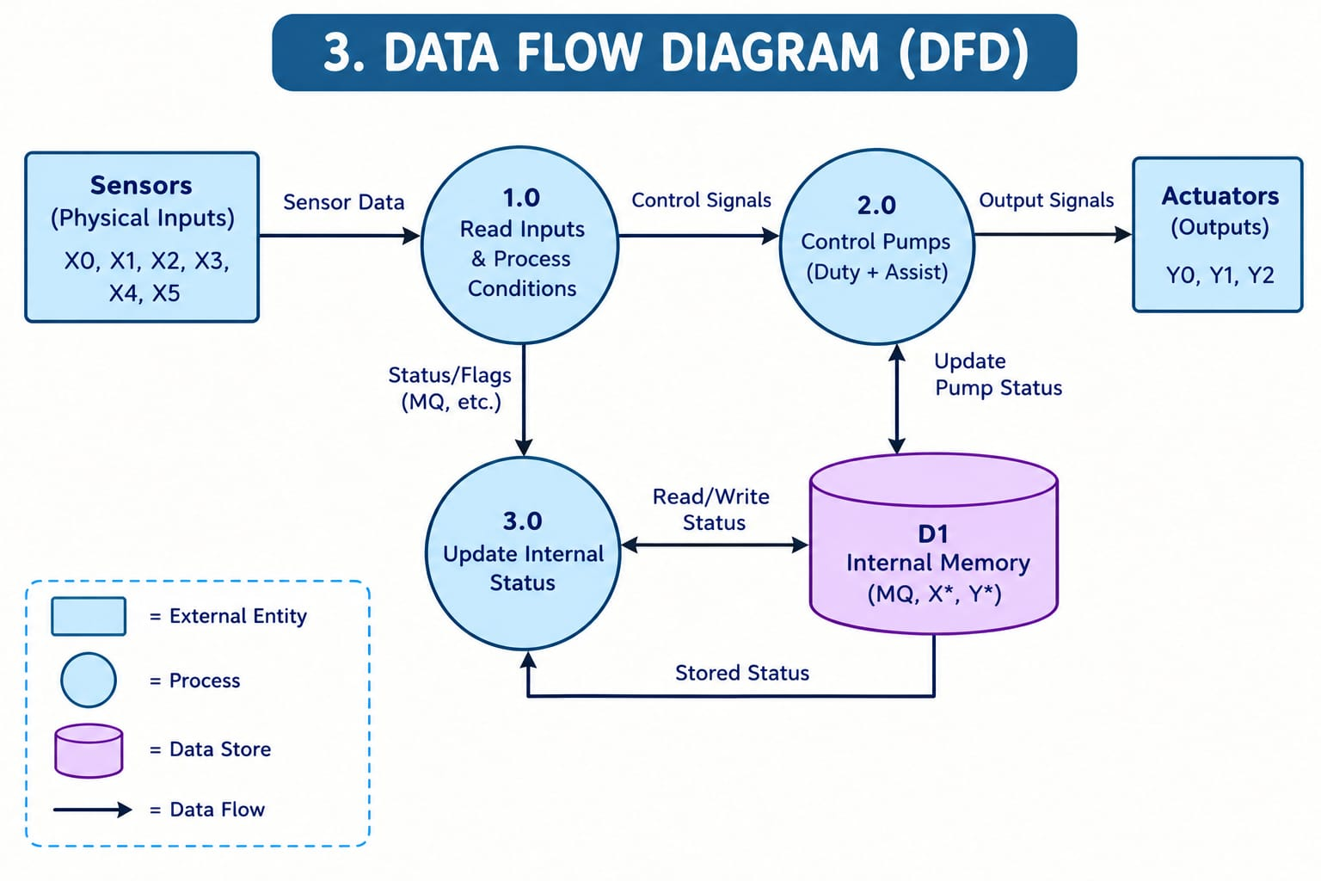
The Data Flow Diagram (DFD) represents the flow of information between different components of the PLC-based tank-level control system. It explains how sensor data is processed, how decisions are made, and how pump operations are controlled.
The Sensors (X0–X5) provide input signals related to the filling request, water level, pump health, and automatic mode. Process 1.0 reads these inputs and checks the operating conditions. The processed control signals are transferred to Process 2.0, which controls the duty and assist pumps. The actuators receive output signals Y0, Y1, and Y2 to operate Pump 1, Pump 2, and the failure warning, respectively.
Process 3.0 updates the internal status and communicates with data store D1. The internal memory stores control flags, pump status, and other relevant information. Thus, the DFD explains how data is collected, processed, stored, and used to control the tank-filling operation efficiently.

Block Diagram
Figure 2: System Hardware & PLC Interfacing Block Diagram
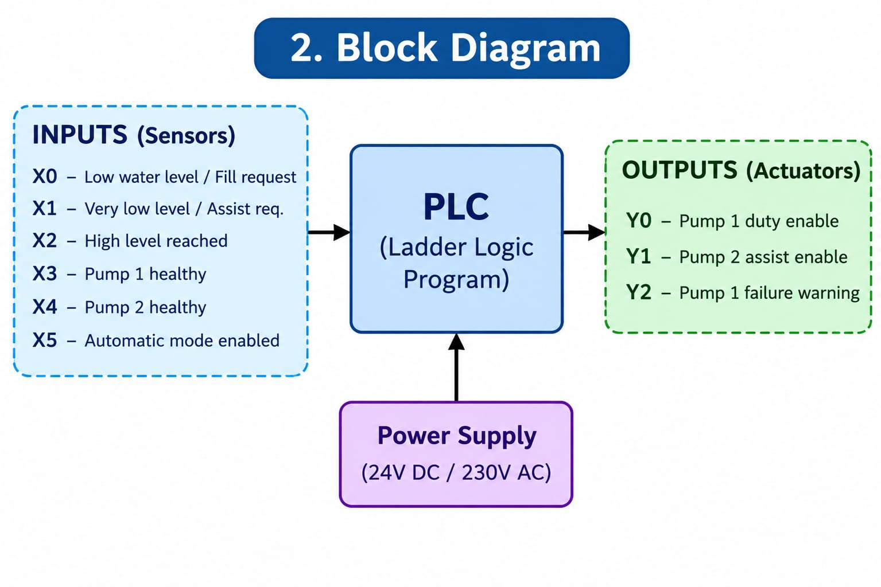

The input section contains six digital inputs, X0 to X5. X0 indicates a low water level or filling request, X1 indicates a very low water level, and X2 indicates that the high water level has been reached. X3 and X4 represent the health status of Pump 1 and Pump 2, while X5 indicates that automatic mode is enabled.
These input signals are provided to the Mitsubishi PLC, which executes the ladder logic program and makes decisions according to the programmed conditions. The output section consists of Y0 for Pump 1 duty operation, Y1 for Pump 2 assist operation, and Y2 for the Pump 1 failure warning.
The power supply provides the required electrical power to the control system. The PLC continuously monitors the inputs and updates the outputs according to the water level and pump conditions. This arrangement provides automatic operation, reduces manual intervention, and improves the reliability of the tank-filling process.

Flow Chart
Figure 3: Dispensing & Fault Watchdog Sequence Flow Chart

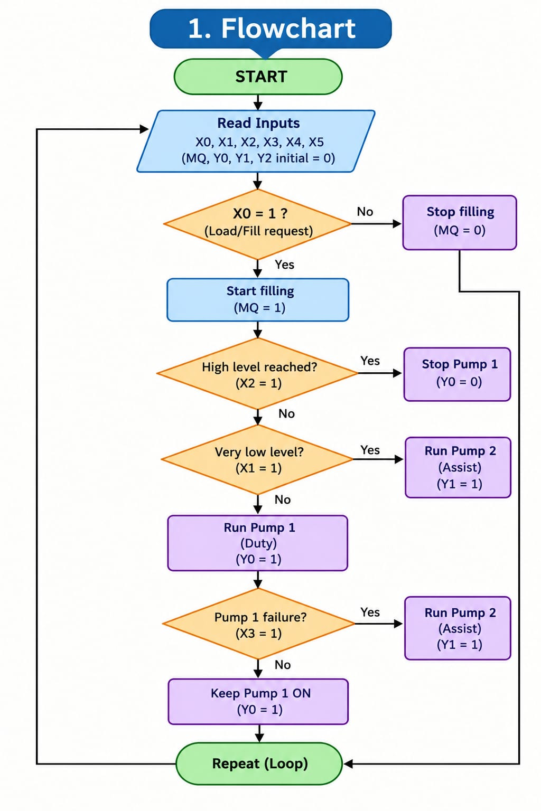

UML & PLC Ladder Diagram
Table 3: Mitsubishi FX5U PLC I/O & Internal Relay Allocation

Device Tag | Type | Function / Description
X0 | Digital Input | Low-Level Sensor — indicates that the tank water level has reached the low-level limit
X1 | Digital Input | High-Level Sensor — indicates that the tank water level has reached the high-level limit
X2 | Digital Input | Duty Pump Overload Feedback — detects overload condition in Pump 1
X3 | Digital Input | Assist Pump Overload Feedback — detects overload condition in Pump 2
X4 | Digital Input | Auto/Manual Mode Selection Switch
X5 | Digital Input | Emergency Stop Push Button
X6 | Digital Input | Duty Pump Manual Start Push Button
X7 | Digital Input | Assist Pump Manual Start Push Button
M0 | Internal Relay | Automatic Mode Enable Flag
M1 | Internal Relay | Duty Pump Operation Command
M2 | Internal Relay | Assist Pump Operation Command
M3 | Internal Relay | High-Level Condition Flag
M4 | Internal Relay | Low-Level Condition Flag
M5 | Internal Relay | Pump Overload Fault Flag

Figure 4: Mitsubishi FX5U PLC Ladder Diagram (MELSOFT GX Works3 Format)
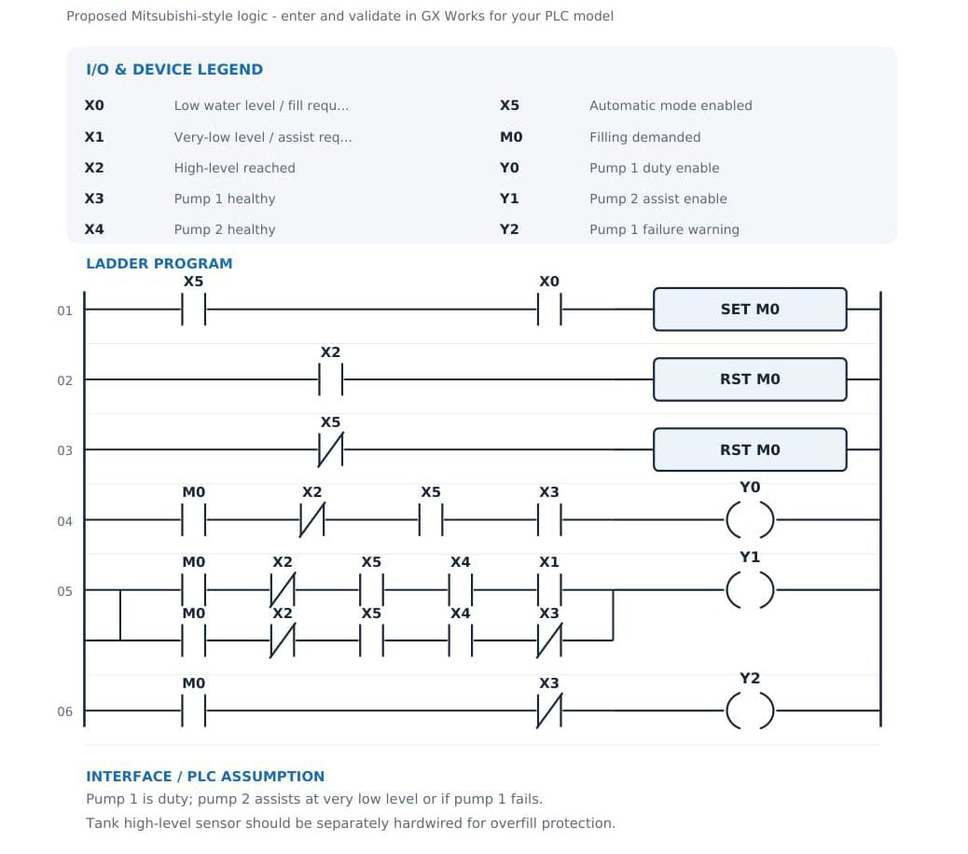

During normal operation, Pump 1 acts as the primary duty pump. Output Y0 turns ON when the filling command is active, the high-level sensor has not been activated, automatic mode is enabled, and Pump 1 is healthy.
Pump 2 acts as the assist pump. Output Y1 operates when the water level reaches a very low condition (X1) or when Pump 1 fails, subject to the programmed pump-health and operating conditions. This provides backup operation when additional pumping is required or the primary pump becomes unavailable.
Output Y2 is used as a failure warning for Pump 1. When the filling command is active and the Pump 1 healthy signal (X3) indicates a fault, the PLC activates the warning output. The PLC repeatedly scans the ladder logic and updates the outputs as input conditions change.
Therefore, the ladder diagram provides automatic tank filling, high-level cut-off, assist-pump operation, and pump-failure indication. A separate hardwired high-level protection circuit can also be used to improve safety and prevent tank overflow.

CHAPTER 5: RESULTS & DISCUSSION

Actual Results
- Because measured hardware results were not supplied, this section describes a verification plan and expected behaviour rather than claiming completed experimental measurements.
- The tests should first be performed in PLC simulation, followed by controlled hardware testing if the prototype is available.

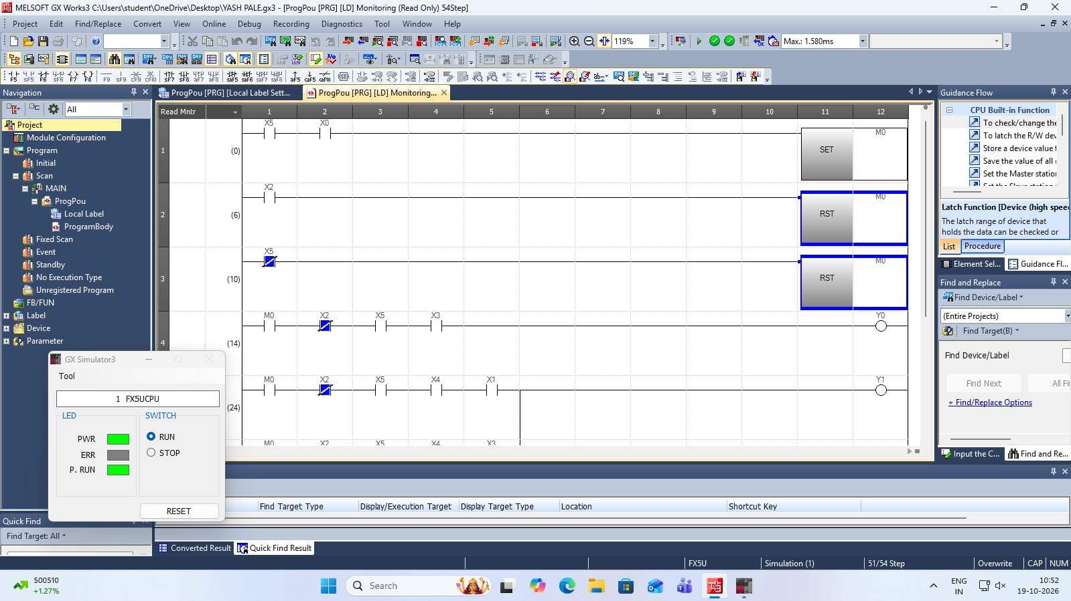

Future Scope
- Analog Level Monitoring: Add an analog level transmitter to display continuous tank level on an HMI.
- Automatic Duty Alternation: Alternate the duty pump after each cycle or according to accumulated running hours.
- Pump-Running Feedback: Add auxiliary contacts or flow/pressure switches to confirm pump operation.

CHAPTER 6:CONCLUSION
The proposed PLC-based tank level control system uses two pumps in a Duty + Assist configuration to automate liquid-level management.
The duty pump handles normal demand, while the assist pump provides additional capacity when the level reaches a higher threshold or the process requires more pumping capacity.
Separate start and stop thresholds help reduce rapid switching, and the PLC can incorporate overload feedback, emergency-stop status, low-low protection, alarms, and optional duty alternation.
The report establishes the control philosophy, system architecture, flowchart, logical I/O allocation, conceptual ladder sequence, and a test plan for implementation.
The final system should be programmed and simulated using the selected PLC software, then commissioned with appropriately rated electrical protection and verified sensors. Measured performance should be documented after actual tests.
With correct design and commissioning, the system can provide a practical educational example of industrial automation using PLCs. It can reduce manual intervention, improve monitoring, and provide additional pumping capacity when required.

REFERENCES
- • Bolton, W., Programmable Logic Controllers, 6th Edition, Newnes/Elsevier, 2015.
- • Petruzella, F. D., Programmable Logic Controllers, 5th Edition, McGraw-Hill Education, 2017.
- • International Electrotechnical Commission (IEC), IEC 61131-3: Programmable Controllers – Programming Languages.
- • International Electrotechnical Commission (IEC), IEC 60204-1: Safety of Machinery – Electrical Equipment of Machines.
- • Selected PLC Manufacturer, PLC Hardware Manual and Programming Manual. Use the manual corresponding to the actual PLC model selected for this project.
- • Selected Level Sensor Manufacturer, Level Switch / Level Transmitter Datasheet and Installation Manual. Use the exact model used in the final prototype.
- • Selected Motor Starter and Overload Relay Manufacturer, Product Catalogue and Installation Instructions.

