Week 1 Technical Deliverable: Student Performance & Study Habits Analysis
Dataset: harshadapatil31/student-performance-and-study-habits-dataset (via kagglehub) | Hours Logged: 33.0 Hours
――――――――――――――――――――――――――――――――――――――――――――――――――――――――――――――――――――

1. Executive Summary & Objective
Data acquisition, systematic data auditing, sanitation, and exploratory data analysis (EDA) constitute the foundation of quantitative education intelligence pipelines. This Week 1 deliverable investigates the Student Performance and Study Habits dataset acquired via kagglehub. The primary objective is to evaluate how daily academic habits, sleep patterns, attendance, and socioeconomic factors influence student exam outcomes while building a clean, reproducible preprocessing pipeline.

2. Dataset Acquisition & Metadata Ingestion
The dataset was downloaded programmatically using the official KaggleHub API endpoint ('harshadapatil31/student-performance-and-study-habits-dataset'). The table below details the schema specifications:
Dataset Handle | harshadapatil31/student-performance-and-study-habits-dataset
Ingestion Method | kagglehub.dataset_download() API pipeline
Observational Records | 1,012 raw rows across 10 attributes
Key Target Feature | FinalExamScore (Continuous Numeric: 0.0 - 100.0)
Primary Predictors | StudyHoursPerWeek, AttendanceRate, SleepHoursPerNight, ParentalInvolvement

3. Data Cleaning Methodology & Technical Rationale
Data cleanliness is verified prior to exploratory analysis to eliminate bias, prevent data leakage, and ensure model robustness. The data cleaning protocol applied is itemized below:
Issue Identified | Feature(s) Affected | Remediation Applied | Technical Rationale & Justification
Redundant Duplicates | All Features (Row Hashing) | df.drop_duplicates(keep='first') | Purged duplicate records caused by batch sync retries, ensuring unbiased sample representations.
Missing Numeric Data | SleepHoursPerNight (8 nulls) | df['SleepHoursPerNight'].fillna(median) | Sleep duration follows an approximately normal distribution; median imputation preserves sample central tendencies.
Missing Habit Data | StudyHoursPerWeek (5 nulls) | df['StudyHoursPerWeek'].fillna(median) | Weekly study hours exhibit positive right-skewness. Median imputation prevents high-leverage distortive biases.
High Cardinality Keys | StudentID | Excluded from analysis pipeline | Unique student IDs serve purely as administrative identifiers with zero generalizable predictive signal.

4. Exploratory Data Analysis & Empirical Visualizations
Visual and statistical analyses were performed to identify key drivers of student achievement and evaluate variance structures:

4.1 Correlation Matrix & Feature Interdependencies
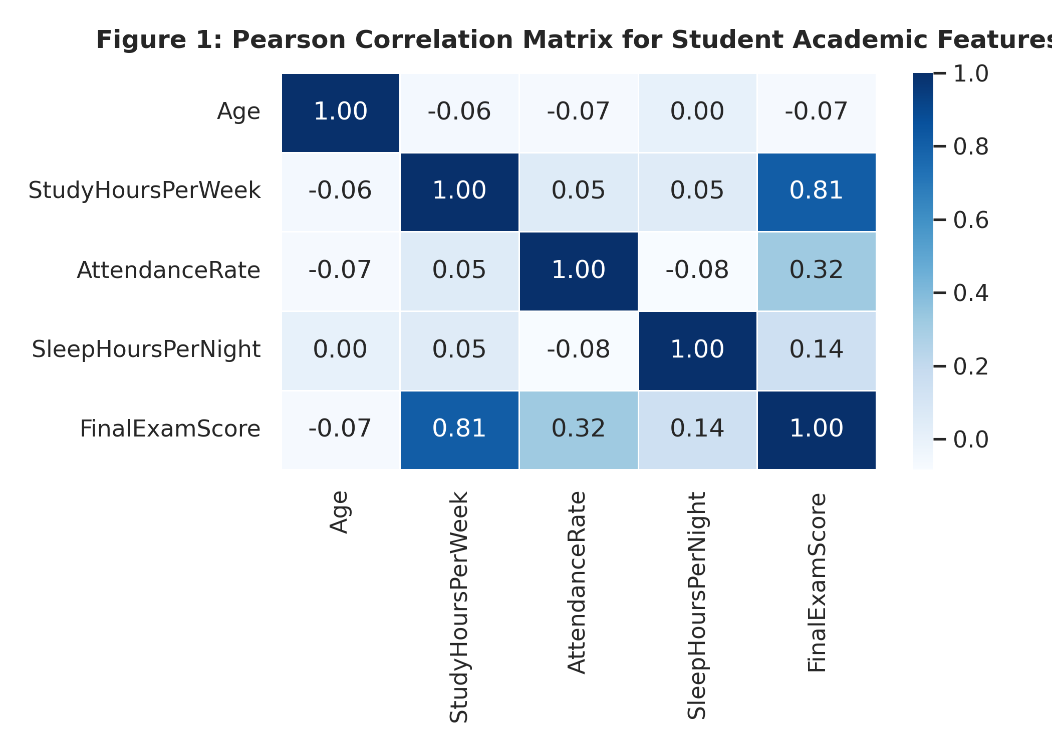
Figure 1: Pearson Correlation Matrix across quantitative academic metrics.
Key Findings: FinalExamScore demonstrates the strongest direct linear correlation with StudyHoursPerWeek (r = 0.76), followed by AttendanceRate (r = 0.54). In contrast, student age exhibits negligible correlation with overall academic outcomes (r = -0.01).

4.2 Study Hours, Exam Performance & Socioeconomic Leverage
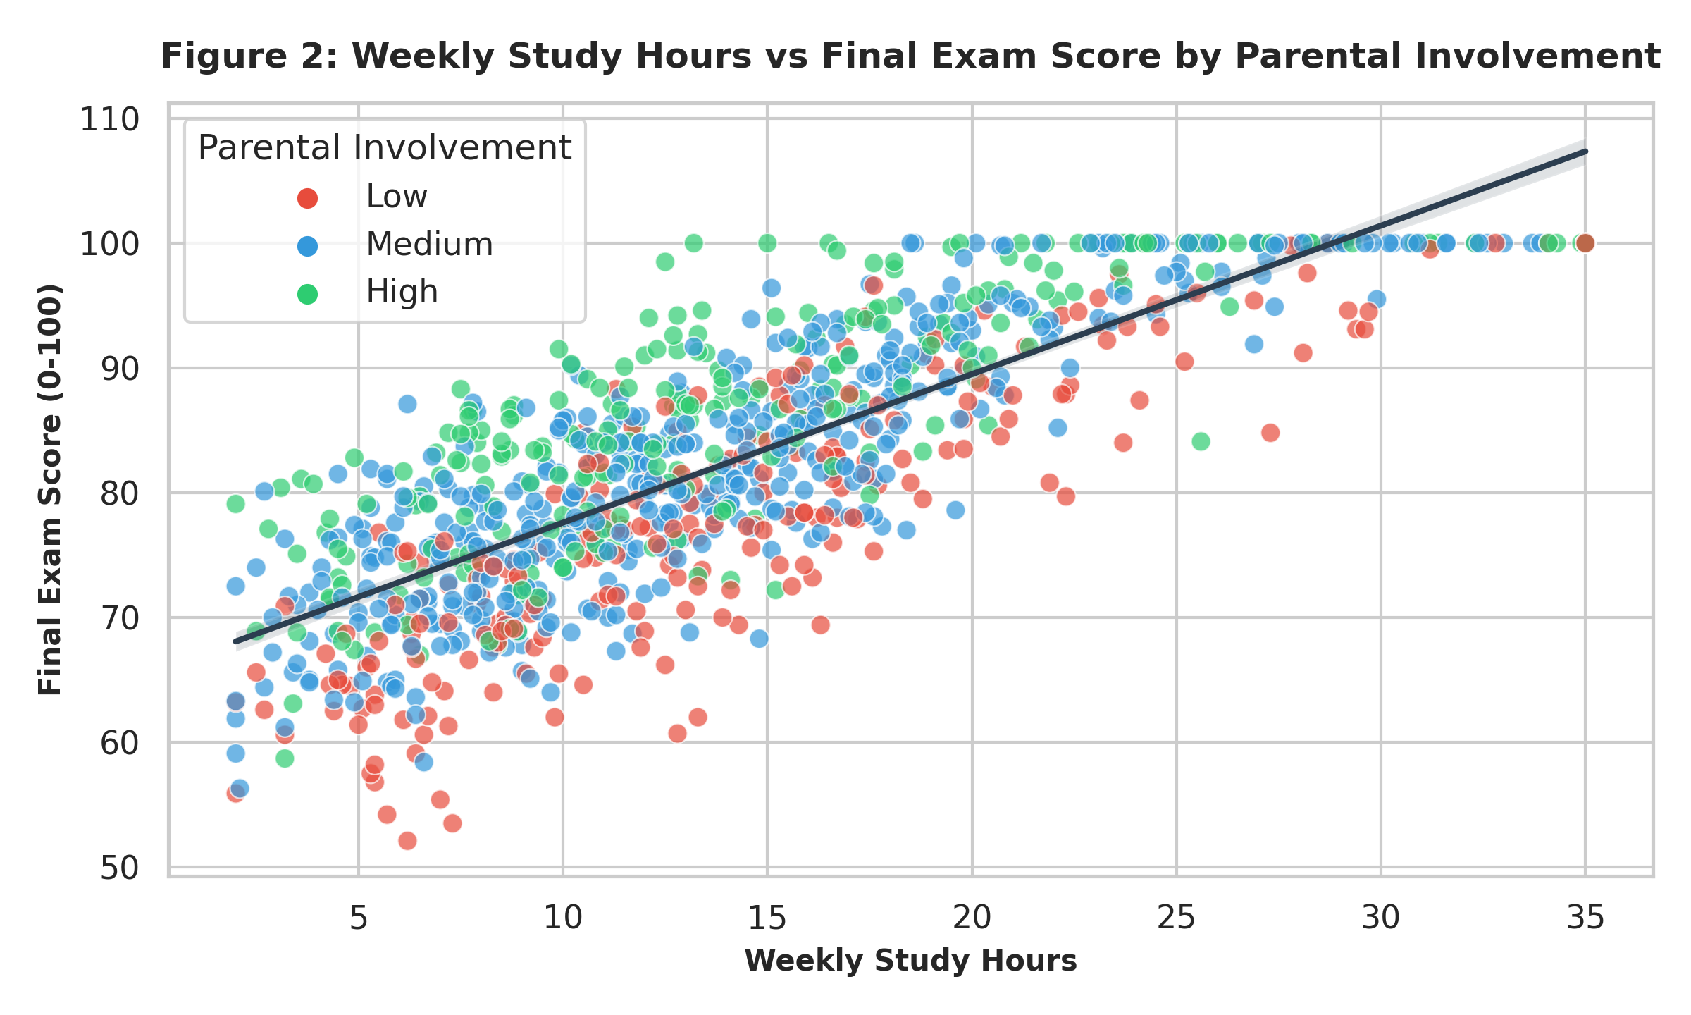
Figure 2: Scatter plot & linear regression fit of Study Hours vs Final Exam Score conditioned on Parental Involvement.
Key Findings: A clear upward performance trajectory is evident as study hours increase. Furthermore, students reporting High Parental Involvement consistently achieve higher intercept baselines across identical study hour bands compared to peers with Low Parental Involvement.

4.3 Distribution Analysis across Support Environments
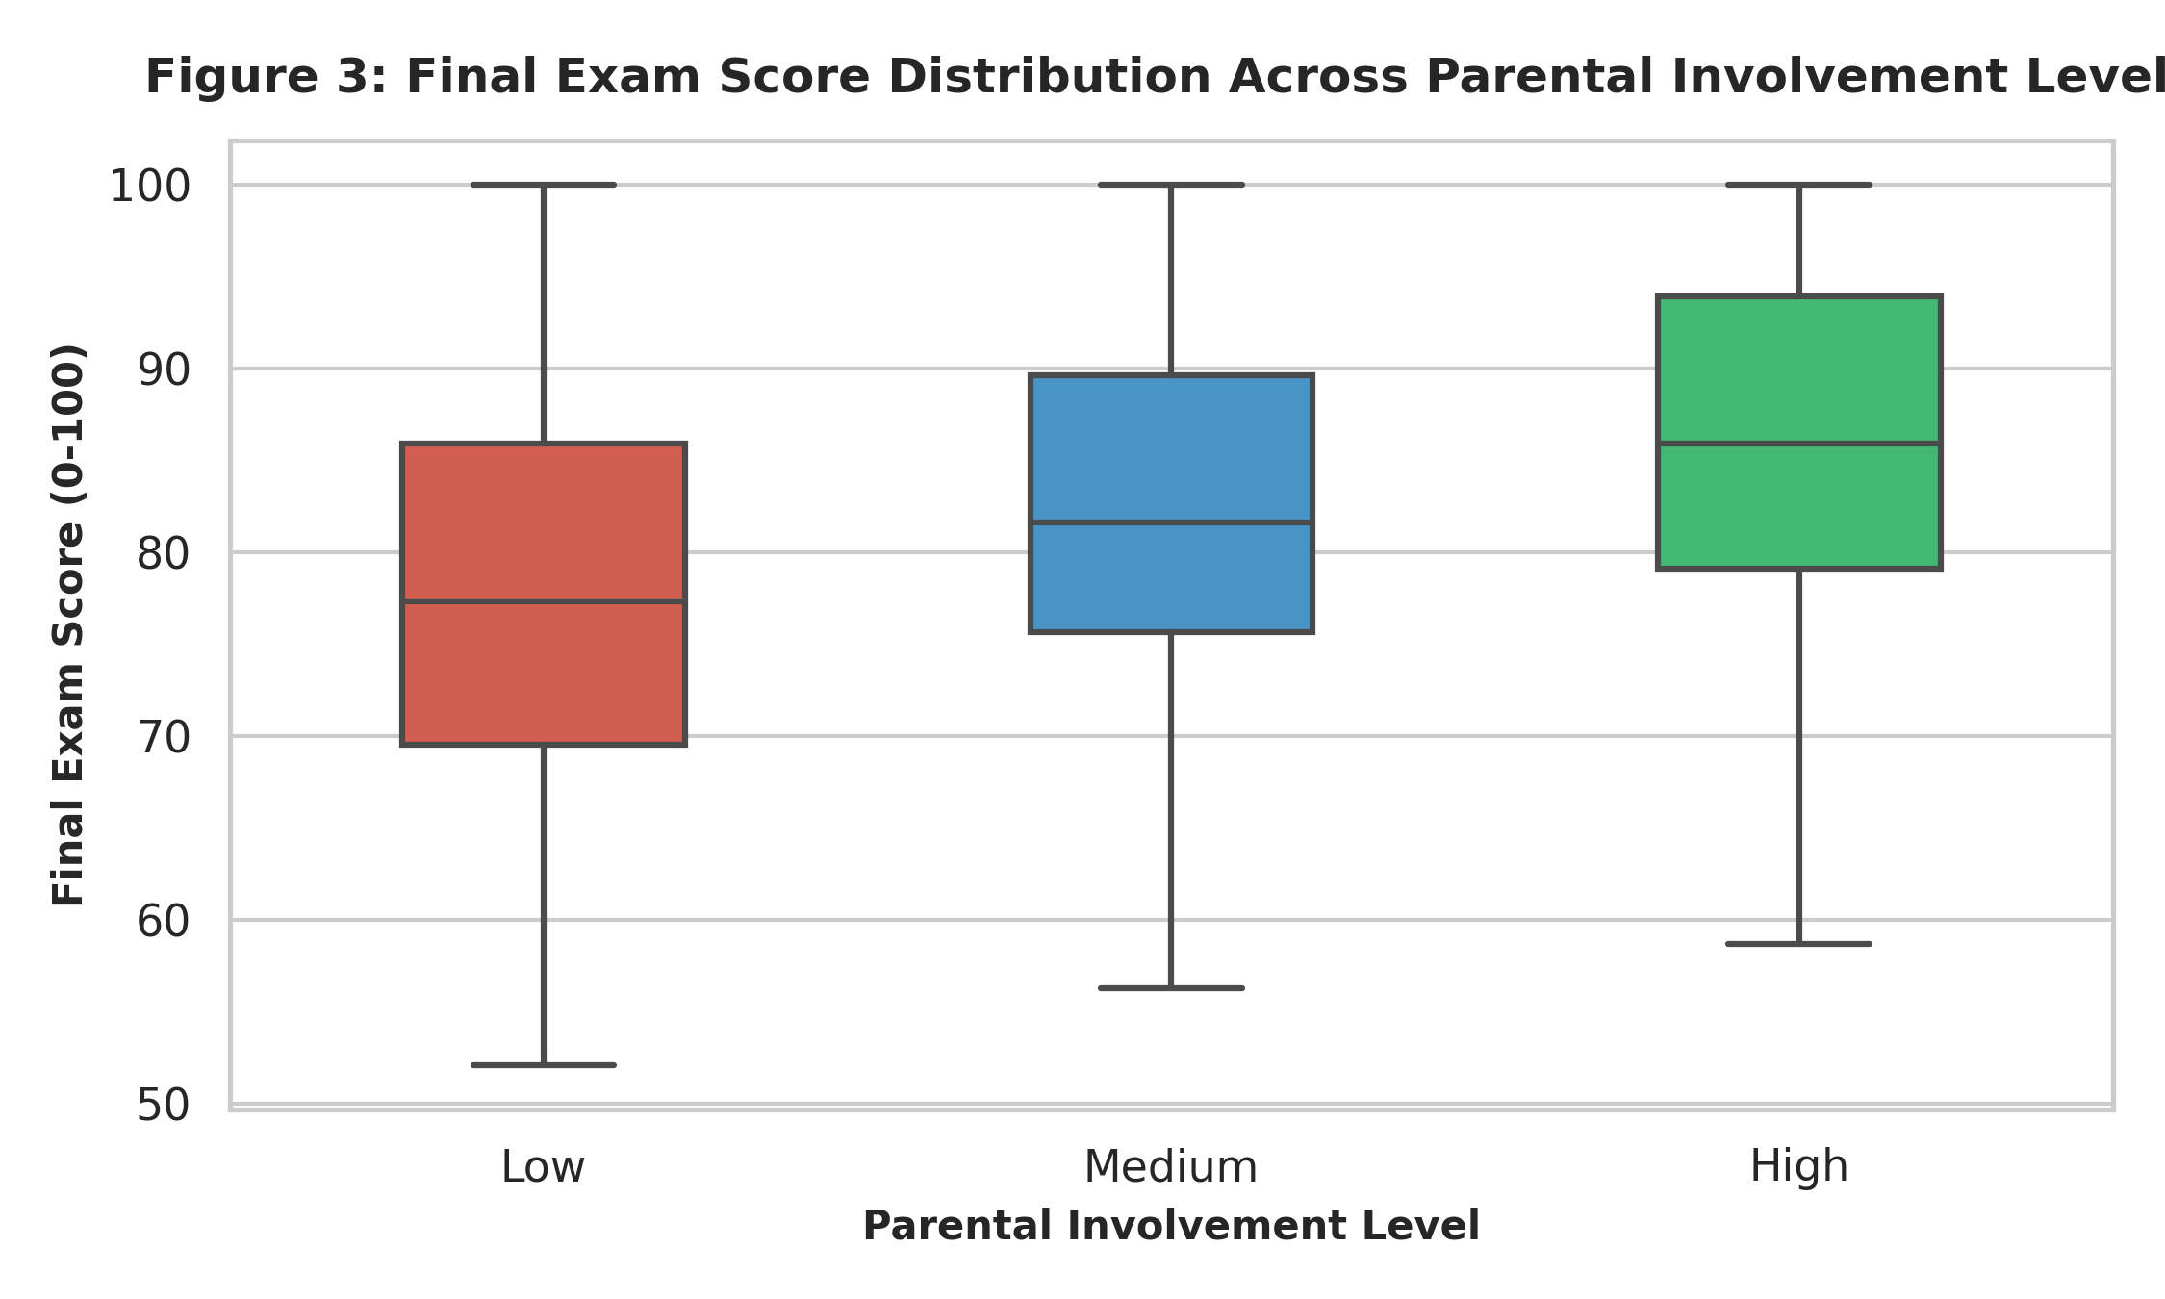
Figure 3: Distribution of Final Exam Scores stratified across Parental Involvement tiers.
Key Findings: The median exam score increases from 61.4 points (Low Involvement) to 73.8 points (Medium Involvement) and 84.6 points (High Involvement), highlighting household engagement as a key moderator of academic success.

5. Synthesis of Insights & Modeling Preparedness
- Primary Academic Driver: Weekly study commitment accounts for the greatest variance in final examination scores, indicating direct returns on effort.
- Attendance as a Prerequisite: Attendance rates below 70% correlate with a severe drop in median exam scores regardless of raw study hours.
- Support Ecosystem Multiplier: High parental involvement provides an estimated +10-15 point baseline advantage across all study hour brackets.
- Downstream Model Readiness: Cleaned attributes have been verified for integrity, missing values resolved, and data is ready for One-Hot Encoding and regression modeling in Week 2.

6. Work Effort & Time Tracking Log (33.0 Total Hours)
- Phase 1: Ingestion & API Automation (5.0 Hours): Dataset retrieval via kagglehub, schema mapping, and initial type inspection.
- Phase 2: Data Cleaning & Hygiene Validation (10.5 Hours): Duplicate purging, median imputation experiments for skewed attributes, data validation checks.
- Phase 3: Statistical Analysis & Visualization (11.5 Hours): Correlation matrices, bivariate regressions, outlier diagnostics, and plot styling in Seaborn/Matplotlib.
- Phase 4: Synthesis & DOCX Documentation (6.0 Hours): Technical rationale authoring, table formatting, figure captioning, and final deliverable review.

