Rule-Based Customer Fraud Risk Analysis Report
End-to-End Fraud Analytics using SQL, Python, and Power BI
Prepared by: Yash Pandey
Role Focus: Data Analytics | Fraud & Risk Analysis
Tools: SQL, Python (Pandas), Power BI

1. Executive Summary
This report presents an end-to-end rule-based fraud risk analysis framework designed to identify high-risk customers based on behavioral and transactional indicators. The solution integrates SQL-based data extraction, Python-driven data validation and rule logic, and Power BI visualization to deliver business-ready insights.
The analysis reveals that a significant portion of customers exhibit fraud-related risk signals, demonstrating the effectiveness of rule-based analytics as a first-line fraud detection mechanism.

2. Business Problem
Digital payment platforms face increasing fraud threats such as unauthorized access, repeated failed login attempts, abnormal device usage, and suspicious account behavior. Traditional manual monitoring does not scale effectively. This project aims to proactively identify high-risk customers using explainable rules that support fraud prevention, compliance, and operational decision-making.

3. Data Sources
The analysis leverages multiple structured datasets representing different dimensions of customer behavior:
- Customer profile data
- Login and failed login activity
- Device usage information
- Transaction and account activity data

4. Data Cleaning and Validation
Comprehensive data preparation was performed to ensure analytical accuracy:
- Duplicate record validation and removal
- Column data type verification and correction
- Standardization of date and timestamp fields
- Data sanity checks and consistency validation
A master analytical table was created by merging all relevant datasets to enable holistic customer-level analysis.

5. Rule-Based Fraud Risk Profiling
Customers were evaluated using a set of explainable fraud risk indicators derived from industry patterns and behavioral analysis:
- Multiple failed login attempts
- Login location changes
- Abnormal or future signup dates
- Irregular device usage patterns
Customers triggering one or more conditions were classified as High-Risk, while others were classified as Low-Risk.

6. Power BI Dashboard Overview
The Power BI dashboard provides an executive-level view of fraud exposure and customer risk distribution. Key components include KPI cards summarizing overall risk, visual distribution of high-risk versus low-risk customers, identification of top risk drivers, and a drill-down table supporting investigation of flagged customers.

7. Key Findings
- Total Active Customers: 289
- High-Risk Customers: 121
- Low-Risk Customers: 168
- Fraud Risk Rate: 41.9%

8. Business Recommendations
- Prioritize monitoring of customers flagged by multiple risk indicators
- Apply enhanced authentication or manual review for high-risk customers
- Use rule-based scoring as a pre-filter before deploying ML-based models

9. Conclusion
This project demonstrates strong proficiency in data analytics, including data preparation, rule-based reasoning, and business-focused visualization. The solution mirrors real-world fraud analytics workflows and provides a scalable, explainable foundation for risk monitoring systems.

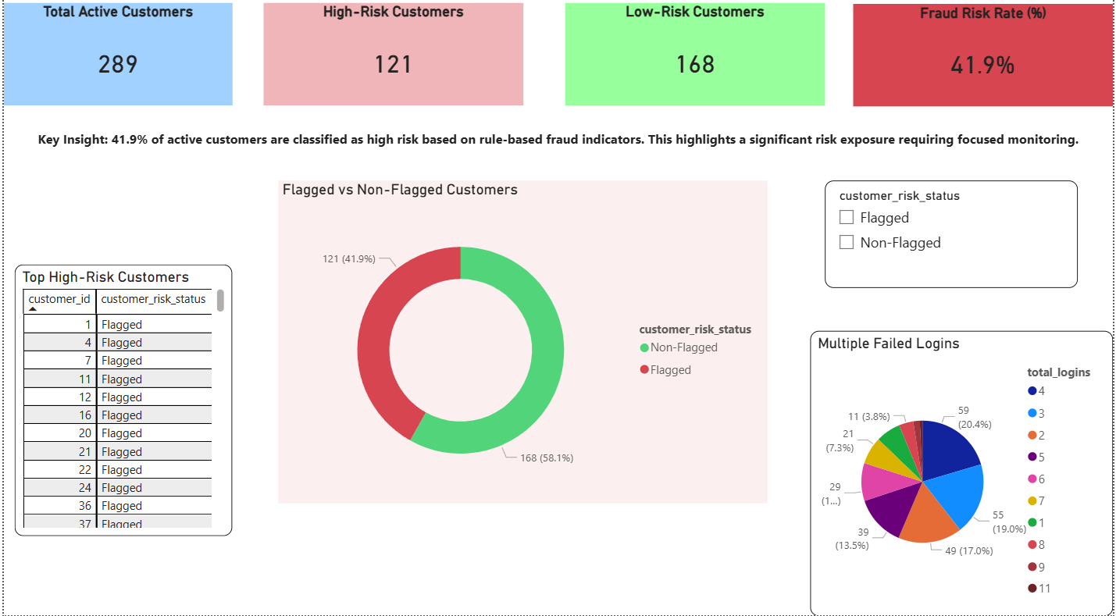
Customer Fraud Risk Overview – Power BI Dashboard

