**Assignment**

**Use Case Scenario**

Your company is developing a new e-commerce application consisting of several

microservices: a front-end service, a product catalog service, and an order processing

service. The goal is to automate the deployment and configuration of these services across development, testing, and production environments using Ansible, Docker, Kubernetes, and

Jenkins.

* **Frontend yml file**

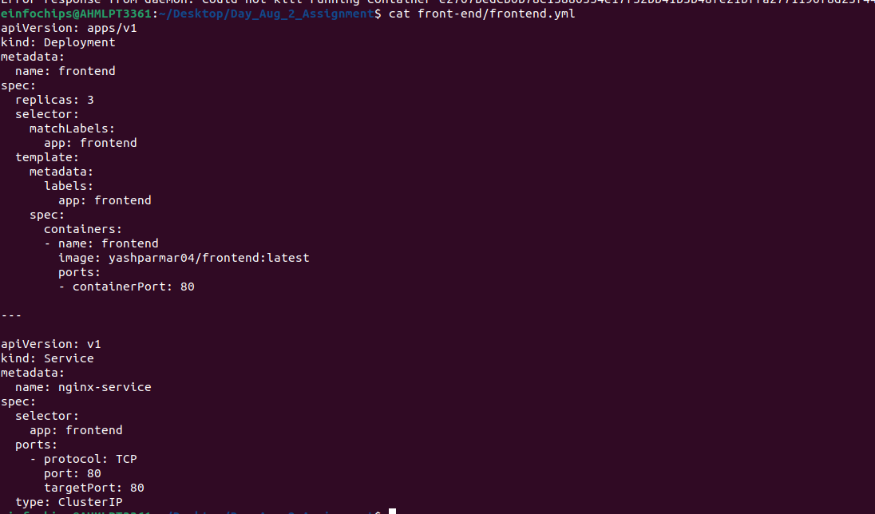

* 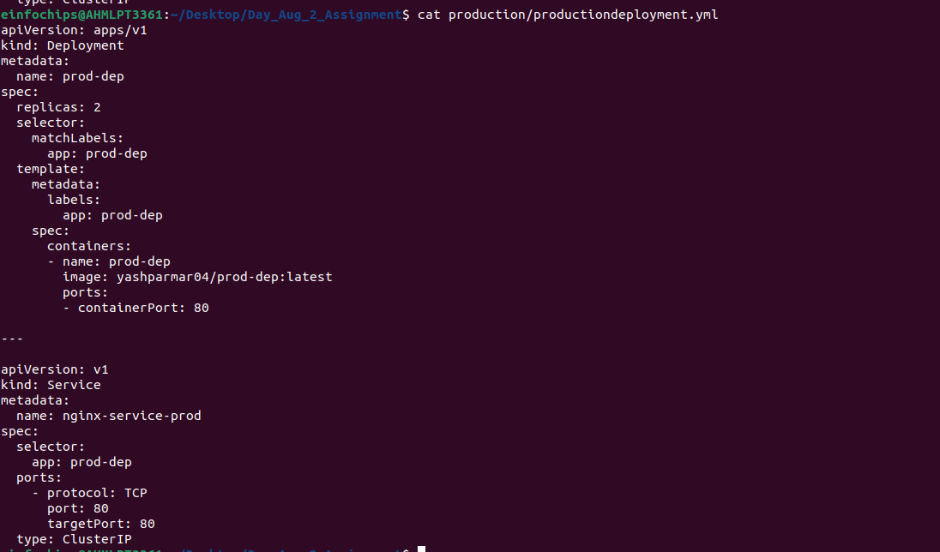**production yml file**
* **testing yml file**

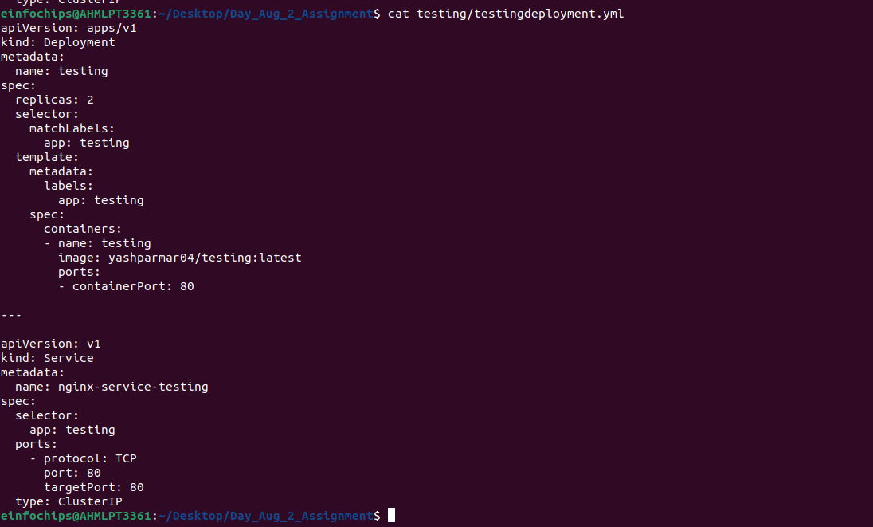

**ingress.yml file**

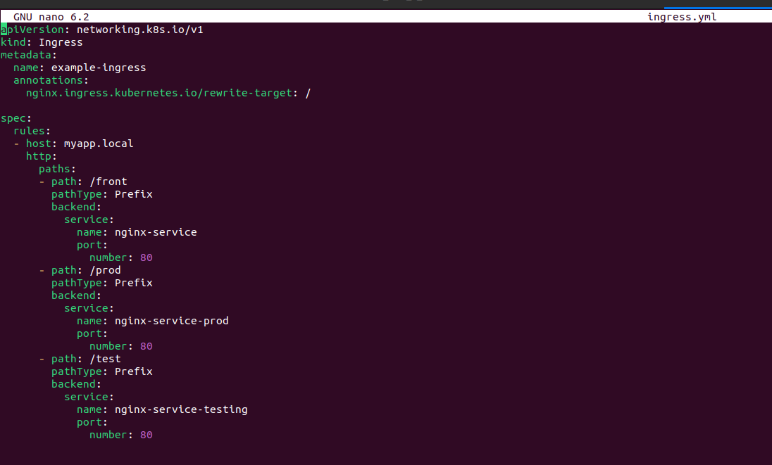

* **build and push image frontend**

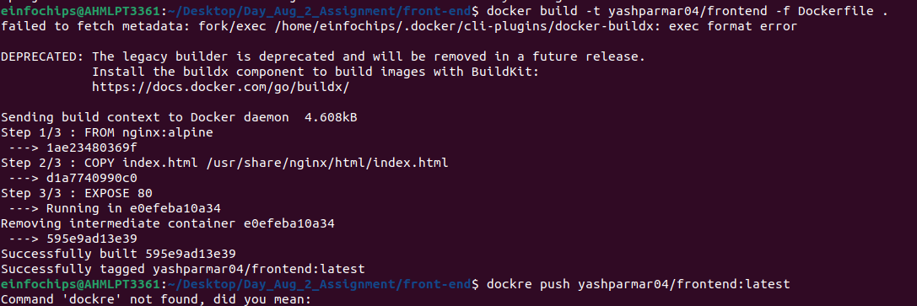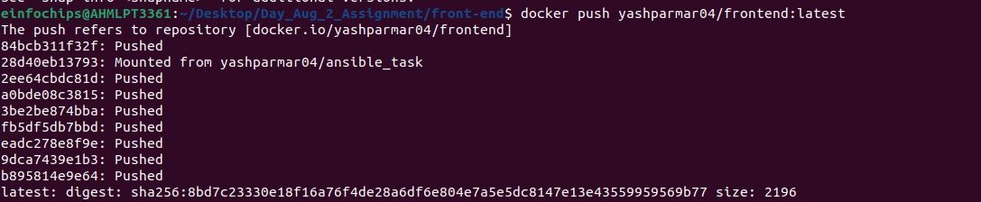

* **build and push image testing**

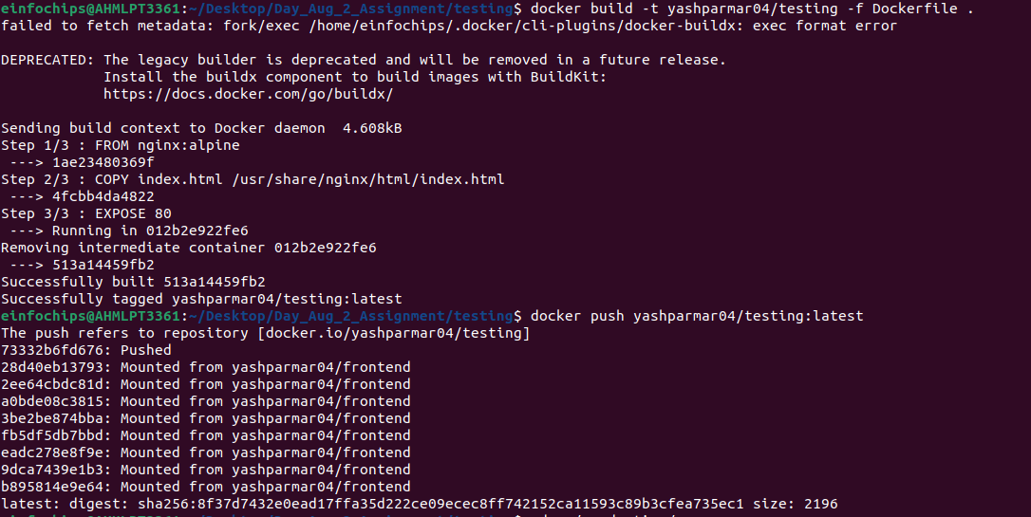

* **build and push image production**

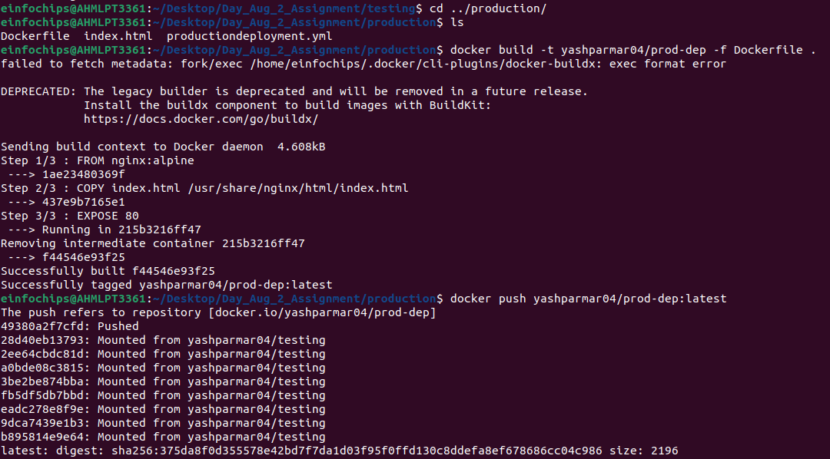

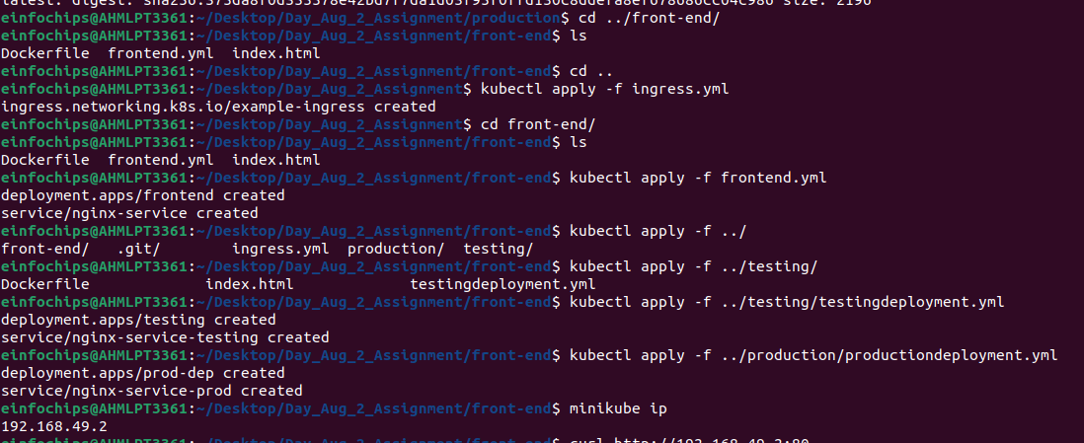

* **Dockerfile**

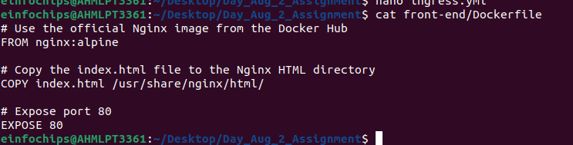

**Docker Pushed images**

* **testing image**

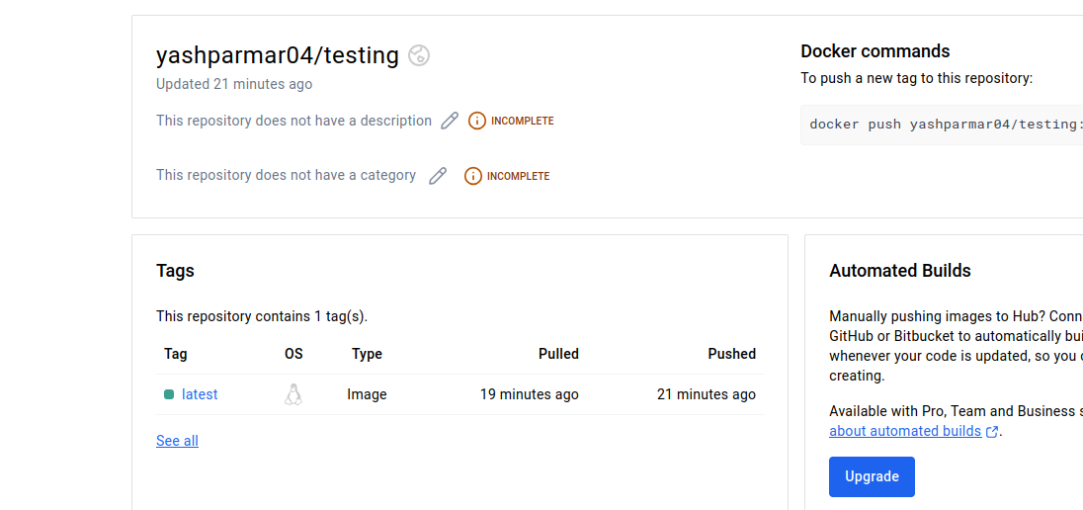

* **Prod image**

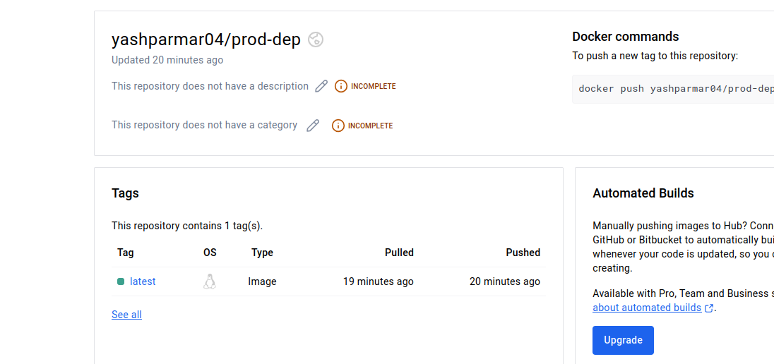

* **frontend image**

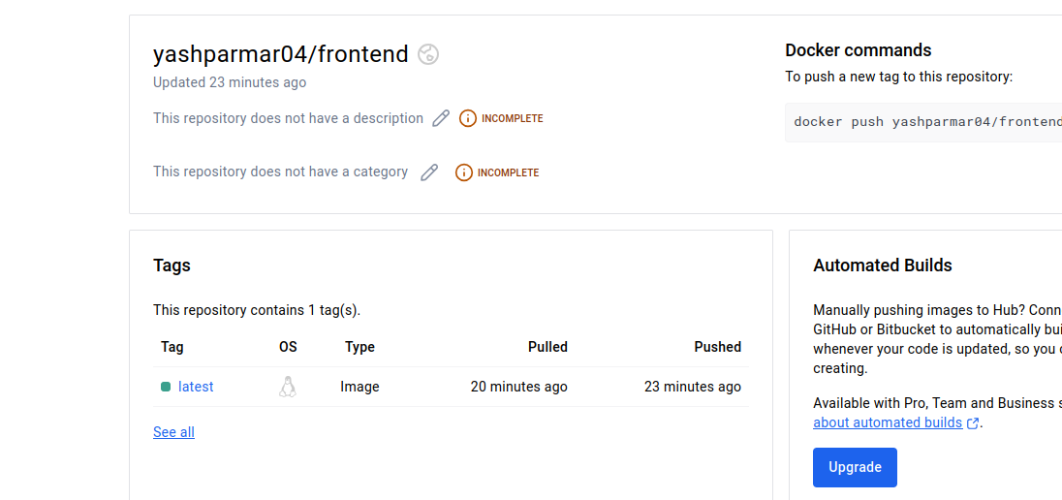

**Output**

* **testing deploymnet**

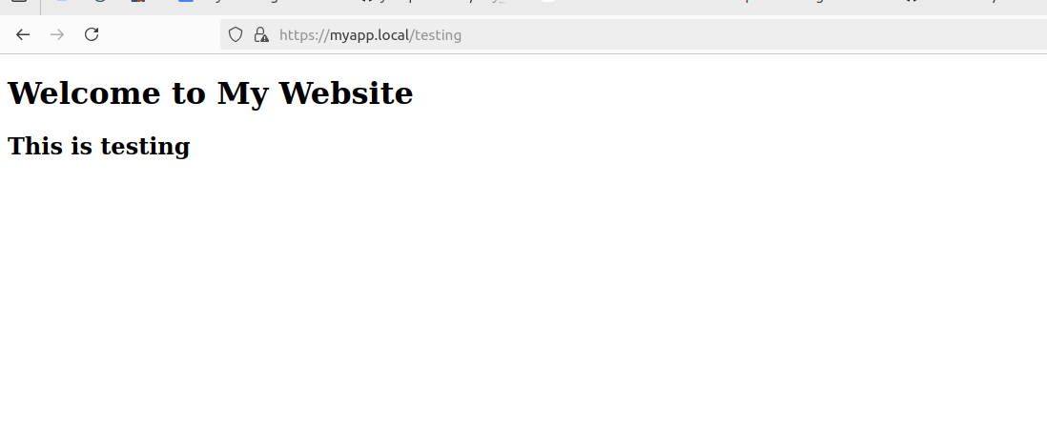

* **frontend deployment**

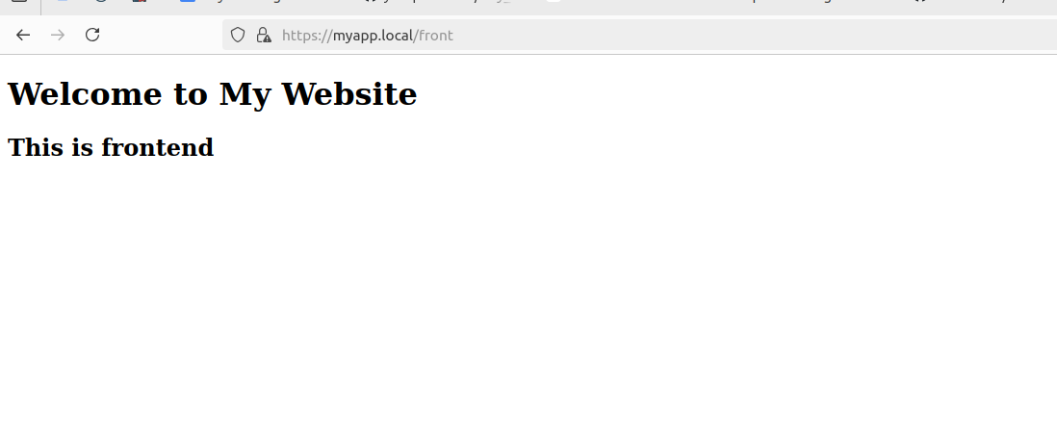

* 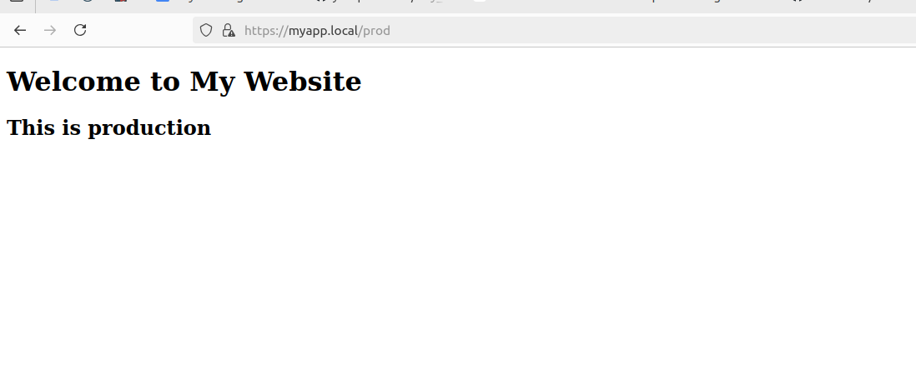**production deployment**