#### **Project 01**

1. **Inventory Plugins**
   * **Activity**: Configure a dynamic inventory plugin to manage a growing number of web servers dynamically. Integrate the plugin with Ansible to automatically detect and configure servers in various environments.
   * **Deliverable**: Dynamic inventory configuration file or script, demonstrating the ability to automatically update the inventory based on real-time server data.

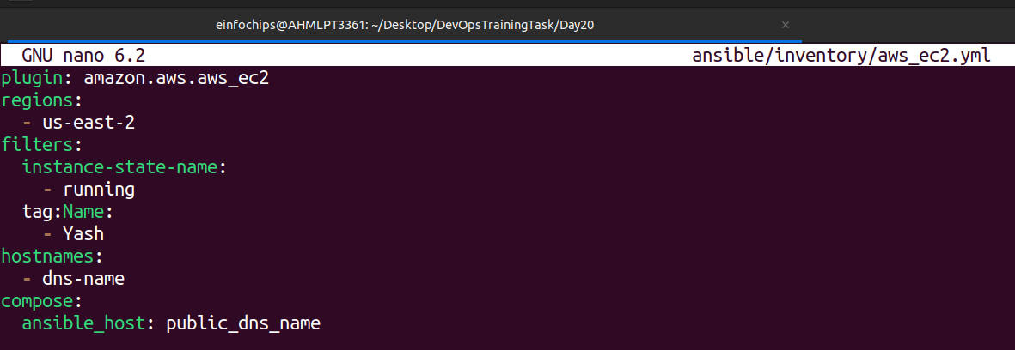

1. **Performance Tuning**
   * **Activity**: Tune Ansible performance by adjusting settings such as parallel execution (forks), optimizing playbook tasks, and reducing playbook run time.
   * **Deliverable**: Optimized ansible.cfg configuration file, performance benchmarks, and documentation detailing changes made for performance improvement.

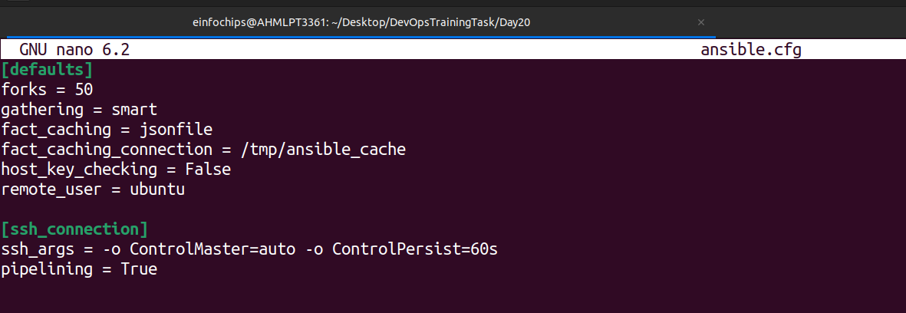

1. **Debugging and Troubleshooting Playbooks**
   * **Activity**: Implement debugging strategies to identify and resolve issues in playbooks, including setting up verbose output and advanced error handling.
   * **Deliverable**: Debugged playbooks with enhanced error handling and logging, including a troubleshooting guide with common issues and solutions.
2. **Exploring Advanced Modules**
   * **Activity**: Use advanced Ansible modules such as docker_container to manage containerized applications and aws_ec2 for AWS infrastructure management, demonstrating their integration and usage.
   * **Deliverable**: Playbooks showcasing the deployment and management of Docker containers and AWS EC2 instances, along with documentation on the benefits and configurations of these advanced modules.

