### **Project 01:**

#### **Project Overview:**

The goal of this capstone project is to combine shell scripting with system monitoring and log management practices. You will create a set of automated tools using shell scripts to manage logs, monitor system performance using Prometheus and Node Exporter, and generate insights using PromQL queries. The project will require a systematic approach, covering scripting fundamentals, log management, and monitoring setup.

### **Project Deliverables:**

1. **Shell Scripts for Basic Operations:**
   * **Task:** Write shell scripts to perform basic system operations, such as checking disk usage, memory usage, and CPU load.
   * **Deliverable:**
     + A collection of scripts that output system performance metrics.
     + Scripts should include error handling and logging.

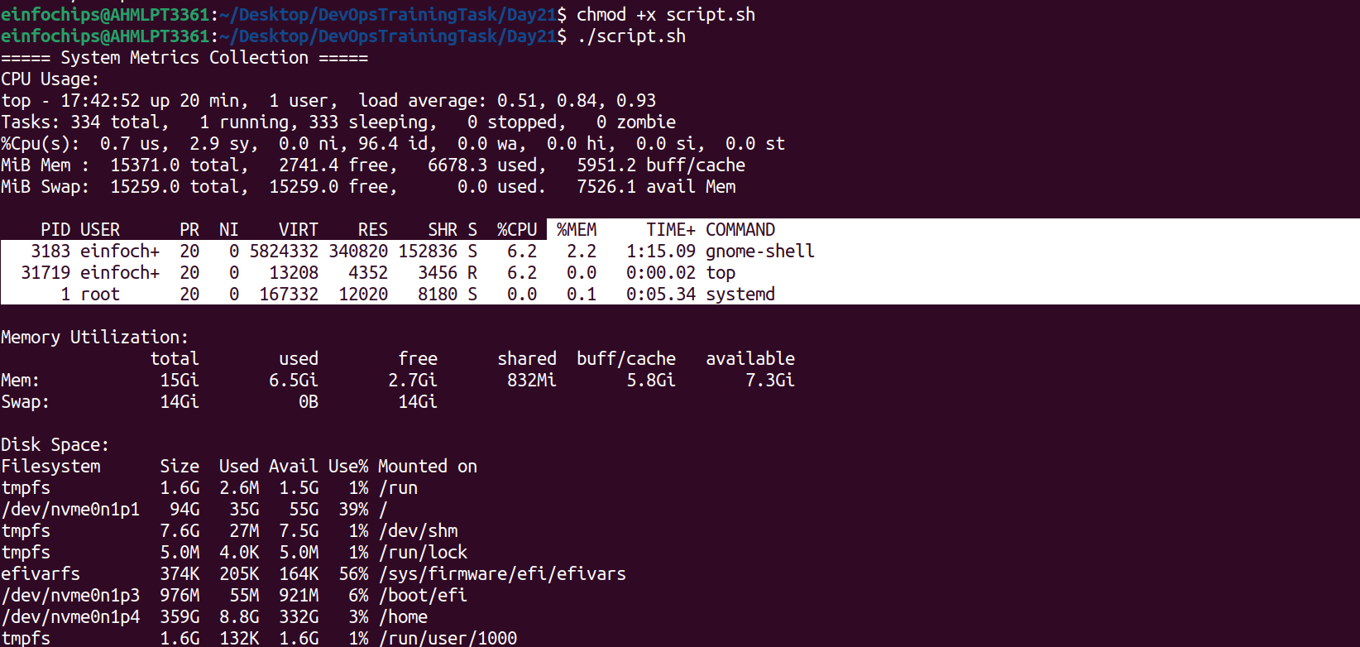

1. **Log Management Script:**
   * **Task:** Develop a script to automate log management tasks such as log rotation and archiving. This script should include the ability to compress old logs and delete logs older than a specified number of days.
   * **Deliverable:**
     + A shell script that performs log rotation based on predefined conditions (e.g., log size, log age).
     + A report generated by the script detailing which logs were rotated, compressed, or deleted.

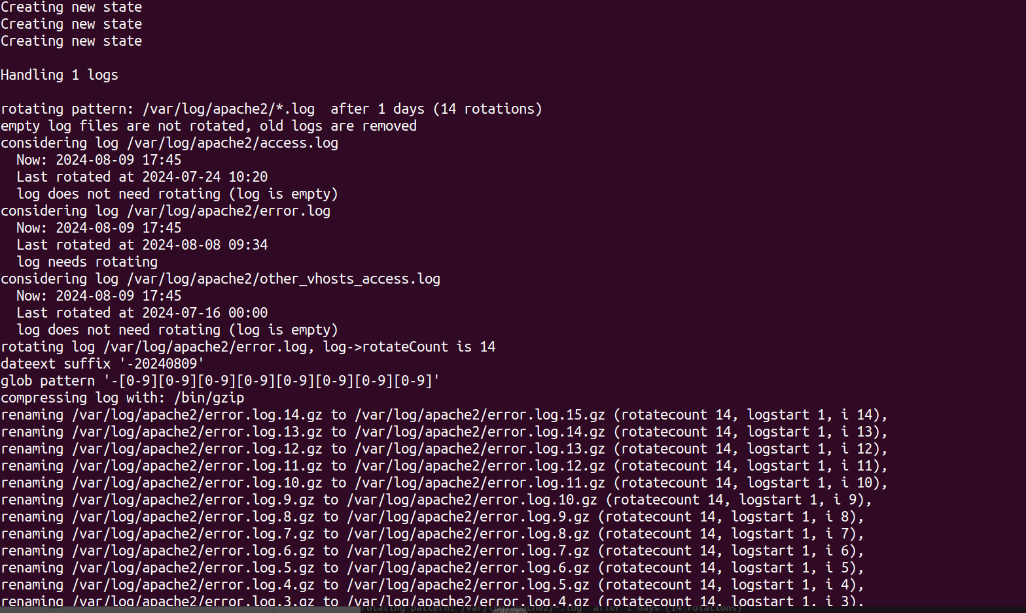

1. **Advanced Shell Scripting - Loops, Conditions, Functions, and Error Handling:**
   * **Task:** Refactor the previous scripts to include loops, conditionals, and functions for modularity. Implement error handling to manage potential issues during script execution.
   * **Deliverable:**
     + Modular shell scripts that use functions for repeatable tasks.
     + Error-handling mechanisms in place for scenarios like missing files, insufficient permissions, etc.
     + Logs that track script execution and any errors encountered.

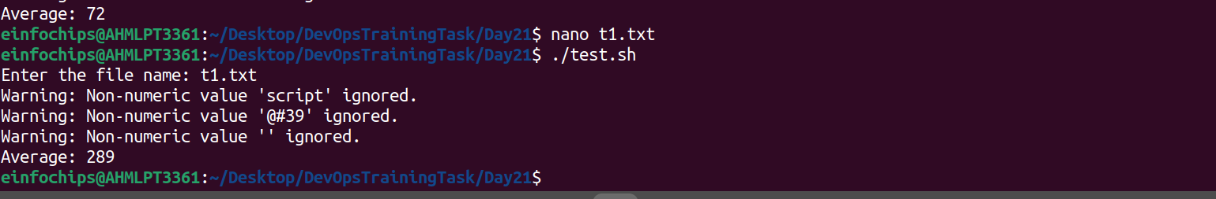

1. **Log Checking and Troubleshooting:**
   * **Task:** Write a script that reads through system and application logs, identifies common issues (e.g., out of memory, failed service starts), and provides troubleshooting steps based on log analysis.
   * **Deliverable:**
     + A script that parses logs for errors or warnings and outputs possible root causes.
     + Documentation on the types of logs checked and the issues identified.
     + A troubleshooting guide based on common errors found in the logs.

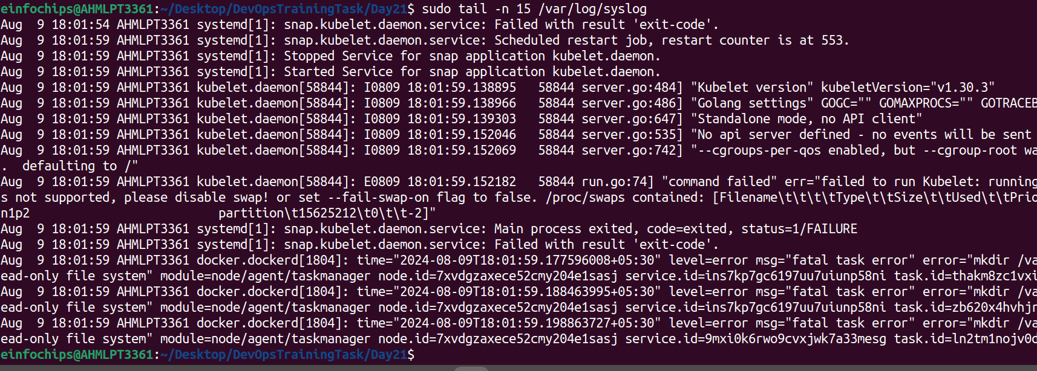

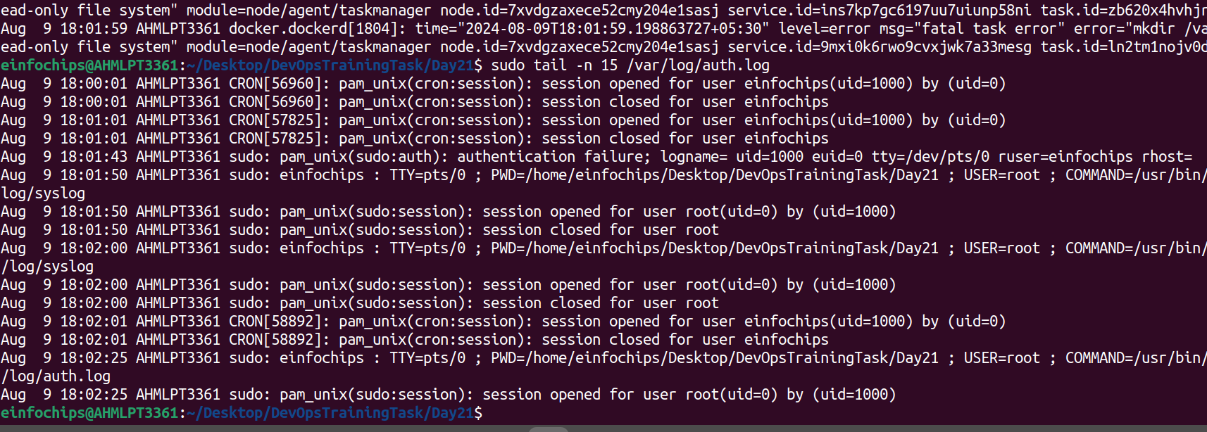

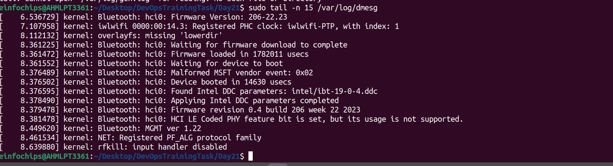

1. **Installation and Setup of Prometheus and Node Exporter:**
   * **Task:** Install and configure Prometheus and Node Exporter on the system. Ensure that Node Exporter is properly configured to collect system metrics.
   * **Deliverable:**
     + A documented installation and configuration process for Prometheus and Node Exporter.
     + A running instance of Prometheus scraping metrics from Node Exporter.

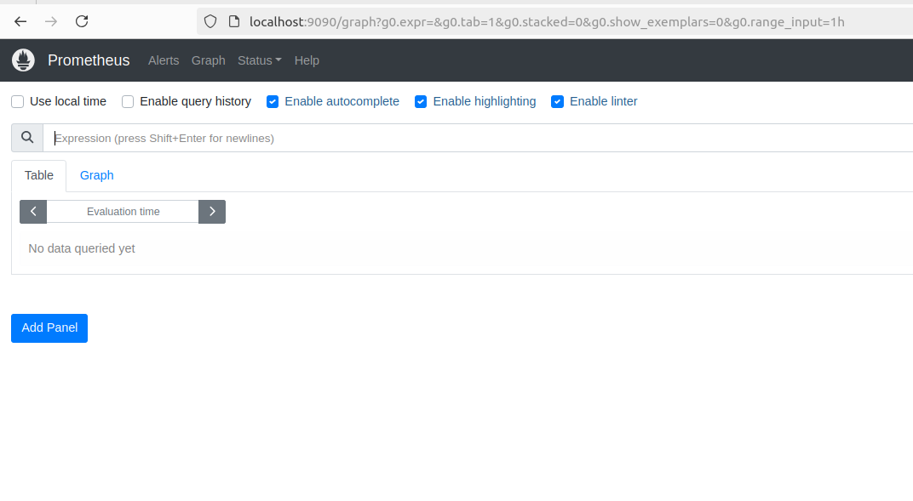

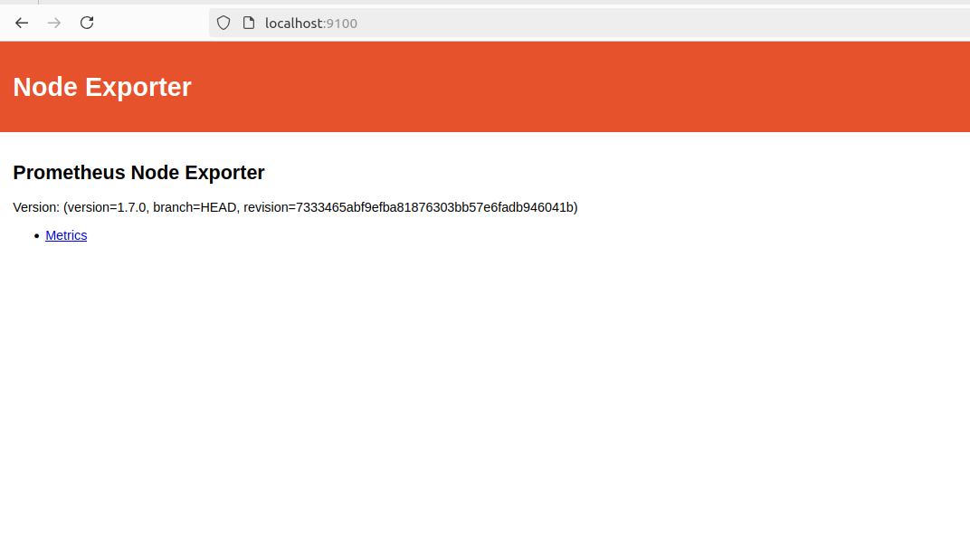

1. **Prometheus Query Language (PromQL) Basic Queries:**
   * **Task:** Create a series of PromQL queries to monitor system performance, such as CPU usage, memory usage, and disk I/O.
   * **Deliverable:**
     + A set of PromQL queries that can be used to monitor key system metrics.
     + A dashboard setup guide or configuration that visualizes these metrics in Prometheus or Grafana.
2. **Final Report and Presentation:**
   * **Task:** Prepare a final report documenting all scripts, the installation and configuration of monitoring tools, and the output of your PromQL queries.
   * **Deliverable:**
     + A comprehensive project report covering all steps, scripts, and results.