**Project - 24**

[**https://326151034032.signin.aws.amazon.com/console**](https://326151034032.signin.aws.amazon.com/console)

**Username:** Lab-user

**Password:** Password_1234

**Permission:** AWSS3FullAccess

### **Comprehensive AWS S3 Management and Static Website Hosting**

#### **Objective:**

To test your knowledge and skills in managing AWS S3 storage classes, lifecycle management, bucket policies, access control lists (ACLs), and hosting a static website on S3. You will apply their understanding in a practical scenario, ensuring you have mastered the critical aspects of AWS S3.

#### **Project Scenario:**

You are tasked with creating and managing an S3 bucket for a fictional company, "TechVista Inc.," that hosts a static website for displaying their product portfolio. The website will have different types of content, including high-resolution images, which require careful storage management to optimize costs. Additionally, the company has strict security requirements for accessing the content.

#### **Project Steps and Deliverables:**

1. **Create and Configure an S3 Bucket:**
   * Create an S3 bucket named techvista-portfolio-[your-initials].
   * Enable versioning on the bucket.
   * Set up the bucket for static website hosting.
   * Upload the provided static website files (HTML, CSS, images).
   * Ensure the website is accessible via the S3 website URL.

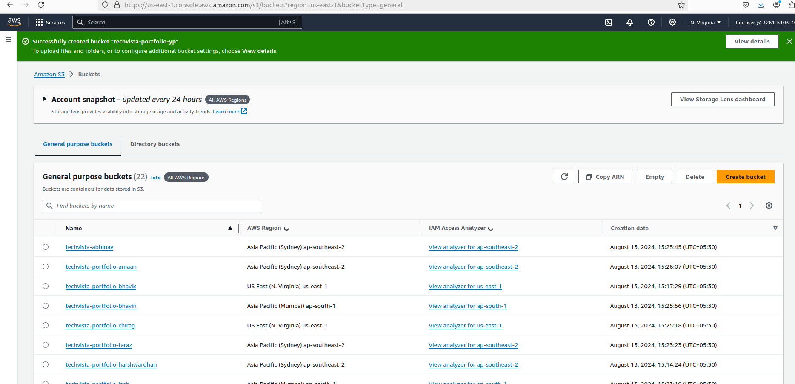

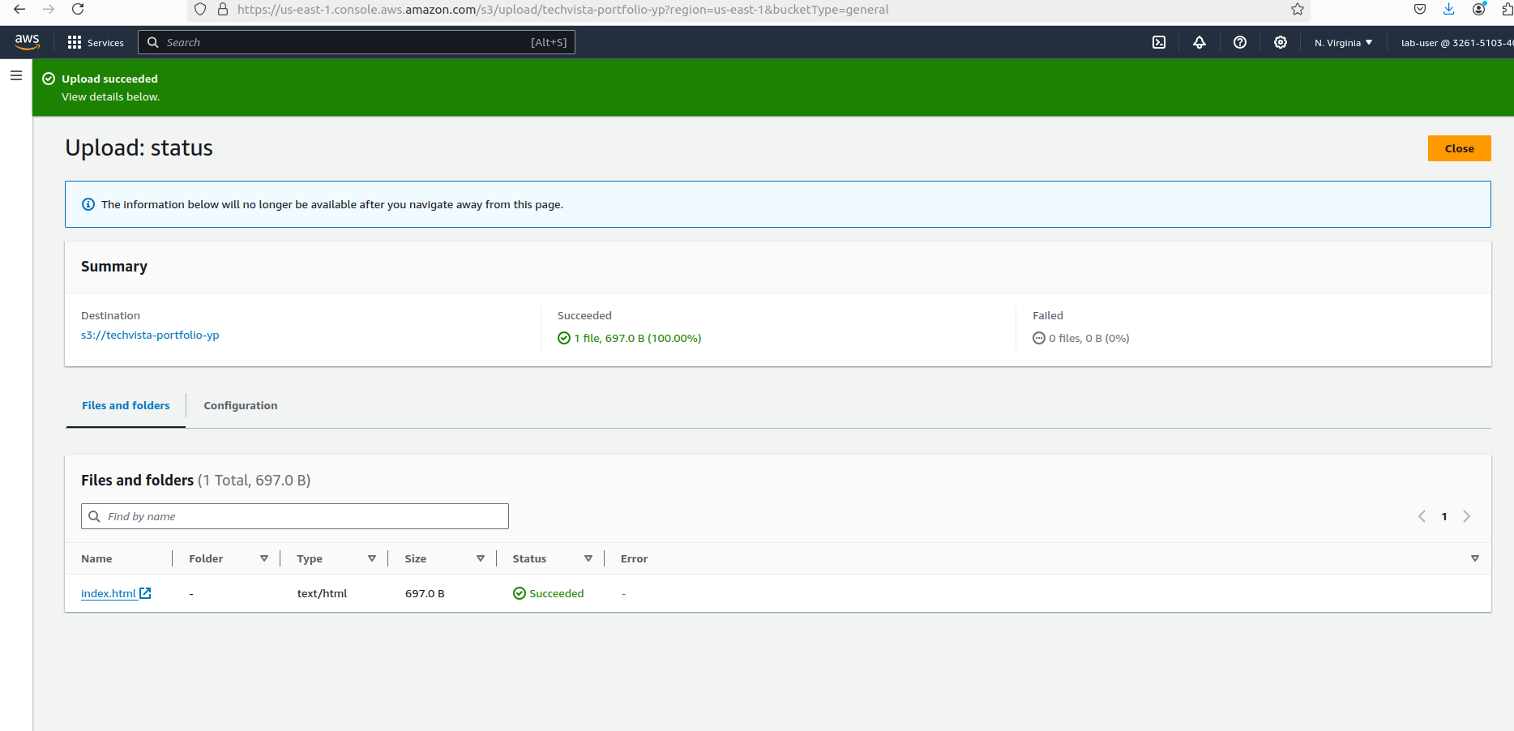

1. **Implement S3 Storage Classes:**
   * Classify the uploaded content into different S3 storage classes (e.g., Standard, Intelligent-Tiering, Glacier).
   * Justify your choice of storage class for each type of content (e.g., HTML/CSS files vs. images).

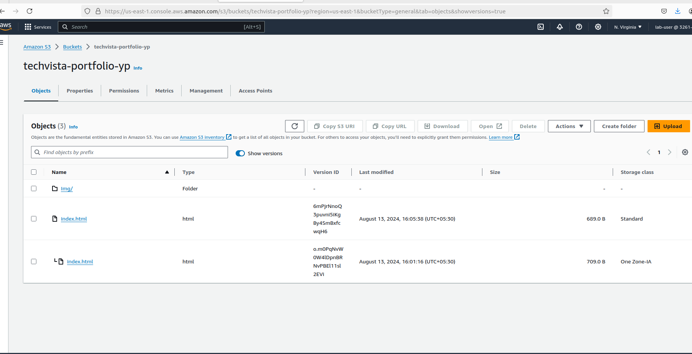

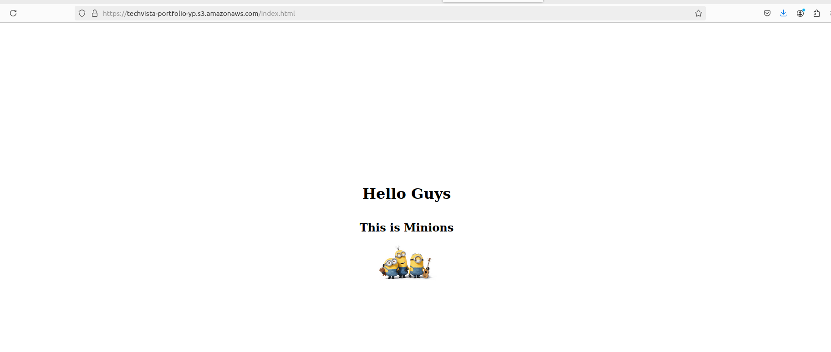

1. **Lifecycle Management:**
   * Create a lifecycle policy that transitions older versions of objects to a more cost-effective storage class (e.g., Standard to Glacier).
   * Set up a policy to delete non-current versions of objects after 90 days.
   * Verify that the lifecycle rules are correctly applied.

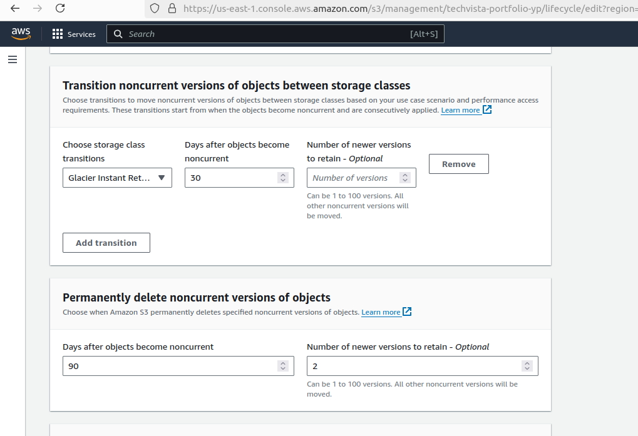

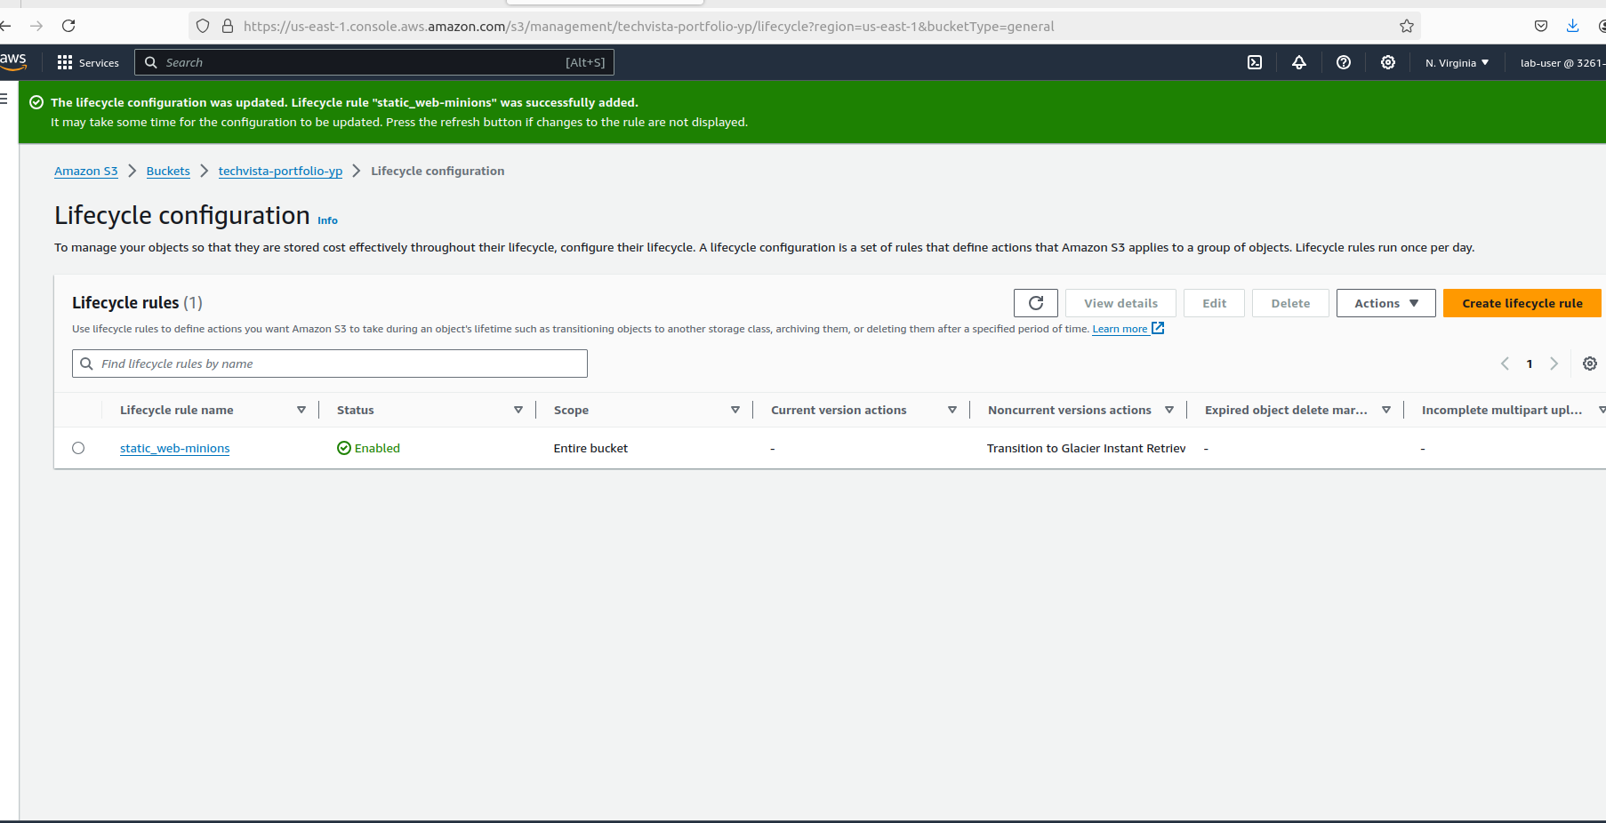

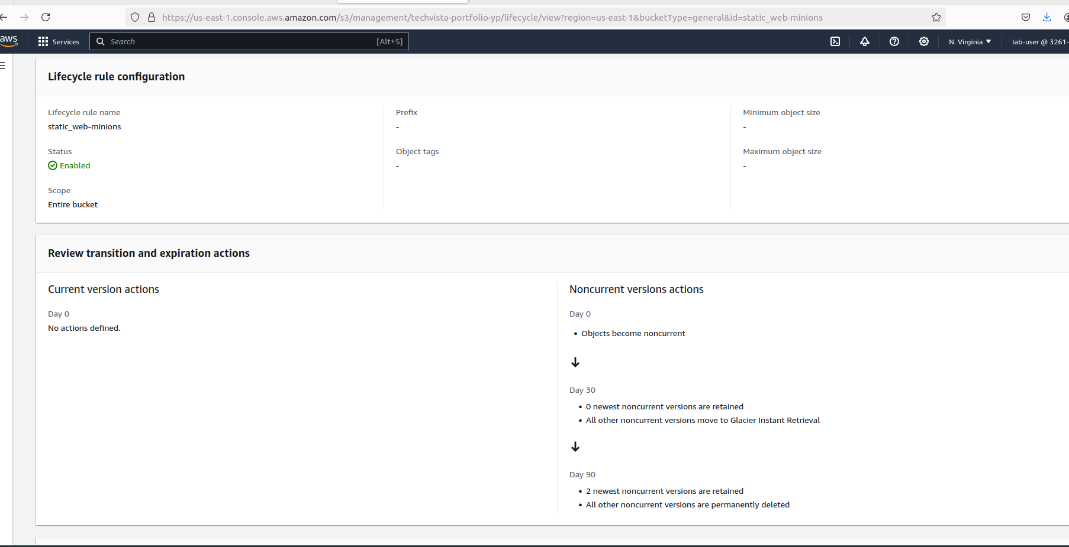

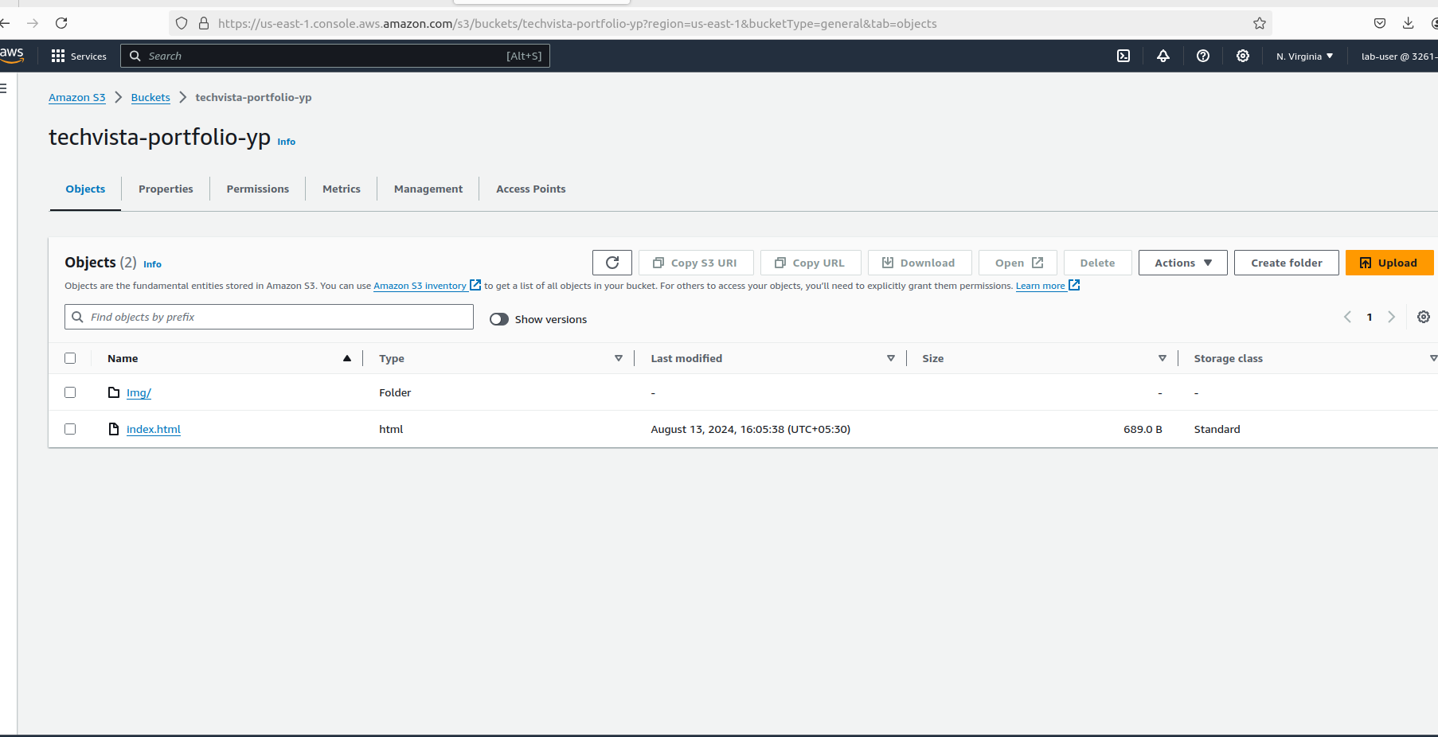

1. **Configure Bucket Policies and ACLs:**
   * Create and attach a bucket policy that allows read access to everyone for the static website content.
   * Restrict access to the S3 management console for specific IAM users using the bucket policy.
   * Set up an ACL to allow a specific external user access to only a particular folder within the bucket.

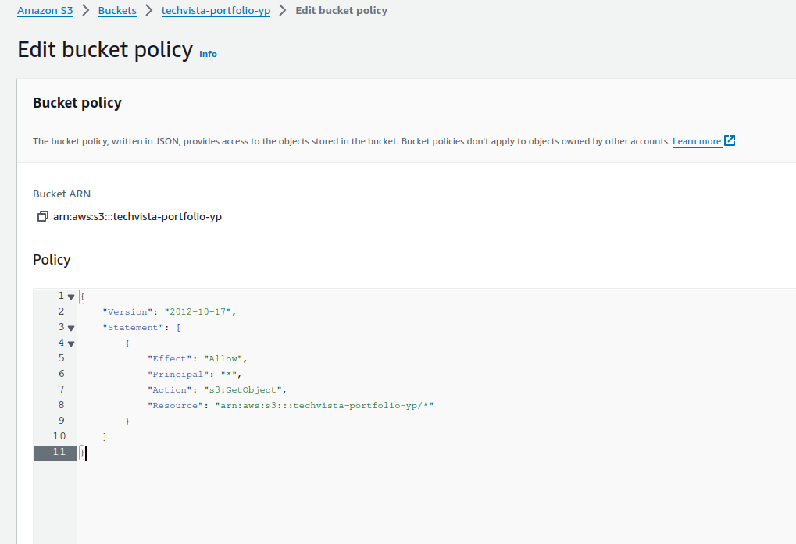

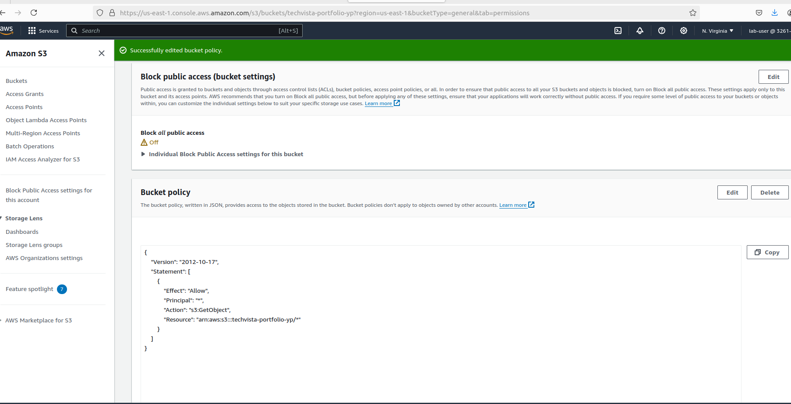

1. **Test and Validate the Configuration:**
   * Test the static website URL to ensure it is accessible.

