SOFTWARE REQUIREMENT & SYSTEM DESIGN SPECIFICATION
Sip & Bite - Smart Food Ordering & Table Reservation System
Project Name: | Sip & Bite (Food Ordering, Delivery & Table Booking Ecosystem)
System Platforms: | Web Application (Laravel PHP) & Android Mobile Application
Document Version: | 1.0 Final Technical Specification
Date of Generation: | August 2026

1 Introduction
The Sip & Bite platform is an advanced, integrated digital solution designed to transform food ordering, table reservation, and delivery management for contemporary food service businesses. Combining a robust web application powered by Laravel PHP with a high-performance Android mobile application, Sip & Bite streamlines the dining and delivery workflow for customers, administrative management, kitchen staff, and delivery personnel.
PROJECT OVERVIEW: Sip & Bite integrates web administration, mobile ordering, table reservations, live distance tracking, and payment processing into a single cohesive platform.

1.1 Proposed System and its Objectives
Traditional restaurant operations often suffer from fragmented manual systems—such as paper-based menu ordering, telephone table bookings, undocumented cash handling, and lack of real-time delivery visibility. The proposed Sip & Bite system automates the entire restaurant ecosystem, providing a digital menu, automated cart calculations, instantaneous table reservation validation, online payments, and geospatial distance tracking.
The primary objectives of the Sip & Bite system are as follows:
- 1. Digitalization of Menu & Ordering: Enable customers to seamlessly explore categorized food & beverage items, filter by dietary preferences (vegetarian vs. non-vegetarian), customize item quantities, and place orders digitally.
- 2. Real-Time Table Reservation System: Provide customers with an intuitive table booking interface to reserve dining tables in advance, specifying date, time slots, guest capacity, and special dining requests, thereby preventing double bookings and reducing table idle time.
- 3. Geospatial Distance & Delivery Tracking: Integrate location services and distance APIs to calculate precise delivery charges, estimate delivery lead times, and track delivery personnel dispatch in real time.
- 4. Multi-Role Operating Environment: Establish role-based access control (RBAC) accommodating Administrators, Kitchen Staff, Delivery Partners, and Customers with tailored dashboards and functional permissions.
- 5. Seamless Payment Gateway Integration: Support multi-channel payment flows, including Razorpay online transactions (Credit/Debit Card, UPI, Net Banking) and Cash on Delivery (COD), with robust status synchronization.
- 6. Quality Assurance & Customer Feedback: Incorporate post-order and post-dining feedback mechanisms to collect ratings and qualitative reviews, assisting management in continuous service enhancement.
1.2 Core Components
The Sip & Bite system architecture is built around five interconnected core modules:
- 1. Web Backend & Admin Subsystem (Laravel Framework): Functions as the central engine managing business logic, routing, authentication, ORM database transactions, and RESTful API endpoints. The web portal features an intuitive Admin Dashboard for managing categories, menu items, table layouts, orders, delivery staff assignments, and financial reports.
- 2. Customer Android Mobile Application: A native Android application offering an engaging user interface for end customers to register, browse rich food catalogs, manage shopping cart items, complete checkout, book tables, and track active order statuses live.
- 3. Delivery Partner Subsystem: Integrated interface within the mobile application enabling delivery personnel to receive real-time order assignments, view customer delivery addresses with latitude/longitude coordinates, update delivery stages ('Out for Delivery' -> 'Delivered'), and mark payments collected.
- 4. Database Subsystem (MySQL): A structured relational database storing system users, menu structures, table availability schedules, orders, order items, delivery profiles, transaction logs, and feedback ratings with strict foreign key constraints.
- 5. Geolocation & Payment API Integration Subsystems: External service integrations including Razorpay API for cryptographic payment verifications and Distance Matrix APIs for accurate geographical distance computation.
1.3 Minimum and Maximum Software/Hardware Requirements
To ensure optimal performance, stability, and responsiveness across web and mobile platforms, the system hardware and software specifications are categorized below into minimum operational and maximum recommended configurations.
Component Layer | Specification Parameter | Minimum Requirement | Maximum / Recommended
Server Side (Web Backend) | Operating System | Ubuntu Linux 20.04 LTS | Ubuntu Linux 24.04 LTS / Cloud Server
Server Side (Web Backend) | CPU Processor | Dual-Core 2.0 GHz | Octa-Core 3.5 GHz+ (Intel Xeon / AMD EPYC)
Server Side (Web Backend) | System Memory (RAM) | 4 GB DDR4 | 16 GB+ DDR5
Server Side (Web Backend) | Storage Capacity | 30 GB SSD | 250 GB+ NVMe SSD
Server Side (Web Backend) | Software Stack | PHP 8.2, MySQL 8.0, Apache/NGINX | PHP 8.3+, MySQL 8.0+, NGINX, Redis Cache
Client Web Interface | Device & Display | Desktop/Laptop (1024x768 display) | Full HD 1080p Desktop/Laptop/Tablet
Client Web Interface | Browser Engine | Google Chrome 90+, Firefox 88+ | Latest Google Chrome / Safari / Edge
Client Web Interface | Network Bandwidth | 2 Mbps Broadband | 100 Mbps+ High-Speed Fiber
Client Mobile App (Android) | Mobile Device OS | Android 8.0 (Oreo / API Level 26) | Android 14 / 15 (Latest API)
Client Mobile App (Android) | Device Memory & Storage | 2 GB RAM, 100 MB free storage | 6 GB+ RAM, 500 MB free storage
Client Mobile App (Android) | Connectivity & GPS | 3G Mobile Data, Basic GPS | 4G LTE / 5G Network, Precision Dual-GPS

1.4 Advantages and Limitations of the Proposed System
Advantages of the Proposed System:
- • Automated Workflow & Error Reduction: Eliminates manual pen-and-paper order processing, preventing order misinterpretations, incorrect billing, and table booking overlaps.
- • Enhanced Customer Convenience: Allows customers to place delivery orders or reserve dining tables anywhere, anytime via mobile app or web portal without waiting in long queues.
- • Real-Time Order & Location Visibility: Provides step-by-step transparency from order placement to kitchen preparation, delivery dispatch, and real-time destination arrival.
- • Integrated Payment Security: Eliminates cash dependency while guaranteeing PCI-DSS compliant online payment transactions powered by Razorpay signature verification.
- • Centralized Business Intelligence: Equips restaurant managers with real-time revenue analytics, popular menu trends, active delivery person availability, and feedback metrics.
Limitations of the Proposed System:
- • Internet Connectivity Reliance: Both web backend and mobile app interfaces require active internet connectivity; offline operation is limited to local cache viewing.
- • Device Hardware Dependency: Delivery personnel and mobile app users require GPS-enabled Android smartphones with functional camera sensors for scanning/navigation.
- • Initial Deployment & Training Effort: Requires initial configuration of server infrastructure, database migrations, and staff onboarding for kitchen and delivery workflows.
2 Requirement Determination & Analysis
Requirement determination and analysis establish the foundational specifications of the Sip & Bite system. This phase involves defining explicit functional interactions, operational constraints, performance criteria, and categorizing the target user groups.
2.1 Requirement Determination
The system requirements are split into Functional Requirements (FR) and Non-Functional Requirements (NFR).
Functional Requirements (FR):
- FR-01 User Authentication & Authorization: The system shall allow users to register, log in, and manage profiles with role-based permissions (Customer, Admin, Delivery Person).
- FR-02 Category & Menu Management: Administrators shall be able to create, update, activate/deactivate menu categories and individual menu items with pricing, imagery, vegetarian flags, and availability status.
- FR-03 Cart & Checkout Processing: Customers shall be able to add menu items to a persistent shopping cart, modify item quantities, enter delivery addresses, and calculate taxes and delivery fees dynamically.
- FR-04 Table Reservation Management: Customers shall be able to book dining tables by selecting date, time slot, and guest count. The system shall validate table capacity and prevent conflicting reservations.
- FR-05 Order Processing & Tracking: The system shall process orders through distinct operational statuses ('Pending', 'Preparing', 'Out for Delivery', 'Delivered', 'Cancelled') and reflect changes across customer and admin dashboards.
- FR-06 Delivery Partner Assignment & Distance Computation: Administrators shall assign available delivery personnel to pending orders. The system shall calculate geographical distance to compute delivery fees and estimated transit times.
- FR-07 Payment Processing: The system shall support Cash on Delivery (COD) and online payments via Razorpay API, verifying transaction IDs cryptographically before order completion.
- FR-08 Feedback & Rating Mechanism: Customers shall be able to submit star ratings (1 to 5) and textual reviews for completed orders and dining experiences.
Non-Functional Requirements (NFR):
- NFR-01 Performance & Response Time: API endpoints shall respond within 300 milliseconds under standard load conditions. Web application pages shall load in under 2 seconds.
- NFR-02 Security & Data Protection: All HTTP communications shall enforce HTTPS/TLS encryption. Sensitive credentials and passwords must be hashed using bcrypt before database storage.
- NFR-03 Reliability & Uptime: The system shall maintain 99.9% uptime. Database transactions must adhere to ACID properties to guarantee data consistency during concurrent ordering.
- NFR-04 Scalability: The architecture shall support horizontal scaling of web servers and database read-replicas to handle peak dining and holiday traffic spikes.
- NFR-05 Usability & Accessibility: Mobile and web interfaces shall follow responsive, ergonomic design principles with intuitive navigation suitable for diverse user demographics.
2.2 Targeted Users
The Sip & Bite system caters to three primary user personas, each interacting with specific system components tailored to their operational goals.
User Category | Target Roles | Primary System Objectives | Key System Functions Utilized
System Administrator | Restaurant Owner, Managers, Head Chefs | Oversee restaurant business, manage menu offerings, monitor table bookings, assign delivery staff, view financial analytics. | Admin Web Dashboard, Menu CRUD, Table Booking Approval, Delivery Assignment, Revenue Analytics.
End Customer | Dine-in Guests, Takeaway & Delivery Clients | Browse food options, place food delivery orders, reserve dining tables, pay online, track live orders, provide feedback. | Android Mobile App, Web Client, Cart & Checkout, Table Booking, Razorpay Gateway, Order Tracking, Feedback.
Delivery Personnel | In-house Drivers, Courier Partners | Receive delivery assignments, view customer locations, navigate transit routes, deliver orders, update fulfillment status. | Android Mobile App (Delivery Module), Order Accept/Status Toggle, Distance Tracking, COD Payment Collection.

3 System Design
System design translates functional requirements into visual structural and behavioral models. This section presents Unified Modeling Language (UML) diagrams—including Use Case Diagram, Class Diagram, and Activity Diagram—followed by a comprehensive Data Dictionary.
3.1 Use Case Diagram
The Use Case Diagram illustrates the interactions between primary system actors (Customer, Admin/Staff, Delivery Person) and the core functional modules within the Sip & Bite system boundary.
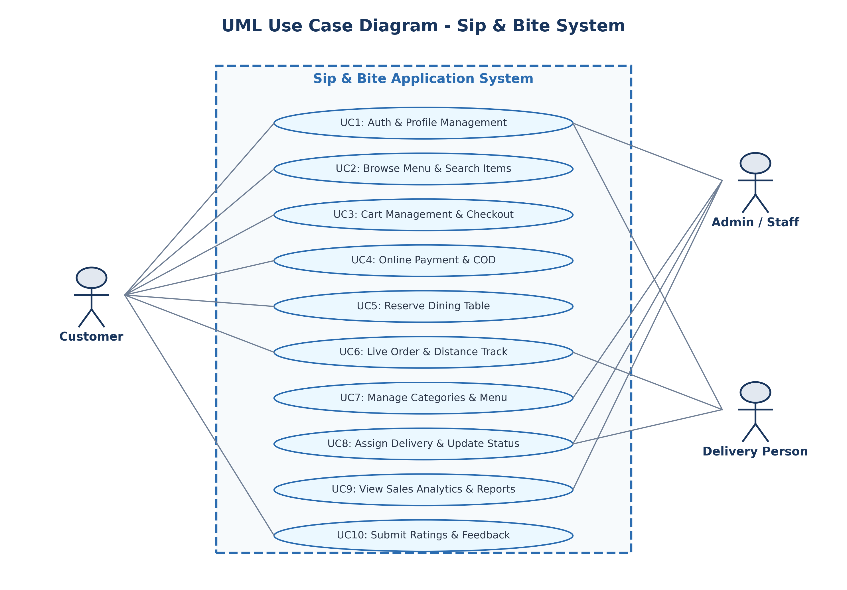
Figure 3.1: UML Use Case Diagram for Sip & Bite System
Use Case Descriptions & Actor Interactions:
- • UC1 Auth & Profile Management: Enables Customers, Admins, and Delivery Personnel to authenticate securely, reset credentials, and maintain profile information.
- • UC2 Browse Menu & Search: Allows Customers to view categorized food items, filter by veg/non-veg tags, and search by dish name.
- • UC3 Cart Management & Checkout: Enables Customers to accumulate items, adjust quantities, specify delivery addresses, and compute total fees.
- • UC4 Online Payment & COD: Supports payment execution via Razorpay gateway signature verification or Cash on Delivery selection.
- • UC5 Reserve Dining Table: Allows Customers to select table dates, times, and party sizes, storing reservations in the database.
- • UC6 Live Order & Distance Tracking: Provides real-time visibility into order status transitions and spatial distance calculation for transit routes.
- • UC7 Manage Categories & Menu: Empowers Admins to add, edit, or disable menu items and categories dynamically.
- • UC8 Assign Delivery & Update Status: Allows Admins to assign delivery staff to orders and enables Delivery Personnel to update delivery progress.
3.2 Class Diagram
The Class Diagram models the static structure of the Sip & Bite system, depicting core domain entities, their key attributes, member methods, and relational associations (one-to-many, one-to-one).
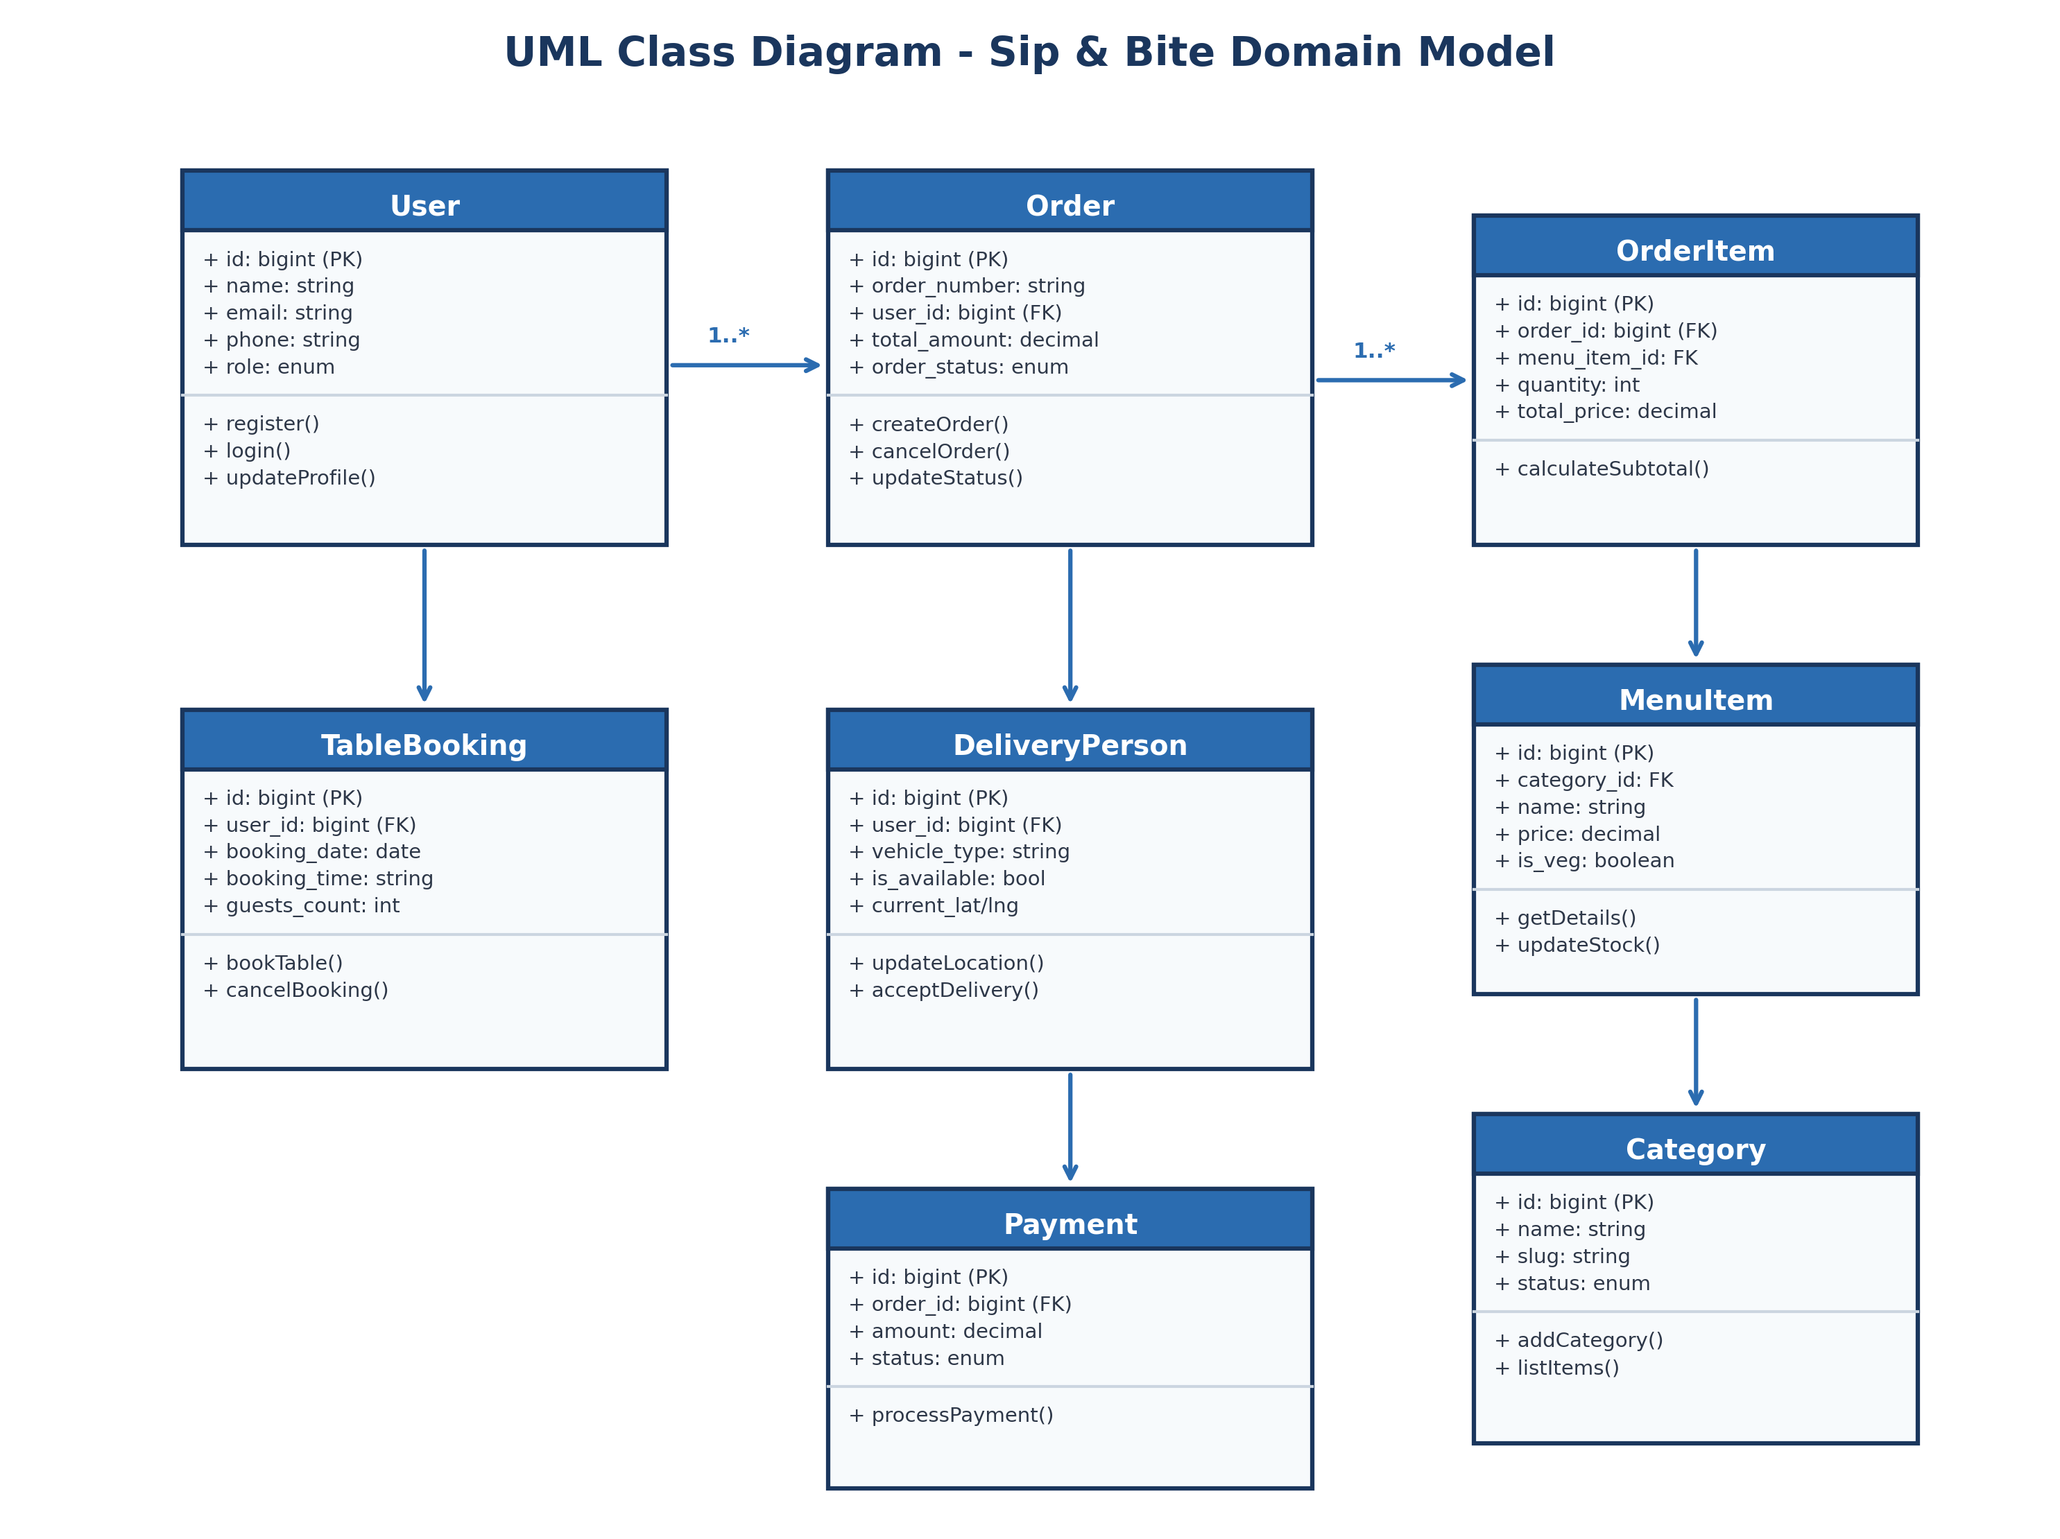
Figure 3.2: UML Class Diagram depicting Entity Relationships
Key Domain Entities and Structural Associations:
- • User Entity: Base entity storing user credentials, phone numbers, and roles. Associated with Order (1 to Many), TableBooking (1 to Many), Address (1 to Many), and Feedback (1 to Many).
- • Category & MenuItem Entities: Category maintains a 1-to-Many relationship with MenuItem. Each MenuItem belongs to one Category and is referenced by multiple OrderItems.
- • Order & OrderItem Entities: Order represents a customer purchase transaction (1-to-Many with OrderItem, 1-to-1 with Payment). It links to User, DeliveryPerson, and Address foreign keys.
- • TableBooking & Table Entities: TableBooking records dining reservations for a specific User, optionally linked to a physical Table entity.
- • DeliveryPerson Entity: Extends user profile data with vehicle attributes, availability toggles, and geolocation lat/lng parameters.
3.3 Activity Diagram
The Activity Diagram specifies the dynamic execution flow of the food ordering, payment verification, kitchen fulfillment, and delivery dispatch process.
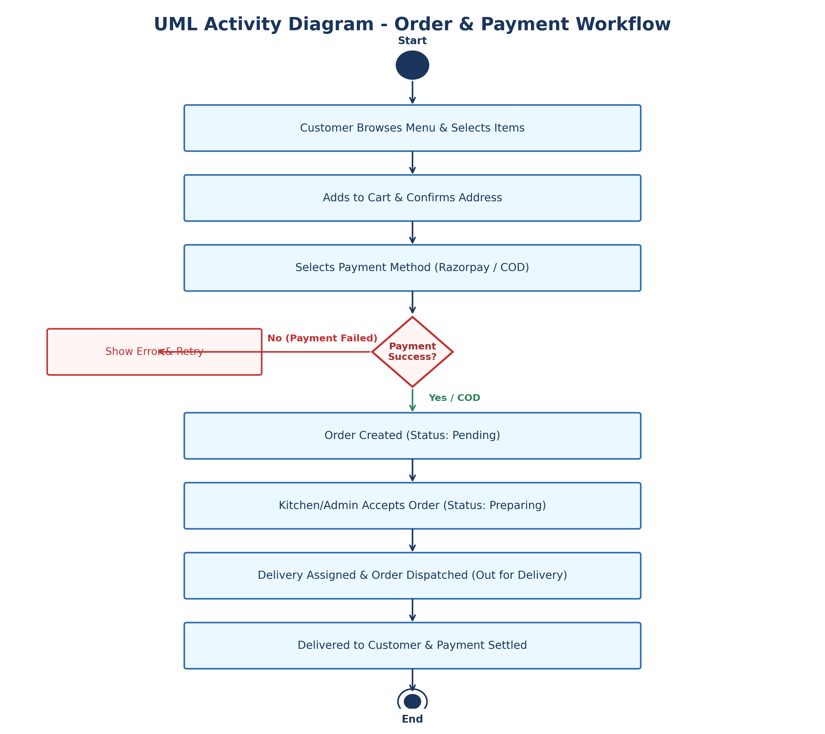
Figure 3.3: UML Activity Diagram for Order Placement & Delivery Workflow
Step-by-Step Activity Sequence:
- 1. Order Initiation: Customer browses menu categories, adds desired dishes to the cart, and proceeds to checkout.
- 2. Delivery Address & Fee Computation: Customer selects a saved address. The system computes taxes and distance-based delivery fees.
- 3. Payment Decision Node: Customer selects Razorpay or Cash on Delivery. For online payments, Razorpay SDK executes cryptographic payment validation.
- 4. Order Confirmation & Kitchen Dispatch: Upon payment success or COD selection, the order status is set to 'Pending'. Admin/Kitchen approves the order and sets status to 'Preparing'.
- 5. Delivery Assignment & Transit: Admin assigns a delivery partner. Status transitions to 'Out for Delivery'. Delivery partner navigates to customer coordinates.
- 6. Order Completion: Delivery partner hands over the food, collects COD payment (if applicable), and marks order 'Delivered'. Customer submits feedback.
3.4 Data Dictionary (table format)
The Data Dictionary defines the precise relational database schema implemented in MySQL for the Sip & Bite application. It outlines table structures, field definitions, data types, key constraints, nullability, and field descriptions.
1. Table Name: users (User Accounts & Authentication)
Field Name | Data Type | Key / Constraints | Nullable | Description & Purpose
id | BIGINT UNSIGNED | PRIMARY KEY, AUTO_INC | No | Unique user account identifier
name | VARCHAR(255) | None | No | Full name of the user
email | VARCHAR(255) | UNIQUE | No | User email address for login
email_verified_at | TIMESTAMP | None | Yes | Timestamp when email was verified
password | VARCHAR(255) | None | No | Bcrypt hashed account password
phone | VARCHAR(20) | None | Yes | Contact phone number
role | ENUM('admin','customer','delivery') | DEFAULT 'customer' | No | System access role
remember_token | VARCHAR(100) | None | Yes | Session remember token
created_at / updated_at | TIMESTAMP | None | Yes | Record creation and modification timestamps

2. Table Name: categories (Food Menu Categories)
Field Name | Data Type | Key / Constraints | Nullable | Description & Purpose
id | BIGINT UNSIGNED | PRIMARY KEY, AUTO_INC | No | Unique category identifier
name | VARCHAR(255) | None | No | Category display name (e.g., Beverages)
slug | VARCHAR(255) | UNIQUE | No | URL friendly category slug
image | VARCHAR(255) | None | Yes | Path to category cover image
description | TEXT | None | Yes | Detailed category description
status | ENUM('active','inactive') | DEFAULT 'active' | No | Category visibility state
created_at / updated_at | TIMESTAMP | None | Yes | Audit timestamps

3. Table Name: menu_items (Food & Drink Catalog)
Field Name | Data Type | Key / Constraints | Nullable | Description & Purpose
id | BIGINT UNSIGNED | PRIMARY KEY, AUTO_INC | No | Unique menu item identifier
category_id | BIGINT UNSIGNED | FOREIGN KEY (categories.id) | No | Parent category reference
name | VARCHAR(255) | None | No | Name of the dish or drink
description | TEXT | None | Yes | Ingredients and dish details
price | DECIMAL(10,2) | None | No | Item unit price in local currency
image | VARCHAR(255) | None | Yes | Path to item photo asset
is_available | BOOLEAN | DEFAULT TRUE | No | Current kitchen availability flag
is_veg | BOOLEAN | DEFAULT TRUE | No | Vegetarian (True) vs Non-Veg (False)
rating | DECIMAL(3,2) | DEFAULT 4.50 | No | Aggregated star rating score
created_at / updated_at | TIMESTAMP | None | Yes | Audit timestamps

4. Table Name: tables (Dining Table Information)
Field Name | Data Type | Key / Constraints | Nullable | Description & Purpose
id | BIGINT UNSIGNED | PRIMARY KEY, AUTO_INC | No | Unique table identifier
table_number | VARCHAR(50) | UNIQUE | No | Table identifier number or code
capacity | INT | None | No | Maximum seating capacity
location | VARCHAR(100) | None | Yes | Table location (Indoor, Terrace, VIP)
status | ENUM('available','booked','maintenance') | DEFAULT 'available' | No | Current operational table status
created_at / updated_at | TIMESTAMP | None | Yes | Audit timestamps

5. Table Name: table_bookings (Customer Table Reservations)
Field Name | Data Type | Key / Constraints | Nullable | Description & Purpose
id | BIGINT UNSIGNED | PRIMARY KEY, AUTO_INC | No | Unique booking reservation ID
user_id | BIGINT UNSIGNED | FOREIGN KEY (users.id) | No | Customer who made reservation
table_id | BIGINT UNSIGNED | FOREIGN KEY (tables.id) | Yes | Assigned physical table reference
booking_date | DATE | None | No | Reserved dining date
booking_time | VARCHAR(50) | None | No | Reserved dining time slot
guests_count | INT | None | No | Number of guests attending
special_request | TEXT | None | Yes | Dietary/seating preferences
status | ENUM('pending','confirmed','completed','cancelled') | DEFAULT 'pending' | No | Booking fulfillment status
created_at / updated_at | TIMESTAMP | None | Yes | Audit timestamps

6. Table Name: delivery_persons (Delivery Staff Profiles)
Field Name | Data Type | Key / Constraints | Nullable | Description & Purpose
id | BIGINT UNSIGNED | PRIMARY KEY, AUTO_INC | No | Unique delivery staff profile ID
user_id | BIGINT UNSIGNED | FOREIGN KEY (users.id) | No | Linked user account ID
vehicle_type | VARCHAR(50) | None | No | Type of vehicle (Bike, Scooter)
vehicle_number | VARCHAR(50) | None | No | Vehicle license plate number
current_lat | DECIMAL(10,8) | None | Yes | Live GPS latitude coordinate
current_lng | DECIMAL(11,8) | None | Yes | Live GPS longitude coordinate
is_available | BOOLEAN | DEFAULT TRUE | No | Staff active duty status
created_at / updated_at | TIMESTAMP | None | Yes | Audit timestamps

7. Table Name: addresses (Customer Delivery Addresses)
Field Name | Data Type | Key / Constraints | Nullable | Description & Purpose
id | BIGINT UNSIGNED | PRIMARY KEY, AUTO_INC | No | Unique address identifier
user_id | BIGINT UNSIGNED | FOREIGN KEY (users.id) | No | Customer owning address
address_line | TEXT | None | No | Street address and landmark
city | VARCHAR(100) | None | No | City name
state | VARCHAR(100) | None | No | State / Province name
pincode | VARCHAR(20) | None | No | Postal code / Zip code
lat | DECIMAL(10,8) | None | Yes | Geocoded latitude coordinate
lng | DECIMAL(11,8) | None | Yes | Geocoded longitude coordinate
is_default | BOOLEAN | DEFAULT FALSE | No | Primary address indicator
created_at / updated_at | TIMESTAMP | None | Yes | Audit timestamps

8. Table Name: orders (Food Delivery & Takeaway Orders)
Field Name | Data Type | Key / Constraints | Nullable | Description & Purpose
id | BIGINT UNSIGNED | PRIMARY KEY, AUTO_INC | No | Unique order record identifier
order_number | VARCHAR(255) | UNIQUE | No | Human readable order number (e.g., ORD1001)
user_id | BIGINT UNSIGNED | FOREIGN KEY (users.id) | No | Customer placing order
delivery_person_id | BIGINT UNSIGNED | FOREIGN KEY (delivery_persons.id) | Yes | Assigned delivery agent ID
address_id | BIGINT UNSIGNED | FOREIGN KEY (addresses.id) | Yes | Target delivery destination
subtotal | DECIMAL(10,2) | None | No | Sum of menu item prices
tax | DECIMAL(10,2) | DEFAULT 0.00 | No | Applied tax amount
delivery_fee | DECIMAL(10,2) | DEFAULT 0.00 | No | Distance computed delivery fee
total_amount | DECIMAL(10,2) | None | No | Final order grand total
payment_method | ENUM('COD','Razorpay') | DEFAULT 'COD' | No | Selected payment channel
payment_status | ENUM('pending','paid','failed') | DEFAULT 'pending' | No | Payment settlement status
razorpay_order_id | VARCHAR(255) | None | Yes | External Razorpay order ID
razorpay_payment_id | VARCHAR(255) | None | Yes | External Razorpay transaction reference
order_status | ENUM('Pending','Preparing','Out for Delivery','Delivered','Cancelled') | DEFAULT 'Pending' | No | Current fulfillment stage
notes | TEXT | None | Yes | Customer cooking/delivery instructions
created_at / updated_at | TIMESTAMP | None | Yes | Audit timestamps

9. Table Name: order_items (Individual Order Line Items)
Field Name | Data Type | Key / Constraints | Nullable | Description & Purpose
id | BIGINT UNSIGNED | PRIMARY KEY, AUTO_INC | No | Unique order item line ID
order_id | BIGINT UNSIGNED | FOREIGN KEY (orders.id) | No | Parent order reference
menu_item_id | BIGINT UNSIGNED | FOREIGN KEY (menu_items.id) | No | Ordered menu item reference
quantity | INT | None | No | Quantity of dish ordered
unit_price | DECIMAL(10,2) | None | No | Price per unit at order time
total_price | DECIMAL(10,2) | None | No | Total line cost (quantity * unit_price)
created_at / updated_at | TIMESTAMP | None | Yes | Audit timestamps

10. Table Name: payments (Transaction Settlement Records)
Field Name | Data Type | Key / Constraints | Nullable | Description & Purpose
id | BIGINT UNSIGNED | PRIMARY KEY, AUTO_INC | No | Unique payment record ID
order_id | BIGINT UNSIGNED | FOREIGN KEY (orders.id) | No | Associated order ID
transaction_id | VARCHAR(255) | UNIQUE | Yes | Gateway payment transaction code
payment_method | VARCHAR(50) | None | No | Payment channel (COD / UPI / Card)
amount | DECIMAL(10,2) | None | No | Total monetary amount processed
status | ENUM('pending','success','failed') | DEFAULT 'pending' | No | Final payment gateway verification state
created_at / updated_at | TIMESTAMP | None | Yes | Audit timestamps

11. Table Name: feedback (Customer Ratings & Reviews)
Field Name | Data Type | Key / Constraints | Nullable | Description & Purpose
id | BIGINT UNSIGNED | PRIMARY KEY, AUTO_INC | No | Unique feedback record ID
user_id | BIGINT UNSIGNED | FOREIGN KEY (users.id) | No | Customer submitting review
order_id | BIGINT UNSIGNED | FOREIGN KEY (orders.id) | Yes | Associated order ID
rating | INT | Check (1 to 5) | No | Star rating given (1 to 5)
comments | TEXT | None | Yes | Qualitative review comment text
created_at / updated_at | TIMESTAMP | None | Yes | Audit timestamps

7 CONCLUSION
The Sip & Bite Smart Food Ordering and Table Reservation System presents a complete, modern, and scalable technological foundation for restaurant management and food delivery operations. By harmonizing a responsive Laravel PHP web backend with an intuitive native Android application, Sip & Bite replaces cumbersome paper workflows with real-time digital automation.
Key achievements and architectural strengths demonstrated in this system design include:
- 1. End-to-End Operational Integration: Seamless synchronization across Customer, Administrative, Kitchen, and Delivery modules ensures real-time status visibility and zero operational lag.
- 2. Robust Data Model & Integrity: The relational database schema, documented comprehensively in the Data Dictionary, enforces foreign key integrity, ACID-compliant order transactions, and optimized spatial queries.
- 3. Geolocation & Payment Efficiency: Distance-based automated fee calculations and Razorpay payment verification provide financial accuracy and transparent customer pricing.
- 4. Scalable Architecture: The modular separation of web APIs, database layers, and mobile clients allows easy future enhancements—such as AI-powered dish recommendations, automated kitchen display systems (KDS), and customer loyalty rewards.
In conclusion, the Sip & Bite system successfully fulfills all functional, technical, and operational objectives, delivering superior dining convenience to customers and driving business growth for restaurant operators.

