# Practicle-1 Date:

## Aim: Write C# code to prompt a user to input his/her name country name and then the output will be shown as an example below: ’Hello Ram From Country India!’

Code:

using System;

using System.Collections.Generic; using System.Linq;

using System.Text;

using System.Threading.Tasks;

namespace practical1

{

class Program

{

static void Main(string[] args)

{

String name, country; Console.WriteLine("Enter your name:"); name = Console.ReadLine(); Console.WriteLine("Enter your country"); country = Console.ReadLine();

Console.WriteLine("Hello {0} From Country {1}!", name, country); Console.ReadKey();

}

}

}

## Output:

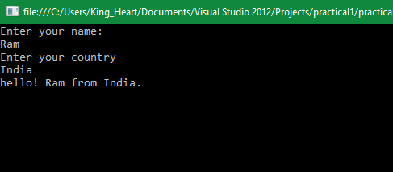

Practicle-2 Date:

Aim: write a C# code to Perform Celsius to Fahrenheit conversion and Fahrenheit to Celsius conversion.

Code:

using System;

using System.Collections.Generic; using System.Linq;

using System.Text;

using System.Threading.Tasks;

namespace prectical2

{

class Program

{

static void Main(string[] args)

{

double cel, fer;

Console.WriteLine("Enter the celsius value :"); cel =Convert.ToDouble( Console.ReadLine()); fer = (1.8)*cel + 32;

Console.WriteLine("The {0} in Fahrenheit is {1}.", cel, fer); Console.ReadKey();

}

}

}

## Output:

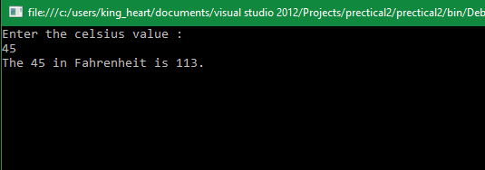

Practical-3 Date:

Aim: Write C# code to display the asterisk pattern as shown below:

*****

*****

*****

*****

*****

Code:

using System;

using System.Collections.Generic; using System.Linq;

using System.Text;

using System.Threading.Tasks;

namespace practicle3

{

class Program

{

static void Main(string[] args)

{

for(int i=0;i<5;i++)

{

for(int j=0;j<=4;j++)

{

Console.Write("*");

}

Console.WriteLine();

}

Console.ReadKey();

}

}

}

## Output:

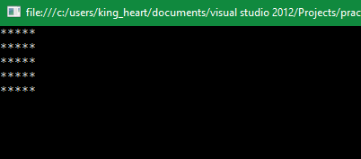

Practicle-4 Date:

Aim: Write a program to increase and decrease font size programmatically.

Code:

using System;

using System.Collections.Generic; using System.ComponentModel; using System.Data;

using System.Drawing; using System.Linq; using System.Text;

using System.Threading.Tasks; using System.Windows.Forms;

namespace Practical4

{

public partial class Form1 : Form

{

int size = 10; public Form1()

{

InitializeComponent();

}

private void btnup_Click(object sender, EventArgs e)

{

size++;

if (size < 48)

{

richTextBox1.Font = new Font("Times New Roman", size, FontStyle.Regular);

}

else

{

MessageBox.Show("Maximum size");

}

}

private void btndown_Click(object sender, EventArgs e)

{

size--;

if (size > 8)

{

richTextBox1.Font = new Font("Times New Roman", size, FontStyle.Regular);

}

else

{

MessageBox.Show("Minimum size");

}

}

private void button3_Click(object sender, EventArgs e)

{

richTextBox1.Font = new Font("Times New Roman", size, FontStyle.Bold);

}

private void button4_Click(object sender, EventArgs e)

{

richTextBox1.Font = new Font("Times New Roman", size, FontStyle.Italic);

}

private void button5_Click(object sender, EventArgs e)

{

richTextBox1.Font = new Font("Times New Roman", size, FontStyle.Underline);

}

}

}

## Output:

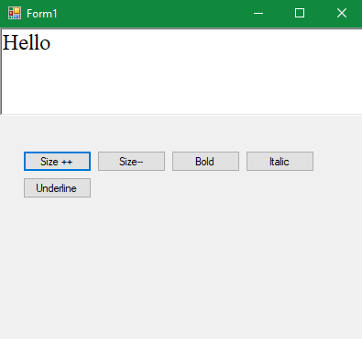

Practicle-5 Date:

Aim: Write a C# code to Convert following currency conversion.

Rupees to dollar, frank, euro.

Code:

using System;

using System.Collections.Generic; using System.ComponentModel; using System.Data;

using System.Drawing; using System.Linq; using System.Text;

using System.Threading.Tasks; using System.Windows.Forms;

namespace WindowsFormsApplication2

{

public partial class Form1 : Form

{

public Form1()

{

InitializeComponent();

}

private void button1_Click(object sender, EventArgs e)

{

Dollar.Text = Convert.ToString(Convert.ToDouble(Rupees.Text)/68); Euro.Text = Convert.ToString(Convert.ToDouble(Rupees.Text) / 115); Frank.Text = Convert.ToString(Convert.ToDouble(Rupees.Text) / 73);

}

}

}

## Output:

## 

Practicle-6 Date:

Aim: Write C# code to do the following

-Convert binary to decimal

-Convert decimal to hexadecimal

-Convert decimal to binary

-Convert decimal to octal

## Code:

using System;

using System.Collections.Generic;

using System.Linq;

using System.Text;

using System.Threading.Tasks;

namespace ConsoleApplication2

{

class Program

{

static void Main(string[] args)

{

while (true)

{

Console.WriteLine("Enter your Choice : ");

Console.WriteLine("1. Binary to Decimal");

Console.WriteLine("2. Decimal to Hexadecimal");

Console.WriteLine("3. Decimal to Binary");

Console.WriteLine("4. Decimal to octal");

Console.WriteLine("5. All");

Console.WriteLine("6. Exit");

int choice = int.Parse(Console.ReadLine());

switch (choice)

{

case 1:

B2D();

break;

case 2:

D2H();

break;

case 3:

D2B();

break;

case 4:

D2O();

break;

case 5:

B2D();

D2H();

D2B();

D2O();

break;

case 6:

break;

default:

Console.WriteLine("Enter valid choice");

break;

}

if (choice == 6)

break;

}

Console.ReadKey();

}

static void B2D()

{

Console.WriteLine("Enter a binary number:");

String binary = Console.ReadLine();

char[] b = binary.ToCharArray();

int i = 0;

int[] r = new int[20];

r[0] = 1;

int t = 1;

for (i = 1; i < 20; i++)

{

t = t * 2;

r[i] = t;

}

int d = 0, j = 0;

for (i = b.Length - 1; i >= 0; i--)

{

if (b[i] == '1')

{

d = d + r[j];

}

j++;

}

Console.WriteLine("Decimal number:\t" + d);

}

static void D2H()

{

Console.WriteLine("Enter a Decimal Number:");

int d = int.Parse(Console.ReadLine());

char[] t = { '0', '1', '2', '3', '4', '5', '6', '7', '8', '9', 'A', 'B', 'C', 'D', 'E', 'F' };

int i = 0;

char[] h = new char[10];

while (d > 0)

{

int temp = d % 16;

h[i] = t[temp];

d = d / 16;

i++;

}

Console.Write("Hexadecimal Number:\t");

i--;

for (; i >= 0; i--)

{

Console.Write(h[i]);

}

Console.Write("\n");

}

static void D2B()

{

Console.WriteLine("Enter a decimal number:");

int d = int.Parse(Console.ReadLine());

int[] b = new int[15];

int i = 0;

while (d > 0)

{

int temp = d % 2;

b[i] = temp;

d = d / 2;

i++;

}

i--;

Console.Write("Binary Number:\t");

for (; i >= 0; i--)

{

Console.Write(b[i]);

}

Console.Write("\n");

}

static void D2O()

{

Console.WriteLine("Enter a Decimal Number:");

int d = int.Parse(Console.ReadLine());

char[] t = { '0', '1', '2', '3', '4', '5', '6', '7' };

int i = 0;

char[] h = new char[10];

while (d > 0)

{

int temp = d % 8;

h[i] = t[temp];

d = d / 8;

i++;

}

Console.Write("Octal Number:\t");

i--;

for (; i >= 0; i--)

{

Console.Write(h[i]);

}

Console.Write("\n");

}

}

## }

## Output :

## C:\Users\yashp\Pictures\Saved Pictures\6.PNG

Practicle-7 Date:

Aim: Write C# code to convert infix notation to postfix notation.

Code:

using System;

using System.Collections.Generic;

using System.Linq;

using System.Text;

using System.Threading.Tasks;

namespace ConsoleApplication2

{

class Program

{

static bool convert(ref string infix, out string postfix)

{

int prio = 0;

postfix = "";

Stack<Char> s1 = new Stack<char>();

for (int i = 0; i < infix.Length; i++)

{

char ch = infix[i];

if (ch == '+' || ch == '-' || ch == '*' || ch == '/')

{

if (s1.Count <= 0)

s1.Push(ch);

else

{

if (s1.Peek() == '*' || s1.Peek() == '/')

prio = 1;

else

prio = 0;

if (prio == 1)

{

if (ch == '+' || ch == '-')

{

postfix += s1.Pop();

i--;

}

else

{

postfix += s1.Pop();

i--;

}

}

else

{

if (ch == '+' || ch == '-')

{

postfix += s1.Pop();

s1.Push(ch);

}

else

s1.Push(ch);

}

}

}

else

{

postfix += ch;

}

}

int len = s1.Count;

for (int j = 0; j < len; j++)

postfix += s1.Pop();

return true;

}

static void Main(string[] args)

{

string infix = "";

string postfix = "";

if (args.Length == 1)

{

infix = args[0];

convert(ref infix, out postfix);

System.Console.WriteLine("InFix :\t" + infix);

System.Console.WriteLine("PostFix:\t" + postfix);

}

else

{

infix = "a+b*c-d";

convert(ref infix, out postfix);

System.Console.WriteLine("InFix :\t" + infix);

System.Console.WriteLine("PostFix :\t" + postfix);

System.Console.WriteLine();

infix = "a+b*c-d/e*f";

convert(ref infix, out postfix);

System.Console.WriteLine("InFix :\t" + infix);

System.Console.WriteLine("PostFix :\t" + postfix);

System.Console.WriteLine();

infix = "a-b/c*d-e--f/h*i++j-/k";

convert(ref infix, out postfix);

System.Console.WriteLine("InFix :\t" + infix);

System.Console.WriteLine("PostFix :\t" + postfix);

System.Console.WriteLine();

Console.ReadLine();

}

}

}

}

## Output:

## C:\Users\yashp\Pictures\Saved Pictures\7.PNG

Practicle-8 Date:

Aim: Write a C# code to convert digits to words.

Code:

using System;

using System.Collections.Generic;

using System.Linq;

using System.Text;

using System.Threading.Tasks;

namespace ConsoleApplication2

{

class Program

{

static void Main(string[] args)

{

int num;

int nextdigit;

int numdigits;

int[] n = new int[20];

string[] digits = { "zero", "one", "two",

"three", "four", "five",

"six", "seven", "eight",

"nine" };

Console.WriteLine("Enter the number");

num = Convert.ToInt32(Console.ReadLine());

Console.WriteLine("Number: " + num);

Console.Write("Number in words: ");

nextdigit = 0;

numdigits = 0;

do

{

nextdigit = num % 10;

n[numdigits] = nextdigit;

numdigits++;

num = num / 10;

} while (num > 0);

numdigits--;

for (; numdigits >= 0; numdigits--)

Console.Write(digits[n[numdigits]] + " ");

Console.WriteLine();

Console.ReadLine();

}

}

}

## Output:

## C:\Users\yashp\Pictures\Saved Pictures\8.PNG

Practicle-9 Date:

Aim: Write a program to change color of Label text control programmatically in Asp .Net.

Code:

Default.aspx :-

<%@ Page Language="C#" AutoEventWireup="true" CodeFile="Default.aspx.cs" Inherits="_Default" %>

<!DOCTYPE html>

<html xmlns="http://www.w3.org/1999/xhtml">

<head runat="server">

<title></title>

</head>

<body>

<form id="form1" runat="server">

<div>

<table>

<tr>

<td>

<h1>

<asp:Label id="lblResult" runat="server" text="Hello welcome to our website."></asp:Label></h1>

</td>

</tr>

<tr>

<td>

<asp:Button id="btnRed" onclick="btnRed_Click" runat="server" text="Red"></asp:Button> <asp:Button id="btnGreen" onclick="btnGreen_Click" runat="server" text="Green"></asp:Button> <asp:Button id="btnBlue" onclick="btnBlue_Click" runat="server" text="Blue"></asp:Button></td>

</tr>

</table>

</div>

</form>

</body>

</html>

Default.aspx.cs :-

using System;

using System.Collections.Generic;

using System.Linq;

using System.Web;

using System.Web.UI;

using System.Web.UI.WebControls;

using System.Drawing;

public partial class _Default : System.Web.UI.Page

{

protected void btnRed_Click(object sender, EventArgs e)

{

lblResult.ForeColor = Color.Red;

}

protected void btnGreen_Click(object sender, EventArgs e)

{

lblResult.ForeColor = Color.Green;

}

protected void btnBlue_Click(object sender, EventArgs e)

{

lblResult.ForeColor = Color.Blue;

}

}

Output:

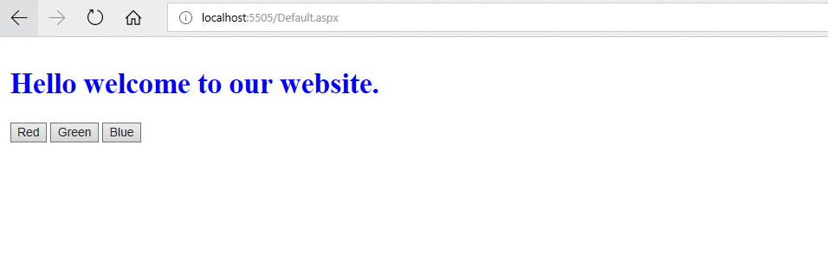

Practicle-10 Date:

Aim: Write a program to Enable-Disable Textbox and change width of TextBox programmatically in Asp .Net.

Code:

Default.aspx :-

<%@ Page Language="C#" AutoEventWireup="true" CodeFile="Default.aspx.cs" Inherits="_Default" %>

<!DOCTYPE html>

<html xmlns="http://www.w3.org/1999/xhtml">

<head runat="server">

<title></title>

</head>

<body>

<form id="form1" runat="server">

<div>

<table>

<tbody><tr>

<td>

<asp:textbox id="txtTest" runat="server">

</asp:textbox></td>

</tr>

<tr>

<td>

<asp:Button id="btnEnableTextBox" onclick="btnEnableTextBox_Click" runat="server" text="Enable"> </asp:Button>

<asp:Button id="btnDisableTextBox" onclick="btnDisableTextBox_Click" runat="server" text="Disable">

</asp:Button></td>

</tr>

</tbody></table>

</div>

</form>

</body>

</html>

Default.aspx.cs :-

using System;

using System.Collections.Generic;

using System.Linq;

using System.Web;

using System.Web.UI;

using System.Web.UI.WebControls;

using System.Drawing;

public partial class _Default : System.Web.UI.Page

{

protected void btnDisableTextBox_Click(object sender, EventArgs e)

{

txtTest.Enabled = false;

}

protected void btnEnableTextBox_Click(object sender, EventArgs e)

{

txtTest.Enabled = true;

}

}

Output:

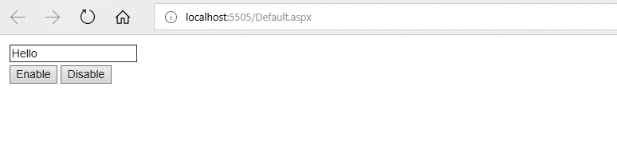

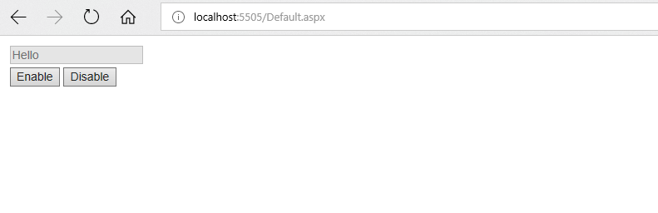

Practicle-11 Date:

Aim: Write a program to check whether empty query string is entered in Asp .net.

Code :

String1.aspx :-

<%@ Page Language="C#" AutoEventWireup="true" CodeFile="String1.aspx.cs" Inherits="_Default" %>

<!DOCTYPE html>

<html xmlns="http://www.w3.org/1999/xhtml">

<head runat="server">

<title></title>

</head>

<body>

<form id="form1" runat="server">

<div>

<table>

<tbody><tr>

<td>

<asp:textbox id="txtTest" runat="server">

</asp:textbox></td>

</tr>

<tr>

<td>

<asp:Button id="btnEnableTextBox" onclick="btnTextBox_Click" runat="server" text="Submit"> </asp:Button>

</td>

</tr>

</tbody></table>

</div>

</form>

</body>

</html>

String2.aspx :-

<%@ Page Language="C#" AutoEventWireup="true" CodeFile="String2.aspx.cs" Inherits="String2" %>

<!DOCTYPE html>

<html xmlns="http://www.w3.org/1999/xhtml">

<head runat="server">

<title></title>

</head>

<body>

<form id="form1" runat="server">

<div>

<asp:Label runat="server" ID="label" text=""></asp:Label>

</div>

</form>

</body>

</html>

String1.aspx.cs :-

using System;

using System.Collections.Generic;

using System.Linq;

using System.Web;

using System.Web.UI;

using System.Web.UI.WebControls;

using System.Drawing;

public partial class _Default : System.Web.UI.Page

{

protected void btnTextBox_Click(object sender, EventArgs e)

{

Response.Redirect("String2.aspx?key=" + txtTest.Text);

}

}

String2.aspx.cs :-

using System;

using System.Collections.Generic;

using System.Linq;

using System.Web;

using System.Web.UI;

using System.Web.UI.WebControls;

public partial class String2 : System.Web.UI.Page

{

protected void Page_Load(object sender, EventArgs e)

{

if (Request.QueryString["key"].ToString() == "")

{

label.Text = "Querystring is empty";

}

else

{

label.Text = Request.QueryString["key"].ToString();

}

}

}

Output:

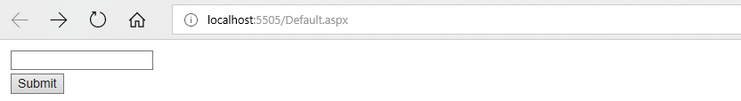

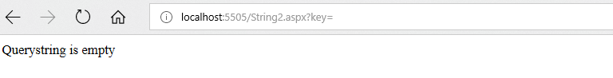

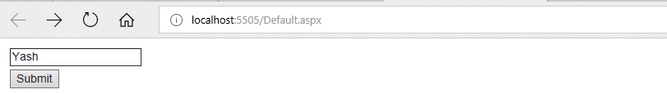

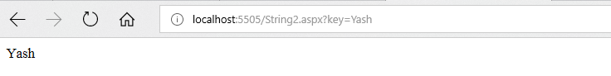

Practicle-12 Date:

Aim: Write ASP.Net program to Store Objects in Session State and Storing Session State in SQLServer.

Code:

Session1.aspx :-

<%@ Page Language="C#" AutoEventWireup="true" CodeFile="Session1.aspx.cs" Inherits="_Default" %>

<!DOCTYPE html>

<html xmlns="http://www.w3.org/1999/xhtml">

<head runat="server">

<title></title>

</head>

<body>

<form id="form1" runat="server">

<div>

User Clicks:

<asp:Label ID="lblClick" runat="server"></asp:Label>

<br/>

<asp:Button ID="Button1" runat="server" OnClick="Button1_Click" Text="Button"/>

<br/>

</div>

</form>

</body>

</html>

Session2.aspx :-

<%@ Page Language="C#" AutoEventWireup="true" CodeFile="Session2.aspx.cs" Inherits="String2" %>

<!DOCTYPE html>

<html xmlns="http://www.w3.org/1999/xhtml">

<head runat="server">

<title></title>

</head>

<body>

<form id="form1" runat="server">

<div>

User Clicks:

<asp:Label ID="lblClick" runat="server"></asp:Label>

<br/>

<asp:Button ID="Button1" runat="server" OnClick="Button1_Click" Text="Button"/>

</div>

</form>

</body>

</html>

Session1.aspx.cs :-

using System;

using System.Collections.Generic;

using System.Linq;

using System.Web;

using System.Web.UI;

using System.Web.UI.WebControls;

using System.Drawing;

public partial class _Default : System.Web.UI.Page

{

protected void Button1_Click(object sender, EventArgs e)

{

if (!IsPostBack)

{

if (Session["Clicks"] == null)

{

Session["Clicks"] = 1;

}

lblClick.Text = Session["Clicks"].ToString();

}

else

{

Session["Clicks"] = Convert.ToInt32(Session["Clicks"]) + 1;

lblClick.Text = Session["Clicks"].ToString();

}

}

}

Session2.aspx.cs :-

using System;

using System.Collections.Generic;

using System.Linq;

using System.Web;

using System.Web.UI;

using System.Web.UI.WebControls;

public partial class String2 : System.Web.UI.Page

{

protected void Button1_Click(object sender, EventArgs e)

{

if (!IsPostBack)

{

if (Session["Clicks"] == null)

{

Session["Clicks"] = 1;

}

lblClick.Text = Session["Clicks"].ToString();

}

else

{

Session["Clicks"] = Convert.ToInt32(Session["Clicks"]) + 1;

lblClick.Text = Session["Clicks"].ToString();

}

}

}

Output:

