Team Number: - 5

Yash Patel - 2310624  
Armin Khaleghi Rad - 2310539  
Rakshit Sain - 2310453

*REPORT*

*ON*

*API ABUSE*

**Table of Content**

1. **Summary**
2. **Introduction**
3. **Types of API Abuse**
4. **Impact**
5. **Common Vulnerabilities Exploited**
6. **Prevention Strategies**
7. **Implementing API Security**
8. **Demo (Attack & Prevention)**
9. **Resources & Technology use**

**10. Conclusion**

**1. Summary on API Abuse**

1.1 Understanding and Addressing API Abuse Threats

This report delves into the critical realm of API abuse, shedding light on its significance, types, impact, and preventive strategies. In an era where digital interactions are paramount, the vulnerabilities associated with APIs demand our utmost attention. This report aims to provide a comprehensive understanding of API abuse, its potential ramifications, and the measures that organizations can adopt to safeguard their digital ecosystems.

1.2 Purpose and Scope

The purpose of this report is to raise awareness about the escalating threats of API abuse and equip stakeholders with actionable insights to fortify their systems against potential breaches. By examining the various dimensions of API abuse, we intend to empower organizations to establish robust security measures that protect both data and user trust.

1.3 Importance of API Abuse Awareness

APIs are the conduits through which digital services communicate and function seamlessly. As this integration grows, so does the potential for abuse. Understanding the gravity of API abuse is paramount, as the consequences span from financial losses and reputation damage to data breaches and system disruption. Acknowledging these threats is the first step toward mitigating them effectively.

1.4 Important Points

* + Various forms of API abuse, including unauthorized access, DoS attacks, data scraping, and more, pose significant risks to digital ecosystems.
  + Common vulnerabilities such as inadequate authentication, lack of input validation, and insecure data transmission serve as entry points for attackers.
  + API abuse incidents can lead to data breaches, financial losses, system downtime, and lasting damage to an organization's reputation.
  + Effective prevention strategies encompass robust authentication, input validation, secure data transmission, and real-time monitoring.
  + Collaborative efforts between developers, security teams, and users are crucial in establishing a multi-layered security posture.

**2. Introduction**

2.1 Addressing the Growing Threat of API Abuse

In an increasingly interconnected digital landscape, Application Programming Interfaces (APIs) serve as the vital conduits that enable seamless communication between various software applications and services. As APIs have become the cornerstone of modern software development, their significance has attracted not only legitimate users but also malicious actors seeking to exploit vulnerabilities for personal gain or disruption. This introduction delves into the realm of API abuse, shedding light on its meaning, importance, and the imperative need to understand and address this burgeoning threat.

2.2 The Role of APIs: Building Bridges in the Digital Realm

APIs are akin to bridges that connect diverse digital platforms, allowing them to share data, functionality, and services seamlessly. They underpin a wide array of applications, from social media networks and e-commerce platforms to banking systems and healthcare services. APIs enable developers to create dynamic and integrated experiences that enhance user interactions and streamline operations.

2.3 Defining API Abuse: The Dark Side of Connectivity

API abuse, however, unveils the darker side of this connectivity. It involves the unauthorized or malicious exploitation of APIs to undermine system integrity, compromise data security, and disrupt services. Just as doors provide access to your home, APIs grant access to digital systems, making them an appealing target for those with nefarious intentions.

2.4 The Urgent Need for API Security: Protecting Digital Interactions

As the world becomes increasingly reliant on digital interactions, the security of APIs becomes paramount. API abuse has the potential to inflict severe damage, ranging from financial losses and customer data breaches to prolonged service disruptions and reputational harm. The need to safeguard these digital entry points has never been more critical, as the consequences of overlooking API security can be both far-reaching and long-lasting.

2.5 Objective of this Exploration: Understanding and Prevention

The objective of this exploration is twofold: to deepen our understanding of API abuse and to equip individuals, developers, and organizations with the knowledge and strategies needed to mitigate its risks. By delving into the various forms of abuse, their impact, and the preventive measures that can be employed, we aim to empower readers to fortify their digital ecosystems against this growing threat.

2.6 Navigating the Presentation: Unveiling API Abuse and its Countermeasures

In the subsequent sections, we will navigate the landscape of API abuse, starting with an overview of the different types of abuse and their potential consequences. We will then examine the vulnerabilities that attackers exploit, providing insights into the weak points that demand reinforcement. Moving forward, we will delve into practical strategies and best practices to prevent API abuse, showcasing the importance of proactive defense.

As we proceed, remember that the insights presented here are not only valuable for developers and security professionals but for anyone vested in the security of digital systems and the protection of sensitive data. By the end of this exploration, we anticipate that you will have gained a deeper understanding of API abuse and the proactive measures required to mitigate its risks effectively.

**3. Types of API Abuse**

API abuse comes in various forms, each posing a distinct risk to the digital ecosystem. Let's explore these types of abuse and uncover real-world examples that highlight their potential impact.

3.1 Unauthorized Access: Sneaking Through Digital Doors

Unauthorized access is like someone trying to enter a locked building without permission. Hackers exploit vulnerabilities to gain entry to systems they shouldn't have access to. This can lead to data breaches, exposing sensitive information to the wrong hands.

3.2 Denial of Service (DoS) Attacks: Flooding the Path

A DoS attack is comparable to a massive crowd blocking a street, preventing everyone from moving. In the digital world, attackers flood systems with excessive requests, causing them to crash and become unavailable. This disrupts services and frustrates users.

3.3 Data Scraping: Silent Theft of Information

Data scraping is like someone secretly copying information from your notebook. Attackers use automated tools to steal data from APIs, often with the intent of selling it or using it maliciously. This can compromise user privacy and lead to identity theft.

3.4 Brute Force Attacks: Relentless Guessing Game

Imagine trying every possible key until one unlocks the door. Brute force attacks work similarly, where hackers attempt countless combinations to guess passwords or access codes. This type of attack targets weak or common credentials.

3.5 Credential Stuffing: Keys for Multiple Doors

Credential stuffing is akin to using the same key for multiple doors. Attackers reuse stolen login information from one platform to access other systems where users might have used the same credentials. This highlights the importance of using unique passwords.

3.6 API Token/Key Theft: Unauthorized Imitation

API token/key theft is like someone copying your house keys. Attackers steal these tokens or keys to impersonate legitimate users, gaining access to systems and data they shouldn't have.

3.7 API Rate Limiting Violations: Excessive Doorbell Ringing

API rate limiting violations are similar to repeatedly ringing a doorbell to annoy residents. Attackers make more requests than allowed, overwhelming the system and affecting its performance.

**4. Impact of API Abuse**

API abuse isn't a theoretical concern—it has concrete and wide-ranging repercussions. Let's explore the real-world impact of API abuse, highlighting the tangible consequences that can arise when these vulnerabilities are exploited.

4.1 Data Breaches: Privacy Invasion

API abuse can lead to data breaches, were unauthorized access exposes sensitive information. Just as a thief can break into a vault and steal valuables, attackers can access personal data, financial records, and proprietary information.

4.2 Financial Losses: Hits to the Bottom Line

API abuse can result in substantial financial losses. Companies may experience downtime, leading to decreased productivity and revenue loss. Furthermore, reputation damage can lead to customer attrition and decreased trust.

4.3 System Downtime: Disrupted Operations

API abuse can overwhelm systems, resulting in downtime. Similar to a power outage affecting an entire neighborhood, system downtime can interrupt user access and disrupt operations.

4.4 Reputation Damage: Erosion of Trust

API abuse incidents can undermine a company's trustworthiness. Just as a neighborhood's safety reputation affects property values, reputation damage can drive customers away and deter potential ones.

4.5 Legal Consequences: Regulatory Fallout

API abuse can have legal ramifications, particularly when user data is compromised. Companies might face lawsuits, regulatory fines, and strained relationships with both customers and regulators.

4.6 Wider Disruption: Collateral Impact

API abuse's impact can extend beyond a single company. Just as a disruption in one house can affect an entire block, API abuse can disrupt the broader digital ecosystem, impacting partners and users.

In Conclusion: Understanding the Real Costs

The repercussions of API abuse are not abstract—they involve really financial, operational, and reputational costs. By recognizing these consequences, we gain a clear understanding of the importance of robust security measures. As we explore prevention strategies, it's crucial to keep these tangible impacts in mind, motivating us to safeguard both digital interactions and the integrity of our systems.

**5. Common Vulnerabilities Exploited**

Attackers often target vulnerabilities in APIs to exploit their weaknesses. Let's delve into some common vulnerabilities that malicious actors exploit, understand their potential impact, and see how attackers can capitalize on them.

5.1 Inadequate Authentication and Authorization: Weak Locks

Weak authentication is like having a flimsy lock on your door. Attackers can guess or bypass passwords, gaining unauthorized access. Insufficient authorization allows them to access functionalities they shouldn't, potentially leading to data breaches or unauthorized actions.

**Impact**: Unauthorized access to sensitive data, potential financial losses, compromised user accounts.

5.2 Lack of Input Validation: Accepting Anything

Imagine accepting packages without checking their contents. APIs that lack input validation can inadvertently accept harmful data, leading to attacks like SQL injection or cross-site scripting (XSS).

**Impact**: Data corruption, manipulation, unauthorized access, and potential data breaches.

5.3 Insecure Data Transmission: Shouting Secrets

Sending data without protection is like shouting private information in public. Attackers can intercept and steal sensitive data during transmission if it's not properly encrypted.

**Impact**: Stolen sensitive information, potential data breaches, and compromised user privacy.

5.4 Insufficient Rate Limiting: Non-Stop Requests

Not enforcing rate limits is like letting someone ring your doorbell non-stop. Attackers can flood the API with excessive requests, overwhelming the system and causing performance issues.

**Impact**: Reduced API performance, slower response times, and potential system downtime.

5.5 Insecure Storage of API Keys/Tokens: Leaving Keys Out

Storing API keys or tokens insecurely is like leaving your keys out in the open. Attackers can steal these credentials and impersonate legitimate users, gaining unauthorized access.

**Impact**: Unauthorized access, data breaches, and potential misuse of user accounts.

5.6 Broken Authentication Flow: Exploiting Gaps

A broken authentication flow is like a door with a faulty lock. Attackers exploit vulnerabilities in the login process, potentially gaining unauthorized access to user accounts.

**Impact**: Compromised user accounts, unauthorized access to sensitive information, potential data breaches.

5.7 Zero-Day Vulnerabilities: Hidden Entryways

Zero-day vulnerabilities are like secret entryways that attackers discover before anyone else. They exploit undiscovered weaknesses in the API, potentially gaining unauthorized access or causing damage.

**Impact**: Unauthorized access, potential data breaches, and potential system compromise.

Understanding these vulnerabilities is crucial for fortifying API security. By addressing these weaknesses and implementing robust security measures, we can thwart attackers and protect both our systems and the data they handle.

**6. Prevention Strategies**

Mitigating API abuse requires a multi-pronged approach. Let's delve into a range of preventive measures designed to fortify API security and protect against potential attacks.

6.1 Robust Authentication and Authorization: Secure Digital Entry

Implement strong authentication methods like OAuth or JWT. Additionally, use Role-based Access Control (RBAC) to assign specific access levels to users, ensuring only authorized parties can interact with APIs.

6.2 Input Validation and Sanitization: Filtering Out Threats

Inspect and sanitize incoming data to prevent attacks like SQL injection and cross-site scripting (XSS). Validate user inputs to ensure they adhere to expected formats and are free from malicious content.

6.3 Secure Data Transmission: Locking Down Data Flow

Encrypt data during transmission using HTTPS (TLS/SSL) protocols. This ensures that sensitive information remains confidential as it travels between systems, preventing eavesdropping by attackers.

6.4 Effective Rate Limiting and Throttling: Managing Traffic Flow

Implement rate limiting to prevent excessive requests from overwhelming the system. Throttling controls, the speed of requests, allowing a manageable flow of data while thwarting abusive behavior.

6.5 CAPTCHA Implementation: Defending Against Bots

Integrate CAPTCHA challenges to differentiate between human and automated requests. This helps prevent bots from abusing APIs and overwhelming systems with malicious traffic.

6.6 Security Audits and Penetration Testing: Regular Checks for Weaknesses

Conduct security audits to identify vulnerabilities in APIs. Perform penetration testing, simulating real-world attacks to assess the system's resilience and identify potential entry points.

6.7 User Education and Awareness: Empowering Responsible Usage

Educate users about secure API practices. Highlight the importance of using strong, unique passwords and recognizing phishing attempts to prevent unauthorized access.

6.8 Collaboration with Security Experts: Harnessing Expertise

Partner with security professionals to assess, implement, and monitor security measures. Their expertise can help identify vulnerabilities and recommend appropriate solutions.

6.9 Real-time Monitoring and Logging: Keeping a Watchful Eye

Monitor API traffic in real time and maintain detailed logs. This enables the swift detection of suspicious activity, allowing for timely intervention and mitigation.

6.10 Continuous Improvement: Staying Ahead of Threats

Security measures should be regularly updated to stay abreast of evolving threats. Regularly assess and enhance security protocols to remain effective against emerging risks.

By implementing these prevention strategies, you create a fortified defense against API abuse. Just as a well-constructed fortress thwarts intruders, a comprehensive security approach ensures the protection of both your digital assets and user trust.

**7. Implementing API Security**

Safeguarding APIs demands the utilization of robust security tools and practices. Let's explore key elements to consider when implementing API security to bolster your digital defenses.

7.1 API Gateways: Centralized Control

API gateways act as sentinels, managing access and enforcing security policies. They provide a centralized entry point, offering authentication, authorization, and traffic filtering.

7.2 Intrusion Detection and Prevention Systems (IDPS): Virtual Guards

IDPS tools monitor for unauthorized activities in real time. They detect anomalies and can take proactive measures to prevent potential attacks.

7.3 Real-time Monitoring and Logging: Vigilance in Action

Continuous monitoring observes API traffic, identifying unusual patterns or behavior. Detailed logs provide a historical record for analysis and forensic investigation.

7.4 Encryption: Locking Data Away

Encryption secures data in transit and at rest. It transforms information into unreadable code, ensuring its confidentiality even if intercepted by attackers.

7.5 Multi-Factor Authentication (MFA): Enhancing Access Security

MFA adds an extra layer of protection beyond passwords. Users must provide additional verification methods like fingerprints or security tokens to access APIs.

7.6 Continuous Improvement: Staying Ahead

Cyber threats evolve, so security measures must evolve too. Regularly assess vulnerabilities, update protocols, and adapt to new threats.

7.7 Compliance with Industry Standards: Meeting the Bar

Adhere to industry-specific regulations and standards. Compliance ensures your security measures align with established guidelines, safeguarding user data and trust.

7.8 Collaboration with DevOps and Security Teams: Unified Efforts

Integrate security practices within development and operational processes. DevOps and security teams collaborating ensure security is prioritized throughout the software lifecycle.

7.9 User Education and Awareness: Empowering Users

Educate users about security best practices when interacting with APIs. Informed users are less likely to engage in risky behaviors that could compromise security.

7.10 Web Application Firewalls (WAFs): Protective Shields

WAFs shield APIs from malicious traffic and threats. They analyze incoming data, identifying and blocking suspicious activity before it reaches the API.

By implementing these security practices, you create a comprehensive and layered defense against potential threats. Just as a fortress relies on multiple walls and mechanisms, a robust API security framework combines tools, practices, and awareness to safeguard your digital assets and maintain user trust.

**8. Demos**

**8.1 Attacks**

8.1.1 Created a Simple Attack page from where we can test the attacks

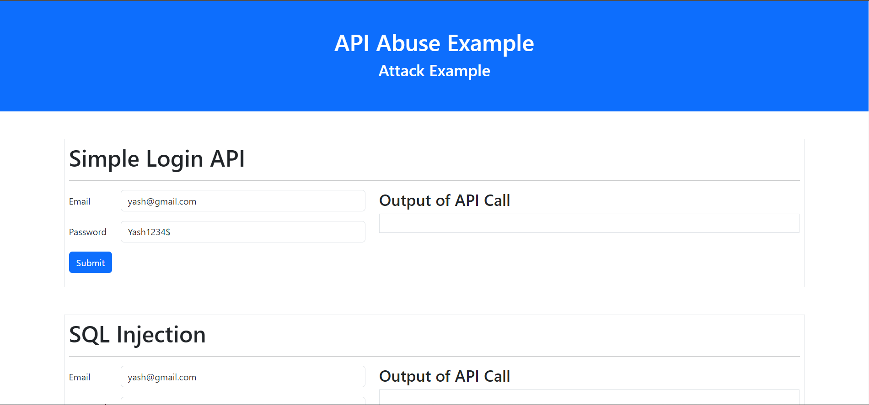

8.1.2 Added 3 Forms and created a Login API.

* 1. Simple Login API
  2. SQL Injection
  3. Brute force Attack

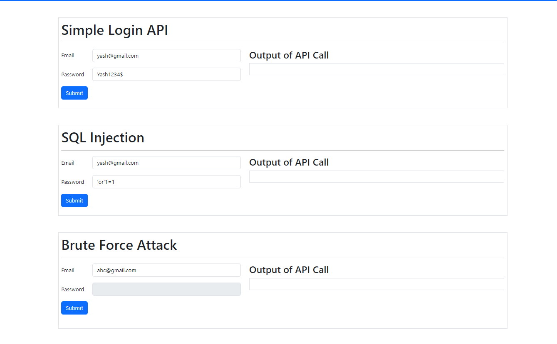

8.1.3 Simple Login API

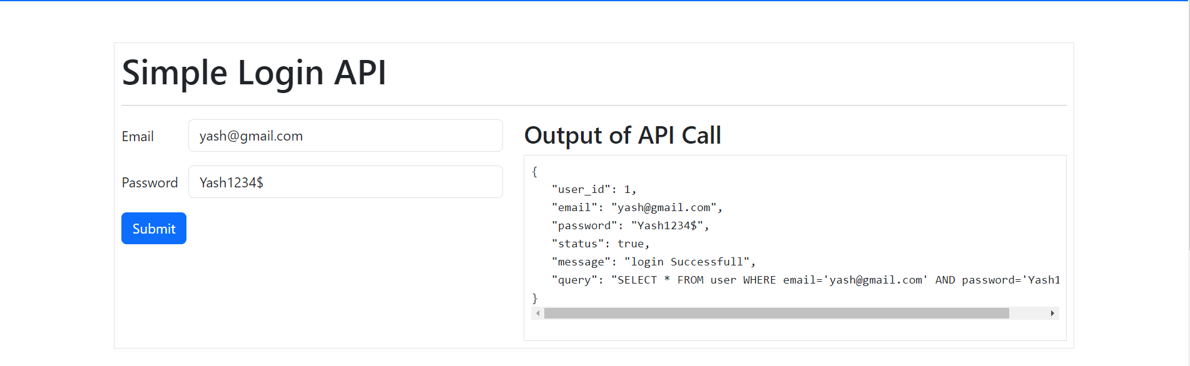

8.1.4 SQL Injection

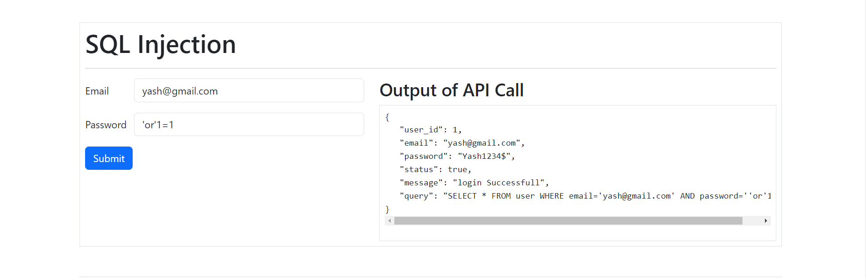

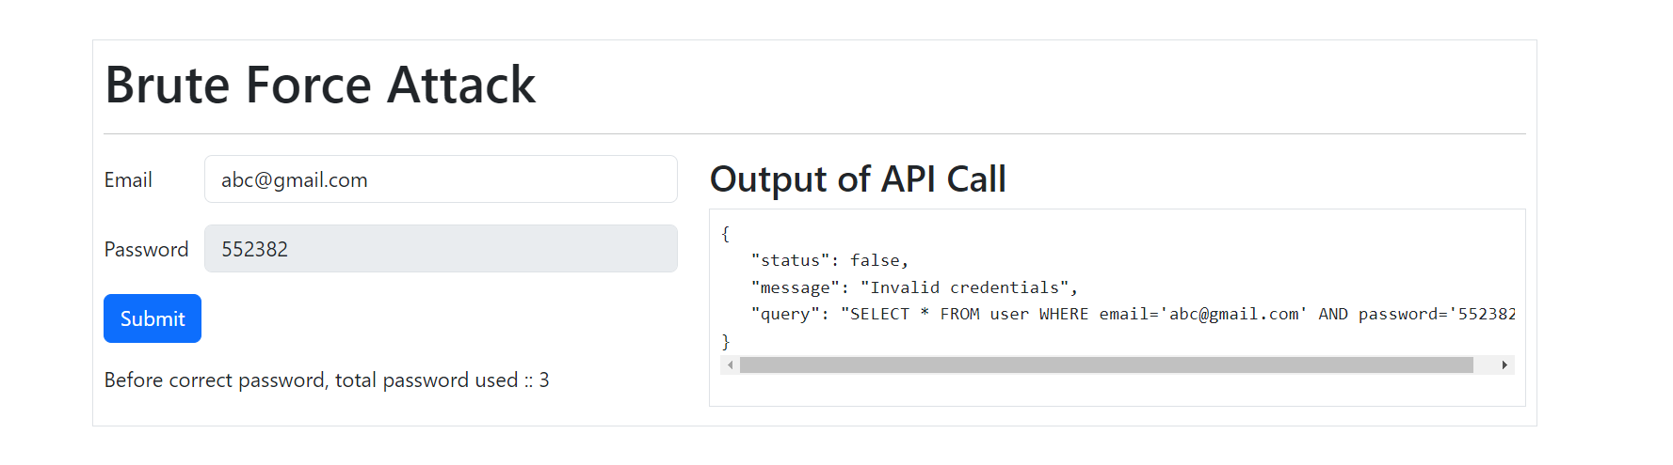8.1.5 Brute Force Attack

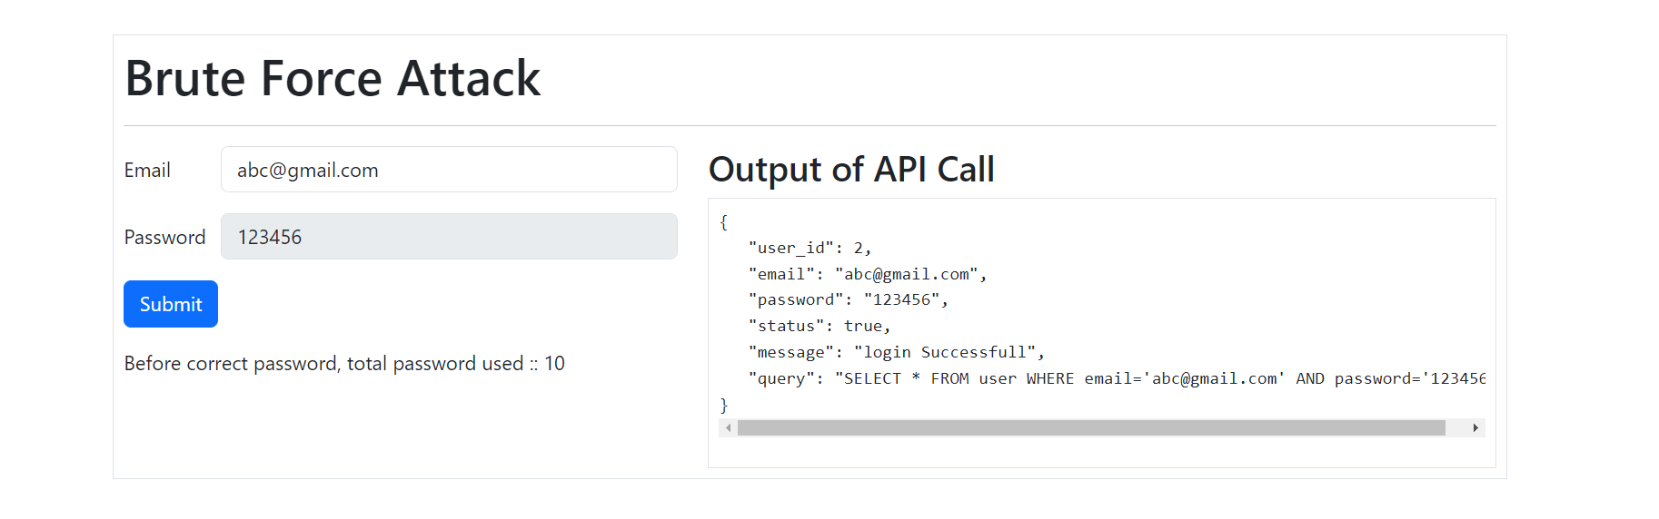

**8.2 Prevention**

8.1.1 Created another page that prevent the attacks

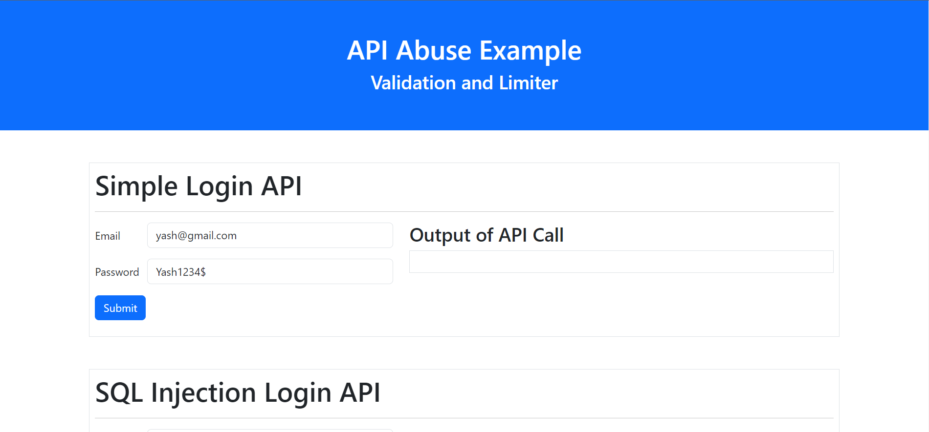

8.1.2 Added 3 Forms with validators and A login API with rate limiter.

* 1. Simple Login API
  2. SQL Injection
  3. Brute force Attack



8.1.3 Simple Login API.



8.1.4 SQL Injection Form with validators.

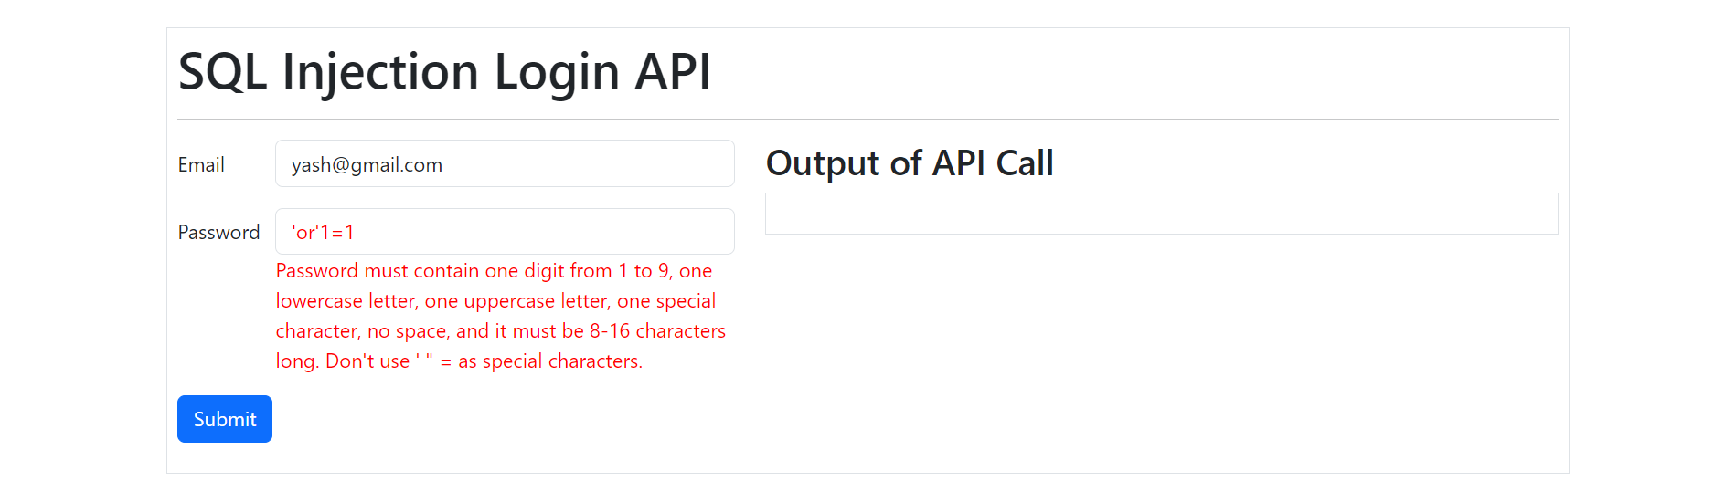

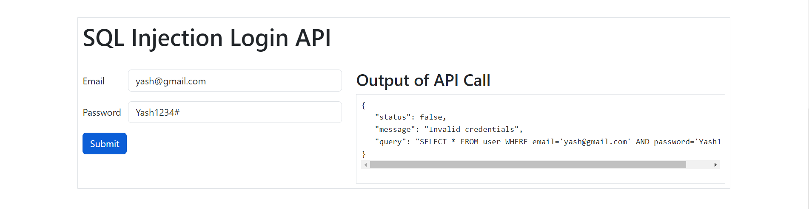

8.1.5 Brute Force Attack Form with Rate Limiter in backend

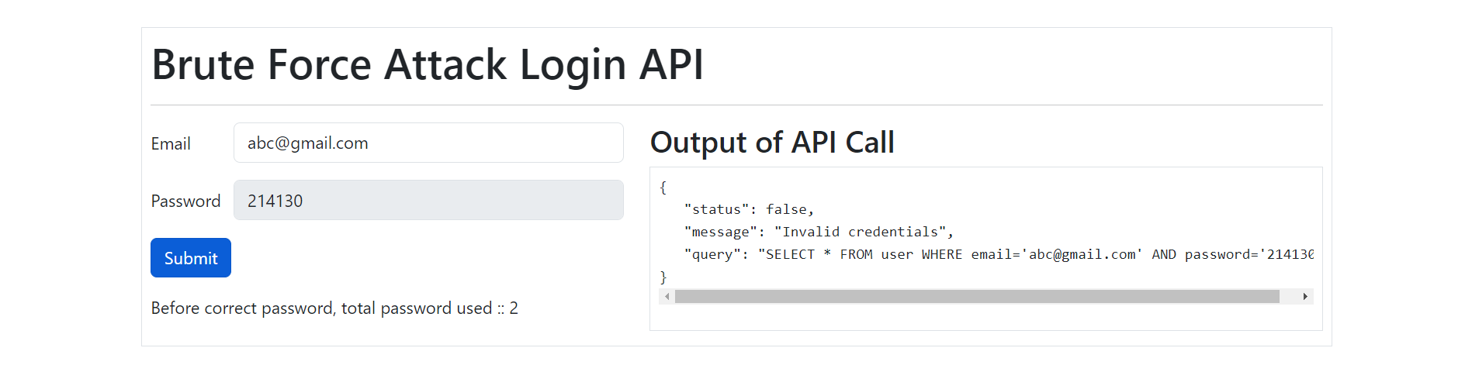

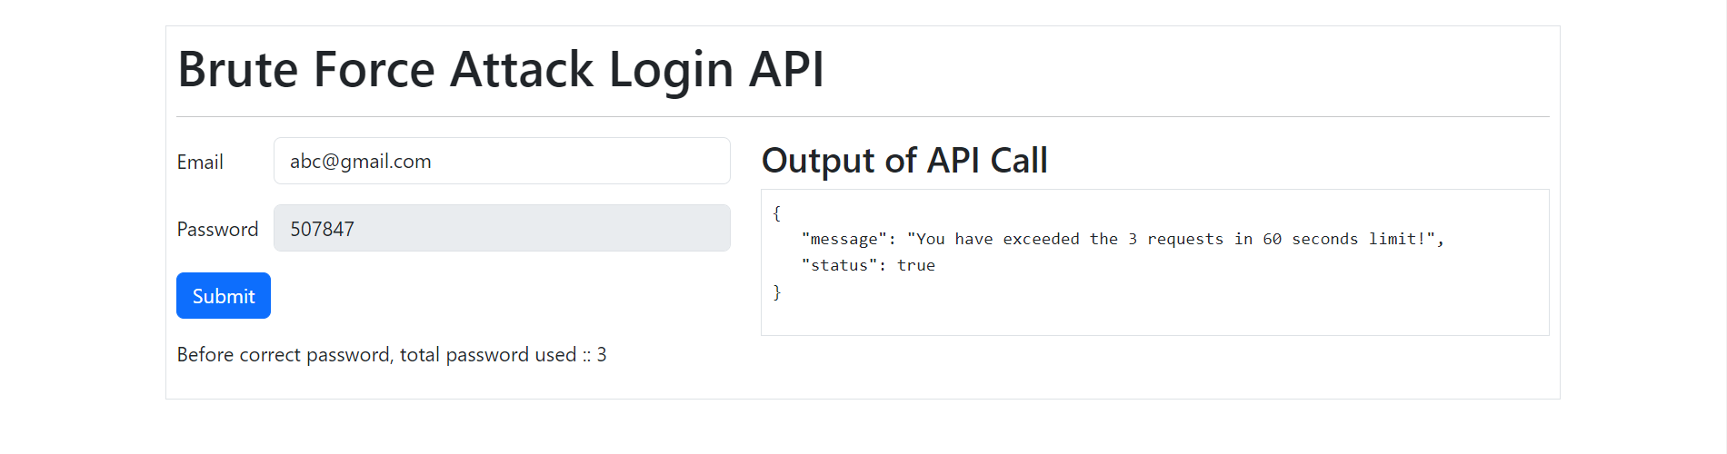

**9. Resources & Technology use**

**9.1 Database:**

Database Name: apiabuse 🡪 Table name: user

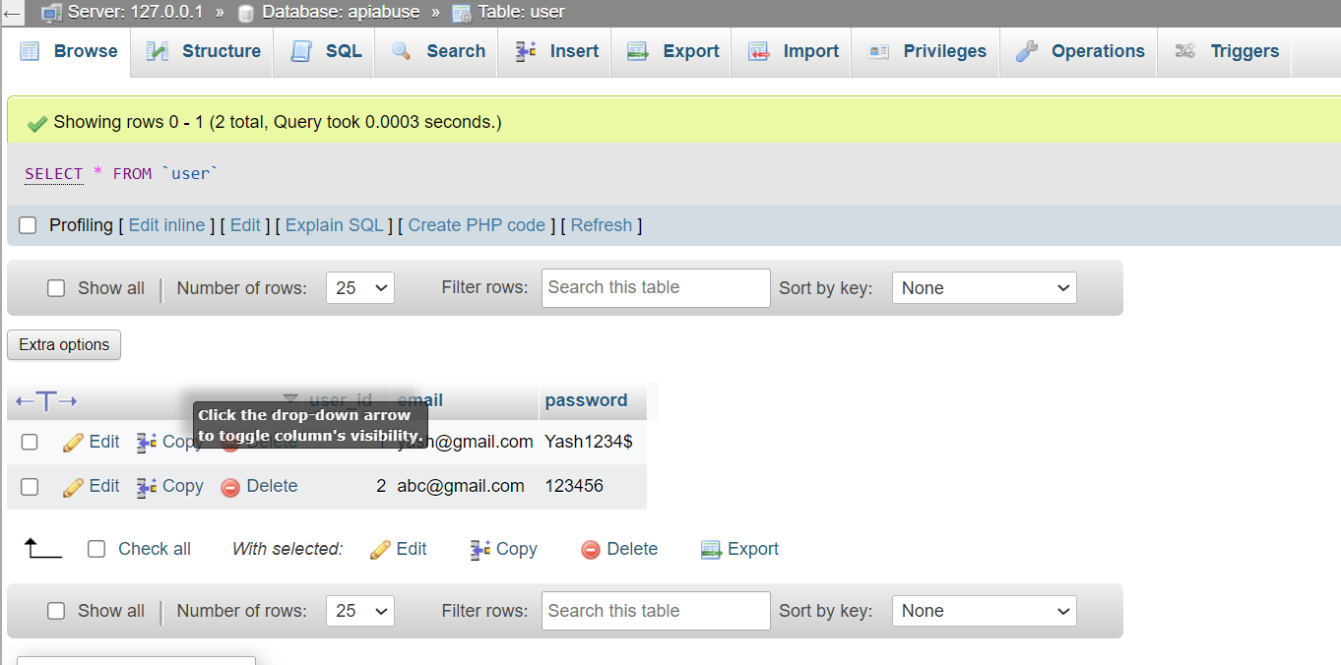

**9.2 APIs:**

1. http://localhost:5000/api/users/login
   * Type: POST
   * Data: {

Email: “”,

Password:””

}

1. <http://localhost:5000/api/users/bruteForceLogin> (With rate Limiter)
   * Type: POST
   * Data: {

Email: “”,

Password:””

}

**9.3 Technology:**

* **Back-End**:
  + NodeJS (Express JS)
  + MySQL (package)
  + Express rate limit (package)
* **Front-End**:
  + Bootstrap
  + JQuery
  + Validate JS (Regex)
* **Server & Database**:
  + Xampp (Apache)
  + MySQL

**9.4 Resources:**

* **Project URL:** [**https://github.com/yashpatel521/API-Abuse**](https://github.com/yashpatel521/API-Abuse)
* **Bootstrap:** [**https://getbootstrap.com/**](https://getbootstrap.com/)
* **JQuery:** [**https://jquery.com/**](https://jquery.com/)
* **Validate JS:** [**https://validatejs.org/**](https://validatejs.org/)
* **Express JS:** [**https://expressjs.com/**](https://expressjs.com/)
* **Express rate limiter:** [**https://www.npmjs.com/package/express-rate-limit**](https://www.npmjs.com/package/express-rate-limit)
* **MySQL:** [**https://www.npmjs.com/package/mysql**](https://www.npmjs.com/package/mysql)

**10. Conclusion**

In a world driven by digital interactions and interconnected systems, the security of Application Programming Interfaces (APIs) emerges as a paramount concern. As we conclude this comprehensive exploration of API abuse and its mitigation, we reflect upon the critical importance of safeguarding these digital bridges.

API abuse is not a hypothetical threat—it is a tangible risk that can lead to data breaches, financial losses, reputational damage, and disrupted services. The potential consequences underscore the necessity of proactive security measures that extend beyond mere compliance.

Through our journey, we've uncovered the various forms of API abuse, the vulnerabilities attackers exploit, and the strategies that can prevent malicious exploitation. We've seen how robust authentication, input validation, secure data transmission, and effective rate limiting can form the first line of defense. Moreover, the implementation of CAPTCHA, security audits, user education, and collaboration with security experts reinforces this defense, ensuring a multi-layered security posture.

API security isn't a one-time endeavor; it's an ongoing commitment. Continuous improvement, adherence to industry standards, and the incorporation of encryption and Multi-Factor Authentication (MFA) are essential aspects of maintaining a secure API ecosystem. By embracing collaboration with DevOps and security teams, organizations can seamlessly integrate security measures into their development lifecycle, ensuring that security remains a priority at every stage.

The path forward demands vigilance, awareness, and proactive action. The insights garnered from real-world case studies, statistics, and industry best practices equip us with the knowledge to navigate this landscape. By adhering to these principles, we can pave the way toward a digital future that is not only innovative and interconnected but also secure and trustworthy.

As we conclude this report, we call upon individuals, developers, businesses, and organizations to embrace these learnings and prioritize API security. By doing so, we collectively contribute to the establishment of a robust digital landscape—one where the potential of APIs is harnessed responsibly, and where the digital bridges we build remain secure against the ever-evolving landscape of threats.