LIFEPLAN AI
Autonomous Multi-Agent Activity & Trip Planner — Detailed Design Document
Course / Project: | Semester VII Flexi / CA3 Capstone Project (Agentic AI)
Project Team: | YASH PATEL (2307012235)  ARSH ANSARI (23070122047)  ALIRAZA SHAIKH (23070122023)
Institution: | Symbiosis Institute of Technology (SIT), Pune  Symbiosis International (Deemed University)
Department: | Department of Computer Science & Information Technology
Repository URL: | https://github.com/yashpatelSIT/lifeplan-ai

1. Architectural Overview & State Machine
LifePlan AI is architected as an autonomous multi-agent state machine operating over an append-only shared blackboard using LangGraph. In contrast to sequential pipeline architectures that cannot backtrack when constraints fail, LifePlan AI implements a hierarchical supervisor-worker pattern with a parallel critique round and peer-to-peer consultation.
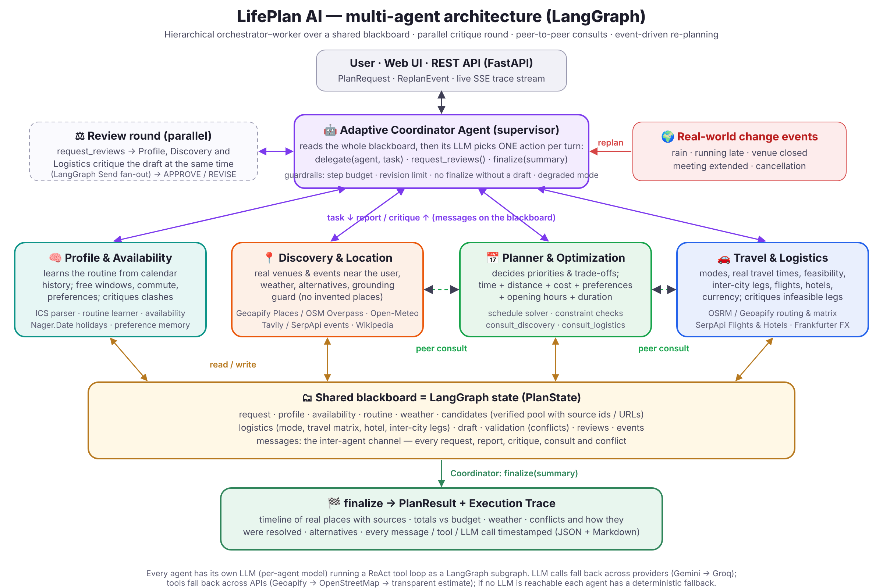
Figure 1: LifePlan AI LangGraph Multi-Agent Architecture & Blackboard State Flow
The compiled main graph (lifeplan/graph.py) contains two primary structural components:
1. Main Orchestrator Loop: The Adaptive Coordinator inspects the blackboard state and conditionally routes to specialized worker nodes.
2. Worker ReAct Loops: Each worker agent executes an internal ReAct loop (Reason + Act) with bound domain-specific tools, committing structured updates back to the shared blackboard.

2. Detailed Agent Specifications & Responsibilities
Agent | Primary Responsibility | Bound Tools | Data Channels
Adaptive Coordinator (Supervisor) | Intent classification, canonical schedule extraction, task delegation, review round arbitration, and plan finalization. | delegate, request_reviews, finalize | messages, conflicts, final_summary
Profile & Availability Agent | Calculates true free-time windows. Manages manual commitments, checks public holidays, and evaluates schedule clashes. | calculate_availability, public_holidays, check_calendar_conflicts | availability, routine, busy
Discovery & Location Agent | Discovers verified POIs, cafes, cultural attractions, and live events. Purges irrelevant colleges/hospitals and checks weather. | search_venues, find_events, get_weather, find_alternatives | candidates, weather, event_sources
Travel & Logistics Agent | Calculates road-network travel times, evaluates transit modes, estimates hotel night costs, and converts currencies. | choose_travel_mode, travel_time, search_hotels, convert_currency | logistics (mode, matrix, hotel, legs)
Planner & Optimization Agent | Schedule synthesis. Solves window-packing constraints, balances pacing buffers, and locks chronological ordering. | build_schedule, validate_plan, consult_logistics, consult_discovery | draft, validation

3. Mathematical Formulations & Deterministic Engine
LifePlan AI does not rely on LLM prompts to enforce physical, financial, or temporal constraints. Instead, the Smart Decision Engine applies deterministic mathematical rules directly to structured candidate and itinerary objects:
A. Coordinate Normalization Formula:
When geocoding coordinates on the Indian subcontinent, latitude and longitude inversion is detected and corrected:
If (lat > 50.0 and lon < 40.0) => (lat', lon') = (lon, lat)
B. Geographic Plausibility Speed Boundary:
To prevent impossible transit estimations, calculated road duration t and distance d are verified against direct Haversine distance d_h:
Plausible = (d >= 0.9 * d_h) and (d <= 4.0 * d_h or d_h <= 5.0) and (speed <= 160 km/h) and not (speed < 2.0 km/h and d > 0.5 km and t > 60 min)
C. 50 km Duplicate Return Suppression Threshold:
To eliminate duplicate return legs back to origin on intermediate vacation nights:
AddReturnLeg = True if d_haversine(LastStop, Origin) <= 50.0 km else False (Return suppressed on intermediate days)
D. Mandatory Return Deadline Back-Calculation:
Given a mandatory return deadline T_deadline and return highway transit duration delta_t:
Latest Permissible Departure T_depart = T_deadline - delta_t
Any activity scheduled at the destination ending after T_depart triggers RETURN_DEADLINE_VIOLATED.
E. Itemized Cost Ledger & Contingency Accounting:
C_direct = C_accommodation + C_intercity + C_local + C_dining + C_activities
C_contingency = ceil(0.05 * C_direct)
C_total = C_direct + C_contingency
Remaining Budget = Budget_max - C_total (Strictly fails if C_total > Budget_max)

4. User Interaction Design & Wizard Workflow
The user experience is structured into a guided 4-step wizard followed by the active itinerary visualization:
• Step 1 — Intent Input: Multi-line natural language prompt with quick suggestion chips ('Weekend getaway', 'Plan a date').
• Step 2 — Preferences & Location: Origin city input, one-click 📍 Current GPS geolocation, budget amount, currency, and activity chips.
• Step 3 — My Existing Commitments: Zero-phantom commitment engine allowing users to add, edit, or remove manual busy blocks with an explicit choice between 'Plan around these commitments' and 'Ignore commitments for this plan'.
• Step 4 — Verified Requirements Review: Pre-execution validation card showing extracted dates, return deadlines, hotel star requirements, and budget ceilings extracted directly from natural language.
• Step 5 — Visualized Itinerary & Map: Chronologically ordered timeline cards, interactive Leaflet route map with numbered pins, prominent itemized cost ledger card, and one-click RFC 5545 .ics calendar export.

5. Test Architecture & Regression Results
The system is validated by an automated regression suite with 93 passing tests. The dedicated overhaul test suite (tests/test_overhaul_regression.py) verifies all 20 acceptance criteria specified in Priority 11:
Regression Test Case | Constraint / Behavioral Invariant Verified | Result
test_01_empty_calendar_and_no_commitments | A new plan with no entered commitments treats calendar as 100% open with zero busy blocks. | PASS
test_02_one_manually_entered_commitment | A single manual commitment constrains only its specific time, splitting free windows around it. | PASS
test_04_pune_to_mumbai_multi_day_vacation | Multi-day intercity trip generates outbound and return transit legs with realistic driving times. | PASS
test_05_mandatory_return_deadline | Activities ending too late to meet return deadline back in Pune trigger RETURN_DEADLINE_VIOLATED. | PASS
test_06_three_star_minimum_hotel | Hotel candidates with < 3 stars are rejected; validator flags HOTEL_STAR_VIOLATION if violated. | PASS
test_07_strict_1500_budget | Itinerary costing ₹4,500 with a ₹1,500 budget is strictly marked as status: 'failed'. | PASS
test_11_invalid_and_swapped_coordinates | Inverted coordinates (lat > 50, lon < 40) are automatically detected and corrected. | PASS
test_12_implausible_route_durations | Unrealistic durations (e.g. 1,204 minutes for 5 km) are rejected by speed plausibility check. | PASS
test_13_duplicate_return_journeys_prevented | Local return to origin on intermediate trip days (> 50 km away) is suppressed. | PASS
test_18_budget_calculation_with_all_categories | Itemized ledger transparently accounts for accommodation, transit, food, activities, and 5% contingency. | PASS

6. Deployment Architecture & Conclusion
LifePlan AI is packaged for continuous cloud deployment via Render.com (render.yaml blueprint) and containerized deployment via Docker. Health checks at /api/health report real-time connectivity to all LLM providers and data sources. By enforcing deterministic physical, financial, and temporal validation, LifePlan AI provides an autonomous planning engine that bridges the gap between conversational AI and real-world execution.

