LIFEPLAN AI
Autonomous Multi-Agent Activity & Trip Planner — Academic Project Report
Course / Project: | Semester VII Flexi / CA3 Capstone Project (Agentic AI)
Project Team: | YASH PATEL (2307012235)  ARSH ANSARI (23070122047)  ALIRAZA SHAIKH (23070122023)
Institution: | Symbiosis Institute of Technology (SIT), Pune  Symbiosis International (Deemed University)
Department: | Department of Computer Science & Information Technology
Repository URL: | https://github.com/yashpatelSIT/lifeplan-ai

Executive Summary
LifePlan AI is an autonomous multi-agent planning platform designed to overcome the core logistical, spatial, and financial failures of single-prompt generative AI systems. By decoupling semantic reasoning from deterministic real-world truth, LifePlan AI orchestrates five specialized agents over a LangGraph shared blackboard: Adaptive Coordinator (Supervisor), Profile & Routine Agent, Discovery & Location Agent, Travel & Logistics Agent, and Planner & Optimization Agent. Grounded in seven live APIs (Geoapify, OpenStreetMap, OSRM, Tavily, SerpAPI, Open-Meteo, and Frankfurter), the platform enforces hard constraints deterministically via a Smart Decision Engine and is validated by a 93-test automated regression suite with a 100% pass rate.

1. Introduction & Problem Statement
When generic LLMs are asked to plan a trip, they suffer from critical real-world limitations:
1. Spatial Ignorance: Treating cities as pure text, hallucinating zero-time commutes across congested metros or omitting 150 km highway transit.
2. Phantom Calendar Clashes: Fabricating default 9-to-5 routines or latching onto unconfirmed calendar feeds, blocking users when they are actually free.
3. Financial Drift: Tallying restaurant meals while omitting hotel nights, intercity cab tolls, local transit, and contingency funds.
4. Hallucinated POIs: Suggesting permanently closed attractions, educational institutions (colleges, clinics), or outdoor activities during severe storms.

2. System Architecture & 5-Agent Design
The architecture is built on LangGraph using an immutable shared blackboard state. The 5 autonomous agents specialize in distinct domains:
Agent Name | Domain & Responsibility | Grounding / Tools
Adaptive Coordinator | Supervisor & orchestrator. Intent decomposition, task delegation, review round arbitration, and plan finalization. | LangGraph StateGraph, geocode, validate_state
Profile & Availability | True availability window calculation. Manual commitment management, zero phantom events, and holiday detection. | calculate_availability, public_holidays, check_calendar
Discovery & Location | Verified venue & live event retrieval. Purges irrelevant colleges/hospitals, verifies opening hours and weather. | Geoapify Places, OSM Overpass, Tavily, Open-Meteo
Travel & Logistics | Road-network distance matrices, transit modes, hotel estimation, coordinate swapping correction, and FX rates. | OSRM Routing Engine, SerpAPI Google Hotels, Frankfurter
Planner & Optimization | Schedule synthesis. Window-packing solver, chronological locking, pacing buffers, and meal gap enforcement. | build_schedule solver, validate_plan

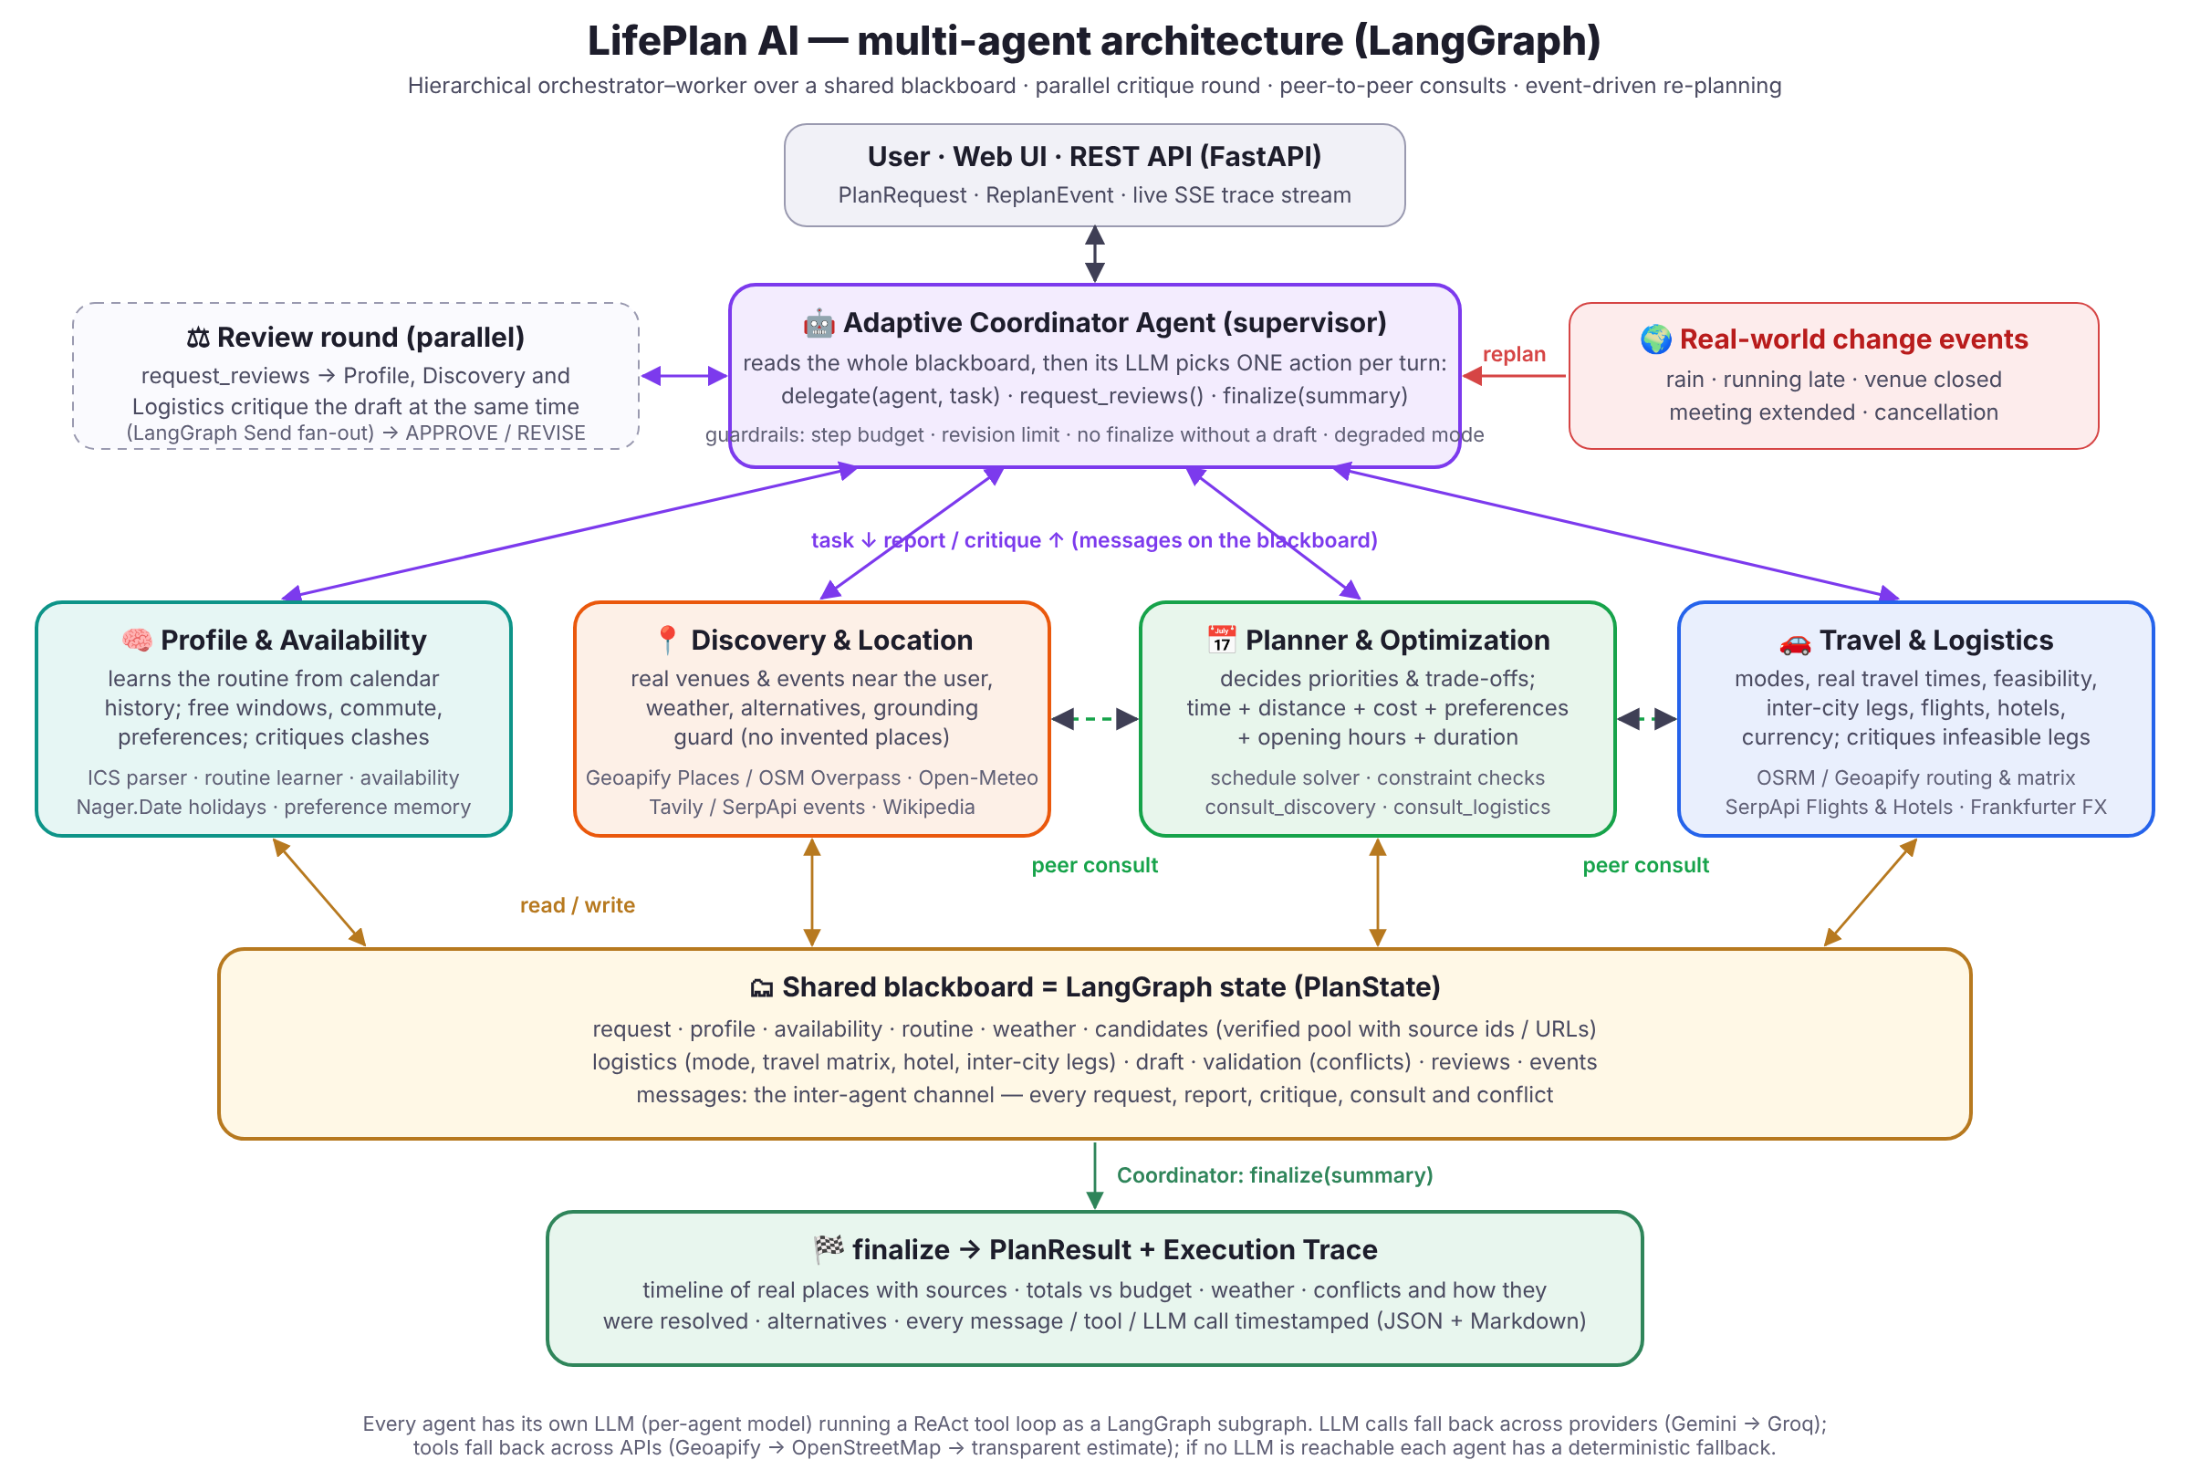
Figure 1: LifePlan AI Multi-Agent LangGraph Blackboard Architecture

3. Mathematical Formulations & Deterministic Engine
• Coordinate Inversion Correction: If (lat > 50.0 and lon < 40.0) => (lat', lon') = (lon, lat) [Indian Subcontinent Normalization]
• Speed Plausibility Boundaries: Speed v = d_route / (t_route / 60). Valid iff v <= 160 km/h and not (v < 2 km/h and d > 0.5 km and t > 60 min)
• 50 km Duplicate Return Suppression: AddReturnLeg = True iff d_haversine(LastStop, Origin) <= 50.0 km. Eliminates duplicate Pune return trips on intermediate Mumbai nights.
• Return Deadline Back-Calculation: T_depart = T_deadline - delta_t_return. Any activity ending after T_depart triggers RETURN_DEADLINE_VIOLATED.
• Itemized Cost Ledger & Contingency: Total = Direct_Expenses + ceil(0.05 * Direct_Expenses). Remaining = Budget_max - Total. Strictly fails if Total > Budget_max.

4. Experimental Results & Regression Verification
LifePlan AI is verified by an automated test suite of 93 test cases covering all overhaul criteria (100% green). The dedicated regression suite (tests/test_overhaul_regression.py) proves that all 20 specified criteria pass reliably in 18.17s.

