|  |  |
| --- | --- |
| https://lh6.googleusercontent.com/NfxikauFutj0NGA6tZLo-9OYuuo3IKL8zEJJ1vcz211S75EzE4cV8OiG_9xiNDI7UXEpwJU3L0HucAlThGrGrN0dBZNqE1lpoGJHT3oGyRmOalINq0YRgVxjjMgLbZ3n8Pq0wpa0thnjQcjh_kKTHUlnU-ExSfeM05HoXY1-s1p-Qtg0OyqjFjrwB05Nj4mxriktv4A | SVKM’s NMIMS  School of Technology Management & Engineering Navi Mumbai Campus |
| Department of Computer Engineering |

|  |  |
| --- | --- |
| Name: YASH PATIL | SAP ID: 70472200140 |
| Semester: III | Year: II |
| Subject: Data Structures and Algorithm | Roll No.: A176 |
| Practical: 1 | Date: 21/7/2023 |
| Batch: 1 |  |

**Aim:–**

Implementation of various array operations like traversal, insertion and deletion using any real life application.

**Theory:–**

We have used static array to implement given problem statement.

Arrays are used to store multiple values in a single variable, instead of declaring separate variables for each value.

To create an array, define the data type (like int) and specify the name of the array followed by **square brackets []**.

To insert values to it, use a comma-separated list, inside curly braces:

We can loop through the array elements with the for loop.

The following example outputs all elements in the myNumbers array:

int myNumbers[] = {25, 50, 75, 100};  
int i;  
  
for (i = 0; i < 4; i++) {  
  printf("%d\n", myNumbers[i]);  
}

**Code/Implementation –**

// Online C++ compiler to run C++ program online

#include <iostream>

using namespace std;

int main()

{

int x;

cout<<"Enter the number of values you want to enter:" ;

cin>>x;

int arr[100];

cout<<"Enter your desired values"<<endl;

for (int i=0;i<x;i++){

cin>>arr[i];

}

int c;

cout<<"1.Transverse"<<endl;

cout<<"2.Insertion "<<endl;

cout<<"3.Deletion"<<endl;

cout<<"Enter your choice: ";

cin>>c;

switch(c){

case 1:

cout<<" "<<endl;

for(int j=0;j<x;j++){

cout<<arr[j]<<" ";

}

break;

case 2:

cout<<" "<<endl;

int loc,element;

cout<<"Enter the index you want to store the element in"<<endl;

cin>>loc;

cout<<"Enter the element you want to store in the place"<<endl;

cin>>element;

if(loc>x)

{

arr[loc]=element;

x=x+1;

for(int j=0;j<x;j++){

cout<<arr[j]<<" ";

}

}

else

{

for(int m=x-1;m>=loc;m--){

arr[m+1]=arr[m];

}

arr[loc]=element;

x=x+1;

for(int l=0;l<x;l++){

cout<<arr[l]<<endl;

}

}

break;

case 3:

int loca;

cout<<" "<<endl;

cout<<"enter the index to be deleted"<<endl;

cin>>loca;

for(int g=loca;g<=x;g++){

arr[g-1]=arr[g];

}

x=x-1;

for(int h=0;h<x;h++)

{

cout<<arr[h]<<endl;

}

break;

} return 0;

}

**Output:-**

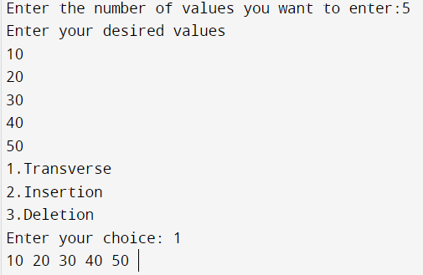

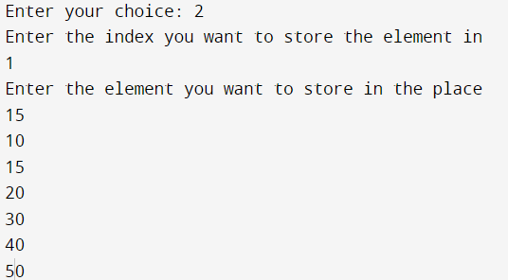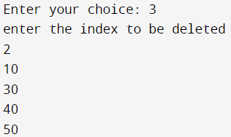

**Conclusion:-**

From the given experiment I was able to learn and execute the operation on insertion, delete, and display of array.

**Outcome: -**

Identified and applied appropriate linear data structure for the given problem