|  |  |
| --- | --- |
|  | SVKM’s NMIMS  School of Technology Management & Engineering Navi Mumbai Campus |
| Department of Computer Engineering |

|  |  |
| --- | --- |
| Name: Yash Patil | SAP ID: 70472200170 |
| Semester: III | Year: II |
| Subject: DSA | Roll No.: A176 |
| Practical: 7 | Date: 25/09/23 |
| Batch: 1 |  |

Aim: – Representation of Binary trees in memory and implementation of Binary Tree traversal algorithms.

# Code/Implementation: -

#include <stdio.h> #include <stdlib.h> struct node

{ int item; struct node* left; struct node* right;

}; void inorderTraversal(struct node* root)

{

if (root == NULL) return; inorderTraversal(root->left); printf("%d ", root->item); inorderTraversal(root->right);

}

void preorderTraversal(struct node* root)

{

if (root == NULL)

return;

printf("%d ", root->item); preorderTraversal(root->left); preorderTraversal(root->right);

} void postorderTraversal(struct node* root)

{

if (root == NULL) return;

postorderTraversal(root->left); postorderTraversal(root->right); printf("%d ", root->item);

}

struct node* createNode(value)

{

struct node* newNode = malloc(sizeof(struct node)); newNode->item = value; newNode->left = NULL; newNode->right = NULL; return newNode;

}

struct node* insertLeft(struct node* root, int value)

{

root->left = createNode(value);

return root->left;

}

struct node* insertRight(struct node* root, int value)

{

root->right = createNode(value);

return root->right;

} int main() {

struct node* root = createNode(1);

insertLeft(root, 12); insertRight(root, 9); insertLeft(root->left, 5); insertRight(root->left, 6); printf("Inorder traversal :\n"); inorderTraversal(root); printf("\nPreorder traversal :\n"); preorderTraversal(root); printf("\nPostorder traversal :\n"); postorderTraversal(root); }

# Output: -

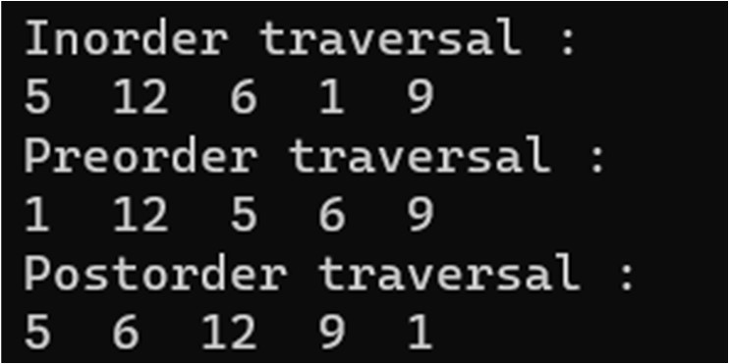

Conclusion: - Represented Binary trees in memory and implemented Binary Tree traversal algorithms.

Outcome: - Represented Binary trees in memory and implemented Binary Tree traversal algorithms.