INDEX

Chapter 1: Quadratic Equations

Module-3
Ch 1 : Quadratic Equations

Introduction:
Very often we come across many equations involving several powers of one variable. If the indices of all these powers are integers then the equation is called a polynomial equation. If the highest index of a polynomial equation in one variable is two, then it is a quadratic
equation.

A quadratic equation is a second degree polynomial in x usually equated to zero. In other words, for an equation to be a quadratic, the coefficient of x² should not be zero and the coefficients of any higher power of x should be 0.

Quadratic Equation:
If p(x) is a quadratic polynomial, then p(x) = 0 is called a quadratic equation.

The general form of a quadratic equation is ax² + bx + c = 0, where a, b, c ∈ R and a ≠ 0.

Roots of a Quadratic Equation:
Let p(x) = 0 be a quadratic equation, then the zeros of the polynomial p(x) are called the roots of the equation p(x) = 0.
Thus, x = α is a roots of p(x) = 0 if and only if p(α) = 0.
Findinoft the roots of a quadratic equation is known as solvinoft the quadratic equation.

EXAMPLES

ON DETERMINING WHETHER A GIVEN EQUATION IS QUADRATIC OR NOT

Eg : Which of the following are quadratic equations?
(i) 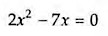 (ii) 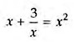 (iii) 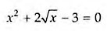 Soln :
(i) Clearly, 2x² - 7x is a quadratic polynomial.
So, the given equation is a quadratic equation.

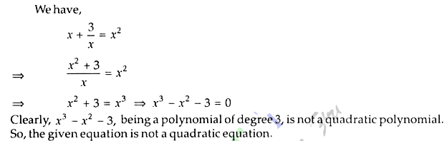
(ii)

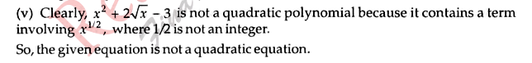
(iii)

ON DETERMINING WHETHER THE GIVEN VALUES ARE SOLUTIONS OF THE GIVEN EQUATION OR NOT

Eg : In each of the following determine whether the given values are solution of the given equation or not:

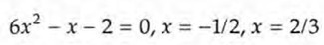
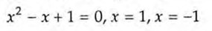
(i)
(ii)

(iii) 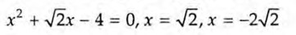 Soln :
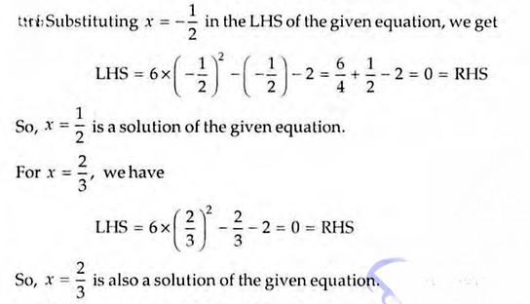
(i)

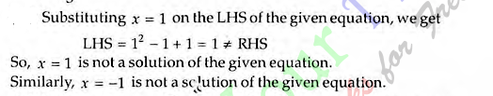
(ii)

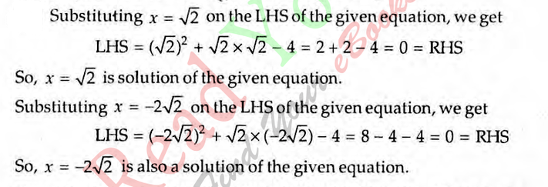
(iii)

ON DETERMINING AN UNKNOWN INVOLVED IN A QUADRATIC EQUATION WHEN ITS ROOT(S) IS (ARE) GIVEN

Eg : In each of the following, determine the value of k for which the given value is a solution of the equation:

- kx² + 2x - 3 = 0, x = 2

- x² + 2ax - k = 0, x = -a

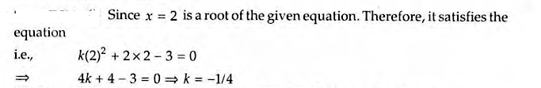
Soln : (i)

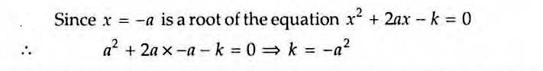
(ii)

Eg : If one root of the quadratic equation 2x² + kx - 6 = 0 is 2, find the value of k . Also find the other root. [ CBSE 2002 ]
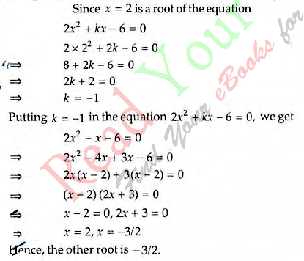
Soln :

The roots of a quadratic equation can be found in two ways:

  - By factorization method
  - By Completing the square
  - By using the direct formula.

 Finding the Roots by Factorization
If the quadratic equation ax² + bx + c = 0 (a ≠ 0) is written in the form, (x - α)(x - β) = 0, then the roots of the equation are α and β.

To find the roots of a quadratic equation, we should first express it in the form of (x - α)(x - β) = 0, i.e., the left hand side, ax² + bx + c of the quadratic equation
ax² + bx + c = 0 should be factorized.

Eg : x² - 5x + 6 = 0

Step 1: The equation is, x² - 5x + 6 = 0. Here a = 1, b = -5 and c = 6.

First write down b (the coefficient of x) as the sum of two quantities whose product is equal to ac. In this case, -5 has to be written as the sum of two quantities whose
product is 6. We write -5 as (-3) + (-2), because the product of (-3) and (-2) is equal to 6.

Step 2: Now, rewrite the equation. In this case, the given equation can be written as x² - 3x - 2x + 6 = 0.

Step 3: Consider the first two terms and rewrite them together after taking out their common factor. Similarly, the third and the fourth terms should be rewritten after
taking out their common factor. In this process, we should ensure that what is left
from the first and the second terms (after removing the common factor) is the same as that left from the third and fourth terms (after removing their common factor).

In this case, the equation can be rewritten as x(x - 3) -2(x - 3) = 0; now (x - 3) is a common factor.

Step 4: If we take out (x - 3) as the common factor, we can rewrite the given equation as (x - 3) (x - 2) = 0.

We know that if α and β are the roots of the given quadratic equation (x - α)(x - β) = 0. Hence, the roots of the given equation are 3 and 2.

Eg : 2x² + 3x - 2 = 0

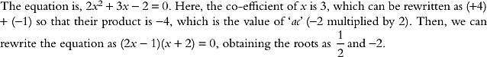
Soln :

Eg : 2x² + x - 3 = 0

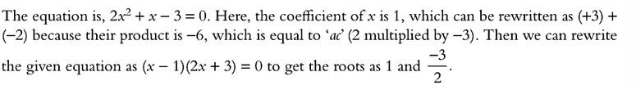
Soln :

Eg : Solve the given quadratic equations by factorization method: 8x² - 22x - 21 = 0

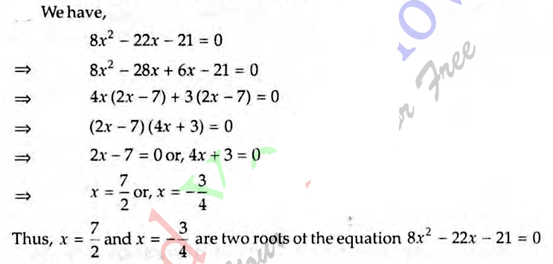
Soln :

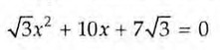
Eg : Solve the given quadratic equation by factorization method:

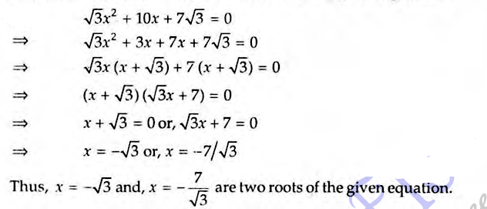
Soln :

Eg : Solve the given quadratic equations : [ CBSE 2006 ]
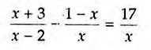
(i) (ii) 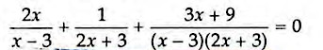
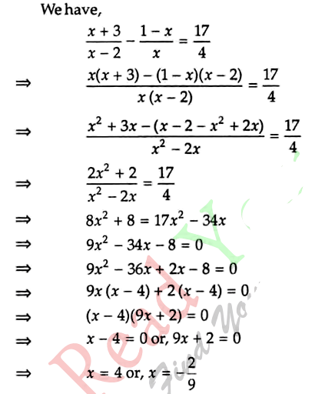
Soln :
(i)

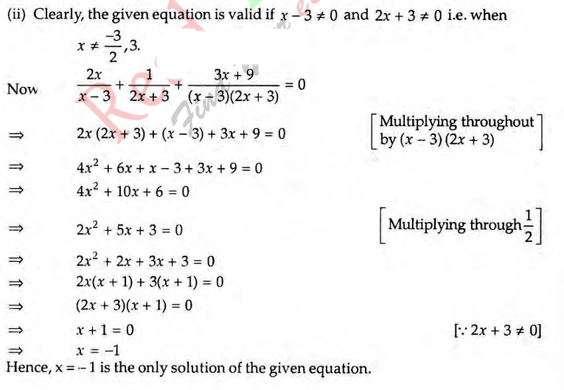

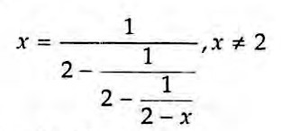
Eg : Solve :

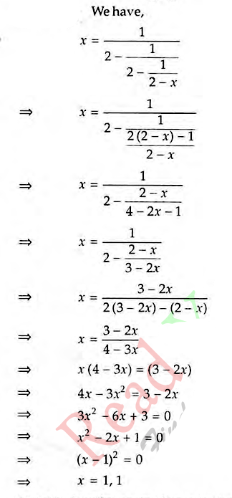
Soln :

Eg : Solve by factorization method : [ CBSE 2004 ]

- x² - 2ax + a² - b² = 0
- x² - 4ax + 4a² - b² = 0
- 4x² - 4a² x + ( a⁴ - b⁴ ) = 0

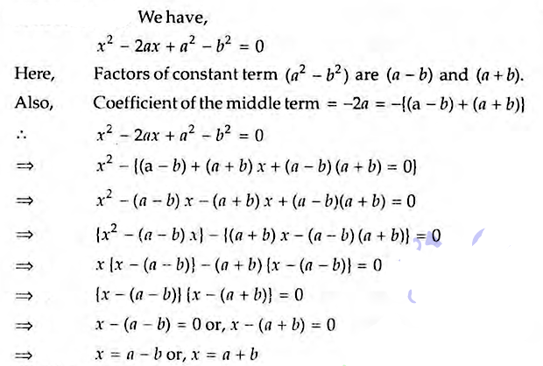
Soln :
(i)

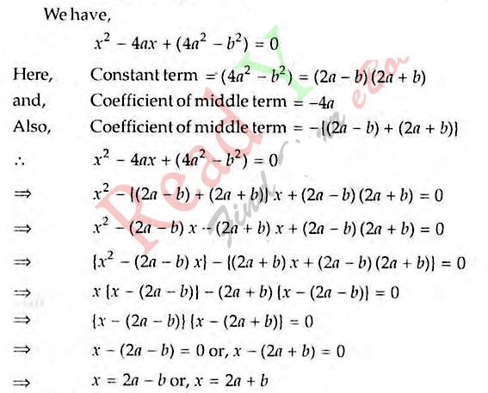
(ii)

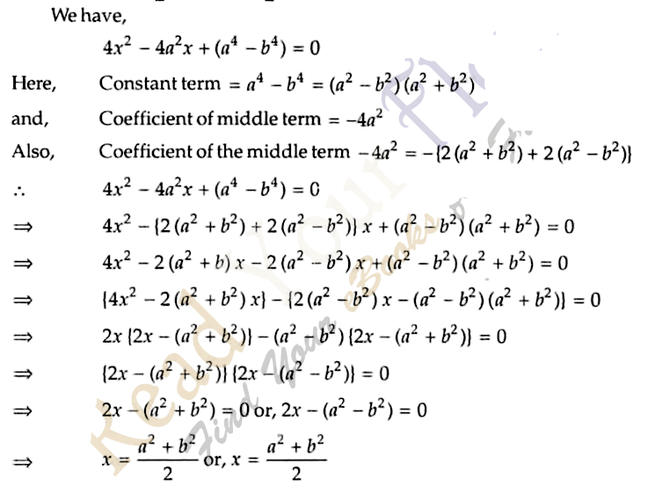

Eg : Solve the following quadratic equations :

- 4x² - 2 ( a² + b² ) x + a² b² = 0
- 9x² - 9 ( a + b ) x + ( 2a² + 5ab + 2b² ) = 0

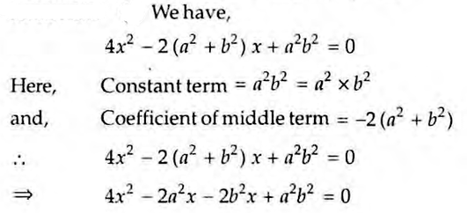
Soln :
(i)

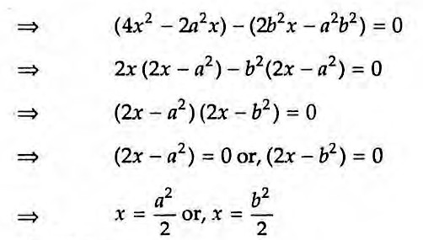

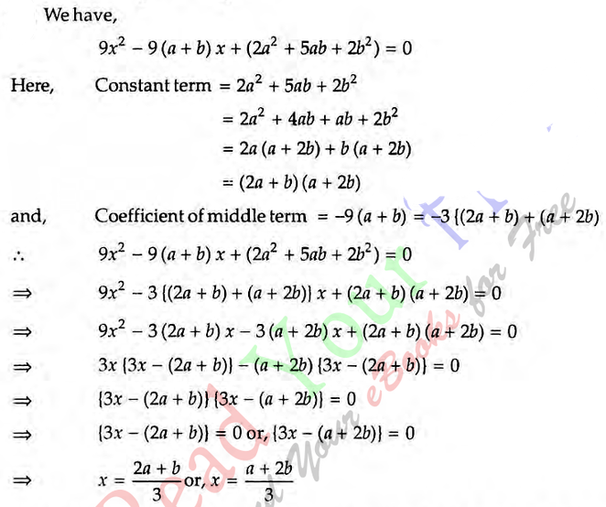
(ii)

Eg : Solve the following quadratic equations by factorization method: [ CBSE 2005 ]

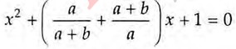
(i)

- x² + x - ( a + 1 )( a + 2 ) = 0
- a² b² x² + b² x - a² x - 1 = 0

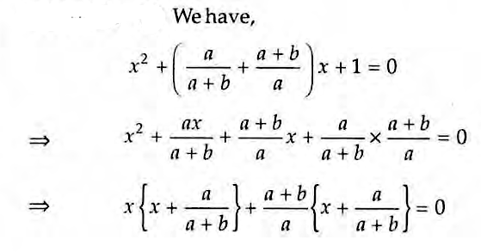
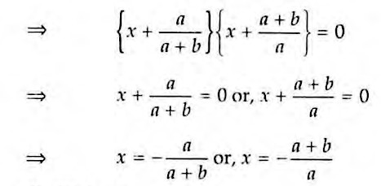
Soln :
(i)

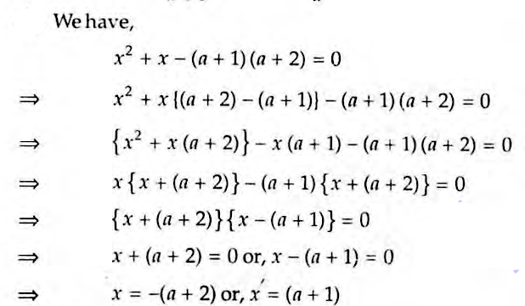
(ii)

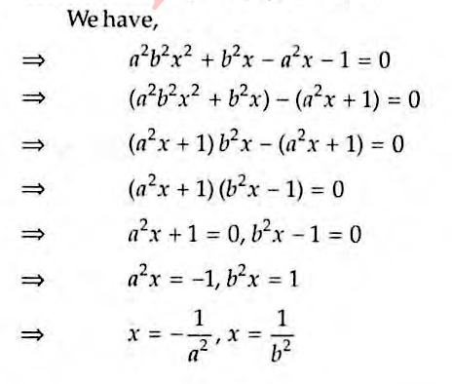

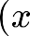
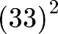
Eg : Solve :
  - 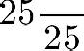 (ii)

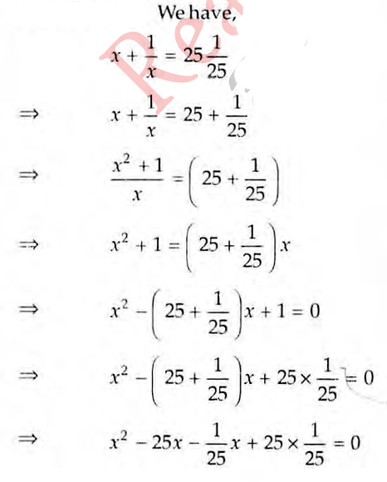
Soln :
(i)

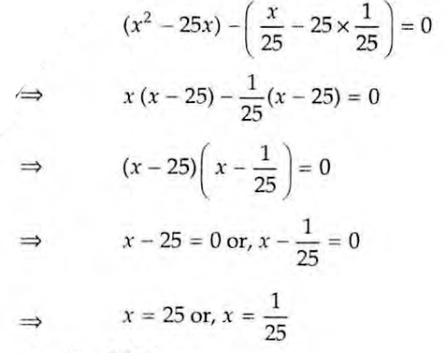

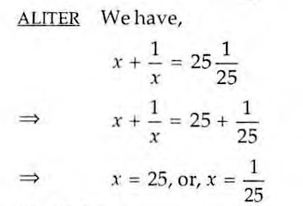

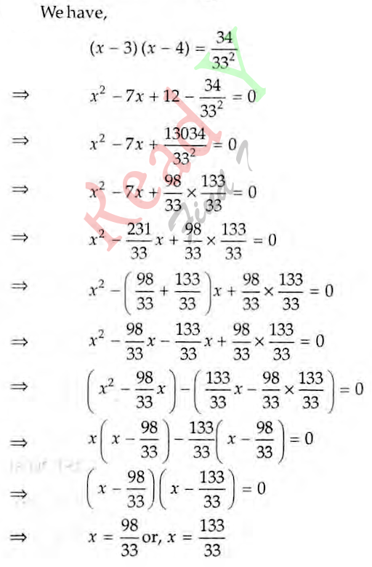

SOLUTION OF A QUADRATIC EQUATION BY COMPLETING THE SQUARE

Step 1 : Obtain the quadratic equation. Let the quadratic equation be ax² + bx + c = 0, a ≠ 0.

Step 2 :
Make the coefficient of x² unity by dividing throughout by it, if it is not unity. i.e., obtain 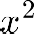

Step 3 : Shift the constant term c/a on RHS to get

Step 4 : Add square of half of the coefficient of x i.e. (b/2a)² on both sides to obtain
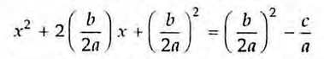
Step 5 : Write LHS as the perfect square of a binomial expression and simplify RHS to get
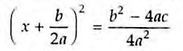
Step 6 : Take square root of both sides to get
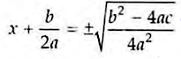
Step 7 : Obtain the values of x by shifting the constant term b/2a on RHS.

Eg : Find the roots of the equation 5x² - 6x - 2 = 0 by the method of completing the square.

Soln :

Eg : Soln :

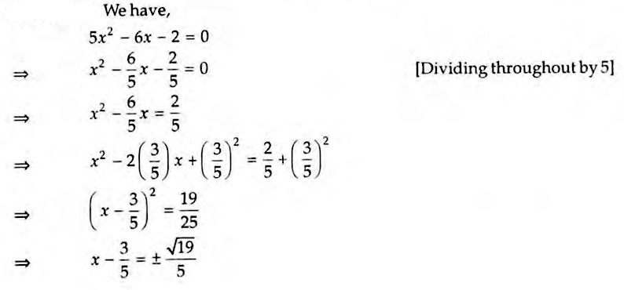
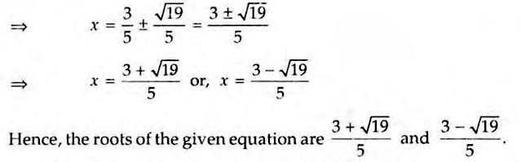

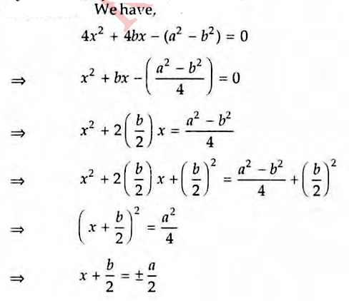
Find the roots of the following equation 4x² + 4bx - (a² - b²) = 0 by the method of completing the square.

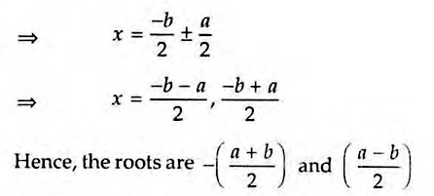

Eg : Find the roots of the equation a²x² - 3abx + 2b² = 0 by the method of completing the square.
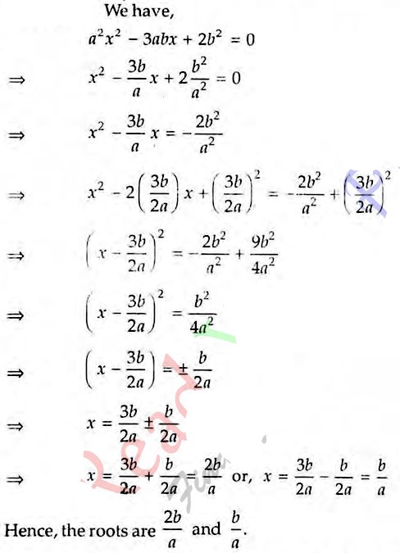
Soln :

Finding the Roots by Using the Formula (Sri Dharacharya Method) :

For the quadratic equation ax² + bx + c = 0, we can use the standard formula given below to find out the roots of the equation.
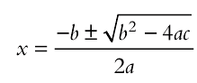
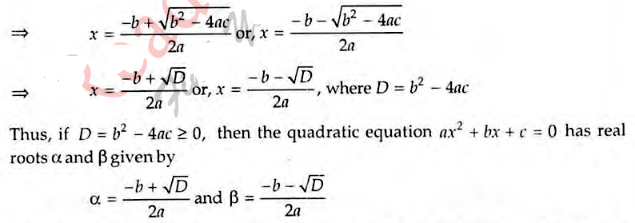

DISCRIMINANT: If ax² + bx + c = 0, a ≠ 0 is a quadratic equation, then the expression b² - 4ac is known as its discriminant and is generally denoted by D.

Sum and Product of Roots of a Quadratic Equation
For the quadratic equation ax² + bx + c = 0, let α and β be the roots, then
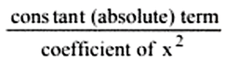
Sum of the roots, ( (α + β ) = = 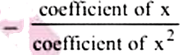 Product of the roots, ( (αβ ) = =

Eg : If the sum of the roots of the equation kx² - 3x + 9 = 0 is 3/11, then find the product of the roots of that equation.

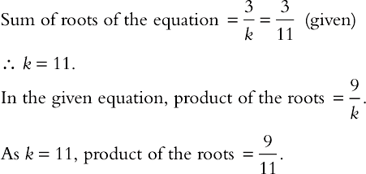
Soln :

Eg : If a and b are the roots of the equation x² + ax -b = 0, then find a and b.
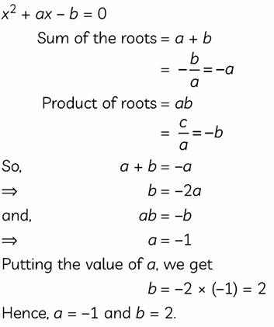
Soln :

Eg : Determine the condition for one root of the quadratic equation ax² + bx + c = 0 to be thrice the other.
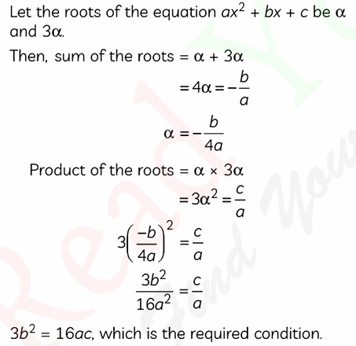
Soln :

Nature of the Roots
We have already learnt that the roots of a quadratic equation with real coefficients can be real or complex. When the roots are real, they can be rational or irrational and, also, they can be equal or unequal.

Consider the expression b² - 4ac. Since b² - 4ac determines the nature of the roots of the quadratic equation, it is called the DISCRIMINANT of the quadratic equation.

- A quadratic equation has real roots only if b² - 4ac ≥ 0.
- If b2 - 4ac < 0, then the roots of the quadratic equation are complex conjugates.

Condition | Nature of Roots
when b² - 4ac < 0 | the roots are complex conjugates
when b² - 4ac = 0 | the roots are rational and equal.
when b² - 4ac > 0 and a perfect square | the roots are rational and unequal.
when b² - 4ac > 0 and not a perfect square | the roots are irrational and unequal.

Notes :
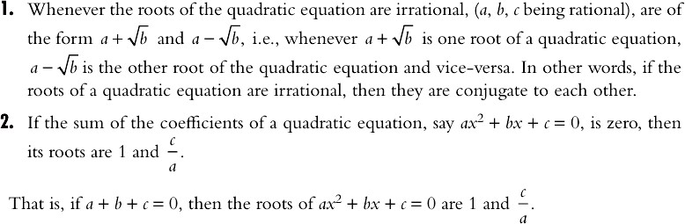

Signs of the Roots
We can comment on the signs of the roots, i.e., whether the roots are positive or
negative, based on the sign of the sum of the roots and the product of the roots of the quadratic equation. T

he following table indicates the signs of the roots when the signs of the sum and the product of the roots are given.

Sign of Product of the Roots | Sign of Sum of the Roots | Sign of the Roots
+ ve | + ve | Both the roots are positive.
+ ve | - ve | Both the roots are negative.
- ve | + ve | One root is positive and the other negative. The numerically greater root is positive.
- ve | - ve | One root is positive and the other negative. The numerically greater root is negative.

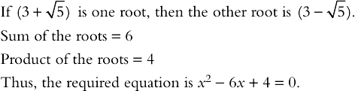
Eg : Soln :

Eg :

Soln :

Eg : Soln :

Eg : Soln :
Find the values of k for which the following equation has equal roots:

(k - 12)x² + 2(k - 12)x + 2 =0
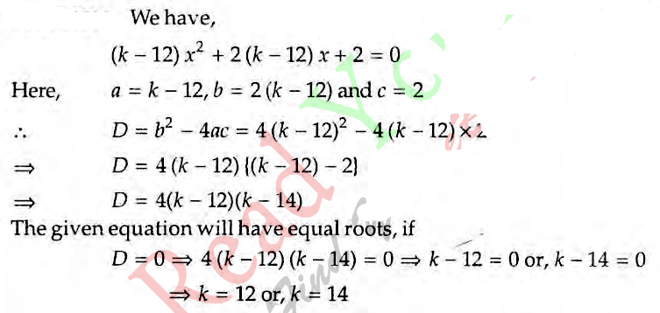

If - 4 is a root of the quadratic equation x² + px - 4 = 0 and the quadratic equation x² + px + k = 0 has equal roots, find the value of k.

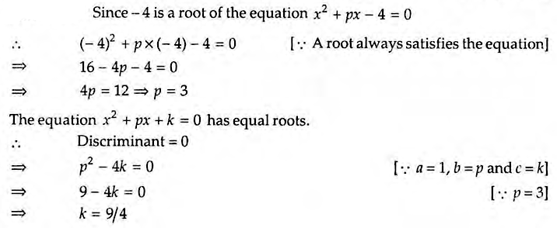

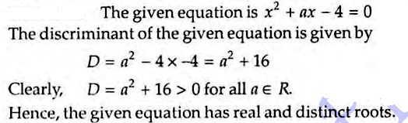
Show that the equation x² + ax - 4 = 0 has real and distinct roots for all real values of a.

Eg : Soln :

Eg : Soln :
Determine the positive values of 'k' for which the equation x² + kx + 64 = 0 and x² - 8x + k = 0 will both have real roots.
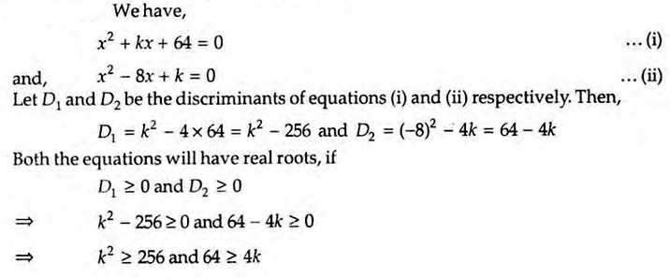

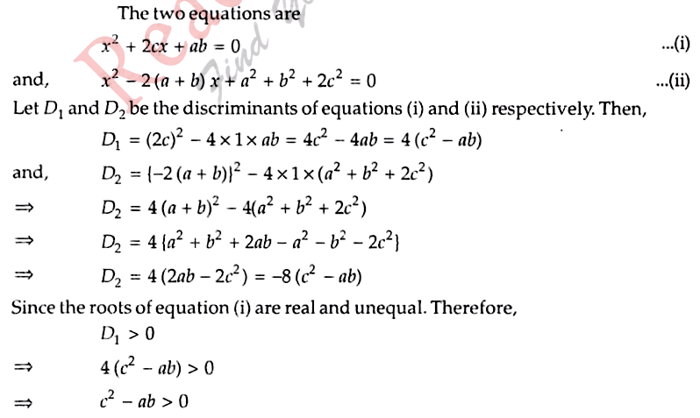
If the roots of the equation x² + 2cx + ab = 0 are real unequal, prove that the equation x² - 2(a + b) x + a² + b² + 2c² = 0 has no real roots.

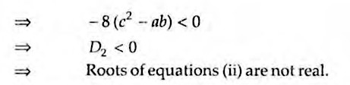

CONSTRUCTING A QUADRATIC EQUATION

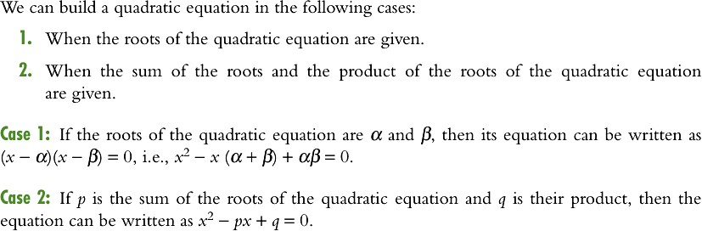

Constructing a New Quadratic Equation by Changing the Roots of a Given Quadratic Equation

consider the quadratic equation ax² + bx + c = 0 and let its roots be α and β respectively. Then, we can build new quadratic equations as per the following points:

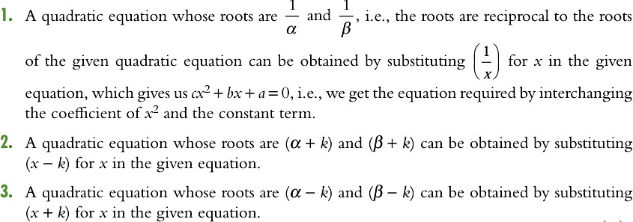
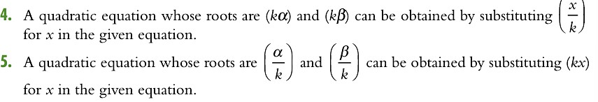

6. A quadratic equation whose roots are (- α ) and ( -β ) can be obtained by replacing x by ( - x ) in the given equation.

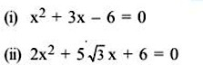
Eg :

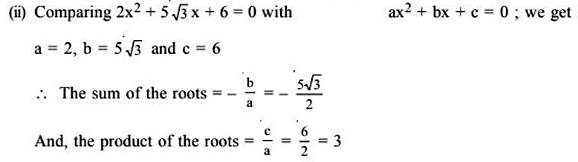
Soln :

Eg :
For each quadratic equation given find the sum of the roots and the product of the roots :

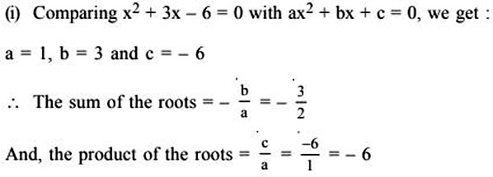

Construct the quadratic equation whose roots are given below :

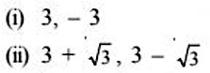

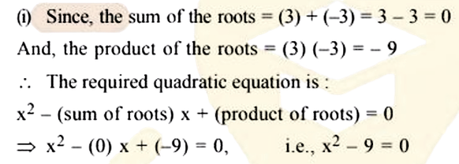
Soln :

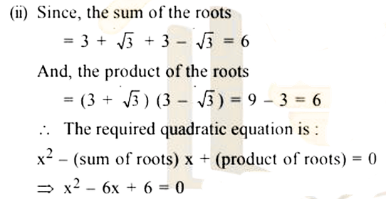

Eg :
If one of the roots of the quadratic equation 2x² + px + 4 = 0 is 2, find the the value of p. and also find the value of the other roots.

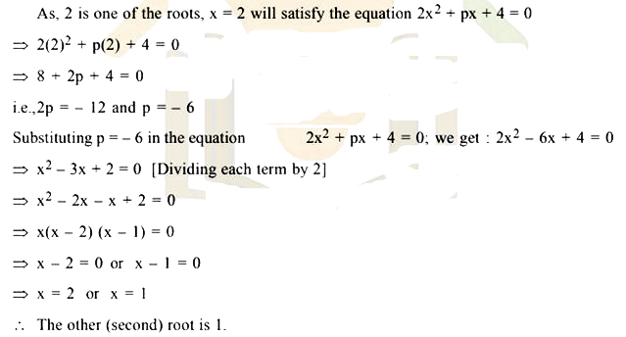

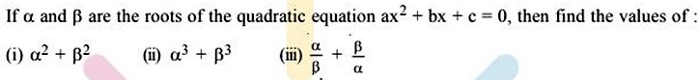
Eg :

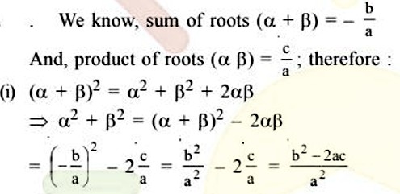
Soln :

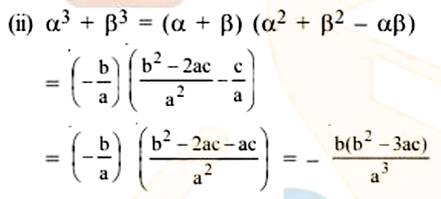
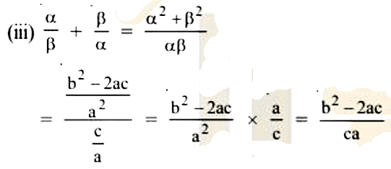

Important Properties of Roots
- If the roots are equal in magnitude but opposite in sign, then coefficient of x = 0 i.e., b = 0.

Example: x² - 4 = 0 ⟹ x = ± 2 clearly, b = 0.
- If unity is a root of ax² + bx + c = 0 then the other root is c/a.

Example: x² - 4x + 3 = 0 ⟹ x = 1, x = 3
∴ Other root c/a = 3/1 = 3
- Irrational roots of a quadratic equation with rational coefficients occur in conjugate pairs.
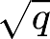
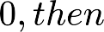
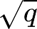
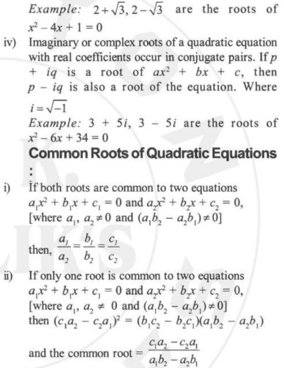

Finding the Roots of a Quadratic Equation by Graphical Method

First Method

First, let us learn how to draw the graph of y = x².

We assume certain real values for x, i.e., we substitute some values for x in y = x². We can find the corresponding values of y. We tabulate the values, as shown below.

Plotting the points corresponding to the ordered pairs (5, 25), (4, 16), (3, 9), (2, 4), (1, 1),
(0, 0) (-1, 1), (-2, 4), (-3, 9), (-4, 16) and (-5, 25) on the graph paper and joining them with a smooth curve we obtain the graph of y = x²,

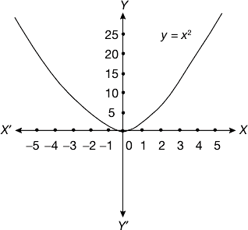

Observation :

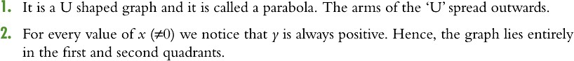

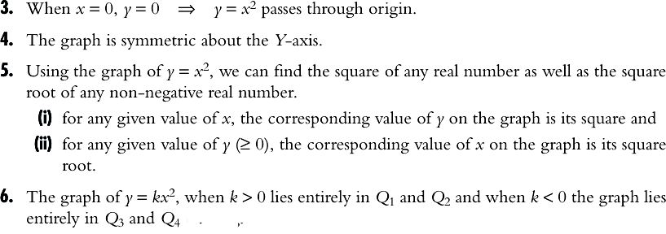

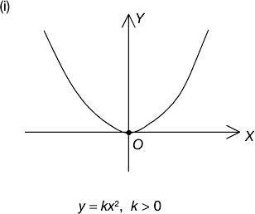
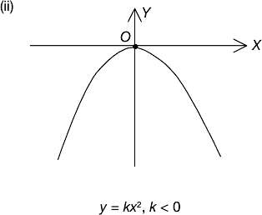

Eg : Solve x² - 5x + 6 = 0 using the graphical method.

Soln : Let y = x² - 5x + 6

x | 0 | 1 | 2 | 3 | -1 | -2 | 4 | 5
y = x² - 5x + 6 | 6 | 2 | 0 | 0 | 12 | 20 | 2 | 6

Plot the points (0, 6), (1, 2), (2, 0), (3, 0), (-1, 12), (-2, 20), (4, 2) and (5, 6) on the graph and join the points with a smooth curve.

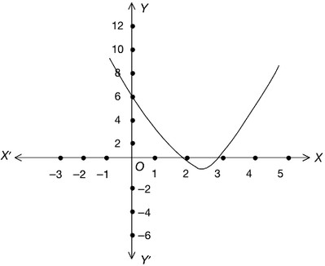

Here we notice that the given graph (parabola) intersects the X-axis at (2, 0) and (3, 0). The roots of the given quadratic equation x² - 5x + 6 = 0 are x = 2 and x = 3.
∴ The roots of the given equation are the x-coordinates of the points of intersection of the curve with X-axis.

Notes :

If the graph meets the X-axis at two distinct points, then the roots of the given equation are real and distinct.
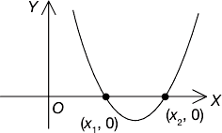


If the graph touches the X-axis at only one point, then the roots of the quadratic equation are real and equal.
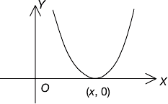

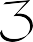
If the graph does not meet the X-axis, then the roots of the quadratic equation are not real, i.e., they are complex.
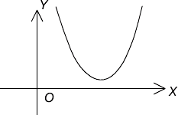

Second Method

We can also solve the quadratic equation px² + qx + r = 0 by considering the following equations:

y = px² (1)
and y = -qx - r (2) Clearly, y = px² is a parabola and y = -qx - r is a straight line.
Step 1: Draw the graph of y = px² and y = -qx - r on the same graph paper.

Step 2: Draw perpendiculars from the points of intersection of parabola and the straight line onto the X-axis. Let the points of intersection on the X-axis be (x₁ , 0) and (x₂ , 0).

Step 3: The x-coordinates of the points in Step (2), i.e., x₁ and x₂ are the two distinct roots of px² + qx + r = 0.

Eg : Solve 2x² - x - 3 = 0.

Soln : We know that the roots of 2x² - x - 3 = 0 are the x-coordinates of the points of intersection of the parabola, y = 2x² and the straight line, y = x + 3.
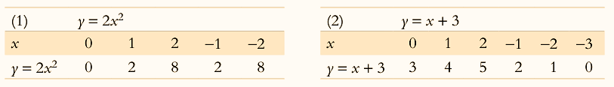

Draw the graph of y = 2x² and y = x + 3 .

Clearly, the perpendiculars drawn from the points of intersection of parabola and the line meet the X-axis at ( 3/2, 0 ) and ( - 1, 0).

∴ The roots of the given quadratic equation 2x² - x - 3 = 0 are 3/2 and -1.
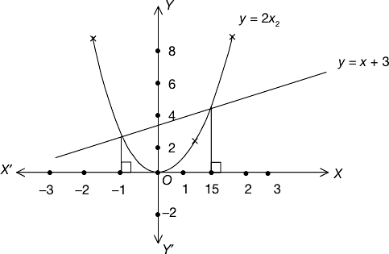

Notes :
If the line meets the parabola at two points, then the roots of the quadratic equation are real and distinct.


If the line touches the parabola at only one point, then the quadratic equation has real and equal roots .
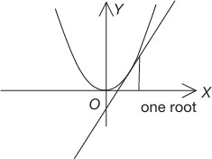

If the line does not meet the parabola, i.e., when the line and the parabola have no points in common, then the quadratic equation has no real roots. In this case, the roots of the quadratic equation are imaginary.

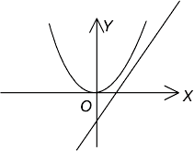

Equations of Higher Degree

- The index of the highest power of x in the equation is called the degree of the equation.

For example, if the highest power of x in the equation is x³, then the degree of the equation is 3.

- An equation whose degree is 3 is called a cubic equation. A cubic equation will have three roots.

Note : An equation whose degree is n will have n roots.

Maximum or Minimum Value of a Quadratic Expression

The quadratic expression ax² + bx + c takes different values as x takes different values.
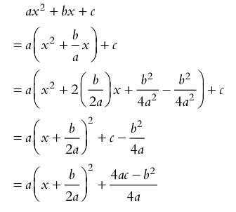
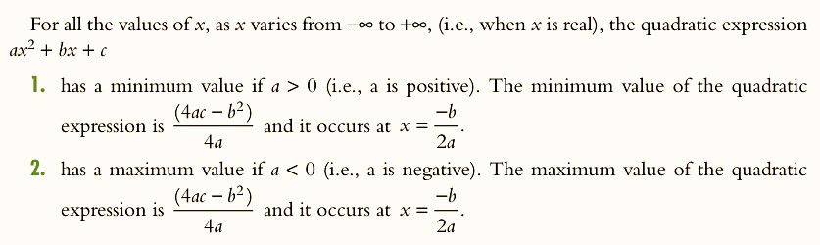

3. When a,b, c ∈ R, the quadratic expression ax² + bx + c has no maximum value when a > 0 and no minimum value when a < 0.

LEVEL - 1

1)

2)

3)

4)

5)

6)

(i)

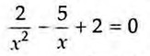
(ii)
Short Answer Type Question :
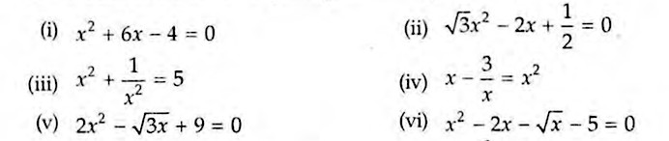
Which of the following are quadratic equations?

(vii) 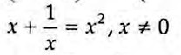 (viii) 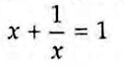
- 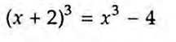 (x) 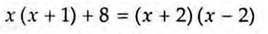

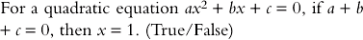

The point ( 1, - 6 ) satisfies the equation y = x2 - x - 6. Is the statement true?

If a = c, then the roots of ax2 + bx + c = 0 are to each other.

Solve by factorization method : 48x2 - 13x - 1 = 0

Solve the following quadratic equations by factorization method :
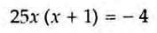

  - Determine whether the given quadratic equations have real roots and if so, find the roots:

    - x2 + x + 2 = 0
    - 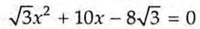

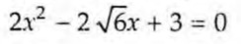
    - 3x2 - 2x + 2 = 0 (iv)

  - Determine the nature of the roots of the following quadratic equations:

    - ( x - 1 ) ( 2x - 5 ) = 0
    - 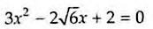

    - ( x - 2a ) ( x - 2b ) = 4ab

Find the least positive value of K for which tlie equation x2 + Kx + 4 = 0 has real roots.

Find the values of K for which the given quadratic equation has real and distinct roots:
- kx2 + 2x + 1 = 0

- x2 - kx + 9 = 0

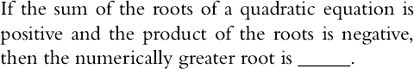

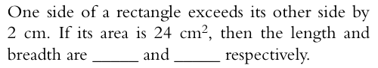

  - For the given quadratic equation find the sum of the roots and the product of the roots : 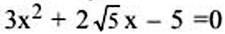

  - Construct the quadratic equation whose roots are : 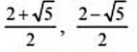

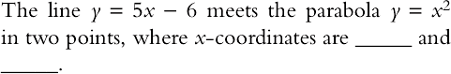

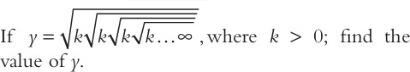

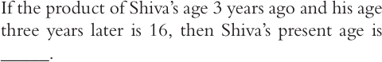

Multiple Choice Type Question :

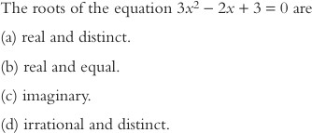

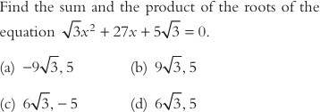

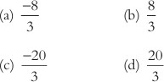
  - If α and β are the roots of the equation x2 - 12x + 32 = 0, then find the value of 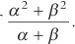

  - Find the maximum or minimum value of the quadratic expression, x2 - 3x + 5 whichever exists.
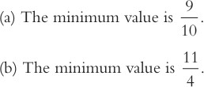
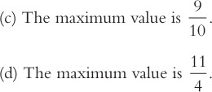

If the roots of the equation ax2 + bx + c = 0 are α and β, then the quadratic equation whose roots are -α and -β is
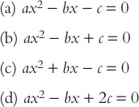

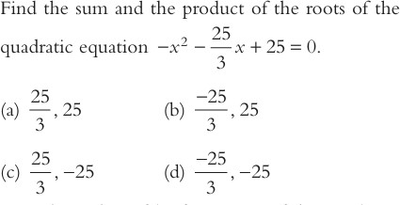

For what value of k, if one root of the quadratic equation 9x2 - 18x + k = 0 is double of the other?
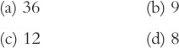

The condition for the sum and the product of the roots of the quadratic equation ax2 - bx + c = 0 to be equal, is

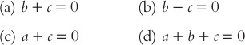

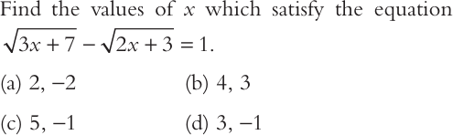

  - Find the product of the roots of x2 + 8x - 16 = 0.
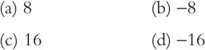

  - Match Type Questions :

Column A (ax² + bx + c = 0) | Column B (Nature of Roots)
(i) b² - 4ac = 0 | (A) Irrational and unequal
(ii) b² - 4ac < 0 | (B) Rational and equal
(iii) b² - 4ac > 0 and perfect square | (C) Complex conjugates
(iv) b² - 4ac > 0 and not perfect square | (D) Rational and unequal
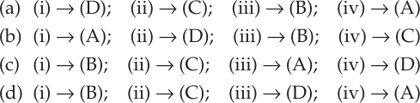

LEVEL - 2

MCQ Type Questions

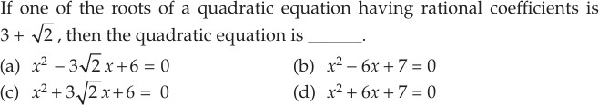
1)

2)

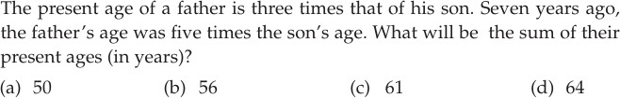
3)

- If A and B are the roots of the quadratic equation x2 - 12x + 27 = 0, then A3 + B3 is .
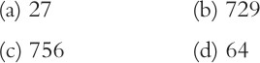

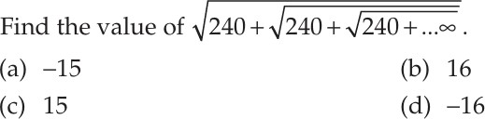
5)

- If the quadratic equation (a2 - b2) x2 + (b2 - c2) x + (c2 - a2) = 0 has equal roots, then which of the fol lowing is true?
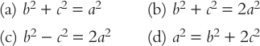

- By drawing which of the following graphs can the quadratic equation 4x2 + 6x - 5 = 0 be solved by graphical method?
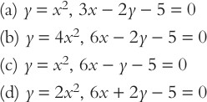

- If the roots of the equation 3ax2 + 2bx + c = 0 are in the ratio 2 : 3, then
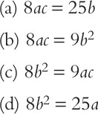

- If the roots of the quadratic equation ax2 + bx + c = 0 are α and β, then the equation whose roots are α2 and β2 is
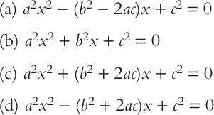

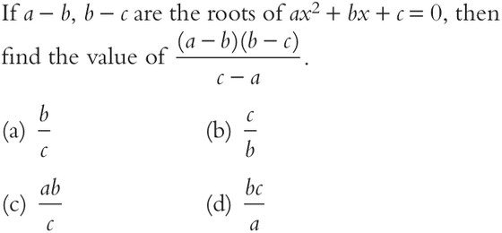

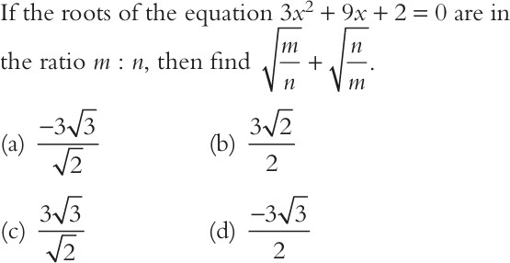

- The difference of the roots of 2y2 - ky + 16 = 0 is 1/3 . Find k.
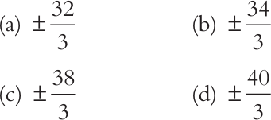

- Ramesh rowed a boat 24 km upstream from point A and returned to A in 10 h.
If the speed of his boat in still water is 5 kmph, find the speed of the stream ( in kmph).

- The discriminant of 2x² - 8x + p = 0 is - 64. The number of values that exist for p is .

- Find the maximum/minimum value of the quadratic expression x2 + 4x + 8.

Descriptive Type Questions :

In each of the following, find the value of k for which the given value is a solution of the given equation:

  - x² - x (a + b) + k = 0, x = a
  - x² + 3ax + k = 0, x = - a

Solve :

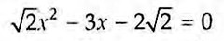
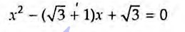
(i)
(ii)

Solve the quadratic equation by factorisation method:
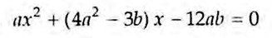

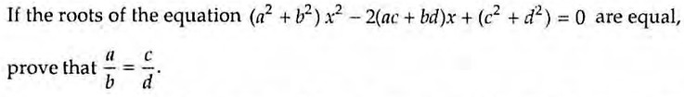

If a and c are such that the quadratic equation ax² — 5x + 3 = 0 has 10 as the sum of the roots and also as the product of the roots, find a and c.

Match Type Questions :

Column A | Column B
The minimum value of 2x2 - 5x + 11 is attained at x = | (a) - 10/3
 | (b) 5/4
One of the roots of the quadratic equa tion 4x² - 9 = 0 is
 | (c) - 5/3
 | (d) 2/3
The product of the roots of the equation 3x² - 2x - 5 = 0 is
 | (e) 3/2

LEVEL - 3
Summative Questions :

- If x = 2/3 and x = -3 are the roots of the equation ax2 + 7x + b = 0, find the values of a and b.
- Solve given quadratic equations by factorization method: (i) 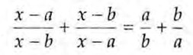
(ii) 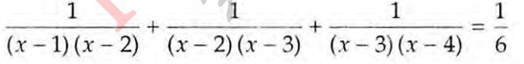

- Solve for x : 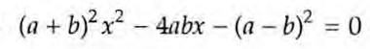

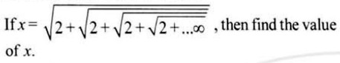

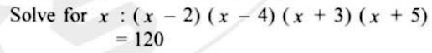

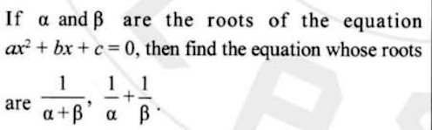

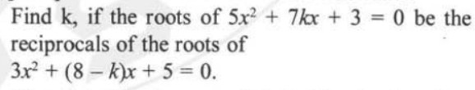

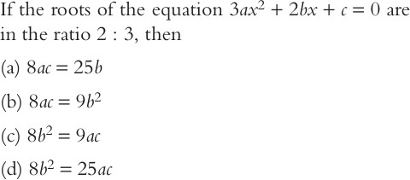

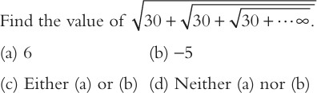

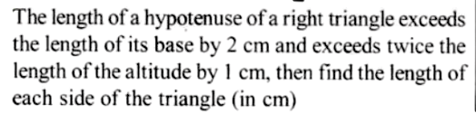

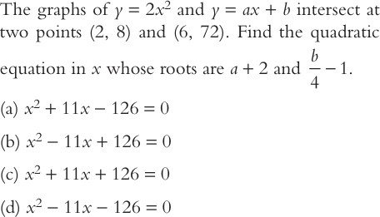

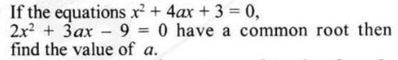

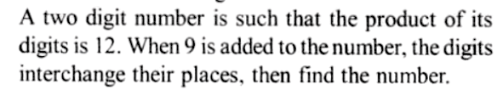

Answer Keys
Level-1
  - (i), (ii), (viii), (ix)

  - True

  - Yes

  - Reciprocal

  - 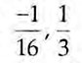

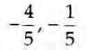
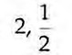
  - (i) (ii)

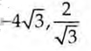
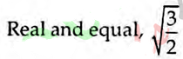
  - (i) Not Real (ii) (iii) Not Real (iv)

  - (i) Real and distinct (ii) Real and equal (iii) Real and distinct

  - k = 4

  - (i) k < 1 (ii) k < -6 or, k > 6

  - Positive

  - 6 cm and 4 cm

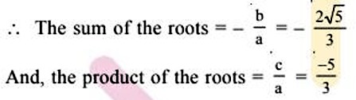

  - 4x2 - 8x - 1 = 0

15) 3, 2
16) k
17) 5 years
18) (c) | 19) (a) | 20) | (d) | 21) | (b) | 22) (b) | 23) | (d)
24) (d) | 25) (b) | 26) | (d) | 27) | (d) | 28) (d)

Level - 2
1) (b) 2) (a) 3) (b) 4) (c) 5) (b) 6) (b) 7) (d)

8) (d) 9) (a) 10) (b) 11) (a) 12) (b) 13) (a) 14) (b)

  - (a)

  - (i) K = 1 (ii) k = 2a2

  - (i) 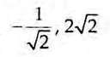 (ii) 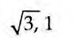
  - 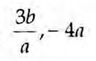

21) a = 1/2 and c = 5

22 ⟶ (b), 23 ⟶ (e), 24 ⟶ (c)

Level - 3 (Hints & Solutions)

- a = 3, b = - 6

- (i) 0, a + b (ii) - 2, 7

- 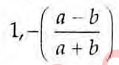

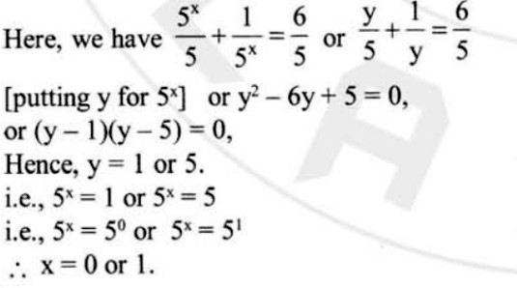
- Soln:

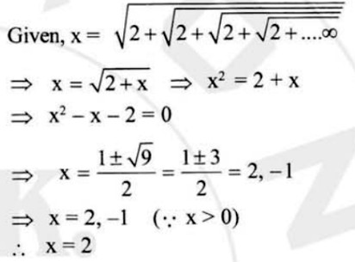
- Soln:

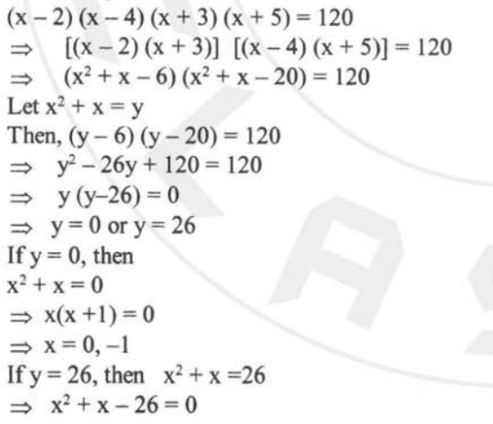
- Soln:

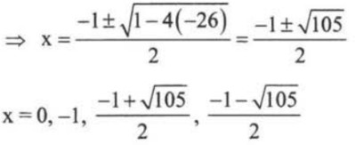
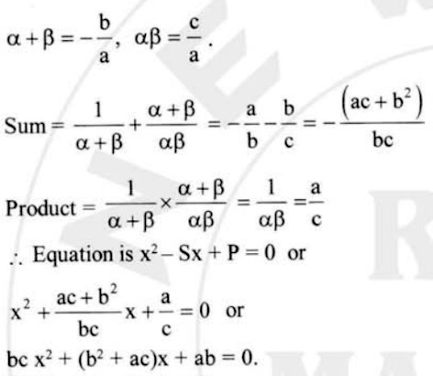
- Soln:

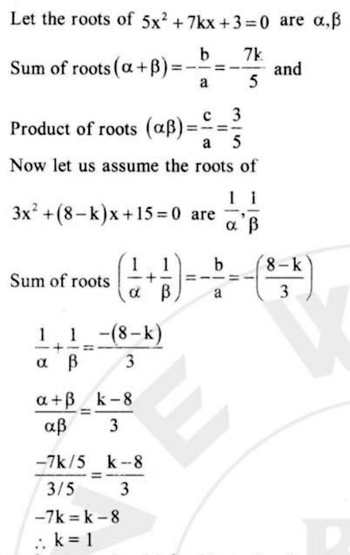
- Soln:

- (d) 11) (a)

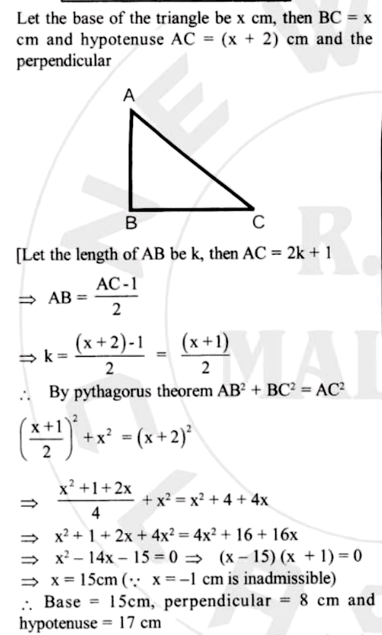
- Soln:

- (d)

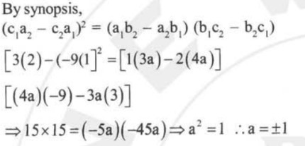
- Soln:

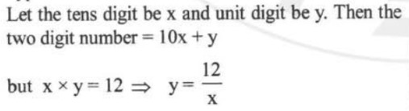
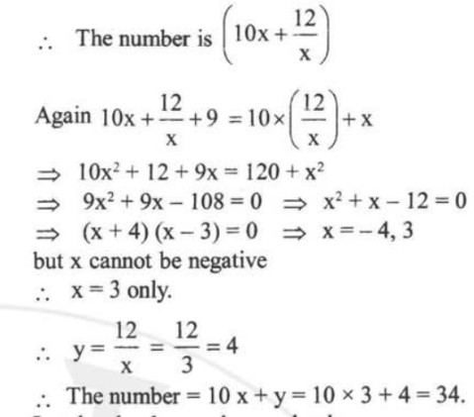
- Soln:

MIND MAP

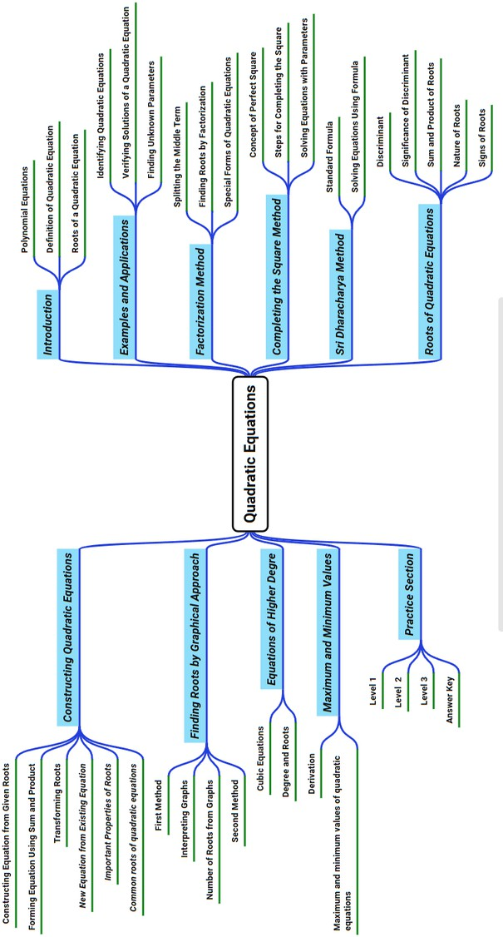

REFERENCES

  - NCERT
  - Concise Selina
  - Pearson
  - Pearson Practice Book
  - NCERT Mathematics Exemplar
  - RD Sharma
  - Newton Classes Foundation Material
  - Self Study Foundation Material

