Contents

**USCS3P01:USCS303 – OPERATING SYSYEM ( OS ) PRACTIAL 3** 2

**Practical – 01 : Implement RR ( Round-Robin) Scheduling Algorithm in Java** 2

**Practical Date :** 2

**Practical Aim :** 2

**Algorithm :** 3

**Flow Chart :** 4

**Solved Examples :** 5

**Gnatt Chart :** 8

**Implementation :** 11

**Input :** 15

**Output :** 16

**Sample Output 1 :** 17

**Sample Output 2 :** 18

**Sample Output 3 :** 19

**Sample Output 4 :** **Error! Bookmark not defined.**

# **USCS3P01:USCS303 – OPERATING SYSYEM ( OS ) PRACTIAL 3**

## **Practical – 01 : Implement RR ( Round-Robin) Scheduling Algorithm in Java**

### **Practical Date : 27 – 07 – 2021**

### **Practical Aim : Implement RR Scheduling Algorithm In Java.**

**CPU Scheduling Algorithms**

Round – Robin (RR) scheduling algorithm is mainly designed for time – sharing system.

This algorithm is similar to FCFS scheduling, but in Round – Robin (RR) scheduling, pre-emption is added which enables the system to switch between processes.

Round – Robin scheduling algorithm is used to schedule process fairly each job a time slot or quantum and the interrupting the job if it is not competed by then the job come after the job which is arrived in the quantum time that makes these scheduling fairly .

### **Algorithm :**

**Step 1:** Input the number of processes and time quanta or time slice required to be scheduled using RR, burst time for each process.

**Step 2:** Choose the first process in the ready queue, set a timer to interrupt it after time quantum and dispatches it. Check if any other process request has arrived. If a process request arrives during the quantum time in which another process is executing, then add the new process to the Ready queue.

**Step 3:** After the quantum time has passed, check for any processes in the Ready queue. If the ready queue is empty then continue the current process. If the queue not empty and the current process is not complete, then add the current process to the end of the ready queue.

**Step 4:** Take the first process from the Ready queue and start executing it. Calculate the Turn Around Time and Waiting Time for each process using RR.

**Step 5:** Repeat all steps above from Step 2 to Step 4.

**Step 6:** If the process is complete and the ready queue is empty then the task is complete.

**Step 7:** Calculate the Average Waiting Time and Average Turn Around Time.

### **Flow Chart :**

READY QUEUE

BURST TIME <TIME QUANTUM

TIME QUANTUM EXPIRES

NO

YES

SELECT A PROCESS

EXECUTE TILL COMPLETION

PROCESS

EXECUTED

COMPLETELY

EXECUTE FOR TIME QUANTUM

### **Solved Examples :**

Example 1:

Consider the following example containing three processes arriving at time t = 0 ms.

|  |  |
| --- | --- |
| **Process ID** | **Burst Time** |
| P0 | 24 |
| P1 | 3 |
| P2 | 3 |

**Step 1:** Consider the time quanta / time slice - 4 ms. Step 2: Following shows the scheduling and execution of processes.

**Step 2.1:** PO process arrives at 0 with 24 ms as the burst time which is greaterthan time quanta - 4 ms. So PO executes for 4 ms and goes in waiting queue.

|  |  |  |
| --- | --- | --- |
| **System Time** | : | 0 |
| **Process Scheduled** | : | P0 |
| **Remaining Time** | : | 24 – 4 = 20 |
| **Waiting Time** | : | 0 + 0 = 0 |
| **Turn Around Time** |  | 0 + 4 = 4 |

**Step 2.2:** Next P1 process executes for 3 ms which is greater than quanta time. So P1 executes and gets terminated.

|  |  |  |
| --- | --- | --- |
| **System Time** | : | 0 |
| **Process Scheduled** | : | P0 , P1 |
| **Remaining Time** | : | 3 – 4 = -1 =0 |
| **Waiting Time** | : | 4 – 0 = 4 |
| **Turn Around Time** |  | 4 + 3 = 7 |

**Step 2.3:** Next P2 process executes for 3 ms which is greater than quanta time. So P2 executes and gets terminated.

|  |  |  |
| --- | --- | --- |
| **System Time** | : | 7 |
| **Process Scheduled** | : | P0 , P1 , P2 |
| **Remaining Time** | : | 3 – 4 = -1 =0 |
| **Waiting Time** | : | 7– 0 = 7 |
| **Turn Around Time** |  | 7 + 3 = 10 |

**Step 2.4:** Now PO turns comes again and it's the only process for execution so for 4 ms of quanta it gets executed.

|  |  |  |
| --- | --- | --- |
| **System Time** | : | 10 |
| **Process Scheduled** | : | P0 , P1 , P2 , P0 |
| **Remaining Time** | : | 20 – 4 = 16 |
| **Waiting Time** | : | 0 |
| **Turn Around Time** |  | 10+ 4 = 14 |

**Step 2.5:** Again, PO continues to execute for next 4 ms. Waiting for PO will be zero.

|  |  |  |
| --- | --- | --- |
| **System Time** | : | 7 |
| **Process Scheduled** | : | P0 , P1 , P2 , P0 , P0 |
| **Remaining Time** | : | 16 – 4 = 12 |
| **Waiting Time** | : | 0 |
| **Turn Around Time** |  | 14 + 4 = 18 |

**Step 2.6:** PO continues to execute for next 4 ms.

|  |  |  |
| --- | --- | --- |
| **System Time** | : | 7 |
| **Process Scheduled** | : | P0 , P1 , P2 , P0 , P0 , P0 |
| **Finish Time** | : | 12 – 4 = 12 |
| **Turn Around Time** | : | 18 + 4 = 22 |

**Step 2.7:** PO continues to execute for next 4 ms.

|  |  |  |
| --- | --- | --- |
| **System Time** | : | 7 |
| **Process Scheduled** | : | P0 , P1 , P2 , P0 , P0 , P0 , P0 |
| **Finish Time** | : | 8 – 4 = 4 |
| **Turn Around Time** | : | 22 + 4 = 26 |

**Step 2.8:** PO continues to execute for next 4 ms.

|  |  |  |
| --- | --- | --- |
| **System Time** | : | 7 |
| **Process Scheduled** | : | P0 , P1 , P2 , P0 , P0 , P0 , P0 , P0 |
| **Finish Time** | : | 4 – 4 = 0 |
| **Turn Around Time** | : | 26 + 4 = 30 |

**Step 3:** Calculate Average Waiting Time and Average Turn Around Time.

|  |  |  |
| --- | --- | --- |
| **Average Waiting Time** | = | ( 6 + 4 + 7 ) / 3 |
|  | = | 17 / 3 |
|  | = | 5.666667 |

|  |  |  |
| --- | --- | --- |
| **Average Turn Around Time** | = | ( 30 + 7 + 10 ) / 3 |
|  | = | 47 / 3 |
|  | = | 16 |

**Step 4:** After scheduling of all provided processes:

|  |  |  |  |
| --- | --- | --- | --- |
| **Process ID** | **Burst Time** | **Turn Around Time**  **(Completion Time - Arrival Time)** | **Waiting Time**  **(Turn Around Time – Burst**  **Time)** |
| P0 | 24 | 30 – 0 = 30 | 30 – 24 = 6 |
| P1 | 3 | 4 + 3 = 7 | 7 – 3 = 4 |
| P2 | 3 | 7 + 3 = 10 | 10 – 3 = 7 |
| Average |  | 15.666667 | 5.666667 |

### **Gnatt Chart :**

|  |  |  |  |
| --- | --- | --- | --- |
| **Process ID** | **Burst Time** | **Turn Around Time**  **(Completion Time - Arrival Time)** | **Waiting Time**  **(Turn Around Time – Burst**  **Time)** |
| P0 | 24 | 30 – 0 = 30 | 30 – 24 = 6 |
| P1 | 3 | 4 + 3 = 7 | 7 – 3 = 4 |
| P2 | 3 | 7 + 3 = 10 | 10 – 3 = 7 |
| Average |  | 15.666667 | 5.666667 |

|  |  |  |  |  |  |  |  |
| --- | --- | --- | --- | --- | --- | --- | --- |
| **P0** | **P1** | **P2** | **P0** | **P0** | **P0** | **P0** | **P0** |
| 0 1 2 3 4 | 5 6 7 | 8 9 10 | 11 12 13 14 | 15 16 17 18 | 19 20 21 22 | 23 24 25 26 | 27 28 29 30 |

**Example 2:**

Consider the following example containing three processes arrive at same time having time slice as 1ms

|  |  |
| --- | --- |
| **Process ID** | **Burst Time** |
| P0 | 2 |
| P1 | 1 |
| P2 | 6 |

**Solution:**

|  |  |  |  |
| --- | --- | --- | --- |
| **Process ID** | **Burst Time** | **Turn Around Time**  **(Completion Time - Arrival Time)** | **Waiting Time**  **(Turn Around Time – Burst**  **Time)** |
| P0 | 2 | 4 – 0 = 4 | 4 – 2 = 2 |
| P1 | 1 | 2 - 0 = 2 | 2 – 1 = 1 |
| P2 | 6 | 9 – 0 = 9 | 9 – 6 = 3 |
| Average |  | 5.000000 | 2.000000 |

|  |  |  |  |  |  |  |  |  |  |
| --- | --- | --- | --- | --- | --- | --- | --- | --- | --- |
| **P0** | **P1** | **P2** | **P0** | **P2** | **P2** | **P2** | **P2** | **P2** | **P2** |
| 0 | 1 | 2 | 3 | 4 | 5 | 6 | 7 | 8 | 9 |

**Example 3:**

Consider the following example containing three processes arrive at same time having same time. Time Quanta = 3

|  |  |
| --- | --- |
| **Process ID** | **Burst Time** |
| P0 | 7 |
| P1 | 3 |
| P2 | 2 |
| P3 | 10 |
| P4 | 8 |

**Solution:**

|  |  |  |  |
| --- | --- | --- | --- |
| **Process ID** | **Burst Time** | **Turn Around Time**  **(Completion Time - Arrival Time)** | **Waiting Time**  **(Turn Around Time – Burst**  **Time)** |
| P0 | 7 | 24 – 0 = 24 | 24 – 7 =17 |
| P1 | 3 | 6 – 0 = 6 | 6 – 3 =3 |
| P2 | 2 | 8 – 0 = 8 | 8 – 2 = 6 |
| P3 | 10 | 30 – 0 =30 | 30 – 10 =20 |
| P4 | 8 | 29 – 0 =29 | 29 – 8 =21 |
| Average |  | 19.4000000 | 13.4000000 |

|  |  |  |  |  |  |  |  |  |  |  |  |
| --- | --- | --- | --- | --- | --- | --- | --- | --- | --- | --- | --- |
| **P0** | **P1** | **P2** | **P3** | **P4** | **P0** | **P3** | **P4** | **P0** | **P3** | **P4** | **P3** |
| 0 | 3 | 6 | 8 | 11 | 14 | 17 | 20 | 23 | 24 | 29 | 30 |

### **Implementation :**

//Name: Yash Patil

//Batch:B2

//PRN: 2020016400809191

//Date:28/7/2021

//Prac-03: RR(with no preemption)Algorithm

import java.util.Scanner;

class P3_RR_YP

{

public static void main(String args[])

{

Scanner input = new Scanner(System.in);

int i, j, k, q, sum = 0;

System.out.print("Enter number of process: ");

int n = input.nextInt();

int burstTime[] = new int[n];

int waitingTime[] = new int[n];

int turnAroundTime[] = new int[n];

int a[] = new int[n];

System.out.println("Enter Burst Time of each process: ");

for (i = 0; i < n; i++)

{

System.out.print("Enter Burst Time for Process - P" + (i) +" : ");

burstTime[i] = input.nextInt();

a[i] = burstTime[i];

}

System.out.print("Enter Time quantum: ");

q=input.nextInt();

for (i = 0; i<n; i++)

waitingTime[i] = 0;

int timer = 0; // Current time

// Keep traversing processes in round robin manner until all of them are not done.

do

{

for (i = 0; i<n; i++)

{

// If burst time of a process is greater than 0 then only need to process further

if (burstTime[i] > q)

{

// Increase the value of ti.e. shows how much time a process has been processed

timer += q;

// Decrease the burst time of current process by quantum

burstTime[i] -= q;

for (j = 0; j<n; j++)

{

if ((j!= i) && (burstTime[j] != 0))

waitingTime[j] += q;

}

} // if ends

// If burst time is smaller than or equal to quantum. Last cycle for this process

else

{

// Increase the value of t i.e. shows how much time a process has been processed

timer += burstTime[i];

for (j = 0; j<n; j++)

{

if ((j != i) && (burstTime[j] != 0)) waitingTime[j] += burstTime[i];

}

// As the process gets fully executed make its remaining burst time = 0

burstTime[i] = 0;

} // else ends

}

sum = 0;

for (k = 0; k<n; k++)

sum += burstTime[k];

} while (sum != 0);

// calculating turnaround time by adding waiting Time + burst Time

for (i = 0; i<n; i++)

turnAroundTime[i] = waitingTime[i] + a[i];

float total = 0;

for (int x : waitingTime)

{

total += x;

}

float averageWaitingTime = total / n;

total = 0;

for (int y : turnAroundTime)

{

total += y;

}

float averageTurnAroundTime = total / n;

// print on console the order of processes scheduled using Round-robin Algorithm

System.out.println("RR Algorithm: ");

System.out.format("%20s %20s %20s %20s\n","Processld","BurstTime","Waiting Time","TurnAroundTime");

for (i = 0; i<n; i++)

{

System.out.format("%20s %20d %20d %20d\n","P"+(i),a[i], waitingTime[i],turnAroundTime[i]);

}

System.out.format("%40s %20f %20f\n","Average",averageWaitingTime,averageTurnAroundTime);

}

}

### **Input :**

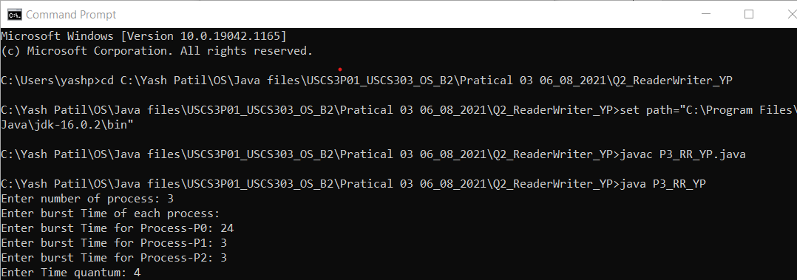

### **Output :**

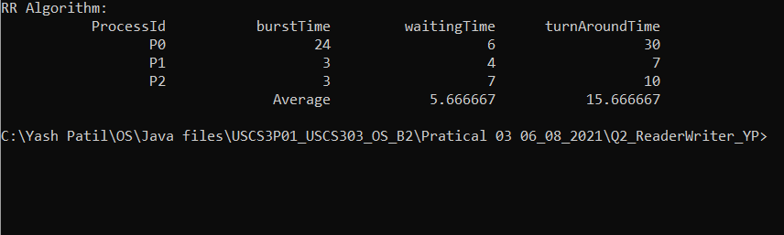

### **Sample Output 1 :**

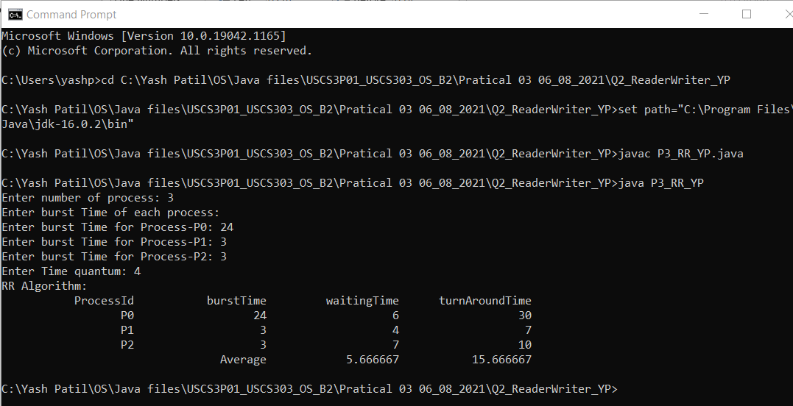

### **Sample Output 2 :**

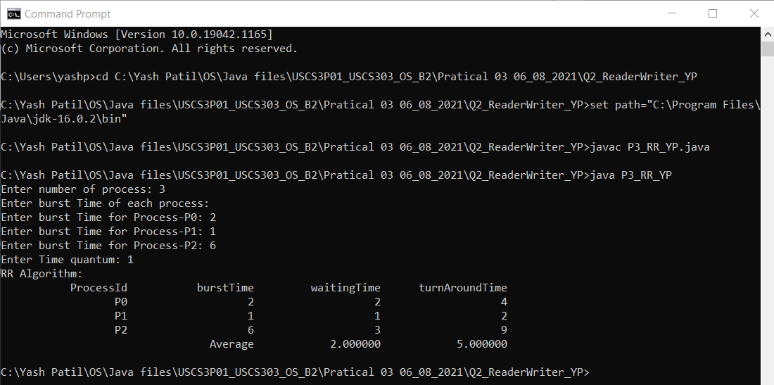

### **Sample Output 3 :**

