**USCS 3P01: USCS303-Operating System(OS) date :20/08/2021**

**Pratical-06**

**Contents**

USCS3P01: USCS303-Operating System (OS)

Aim………………………………………………………………………………………..…2

Banker’s Algorithm……………………………………………………………………2

Date Structure (Banker’s Algorithm) …………………………………….….3

Safety Algorithm…………………………………………………………………….….3

Resource-Request Algorithm …………………………………………………….3

Example………………………………………………………………………………….....4

Implementation…………………………………………………………………………9

Input……………………………………………………………………………………..….13

Output………………………………………………………………………………….…..14

Sample Output………………………………………………………………….……….15

1

**Aim**: Blanker’s Algorithm

**Contents**:

For the banker algorithm to operate each process has to a Priority specify its maximum requirement of resources.

**Process**:

One can also determine whether a process request for allocation of resources be safely granted immediately.

**Prior Knowledge**: Date structure used in banker algorithm.

Safety algorithm and resource request algorithm.

Banker’s Algorithm:

1) The resource-allocation -graph algorithm is not applicable toa resource allocation system with instences of each resources type.

2) The deadlock -Avoidance algorithm that we describe next is applicable to such a system but is less efficient than the resources -allocation graph scheme.

3) This algorithm is commonly know as the banker’s algorithm.

4) Banker's algorithm is a deadlock avoidance algorithm.

5) It is the name so because this algorithm is used in banking system to determine whether a loan can be granted or not

6) The name was chosen because the algorithm could be used in banking system to ensure that the bank never are located its available cash in such a way that it would no longer satisfy the needs of its customer.

Banker’s Algorithm -how it works:

1) Consider there are an account holder in a bank and the sum of the money in all of their account is S.

2) Every time a loan has to be granted by the bank it subtracts the loan amount from the total money the bank has.

3) Then it's check if that different is greater than S.

4) It is done because only then the bank would have enough money if all the an account holder draw all their money At once.

5) When a new thread enter the system it must declare the maximum number of instance of each resource type that it may need

6) This number may not exceed the total number of a source in the system .

2

7) when a user request a set of resource the system must determine whether the allocation of these resources will leave the system in a safe state.

8) If it will, the resources are allocation; otherwise, the thread must wait until some other thread release enough resources.

Date Structures (Banker’s Algorithm):

Available : A vector of length m indicate the number of available resources of each type. If Available[j] equals k, then k instance of resource type Rj are available.

Max: An n × m matrix defines the maximum demand of each thread . if Max[i][j] equals k, then thread Ti may request at most k instance of resources type Rj.

Allocation : An n × m matrix defines the number of resources of each type currently allocated to each thread. If Allocation[i][j] equals k, then thread k, then thread Ti is currently allocation k instance of resources type rj.

Need: An n × m matrix indicate the remaining resources need of each thread . if Need[i][j] equals k, then thread Ti may need k more instance of resources type Rj complete its task.

Need[i][j]=Max[i][j]-Allocation[i][j]

Safety Algorithm:

Step 1: Let Work and Finish be vectors of length m and n , respectively . Initialize work=Available and finish[i]=false for i=0,1,…….n-1.

Step 2: find an index i such that both

Step 2: Finish[i]==false

Step 3: Needi ≤ Work

If no such I exists go to step 4.

Step 3 : Work = Work + Allocation;

Finish[i]=true

Go to Step 2.

Step 4: If Finish[i]== true for all I, then the system is in a safe state.

Resource-Request Algorithm :

1) Let Request be the request vector for thread Ti.

2) If Requesti [j]==k , then thread Ti wants k instance of resources type Rj.

3) When a request for resources is made by thread Ti , the following actions are taken:

Step 1: If Requesti ≤ Needi go to Step 2. Otherwise , raise an error condition , since the thread has exceeded its maximum claim.

Step 2 : if Requesti ≤ Availablei go to Step 3, Otherwise , Ti must wait, since the resources are not available. 3

Step 3: Heather system printed to had allocated the requested resource to third Ti by modify the state has follows;

Available = Available – requesti

Allocationi = Allocationi + Requesti

Needi = Needi – Requesti

if the resulting resource allocation state it safe the transaction is completed and the thread Ti is allocated its resources .

however if the new state is unsafe then Ti must wait a request and the old resource allocation state is restored.

Example 1: Consider a system with five Threads T0 through T4 and three resource type A ,B and C. resource type A has ten instance ,resource type B has file systems and resource type C has seven instance. suppose that the following is snapshot represent the current state of the system.

|  |  |  |  |
| --- | --- | --- | --- |
| Threads | Allocation | Max | Available |
|  | A B C | A B C | A B C |
| T0 | 0 1 0 | 7 5 3 | 3 3 2 |
| T1 | 2 0 0 | 3 2 2 |  |
| T2 | 3 0 2 | 9 0 2 |  |
| T3 | 2 1 1 | 2 2 2 |  |
| T4 | 0 0 2 | 4 3 3 |  |

Need Matrix = Max-Allocation

|  |  |  |  |  |
| --- | --- | --- | --- | --- |
| Threads | Allocation | Max | Available | Need |
|  | A B C | A B C | A B C | A B C |
| T0 | 0 1 0 | 7 5 3 | 3 3 2 | 7 4 3 |
| T1 | 2 0 0 | 3 2 2 |  | 1 2 2 |
| T2 | 3 0 2 | 9 0 2 |  | 6 0 0 |
| T3 | 2 1 1 | 2 2 2 |  | 0 1 1 |
| T4 | 0 0 2 | 4 3 3 |  | 4 3 1 |

We claim that the system of current in safe state in the sequence satisfy the supplies criteria.

Example 2: Consider the following System

|  |  |  |  |
| --- | --- | --- | --- |
| Threads | Allocation | Max | Avilable |
|  | A B C | A B C | A B C |
| P0 | 1 1 1 | 4 3 3 | 2 1 0 |
| P1 | 2 1 2 | 3 2 2 |  |
| P2 | 4 0 1 | 9 0 2 |  |
| P3 | 0 2 0 | 7 5 3 |  |
| P4 | 1 1 2 | 1 1 2 |  |

SOLVE:

Need Matrix = Max-Allocation

|  |  |  |  |  |
| --- | --- | --- | --- | --- |
| Threads | Allocation | Max | Available | Need |
|  | A B C | A B C | A B C | A B C |
| P0 | 1 1 1 | 4 3 3 | 2 1 0 | 3 2 1 |
| P1 | 2 1 2 | 3 2 2 |  | 1 1 0 |
| P2 | 4 0 1 | 9 0 2 |  | 5 0 1 |
| P3 | 0 2 0 | 7 5 3 |  | 7 3 3 |
| P4 | 1 1 2 | 1 1 2 |  | 0 0 0 |

We claim that the system of current in safe state in the sequence satisfy the supplies criteria.

Example 3: Consider the following example containing five processes and 4 types of resources :

|  |  |  |  |
| --- | --- | --- | --- |
|  | Allocation Matrix | Max Matrix | Available Matrix |
|  | A B C D | A B C D | A B C D |
| P0 | 0 1 1 0 | 0 2 1 0 | 1 5 2 0 |
| P1 | 1 2 3 1 | 1 6 5 2 |  |
| P2 | 1 3 6 5 | 2 3 6 6 |  |
| P3 | 0 6 3 2 | 0 6 5 2 |  |
| P4 | 0 0 1 4 | 0 0 1 4 |  |

We claim that the system of current in safe state in the sequence P0>P3>P4>P1>P2> satisfy the supplies criteria.

Implementation:

//Name: Yash Patil

//Batch: B2

//PRN: 2020016400809191

//Date:20/8/2021

//Prac-04:Banker's Algorithm

import java.util.Scanner;

public class P6_BankersAlgo_YP{

private int need [][], allocate[][],max[][], avail[][],np,nr;

private void input(){

Scanner sc=new Scanner(System.in);

System.out.print("Enter no.of processes: ");

np=sc.nextInt(); //no. of processes

System.out.print("Enter no. of processes: ");

nr=sc.nextInt();//no.of rescources

need=new int[np][nr];//initializing arrays

max=new int[np][nr];

allocate=new int[np][nr];

avail=new int[1][nr];

for(int i=0;ii++){

System.out.print("Enter allocaton matrix for process P"+i+":");

for(int j=0;j++)

allocate[i][j]=sc.nextInt();//allocation matrix

}

for(int i=0;i<np;i++){

System.out.print("Enter maximum matrix for process P"+i+":");

for(int j=0;j<nr;j++)

max[i][j]=sc.nextInt();//max matrix

}

System.out.print("Enter available matrix for process P0:");

for(int j=0;j<nr;j++)

avail[0][j]=sc.nextInt(); //available matrix

sc.close();

}//input() ends

private int[][] calc_need(){

for(int i=0;i<np;i++)

for(int j=0;j<nr; j++)//calculating need matrix

need[i][j]=max[i][j]-allocate[i][j];

return need;

}//calc_need()ends

private boolean check(int i){

//checking if all resources for ith process can be allocated

for(int j=0;j<nr;j++)

if(avail[0][j]<need[i][j])

return false;

return true;

} //check() ends

public void isSafe(){

input();

calc_need();

boolean done[]=new boolean[np];

int j=0;

//printing Need Matrix

System.out.println("========Need Matrix========");

for(int a=0;a<np;a++){

System.out.print(need[a][b]+"\t");

}

System.out.println();

}

System.out.println("Allocated process:");

while(j<np){// until all process allocated

boolean allocated=false;

for(int i=0;i<np;i++)

if(!done[i] && check(i)){//trying to allocate

for(int k=0;k<nr;k++)

avail[0][k]=avail[0][k]-need[i][k]+max[i][k];

System.out.print("P"+i+">");

allocated=done[i]=true;

j++;

}//if block

if(!allocated)

break; //if no allocation

}//while ends

if(j==np)//if all processes are allocated

System.out.println("\nSafely allocated");

Else

System.out.println("All/Remaining process can\'t be allocated safely");

}//isSafe()ends

public static void main(String[]args){

new P6_BankersAlgo_YP().isSafe();

}

}//class ends

**Input** :

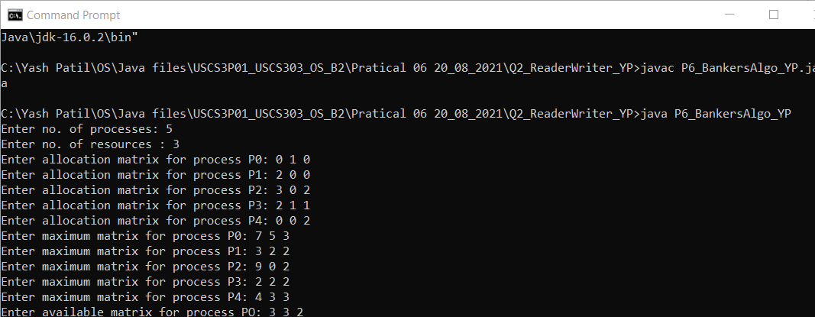

**Output :**

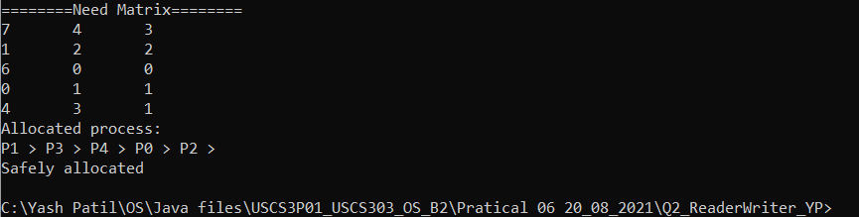

**Sample output:**

**Question 1 :**

**Calculate the content of the need matrix?**

**Check if the system is in a safe state?**

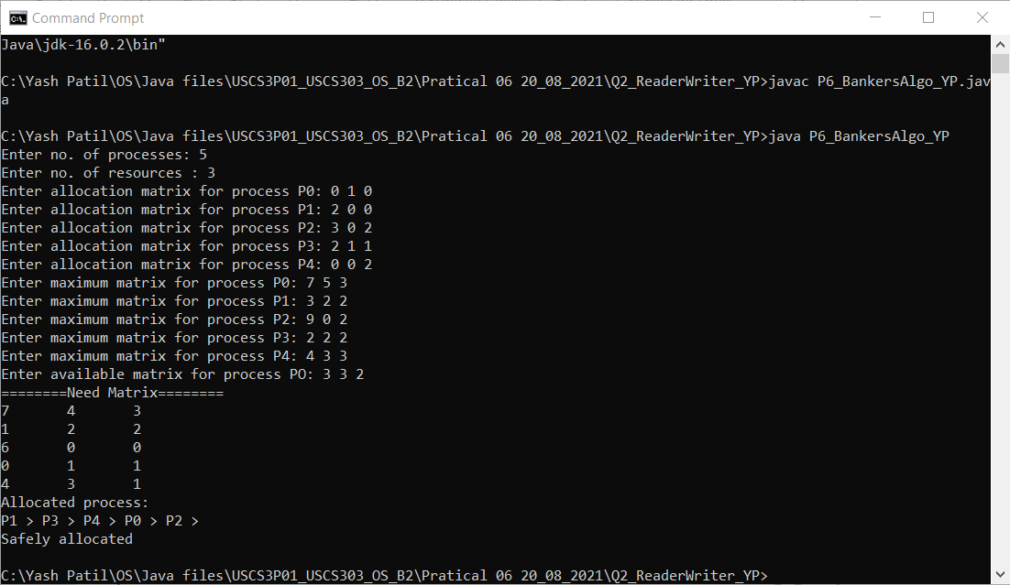

**Question : 02**

**Calculate the content of need matriz?**

**Check if the system is in a safe state?**

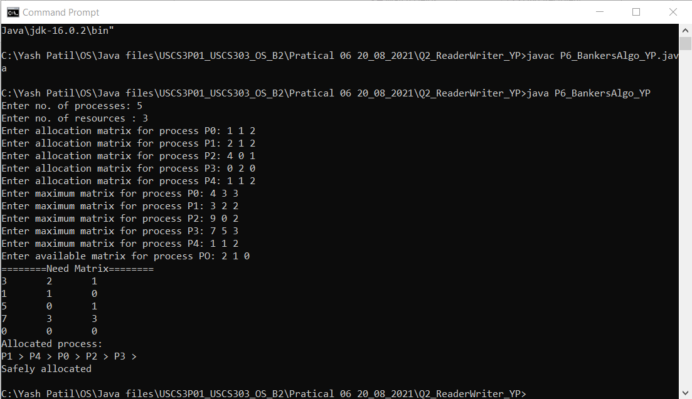

**Question 03:**

Consider the following example containing five processes and 4 types of resources:

Calculate the Need matrix and the sequence of safety allocation?

