Real-Time Detection of Operator Mental Workload from Eye Tracking, and Adaptive On-Screen Guidance During Maintenance Procedures
Methodology
Abstract
This paper presents RTAPS, a system that estimates an operator's mental workload during hazardous maintenance procedures and adapts the on-screen instructions accordingly. The sole sensor is a lightweight wearable eye tracker. Once per second, the system summarises the operator's recent ocular activity and applies a trained classifier to label mental workload as low or high; when high workload is detected, the interface reveals additional step-by-step guidance. We describe what is measured and in what units, how the ocular signals are transformed into model inputs, how the model was trained and evaluated, and the principal design decisions that keep its predictions grounded in the operator's physiology rather than in task-order artefacts. Particular attention is given to a methodological pitfall we term the step-timing problem, and to the procedure used to avoid it.
1. Background and aim
Mental workload denotes the amount of mental effort a task imposes. Elevated workload is associated with an increased likelihood of error, so timely support can be beneficial. A substantial body of research demonstrates that ocular signals reflect mental effort: the pupil tends to dilate, blink frequency tends to decrease, and gaze is held longer when a task is demanding [1,2,3]. RTAPS exploits these signals to estimate workload continuously and to deliver additional guidance when it is most likely to be required, and less when it is not. The remainder of this paper sets out the method in full, so that each step can be reproduced.
2. Materials and Methods
2.1 Overview of the system
RTAPS comprises two components (Figure 1). The first operates live, while the operator works: a wearable eye tracker streams ocular data to a computer, which condenses the recent activity into a small set of summary values; a trained model then classifies workload as low or high every second, and the operator's display presents additional guidance whenever the classification is high. The second component is performed beforehand: the model is constructed from recordings of earlier sessions. The live system and the model-building pipeline use identical settings throughout, ensuring that the values the model observes during deployment are consistent with those on which it was trained.
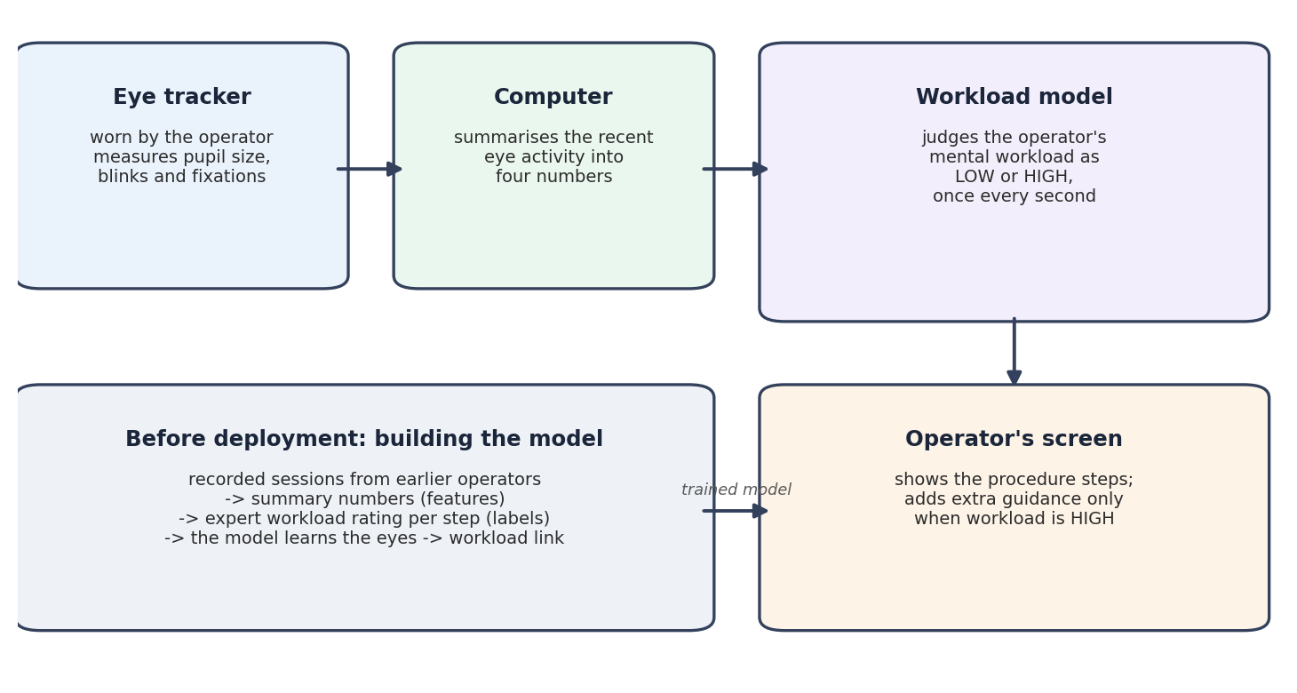
Figure 1. The live system (top right) and the offline model-building pipeline (bottom left).
2.2 Procedures and participants
The study covers three industrial maintenance procedures, namely centrifuge operation, column flushing, and pressure testing, each comprising an ordered sequence of steps that the operator completes in turn. The model was constructed from recordings of 11 participants performing these procedures.
2.3 What is measured, and in what units
All inputs derive from a single wearable eye tracker. While the operator works, the device continuously reports pupil size and separately registers two classes of event: blinks and fixations (the brief intervals during which the eye remains stationary on a single location). Table 1 lists every quantity that enters the system together with its unit of measurement. Units are stated explicitly because the system combines quantities of markedly different kinds, namely a relative size, a rate of change, a count, and a duration, and an error in any single unit would introduce systematic distortion of the result.
What we measure | Unit | Notes
Pupil size (diameter) | millimetres (mm) | about 120 readings per second
Blink length | seconds | blinks exceeding 2 s are treated as tracking loss and excluded
Fixation length | milliseconds (ms) | a fixation is an interval during which the eye remains stationary
Step workload score | index (no natural unit) | an expert rating of the demand imposed by each step
Normalised step score | 0 to 1 | the step's score divided by that of the most demanding step in the procedure
Workload label | low / high | the value the model is trained to predict

Table 1. The quantities used by the system and their units.
2.4 Turning eye data into inputs for the model
A model cannot operate on raw ocular data directly, so these data are first condensed into a small set of summary values, termed features. RTAPS employs four features, each characterising the recent past rather than a single instant (Table 2). All four are established ocular markers of mental effort: the pupil dilates and its rate of dilation increases with task-evoked effort [1, 8, 9], spontaneous blink rate decreases under higher load [2], and fixations lengthen with deeper cognitive processing [3]. The pupil diameter slope is included because it captures the trend of pupil change, whether effort is building or easing over the 10-second window, which complements the level captured by mean pupil size. It's research-supported (gradual cognitive dilation has a characteristic velocity), though it's the least classically-established of the four and not the strongest single predictor. Pupil samples arrive at a high rate, so the two pupil features summarise the preceding 10 seconds; blinks and fixations occur less frequently, so the corresponding features summarise the preceding 30 seconds. The model nevertheless produces a fresh classification every second.
It is important to specify precisely what the model receives each second, because the eye tracker produces considerably more data than this, on the order of 120 pupil samples per second. The model is not supplied with a single raw sample, nor with the first sample to arrive within each second; either choice would discard most of the available signal and yield an unstable input. Instead, each second the system summarises a complete recent window of samples into the four features described above: the two pupil features are the mean percentage change and the trend (slope) of pupil size over the preceding 10 seconds, the blink feature is the number of blinks in the preceding 30 seconds, and the fixation feature is the mean fixation duration over the preceding 30 seconds. The value transmitted for each feature is therefore a window-level summary, namely a mean, a trend, or a count, rather than any individual instantaneous sample. Only good-quality samples contribute to these summaries: any sample flagged by the eye tracker as low quality is discarded prior to aggregation.

Feature | Unit | Look-back window
Pupil size relative to the operator's resting baseline; larger values typically indicate greater effort | % change | 10 seconds
The direction and rate of change of pupil size (dilating or constricting) | mm per second | 10 seconds
The number of blinks; fewer blinks typically indicate higher load | count of blinks | 30 seconds
The mean fixation duration; longer fixations typically indicate deeper processing | milliseconds | 30 seconds

Table 2. The four features the model uses. (For traceability, their names in the code are pupil_pcps_mean, pupil_diam_slope, blink_rate_30s and fixation_dur_mean_ms.)
2.5 A personal baseline for pupil size
Pupil size varies considerably between individuals, so a given absolute size is meaningful only relative to that operator's resting size. To establish this reference, the operator fixates a central cross for two minutes before the procedure begins, during which the resting pupil size is recorded. Thereafter, pupil size is expressed as a percentage change from this personal baseline, rendering the measure comparable across individuals. The system issues no workload classifications until this baseline has been acquired.
2.6 Defining the correct answer: workload labels
Training a model requires examples annotated with the correct answer. Here the correct answer is the operator's true mental workload, for which no moment-by-moment record was available. We therefore adopted an established expert method, a VACP analysis [4], that rates the demand of each step in each procedure. Within a procedure, these ratings are rescaled so that the most demanding step equals 1 and the remainder fall below it (Figure 2, lower panel). The steps are then partitioned into low and high workload at a threshold selected to separate the two groups cleanly. Each step thus receives a low or high label derived entirely from the expert analysis; no estimated or arbitrary labels were used.
2.7 Linking the eye data to the labels in time
The eye data and the workload labels come from two separate places, and we need to join them together. The eye tracker records the eyes second by second, but it does not know how hard the operator was working. The labels say how demanding each step is (low or high), but on their own they are not attached to any eye data. To train the model, every second of eye data needs the correct label sitting next to it.
We join the two using time. The eye tracker stamps every reading with the moment it was taken, and we also know when each step started and ended (for example, step 3 might run from the 70th to the 120th second of the session). So for each one-second piece of eye data, we look at its time, find which step was active at that moment, and give it that step's label (Figure 2, upper panel). In short, the time tells us which step the operator was on, and the step tells us the workload label.
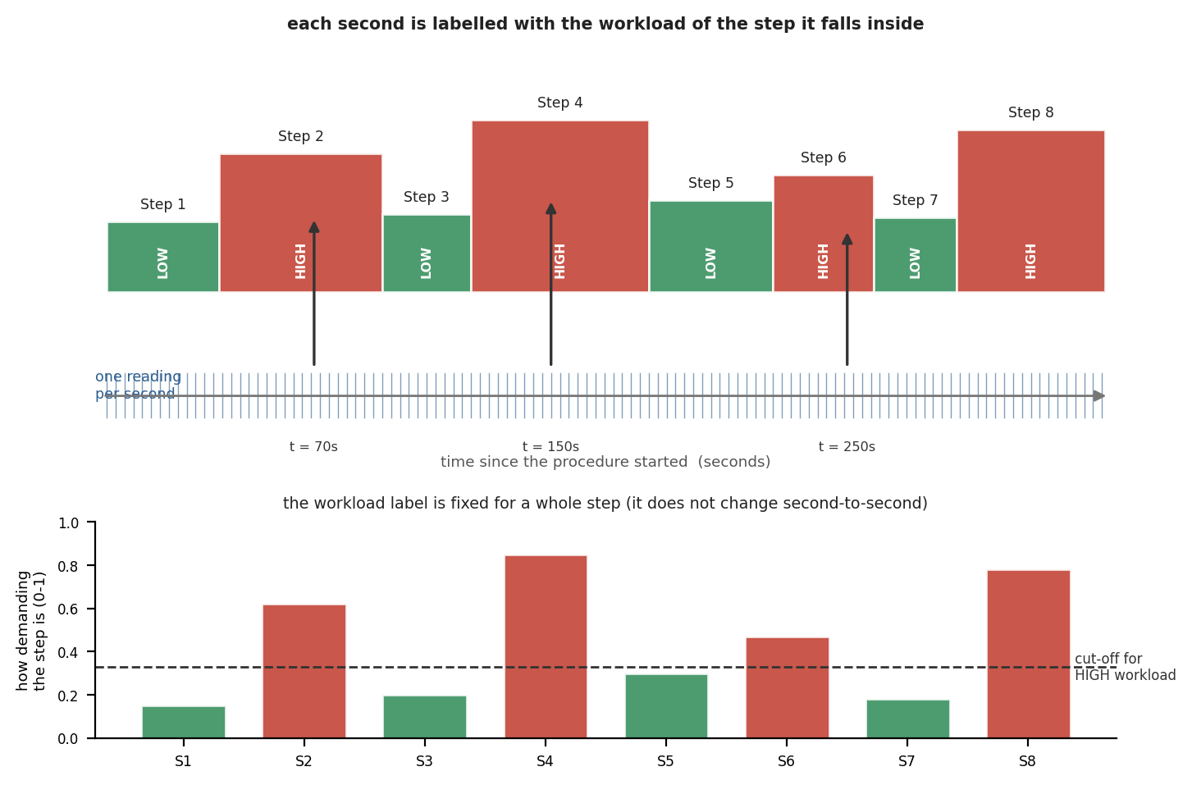
Figure 2. Alignment of ocular observations with labels. Top: each one-second observation is assigned the workload label of the step within which it falls. Bottom: a step's label is derived from its assessed demand, partitioned at a threshold.
2.8 The step-timing problem and the exclusion of step information from the model
This way of labelling hides a trap. Because every label is decided purely by which step the operator is on, and the steps always happen in the same order, simply knowing how far into the session the operator is almost gives away the answer. If we let the model see the step number or the elapsed time, the easiest thing for it to do would be to memorise a simple list (for example, "step 5 of the centrifuge means high") and ignore the eyes completely. We checked this directly: adding the step number pushed accuracy up to about 99%, but the eye signals then counted for almost nothing, and such a model would not work on a new procedure, or on one whose steps were re-ordered. To avoid this, we use the step number and the time only in the background, to attach the correct label, and we deliberately keep them out of what the model sees. This forces the model to base its decision on the eyes alone.
2.9 The model
The four features are mapped to a low-or-high classification using a Random Forest. A Random Forest is an ensemble of many binary decision trees, each of which casts a vote, with the majority determining the outcome; it is a well-established method that performs well on modest datasets and provides a measure of its own confidence. The model's hyperparameters were selected automatically by a search over many configurations, retaining the best-performing combination; the final model comprises several hundred trees. When a feature is occasionally missing, it is imputed with a neutral, typical value so that a classification can still be produced.
A further safeguard is interposed between the model and the display. To prevent the on-screen guidance from alternating with every transient fluctuation, the display switches to high only after the model has reported high for three consecutive seconds, and the counter is reset at the start of each new step.
2.10 How we tested the model
The central question is whether the system generalises to an individual it has not previously encountered. It was therefore evaluated using participant-grouped cross-validation: participants are partitioned into groups, the model is trained on a subset of groups and tested on the remainder, and no participant appears in both the training and test sets. Every figure reported below is derived from data the model did not observe during training. Performance is summarised using accuracy (the proportion of correct classifications), balanced accuracy (which adjusts for class imbalance), and Cohen's kappa, a standard measure of agreement beyond chance for which 0 denotes performance no better than chance and 1 denotes perfect agreement.
3. Results
How often each answer appears depends on how it is counted. Looking second by second, which is the level at which the model operates, the two workload classes are relatively balanced: approximately 54% of the observations correspond to high workload and 46% to low workload. At the step level, however, only about 23% of the procedure steps are classified as high workload, because the higher-workload steps tend to last longer and therefore contribute more data points.
The results are shown in Table 3. To evaluate how well the model generalizes to new users, we conducted a held-out test using data from three operators who were completely excluded from model development and training. At the one-second level, the model achieved an accuracy of 57% and a balanced accuracy of 59%. Accuracy measures the overall percentage of correct predictions, while balanced accuracy gives equal weight to both workload classes and is therefore less affected by unequal class frequencies. The close agreement between these two measures indicates that the model performs consistently across both low- and high-workload conditions.
When predictions were aggregated at the step level, the model achieved an accuracy of 52% and a balanced accuracy of 61%. The higher balanced accuracy suggests that the model is able to distinguish between low- and high-workload states more effectively than overall accuracy alone might indicate, despite the unequal distribution of workload classes at the step level. This is particularly important because high-workload steps are less common but represent the situations where adaptive support is most valuable.
These results are encouraging given that the model relies exclusively on four eye-based measures and is trained using workload labels derived from procedure-level expert assessments rather than direct operator self-reports. Despite these constraints, the model consistently identified meaningful workload-related signals and generalized successfully to operators not seen during training.
All four eye measures contributed to the model's decisions, with no single feature dominating performance. The learned patterns were consistent with established findings in the eye-tracking and workload literature: periods of higher workload were associated with slightly larger pupil diameter, fewer blinks, and longer fixation durations. The fact that the model independently recovered these well-documented physiological relationships suggests that it is capturing genuine indicators of cognitive workload rather than relying on procedural artifacts or timing information.
Taken together, these results demonstrate the feasibility of estimating operator mental workload using a lightweight eye-tracking system in real time. The ability to generalize to previously unseen operators while using only physiological eye-tracking signals provides a promising foundation for adaptive guidance systems that respond dynamically to operator cognitive state. Future work will focus on collecting finer-grained workload labels and expanding the participant pool to further improve model performance and robustness.
Tested on operators not seen in training | Accuracy | Balanced accuracy
Per second | 57% | 59%
Per step | 52% | 61%
Table 3. Performance of the deployed model, measured on operators it was not trained on.
4. Limitations and Future Work
The most significant limitation concerns the labels. Because each step carries a single workload label that does not vary within the step, no finer target is available for the model to learn, which bounds the attainable accuracy. The most valuable next step is to obtain the operator's own workload on a moment-by-moment basis. We intend to do so in a field study employing a brief, single-item mental-workload rating (1 to 5) elicited verbally after each step [5], together with a comprehensive standard questionnaire administered at the end of each procedure [6]. Operators will also be asked directly whether they found the system useful [7]. A second limitation is the small number of participants (11), which will be addressed with additional data.
5. Conclusion
RTAPS demonstrates a complete and transparent pipeline from a single wearable eye tracker to second-by-second, physiology-based estimates of mental workload that drive adaptive on-screen guidance. The system learns from the operator's ocular signals rather than from the predictable temporal progression of the procedure. The present accuracy is limited principally by the coarseness of the available workload labels; obtaining finer, operator-reported workload is the clear next step, and the planned field study is designed to provide precisely that.
References
[1] Beatty, J. (1982). Task-evoked pupillary responses, processing load, and the structure of processing resources. Psychological Bulletin, 91(2), 276-292.
[2] Stern, J. A., Walrath, L. C., & Goldstein, R. (1984). The endogenous eyeblink. Psychophysiology, 21(1), 22-33.
[3] Holmqvist, K., et al. (2011). Eye Tracking: A Comprehensive Guide to Methods and Measures. Oxford University Press.
[4] Zhu, et al. (2025). VACP-based mental-workload estimation for procedural tasks.
[5] Tattersall, A. J., & Foord, P. S. (1996). An experimental evaluation of instantaneous self-assessment as a measure of workload. Ergonomics, 39(5), 740-748.
[6] Hart, S. G., & Staveland, L. E. (1988). Development of NASA-TLX. Advances in Psychology, 52, 139-183.
[7] Davis, F. D. (1989). Perceived usefulness, perceived ease of use, and user acceptance of information technology. MIS Quarterly, 13(3), 319-340.
[8] van der Wel, P., & van Steenbergen, H. (2018). Pupil dilation as an index of effort in cognitive control tasks: A review. Psychonomic Bulletin & Review, 25(6), 2005-2015.
[9] Kahneman, D., & Beatty, J. (1966). Pupil diameter and load on memory. Science, 154(3756), 1583-1585.

