Time Series Analysis Assignment

Yashdeep

03/03/2020

## Setup root directory for R Markdown

knitr::opts_knit$set(root.dir = 'C:/Users/Hp/Desktop/R Programming')

## Environment Setup

setwd("C:/Users/Hp/Desktop/R Programming")  
getwd()

## [1] "C:/Users/Hp/Desktop/R Programming"

## Invoke Libraries

library(dygraphs)

## Warning: package 'dygraphs' was built under R version 3.6.2

library(forecast)

## Warning: package 'forecast' was built under R version 3.6.2

## Registered S3 method overwritten by 'quantmod':  
## method from  
## as.zoo.data.frame zoo

library(TTR)

## Warning: package 'TTR' was built under R version 3.6.2

library(tseries)

## Warning: package 'tseries' was built under R version 3.6.2

library(stats)

## Data Import

GasData <- forecast::gas  
head(GasData)

## Jan Feb Mar Apr May Jun  
## 1956 1709 1646 1794 1878 2173 2321

is.ts(GasData)

## [1] TRUE

ts.plot(GasData)

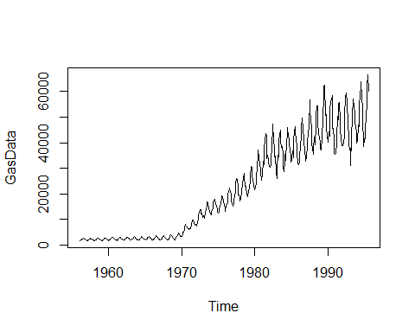

## Segmenting Time Series Data

Actual.GasData <- window(GasData, start = c(1970,1), frequency = 12)

## Decomposing Time Series

Actual.GasData.Decomp <- stl(Actual.GasData, s.window=7)  
autoplot(Actual.GasData.Decomp)

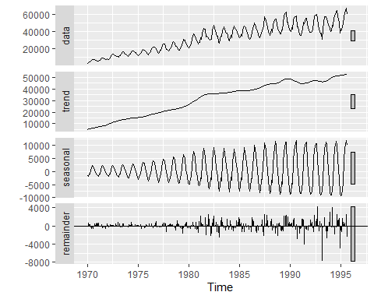

## Train and Test Data

Gas.Train.Data <- window(Actual.GasData, start = c(1970,1), end = c(1993,12), frequency = 12)  
Gas.Test.Data <- window(Actual.GasData, start = c(1994,1), frequency = 12)  
Gas.Train.Data

## Jan Feb Mar Apr May Jun Jul Aug Sep Oct Nov  
## 1970 3345 4220 4874 5064 5951 6774 7997 7523 7438 6879 6489  
## 1971 5919 6183 6594 6489 8040 9715 9714 9756 8595 7861 7753  
## 1972 7778 7402 8903 9742 11372 12741 13733 13691 12239 12502 11241  
## 1973 11569 10397 12493 11962 13974 14945 16805 16587 14225 14157 13016  
## 1974 11704 12275 13695 14082 16555 17339 17777 17592 16194 15336 14208  
## 1975 12354 12682 14141 14989 16159 18276 19157 18737 17109 17094 15418  
## 1976 13260 14990 15975 16770 19819 20983 22001 22337 20750 19969 17293  
## 1977 15117 16058 18137 18471 21398 23854 26025 25479 22804 19619 19627  
## 1978 17243 18284 20226 20903 23768 26323 28038 26776 22886 22813 22404  
## 1979 18839 18892 20823 22212 25076 26884 30611 30228 26762 25885 23328  
## 1980 21433 22369 24503 25905 30605 34984 37060 34502 31793 29275 28305  
## 1981 27730 27424 32684 31366 37459 41060 43558 42398 33827 34962 33480  
## 1982 30715 30400 31451 31306 40592 44133 47387 41310 37913 34355 34607  
## 1983 26138 30745 35018 34549 40980 42869 45022 40387 38180 38608 35308  
## 1984 28801 33034 35294 33181 40797 42355 46098 42430 41851 39331 37328  
## 1985 32494 33308 36805 34221 41020 44350 46173 44435 40943 39269 35901  
## 1986 31239 32261 34951 38109 43168 45547 49568 45387 41805 41281 36068  
## 1987 32791 34206 39128 40249 43519 46137 56709 52306 49397 45500 39857  
## 1988 35567 37696 42319 39137 47062 50610 54457 54435 48516 43225 42155  
## 1989 37541 37277 41778 41666 49616 57793 61884 62400 50820 51116 45731  
## 1990 40459 40295 44147 42697 52561 56572 56858 58363 45627 45622 41304  
## 1991 35592 35677 39864 41761 50380 49129 55066 55671 49058 44503 42145  
## 1992 38963 38690 39792 42545 50145 58164 59035 59408 55988 47321 42269  
## 1993 37059 37963 31043 41712 50366 56977 56807 54634 51367 48073 46251  
## Dec  
## 1970 6288  
## 1971 8154  
## 1972 10829  
## 1973 12253  
## 1974 13116  
## 1975 14312  
## 1976 16498  
## 1977 18488  
## 1978 19795  
## 1979 21930  
## 1980 25248  
## 1981 32445  
## 1982 28729  
## 1983 30234  
## 1984 34514  
## 1985 32142  
## 1986 34879  
## 1987 37958  
## 1988 39995  
## 1989 42528  
## 1990 36016  
## 1991 38698  
## 1992 39606  
## 1993 43736

Gas.Test.Data

## Jan Feb Mar Apr May Jun Jul Aug Sep Oct Nov  
## 1994 39975 40478 46895 46147 55011 57799 62450 63896 57784 53231 50354  
## 1995 41600 41471 46287 49013 56624 61739 66600 60054   
## Dec  
## 1994 38410  
## 1995

## Decompose Forecast

Gas.Dec<-stl(Gas.Train.Data, s.window=7)  
autoplot(Gas.Dec)

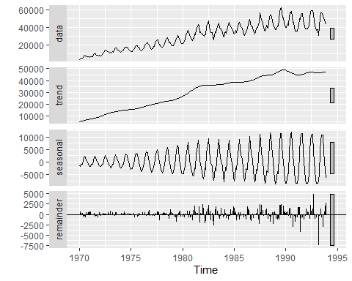

Gas.Dec.Forecast <- forecast(Gas.Dec, method="rwdrift", h=20)  
  
Vec <- cbind(Gas.Test.Data,Gas.Dec.Forecast$mean)  
ts.plot(Vec, col=c("blue", "red"), main="Actual vs Forecast")

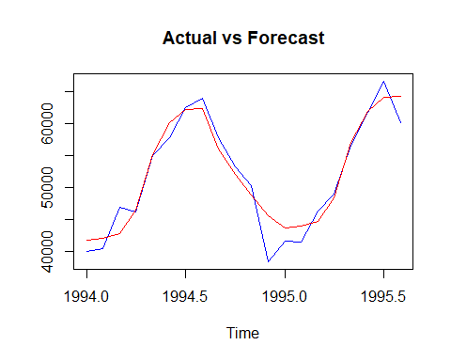

MAPE <- mean(abs(Vec[,1]-Vec[,2])/Vec[,1])  
MAPE

## [1] 0.03986951

accuracy(Gas.Dec.Forecast$mean,Gas.Test.Data)

## ME RMSE MAE MPE MAPE ACF1  
## Test set -384.4016 2520.108 1894.125 -1.154585 3.986951 -0.02962754  
## Theil's U  
## Test set 0.4818363

## Simple Moving Average SMA Forecast

SMA.Gas <- SMA(Actual.GasData, n=12)  
autoplot(SMA.Gas)

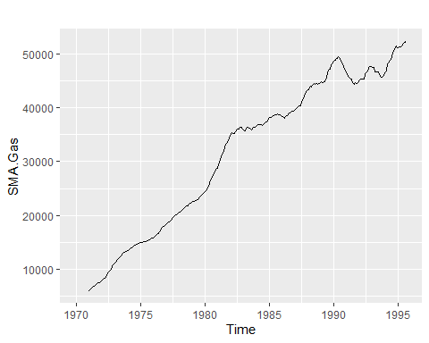

ts.plot(SMA.Gas,Actual.GasData, gpars = list(col = c("black", "red")))

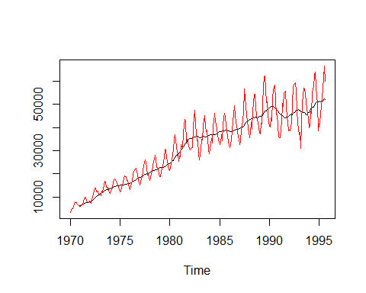

## Simple Exponential Smoothing SES Forecasr

SES.Gas <- ses(Gas.Train.Data, h = 20)   
SES.Gas

## Point Forecast Lo 80 Hi 80 Lo 95 Hi 95  
## Jan 1994 43736.25 39450.71 48021.79 37182.08 50290.42  
## Feb 1994 43736.25 37675.88 49796.62 34467.72 53004.78  
## Mar 1994 43736.25 36313.97 51158.53 32384.85 55087.65  
## Apr 1994 43736.25 35165.81 52306.69 30628.90 56843.61  
## May 1994 43736.25 34154.26 53318.25 29081.86 58390.65  
## Jun 1994 43736.25 33239.74 54232.76 27683.22 59789.28  
## Jul 1994 43736.25 32398.75 55073.75 26397.04 61075.47  
## Aug 1994 43736.25 31615.97 55856.53 25199.88 62272.62  
## Sep 1994 43736.25 30880.77 56591.73 24075.49 63397.01  
## Oct 1994 43736.25 30185.40 57287.10 23012.02 64460.49  
## Nov 1994 43736.25 29524.01 57948.49 22000.51 65471.99  
## Dec 1994 43736.25 28892.06 58580.44 21034.03 66438.48  
## Jan 1995 43736.25 28285.94 59186.56 20107.04 67365.46  
## Feb 1995 43736.25 27702.72 59769.79 19215.07 68257.43  
## Mar 1995 43736.25 27139.97 60332.53 18354.43 69118.07  
## Apr 1995 43736.25 26595.70 60876.81 17522.03 69950.47  
## May 1995 43736.25 26068.18 61404.33 16715.26 70757.24  
## Jun 1995 43736.25 25555.96 61916.54 15931.89 71540.61  
## Jul 1995 43736.25 25057.78 62414.72 15170.00 72302.50  
## Aug 1995 43736.25 24572.55 62899.95 14427.90 73044.60

autoplot(SES.Gas)

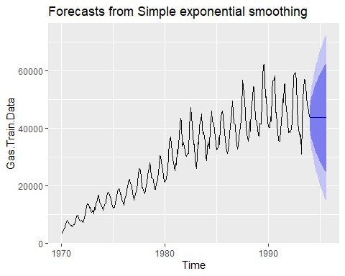

accuracy(SES.Gas,Gas.Test.Data)

## ME RMSE MAE MPE MAPE MASE  
## Training set 131.0317 3332.394 2416.021 0.1509165 8.113316 0.9164853  
## Test set 8054.6483 11842.644 9729.374 13.0684043 17.260680 3.6907077  
## ACF1 Theil's U  
## Training set 0.3030855 NA  
## Test set 0.7477934 1.962399

## Holts Winter Additive Model Forecast

HW.Gas <- ets(Gas.Train.Data, model = "AAA")  
autoplot(forecast(HW.Gas))

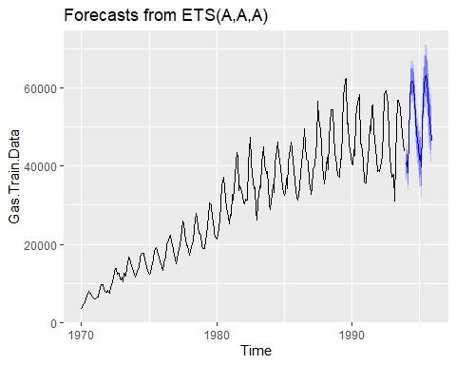

summary(HW.Gas)

## ETS(A,A,A)   
##   
## Call:  
## ets(y = Gas.Train.Data, model = "AAA")   
##   
## Smoothing parameters:  
## alpha = 0.3409   
## beta = 1e-04   
## gamma = 0.5937   
##   
## Initial states:  
## l = 6253.2029   
## b = 119.5505   
## s = -4511.743 -2141.073 234.0436 2010.202 5919.329 7284.466  
## 5272.425 2485.985 -2602.642 -3068.389 -5131.983 -5750.62  
##   
## sigma: 2109.357  
##   
## AIC AICc BIC   
## 6057.255 6059.521 6119.525   
##   
## Training set error measures:  
## ME RMSE MAE MPE MAPE MASE  
## Training set 78.6797 2049.926 1551.876 0.4622781 7.506005 0.5886835  
## ACF1  
## Training set 0.2737321

HW.Gas.Forecast <- forecast(HW.Gas, h = 20)  
accuracy(HW.Gas.Forecast, Gas.Test.Data)

## ME RMSE MAE MPE MAPE MASE  
## Training set 78.6797 2049.926 1551.876 0.4622781 7.506005 0.5886835  
## Test set 361.0051 3282.923 2304.836 0.4931982 4.666909 0.8743087  
## ACF1 Theil's U  
## Training set 0.2737321 NA  
## Test set -0.2141277 0.6904703

## Holts Winter Muultiplicative Model Forecast

HW.Gas.M <- ets(Gas.Train.Data, model = "MAM")  
autoplot(forecast(HW.Gas.M))

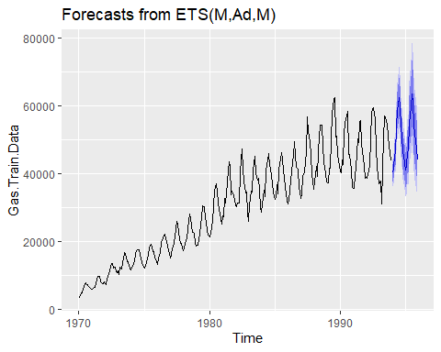

summary(HW.Gas.M)

## ETS(M,Ad,M)   
##   
## Call:  
## ets(y = Gas.Train.Data, model = "MAM")   
##   
## Smoothing parameters:  
## alpha = 0.4257   
## beta = 0.012   
## gamma = 1e-04   
## phi = 0.98   
##   
## Initial states:  
## l = 4869.9566   
## b = 273.5478   
## s = 0.8559 0.9265 1.0036 1.0655 1.1899 1.24  
## 1.1669 1.0767 0.9225 0.9092 0.8336 0.8096  
##   
## sigma: 0.0497  
##   
## AIC AICc BIC   
## 5772.061 5774.604 5837.995   
##   
## Training set error measures:  
## ME RMSE MAE MPE MAPE MASE  
## Training set 133.4324 1677.522 1108.64 0.2410877 3.609768 0.4205478  
## ACF1  
## Training set 0.05928632

HW.Gas.Forecast.M <- forecast(HW.Gas.M, h = 20)  
accuracy(HW.Gas.Forecast.M, Gas.Test.Data)

## ME RMSE MAE MPE MAPE MASE  
## Training set 133.4324 1677.522 1108.640 0.2410877 3.609768 0.4205478  
## Test set 837.7457 2261.822 1741.524 1.2199577 3.377535 0.6606240  
## ACF1 Theil's U  
## Training set 0.05928632 NA  
## Test set 0.07644203 0.3958095

## Stationarity Test

## H0 : Time series is not Stationary

## Ha : Time series is stationary

## Accoring to dickey fuller test since the p-value is highly significant we can

## reject the null hypothesis and confidently say that time series is stationary

adf.test(Actual.GasData)

## Warning in adf.test(Actual.GasData): p-value smaller than printed p-value

##   
## Augmented Dickey-Fuller Test  
##   
## data: Actual.GasData  
## Dickey-Fuller = -4.7629, Lag order = 6, p-value = 0.01  
## alternative hypothesis: stationary

## Autocorrrelations and Partial Autocorrelations

acf(Actual.GasData, lag.max = 90)

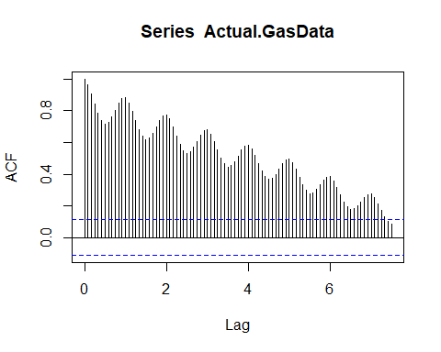

acf(Gas.Train.Data, lag.max = 90)

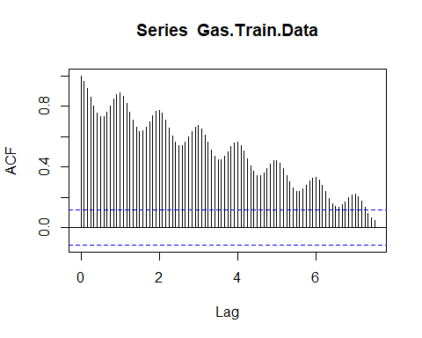

pacf(Gas.Train.Data, lag.max = 90)

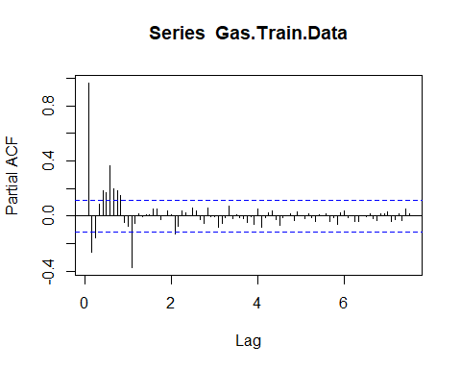

## Manual ARIMA Model

Gas.Arima <- arima(Gas.Train.Data, order = c(3,0,2))  
Gas.Arima

##   
## Call:  
## arima(x = Gas.Train.Data, order = c(3, 0, 2))  
##   
## Coefficients:  
## ar1 ar2 ar3 ma1 ma2 intercept  
## 2.7206 -2.6995 0.9782 -1.8324 0.9781 30587.29  
## s.e. 0.0116 0.0218 0.0113 0.0194 0.0200 15900.59  
##   
## sigma^2 estimated as 5158667: log likelihood = -2640.13, aic = 5294.26

hist(Gas.Arima$residuals, col = c("beige"))

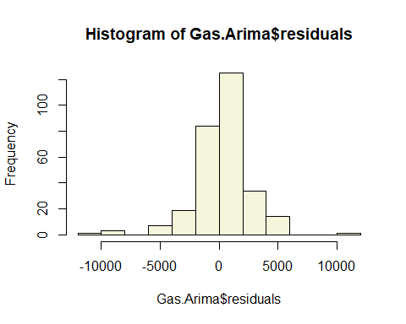

tsdisplay(residuals(Gas.Arima), lag.max=15, main='Model Residuals')

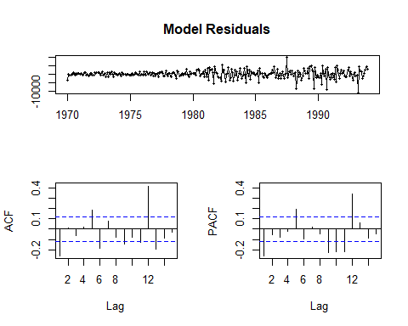

## H0: Residuals are independent

## Ha: Residuals are not independent

## Residuals are independent

Box.test(Gas.Arima$residuals)

##   
## Box-Pierce test  
##   
## data: Gas.Arima$residuals  
## X-squared = 18.784, df = 1, p-value = 1.464e-05

## Forecast using Manual ARIMA Model

Arima.Gas.Forecast <- forecast(Gas.Arima,h=20)  
Arima.Gas.Forecast

## Point Forecast Lo 80 Hi 80 Lo 95 Hi 95  
## Jan 1994 39761.95 36851.10 42672.81 35310.18 44213.72  
## Feb 1994 38437.77 34544.32 42331.22 32483.25 44392.29  
## Mar 1994 40041.05 35653.02 44429.09 33330.13 46751.97  
## Apr 1994 44089.95 39492.00 48687.91 37057.99 51121.92  
## May 1994 49481.99 44814.48 54149.50 42343.65 56620.33  
## Jun 1994 54790.02 50100.28 59479.76 47617.68 61962.36  
## Jul 1994 58636.14 53927.85 63344.42 51435.44 65836.84  
## Aug 1994 60045.68 55287.11 64804.25 52768.08 67323.29  
## Sep 1994 58690.49 53783.89 63597.10 51186.49 66194.50  
## Oct 1994 54960.98 49734.58 60187.37 46967.90 62954.06  
## Nov 1994 49851.64 44123.94 55579.33 41091.88 58611.39  
## Dec 1994 44693.24 38366.99 51019.50 35018.07 54368.41  
## Jan 1995 40803.51 33908.24 47698.78 30258.10 51348.92  
## Feb 1995 39147.93 31812.22 46483.64 27928.93 50366.93  
## Mar 1995 40097.86 32485.23 47710.48 28455.35 51740.36  
## Apr 1995 43346.34 35594.97 51097.71 31491.64 55201.04  
## May 1995 48000.28 40193.44 55807.12 36060.75 59939.81  
## Jun 1995 52821.82 44993.73 60649.90 40849.79 64793.84  
## Jul 1995 56553.87 48710.56 64397.19 44558.56 68549.19  
## Aug 1995 58244.33 50371.42 66117.24 46203.75 70284.90

autoplot(Arima.Gas.Forecast)

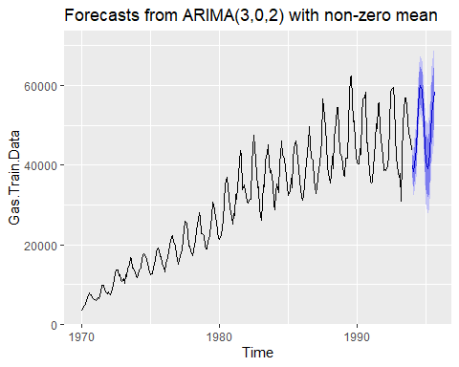

accuracy(Arima.Gas.Forecast,Gas.Test.Data)

## ME RMSE MAE MPE MAPE MASE  
## Training set 260.6018 2271.270 1562.571 0.5147922 5.438976 0.5927405  
## Test set 3166.0583 5012.426 4058.029 5.6038306 7.721536 1.5393591  
## ACF1 Theil's U  
## Training set -0.2553851 NA  
## Test set 0.5048427 0.9547869

## Auto ARIMA Model

Gas.Auto.Arima = auto.arima(Gas.Train.Data, seasonal = TRUE)  
hist(Gas.Auto.Arima$residuals)

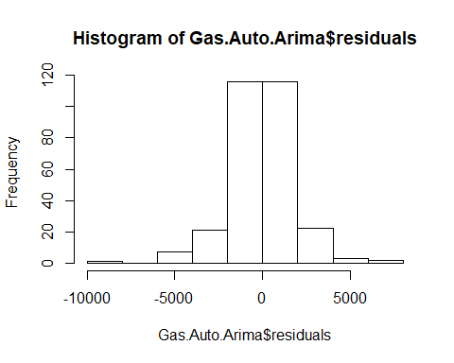

Gas.Auto.Arima

## Series: Gas.Train.Data   
## ARIMA(2,1,1)(0,1,2)[12]   
##   
## Coefficients:  
## ar1 ar2 ma1 sma1 sma2  
## 0.5017 0.2057 -0.9583 -0.4404 -0.1236  
## s.e. 0.0738 0.0722 0.0426 0.0676 0.0639  
##   
## sigma^2 estimated as 3535010: log likelihood=-2463.67  
## AIC=4939.33 AICc=4939.64 BIC=4961.03

## Forecast Auto ARIMA Model

Gas.Forecast.AArima <- forecast(Gas.Auto.Arima, h = 20)  
autoplot(Gas.Forecast.AArima)

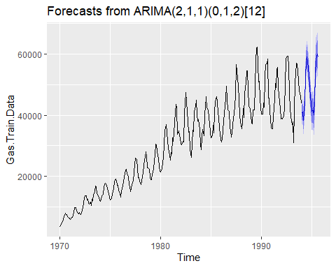

accuracy(Gas.Forecast.AArima,Gas.Test.Data)

## ME RMSE MAE MPE MAPE MASE  
## Training set -79.06125 1820.459 1260.153 -0.4954352 4.077759 0.4780222  
## Test set 2637.01567 4082.543 3318.157 4.6201750 6.370687 1.2586983  
## ACF1 Theil's U  
## Training set -0.005838212 NA  
## Test set 0.034941965 0.7936968