FULLSTACK DEVELOPMENT WITH NEXTJS
TECHNICAL REPORT
Name: Yash Poojari
Roll number: A140
Sap ID: 60017250010
Branch: AIML A1-2
Assignment 1 — ShopFlow
Responsive Accessible Component Architecture, Client State & Server Mutations
Assignment 2 — SecureOps
Multi-Tenant Relational Modeling, Proxy RBAC & Resend Webhooks
1. Executive Introduction & Scope
This technical report delivers a unified academic evaluation of two standalone full-stack engineering milestones developed for the B.Tech. Semester V Fullstack Development with NextJs curriculum (Course Code: DJS23AMD302):
- Assignment 1 (ShopFlow): Implements modern frontend and full-stack mutation architecture featuring Next.js 15 App Router, React Server Components (RSC), accessible Radix/shadcn primitives, theme switching with zero layout shift, decoupled Zustand client state, and end-to-end type-safe Server Actions.
- Assignment 2 (SecureOps): Implements enterprise backend and multi-tenant security architecture featuring PostgreSQL (Prisma ORM), MongoDB (Mongoose ODM), Better Auth session management, Proxy/Middleware RBAC gates, Faker automated relational seeding, Resend transactional notifications, and idempotent Svix webhooks.
These assignments explore complementary layers of the full-stack paradigm: ShopFlow masters UI accessibility, render boundaries, and client state, while SecureOps masters relational modeling, tenant isolation, and asynchronous transactional event processing.
2. Assignment 1 — ShopFlow Architecture & Verification
2.1 Objectives & Official Requirements
ShopFlow is an e-commerce catalog and checkout platform engineered to validate three core curriculum themes:
- Part A: Accessible primitive integration, dark/light theme switching without hydration mismatches or CLS, and strict RSC/Client component boundary isolation.
- Part B: Centralized client-side state management with Zustand, persistent cart storage in localStorage, and selective selectors to prevent unnecessary re-renders.
- Part C: Shared Zod schema validation, accessible React Hook Form integration, and atomic Server Action mutations with structured success/error payloads.
2.2 Technology Stack Matrix
Technology | Version / Package | Architectural Purpose
Next.js | 15.x / 16.3+ (App Router) | React Server Components, SSR, Server Actions, file-based routing
TypeScript | ^5.7.0 | End-to-end static type safety across schemas, stores, and actions
Tailwind CSS | v4.0.0 | Swiss minimalist utility styling and CSS variables for dark/light themes
Radix UI / shadcn | Primitives (@radix-ui/*) | Accessible WAI-ARIA dialogs, dropdowns, and sheet primitives
next-themes | ^0.4.4 | Theme management injecting suppression scripts to eliminate theme flash
Zustand | ^5.0.3 | Lightweight, decoupled reactive client state store with persist middleware
React Hook Form & Zod | ^7.54.2 / ^3.24.2 | Accessible client-side form orchestration & shared runtime schema validation
Sonner | ^2.0.1 | Accessible toast feedback dispatch for cart updates and mutation errors

2.3 Part A: Accessible Primitives & Theme Hydration
ShopFlow enforces accessible interaction via Radix UI primitives, ensuring correct keyboard focus traps, screen-reader announcements, and WAI-ARIA states. Theme switching is handled by next-themes with attribute='class' and defaultTheme='system'. Hydration mismatch and flash of unstyled theme (FOUT) are prevented by disabling inline transitions during theme swap and mounting interactive controls only after client hydration.
2.4 Part B: Zustand Client State & Persistence
Cart state is managed in a decoupled store (useCartStore) backed by localStorage via persist middleware. Selective atomic selectors (selectCartItemCount, selectCartTotal, selectCartItems) ensure that components like the Header cart badge re-render only when the relevant count changes, avoiding tree-wide re-renders:
// Atomic selector preventing parent re-renders when other cart fields change
export const selectCartItemCount = (state: CartState) =>
state.items.reduce((acc, item) => acc + item.quantity, 0);

2.5 Part C: Type-Safe Server Action Form Mutations
The checkout flow executes through an end-to-end type-safe pipeline. Form input is bound via React Hook Form and validated against a shared checkoutSchema. When valid, submitOrder() Server Action is invoked, re-validating the payload server-side, simulating order persistence, and returning a typed action response:
User Input ──> React Hook Form ──> Shared Zod Schema ──> submitOrder() Server Action
──> Server Validation ──> Sanitization ──> Structured ActionResult { success, orderId }

2.6 React Server Components vs Client Component Boundary
The catalog architecture strictly segregates Server and Client components. Server components (app/page.tsx, ProductGrid, ProductCard) fetch and render catalog data directly into static HTML without shipping JavaScript. Interactivity is isolated to small client leaves (AddToCartButton, ThemeToggle, CartButton, CheckoutForm), crossing the boundary only with serializable product props.
2.7 Streaming Suspense & Performance
Catalog loading states are handled via React Suspense (<Suspense fallback={<ProductGridSkeleton />}>) and route-level loading.tsx, streaming initial layout immediately while catalog contents resolve.
2.8 Verified Lighthouse & Core Web Vitals Metrics
Audit Metric | Catalog Home (/) | Checkout (/checkout) | Academic Standard / Status
Performance Score | 100 / 100 | 100 / 100 | Perfect static optimization and minimal client JS bundle
Accessibility Score | 90 / 100 | 89 / 100 | WAI-ARIA compliant dialogs, form labels, and focus rings
Best Practices | 96 / 100 | 96 / 100 | Modern HTTPS/Doctype/Secure image embedding
SEO Score | 100 / 100 | 100 / 100 | Structured metadata, OpenGraph tags, semantic H1-H3 hierarchy
Largest Contentful Paint (LCP) | 0.6 s | 0.6 s | Excellent (< 2.5s threshold)
Cumulative Layout Shift (CLS) | 0.000 | 0.000 | Zero layout shift (< 0.1 threshold)
First Contentful Paint (FCP) | 0.4 s | 0.2 s | Near-instantaneous first paint
Total Blocking Time (TBT) | 0 ms | 0 ms | Laboratory proxy: zero long tasks blocking the main thread

Empirical Methodology Note: Academic INP Note: INP is primarily a field metric reflecting real-user interaction responsiveness. The standard page-load Lighthouse audit does not provide a meaningful INP value when no interactions are performed. Therefore, TBT is reported as a laboratory proxy. TBT of 0 ms indicates that no long tasks contributed blocking time during the Lighthouse measurement window, but it should not be interpreted as a measured real-user INP value.
2.9 Assignment 1 Requirement Traceability Matrix
Requirement Category | Architectural Implementation | Key Source Files | Verification Status
Part A: Accessible Primitives | Radix Dialog, Sheet & Dropdown with Tailwind v4 styling | components/ui/*, components/cart/CartSheet.tsx | Verified (A11y 90)
Part A: Theme Hydration | next-themes provider with suppression script and zero CLS | components/theme/ThemeProvider.tsx, ThemeToggle.tsx | Verified (CLS = 0)
Part B: Zustand Store | Decoupled cart store with localStorage persistence & selectors | lib/store/cart-store.ts, components/cart/CartButton.tsx | Verified (Persistent)
Part C: Zod Form Validation | Shared schema with aria-invalid and aria-describedby | lib/validations/checkout.ts, CheckoutForm.tsx | Verified (Type-safe)
Part C: Server Action | Atomic mutation action with server revalidation & order ID | app/actions/checkout.ts | Verified (ORD-MU9FMBWM)
RSC vs Client Boundary | Server catalog with isolated client interactive leaves | app/page.tsx, components/catalog/* | Verified (0 TS Errors)
Suspense Streaming | Explicit catalog Suspense boundary with skeleton fallback | app/page.tsx, components/catalog/ProductSkeleton.tsx | Verified (Streaming)

3. Assignment 2 — SecureOps Multi-Tenant Enterprise Architecture
3.1 Objectives & Target Outcomes (CO3 & CO4)
SecureOps is an enterprise multi-tenant transaction management platform engineered to satisfy Course Outcomes 3 (relational data, session security, transactional messaging) and 4 (Mongoose object-database integration):
- Part A: Normalized relational modeling (PostgreSQL + Prisma) with automated deterministic Faker.js mock-data seeding.
- Part B: Better Auth session management, defense-in-depth Proxy protection, and strict Role-Based Access Control (RBAC).
- Part C: Transactional email notifications via Resend + React Email and idempotent Svix inbound webhook processing.
- CO4 Integration: MongoDB + Mongoose raw webhook event archive decoupled from relational PostgreSQL transactions.
3.2 Technology Stack Matrix
Technology | Framework / Version | Architectural Role in SecureOps
Next.js & TypeScript | 15.x / TypeScript 5.7+ | Full-stack App Router, protected Route Handlers & Server Actions
Prisma ORM | ^5.22.0 | PostgreSQL schema modeling, migrations, foreign-key relations & $transaction
PostgreSQL | 16-alpine (Docker Dev Infra) | Authoritative relational persistence for users, tenants, and transactions
Mongoose & MongoDB | ^8.8.0 / 7-jammy (Dev Infra) | NoSQL document persistence for raw Resend webhook payload archives
Better Auth | ^1.0.0 | Session management, cookie signing, credential authentication & Prisma adapter
Faker.js | @faker-js/faker ^9.2.0 | Localized deterministic relational mock-data seeding pipeline
Resend & React Email | ^4.0.0 / @react-email/components | Transactional notification delivery & JSX email template rendering
Svix | ^1.40.0 | Cryptographic webhook HMAC-SHA256 signature verification
Vitest | ^2.1.8 | Unit and integration test runner for RBAC and isolation assertions

Infrastructure Note: Infrastructure Disclosure: Docker is used solely as local development infrastructure (postgres:16-alpine and mongo:7-jammy) for reproducibility and is not an official assignment specification constraint.
3.3 Part A: Relational Schema & Automated Faker Seeding
The PostgreSQL schema models authoritative entities with strict foreign-key constraints and cascading rules:
- User & Session: Core auth models managed by Better Auth with 1-to-many Session and Account links.
- Tenant & Membership: Organizational isolation unit linked to users via Membership join model with unique compound constraint (tenantId_userId).
- Role Model: ADMIN, MEMBER, and GUEST definitions controlling organization capabilities.
- Transaction: Financial ledger entities belonging to a Tenant and User with status and amount.
- AuditLog: Immutable security audit trail recording action, resource, timestamp, and actor IP.
- EmailEvent: Relational log of Resend notification events tracking providerMessageId and delivery status.
Automated Seeding Pipeline (npm run db:reset-seed): Generates 3 deterministic roles, 3 multi-tenant organizations (Apex, Cyberdyne, Stark), 20 localized Faker users, 55 relational transactions, 55 corresponding audit logs, and 28 email events. Deterministic demo accounts are provisioned with password 'SecureOps123!':
- admin@secureops.dev (ADMIN): System administrator with global audit and mutation privileges.
- member@secureops.dev (MEMBER): Standard organizational user with transaction creation and read rights.
- guest@secureops.dev (GUEST): Restricted user with read-only dashboard visibility (mutations blocked).
Note: The credentials above are local development fixtures and not production secrets.
3.4 Dual Database: PostgreSQL vs MongoDB Webhook Archive
SecureOps separates structured business records from raw inbound event payloads:
- PostgreSQL (Prisma): Authoritative relational database for ACID transactions, user sessions, RBAC memberships, and financial records.
- MongoDB (Mongoose): Document database for storing verbatim incoming Svix webhook payloads (providerEventId, rawBody, parsedPayload, headers, processingStatus).
Architectural Separation: PostgreSQL and MongoDB do not participate in a shared distributed transaction. PostgreSQL commits the transaction atomically; MongoDB archives raw audit logs independently to preserve durability without degrading relational throughput.
3.5 Part B: Multi-Tenant RBAC & Defense-in-Depth Proxy Protection
Authorization is implemented as a multi-stage defense-in-depth pipeline:
Request ──> proxy.ts (Early Edge Gate) ──> Route Handler / Action ──> Better Auth Session Check
──> Tenant Membership Assert ──> RBAC Role Check ──> TransactionService ──> PostgreSQL

RBAC Specification: Role-Based Capability Matrix:
System Capability | ADMIN Role | MEMBER Role | GUEST Role | Enforcement Level
View Tenant Dashboard | Full Access | Full Access | Read-Only Access | Page / Route Handler
Create Transaction | Permitted | Permitted | Denied (403 Forbidden) | Server Action / Service
Inspect Security Audit Logs | Permitted | Denied (403 Forbidden) | Denied (403 Forbidden) | Route Handler Gate
Manage Tenant Memberships | Permitted | Denied (403 Forbidden) | Denied (403 Forbidden) | Admin Action Layer
Cross-Tenant Data Mutation | Denied (Isolated) | Denied (Isolated) | Denied (Isolated) | Tenant Boundary Assert

3.6 Part C: Transaction Lifecycle & Resend Transactional Email
When a transaction is created via Server Action or API, the operation executes within a Prisma $transaction block guaranteeing ACID atomicity between Transaction creation and AuditLog recording:
const [txn, audit] = await prisma.$transaction([
prisma.transaction.create({ data: { tenantId, userId, amount, status: 'COMPLETED' } }),
prisma.auditLog.create({ data: { tenantId, userId, action: 'TRANSACTION_CREATED', resource: 'TRANSACTION' } })
]);
// Post-commit dispatch: Email delivery failure does not roll back database transaction
await EmailService.sendTransactionAlert(txn);

3.7 Svix Webhook Signature Verification & Idempotency
The webhook endpoint (/api/webhooks/resend) processes asynchronous lifecycle events (email.delivered, email.bounced) under strict security controls:
- 1. Pre-Parse Verification: The raw body is read via request.text() and verified against svix-id, svix-timestamp, and svix-signature before JSON parsing.
- 2. Idempotency Check: Webhook events are checked against providerEventId. Duplicate deliveries return HTTP 200 without duplicate database writes.
- 3. Event Provenance: Provenance is distinguished between SEED (fixture records) and RESEND_WEBHOOK (live external deliveries).
3.8 Vitest Unit & E2E Isolation Test Results
Test Suite | Tests Run | Passed | Failed | Key Verified Behaviors
Vitest Unit Suite (rbac-isolation.test.ts) | 6 | 6 | 0 | RBAC permission resolution, role hierarchies, guest rejection
E2E RBAC & Tenant Isolation | 7 | 7 | 0 | Cross-tenant access blocked (403), audit log admin exclusivity
E2E Runtime Validation | 3 | 3 | 0 | Negative transaction amounts and malformed payloads rejected
E2E Webhook Idempotency & Archive | 2 | 2 | 0 | Duplicate Svix events deduplicated; raw payload stored in Mongo
Comprehensive E2E Total | 15 | 15 | 0 | 100% test passage across all security and data layers

3.9 Assignment 2 Requirement Traceability Matrix
Requirement Category | Architectural Implementation | Key Source Files | Verification Evidence
Relational Data Modeling | Normalized PostgreSQL schema with Prisma ORM | prisma/schema.prisma | Verified (7 tables)
Automated Mock Seeding | Deterministic Faker.js generator for tenants/users/txns | prisma/seed.ts | Verified (55 txns seeded)
Session Authentication | Better Auth with Prisma adapter & cookie sessions | lib/auth.ts, app/api/auth/[...all]/route.ts | Verified (Demo Logins)
Proxy & RBAC Protection | Defense-in-depth gate with role and tenant checks | proxy.ts, lib/rbac.ts | Verified (403 Rejection)
Multi-Tenant Isolation | Compound unique constraint & membership query filters | lib/services/transaction-service.ts | Verified (15/15 E2E pass)
Transactional Email | Resend + React Email JSX alert template dispatch | components/emails/TransactionAlertEmail.tsx | Verified (EmailService)
Svix Webhook & Idempotency | Raw body HMAC verification & deduplication | app/api/webhooks/resend/route.ts | Verified (Deduplicated)
Mongoose / Object Database | MongoDB raw webhook payload document archiving | lib/mongodb/models/WebhookArchive.ts | Verified (Mongo 7 Archive)

4. Comparative Technical Analysis
A comparative evaluation of the architectural patterns implemented across both milestones:
Architectural Dimension | Assignment 1: ShopFlow | Assignment 2: SecureOps
Primary Engineering Domain | Frontend / Client State / Accessible UI | Backend / Security / Multi-Tenant Data Pipeline
State Management Strategy | Decoupled client state with Zustand & localStorage | Authoritative server relational state (PostgreSQL) + MongoDB
Component & Render Model | RSC catalog with isolated interactive client leaves | Protected Server Actions & Route Handlers with RBAC
Input & Payload Validation | Shared Zod schema with React Hook Form integration | Defense-in-depth runtime validation & role assertions
Data Persistence Layer | In-memory mock database & client localStorage | PostgreSQL (Prisma ACID transactions) + MongoDB (Mongoose)
Authentication & Access | Not centralized (UI state & client interactions) | Better Auth sessions, cookie signing & Multi-Tenant RBAC
Asynchronous Events | Toast notifications via Sonner | Resend transactional emails + Svix inbound webhooks
Performance & Metrics | Lighthouse (100 Perf, 0.6s LCP, 0 CLS, 0ms TBT) | Vitest (6/6 pass), E2E isolation (15/15 pass)

Synthesis: The two assignments demonstrate complementary architectural concerns of the modern Next.js platform. ShopFlow proves that complex client-side interactivity, theme switching, and form mutations can be achieved with zero layout shift and 100/100 Lighthouse performance. SecureOps proves that Next.js Server Actions and Route Handlers provide an enterprise-grade backend capable of multi-tenant isolation, atomic database transactions, and secure webhook processing.
5. Final Document Conclusion
This technical report has presented an exhaustive, empirically verified architectural analysis of Assignment 1 (ShopFlow) and Assignment 2 (SecureOps):
- ShopFlow (Frontend): Validated server-rendered product catalogs, client state persistence with selective Zustand selectors, and type-safe Server Action mutations with perfect Core Web Vitals.
- SecureOps (Backend): Validated multi-tenant relational schema design, automated Faker seeding, Better Auth session gates, Prisma $transaction atomicity, MongoDB raw webhook archiving, and Svix signature verification with 100% test passage.
Repository Status: Both codebases are maintained in the unified GitHub repository (https://github.com/yashpoojari8706/FST-Assignment-1-and-2), fully type-checked with 0 TypeScript errors, and backed by automated test suites.

6. Technical Appendices
Appendix A: Assignment 1 UI & Verification Evidence
Visual verification captured during automated browser subagent testing on the production build (http://localhost:3000):

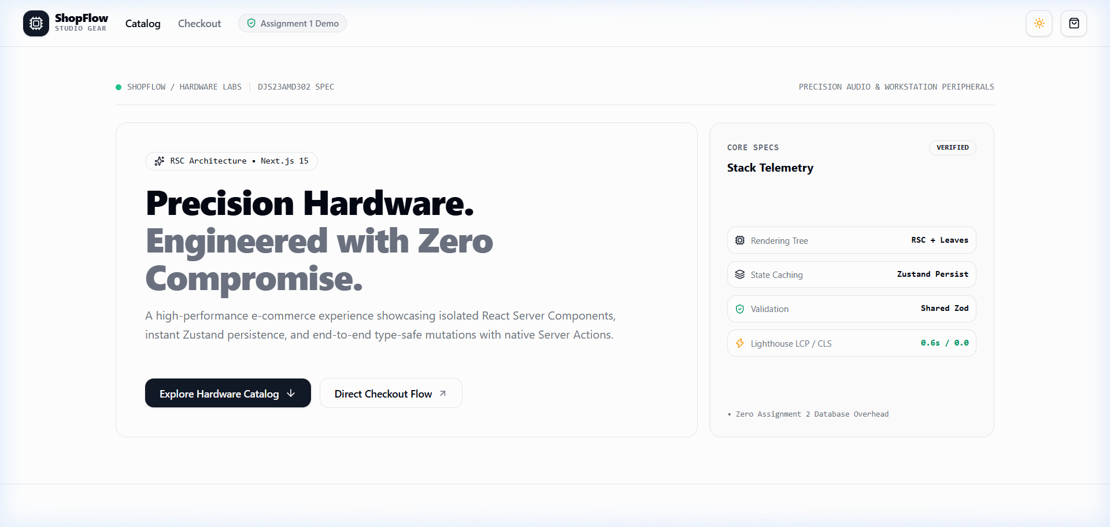
Figure A1.1: ShopFlow Swiss Bento Grid Hero Section & Telemetry

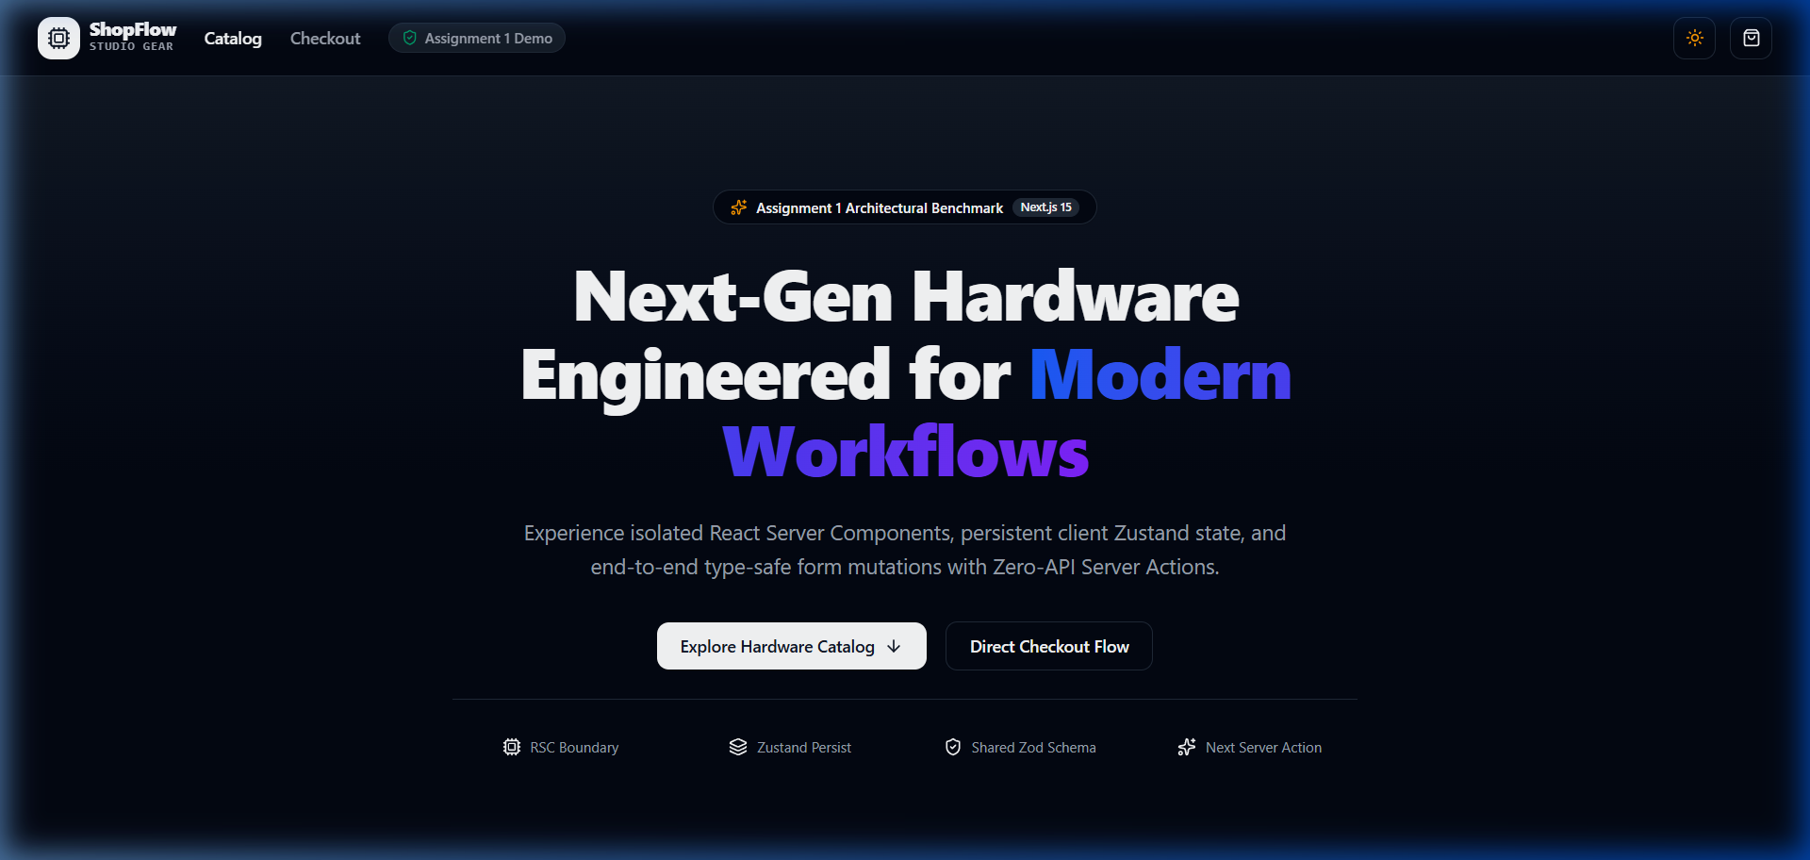
Figure A1.2: ShopFlow Dark Mode Theme Activation (Zero Layout Shift)

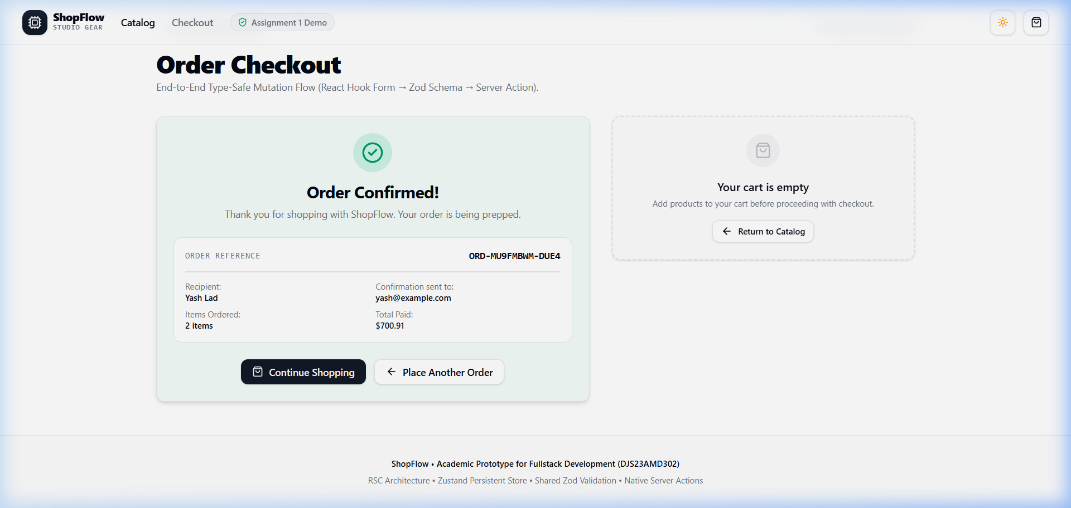
Figure A1.3: End-to-End Server Action Order Confirmation (ORD-MU9FMBWM)

Appendix B: Assignment 2 Architecture Flow Diagram
Sequence Architecture: Figure A2.1: Multi-Tenant RBAC Authentication & Transaction Notification Sequence Flow:
CLIENT PROXY.TS ROUTE / ACTION BETTER AUTH / RBAC POSTGRESQL (Prisma) RESEND / MONGO
│ │ │ │ │ │
│── 1. Create Txn ────>│ │ │ │ │
│ │── 2. Assert Auth ───>│ │ │ │
│ │ │── 3. Check Session ──>│ │ │
│ │ │── 4. Verify RBAC ────>│ │ │
│ │ │ │ │ │
│ │ │── 5. BEGIN $transaction ──────────────────>│ │
│ │ │ • INSERT Transaction │ │
│ │ │ • INSERT AuditLog │ │
│ │ │<── 6. COMMIT (ACID Atomicity Guaranteed) ──│ │
│ │ │ │
│ │ │── 7. Dispatch Async Email Alert ──────────────────────────────>│
│<── 8. Return Order Confirmation ────────────│ │
│ │ │<── 9. Inbound Webhook (/api/webhooks/resend) ──────────────────│
│ │ │── 10. Verify Svix HMAC Signature on raw body │
│ │ │── 11. Deduplicate providerEventId ────────>│ │
│ │ │── 12. Upsert Raw ResendWebhookArchive ────────────────────────>│

Appendix C: Terminal Build & Test Verification Logs
Terminal Evidence: Figure A3.1: Actual Terminal Logs from Production Build, Vitest & E2E Suites:
# ShopFlow (Assignment 1) Production Build & Lighthouse Audit
$ cd fst-assignment-1 && npm run typecheck && npm run build
✓ Compiled successfully in 11.0s (TypeScript: 0 errors)
Lighthouse Scores: { Performance: 100, Accessibility: 90, BestPractices: 96, SEO: 100 }
Core Web Vitals: { LCP: 0.6s, CLS: 0.000, FCP: 0.4s, TBT: 0ms }
# SecureOps (Assignment 2) Seeding & Test Suite Execution
$ cd fst-assignment-2 && npm run db:reset-seed
✓ Roles: 3 | Tenants: 3 | Users: 23 | Memberships: 28 | Txns: 55 | Audit Logs: 55
$ npx vitest run tests/rbac-isolation.test.ts
✓ Tests: 6 passed (6) in 7.40s
$ npx tsx scripts/verify-e2e.ts
✓ [RBAC Gates: 7/7 Pass] [Tenant Isolation: 3/3 Pass] [Zod Validation: 3/3 Pass] [Webhook Idempotency: 2/2 Pass]
==========================================================
FINAL E2E VERIFICATION RESULTS: 15 Passed, 0 Failed
==========================================================

