Institute of Computer Technology

B. Tech Computer Science and Engineering

Subject: BOSS (2CSE204)

**PRACTICAL-1**

**Objective:** To learn about accessing the Command Line in Linux

**Commands:**

**date –** To show the current date and time of the local system.

**file –** To check the type of file.

**cat –** To show the content of file in the terminal in Linux.

**less –** To show the content of file in the terminal in Linux with scrolling facilities by navigation keys.

**head –** To show the first 10 lines of any file in terminal in Linux.

**passwd –** To change the current password of the current user in Linux.

**tail –** To show the last 10 lines of any file in terminal in Linux.

**wc –** To display the size of file in terminal in Linux.

**Exercise: -**

**Jihan wants to perform following operations in terminal window using CLI. Kindly implement a appropriate commands for the given scenarios.**

**1. He wants to display the current time and date on terminal window.**

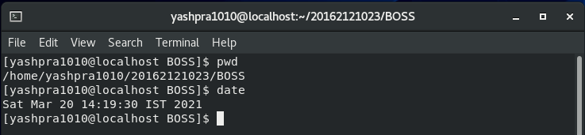

**2. Display the current time in 12-hour clock time (for example, 11:42:11 AM). Hint: The format string that displays that output is %r.**

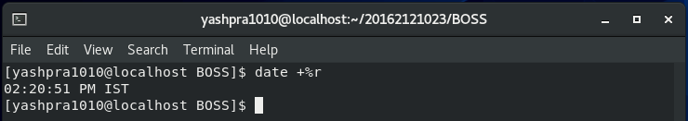

**3. zcat is available file in system. Jihan wants to check that What kind of file is /home/student/zcat? Is it readable by humans? How will he check?**

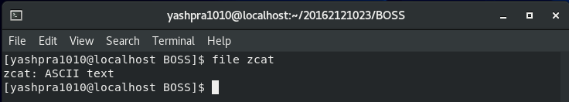

**4. He wants to display the size of zcat on terminal.**

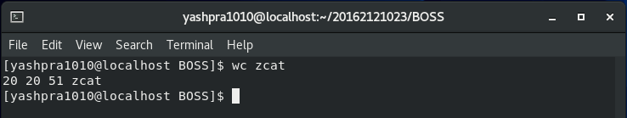

**5. He wants to display the first 10 lines of zcat.**

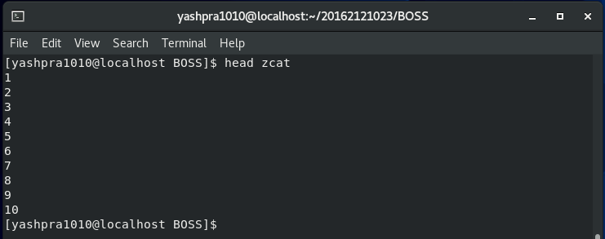

**6. He wants to display the last 10 lines of the zcat file.**

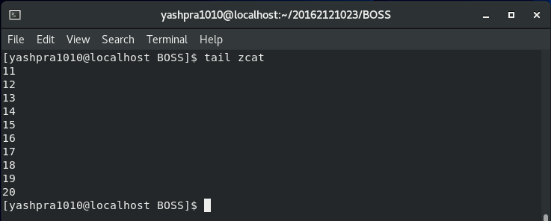

**7. Jihan wants to repeat the previous command using keystrokes.**

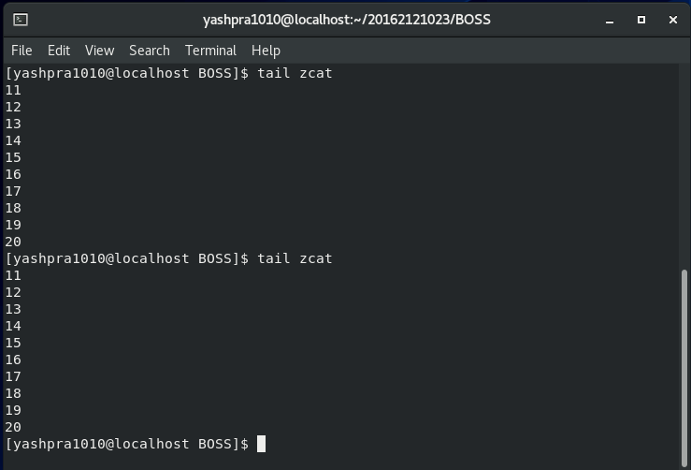

**8. Now, He needs to display the last 20 lines in the file. Use command-line editing to accomplish this with a minimal number of keystrokes.**

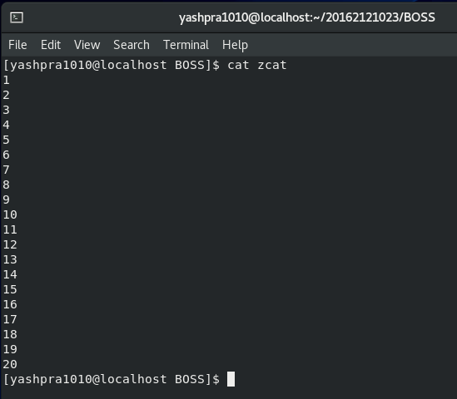

**9. He wants to run date +%r command again through shell history.**

