Institute of Computer Technology

B. Tech Computer Science and Engineering

Subject: BOSS (2CSE204)

**PRACTICAL-10**

**AIM: - To learn about managing network in linux.**

**Commands:**

* **nmcli –** This command is used for controlling network manager.
* **hostnamectl –** It is used for the administration of separate hosts on single system.

**Exercise:**

**1. Creare new user Student. Set password “student123”.**

***SOLUTION***

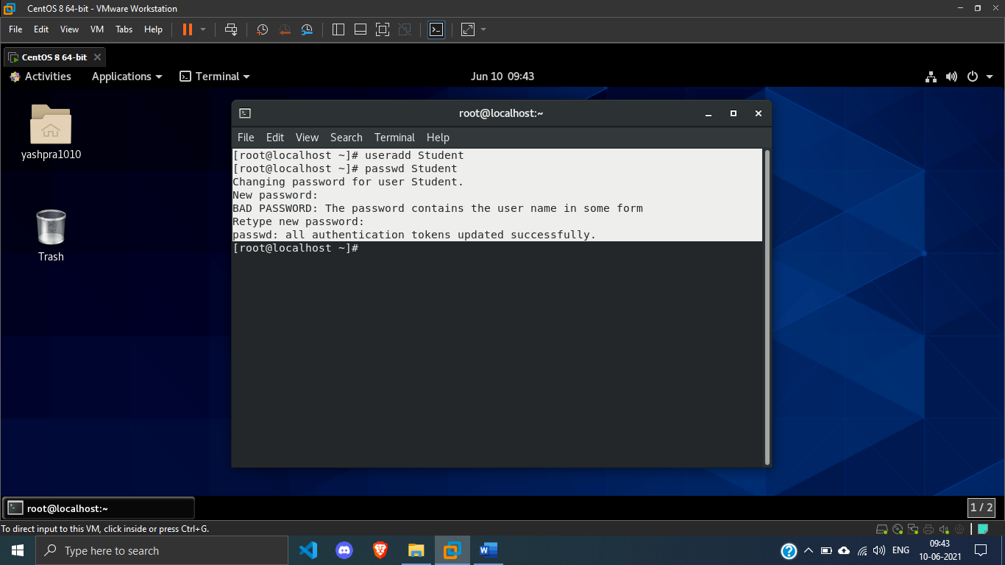

**2. Use the ssh command to log in to localhost as the Student user.**

***SOLUTION***

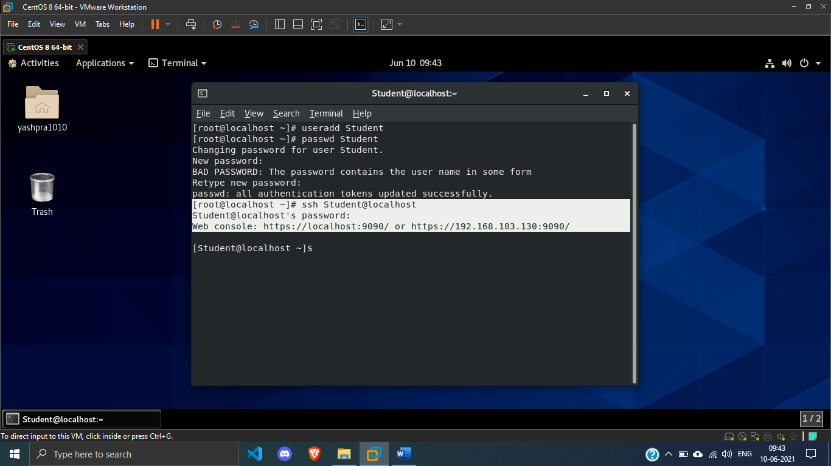

**3. Switch to the root user.**

***SOLUTION***

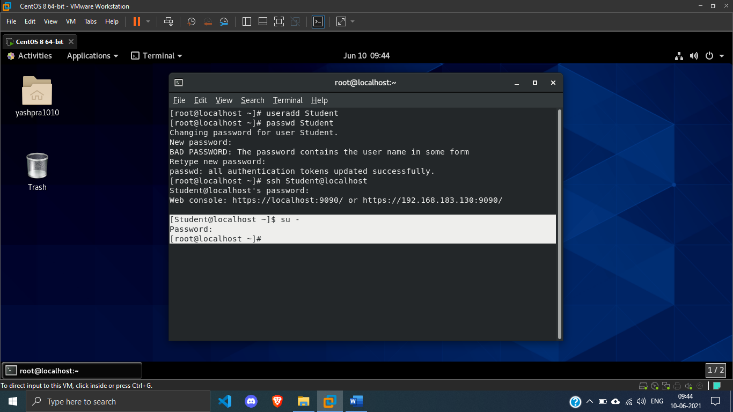

**4. Create a new connection with a static network connection using the settings in the table.**



***SOLUTION***

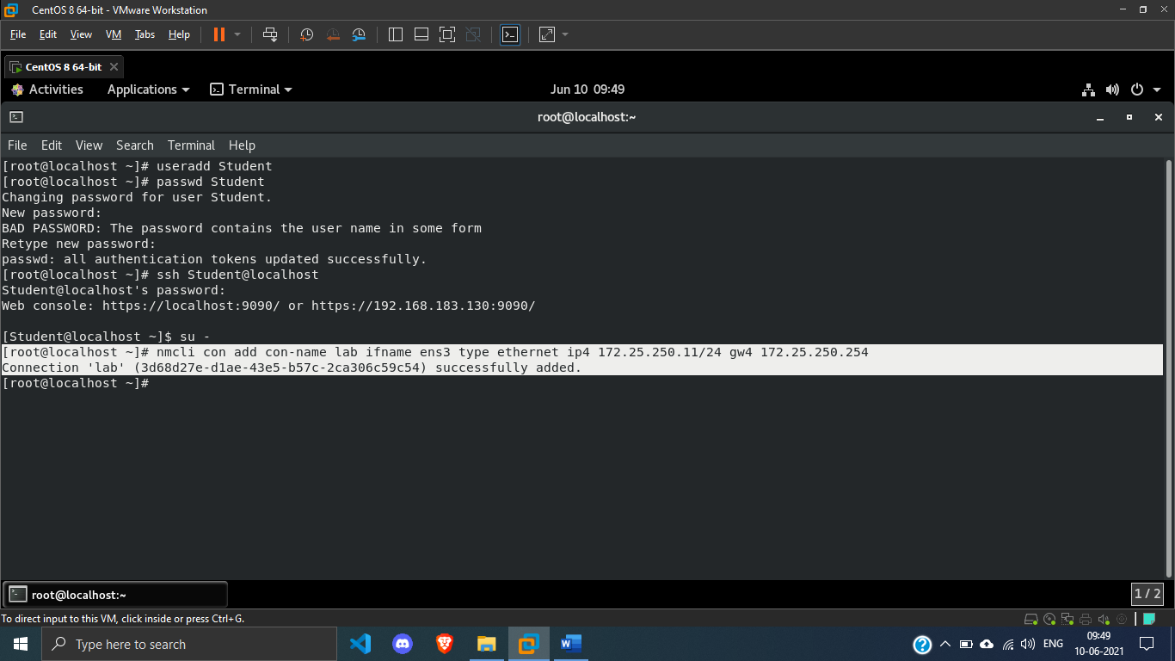

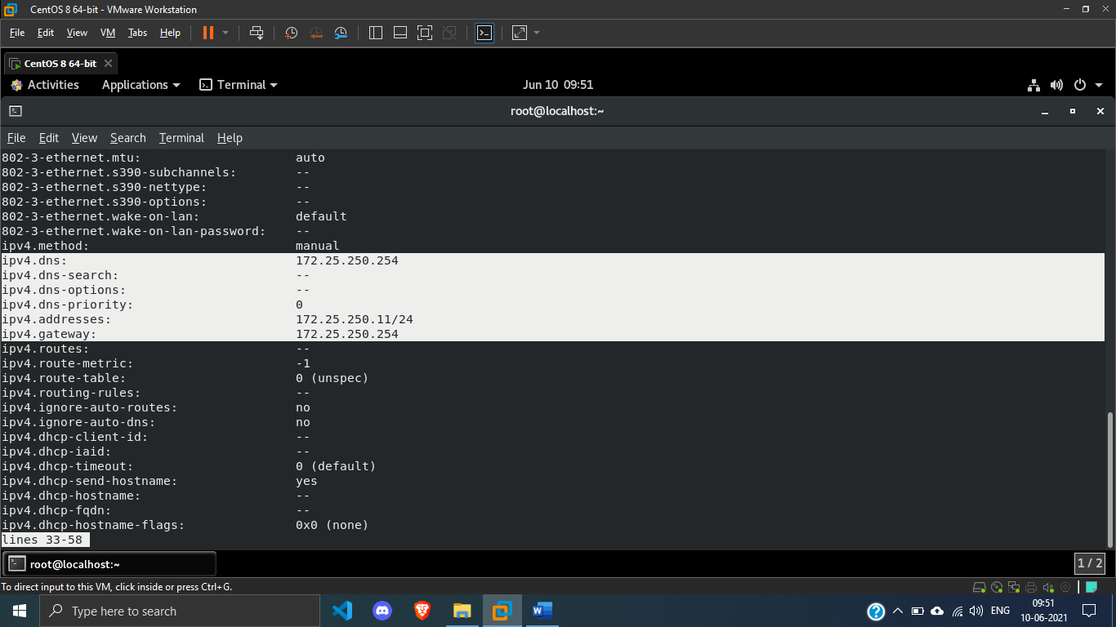

**5. Configure the new connection to be autostarted. Other connections should not start automatically.**

***SOLUTION***

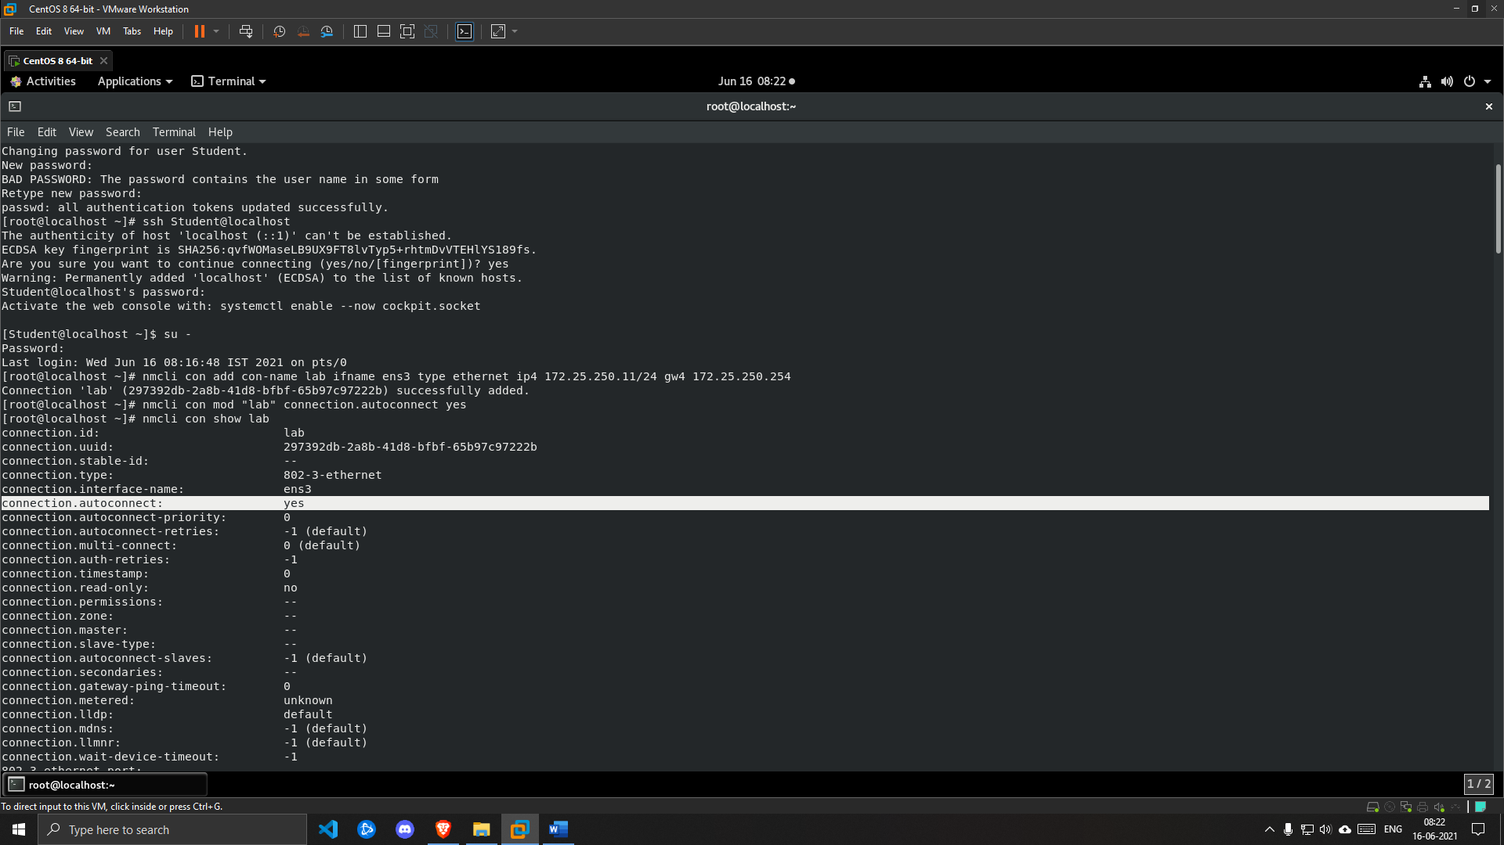

**6. Modify the new connection so that it also uses the address 10.0.1.1/24.**

***SOLUTION***

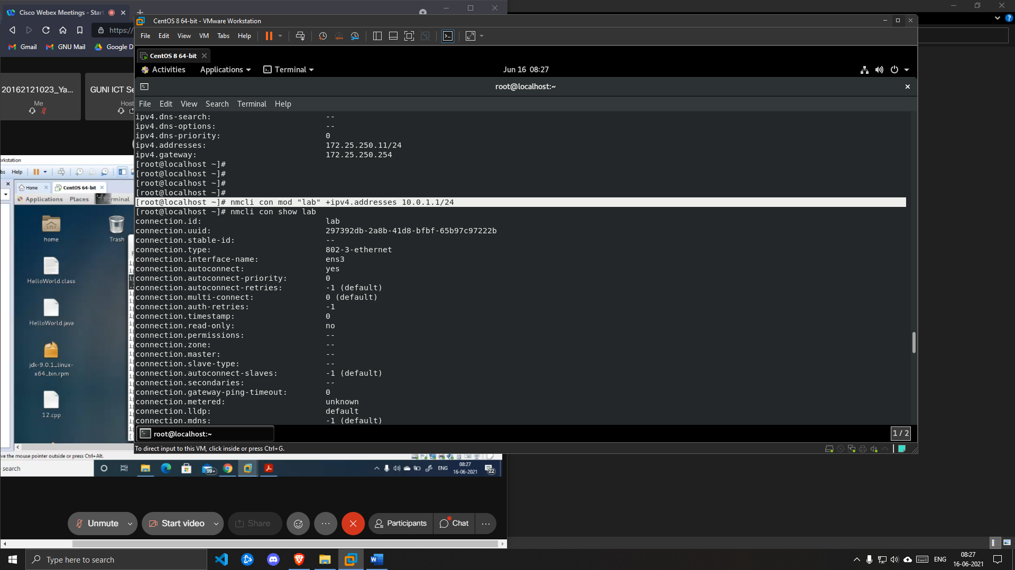

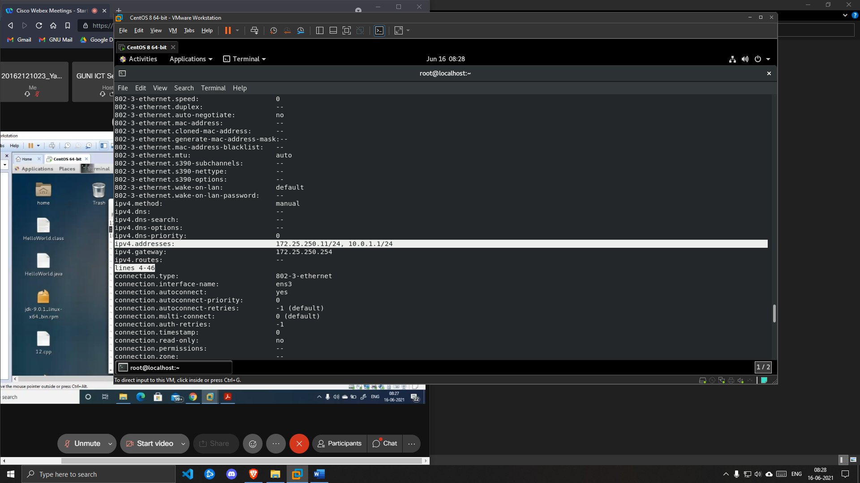

**7. Configure the hosts file so that 10.0.1.1 can be referenced as private.**

***SOLUTION***

